Option #1

Pseudocode:

Class Module4

INITIALIZE total to 0

INITIALIZE average to 0

INITIALIZE maximum to NEGATIVE_INFINITY

INITIALIZE minimum to POSITIVE_INFINITY

INITIALIZE counter to 0

WHILE counter < 5 DO

PROMPT user to enter a number

READ userInput

IF userInput < 1 THEN

OUTPUT "Input must be > 0"

CONTINUE to next iteration

END IF

ADD userInput to total

IF userInput > maximum THEN

SET maximum = userInput

END IF

IF userInput < minimum THEN

SET minimum = userInput

END IF

INCREMENT counter by 1

END WHILE

OUTPUT "************"

OUTPUT "Total: " + total

SET average = total / 5

OUTPUT "Average: " + average

OUTPUT "Maximum: " + maximum

OUTPUT "Minimum: " + minimum

OUTPUT "Interest: " + (total * 0.2)

Source Code:

import java.util.Scanner;

public class Module4 {

    public static void main(String[] args) {

        Scanner scnr = new Scanner(System.in);

        float userInput;

        float total = 0;

        float average = 0;

        float maximum = Float.NEGATIVE_INFINITY;

        float minimum = Float.POSITIVE_INFINITY;

        int counter = 0;

        while (counter < 5) {

            System.out.println("Enter a value:");

            userInput = scnr.nextFloat();

            if (userInput < 1) {

                System.out.println("Input must be > 0");

                continue;

            }

            total += userInput;

            if (userInput > maximum) {

                maximum = userInput;

            }

            if (userInput < minimum) {

                minimum = userInput;

            }

            counter++;

        }

        System.out.println("************");

        System.out.println("Total: " + total);

        average = total / 5;

        System.out.println("Average: " + average);

        System.out.println("Maximum: " + maximum);

        System.out.println("Minimum: " + minimum);

        System.out.println("Interest: " + total * 0.2);

    }

}

Screenshot of application execution

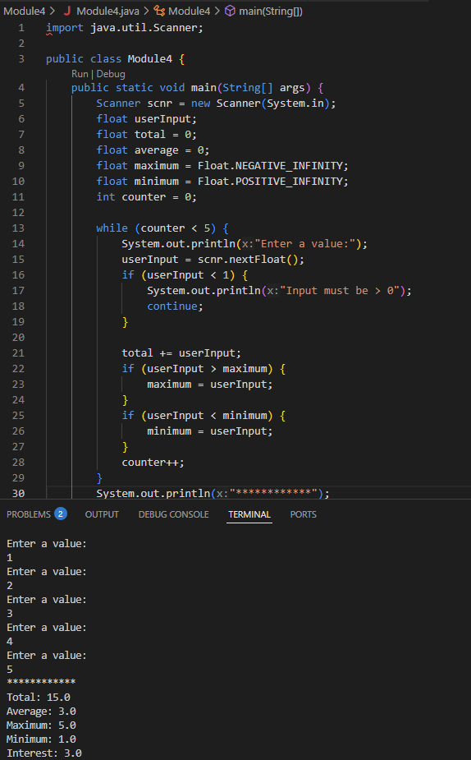

Git Repository