# Option #1

## Pseudocode

Class Module5

INITIALIZE integer array weeklyTemps = [65, 71, 73, 70, 85, 82, 82]

INITIALIZE string array daysOfWeek = ["Sunday", "Monday", "Tuesday", "Wednesday", "Thursday", "Friday", "Saturday"]

OUTPUT "Enter a day of the week. Enter 'week' for all days:"

READ userInput from user

TRIM any extra whitespace from userInput

IF userInput equals "week" (ignoring case) THEN

FOR each index i from 0 to length of daysOfWeek - 1 DO

DISPLAY daysOfWeek[i] + ": " + weeklyTemps[i]

END FOR

ELSE

FOR each index i from 0 to length of daysOfWeek - 1 DO

IF daysOfWeek[i] equals userInput (ignoring case) THEN

DISPLAY daysOfWeek[i] + ": " + weeklyTemps[i]

EXIT loop

END IF

END FOR

END IF

## Source Code

import java.util.Scanner;

public class Module5 {

    public static void main(String[] args) {

        Scanner scnr = new Scanner(System.in);

        int[] weeklyTemps = { 65, 71, 73, 70, 85, 82, 82 };

        String[] daysOfWeek = { "Sunday", "Monday", "Tuesday", "Wednesday", "Thursday", "Friday", "Saturday" };

        String userInput;

        int i;

        System.out.println("Enter a day of the week. Enter 'week' for all days:");

        userInput = scnr.next().trim();

        if (userInput.equalsIgnoreCase("week")) {

            for (i = 0; i < daysOfWeek.length; ++i) {

                System.out.println(daysOfWeek[i] + ": " + weeklyTemps[i]);

            }

        } else {

            for (i = 0; i < daysOfWeek.length; ++i) {

                if (daysOfWeek[i].equalsIgnoreCase(userInput)) {

                    System.out.println(daysOfWeek[i] + ": " + weeklyTemps[i]);

                    break;

                }

            }

        }

    }

}

## Screenshots:

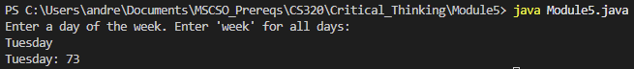

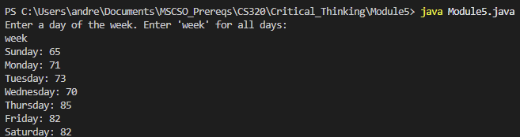

## GIT Repository:

https://github.com/ac-potts/CS320_CritThinking/tree/main/Module5