Date: February 8, 2019
Version: 0.16

AMSAT
PACSAT Ground Station Manual

Introduction
Thank you for downloading the PACSAT Ground Station software.

PACSATground is experimental. We are sure it can be improved. Please provide feedback and suggestions by email to g0kla@arrl.net or by logging an issue at https://github.com/ac2cz/Falcon/issues

In theory this ground station will work with any Pacsat, but it was written specifically to support FalconSat-3. In particular the support for telemetry collection is probably bespoke to that spacecraft.

License
PACSATground is Copyright (C) 2019 AMSAT-NA

This program is free software: you can redistribute it and/or modify
it under the terms of the GNU General Public License as published by
the Free Software Foundation, either version 3 of the License, or
(at your option) any later version.

This program is distributed in the hope that it will be useful,
but WITHOUT ANY WARRANTY; without even the implied warranty of
MERCHANTABILITY or FITNESS FOR A PARTICULAR PURPOSE. See the
GNU General Public License for more details.

You should have received a copy of the GNU General Public License
along with this program. If not, see <http://www.gnu.org/licenses/>.

Table of Contents

1 Introduction 1
1.1 License 1
2 Table of Contents 2
3 Getting Started 3
3.1 A bit about PacSats 3
3.2 Installing and running 3
3.3 Troubleshooting Issues running PACSATground 4
3.4 Setup 6
3.4.1 Using a Software TNC 6
3.4.2 Using a Hardware TNC 7
3.4.3 Initial Test 7
4 Live operation 8
4.1 First pass 8
4.2 All about the directory 10
4.3 Telemetry 12
4.4 Directory Selection Equations 15
4.5 Uploading Files 16
5 Appendix 18
5.1 Starting in Different Directories 18
5.2 Troubleshooting 19

IF YOU CAN SEE THIS TEXT PLEASE TURN OFF “DISPLAY HIDDEN TEXT” IN YOUR MICROSOFT WORD. THIS HIDDEN TEXT IS USED FOR REQUIREMENTS TRACKING.

Getting Started

A bit about PacSats

FalconSat-3 and similar spacecraft run software that follows the PacSat protocols. This is a clever set of software routines that provide a delay tolerant network connection to the spacecraft. The protocols are split into two halves. The broadcast protocol is used to receive data from the spacecraft. The files and data available on the spacecraft are broadcast as a directory listing. This means that all ground stations can listen and record the data.

Specific files are requested by transmitting a broadcast request to the spacecraft. The file is then broadcast in chunks of data and again all ground stations can receive it. Each ground station can then request the parts of the file that they missed. This makes it a very efficient way to communicate data to many stations and makes it possible to download the directory and files across fades and different passes of the spacecraft.

To upload files a ground station makes a dedicated connection to the spacecraft by logging in. The spacecraft then confirms space is available and provides the file number to use. The data is then uploaded. Again this is very delay tolerant and picks up seamlessly across fades or passes.

You may think this is all very old and out of date, and perhaps the speed at 9600bps is, but the protocols form the basis of modern high speed, delay tolerant communications through spacecraft. It is a very robust solution to transmitting data around the world with no dependence on the telecoms infrastructure.

A Pacsat like FalconSat-3 produces a decent amount of telemetry. That telemetry is broadcast periodically and stored in Whole Orbit Data (WOD) files on board. In fact there is more data stored than a single AMSAT Operations ground station can download. So we are asking for your help collecting telemetry. Any WOD files you collect and any broadcast telemetry you receive can be forwarded to the AMSAT telemetry server. Partial files are just as helpful as complete files because we reassemble them centrally. So receive only ground stations can contribute too.

Installing and running

There is no fancy installer for Pacsat Ground. You just unzip the distribution and put it in the directory of your choice.

To run on Windows double click PacSatGround.exe. To run on Linux or MacOs you may be able to double click on the jar file. If that does not work then you can run from the command line. Make sure you are in the same directory as the program, then run with:
java -jar PacSatGround.jar

MacOs makes all of this quite difficult for non technical users. If you have difficulty on MacOs then reach out and we will help.

When PACSATground starts you should have the Welcome screen shown below (unless you passed the data folder as a command line parameter. We recommend you choose a data folder that is different to the location of the program. This makes upgrades easier and avoids issues if the installation folder is not writable.

You need to put a valid Amateur Radio callsign if you are going to transmit to the spacecraft. If you are a receive only ground station then put something useful and unique as we use this to keep track of who has contributed telemetry.

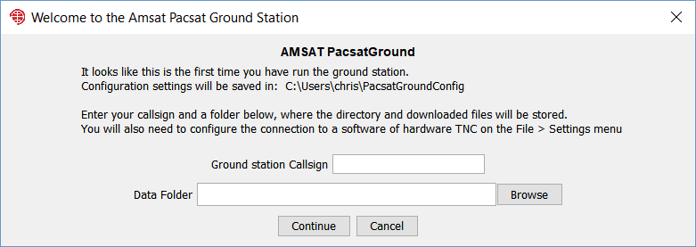

Pacsat Ground will write the configuration file into your home directory. This means it can find the configuration even if you change the data folder or move the installed program. For me on Windows that is c:\users\chris\PacsatGroundConfig\PacSatGround.properties

Troubleshooting Issues running PACSATground

Pacsat Ground will not start if you do not have java installed. You will get a message from the launcher telling you to download and install the latest version. Use Java version 8 (also called 1.8) or later.

If you get an error message from Windows SmartScreen like the below, then click “More Info” and then “Run Anyway”. Windows gives this message for new or little known applications that have not established a reputation.

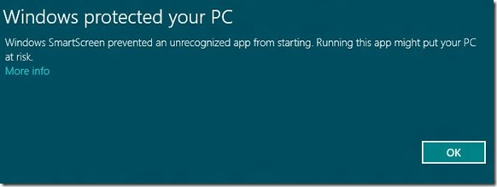

MacOS has similar security precautions.

If you are on Windows and the program complains that it is missing MSVCR100.dll or something similar to that, then you need to install the Microsoft Visual C++ redistributable:
For 32 bit Windows: http://www.microsoft.com/download/en/details.aspx?id=5555
For 64 bit Windows: http://www.microsoft.com/download/en/details.aspx?id=14632

If PacSatGound still won’t start, then ask for help on the amsat-bb mailing list or email g0kla@arrl.net

Setup
Pacsat ground is designed to have minimal setup. The parameters needed to connect to FalconSat-3 are included in a configuration file. So you do not need to setup callsigns for the spacecraft. You do need to decide how you are connecting the computer to your radio and configure the connection. You have two options, a software TNC or a traditional hardware TNC.

Using a Software TNC

A software TNC such as hs_soundmodem is the best choice for most people. On the File > Settings screen make sure that TCP is selected in the TNC settings. The hostname should be 127.0.0.1 if you are running soundmodem on the same machine. The default port is 8100, though you can change it in soundmodem.

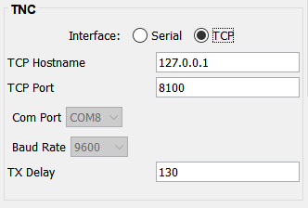

You need to download hs_soundmodem (hs for high speed). In soundmodem you choose FSK G3RUH 9600bp as the modem type on the Settings > Modems screen. Configure it to be full duplex.

On the Settings > Devices screen select the sound card or cards that you will connect to your radio. Make sure the radio is in 9600bps packet mode.

Under Server Setup, also on the Devices screen, make sure that KISS Server Port is enabled and has the same port number as the one you used in Pacsat Ground.

You will also need to arrange a way to key your radio using a COM port. Select the COM port that you have used on the Devices screen.

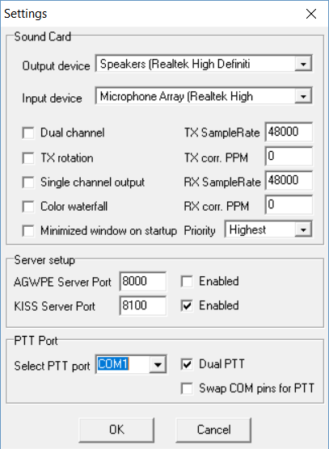
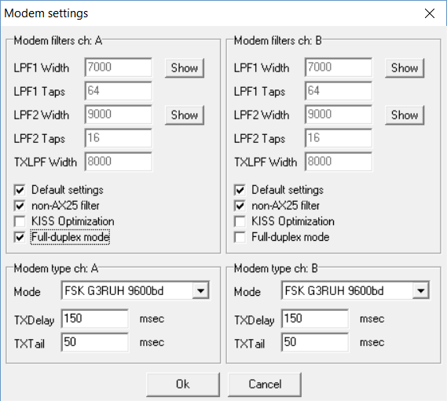

Using a Hardware TNC

If you have a hardware TNC then you can use that instead of hs_soundmodem. On the File > Settings screen make sure that Serial is selected in the TNC section. Select the serial Com port that you are using to connect to the TNC. The baud rate here is the connection speed to the TNC and not the speed that the data is transmitted to the spacecraft.

You need to restart PacsatGround to connect to the TNC. PacsatGround tries to put the TNC into KISS mode and you should see the typical light sequence. If that does not work then you should manually put the TNC into KISS mode and leave it like that.

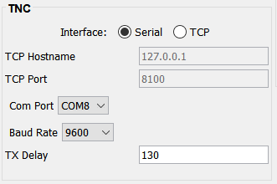

Initial Test

Is the TNC connected? If you press the “DIR” button at the top of the main window it will request a directory, even if the spacecraft has not been heard. You should see lights operate on your TNC and the radio should be keyed. RF should be transmitted. So make sure the antenna or a dummy load is connected! In a software TNC you will see the KISS bytes printed on the display.

Live operation

First pass
The spacecraft is constantly transmitting, so an initial test just listens for the spacecraft. 9600bps packet radio sounds like white noise, so it can be hard to tell if you are receiving the signal. The S meter may well move and the DCD light will come on when data is being heard. Like all spacecraft you will need to compensate for doppler by retuning the radio. I have my FT736R connected to SatPC32 for that purpose.

Let’s look at a pass and talk about the display in the ground station:

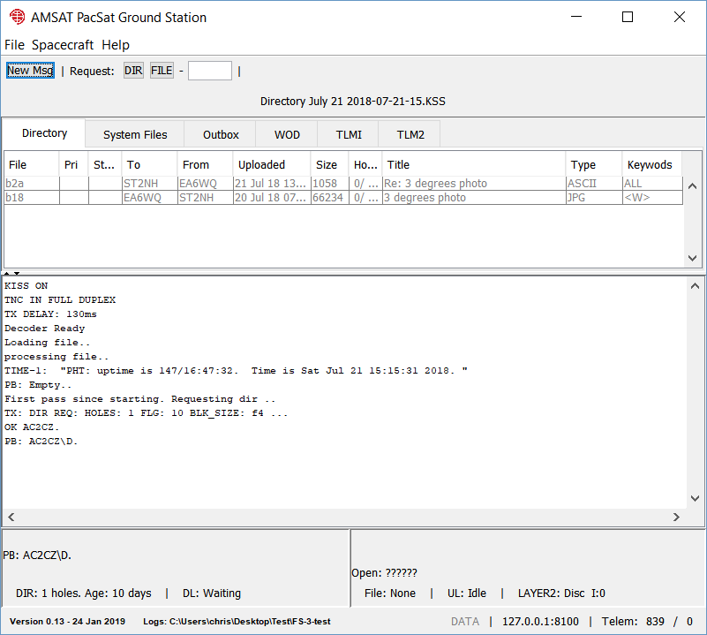

When we start the ground station it prints KISS ON, TNC IN FULL DUPLEX and TX DELAY: XXXms. It sends those KISS commands to the TNC. You can see these printed in the log area of the screen shot above. Ignore the words “Loading file..” and “processing file..” which show I replayed a KISS file to show this data.

In the absence of any requests the spacecraft transmits several things. First we see the time on the spacecraft. The next message is the status of the “PB”. The PB is a queue indicating who has requested Pacsat data to be Broadcast. If no one has requested anything you will see:

PB Empty ..

This indicates that no one is on the PB but that the PB is available for use.

Pacsat Ground then notes that this is the “First pass since starting..” and requests the directory. If you don’t want PacsatGround to transmit (perhaps no transmitter is even connected) then you can disable it on the File > Settings screen by selecting “Inhibit Transmitter”.

If the transmitter is enabled then the message transmitted to the spacecraft is shown, which in the screen shot above is a directory request for 1 hole:

TX: DIR REQ: HOLES: 1 FLG: 10 BLK_SIZE: f4 ...

When then get two responses:

OK AC2CZ.
PB: AC2CZ\D.

This shows that our transmission was heard and that we are now on the PB with a directory request. Note that the status of the PB is also shown in the bottom left of the window, together with the number of holes in the directory and its age, meaning the oldest file header that Pacsat Ground will request. You can adjust this age on the Spacecraft > FalconSat-3 screen.

While we are requesting the directory the spacecraft will transmit telemetry and other status messages, including the status of the uplink. For example, if we see a message like:

Open ABCD:

This means that the uplink to the spacecraft is open and available for use. There are 4 possible uplinks (A-D) but I think only A is available. Notice that the status of the uplink is shown in the bottom right of the window together with details of the uplink state machine and the layer 2 state machine. These are mostly to help me debug things, but if you are curious I can explain what it all means.

If the uplink is available and you have a file to upload, then Pacsat Ground will attempt to login. See the section on uploading files below.

All about the directory
The spacecraft has an onboard file system which stores Pacsat headers for each file. The files are split into two types: System files and User files. The user files are shown on the “Directory” tab and the system files are shown on the “System Files” tab. It is really one directory, but it is split this way due to the volume of system files.

We see a typical directory listing for user files below. If we have received the Pacsat file header for a file, but no other data, then it is in light grey. Once we receive some data the file is in black. You can see in the “Holes” column the number of holes and the percentage of bytes. Holes can be of any size, so the number is not that meaningful and can rise and fall as different parts of the file are received. Eventually the holes will reach zero and the percentage downloaded reaches 100. The file will then be colored blue unless it is directly to you, then it is red.

Unread files are in bold. Read files are no longer in bold.

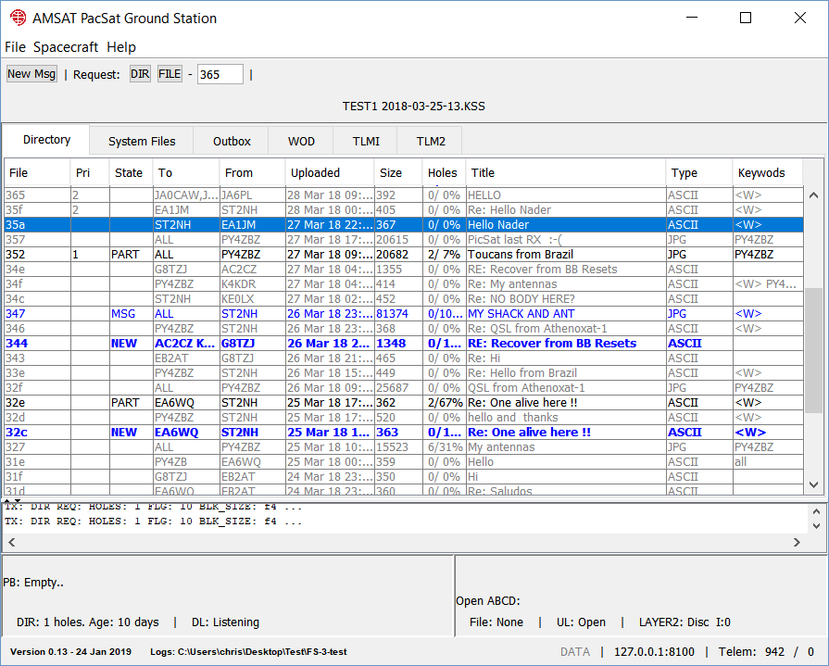

To mark a file for download, select it with the mouse or the arrow keys and then press one of the numeric keys from 1-4. This will give it a download priority, with 1 being the highest priority. You can also select 0 to clear the priority or N to prevent the file from being downloaded automatically, as discussed below in the section on Directory Selection Equations.

If you double click on a file then it opens in another window, as I did with the message “MY SHACK AND ANT” from Nader, ST2NH. You see the result below, a really nice image he uploaded.

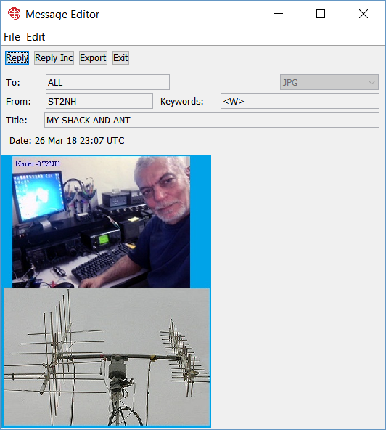

From here you can reply to the message. If it is a text based message you can press “Reply Inc” to include the original message in your response.

Telemetry

We would like your help downloading telemetry from the spacecraft and then uploading it to the telemetry server. All you need to do is go to the File > Settings screen and complete some of the details. Fill in your locator or lat/long and make sure “Send AMSAT Telemetry” is selected. Then any downloaded telemetry is forwarded to the server.

This will automatically forward broadcast telemetry and any full or partial Whole Orbit Data Files received. If you are able to transmit to the spacecraft you may want to ask for WOD files to be downloaded automatically using a Directory Selection Equation, as described below. Even if you don’t manage to download complete files, any partial fragments are very helpful.

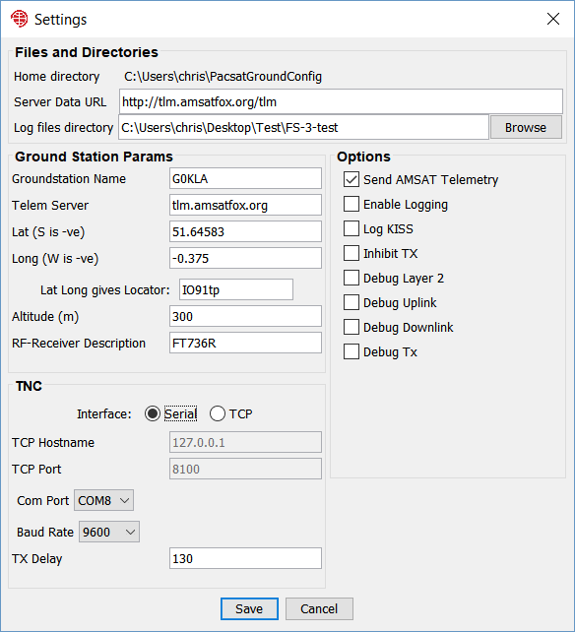

Downloaded telemetry is shown on the WOD, TLMI and TLM2 tabs. If you are familiar with FoxTelem then you will recognize these screens. Like FoxTelem, if you click on a value a graph opens up and plots the data that you have collected.

You can download the telemetry that everyone else has uploaded. Select File > Fetch Server Data. But be careful. You will get a warning that your existing log file data will be overwritten. This will only overwrite telemetry logs and won’t impact your directory, your downloaded System Files or your uploads. If you don’t want to overwrite, then switch to a new directory using File > Settings or create shortcuts to start PacsatGround with different directories passed in as a parameter. I have a shortcut called FS-3 Server that starts PacsatGround in a directory that only contains server data.
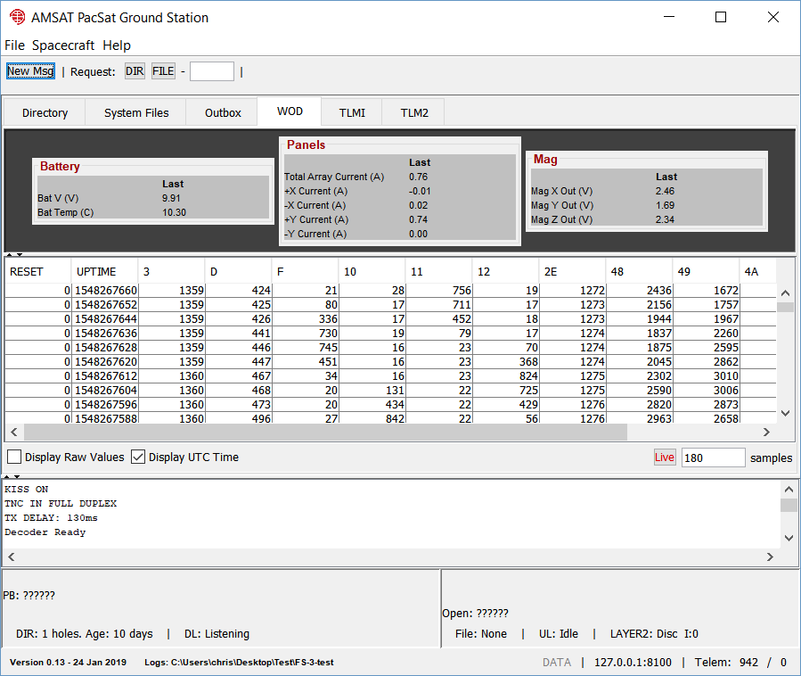

Below is a graph of Bat V from the Whole Orbit Dat, showing the last 180 values. By default this is plotted against UTC. Unlike the Fox spacecraft “Uptime” just shows the number of seconds since the Unix date epoch and not the uptime of the spacecraft.

You can use the “+” button in the top left to add other traces from the same data set. Saving to a file as CSV values is not yet working. Let me know if you need it.

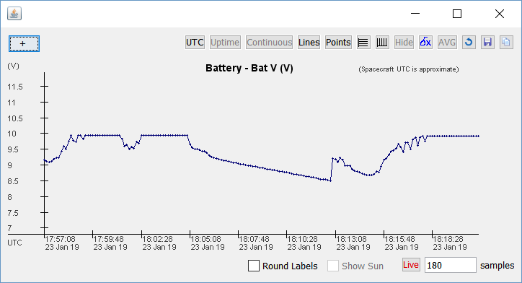

Directory Selection Equations

It is fun to watch a Pacsat pass and see the files appear. You can select them for download and compose a response in real time. If you are lucky it gets uploaded before the pass is done. But you can not always be in front of the computer. If someone sends a message directly to you, then it would be nice if it was automatically downloaded without you having to give it a priority. To do this you setup a directory selection equation. It’s called an equation for historical reasons.

On the Spacecraft > FalconSat-3 screen you can see a section of the window for Equations. It is initially empty. Click “Add” to enter an equation, which gives you the screen below:

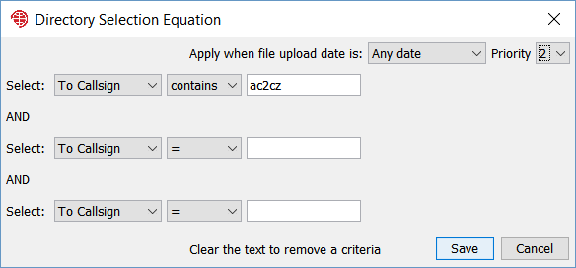

On this screen I have specified that if “To Callsign” in the Pacsat Header contains the string AC2CZ then set the priority to 2. This applies to a file with any upload date.

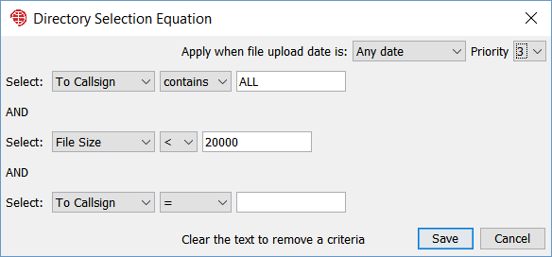

In the example above I have specified that the message needs to be to ALL and the size of the file should be less than 20k. This will exclude large images. Priority is 3.

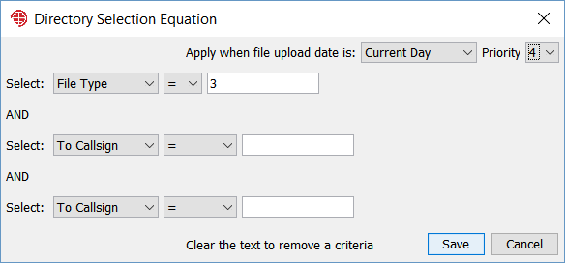

And then in the example above I have specified the File Type to be “3” which is a Whole Orbit Data (WOD) file. If you are willing to help collect telemetry, set this rule up. Note that it will flag todays file’s only, but it does not automatically switch the rule off. You can setup another rule to set File Type 3 to Priority N after 2 or 3 days. This prevents you from getting back logged with older telemetry files.

See the appendix for File Types.

Uploading Files

If you press “New Msg” on the main screen you get an editor window, ready to create a new message.

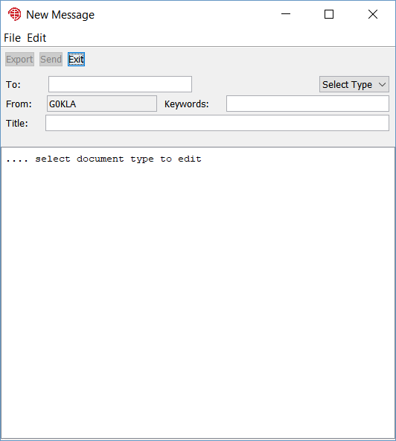

You can not enter any text until you select the type. For a text message pick ASCII. If you want to upload an image then pic JPG. I need to add some more image types. You can actualy pic PNG or some other image formats and it will create the message and upload it. It will probably work with PacsatGround but it may confuse legacy software like WISP. If you test it. Let me know what happens.
In the “To” Field you put one or more callsigns and/or ALL. Keep the title short and pick some keywords if you want.

One you hit “Send” the message is added to the Outbox and can be seen on the Outbox tab. Here we can see if the spacecraft has assigned it a file number yet. We also see the State, which is QUE and which becomes SENT or FAIL depending on the result of the upload. If the upload fails then an error message is printed in the log area. I’d like the message to go here in a future release.

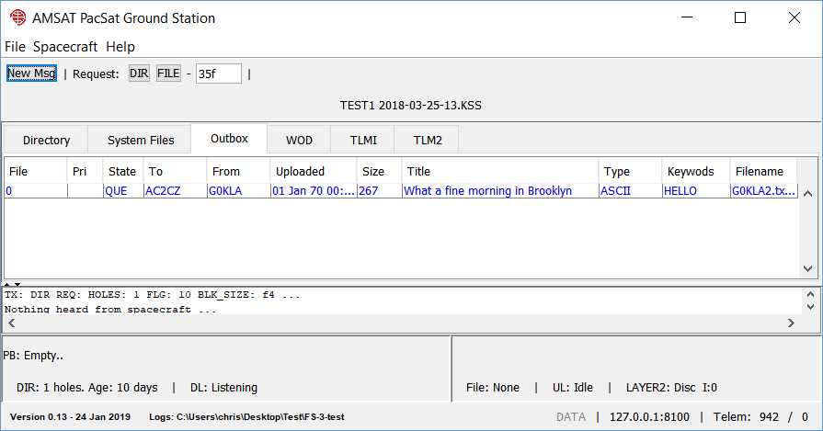

Appendix

Starting in Different Directories

You can pass the data directory in at startup, so that you can use scripts or short cuts to run PacsatGround with different data sets. This is most useful to keep a separate copy of server data.

On Linux or MacOs create a shell script with something like the following:

cd <directory where Pacsat Ground is installed>
java -jar PacSatGround.jar /home/chris/radio/fs-3-data

if java is not in your path you will need the full path to java

On windows go to the folder where PacsatGround is installed.
- Right click on PacSatGround.exe and dag the icon to the place you want a shortcut. When you release the button you get a menu. Pick “Create Shortcut Here”.
- Right click on the new icon and select Properties. In the field “Target” add the Data folder directory after the target as the first parameter passed to the program when it is launched. In fact you can cut and paste the directory from Explorer if you click in the path at the top of the window.
- Now when you double click the icon it runs PacsatGround using the passed directory as the data folder. It uses a unique set of settings which are stored in the data folder.

File Types

This is the list of Pacsat File types I have.

0 ASCII Text message.
2 Bulletin Board Satellite Gateway Files
3 UOSAT whole orbit data
6 MSDOS EXE file
7 MSDOS COM file
8 Keplerian elements - NASA format
9 Keplerian elements - AMSAT format
12 Binary file(s).
13 Multiple files, all ASCII text
14 Picture file - GIF format
15 Picture file - PCX format
16 Picture file - JPG format
17 Confirmation Message
18 Multiple destination SatGate files
19 Internet forward files
200 Config. files U/L from command stations
201 AL FTL0/PB activity logs
202 BL Broadcast logs
203 WD whole data logs
204 ADCS logs
205 TDE data
206 SCTE data
207 Transputer logs (including EISLOG)
208 SEU logs (ELTLOG)
209 CPE files (UO3)
210 Battery charge logs
211 Image files
212 PL* (SPL Logs)
213 CU* (PCT Log Files)
214 PC* (PCT Command Logs)
215 Quick look image files
221 CCD Image files (KO23)
222 CPE Result files (KO23)
255 All others not fitting in the above

Troubleshooting

The TNC seems to be receiving data but nothing is shown in Pacsat Ground | Make sure you are in KISS mode. Try connecting to the TNC from a normal terminal and putting it manually into KISS mode. If there is a special way to put your TNC into KISS let me know. Right now it uses the TNC2 compatible method, sending the string KISS ON followed by RESTART.  Also note that it takes the TNC out of KISS when it exits. By sending a KISS frame with one byte ff. (The whole frame is c0,ff,c0)
I never transmit any data from the TNC even though PacsatGround sends data to it | Are you really in Full Duplex mode?
It crashed, what do I do? | Log an issue on github.com/ac2cz/Falcon/issues or send an email to the author g0kla@arrl.net
I connect to my computer using a Remote Desktop Connection (RDP) and Pacsat Ground is always not running. | This seems to be a Windows “feature”. When you connect the RDP connection kills something in the audio subsystem that upsets Java. This is outside the Pacsat Ground code base and I don’t have a fix. I recommend using AnyDesk for remote connections.

