Date: November 26, 2020
Version: 1.09

AMSAT Fox-1
Telemetry Decoder Manual

Introduction
Thank you for downloading the Fox Telemetry Decoder. You can use this program to demodulate, store and analyze telemetry data from AMSAT’s Fox series of CubeSats. We hope that you will also upload the telemetry you receive to the AMSAT server so that it can be used by other scientists, students and our research partners, whose experiments fly with the Fox satellites.

FoxTelem is experimental. We are sure it can be improved. Please provide feedback and suggestions by email to g0kla@arrl.net or by logging an issue at https://github.com/ac2cz/FoxTelem/issues

AMSAT has launched four spacecraft based on the Fox-1 architecture and will launch one more. They are named Fox-1A through Fox-1E, but as each is launched they are assigned an OSCAR number. After launch that number is used for tracking and dissemination of Keplerian Elements (Keps), also called Three Line Elements (TLEs). If you decide to have FoxTelem calculate the position of the spacecraft, then you will need to make sure that the name in FoxTelem is the same as the name in the TLEs.

Fox-ID | Name in this document and at Launch | Name Post Launch
1 | Fox-1A | AO-85
2 | RadFxSat / Fox-1B | AO-91
3 | Fox-1Cliff | AO-95
4 | Fox-1D | AO-92
5 | RadFxSat2 / Fox-1E | -
8 | Golf-T | -

In FoxTelem 1.08 and later you can also assign a display name to label the spacecraft on tabs and graphs. For example if you have to set the name to AO-91 to match the Keplerian elements in the file you receive, you can also set the display name to RadFxSat. Then tabs and graphs for Fox-ID 2 will have that title.

Fox-1 satellites launched so far include three telemetry formats:
- Data Under Voice (DUV) is 200 bps FSK data sent at the same time as the transponder audio. Whenever the FM transmitter is on, data is being sent. This happens during beacons and during live QSOs.
- High Speed is 9600 bps FSK sent instead of the transponder. This is used for data intensive experiments such as the Virginia Tech Camera on Fox-1D (AO-92) and University of Iowa HERCI experiment on Fox-1D (AO-92). On Fox-1A (AO-85) high speed was only used to test the functionality. This mode is only active when commanded from the ground. You can recognize High Speed because it sounds like an old school computer modem.
- PSK is 1200 bps BPSK data sent alongside a linear transponder. This provides continuous real time telemetry and whole orbit data on HuskySat. In the future it will support Fox-1E and Golf-T.

FoxTelem will receive and store all three formats assuming you can feed it clean audio or IQ signals from a hardware Software Defined Radio (SDR).

In addition to the Fox-1 spacecraft, the AMSAT-NA Linear Transponder (LT), Internal Housekeeping Unit (IHU) and BPSK Modulator is being leveraged by University partners directly in their spacecraft. This uses the same PSK format as Fox-1E to transmit telemetry to earth. HuskySat was the first such partnership. It was launched November 2, 2019.

Fox-ID | Spacecraft owner | Name in this document and at Launch | Name Post Launch
7 | University Of Washington | HuskySat | HO-107

License
FoxTelem is Copyright (C) 2015-2020 AMSAT-NA

This program is free software: you can redistribute it and/or modify
it under the terms of the GNU General Public License as published by
the Free Software Foundation, either version 3 of the License, or
(at your option) any later version.

This program is distributed in the hope that it will be useful,
but WITHOUT ANY WARRANTY; without even the implied warranty of
MERCHANTABILITY or FITNESS FOR A PARTICULAR PURPOSE. See the
GNU General Public License for more details.

You should have received a copy of the GNU General Public License
along with this program. If not, see <http://www.gnu.org/licenses/>.

Table of Contents

1 Introduction 1
1.1 License 2
2 Table of Contents 3
3 Getting Started 5
3.1 Installing 5
3.2 Running for the first time 5
3.3 Testing with a wav file 7
3.4 Launching one or more copies of FoxTelem 7
3.5 Troubleshooting Issues running FoxTelem 9
4 Decoding 11
4.1 FSK Low Speed Telemetry (DUV) 11
4.2 FSK High Speed Data Mode 11
4.3 BPSK – Binary Phase Shift Keying 12
4.4 Selecting a source 14
4.5 Setting up the levels 15
4.6 Feeding the Audio 16
4.7 Decoding from an IQ source such as the FUNcube Dongle 17
4.8 Starting the decoder 18
4.9 Finding the Satellites Signal in FoxTelem’s SDR 19
4.9.1 Tracking spacecraft 19
4.9.2 Find Signal 20
4.9.3 Calculate Doppler 22
4.10 Automatically retune / switch modes 23
4.11 Auto Start (When Above Horizon) 24
4.12 FSK DUV + HS Mode 25
4.13 NCO – The Numerically Controlled Oscillator 26
4.14 Starting the decoder at launch 26
4.15 Counting Frames and Payloads 26
5 Fox Telemetry Format 27
5.1 Data Under Voice 27
5.2 High Speed Telemetry 27
6 Sending Data to the Server 28
7 Downloading data from the Server 29
8 Understanding the Data 30
8.1 Fox Health Screen 30
8.2 Graphing Telemetry Values 32
8.3 Multiple Variables on one graph 36
8.4 Earth Plots 36
8.5 Radiation Experiment 37
8.6 Camera Images 37
9 Making Measurements 38
9.1 Overview 38
9.2 Signal to Noise Measurements 38
9.3 Azimuth and Elevation 38
9.4 Time of Closest Approach 38
9.5 Sky Plots of Measurements 39
10 Getting Better Decodes 39
10.1 Eye Diagram 39
10.2 PSK 40
10.3 PSK Phasor 41
10.4 High Speed Bandwidth 42
11 Settings 42
11.1 Files and Directories 43
11.2 Decoder Options 44
11.3 Ground Station Parameters 45
11.4 Formatting 45
11.5 Measurements 45
11.6 Debug Options 46
12 Spacecraft Configuration 48
12.1.1 Adding and Removing Spacecraft 48
12.1.2 Spacecraft Configuration File 48
12.1.3 Telemetry Layout Files 51
12.1.4 Conversions 52
12.1.5 Conversions Curves 53
13 Troubleshooting 54

IF YOU CAN SEE THIS TEXT PLEASE TURN OFF “DISPLAY HIDDEN TEXT” IN YOUR MICROSOFT WORD. THIS HIDDEN TEXT IS USED FOR REQUIREMENTS TRACKING.

Getting Started

Installing
FoxTelem is supplied as an archive file (.zip on windows and gzip on Linux/MacOs). You can unzip the contents and put it in the directory of your choice. Right on the desktop works well, as does somewhere in your home directory or documents directory. If you install it into the MacOS Applications folder or into the Windows “Program Files” folder, then make sure you choose a different directory to write the decoded data into. You can do this the first time you run the program and is a good practice for all installs.

Running for the first time

Run FoxTelem by double clicking FoxTelem.exe on Windows. On MacOS or Linux, you should be able to double click the foxtelem start script.

When FoxTelem starts you should have the Welcome screen shown below (unless you passed the logfile directory as a command line parameter. We recommend you choose a logfile directory that is different to the location of the program.

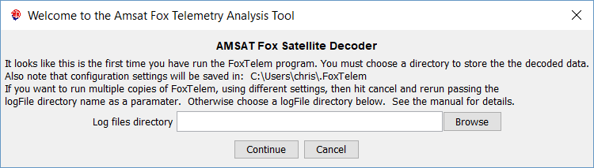

FoxTelem will be able to decode from all the Fox spacecraft. You will be asked which spacecraft you want to decode. FoxTelem will then copy the spacecraft configuration files from the installation directory, into the chosen logfile directory.

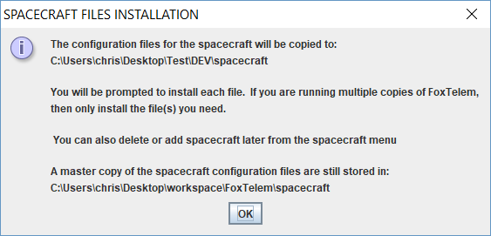

This is not permanent. You can later add or remove spacecraft files from the Spacecraft menu. Feel free to just add one to get started. A master copy of each spacecraft file is stored in the spacecraft subdirectory of the installation folder.

For each spacecraft you can copy in the file or skip it. If you are going to run one copy of FoxTelem then you can install the current live spacecraft - Fox-1A (AO-85), RadFxSat (AO-91), Fox-1D (AO-92) and Fox-1C (AO95) when I wrote this. If you are running multiple copies of FoxTelem then just select the spacecraft required for the copy you are setting up.

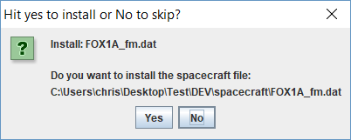

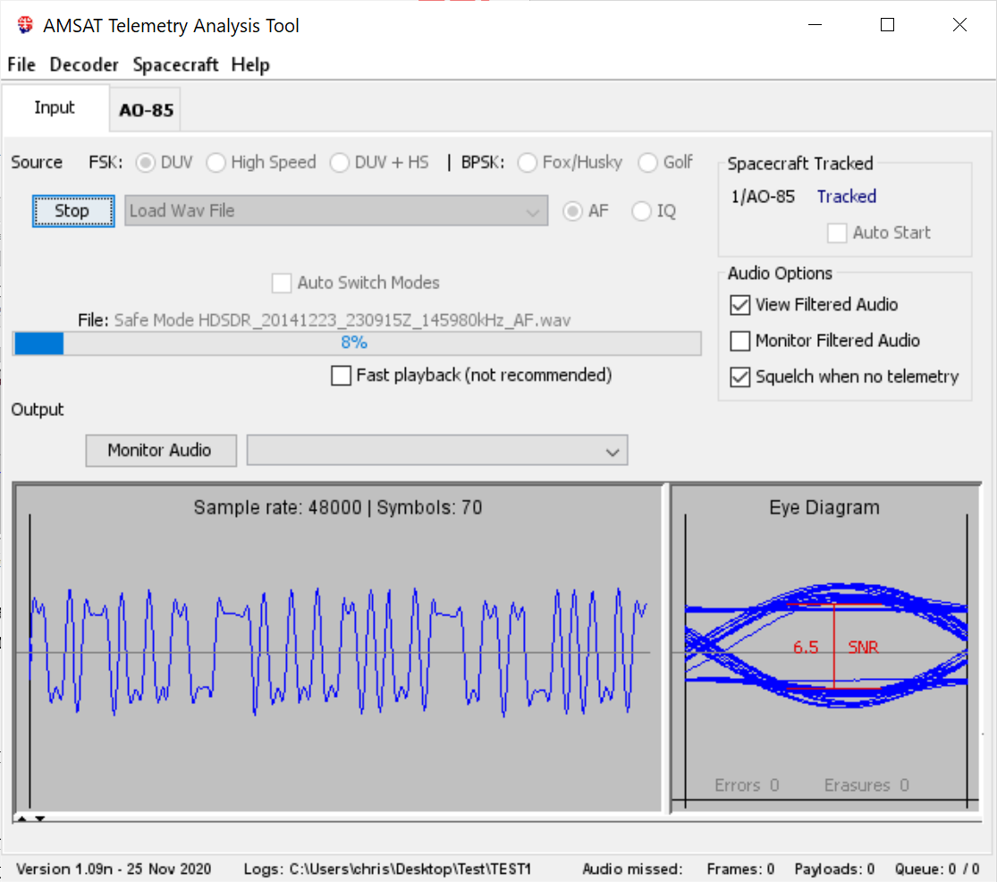
Testing with a wav file
To confirm everything is working you can download a test wav file from amsat.us/FoxTelem/recordings. A recording ending in AF is audio as received from a radio. A recording ending in RF is an IQ file.

Select “Load Wav File” from the FoxTelem “File” menu and navigate to the directory where you saved the file.

A recorded file will play through very quickly. If you want it to process at normal speed press the “Monitor Audio” button and uncheck “Squelch when no telemetry”. This will force FoxTelem to play the audio back through your speakers and will slow down the playback to normal speed. You will need to have a valid output device selected.

Then press the “Start” button.

The file will play through the decoder and the audio waveform will be shown together with an eye diagram. You should get a number of frames decoded.

There should be data visible on the AO-85 satellite tab. If the data is difficult to read because the font is too large or too small then open the settings screen from the File menu and change the font size for the Health Modules.

Launching one or more copies of FoxTelem
You can run FoxTelem in two different ways. In Option 1, you use one copy of FoxTelem that decodes all the satellites you want to track. In Option 2, you run multiple copies of FoxTelem that each track different satellites. Broadly speaking if you use one radio or a single SDR you will probably run one copy of FoxTelem. If you use multiple radios, soundcards or SDRs then you will use multiple copies of FoxTelem.

There are Pros and Cons to these two approaches, which can be summarized below:

Running a Single Copy

Run FoxTelem by double clicking FoxTelem.exe on Windows. On MacOS or Linux, you should be able to double click the foxtelem start script. You may also be able to double click the FoxTelem.jar file, but this can be unreliable on different versions of Unix because the current directory is not always set to the Jar file directory.

When running a single copy:
Pros:
One copy of FoxTelem stores its settings in a central place. It uses one logfile directory to store the decoded telemetry from all spacecraft. All spacecraft decoders share the same audio input or device. It’s simple to understand and configure.

Cons:
You cannot decode two spacecraft at the same time. You can’t use two radios or two SDRs. The “Find Signal” algorithm may not work as well when multiple satellites are being tracked as it needs to check each in turn.

Running Multiple Copies

Run FoxTelem from a script or batch file or from a short cut.

On Windows this is easiest with a short cut. Create one as follows:
- Right click on the FoxTelem.exe file and select “Create Shortcut”. You can also right click and drag FoxTelem.exe out to another folder or your desktop. When you release the mouse button “Create Shortcut” is presented as an option.
- Right Click on the short cut and select “Properties”.
- Now go to explorer and find or create the directory you want to use for log files. This will also be where the configuration gets stored.
- Click in the box at the top of the explorer window that displays the folder path and it will highlight it. Type Ctrl-C to copy it.
- Go back to the shortcut properties window and put your cursor in the “Target” text field. This contains the full path to FoxTelem.exe. Insert a space at the end then paste the path to the logfile directory with Ctrl-v.
- Click OK.
- Move the short cut to your desktop or where you would like to have it. Double clicking this shortcut will now run FoxTelem with this logfiles directory and a unique set of Configuration.

On Mac or Linux create a new bash shell script. Name it something like FoxTelem_AO-85. In the script put:

#!/bin/bash
<path-to-foxtelem-install-dir>/foxtelem <path-to-logfile-dir>

Note that this is running the start script rather than the jar file. You can run the jar file directly if you want, but you may need some or all of the settings from the launch script.

Make this script executable with chmod +x FoxTelem_AO-85.
You should be able to run FoxTelem with this script.

When running multiple copies:
Pros:
You can decode from two spacecraft at the same time. You can use FoxTelem to read audio from as many audio inputs or devices as you like, such as a 2m radio and a 70cm radio, or two different SDRs on the same or different bands.

Cons:
You can not decode from two bands with a single SDR. With multiple copies of FoxTelem listening to the same SDR you need to keep each copy on the same band. To decode from two bands you need to use two different SDRs.

You need to pass a command line parameter to FoxTelem when you run it, so it knows which logfile directory you want it to use. The configuration and decoded spacecraft data are stored in different logfile directories, so you need to configure each. It is more complicated than running a single copy.

Troubleshooting Issues running FoxTelem
FoxTelem will not start if you do not have java installed, FoxTelem 1.04 requires Java version 6 (sometimes called 1.6) and FoxTelem 1.05 and later requires Java version 8. You will get a message from the launcher telling you to download and install the latest version.

If you get an error message from Windows SmartScreen like the below, then click “More Info” and then “Run Anyway”. Windows gives this message for new or little known applications that have not established a reputation.

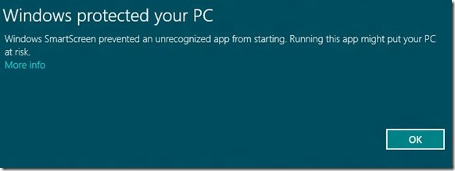

MacOS has similar security precautions and they have changed in recent releases. It may be a message like the below. It may also say that FoxTelem is dangerous, corrupt or not runnable.

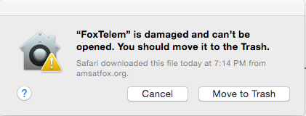

FoxTelem is not really damaged and it can in fact be opened. The easiest way to fix it is to right click (which would be two-finger click on a touch pad or magic mouse) and select "run" from the menu. You will get a similar message, but one of the choices is "run anyway". After you do that the first time, you should not need to again. The message is displayed because your “Security and Privacy” settings do not allow applications that are not installed from the Mac App Store. If the “right click / two-finger click” option does not work then you will need to temporarily change your Security and Privacy settings. Change them back after you have run FoxTelem. It should run the next time without changing the settings.

If you are on Windows and the program complains that it is missing MSVCR100.dll or something similar to that, then you need to install the Microsoft Visual C++ redistributable:
For 32 bit Windows: http://www.microsoft.com/download/en/details.aspx?id=5555
For 64 bit Windows: http://www.microsoft.com/download/en/details.aspx?id=14632

If you do not know if you have 32 or 64 bit Windows then on Windows 7 Open “System” by clicking the Start button, right-clicking Computer, and then clicking Properties. Under System, you can view the system type.
On Windows 10 right click the start menu and select System.

If FoxTelem still won’t start, then see the troubleshooting section at the end of the manual, ask for help on the amsat-bb mailing list or email g0kla@arrl.net

Decoding
The telemetry for a Fox-1 FM spacecraft is sent in two different ways. During all beacons and while the transponder is on, low speed telemetry is sent on the same frequency, even while the transponder is in use. At certain times the transponder may be commanded off and high speed data mode may be in use.

The telemetry for Fox-1E and any other Fox spacecraft with a linear transponder will be 1200 bps Phase Shift Keying (PSK).

These three modes are described in the following sections.

FSK Low Speed Telemetry (DUV)
This is sent as Data Under Voice (DUV) in the audio band from 0 to 200Hz in the same FM channel as the transponder audio. While a QSO is in progress, we can receive telemetry from the spacecraft.

This makes certain demands on the ground station. There should be no high pass filtering of the FM audio. Ideally the band from 0 to 200Hz is untouched when it is received from the telemetry decoder. Unfortunately, this is not the case for almost all radios.

What we want to receive is something like below. You can see all of the bits, although there is some “ringing” from filtering in the decoder itself. The eye diagram shows the last set of bits received, drawn one on top of another. We can see a nice shape and it fits into the sample window. The bits are sampled vertically at the midpoint, with the signal to noise shown by the red line. We want a signal to noise ratio of at least 3dB. Higher is better. 2dB is marginal. 10dB is excellent. We also see the Error rate in the Eye Diagram window. This is updated each time we receive a frame from the satellite and shows the number of bytes that were corrected by the Reed Solomon (RS) Decoder (Errors) and the number of bytes that were invalid 8b10b words (Erasures).

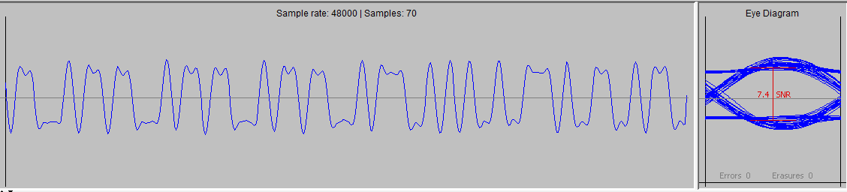

FSK High Speed Data Mode
High speed data is sent at 9600 bits per second Frequency Shift Keying (FSK). This is not the same format as G3RUH or other packet modes and can not be decoded with a hardware or software TNC.

High speed data puts even further demands on the ground station. Some radios may work through the 9600 bps data port, but best results will be obtained with a Software Defined Radio (SDR).

In High Speed Mode we want to receive a bit pattern and eye diagram like the below. Note that the bits are represented by far fewer samples and the eye diagram is now angular. The bit Signal To Noise ratio it typically lower for the same RF signal level. This means that a stronger signal (or a bigger antenna) is needed to decode high speed data. Like DUV, the errors and erasures from the RS Decoder are shown. Each high speed frame has 21 RS code words, which can each correct up to 32 errors, so the values can become quite high. This is Forward Error Correction in action and the reason you can’t use a Packet TNC.

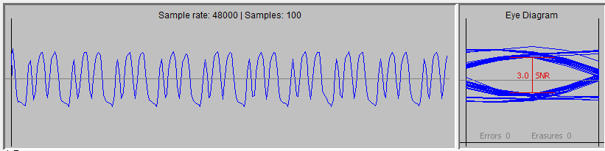

BPSK – Binary Phase Shift Keying
Fox-1E will fly with a linear transponder. Freed from the requirement to use Frequency Modulation the telemetry data will be sent with Phase Shift Keying due to its superior performance compared to FSK. For example the Costas Loop decoder, together with the coding gain we obtain from Forward Error Correction (FEC), can decode PSK when it is only 2-3dB above the noise. FSK needs a much stronger signal.

PSK data does not have the strict filtering requirements that DUV and High Speed Data mode require from the radio receiver. It should decode from a single sideband radio or your favorite SDR. The radio needs to be close enough to the signal for the decoder to find it. The decoder searches about 2kHz above and below the tune point to locate the data. It should be possible to tune the radio or an SDR with Doppler prediction and then let FoxTelem handle the fine tuning to decode the data.

FoxTelem supports two PSK decoders as an experiment. They are referred to as the BPSK Costas (or Costas Loop) decoder and the BPSK Dot Product (DP) decoder. Feel free to use either and report back your results. Testing on the ground with simulated data has indicated that both work well in different situations. Read the research here: http://www.g0kla.com/workbench/2019-03-09.php. With that said testing with HuskySat showed that the Dot Product decoder was usually superior for real signals from space. For that reason the Dot Product decoder is the default. If you want to use the Costas Loop decoder then you can select it from the File > Setting window, where it is one of the decoder options:
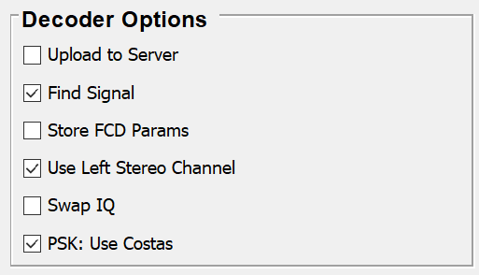

Examples of the two BPSK decoders are shown below. The details of these displays are explained in “Getting Better Decodes” later in this manual.

FoxTelem decoding with a Dot Product BPSK Decoder

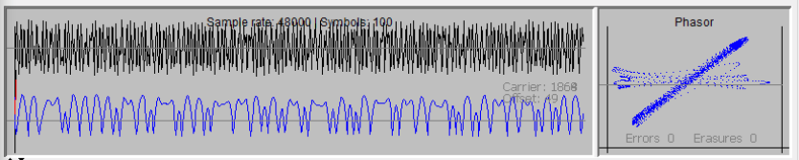

FoxTelem decoding with a Costas Loop BPSK Decoder
Directly from the FoxTelem SDR
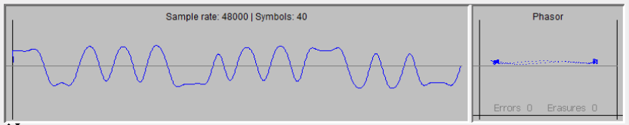

From an audio source
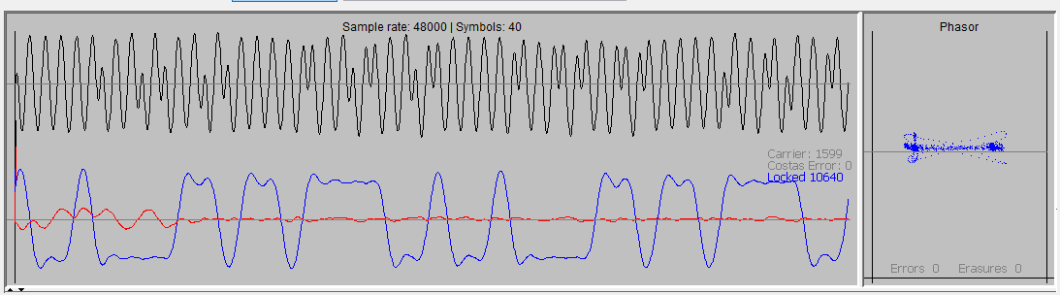
FoxTelem 1.09 also supports two different Frame layouts that the BPSK decoder can decode. You select which frame layout you want to decode on the main Source screen as shown below, where the Fox-1E and HuskySat format is selected:

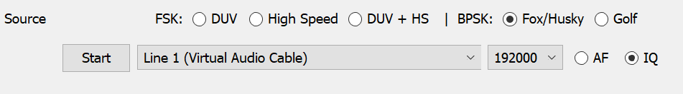

If you want to automatically switch between different decoders and formats, you can setup the default decoder for each spacecraft on the Spacecraft settings screen. This is used by the “Automatic Mode Switching” algorithm described later in this manual.

Selecting a source
FoxTelem decodes audio, but there are many ways to source it. On the Input tab you select the source in the pull down box near the top, just to the right of the “start” button. One approach is to pick one of your sound cards and then feed audio into that sound card from a radio.

In the example below FoxTelem is reading from the “Primary Sound Capture” source, it will process Low Speed (Data Under Voice) with a 48000 bits per second sample rate. (This must be the sample rate that the sound card has and FoxTelem needs to match it. You can’t change the sample rate that FoxTelem runs at without changing the sample rate of the audio that it receives.) Finally, it is expecting normal audio (AF) from a radio.

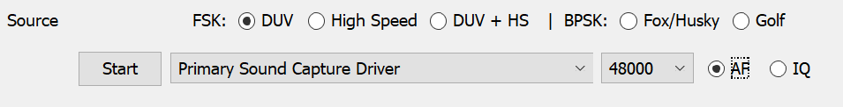

FoxTelem can also read IQ audio and act as a Software Defined Radio (SDR). You do this by selecting a source that supplies In Phase audio on one stereo channel and Quadrature audio on the other. You set the correct sample rate and you choose IQ, rather than AF (to the right of the sample rate pull down). If the device is the FUNcube Dongle or the RTL-SDR then you should also be able to set the frequency directly. If it is another device, then you will need an external program to control it. FoxTelem will just read the IQ audio.

On some Mac Computers, FoxTelem may only read from the default device (this is likely a bug that I need to fix). You can select the default device from System Preferences>Sound then select Input and set the device you want as the sound input.

If you are not seeing any sound card devices on the Mac, then you may have the sample rate set to a level where no sound cards are supported. Try setting it to 48000. If you no longer have a sample rate pull down, then you need to delete the foxtelem.properties file as a work around. This is a known issue.

Setting up the levels
You may need to adjust the sound levels in your operating system. I had to adjust the levels in Windows. From the control panel I selected: Hardware and Sound> Manage Audio Devices> and then adjusted the properties for the sound card on the Custom and Levels tabs. In Windows 10 you can get directly to the Audio devices by typing “Manage Audio Devices” at the start menu.

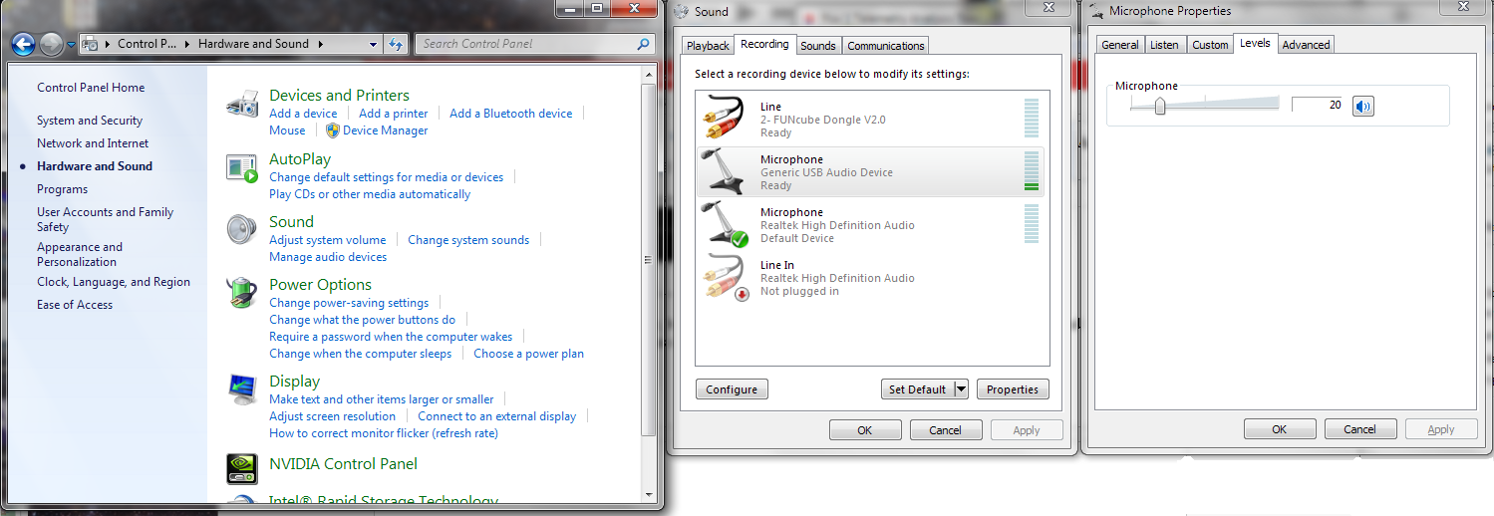

On the Custom tab I unchecked AGC and on the Levels tab I set it to 50. You may have other settings for your sound card.

To set the levels correctly in FoxTelem, uncheck the “View Filtered Audio”, shown below on the right, and make sure that the signal is visible but does not take up more than a quarter to a half of the display. If it is too low, you won’t decode frames, if it is too high you will see it square off on the display. The exact setting is not critical because FoxTelem has some AGC built in. Too high a level is more of a danger than too low. Also note that the white noise when there is no FM signal is usually much louder, which is to be expected. This may well drive the decoder into distortion. A quiet transponder, which has been keyed, but which has no audio signals in it, should not distort. The spacecraft will still be transmitting telemetry and you can decode it.

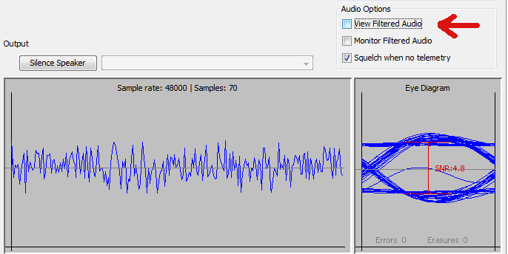

Also note that the sample rate is shown on the Advanced tab (in the Windows example screens). Windows typically defaults it to 44100 and the decoder defaults to 48000. Your Operating System may default to something else. The sample rate in the sound card setup needs to be the same as the sound card sample rate in the decoder or you will get a poor decode rate. The Source Selection image above shows the sound card rate near the top.

Why do we default FoxTelem to 48000 if Windows defaults to 44100? Because 44100 does not work as well. 9600 bits per second, 1200 bits per second and 200 bits per second all divide equally into 48000. This means fewer corrections to keep the clock in sync and a better decode rate.

Feeding the Audio
You can wire a cable from the data out port of your radio to both stereo channels of a 3.5mm plug and connected it to the sound card. Select the widest audio bandwidth that you can, because we want a response down to nearly DC. Usually this is a 9600 baud packet setting or a direct feed from the FM discriminator. I got the best results by modifying my FT-736R to feed audio from the discriminator, but my FT-817 was also able to decode Fox without modification, using the 9600 baud data output port.

The results from most radios are workable but not ideal. The audio below is from the FT-817. Note the shape of the bits. This is characteristic of high pass filtering, even though I am using the data port. The bits start at their full value then steeply slope.

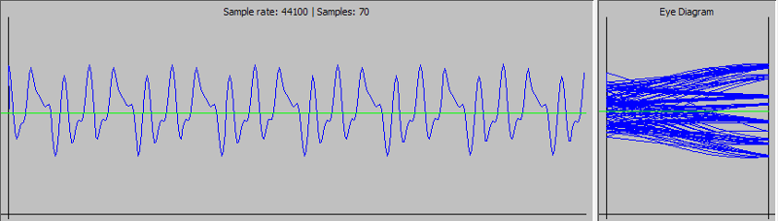

The frequency spectrum shows a null below 20Hz and the FT-817 seems to decode about 10% fewer frames than the modified FT-736R.

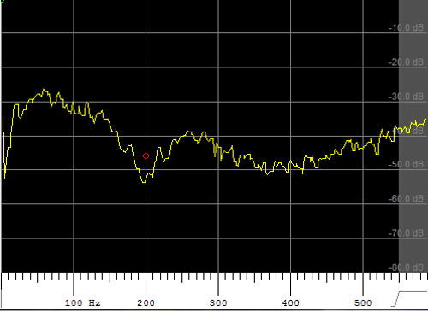

With that said, many stations are using radios very successfully, with some of our highest contributors using a TS-2000 exclusively.

Decoding from an IQ source such as the FUNcube Dongle
A software defined radio is a good choice because we get no filtering of the low frequency audio. The FUNcube Dongle, for example, can receive the telemetry and pass the IQ baseband audio untouched to FoxTelem.

You have two choices to set this up. Either receive the audio in your favorite SDR software and feed the demodulated audio to the telemetry decoder or use the IQ demodulation in the telemetry decoder itself. Both should work. Here are the advantages and disadvantages of using FoxTelem’s IQ demodulator:

Advantages
- FoxTelem will find the satellites signal when it appears and will follow the Doppler. You do not need a separate application to set the frequency.
- FoxTelem will setup default filters and settings that are optimal for the telemetry formats
- FoxTelem will measure several parameters about the received signal such as Signal to noise ratio.
- You don’t need to use another piece of software, such as Virtual Audio Cable, to connect the two programs. Or feed the audio out of the computer and back in again with a physical cable.

Disadvantages
- A separate SDR program may have better capabilities than the SDR in the Telemetry Decoder.
- Your existing SDR may already be configured to work with Doppler correction software and the rest of your ground station
- FoxTelem can be more compute-intensive than some other SDR programs and may not work as well on slower computers

In either case, you should receive bits that are something like the image below in “Starting the Decoder” (which is using the IQ demodulation in the decoder and shows the Frequency spectrum).

Starting the decoder
The start button kicks off the decoder and FoxTelem reads audio from the audio source that you selected. If this is audio from a separate SDR program such as SDR# or HDSDR then make sure the AF radio button is selected and the sample rate is the same as your sound card or SDR/Virtual Cable. If it is IQ audio from the FUNcube Dongle or another SDR, then make sure that the IQ radio button is selected.

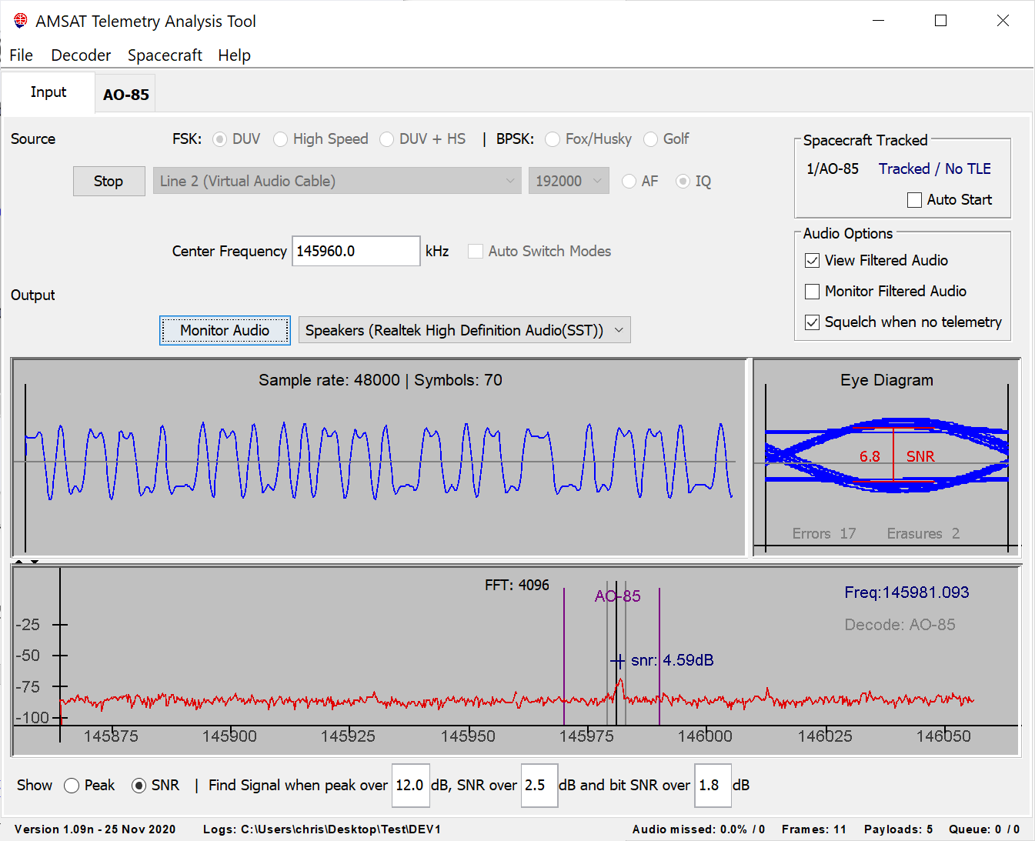

If you are receiving from an SDR like the FUNcube Dongle then setting the frequency will change the frequency that the dongle is tuned to and set the correct filters. For some SDRs, you will need to use a separate control program to set the frequency and any filters. In both cases, the frequency will be the center frequency of the displayed RF spectrum. This is not the frequency that you are receiving, which is shown by the black vertical line. FoxTelem will measure the receiver frequency by calculating the offset from the center. You should avoid decoding the satellite in the center of the spectrum because it will be distorted by a noise spike that sits in the middle.

Finding the Satellites Signal in FoxTelem’s SDR
You can monitor several satellites in FoxTelem. For example, if you are using the SDR in FoxTelem (IQ Mode) with the center frequency set to 145940.000 and 192kHz of spectrum is available, then Fox-1A (AO-85), RadFxSat (AO-91), Fox-1Cliff and Fox-1D (AO-92) can all be monitored.

What happens though if one spacecraft is transmitting on 435750.00 while the others are on 2 meters? Or if one spacecraft is transmitting with PSK while the others are using FSK? For that you will want to review “Automatically Retune / Switch Modes, in the section below this. This section focuses on the algorithms for finding the spacecraft signal itself.

Tracking spacecraft

The first step is to enable or disable tracking of a given Spacecraft. You can do this by clicking on them in the list to the top right of the Input Screen. Below we see AO-85 and AO-91 tracked, while AO-92 is not tracked. In the example below FoxTelem is calculating their position (which is setup on the File > Settings window – check the box that says “FoxTelem calculates Position”). It then shows the Azimuth and Elevation. Clicking on the Blue or Grey text will toggle tracking on/off.

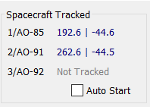

Notice also that there is a priority order for the spacecraft which determines which will tune the FoxTelem SDR if two spacecraft are in the sky at the same time. You set the priority on the Spacecraft screen from the Spacecraft menu, near the top.
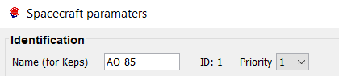

Now FoxTelem will track this spacecraft before others with a higher number.

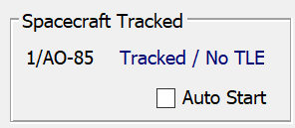
No Keps?
If you have a message in the tracking window that says No TLE, then it means FoxTelem can not find the Three Line Elements or Kelperian Elements (Keps) for this spacecraft. You probablly don’t have the name setup correctly. It needs to match the name of the spacecraft in the nasabare.txt file that FoxTelem downloads from AMSAT’s website. You can change the Name (for keps) on the Spacecraft screen from the spacecraft menu. In the example above it says AO-85.

With that said, there are two option for the actual tracking:
- Find Signal: Search for the signal based on appearance of a characteristic signal in the expected frequency range. Follow the signal and record its frequency while decoding the data.
- Calculate Doppler and decode the signal at the predicted frequency

Why are there two options? Good question. We will explain below, first covering Find Signal and then Calculate Doppler. And in fact there are three options, because you can disable both. Though this is likely only useful in the lab.

Find Signal

For a new user it is easiest just to click Find Signal and let FoxTelem take care of things. It also allows a researcher to measure the signal characteristics more easily. You don’t have to worry if the Doppler calculation is inaccurate, perhaps because the spacecraft oscillator has significant thermal drift or you forgot to update the TLEs. Even the downlink frequency and tracking bands can be loosely defined. Find Signal will still work. You enable Find Signal on the File > Settings Panel, in the Decoder Options.

The image below shows FoxTelem tracking Fox-1D / AO-92 with a High Speed Signal. Even though this is noisy, we can see the characteristic shape of the High Speed telemetry. Note that SNR is checked bottom left, so the value just above the signal is the Signal to Noise Ratio. Also note that the search range shown by the purple bars is the search for the center of the signal. It is the range that the tune point will search. The signal can extend outside the search range as long as the center of the signal remains inside it. These bars are the frequencies defined on the Spacecraft screen and are called Lower Freq Bound and Upper Freq Bound.

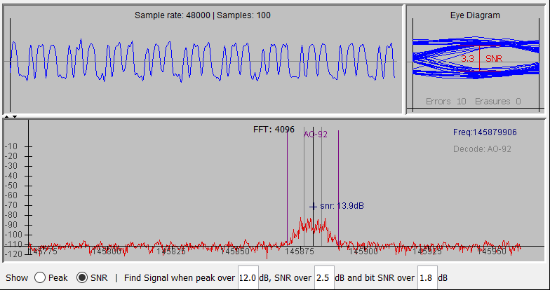

In fact, there is a trick to setting the search range. Once you have some data at your ground station, open the Measurements Tab for the spacecraft and look at the “Carrier Frequency” that FoxTelem has been logging. This is a log of the tune point in FoxTelem’s SDR for each frame that you have received. If you click on the value and plot a graph, you can see the classic s shape of the Doppler curve for a single pass. You can also look at a long period and see the maximum and minimum frequencies. Use these as a guide to set the search range. But do not set it too tight as long term thermal drift causes the nominal spacecraft frequency to change over time. Once you have enough data, you will also be able to see that on the measurements tab.

When FoxTelem finds a signal in the expected frequency range, it checks to see if it contains valid satellite telemetry. If it does, then it pauses the scan and decodes the data in the normal way. You can see in the image above that “Decode” is displayed in the top right of the Frequency Spectrum window.

If the signal is lost then FoxTelem waits 2 minutes before resuming the scan. It will display “Faded” during this wait. This is just longer than the period between beacons and will allow FoxTelem to track a pass when the satellite is in Safe Mode or when the transponder is not in use.

After 2 minutes, if no signal is received, then FoxTelem assumes the pass is over and scanning is resumed. Parameters such as Time of Closest Approach (TCA) are calculated at the end of a pass. You will see 1 frame held in the server queue until the pass is considered complete because the TCA and frequency at TCA are added to that frame before it is sent to the AMSAT server.

Find Signal can be further refined as follows:

- Setting “when peak over X dB” to a value will fine tune when FoxTelem jumps to a signal to test it. If you have interference in the pass band then you may want to set this higher to avoid scanning them. If you have a clear passband but the spacecraft is often weak, you may want to set it lower. This value is the same as the value displayed beside a signal when “Show Peak” is checked
- When FoxTelem has switched to a signal it then confirms that the “SNR is over Y dB”. This is the average signal to noise and is the same as the value shown beside a signal when “Show SNR” is checked.
- If the Average Signal to Noise ratio is high enough then FoxTelem checks the Signal to Noise Ratio of the bit stream. This is the SNR value shown in the eye diagram. If it is above the third threshold then it decides that this is a signal from a Fox satellite and locks onto it

Calculate Doppler

Find Signal can miss frames when there is fading or when we are in beacon mode. It is also incompatible with the automatic center frequency retuning and automatic mode switching. BPSK decoding with Find Signal can be problematic due to the tight requirements to follow the frequency and phase. If you are getting frustrated with Find Signal then accurate tracking of the Doppler may be the best approach. I say “may” because there are plenty of things to get wrong with Doppler tracking and you may get less decodes than Find Signal. But when properly setup the results are usually better.

You enable Doppler calculation on the File > Settings screen bottom left. Toggle “FoxTelem Calculates Doppler” on. Note that it is dependent on “FoxTelem Calculates Position” being on and that in turn requires that you have defined your ground stations position.

If FoxTelem calculates Doppler, then it will download the latest Keps in the background and will tune the SDR. But it does not know how accurate your SDR hardware is or what frequency the spacecraft telemetry is actually on. It almost certainly is not precisely the frequency published by AMSAT and will vary over time. Advanced users will tweak the SDR and downlink frequency on a periodic basis to maximize performance.

With Doppler calculation on, the frequency delta from the nominal downlink frequency is displayed alongside the tracking information for the spacecraft. Now we have Azimuth, Elevation and Doppler shift.

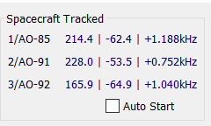

If the Doppler tracking is inaccurate then make sure your SDR is calibrated. Try listening to a known signal and adjust the center frequency until it is precise. You can set the center frequency to the nearest Hz by specifying decimals in the center frequency box.

If your SDR is calibrated and the calculation is still not accurate, then make sure you have the best downlink frequency of the spacecraft. This is not exactly the published frequency, but will be close. It is slightly off due to thermal characteristics of the small spacecraft. If in doubt monitor it over time and adjust. Advanced users could run another copy of FoxTelem in parallel with “Find Signal” enabled so that it logs the actual downlink frequency for analysis.

Confirm that FoxTelem has downloaded the latest TLEs (keps) into the spacecraft directory. You should be calculating the same Doppler offset as another prediction program like SatPC32, assuming they have the same TLEs. FoxTelem uses the Three Line Elements (TLEs) from nasabare.txt and downloads them automatically from amsat.org. You need to make sure that the name of the spacecraft in FoxTelem is the same as the name in nasabare.txt. In FoxTelem the “keps name” is setup from the Spacecraft menu. Note that this can be different from the displayed name on the GUI.

You can review nasabare.txt at this url:
www.amsat.org/amsat/ftp/keps/current/nasabare.txt

Automatically retune / switch modes
In some situations, you may want a single copy of FoxTelem to automatically retune the center frequency of the SDR, or switch modes between PSK and FSK, as different spacecraft pass over your ground station. This can be useful when FoxTelem’s SDR is being used or when reading audio from a real radio and the mode needs to be switched.

This option is enabled in the center of the Source Panel on the input tab. Below we see FoxTelem in SDR (IQ) mode and that the “Auto Switch Modes” option is grayed out.

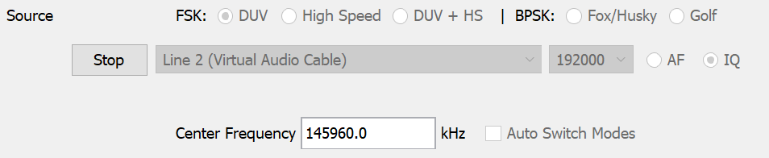

In AF or IQ mode the “Auto Switch Modes” option is available if FoxTelem knows when the spacecraft is above the horizon. It will also be greyed out if Find Signal is enabled and Auto Start is off. It is incompatible with continuously running “Find Signal” because the mode would be constantly switched as each Spacecraft is checked.

For FoxTelem to know when a spacecraft is above the horizon either “FoxTelem calculates position” or “Read Position from SatPC32” need to be enabled on the settings window.

When Auto Switch modes is enabled then FoxTelem will attempt to switch the decoder mode when the spacecraft rises over your ground station and the mode is wrong. If two spacecraft are above the horizon then the mode is changed to the highest priority spacecraft.

You can adjust the priority of a spacecraft and the mode that will be set from the Spacecraft settings window. For example to change the details for AO-85 goto to the menu Spacecraft > AO-85 and change the priority or mode on the screen that opens up. The screen clipping below shows AO-85 with Priority 1 and the default mode of FSK DUV 200 bps.

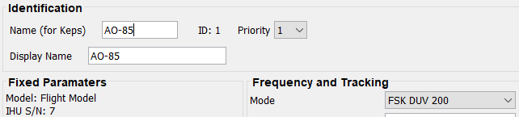

Additionally, if using the FoxTelem SDR (IQ mode) and “Find Signal” is disabled, usually because “FoxTelem calculates Doppler” is enabled, then “Retune center / Switch modes” will be shown in the middle of the Source panel on the Input tab.

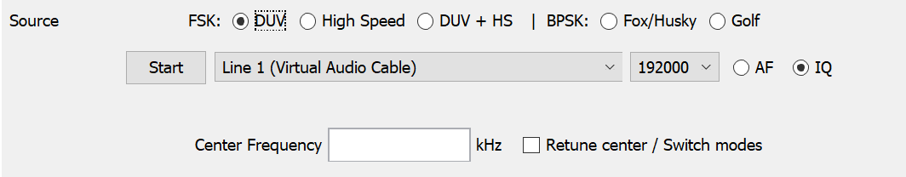

When “Retune center / Switch modes” is enabled then FoxTelem will attempt to retune the SDR in addition to switching the decoder mode, when the spacecraft rises over your ground station. The center frequency will be retuned if the spacecraft’s downlink frequency is outside the usable portion of the SDR band. Again, if two spacecraft are above the horizon then this is subject to the priority that you have set for the spacecraft.

Auto Start (When Above Horizon)
From Version 1.05 you can pause the decoder between satellite passes to minimize the amount of processing power needed. This is particularly important if multiple copies of FoxTelem are being run.

Note that this setting has no relation to tracking, retuning or mode switching. It is simply an option to save CPU by pausing the FoxTelem SDR and Decoder between passes. It does nothing else.

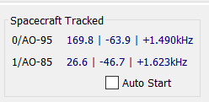

You enable this mode by checking the “Auto Start” checkbox on the Input tab or “Auto Start When above horizon” on the Settings screen. This option is only available if FoxTelem knows when the Spacecraft is above the horizon. You can use “FoxTelem calculates position” or, if you are running under Windows and would prefer to use SatPC32 to determine if the satellite is up, then you can check “Read position from SatPC32”.

For this to work the name of the satellite needs to be the same as the name in nasabare.txt, if FoxTelem is calculating, or in SatPC32 if that is making the calculations. You can change the name in FoxTelem on the Spacecraft screen from the spacecraft menu. In SatPC32 you can temporarily test the connection using Auxiliary Files>DivOptions.SQF. In that file you set Line #2 to +. This will cause SatPC32 to constantly output DDE data and FoxTelem will believe that the spacecraft is above the horizon. However, you can not leave SatPC32 in that mode or FoxTelem will assume the satellite is permanently above the horizon.

FSK DUV + HS Mode
While you can manually select Data Under Voice (DUV) or High Speed decoding, this may not be ideal for an unattended decoder. There is a third option labeled DUV + HS. In this mode FoxTelem runs two decoders in parallel. Both decoders are executing the Find Signal algorithm, if it is enabled, and both decoders are attempting to decode frames.

This may be confusing compared to “Auto Switch Modes” described above. But this is a different situation where we have a spacecraft and we do not know in advance what mode it will be in. You can therefore set the decoder in DUV + HS mode. If you are using “Auto Switch Modes” you set the default mode for the spacecraft to “FSK DUV + HS”, as shown in the screen clipping below. This is likely only useful for AO-92 at the current time because none of the other Fox spacecraft have experiments that require high speed data.

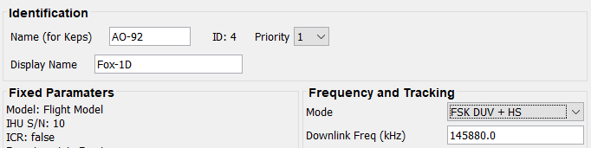

It may sometimes seem to take FoxTelem a while to switch from one decoder to another, but no data is missed. The decoders are not really switched. The decoder being displayed on the screen is swapped from one to the other, but it has been decoding in the background all the time.

DUV + HS is CPU intensive. If your computer is able to run both decoders at the same time, then this is a good setting. If you are missing audio, with a red warning message printed at the bottom of the screen, then de-select this option.

NCO – The Numerically Controlled Oscillator
From FoxTelem 1.07 the SDR now defaults to a Numerically Controlled Oscillator (NCO). This is a discrete version of a VFO and is mixed with the IQ data stream to create the baseband signals. The filtering is performed with Polyphase filters that also handle the decimation. This is a cleaner down conversion than the original FFT filter design and is able to support wider bandwidth SDRs. If you are interested in how this works then you can read about it here:
https://www.g0kla.com/sdr/index.php

Starting the decoder at launch
If the decoder is running when you stop FoxTelem, then it will be running when you start FoxTelem again. This allows you to start FoxTelem from another program or have FoxTelem automatically start when the Operating System boots. You can find instructions online to add FoxTelem to the boot sequence and to configure the BIOS so that your computer automatically restarts after a power failure. You may also need to configure windows to automatically login.

Counting Frames and Payloads
In the bottom right of the Window you can see three totals, Frames, Payloads and Queued. These need a little bit of explanation.

Frames counts the number of frames that have been received from all spacecraft since the program was restarted. This is very useful for testing, but not for much else. You can see how many frames you have decoded since you changed settings and you can compare two copies of FoxTelem side by side. You can also use this to compare against the number of frames that are reported by the AMSAT server, since it also counts frames and not payloads.

Payloads is a summary of all of the payloads that are stored in FoxTelem’s database. If you add up the totals on all of the sub-tabs, then it will equal back to this number. It does not include the measurements that you have taken locally. It is also worth remembering that payloads and frames are not the same thing. A high speed frame contains many payloads, for example.

Queued is the number of frames that are waiting to be sent to the AMSAT server. If you have a fast internet connection then you may not see anything in this field. If it increases steadily and does not go down then you may not be connected to the internet or the AMSAT server may be down temporarily. You will also see 1 record held in the queue if you are using find signal. This final record contains a measurement of the Time of Closest Approach (TCA) and is sent to AMSAT. FoxTelem waits until the pass is over (or until no signal is received for 2 mins) before sending this record.

Fox Telemetry Format

Data Under Voice
During Safe Mode beacons, when the voice announcement says, “Fox X, Safe Mode”, during Transponder beacons, when the announcement says “Hi, this is Amateur Radio satellite Fox X” and when the transponder is on, data is being sent to the ground. This is 200 bps data sent in the sub audible band.

DUV data is transmitted in a Frame with a Header, Payload and a set of Forward Error Correction (FEC) bytes. The header contains 6 bytes of data and holds the Fox id for the spacecraft, the reset (number of times the computer has rebooted), the uptime in seconds since the last reboot and the type of payload.

There are 4 types of DUV payload, each 58 bytes in length. Type 1 payloads contain real time telemetry values from the spacecraft. Type 2/3 contain the maximum and minimum values of the real time telemetry. Type 4 payloads contain 58 bytes of experiment data and vary depending on the experiments that the spacecraft is carrying. On Fox-1A (AO-85) this contains data from the Vanderbilt University Low Energy Proton experiment, which is measuring the effect of radiation on non-space rated (COTS) memory chips.

The FEC trailer contains 32 check bytes and allows us to correct significant errors due to fading or noise.

It takes the spacecraft 4.85 seconds to send a DUV frame (10 bits for the sync word, 960 bits of data, at 200 bps). We receive 2 frames in each beacon and 12 frames per minute in transponder mode. The beacon frames alternate between Real Time Telemetry and Max/Min Payloads. The transponder sends telemetry and experiment payloads in an alternating pattern of frames.

High Speed Telemetry
High speed telemetry is sent at 9600 bps. Each High Speed frame also takes about 5 seconds to send, but they contain a lot more data. The High Speed frame contains a header with the Fox id for the spacecraft, the reset (number of times the computer has rebooted) and the uptime in seconds since the last reboot. The header is followed by Type 1, Type 2 and Type 3 telemetry payloads.

The rest of the high speed frame contains experiment data and varies by spacecraft, as described below:

Fox-1A (AO-85)
In Fox-1A this is data from the Vanderbilt Radiation experiment and was intended as a test of high speed data for later spacecraft. This testing is now finished and the mission is complete. There is no intention to turn this on again.

For historical reference it was designed to download data from the experiment’s buffer, which contains stored readings over many orbits. The number of type 4 payloads included in the high speed frame was variable, but typically 16 – 30. When a high speed frame was decoded you saw a big jump in the number of payloads on the radiation tab and in the footer (beside the word Decoded). The number of frames queued for upload or the number of frames you saw on the Telemetry Leaderboard were only increment by one, so for high speed they do not equal the number of payloads decoded.

Fox-1B (AO-91)
Fox-1B has the same high speed capabilities as Fox-1A. Given high speed is now already tested, there is no intention to turn on high speed data. FoxTelem does not need to be set in Auto Mode and can be left in DUV for this spacecraft,

Fox-1D (AO-92)
Fox-1D has two high speed data modes, Camera and HERCI.

In Camera mode pictures are continuously downlinked to the ground line by line from Virginia Tech’s student camera experiment. Even if a single ground station only receives a few lines, the server assembles all of the received lines into an image for all to see.

HERCI mode downloaded experiment data from the University of Iowa’s student radiation experiment. This mission is now complete and there is no intention to switch on HERCI mode again. The High Energy Radiation Cubesat Instrument was designed to survey the radiation environment that Fox-1D passed through.

Sending Data to the Server
You can help the research of students at participating Universities and contribute to the design and build of future AMSAT satellites by sending your received telemetry frames to the AMSAT server.

To send data first open the Setting screen from the File menu. Select the checkbox labeled “Upload to Server”. You then need to supply your Amateur Radio callsign or some other unique identifier (e.g., "Kilowatt County Elementary School"). The identifier can also have an optional additional identifier so KA2UPW is valid, but so is KA2UPW-9 (indicating a second station this callsign is using to also collect telemetry) or something like KA2UPW-FM13 (this is indicating a grid square where the station is collecting telemetry).

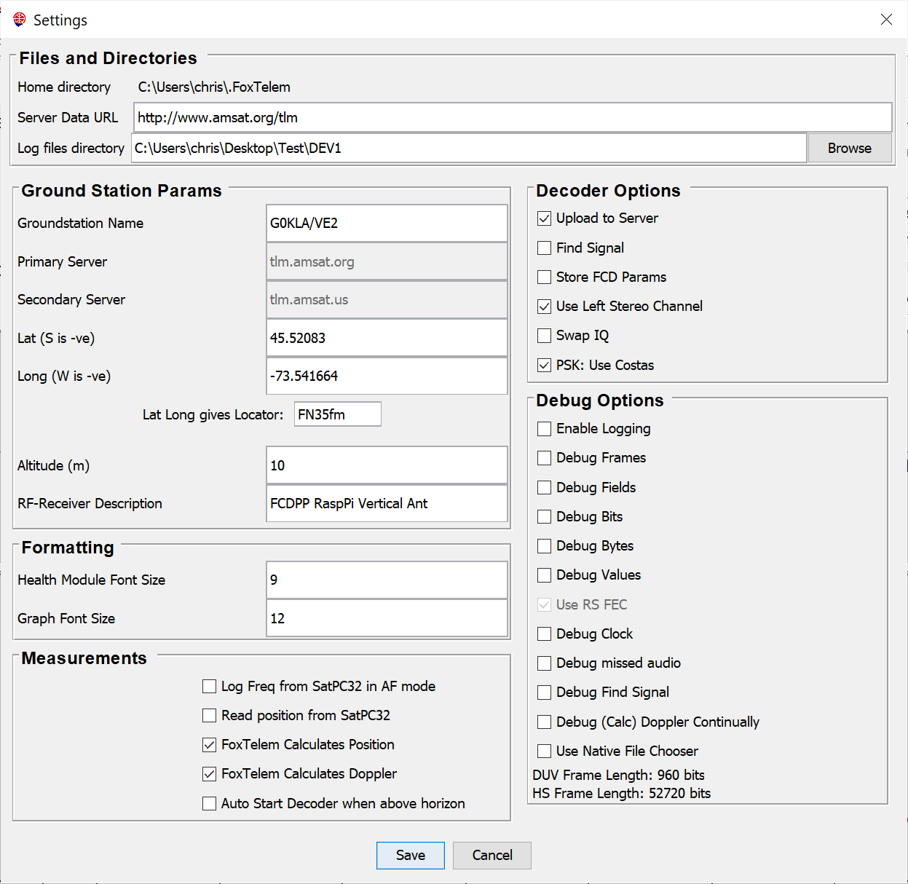

You also need to supply latitude and longitude of your ground station. This calculates the grid square that you are in as a check. Or you can enter the 6 digit maidenhead grid square and lat-long is calculated for you. Note that is slightly less precise that entering your actual latitude and longitude.

Downloading data from the Server
All of the data sent to the AMSAT server is available for your analysis. You can download a local copy from the File > Fetch Server Data menu option. Select the spacecraft you want to download. The server data can be quite large. For example the downloaded file for AO-85 is approaching 100MB. Only download the spacecraft that you want to analyze. Then a minimal amount of data is transferred.

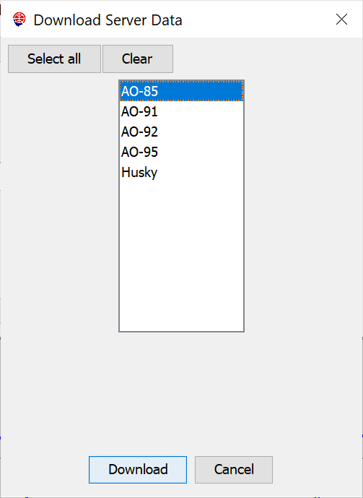

Once you click download, this will warn you that your data will be overwritten. You should use a different logfile directory from your live captured data. Section 3.2, Launching FoxTelem, describes how to setup multiple decoders. You can use this approach to have a different “decoder” for Server Data. Create a script, shortcut or batch file to launch FoxTelem. Pass it the logfile directory where you want to store the server data. When you use that script, shortcut or batch file FoxTelem will be started with the logfile directory already set to the server data directory. Any changes you make to layout, graphs, or other settings will not impact your live decoder that you use to collect telemetry. When you “Fetch Server Data” it will be safely stored in a directory separate to your own collected telemetry.

Understanding the Data

Fox Health Screen
The health screen shows the latest real time values received from the spacecraft at your ground station. It also shows the latest Maximum and Minimum values. You can access previous values by clicking RT, MAX or MIN at the bottom left of the window. This will open a list of historical records. You can then click on a telemetry row in the table at the bottom of the screen to see the values in the top section. You can scroll through the data using the arrow keys and the values will be displayed in the top section.

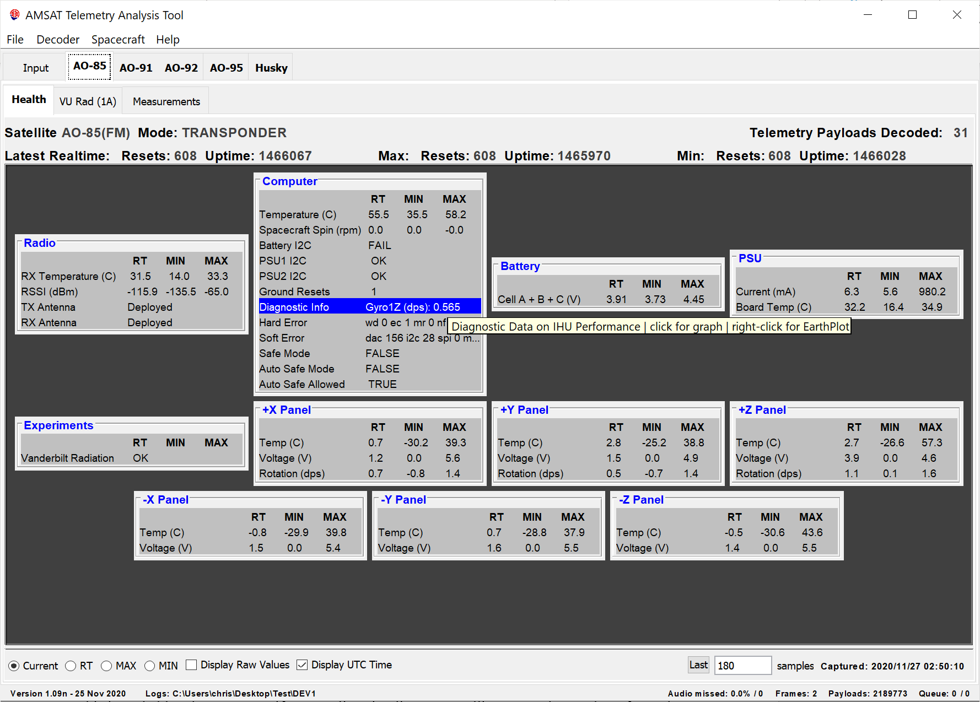

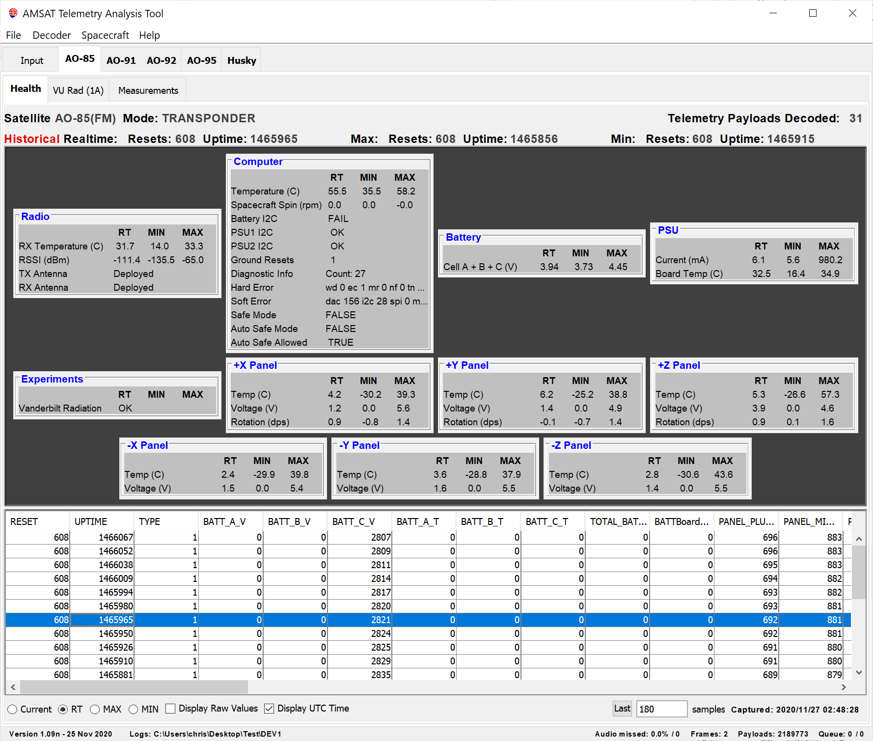
When the Historical records are hidden because the “Current” radio button is checked, FoxTelem shows the latest real time data from the spacecraft. This is probably what you want if you are listening live to a satellite pass.

If the Historical records are shown then the number of samples to the right of the “Last” button determines how many realtime payloads are shown in the table. This is the latest records.

If you press the “Last” button it changes to “Next” and shows “from Reset” and “from Uptime”. Setting the reset and uptime allows you to show a subset of the payloads. This will show a set of payloads forward from that reset/uptime. If you are decoding live then payloads are still stored and can be reviewed later.

If you press the “Next” button it changes to “Range” and allows you to plot a range of Reset and Uptime.

Most people can’t think in a Reset/Uptime timebase. Clicking the Display UTC Time at the bottom of the screen will change the search ranges to UTC times. You can use the following formats to enter dates:

YYYYMMDD HHMMSS - for example 20180101 23:00:00 is 11pm on new years day
YYYY/MM/DD HH:MM:SS - 2018/01/01 23:00:00 is the same date
dd MMM yy HH:mm:ss - 01 Jan 18 23:00:00 is the same date again

In addition to entering dates you can enter the words: now, yesterday and launch. Those dates will be automatically inserted.

If you forget the formats you can hover your mouse over the entry boxes, it will show the formats that it allows.

Graphing Telemetry Values
A graph opens when a telemetry row in the health tab is clicked with the mouse. By default, the graph shows the last 180 readings. A real time value is downloaded once every 10 seconds or so in Data Under Voice (DUV) telemetry mode. So, 180 readings is about 1800 seconds of data, or 30 minutes. This will therefore show a complete pass of the satellite without changing the settings.

The graph below shows the Internal Temperature of the onboard computer or Internal Housekeeping Unit (IHU). The time axis is recorded on the spacecraft and shows Uptime in seconds since the last reset, with the reset number underneath the first Uptime label.

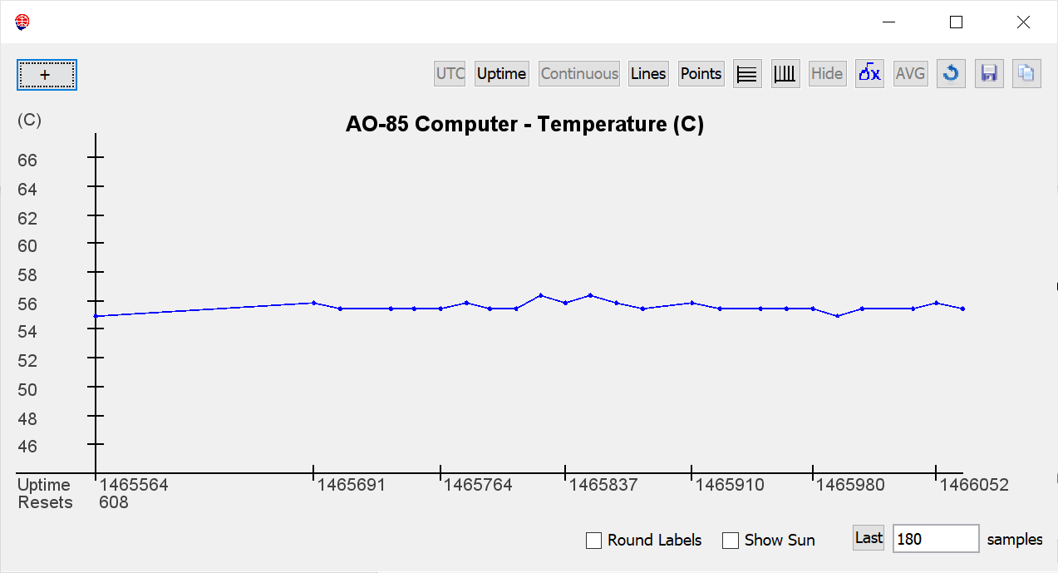

You can plot more or fewer samples by changing the number from 180 and hitting enter.

When the “Last” button is shown, FoxTelem plots a continuously updating graph for real time monitoring of the spacecraft. This is probably what you want if you are listening live to a satellite pass.

If you press the “Last” button it changes to “Next” and shows “from Reset” and “from Uptime”. Setting these you can plot a subset of the data. This will no longer automatically grab the latest samples from the spacecraft, but rather will plot samples forward from that reset/uptime. If that includes the latest samples, then you will still see them appear live. If it does not, then the data will remain static. If you are completely confused and the graph is not doing what you want, then hit the reset button in the top right to reset the graph to its default values.

If you press the “Next” button it changes to “Range” and allows you to plot a range of Reset and Uptime.

Most people can’t think in a Reset/Uptime timebase. Clicking the UTC button at the top of the graph will change the search ranges to UTC times. You can use the following formats to enter dates:

YYYYMMDD HHMMSS - for example 20180101 23:00:00 is 11pm on new years day
YYYY/MM/DD HH:MM:SS - 2018/01/01 23:00:00 is the same date
dd MMM yy HH:mm:ss - 01 Jan 18 23:00:00 is the same date again

In addition to entering dates you can enter the words: now, yesterday and launch. Those dates will be automatically inserted.

If you forget the formats you can hover your mouse over the entry boxes, it will show the formats that it allows.

Continuous Plot

If no data is received from the spacecraft for some time, then you probably do not want to plot big empty spaces. In that case, the graph automatically cuts out blank sections of the data. This allows you to see several passes one after the other, without large gaps in between them. If you want to show the data in the right positions on the graphs timeline then tick “Continuous”.

Plotting data with gaps in it using a timebase that continually resets makes plotting labels at the bottom of the graph a bit tricky. By default FoxTelem plots labels spaced evenly, but they are not round values. If you click the Round Labels checkbox then FoxTelem will do its best to create labels that are rounded to sensible values. This may result in gaps. Clicking “Continuous” may solve that, but it may not be what you wanted.

Copy / Paste

There are three ways to copy data from the graph.

Firstly, your Operating System probably has a print screen function. In Windows Alt-PrntScrn will copy just the active window and will allow you to past the result into another document.

If you want to have just the graph itself, then use the Copy button in the top right. The previous graph is show below, copied in this way.

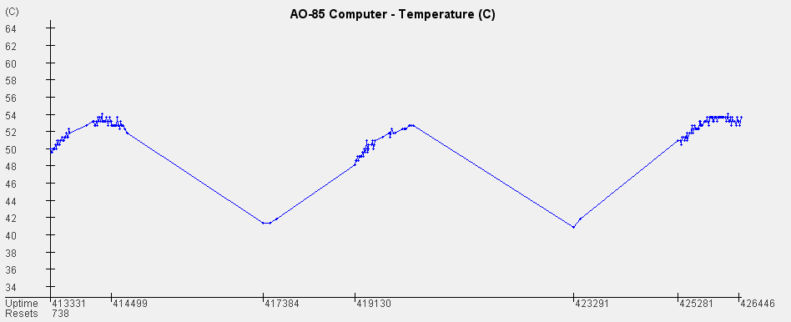

Finally, you can save the data values to a csv file using the save button. This will save the data that you have selected for display.

Average and First Difference
In addition to the reset, copy and save buttons, there are two buttons in the top right that draw an additional graph trace.

AVG draws a running average by summing the samples around a given point. The default is 12 samples, but you can change the amount in a new field that appears on the bottom of the graph. Here is a 1200 average plot of the rotation around Z for AO-85, showing a month of data (or about 21000 samples). Large averages take a while to plot, so you may have to wait as it redraws.

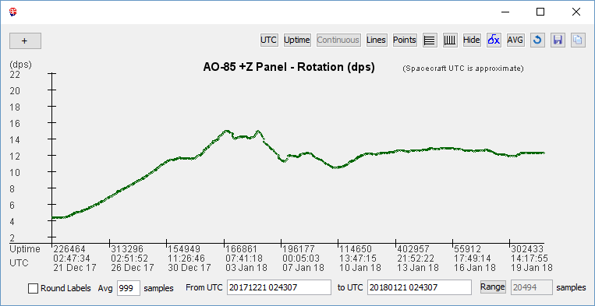

The dx (or delta x) button plots the first difference of the samples (which is equivalent to the first derivative for a continuous graph). Try that with a frequency plot of the last pass and see if you can tell how TCA is calculated.

Show Sun

If FoxTelem has valid Three Line Elements (TLEs) then we can add a background color to show when the spacecraft was in sun or in eclipse. The plot below shows the battery voltage for AO-91 for the last day.

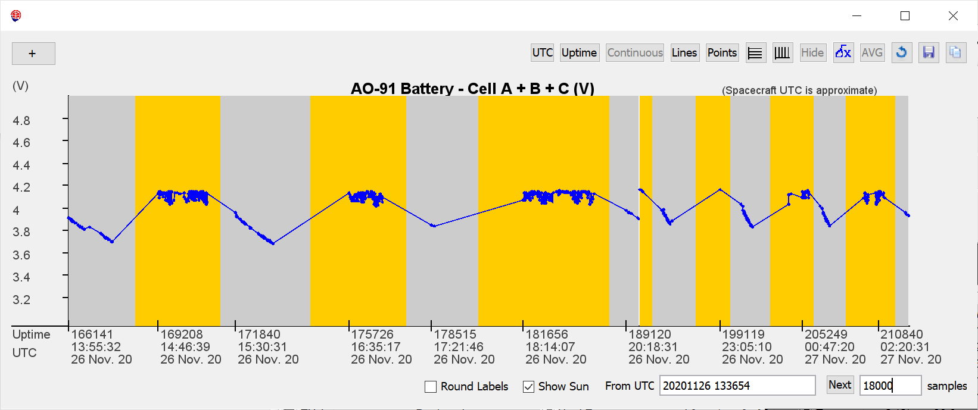

Multiple Variables on one graph
The “+” sign on the top left of a graph can be used to add additional traces. If we add BATT_C_V, the Battery Voltage, to the IHU Temperature graph then we get the following graph. Note that the Voltage is now shown with a new axis on the right. You can keep adding additional traces as long as the units are the same as one of the two vertical axis. All other graph functions work as expected, including exporting data to a file, which exports all variables chosen.

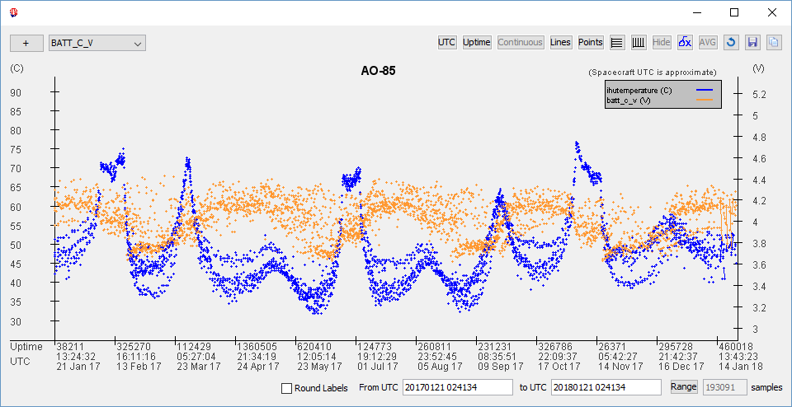

Earth Plots
From Version 1.06 most parameters can be plotted against the surface of the Earth. To open an Earth Plot, Right Click or Control-Click the telemetry row. The chart below is an Equirectangular Projection of AO-91s battery voltage for about 10 days. It clearly shows where the stations are that collect telemetry. If you plot this for you own data, you get a nice cloud around your ground station showing your reception horizon.

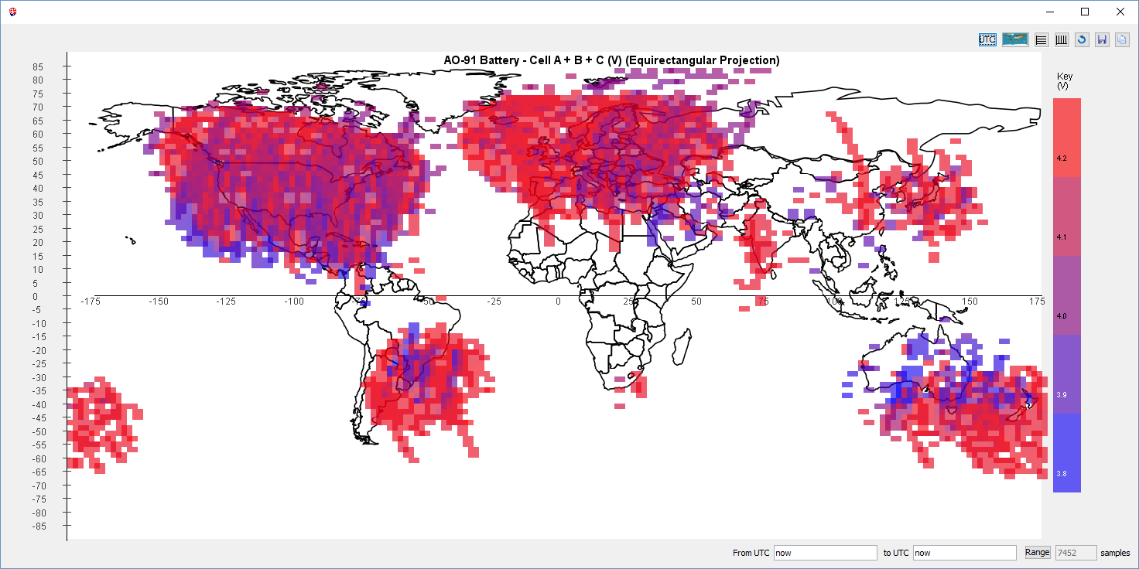

Earth plots are only possible if you have historical Three Line Elements (TLEs) for the dates that you are plotting. If you just have the latest TLE then data plotted more than a month in the past is very inaccurate. FoxTelem builds a set of historical TLEs for you automatically, but it only started when you installed FoxTelem v1.05. You can replace the TLE file with a full history by grabbing a TLE history file from AMSAT. They can be found here for some spacecraft:
http://www.amsat.org/tle/historical/

Radiation Experiment
The Vanderbilt University Radiation Experiment is testing Commercial Off the Shelf (COTS) memory chips in space to see how they are affected by radiation.

Camera Images
Camera Images are downloaded in High Speed telemetry mode if the Virginia Tech Camera is present on the spacecraft. Fox-1A (AO-85) and RadFxSat / Fox-1B (AO-91) do not have a Camera, but Fox-1Cliff (AO-95) and Fox-1D (AO-92) spacecraft do. However AO-95 is not functioning correctly, likely due to a receiver issue, and the spacecraft can not be commanded to take pictures. AO-92 is now sadly dormant, but you can see the archive of pictures taken here:
https://www.amsat.org/tlm/showImages.php?id=4

Making Measurements

Overview
In addition to the telemetry and science data received from the satellite, you can make measurements at your ground station and store them for analysis. Out of the box, FoxTelem can measure:
- Signal To Noise level of the received bits
- Signal To Noise level of the RF (in IQ mode)
- RF signal strength (in IQ mode)
- Azimuth and Elevation (from SatPC32, using the DDE interface on Windows)
- Frequency (in IQ mode or using the SatPC32 DDE interface on Windows)
- Time of Closest Approach (TCA) through Doppler analysis (in IQ mode)

Each of these measurements are stored at the time a frame is detected and they are timestamped with both the current UTC time and with the reset/uptime that was on the received frame. This gives a sample about every 5 seconds.

Signal to Noise Measurements
Signal to noise measurements can be used to optimize your station and to help understand how radio signals are propagated from the spacecraft. Store the results and compare them when you have made changes. What difference does a pre-amp make? A higher gain antenna? A different receiver? What is the difference in signal to noise vs elevation at your QTH (ground station location)? Does the RF signal to noise ratio correlate with the bit signal to noise ratio? Which should be optimized?

Azimuth and Elevation
FoxTelem cannot read your rotator directly, but it can calculate the expected position or grab the information from another program such as SatPC32 using its DDE interface.

If you would like FoxTelem to calculate this information, then select “FoxTelem Calculates Position” from File > Settings. If the option is greyed out, then you need to first provide the position of your ground station.

On Windows you can choose “Read Position from SatPC32” on the File > Settings window. See the DDE Interface section of SatPC32’s manual for details on setting this up.

Time of Closest Approach
The Doppler on the frequency of the satellite tells us something about how the spacecraft is moving relative to our current position on the earth. We can use this to work out when the spacecraft is closest to our ground station. This is the Time of Closest Approach (TCA) and it is a very helpful measurement to confirm or refine orbital elements. We can also use it to see how stable the downlink frequency is. TCA is especially useful when a spacecraft has recently been launched.

You can measure TCA by logging the frequency of the downlink signal. If the frequency at the satellite was unconditionally stable and we knew exactly what frequency it was on, then you could measure when the received frequency at your ground station equals the nominal frequency and call it TCA. However, a small 10cm CubeSat has a challenging thermal environment and we cannot rely on the frequency of the downlink for this measurement. Instead, this measurement will tell us what the nominal frequency is.

If you are running FoxTelem in IQ mode then it will store the downlink frequency throughout a pass. At the end of a pass it calculates when the frequency changes at the fastest rate. This should be at or very near to the nominal downlink frequency. It then stores the time when this happened (TCA) and the frequency at that time. You can see the measurements for the last pass on the measurements tab.

We cannot measure TCA by reading the frequency from SatPC32 or another prediction program. We need to know the actual frequency of the satellite, not the calculated frequency.

Sky Plots of Measurements
There are two options for graphing measurements. You can click on the measurement value and open a graph, just as you can for spacecraft telemetry. In addition, there is a button to the right of each value that opens a sky plot, which plots the data against elevation and azimuth, as seen from your ground station. Below you can see the received signal strength in dBm plotted against the satellites position in the sky. A darker color is a stronger signal.

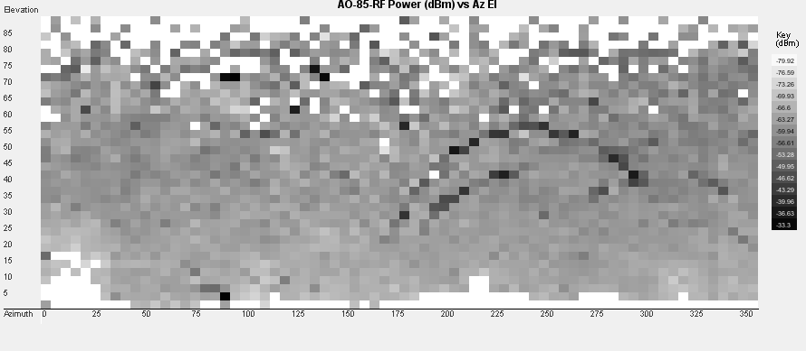

Getting Better Decodes

Eye Diagram

A subtle distortion in the FSK eye diagram like the plot on the left perhaps shows a mismatch between the sample rates at some point in the chain. A much better eye diagram is shown on the right.

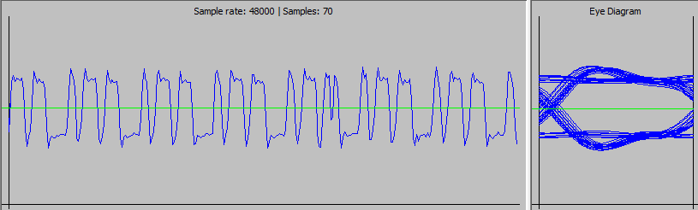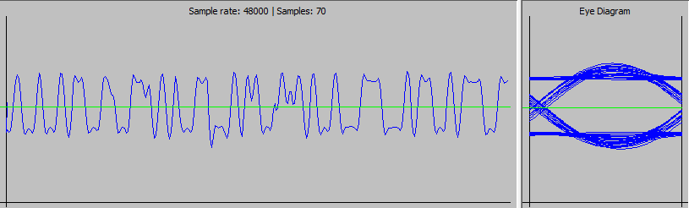

First of all, set the sample rate to 48000 samples per second if possible. The divides evenly into 200 bps and 9600 bps and gives slightly better decodes. With a strong signal it makes no difference , but if the signal is distorted or weak then it can help.

Secondly, make sure that the sound card or audio source is also set to 48000. Windows likes to set everything to 44100 by default, so you need to go into the Control Panel to change it. If you are using a virtual cable to connect an SDR to FoxTelem, then be aware that when initially started cables will be defaulted to 44100 by Windows. FoxTelem or the SDR can not then reset them to 48000. Virtual Audio Cable is a good example of this and it mentions the issue in its manual. When you configure a new cable you give it a range of sample rates. Windows will then pick 44100 if it is available. Even if that is not what you wanted. So I setup two cables, and narrowed the range of samples rates to one value. One cable is then for 48000 and the other is for 192000. Then there is no question about the rate that Windows will give them.

The eye diagram is shown below decoding a DUV signal. The more open the eye is the better the signal will decode. If there is less noise then the bits that make up the eye fit more precisely on top of each other and the blue lines are thinner. The signal to noise ration of the eye is measured from the average high value to the average low value. The red bars are therefore in the middle of the set of blue lines. For DUV an Eye SNR of 2dB or more is needed to decode. 6.7dB is excellent. More is even better.

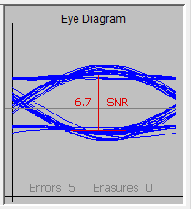

PSK
You can display an eye diagram and/or a phasor for PSK. The Eye diagram functions as described above. The phasor is described in the section below.

When you decode PSK audio you have two traces. The black trace is the actual audio. Notice that this is still clearly a PSK signal together with the expected phase shifts even though it is now down converted to around 1.2kHz. The blue trace then shows the recovered bits. For a Costas Loop the recovered bits look like the bits that were originally encoded. We recover their exact shape because the frequency and phase are locked to the data carrier.

The Dot Product decoder also displays the audio in black. There are 100 bits decoded at a time, rather than 40, but otherwise this looks the same as the Costas Loop. The blue trace is no longer the original bit shape. It is the energy of the bits. We can plot the recovered bit shape and it looks very similar to the Costas Loop, but it is continuously oscillating because we are not locked in phase. It does not help us determine if we have the signal tuned correctly. The decoder uses the energy of each bit to determine its value and this is more helpful to plot. Note that the SNR of the eye diagram appears much less and this is reflected in its ability to decode noise signals.

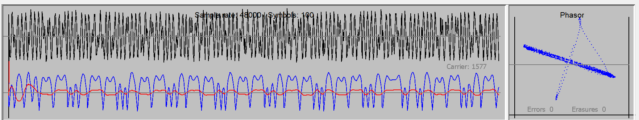

PSK Phasor
For BPSK you can display an eye diagram and/or a phasor. The phasor plots the phase of each sample. The phasor is shown below for a Costas Loop. The red notation has been added to aid explanation. FoxTelem does not plot it.

If we have a point plotted on the red dotted “unit circle” then it has a Magnitude of 1 and a phase given by the angle from 0. The angles for 0 and 180 are shown. The blue dots and noise are from the Costas loop. The loop locks the signal so that the transitions are between 0 and 180 degrees. This is what we expect to see.

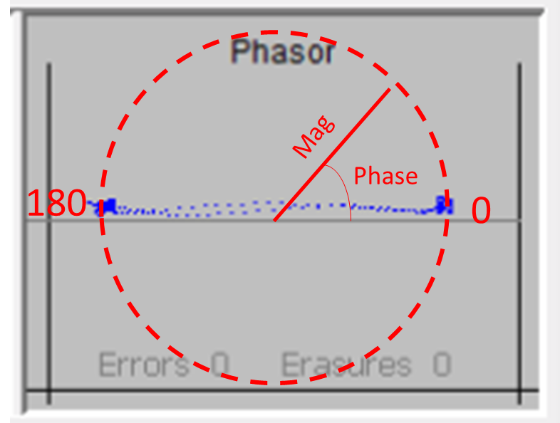

The phasor from the Dot Product BPSK decoder is shown below. Now the phasor is a straight line rather than two dots. This tells us that our samples are varying in magnitude as well as phase. We also have a phase variation between 30 degrees and 210 degrees rather than between 0 and 180. The Dot Product decoder is a “non Coherent” decoder. It does not need to lock the phase to exactly 0 and 180 degrees. The phase will rotate, sometimes quite fast, and we still decode the bits.

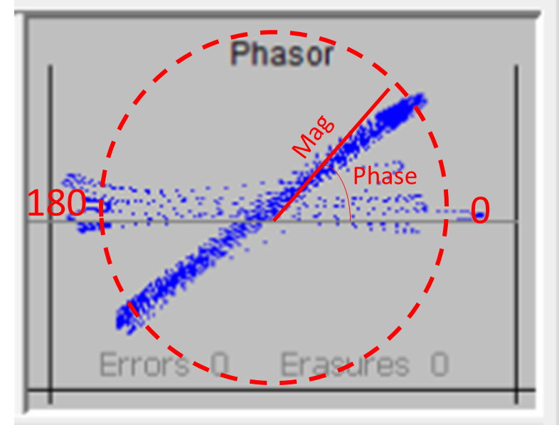

High Speed Bandwidth
High speed data from Fox is 9600 bits per second FSK. The FM signal is 20kHz wide. Make sure that the radio you are using is on a wide enough setting to accommodate.

Settings
The settings screen is accessed from the File menu. This contains 6 types of options:
- Files and Directories
- Decoder Options
- Server Upload Parameters
- Formatting
- Measurements
- Debug Options

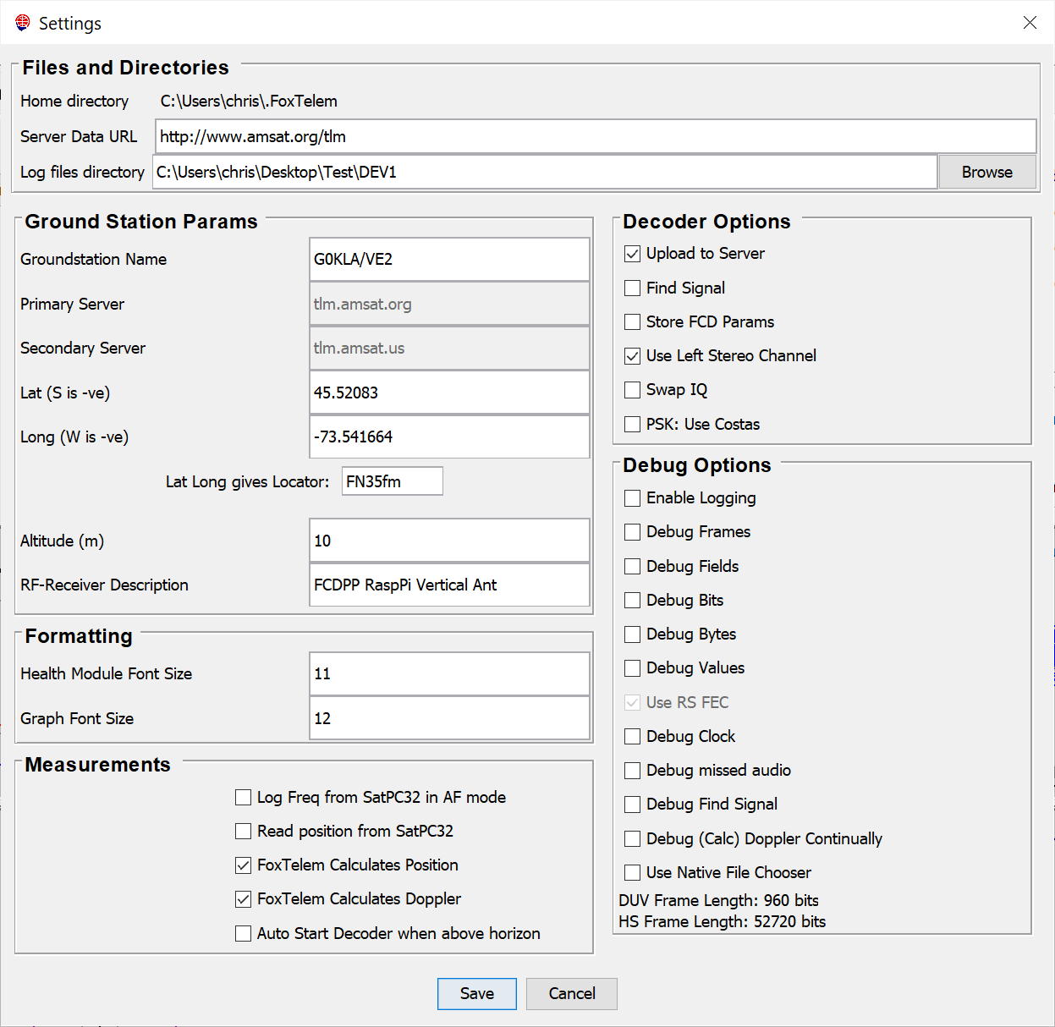

Files and Directories
The Home Directory is noted because this is the location of the properties file. It is unlikely that you will need to directly edit the properties, but it is good to know where they are stored.

The Server Data URL is the location of the server data. If you go to this URL you will be able to see the data that has been uploaded by ground stations around the world. This is also the URL used by FoxTelem to download data from the server.

The Log files directory sets the directory that the downloaded telemetry data is stored in. FoxTelem has a number of files that it stores on disk. It’s worth describing them first. They are as follows:

- spacecraft – directory that stores the spacecraft configuration files
- images – directory that stores images downloaded from the Virginia Tech Camera (if present)
- seq.dat – file that stores the next sequence number to be sent to the server
- rawHSframes.log – queue of the high-speed frames to upload to the server
- rawDUVframes.log – queue of the low speed frames to upload to the server
- FoxTelemDecoder.log – the log file from FoxTelem. Updated if the Setting “Enable Logging” is checked.
- FoxTelem.jar – The FoxTelem core program classes
- FoxTelem.properties – The FoxTelem settings that are stored between program executions. Editable from the File>Settings screen and elsewhere in the program. Not designed to be user editable. This is stored in the Home Directory, shown at the top of the settings screen
- Fox3jpg_index.dat – An index file the stores the images that have been downloaded from the VT Camera. Present on Fox-1C
- FOXDB – Your logs of the payloads downloaded from Fox. Additional log files will be created for other satellites. You do not need to send this data to AMSAT. This is your own personal archive for experimentation and analysis. You can send it to other people, who can open it with FoxTelem by pointing FoxTelem at a different directory where they save the files.

Decoder Options
Upload to Server – select this if you want to send your collected data to the AMSAT telemetry server. You will need to supply some of the Ground Station parameters if you check this option, specifically a Ground Station Name and your location.
Find Signal – Check this to automatically follow the signal if you are decoding from FoxTelem’s SDR. Checking this unchecks “FoxTelem calculates Doppler”
Store FCD Params – Check this if you want the FCD parameters to be saved when you exit. This is useful if you want to recover the parameters of your ground station restarts after a power failure. Note that it can conflict with other programs running on the same computer.
Use Left Stereo Channel – The default is for FoxTelem to read audio from the left stereo channel of your soundcard. If you uncheck this, it will read from the right. There is no issue if you supply audio to both channels. This setting is ignored in IQ mode, when both channels are read.
Swap IQ – This swaps the I and Q channels in the IQ decoder
PSK: Use Costas – This uses the Costas Decoder when we are decoding BPSK, rather than the Dot Product decoder. The Costas Decoder needs less Signal To Noise Ratio for decodes, but is slightly more vulnerable to fading.

Ground Station Parameters
Ground station name is the unique identifier that you will use to store data on the AMSAT telemetry server. If you are a licensed Amateur Radio Operator, we recommend you use your callsign. Otherwise use the name of your organization or something else that will be unique. This is limited to 32 characters.

To be clear, we do not enforce uniqueness. We only use the name to keep track of how many frames each station supplied.

Primary and Secondary server are not user editable

Latitude / Longitude or Locator need to be specified if you supply decoded data to AMSAT. You can either enter a Maidenhead locator or your lat/long. One will calculate the other

Altitude will be supplied to AMSAT along with your data if you specify it.

RF-Receiver can be specified to give us an idea of the types of stations that are in operation. This is limited to 50 characters.

Formatting
Health Module Font Size – change the size of the font on the Satellite tabs so that it is more readable or so that it fits in the space available
Graph Font Size – change the size of the font on the graph axis

Measurements
Log Freq from SatPC32 in AF Mode – this is only visible on the Windows platform. Select this if you want FoxTelem to read the frequency from SatPC32 using DDE when deciding in AF mode. This might be useful if SatPC32 is tuning your radio and you want to store the actual frequency the radio was tuned to each time a frame is received
Read Position from SatPC32 – this is only visible on the Windows platform. Select this if you want FoxTelem to read the satellite position from SatPC32 using DDE. This will allow the Azimuth and Elevation to be stored for later analysis. It will also allow automatic start/stop of the decoder if “Start decoder when above horizon” is also set
FoxTelem calculates position – If this is selected then FoxTelem will calculate the position of the spacecraft. It will automatically download the needed Keplerian Elements from AMSAT.
FoxTelem calculates doppler – Set this when you want FoxTelem to tune the SDR to the predicted frequency of the spacecraft. This toggles “Find Signal” off.
Auto Start decoder when above horizon – when selected the decoder will be off unless a tracked spacecraft is above the horizon. This limits the amount of processing power that FoxTelem consumes.

For position and Doppler calculation to work, whether from SatPC32 or by FoxTelem, the name of the Spacecraft needs to match the name in the Keplerian elements file. FoxTelem uses the nasabare.txt Three Letter Element (TLE) / Keplerian Element file. You can check the names here: https://www.amsat.org/amsat/ftp/keps/current/nasabare.txt If the name is different, then you can change the name in FoxTelem on the spacecraft parameters screen.

If FoxTelem cannot find the needed Keplerian elements, then it will warn you. This is a problem at first launch. If elements have been released, but are not yet in nasabare.txt, then you can manually write them into the spacecraft sub-directory of you logfile directory. The file is named foxX.tle, where X is the Fox-ID and contains one Three Line Element (TLE) set for each set of Keplerian elements downloaded for that spacecraft. They are stored in Epoch order. At launch you just need one TLE set.
e.g. for Fox-1A the file is called FOX1.tle and will contain one or more TLE sets like this, with the Epoch shown in bold. If there are multiple TLEs then the Epoch will be different for each:

AO-85
1 40967U 15058D 17278.51421614 .00000880 00000-0 11831-3 0 01124
2 40967 064.7745 244.1947 0178987 037.6014 323.7456 14.75520632016072

Debug Options
Enable Logging: Write additional debug and errors to the log file. This creates a significant volume of data and should only be used temporarily.

Debug Frames: Print out information about the decoded frames, such as the start and end bit positions, the payload type, the number of erasures and corrections.

Debug Fields: Print out the decoded payloads field by field, so that you can see all of the raw values in the log file.

Debug Bits: Print out a very verbose listing of the bits decoded

Debug Bytes: Print out the decoded payload bytes

Debug Values: Enter a special mode where the audio display is frozen and can be advanced with a play and pause button. Print out the sample number and show the way that the audio is sliced into bits.

Use RS FEC: Run the RS decoder to error correct and check frames. If this is off then uncorrected and corrupt frames will be passed as valid. This can be useful in the early stages of debugging a new format or spacecraft. In most cases it should be left on.

Debug Clock: Prints out details of the clock recovery, showing how much the clock was adjusted each time it was updated.

Debug Missed Audio: Displays some debug information on the audio graph to help understand the performance of the audio sampling sub-system.

Debug Find Signal: Prints out details of the find signal state machine to the log file.

Debug Calc Doppler Continually: Calculate Doppler and tune the SDR for the first spacecraft in the priority order. Do not wait for the spacecraft to be above the horizon.

Use Native File Chooser: When files are opened from the GUI, the default is to use the File choosing window that is supplied by the Operating System. If you have problems with opening files then try unchecking this. A cross platform Java File Chooser will then be used.

Spacecraft Configuration
The spacecraft directory contains a number of files that are used to setup FoxTelem for each Fox Satellite. As more Fox Satellites are launched, we will supply more configuration files. The directory contains a set of files such as the following, with additional files if more Satellites are configured or more experiments are onboard.

- FOX1x_fm.dat – The spacecraft configuration file for the Fox 1x Flight Model. This is stored in a subdirectory of your logfiles directory and contains configuration parameters for the spacecraft.
- FOX1x_fm.MASTER – The master copy of the spacecraft configuration file stored in the installation directory
- FOX1x_rttelemetry.csv – the layout file for the Real Time Telemetry Payloads and the configuration needed to display them in FoxTelem
- FOX1x_mintelemetry.csv – the layout file for minimum values payloads
- FOX1x_maxtelemetry.csv – the layout file for maximum values payloads
- FOX1x_rssiFM.tab – a lookup table for the Received Signal Strength telemetry raw value. There are several look up tables for each satellite.
- jpeg_header.out – Virginia Tech’s header file for the JPEG images that will be part of FOX-1C
- jpeg_header_low_res.jog – Virginia Tech’s header file for the Fox-1D (AO-92) images
- measurements.csv – the layout file for the ground station measurements
- passmeasurements.csv – the layout file for the ground stations pass measurements
- stpHeader.csv – the layout of the STP_HEADER table. Used by the server.

Adding and Removing Spacecraft

From the spacecraft menu select “Add” to add a new spacecraft to FoxTelem. You will see a list of the spacecraft MASTER files available. Selected one and click Open. It will be installed by FoxTelem.

To remove a spacecraft select “Remove” from the spacecraft menu. You will see a list of the installed spacecraft files. Select the one you want to remove. This will not delete any of the stored telemetry, but it will no longer be visible on the GUI.

Spacecraft Configuration File

A spacecraft configuration file exists for each Fox satellite that you wish to receive data from. We will supply new files as new Fox satellites are launched. If you edit this file, make a backup of the existing file. You can view these parameters from the Spacecraft menu. Here is the Fox-1B screen:

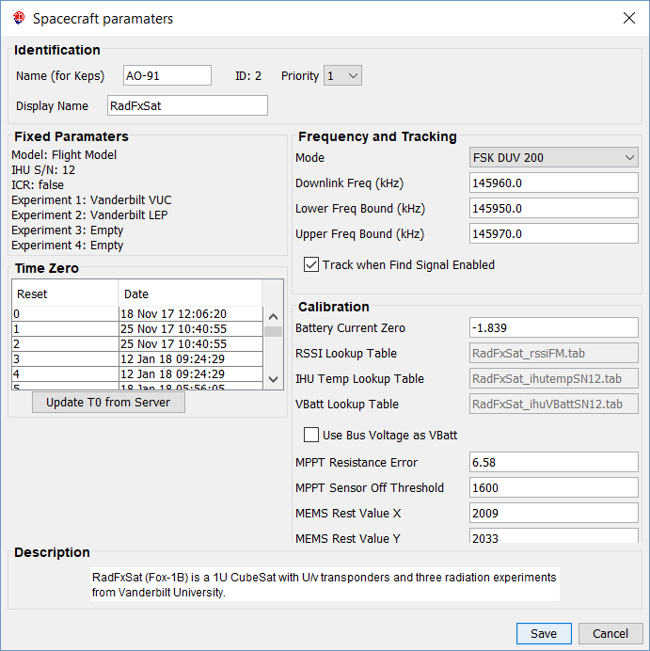

The data is stored in a java “properties” file which consists of key-value pairs. A line either starts with a #, meaning it is a comment, or it has a key followed by an = then the value.

The valid keys are:

foxId – this is the id of the satellite, where 1 = 1A, 2 = 1B etc. You can not load two satellite configuration files with the same foxid

catalogNumber – this is the NORAD catalog number for the satellite and is unused currently

name – this is the name that is used to extract Three Line Elements TLEs from the Keplerian Elements file. E.g. AO-85. It must match the name in nasabare.txt. If SatPC32 is used to indicate when the spacecraft is above the horizon, then this name needs to be the same as the name in SatPC32.

displayName – this is the name that is displayed in FoxTelem for this satellite. E.g. Fox-1A or AO-85.

description – this is a helpful description so we know which satellite we are talking about

model – this is the model number where 0 = Engineering Model, 1 = Flight Model and 2 = Flight Spare

IHU_SN – this is the serial number of the IHU board

EXPx – this indicates what is in experiment x slot, where x is 1 – 4. The value is then a number, which indicates the following:
0 – Experiment slot is empty
1 – Vanderbilt Vulcan Radiation Experiment
2 – Virginia Tech Camera
3 – IOWA State HERCI Experiment
4+ are currently reserved for future use

telemetryDownlinkFreqkHz – the nominal transmit frequency for the downlink telemetry, e.g. 145980 for Fox-1A

minFreqBoundkHz – the lower frequency bound when the “Find Signal” algorithm is searching for this satellite

maxFreqBoundkHz – the upper frequency bound when the “Find Signal” algorithm is searching for this satellite

BATTERY_CURRENT_ZERO – the calibration point for zero battery current, e.g. -1.839 for Fox-1A

rssiLookUpTableFileName – the lookup table to use for RSSI values

ihuTempLookUpTableFileName – the lookup table to use for the IHU temperature. Specific to each IHU Serial Number

ihuVBattLookUpTableFileName – the lookup table to use for Battery Voltage

rtLayoutFileName – the layout file for the RT Telemetry

maxLayoutFileName – the layout file for the MAX Telemetry

minLayoutFileName – the layout file for the MIN Telemetry

radLayoutFileName – the layout file for the Raw Radiation Bytes. This is the format that is saved to disk

rad2LayoutFileName – the layout file for the Radiation Telemetry. This is the format displayed in the Vanderbilt Radiation Tab if “Telemetry” is selected.

measurementsFileName – the layout file for the measurements made locally at your ground station

passMeasurementsFileName – the layout file for the measurements made for each satellite pass

useIHUVBatt – set to true if the IHU is used to measure Battery Voltage, rather than the Battery Board.

MPPT Resistance Error – the extra, unintended resistance in the RTD measurement circuit. This circuit measures the temperature of the solar panels. The error resistance value is used in the calculation of the temperature

MPPT Sensor Off Threshold – The solar panel temperature sensors are off when the panel is not illuminated. This raw value is the minimum required for FoxTelem to display a value. Set it to 0 to see all values of the sensor.

Telemetry Layout Files
The telemetry layout files contain a row for each value in the telemetry. These are read by FoxTelem when it starts and are used to parse the received telemetry once it has been demodulated. The first row of the file contains the number of rows, followed by the column names. The number of rows specified then follows, with a value REQUIRED in each column. The file is comma delimited and is easiest to edit in a spreadsheet program such as Microsoft Excel. Make sure you save it as a csv file again.

The columns are as follows:

TYPE - For information only. RT, MAX, MIN or RAD. Ignored by the program

FIELD - The name of the field. Must be unique. Used by FoxTelem to keep track of the value internally.

BITS - The number of bits in the field. (As a side note Fox sends bits with the most significant bit first, but it is little endian, so we get the least significant byte first. This made the decoder more entertaining to write.)

UNIT - The units that the telemetry value will have after we convert the raw value. This is displayed on screens and graphs.

CONVERSION – The conversion routine to run on the raw value. This is an integer value. See Conversions below to understand what the integers mean.

MODULE – The name of the module on the “Health” tab that this value should be displayed in. If RT, MAX and MIN are displayed on the same line, then this only needs to be set in the RT layout file.

MODULE_NUM – The number specified determines the order of the modules on the Health tab. The first module should be “1”. Modules then follow numerically. Modules starting with “10+” are displayed in the lower half of the screen.

MODULE_LINE – This is the line in the module that the value is displayed on, starting with line 1.

LINE_TYPE - A numeric value, with the following meanings:
0 – Display value in the Real Time column only on this line. E.g., Antenna Status has no Max or Min value. Confusingly, we use this to display things like “Soft Error” which is only in the MIN Values Payload. So we specify the module and module line for it, but give it LINE_TYPE 0
1 – Display value in the MAX column – never used
2 – Display value in the MIN column – never used
3 – Display values in ALL columns – used for most values

SHORT_NAME – The name that is displayed on the Health Tab for this telemetry value .

DESCRIPTION – The description that appears when the mouse is hovered over this value.

Conversions
It turns out that taking raw values measured by Analog to Digital Converters (ADCs) on the spacecraft and converting them into real, accurate measurements across multiple satellite, is non-trivial. We have therefore specified several conversion routines. Following Fox-1E no more will be added in the future as Curve Conversions will support all future conversion needs. See the next section.

The list of existing Conversion values are defined here:
https://github.com/ac2cz/FoxTelem/blob/master/src/telemetry/BitArrayLayout.java
The Conversion routines are implemented here:
https://github.com/ac2cz/FoxTelem/blob/master/src/telemetry/FramePart.java

For Fox-1A we had the following conversions:
Integer | Name | Description | Conversion
0 | CONVERT_NONE | Use the raw value as is | None
1 | CONVERT_INTEGER | Use the raw value as an integer | Round to zero decimal placed
2 | CONVERT_V25_SENSOR | Treat the raw value as a reading by the 2.5V ADC | Raw * 2.5/4096
3 | CONVERT_V3_SENSOR | Treat the raw value as a reading by the 3V ADC | Raw * 3/4096
4 | CONVERT_BATTERY | Convert the raw value into a battery voltage depending on the resistor network used to apply the value to the ADC | Battery A uses the 2.5V ADC, Battery B uses the 2.5V sensor / 0.76, Battery C uses the 2.5V sensor / 0.5
5 | CONVERT_SOLAR_PANEL | Convert the raw value from the solar panels | Raw * 3V ADC / 0.428
6 | CONVERT_SOLAR_PANEL_TEMP | Converts the raw value to a temperature in Celsius | Lookup the value in the Solar Panel Temperature Table, held inside FoxTelem
7 | CONVERT_TEMP | Converts the raw value to a temperature in Celsius | Lookup the value in the Temperature Table, held inside FoxTelem
8 | CONVERT_BATTERY_TEMP | Converts the raw value to a temperature in Celsius | Lookup the value in the Battery Temperature Table, held inside FoxTelem
9 | CONVERT_BATTERY_CURRENT | Calculate the positive or negative battery current in mA given the voltage across a sense resistor | (( rawValue * 2.5V ADC -0.05) * Battery Zero Value (in the spacecraft file) + 2) * 1000
10 | CONVERT_PA_CURRENT | Calculate the PA current in mA given the voltage across a sense resistor | ((rawValue * 3V ADC) / 50 / 0.2 ) * 1000
11 | CONVERT_PSU_CURRENT | Calculate the PSU current in mA given the voltage across a sense resistor | ((rawValue * 3V ADC) / 0.003 )
12 | CONVERT_SPIN | SPIN is 3.8 fraction fixed point. | If raw value > 2^11 (2048) - 1 then value = value - 2^12 (4096). This gives a signed value which we then divide by 256 to get a signed double
14 | CONVERT_RSSI | Converts the raw value to the Received Signal Strength in dBm | Lookup the value in the RSSI table, which is specified in the Spacecraft configuration file
15 | CONVERT_IHU_TEMP | Convert the raw value to the IHU internal temperature in Celsius | Lookup the value in the IHU Temperature table, which is specified in the Spacecraft configuration file
16 | CONVERT_ANTENNA | Convert the 2 bits into values for the antenna deployment status | 0 = Stowed, 1 = Deployed
17 | CONVERT_STATUS_BIT | Convert the bit into a status value | 0 = OK, 1 = FAIL
18 | CONVERT_IHU_DIAGNOSTIC | A set of diagnostic bits that are converted into values for debugging the IHU
19 | CONVERT_HARD_ERROR | Watchdog status and the type of error that last reset the spacecraft
20 | CONVERT_SOFT_ERROR | Other non fatal errors
21 | CONVERT_BOOLEAN | Convert the bit into a Boolean value | 0 = FALSE, 1 = TRUE
22 | CONVERT_MPPT_CURRENT | Calculate the current from the Maximum Power Point Tracker (if installed) based on the voltage across a sense resistor | (rawValue * 2.5V ADC) / 2.5
23 | CONVERT_MPPT_SOLAR_PANEL | Calculate the voltage for each solar panel, as measured by the Maximum Power Point Tracker | rawValue * 2.5V ADC * (6.54/2.42)
24 | CONVERT_MPPT_SOLAR_PANEL_TEMP | Calculate the temperature of each solar panel, as measured by the Maximum Power Point Tracker | Lookup the value in the MPPT Solar Panel Temperature table
25 | CONVERT_16_SEC_UPTIME | Convert Vulcan uptime to seconds | rawValue * 16

Conversions Curves

Version 1.09 of FoxTelem introduces the concept of Conversions based on curves and these will be used on all future spacecraft. A configuration file is specified in the Spacecraft master configuration file as follows:

useConversionCoeffs=true
conversionCurvesFileName=GOLF-T_conversion_curves.csv

That tells FoxTelem that this spacecraft will use the new conversion approach and that the configuration file is called GOLF-T_conversion_curves.csv. In that file we find the following type of information.
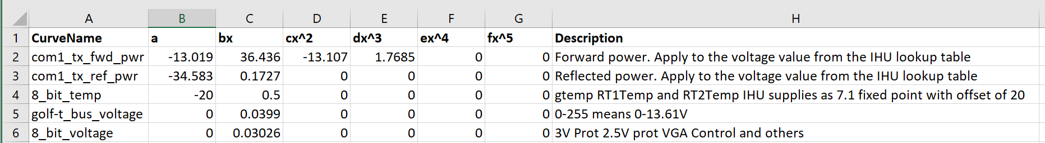

In the next release of FoxTelem this will be fully supported.

Troubleshooting

Symptom | Solution
Poor decodes or no decodes | 1. Are you trying to decode directly from the radios headphone jack or speaker output? That won’t work. See the earlier sections of the manual on decoding from a radio.  2. Is the sample rate different to the sound card? Has Windows (or another OS) set the sound card up with 44100, even though you told it not to?  3. Is Virtual Audio Cable (VAC) or another similar audio transport running at a different rate? 4. Do you have the free version of Virtual Audio Cable (VAC)? It contains a voice announcement that impacts decoding and increases the error rate.  5. Is your SDR outputting audio at a different rate?  6. Is your SDR audio filtering set to cutoff important frequencies?  7. Is the volume set to high and the wave form is distorted?  8. What is the Signal to Noise ratio of the eye diagram – assuming you have one? It should be 2+, preferably 6+
Decoder stalls when a frame is received | 1. Is the bit level debugging on, or some other verbose debugging? Check on the File>Settings screen  2. Has the FoxTelemDecoder.log file grown to a huge size?  3. Are you nearly out of disk space?
I am using HDSDR and I have missing lines in the images I am receiving from the Virginia Tech Camera onboard Fox-1C (or another Fox sat) | We have seen a bug in HDSDR where it skips a few bits and the decode is corrupted. Set the Bandwidth to 96000 in HDSDR and the Sample Rate to 96000 in VAC (if you use it) and in FoxTelem. This should work around the issue.  That said, in 1.06 and later there is an algorithm to re-insert bits dropped by the audio software. It is enabled from the settings tab.
FoxTelem does not start when I launch it | 1. Maybe you have a FUNcube dongle connected to your computer and it has crashed. Try unplugging the dongle and restarting FoxTelem.  2. If you edited the spacecraft files, perhaps something is causing FoxTelem to crash. Try putting the default spacecraft files back in place.  3. See if the file FoxTelemDecoder.log has been created in the installation directory. See if this contains and error messages.  4. Try running FoxTelem from the command line to see if any errors are reported to the console.  5. If a file called foxtelem.properties has been created in the installation directory, you could manually edit it and set logging=true. Then try again and see if error messages are written to the console or to the FoxTelemDecoder.log file.  3. If FoxTelem ran previously, try renaming foxtelem.properties temporarily. FoxTelem will create a new properties file when it starts up.
I try to run the FoxTelem.exe file on Windows and it tells me that it is missing MSVCR100.DLL or a similar error | This is the Microsoft Visual C library and should already be installed with Windows. An aggressive Uninstall application may have removed it from your system. See this help article from Microsoft:  http://answers.microsoft.com/en-us/windows/forum/windows_other-performance/msvcp100dll-missing/9a687c31-0619-4ee9-b511-020985e29b5f
I’m confused about Java on the Mac. Apple do not seem to support it anymore, what is going on? | Before MacOS 10.7 (Lion) you used the Apple supplied version of Java (version 6). You should be able to do this through Software Update in the System Preference.  Apple no longer maintains the Java runtime environment, so post 10.7.3 you are advised to install the latest runtime environment, which you can download from java.com. However, this is not compatible with FoxTelem on the Mac (even though it is on all other platforms). So you will need to install the old version of Java. See the issue below.
I try to run FoxTelem on the Mac and it tells me that it is a “legacy” app and I need an old version of Java  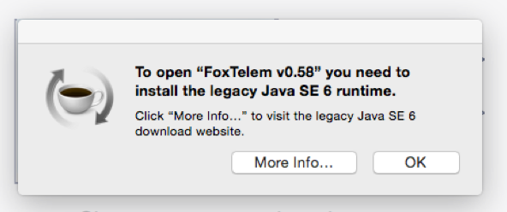 | To maintain compatibility with older Macs (see the question above) we have made FoxTelem available with Java 6. Follow the instructions and install the legacy version.
I was running FoxTelem on my laptop, tablet, windows phone, windows fridge etc and when I came back it looks like the audio was disconnected. The blue audio graph is blank. | Windows, and probably other platforms, can put the audio system to sleep when the computer sleeps or hibernates. This seems to disconnect the audio system from FoxTelem. When the computer awakens, you need to stop and start the decoder to reconnect it. You can prevent this by stopping the computer going to sleep or hibernating in the Power Settings.  Windows also has a mode called "Connected Standby" which is not Sleep mode and is not fully running. It is used on laptops and tablets. It shuts off audio in that mode. It is trying to save you battery power, but it gives no easy option to leave the audio running.  You can turn off Connected Standby in the registry as follows:  Tap on the Windows-key, type regedit.exe and hit the Enter-key.  Navigate to the key:  HKEY_LOCAL_MACHINE\SYSTEM\CurrentControlSet\Control\Power  Locate the preference CsEnabled on the right side.  Double-click on it, and set its value to 0.  Restart the PC.  A negative effect of this is that it may take longer for your device to wake up, which impacts when the device is ready for use.
The Frequency Spectrum is truncated in IQ mode and only seems to show the middle part. See Figure 1. | Even though you may have set FoxTelem to the right sample rate (e.g. 192000 or 96000) the audio source you are reading from is supplying audio at a lower rate. Figure 1 shows FoxTelem expecting samples at 192000 and receiving samples at 48000.
I connect to my computer using a Remote Desktop Connection (RDP) and FoxTelem is always not running. | This seems to be a Windows “feature”. When you connect the RDP connection kills something in the audio subsystem that upsets Java. This is outside the FoxTelem code base and I don’t have a fix. I recommend using AnyDesk for remote connections.

Figure 1: Too narrow a bandwidth on audio device used for IQ source
