NASA EXOPLANET ANALYSIS
The Exoplanet Field Guide
Interactive NASA Exoplanet Dashboard
Design, implementation and evaluation of an interactive NASA exoplanet dashboard

Project by
Alpaycan Cabbar

Data source
NASA Exoplanet Archive
Table of Contents
1. Dataset Overview 2
2. Dashboard Design 3
3. Key Findings 4
4. Reflection 5
References 5

List of Figures
Figure 1.Discovery Trends filter navigator 3
Figure 2.Selected-period summary cards 3

List of Tables
Table 1.Principal variables used in the dashboard 2
Table 2. Principal findings from the NASA snapshot 4

1. Dataset Overview
The analysis uses the Planetary Systems Composite Parameters table from the NASA Exoplanet Archive. The fixed snapshot downloaded on 30 July 2026 contains 6,324 confirmed planets associated with 4,738 host systems, 11 discovery methods and discovery years from 1992 to 2026. Each row represents one confirmed planet and combines the archive's preferred planetary, orbital and stellar measurements. NASA's archive was selected because it is authoritative, sufficiently large and suitable for analyzing discovery growth, detection methods and the measured diversity of confirmed worlds. The dataset describes confirmed observations rather than the complete planetary population, so the dashboard does not treat it as a census of the galaxy.
The source table contained 703 columns. The application loads 22 selected fields to provide a compact analytical dataset and a richer downloadable extract. Eight headline fields are displayed in the searchable table to preserve readability, while additional fields support the visualizations, selected-planet profile and optional follow-up analysis in the downloaded CSV. Planet and host names identify records; discovery year, method and facility support temporal and categorical comparisons; and radius, mass, density, equilibrium temperature, received starlight, orbital period and eccentricity describe measured planetary characteristics. Stellar distance was converted from parsecs to light-years, while host-star temperature, mass and radius provide system context. Earth-relative units are used wherever possible because they allow a non-technical reader to understand unfamiliar measurements without removing their scientific meaning.
NASA variable | Meaning and unit | Dashboard use
Disc_year | Year of discovery | Annual trends and year filters
discoverymethod | Method used to detect the planet | Method comparisons and filters
disc_facility | Facility credited with the discovery | Top Discovery Facilities chart
pl_rade | Planet radius relative to Earth | Size distribution and Earth comparison
pl_orbper | Orbital period in Earth days | Exoplanet-year analysis
pl_orbeccen | Orbital eccentricity from 0 to 1 | Orbit-shape analysis
pl_insol | Received starlight relative to Earth | Earth-comparison scatter plot
sy_dist | System distance in parsecs | Converted to light-years for analysis
Table 1.Principal variables used in the dashboard
Preparation focused on transparent comparison. Numeric variables were checked for missing and non-positive values, and readable groups were created for size, year length, distance and orbit shape. Missing measurements were excluded only from the calculation that required them, so the radius analysis uses 6,274 planets, orbital-period analysis 5,981, distance analysis 6,297 and eccentricity analysis 5,273. This preserves valid evidence without implying that every measurement is complete. All planet records remain available in Data Explorer, and 2026 is consistently labelled year-to-date because the snapshot ends on 30 July.

2. Dashboard Design
The dashboard follows a five-stage analytical narrative. Overview establishes the scale and coverage of the archive; Discovery Trends examines change over time and differences between detection methods; Planet Characteristics translates specialist measurements into Earth-relative comparisons; Data Explorer supports record-level checking; and Key Findings interprets the strongest patterns and limitations. Persistent top navigation keeps this reading sequence visible, while each newly selected tab returns to the top so that its introduction is encountered before the detailed evidence.
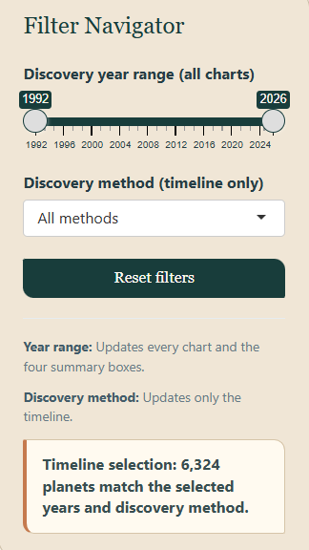
Figure 1.Discovery Trends filter navigator
The field-guide theme makes a scientific dataset approachable without weakening its analytical purpose. Cream backgrounds reduce glare, dark green provides a stable identity for navigation and headings, navy carries the principal analytical marks, and gold or coral identifies reference points, secondary series and incomplete 2026 data. Repeated cards and consistent spacing create visual continuity. Color is reinforced by labels, ordering and annotations, so meaning does not depend on hue alone. The Overview combines summary cards with annual and method-level charts because the audience needs both archive scale and an immediate explanation of how that scale accumulated.
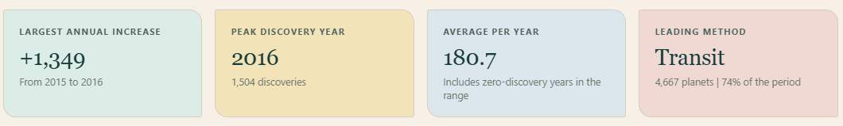
Figure 2.Selected-period summary cards
Visual forms were matched to the analytical questions. A time-series chart highlights annual peaks, while ranked horizontal bars accommodate long method and facility names. A proportional stacked chart shows changes in each method’s share, and a cumulative line traces archive growth. Planet size, orbital period, distance and eccentricity are presented as grouped distributions with Earth-relative explanations. The interactive scatter plot uses logarithmic axes because radius and received starlight span several orders of magnitude; Earth serves only as a measurement reference, not a habitability classification. Direct labels and annotations identify the 2014 and 2016 peaks and incomplete 2026 data.

3. Key Findings
Confirmed exoplanet discoveries have increased rapidly but unevenly. The NASA snapshot records 869 discoveries in 2014 and 1,504 in 2016, up 1,349 from 155 in 2015 and making 2016 the busiest complete year. The chart annotations reference NASA’s validation announcements of 715 Kepler planets in 2014 and 1,284 in 2016 (NASA, 2014; NASA, 2016); these contextualise the peaks but do not represent complete annual totals. Transit dominates with 4,667 of 6,324 records (73.8 per cent), followed by Radial Velocity with 1,195. This demonstrates the productivity of Transit surveys but primarily reflects detection geometry, survey design and confirmation practices rather than the true distribution of planets in the galaxy.
Finding | Evidence | Interpretation
Peak discovery year | 1,504 planets in 2016, an increase of 1,349 from 2015 | Catalogue growth is uneven and influenced by major survey and validation activity
Leading method | Transit accounts for 4,667 of 6,324 planets (73.8%) | The confirmed archive is strongly shaped by detection methods and survey design
Length of an exoplanet year | 5,326 of 5,981 measured planets (89.0%) orbit in less than one Earth year | Short-period planets generate more frequent signals and are generally easier to detect repeatedly
Reported orbit shape | 4,002 of 5,273 measured eccentricities (75.9%) are below 0.1 | Nearly circular orbits form the largest measured group, although 1,051 values are missing and some zeros may be assumed
Table 2. Principal findings from the NASA snapshot
Among 6,274 planets with reported radius data, the median is 2.86 Earth radii, while the largest dashboard group contains 2,079 planets between two and four Earth radii. Of 5,981 planets with reported orbital periods, 5,326 (89.0 per cent) orbit in less than one Earth year; the 10.77-day median partly reflects detection bias towards short-period planets, whose signals recur more frequently. Of 5,273 planets with reported eccentricity, 4,002 (75.9 per cent) fall below 0.1 and are therefore classified as nearly circular. However, eccentricity is missing for 1,051 planets, and some reported zeros may represent assumed circular orbits. The median recorded distance is 1,176 light-years among 6,297 measured planets, demonstrating the reach of modern surveys. Nevertheless, the Earth-comparison plot shows that similar radius and received starlight alone cannot establish whether a planet is habitable (NASA Science, 2024).

4. Reflection
The dashboard's main strength is its coherent movement from context to exploration and interpretation. Earth-relative definitions, scoped filters, reactive summaries, direct labels, accessible chart descriptions and downloadable records make a technically complex archive understandable without hiding its limitations. Data Explorer provides an audit path from aggregate charts to individual records, while Key Findings prevents the project from ending as a collection of disconnected visualizations. The consistent field-guide design strengthens this narrative without distracting from the evidence.
The principal limitations are the fixed snapshot, incomplete 2026 coverage, unequal measurement availability and the absence of uncertainty intervals. Grouped categories improve readability but hide variation within each band, and the confirmed archive is shaped by geometry, survey targeting, instrument sensitivity and confirmation procedures. The findings are therefore descriptive of recorded discoveries rather than the complete population of planets. The interface also contains substantial vertical content and has not been evaluated through formal usability testing with its intended non-technical audience.

References
Carney, S. (2026, April 15). What Is Exoplanet Watch? / Background Information. Retrieved from NASA Science: https://science.nasa.gov/citizen-science/exoplanet-watch/background/
How the Archive Calculates Values in the Planetary Systems Composite Parameters Table. (2026, June 10). Retrieved from NASA Exoplanet Archive: https://exoplanetarchive.ipac.caltech.edu/docs/pscp_calc.html
NASA Exoplanet Science Institute. (2026, June 10). How the Archive Calculates Values in the Planetary Systems Composite Parameters Table. Retrieved from NASA Exoplanet Archive: https://exoplanetarchive.ipac.caltech.edu/docs/pscp_calc.html
NASA Exoplanet Science Institute. (2026, June 4). Planetary Systems and Planetary Systems Composite Parameters Table Definitions. Retrieved from NASA Exoplanet Archive: https://exoplanetarchive.ipac.caltech.edu/docs/API_PS_columns.html

