How to Install SQL Server Management Studio on your Local Computer
- Sergey Gigoyan
- February 8, 2021
- SQL Server Management Studio
Problem
We are going to illustrate some common tips for working with Microsoft SQL Server Management Studio (SSMS) which is the most popular IDE for working with SQL Server databases. So, we are going to start the series of tips from the beginning - installation of SQL Server Management Studio on the Windows operating system. Usually, SSMS is installed on the same machine (server) where the SQL Server Engine and other features are installed, but sometimes database developers do not have remote access to the database server and they need SSMS installed locally and connect to the remote databases. In this article we will show how to install SSMS on the local computer and how to connect to the remote SQL Server instances.
Solution
It is possible to install SQL Server Management Studio on local machine without having other SQL Server components. Below we will demonstrate different ways to install SSMS step by step on a local machine and how to connect to the remote instance using SSMS.

Installing SSMS from Microsoft SQL Server installation media
One of the ways to install SSMS is using SQL Server installation disk. Let’s illustrate this process by using SQL Server 2014 as an example. When SQL Server Installation Center is opens, choose “Installation” and then choose “New SQL Server stand-alone installation or add features to an existing installation”:
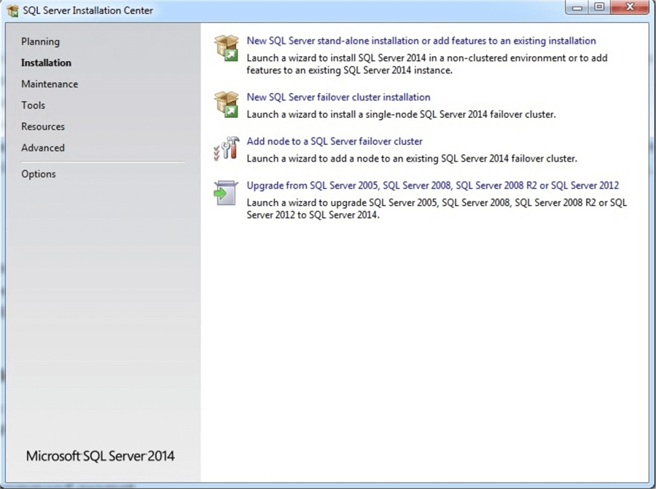
In the “Setup Role” window choose “SQL Server Feature Installation” to configure the install:
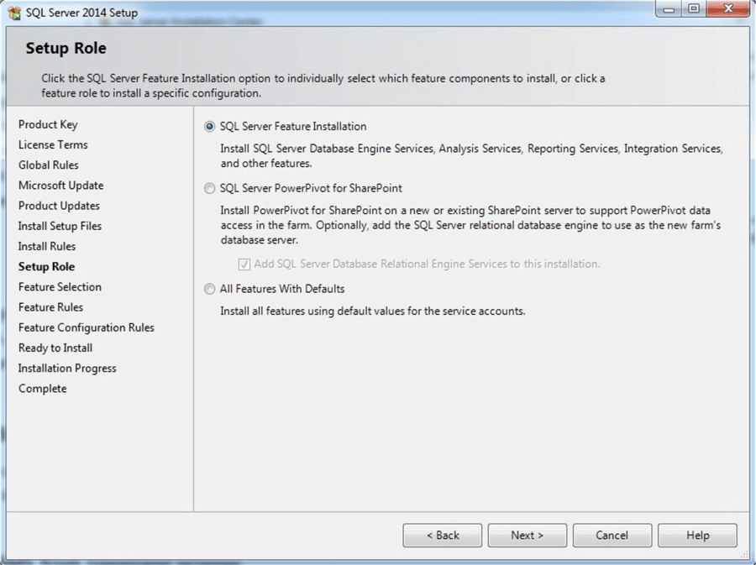
After clicking “Next” from the features list choose only “Management Tools – Basic and Management Tools – Complete” as shown below:
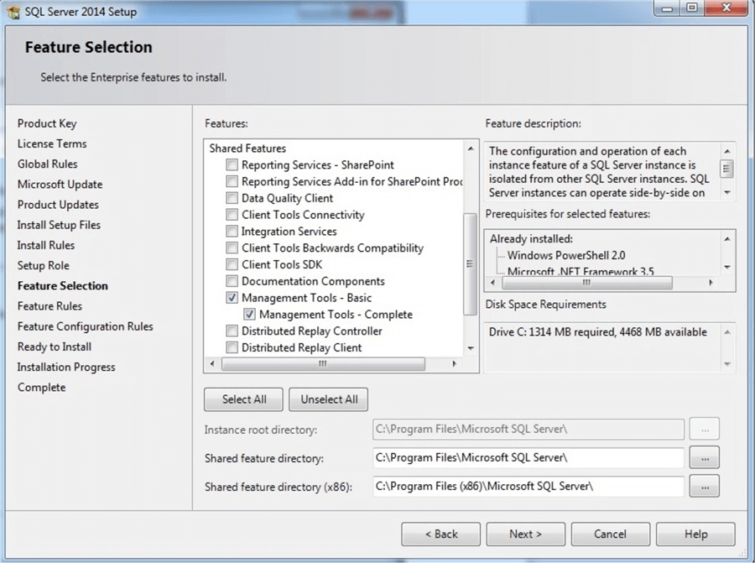
After pressing the “Next” button several times and accepting the license terms the “Ready to Install” window appears as shown below in the installer:
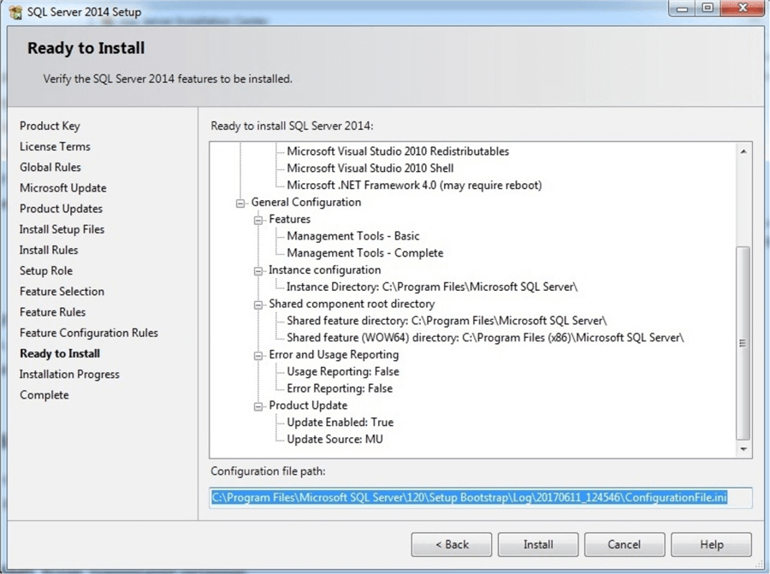
There we can see configuration file path. Using this file, we can install SSMS on other machines with the same configuration. Click install and wait for installation to complete. When it is successfully completed, the following window appears:
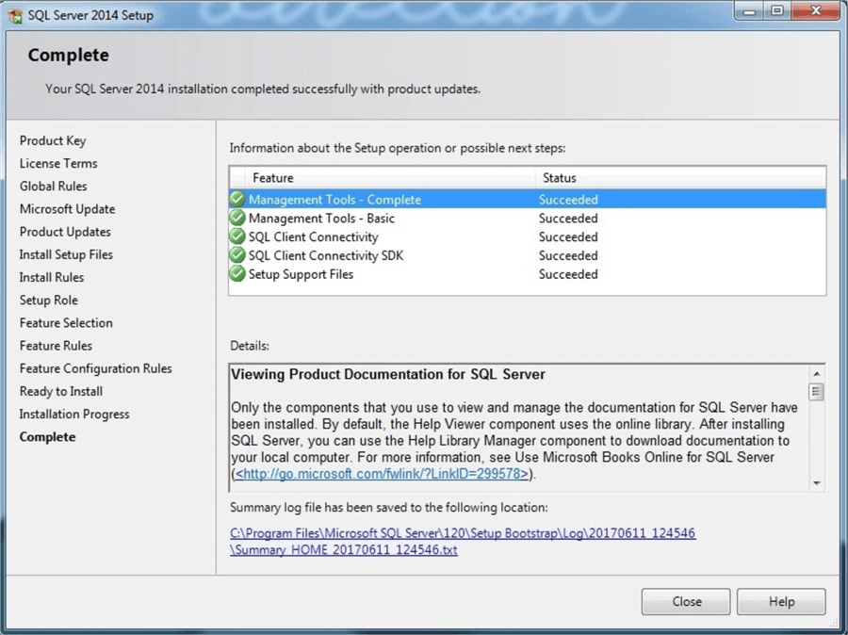
After the install, you can click on the Start Menu and find it in the programs list under “Microsoft SQL Server 2014”:
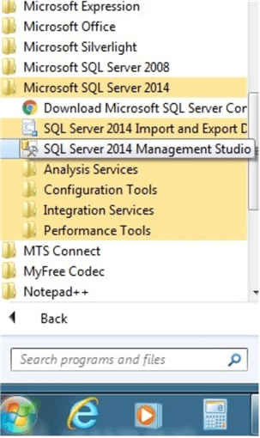

Installing Microsoft SQL Server Management Studio from configuration file
In the install example above, the SSMS installation file was created in file ConfigurationFile.ini. Opening this file, we can see that only “SSMS” and “ADV_SSMS” is selected from features list:
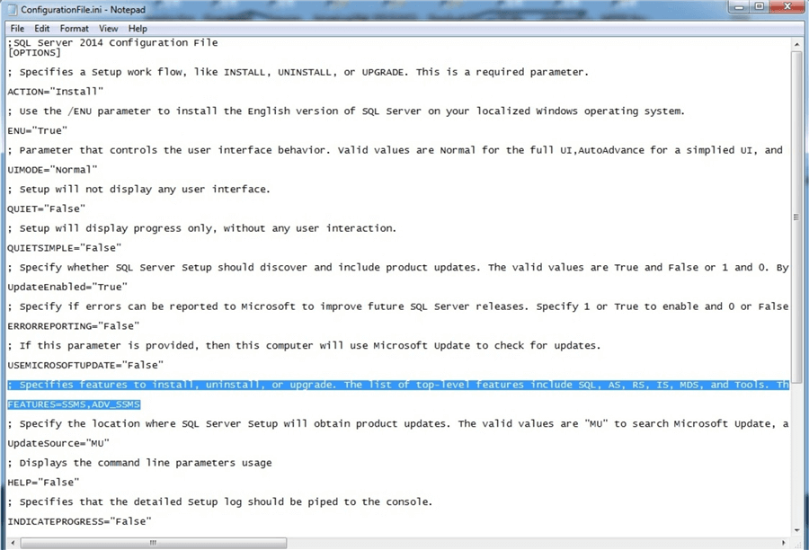
Using this file, we can install SSMS on other computers with the same configuration as it was installed on the original machine. In addition, it is possible to specify new features to install or remove. To install from the configuration file, we open “cmd.exe” and run the following command:
C:\Users\Administrator>i:\setup.exe /ConfigurationFile="C:\Program Files\Microsoft SQL Server\120\Setup Bootstrap\Log\20170611_124546/ConfigurationFile.ini" /Q /IAcceptSQLServerLicenseTerms="True"

As shown above the SQL Server installation media path and the configuration file path must be specified. The parameter “Q” means that installation will be silent, which means that we do not see an installation progress window and we will not be able to check or uncheck features. When we use silent installation it is important to set IAcceptSQLServerLicenseTerms=”True”.
After pressing “Enter” we will receive the following error: “/UIMode setting cannot be used in conjunction with /Q or /QS.” as shown below:
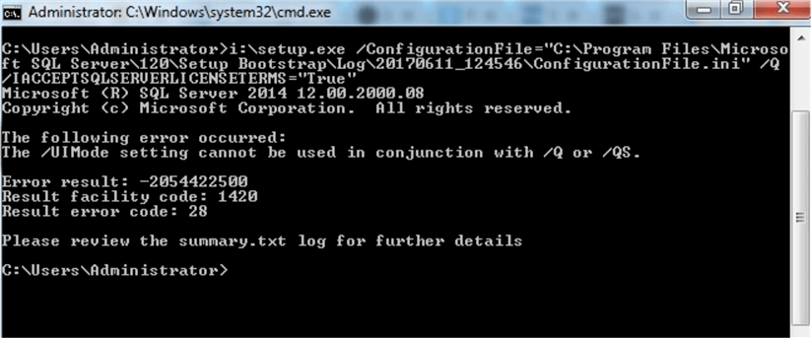
This error can be avoided by commenting out the UIMODE=”Normal” string in the configuration file as shown below:
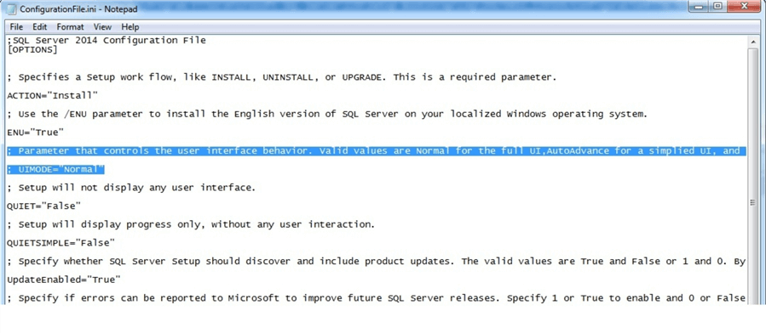
Running the command again will start the installation of SSMS, however we will not be able to see the installation process as we chose the silent installation mode. After installation is finished, SSMS will be installed and in the programs list.

Downloading and installing standalone SSMS
It is also possible to download SSMS separately from SQL Server, in other words download a standalone version of SSMS. To do this we will use this link: https://docs.microsoft.com/en-us/sql/ssms/download-sql-server-management-studio-ssms
We can see that SQL Server Management Studio 17.1 is available. Scroll down if you want to choose a previous version of SSMS:
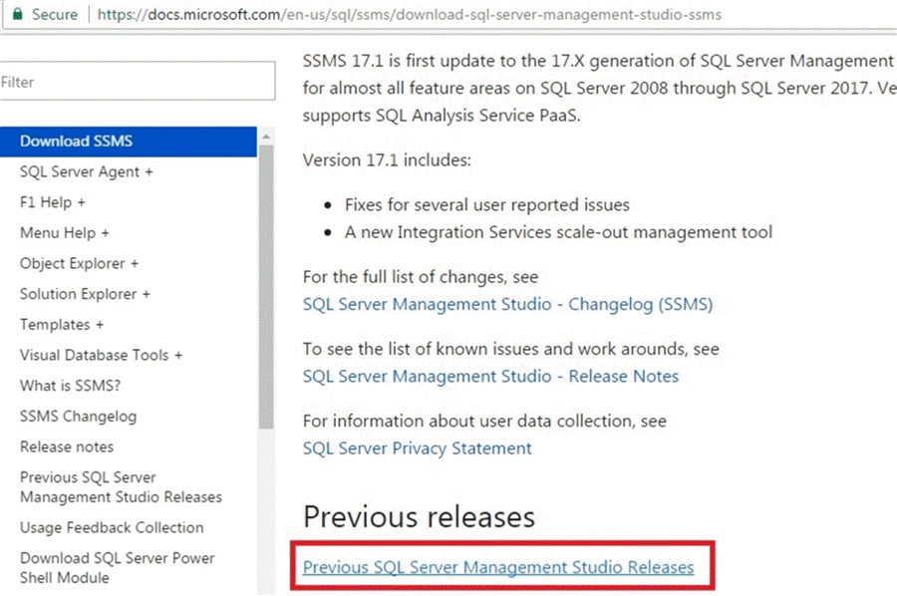
The link for previous releases is: https://docs.microsoft.com/en-us/sql/ssms/previous-sql-server-management-studio-releases
Let’s download and install SSMS 2014 SP1:
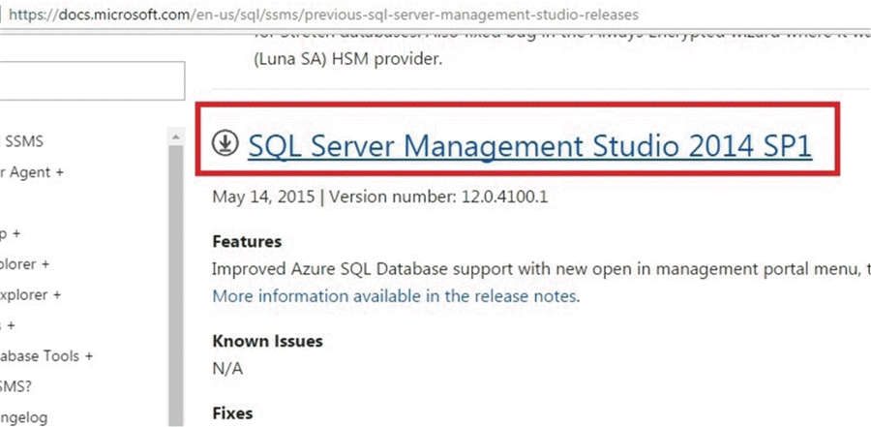
After clicking the SSMS 2014 SP1 download link, the download will begin. When the download completes, we run the “SQLManagementStudio_x86_ENU.exe” to extract the files and then run setup.exe in the extracted files. The SQL Server Installation Center opens and we can see that there are only SQL Server Management features available to install (assuming we are doing this test on a computer where SSMS is not installed):
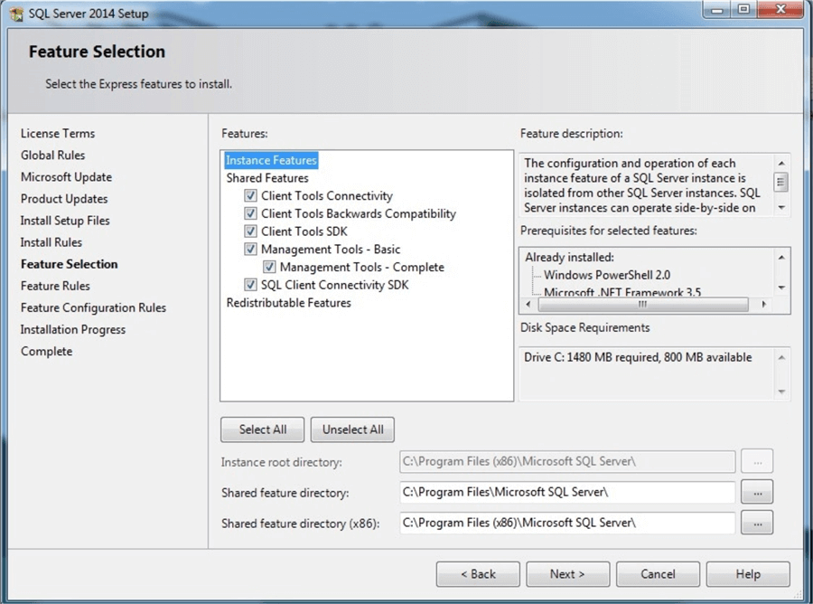
So, from here we will be able to install SSMS like in the previous example.
In addition, when we are installing SSMS from the SQL Server 2016 Installation Center there is no SQL Server Management tools in the feature’s selection list. There are separate options in the SQL Server 2016 Installation Center for management tools - “Install SQL Server Management Tools”. Also, it is possible to have more than one SSMS version installed on the computer. For example, you can have both - SSMS 2014 and SSMS 2016 on the same machine.

Connecting to the remote instance from SSMS
Now we are going to illustrate how to connect to the remote server using the locally installed version of SSMS (assuming the remote SQL Server is accessible from the local computer). To connect to the remote instance, we are opening SSMS and in the “Connect to Server” window in the “Server name” field we should enter the remote server details in the following format:
<Remote Server name or IP address> / <Instance Name>, <port>

In the following image, we are going to connect to the remote server’s default SQL Server instance with an IP address of ’192.168.56.102’ that will use the default SQL Server port of 1433 and use SQL Server authentication:
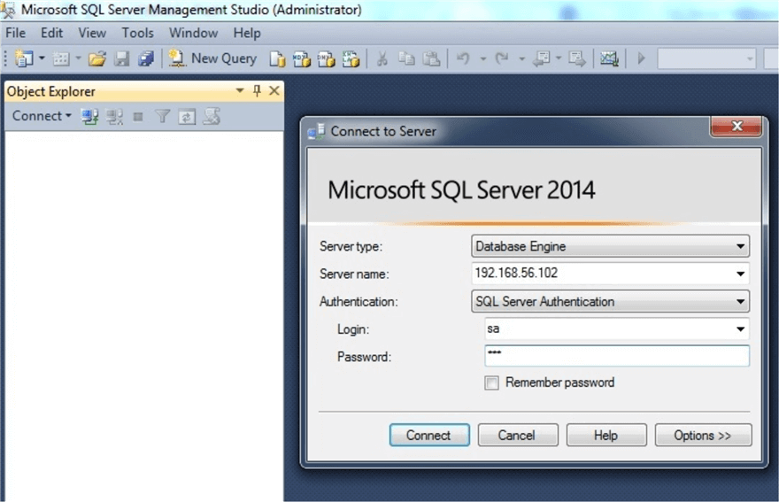
After typing the password for the login, we will be successfully connected:
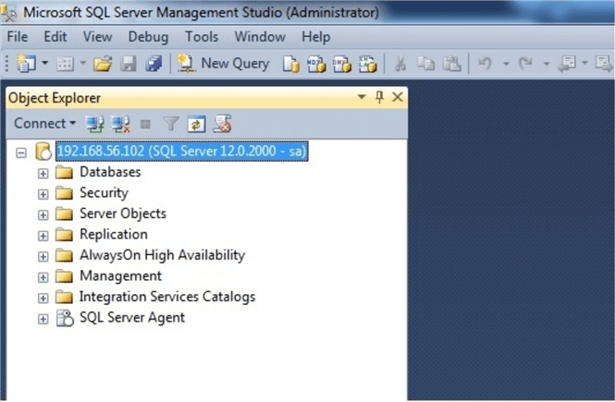
If the server had a different port number such as 2040, we would connect as follows using the port number in the Server Name field.
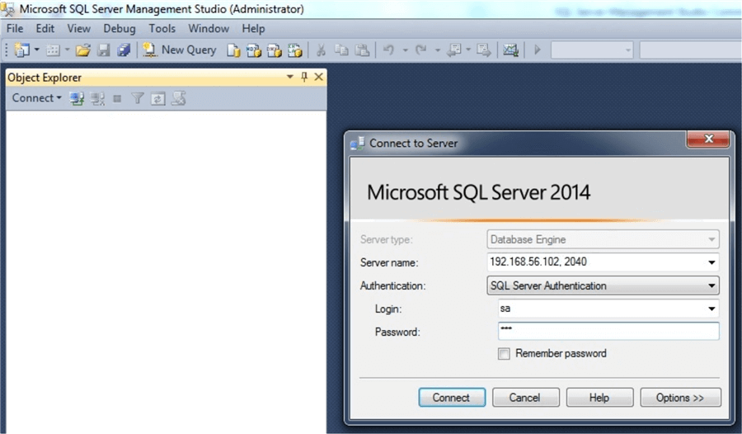

Conclusion
As we can see it is possible to install only SQL Server Management Studio on a local machine (without installing the SQL Server database engine and its other components) and connect using SSMS to a remote SQL Server instance. Installation of SSMS is possible from the SQL Server Installation Center and it is possible to download and install only SSMS. Like other SQL Server features it is possible to install SSMS using a configuration file from the command line.

SQL Server Management Studio 18 Download, Install and Configure
- Joe Gavin
- July 21, 2026
- SQL Server Management Studio
- 2 Comments
Problem
You’re need to access a Microsoft SQL Server instance. If you’re going to manage it or develop on it, you will need install a tool like Microsoft SQL Server Management Studio (SSMS) to do so. In this tutorial, we look at how to install SSMS via the GUI and command line.
Solution
We’ll look at a brief history of SSMS, what it is, and walk through the process of downloading, installing, connecting to a SQL Server, some basic functionality, and how to check for new versions.
For the purposes of this tutorial, I am installing SSMS 18.10 on a Windows Server 2019 operating system Virtual Machine and will connect to a SQL Server 2019 SQL Server which are all the latest versions as of the time of writing.

What is SSMS?
Earlier versions of SQL Server came with a graphical tool (IDE) and SQL script editor called Enterprise Manager. It was upgraded along with each version and used up through SQL Server 2000. It was updated and repackaged based on Visual Studio toolset as SQL Server Management Studio in SQL Server 2005 and the name continues.
SSMS is a powerful integrated environment that lets you:
- Configure, monitor, and manage On-Premises and Azure SQL Servers and databases
- Design, develop and execute T-SQL queries, SQL scripts, stored procedures and functions against SQL Server databases with a query editor
- Generate scripts from database objects or GUI based processes
- Also connects to:
  - SQL Server Reporting Services (SSRS)
  - SQL Server Reporting Analysis Services (SSAS)
  - SQL Server Integration Services (SSIS)
Prior to SQL Server 2016, SSMS was installed from the same SQL Server media used to install the SQL Server database engine. As of SQL Server 2016, it’s a separate downloadable install and is released independently of the SQL Server database engine releases. This allows:
- Anyone to install it without needing access to the install media
- Easy updates as they are now frequently released
Other features are:
- Works with all supported versions of SQL Server
- Cost is $0.00 for DBAs, Developers and Business Intelligence Professionals

Download SSMS
Let’s get started.
Obtaining SSMS is much easier now as there is no need to find your install media. Simply go to: Download SQL Server Management Studio (SSMS) and you will be redirected to the download page of the latest version.
Here, you can:
- Find a link to the release notes
  - See what’s been fixed
  - Make sure there is no functionality you need that was broken (it happens)
- Find links to older SSMS versions
  - Downgrade to an earlier version if there is broken functionality you weren’t aware of if you didn’t read the release notes (we all forget to do that sometimes)
- Download the installer executable
To start the download, click the Free Download for SQL Server Management Studio (SSMS) x.x link on this page Download SQL Server Management Studio (SSMS).
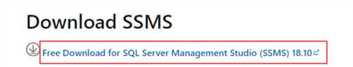

Install SSMS
Now that we have the installer, SSMS-Setup-ENU.exe, in our download directory we can choose one of the two install options. The first is the traditional way through the GUI by responding to prompts, in an attended install. The second is running it from a command prompt with some options for an unattended or silent install. As GUI method is the most likely method, we’ll look at that first.

Install SQL Server Management Studio with GUI
Open your download directory in Windows Explorer.
- Right click on the SSMS-Setup-ENU.exe
- ‘Run as administrator’
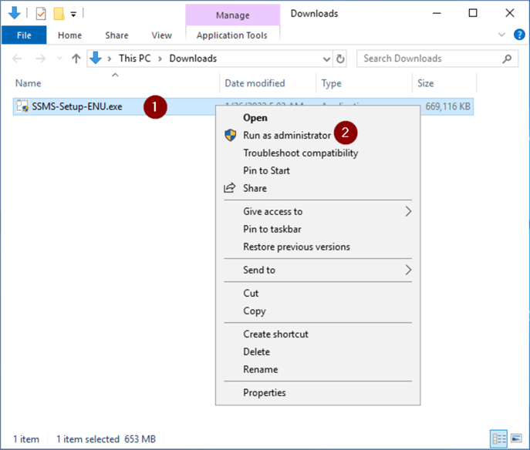
- If you’re prompted with ‘Do you want to allow this app to make changes to your device?’, click ‘Yes’
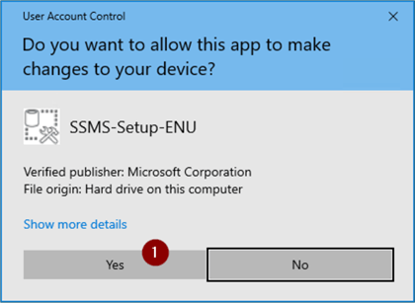
- Leave the default install directory or change it if you want, but note that if you change the install directory and want to start SSMS from Start > Run you’ll need to add the directory to your %PATH% environment variable
- Click ‘Install’
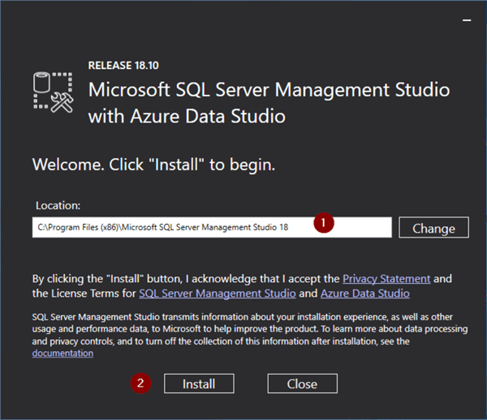
The ‘Setup Completed’ without any errors indicates the install is done.
- Click ‘Close’
- Check the install log file under %TEMP%\SSMS
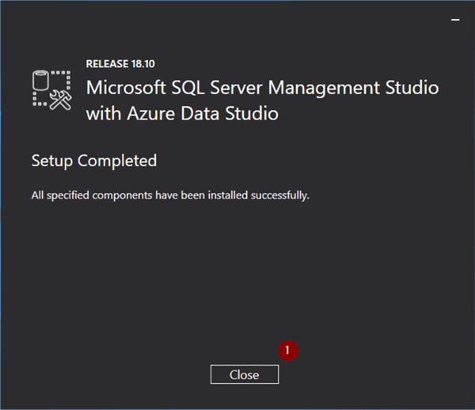

SSMS Unattended Install from Command Line
In the event you want to install from a script you can do an unattended install from the command line.
Open Search and enter cmd.exe.
- Right click cmd.exe
- ‘Run as administrator’ (install will fail with access denied if you don’t do it this way)
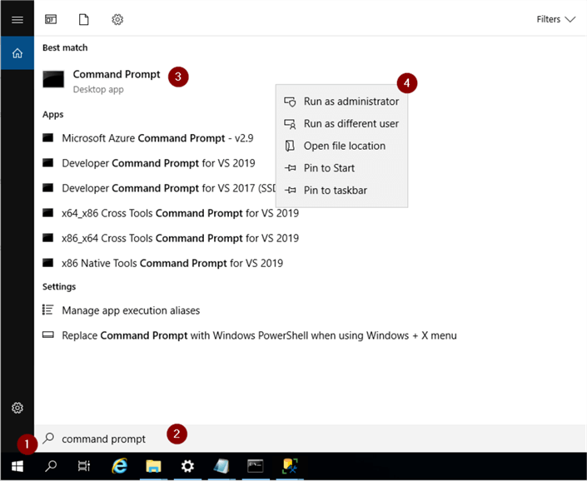
- If you’re prompted with ‘Do you want to allow this app to make changes to your device?’, click ‘Yes’
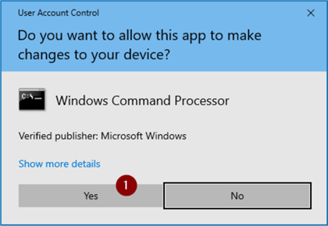
Use the ‘cd’ command to change to the directory where you downloaded SSMS-Setup-ENU.exe. For this example, I ‘m opening the installer from my user’s Downloads directory and installing it in the default install directory with the following commands.
cd \users\username\Downloads
start "" /w SSMS-Setup-ENU.exe /Quiet

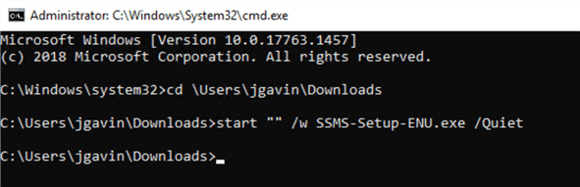
When the command prompt returns, make sure there are no errors displayed on the screen and check the install log file under %TEMP%\SSMS

Create a SSMS Desktop Shortcut
The install is done, and we can create a desktop shortcut to SSMS.
- Open Search
- Enter ssms
- ‘Open file location’
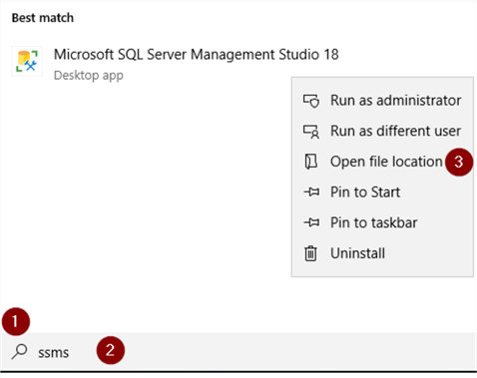
- Right click Ssms.exe
- ‘Send to’
- ‘Desktop (create shortcut)’
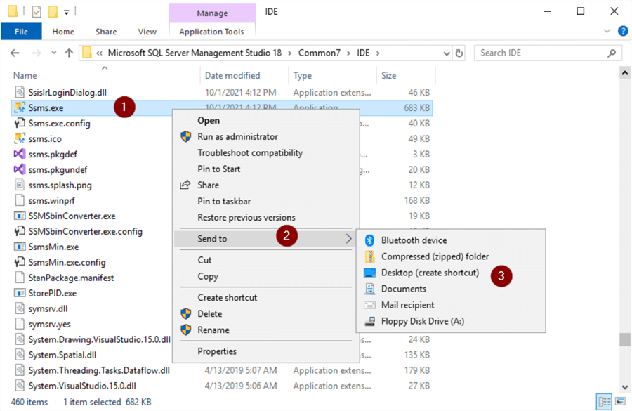
We know it’s a shortcut so let’s rename it.
- Right click ‘Ssms.exe - Shortcut’
- Rename to something like ‘SSMS’ and hit Enter
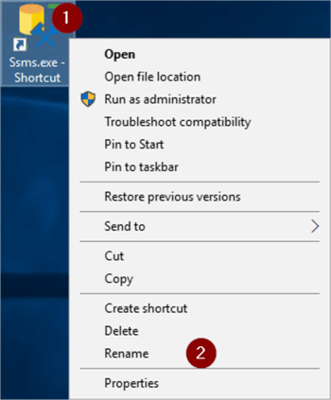

Start SSMS and Connect to Server
- Double click the shortcut
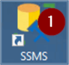
- Server name and authentication – enter server name and authentication information
- Click Connect
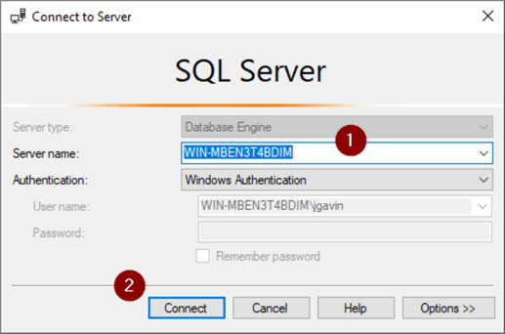
And you’re brought to the main SSMS screen. If the Object Explorer windows doesn’t open automatically simply go to View > Object Explorer or hit F8.
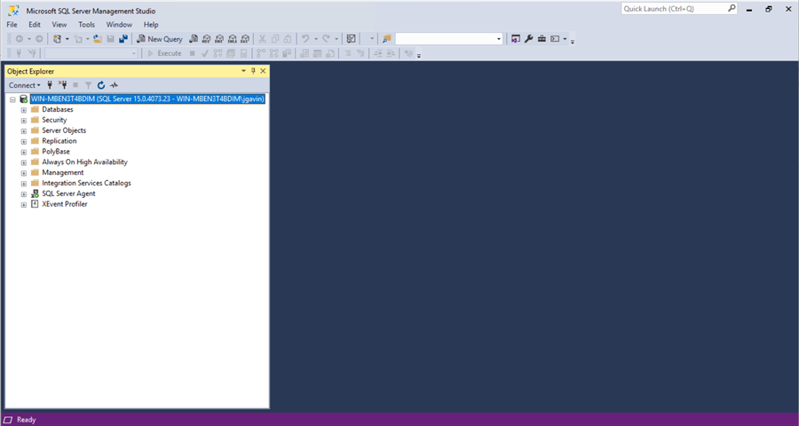
In the Object Explorer you can connect to another server, and expand a server dropdown where you can access Databases, Security Objects, SQL Agent, and more.
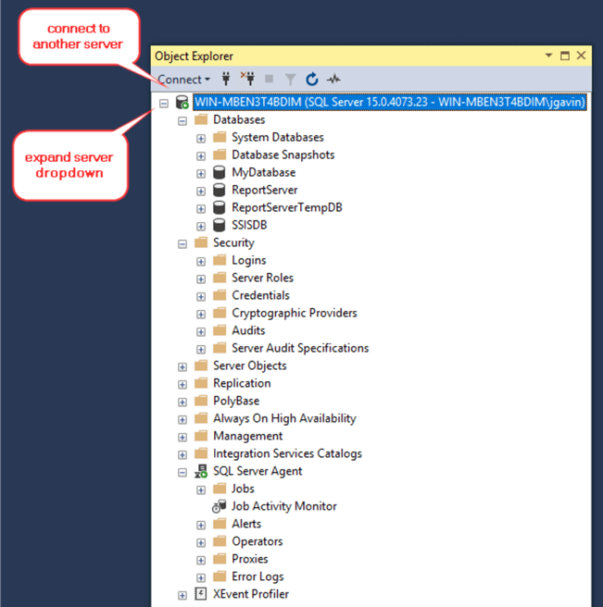

Upgrading SSMS
By default, SSMS will automatically check for updates when you start the application.
To manually check, or disable automatic checking:
- Tools
- Check for Updates…
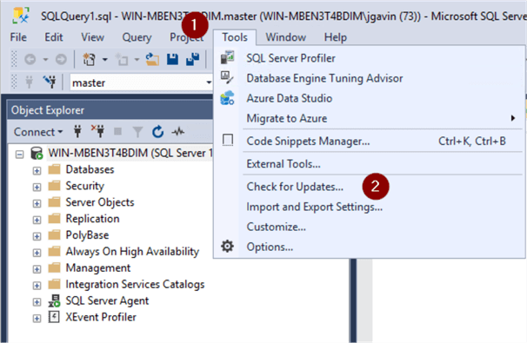
If there is an update available, a link to the download site will be displayed.
It’s unlikely you would want to disable automatic checking, but if you do simply uncheck ‘Automatically check for updates for SQL Server Management Studio’.
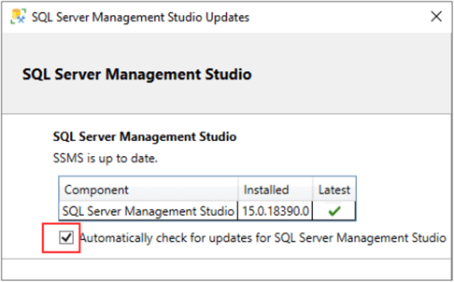
One thing to note, when you install later versions of SSMS 18, you also install Azure Data Studio (ADS). While SSMS is geared toward database administration and development work, ADS is still suitable for administration, especially with some of the extensions for it, but is more geared toward development work.

SSMS Productivity Tips and Tricks
- Joe Gavin
- July 21, 2026
- SQL Server Management Studio
Problem
You’re using Microsoft SQL Server Management Studio (SSMS) and would like to become more productive with this IDE. Check out these tips on how to make the most of SSMS.
Solution
In this tutorial, we’ll look at 10 handy productivity tips and hidden secrets that will help you save time for database administration and development. We’ll be using SSMS 18.11.1 and will connect to a SQL Server 2019 database engine which are both the latest versions as of the time of writing. These items will work with older versions of SSMS as well as other versions of SQL Server.
Just in case you need it, here is how to download and install SQL Server Management Studio. Let’s get started.

Top SSMS Productivity Tips
- Drag and Drop Object Names from Object Explorer to a Query Window
- Registered Servers in SSMS
- Block Highlighting in Query Window
- Switch Query Tabs in SSMS
- Upper Case and Lower Case Text in SSMS
- Cycle Clipboard Ring in SSMS
- Database Dropdown in SSMS
- Switch between Results and Messages Tabs
- Comment and Uncomment Selected Text
- Open Integrated Web Browser in SSMS
- Hotkeys in SSMS

Drag and Drop Object Names from Object Explorer to a Query Window
This SSMS functionality lets you drag most database object names from the Object Explorer to a Query Window. This can save a lot of typing and typing mistakes.
In this example we’re going to select all columns from the dbo.Categories table in the sample Northwind SQL Server database.
- Expand the server dropdown
- Expand Databases
- Expand Northwind
- Expand Tables
- Expand dbo.Categories
- Click and hold Columns and drop after the SELECT
- Click and hold database name and drop after the FROM
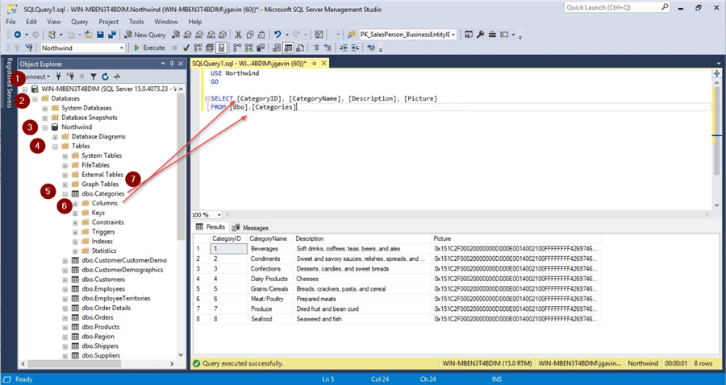

Registered Servers in SSMS
Registered Servers let you:
- Preserve connection information for SQL Server authentication and Windows authentication
- View service status
- Connect Object Explorer and Query Editor
- Organize your SQL Server by category in groups, i.e. development, test, production, geography, data center, Windows Server, Linux, etc.
- Display a more user-friendly server name in the management tool
- Provide detailed server descriptions
- View the SQL Server log files for online or offline SQL Server instances
To register a SQL Server, Ctrl + Alt + G or:
- View
- Registered Servers
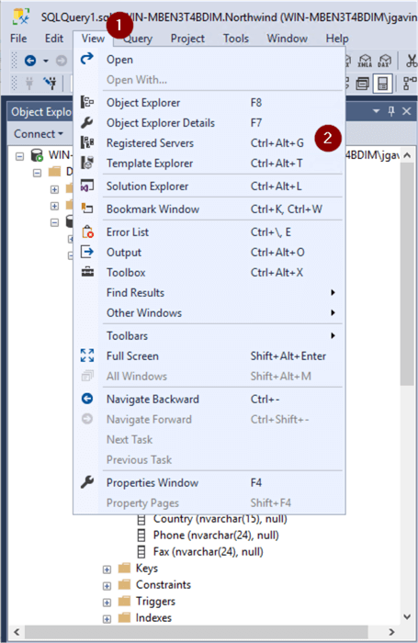
- Right click on Local Server Groups
- New Server Group…
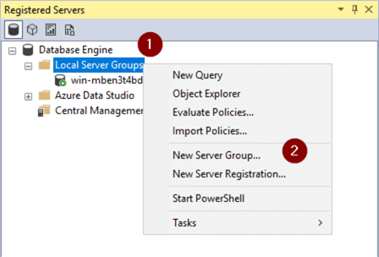
- Name Group and optionally add a Description
- OK
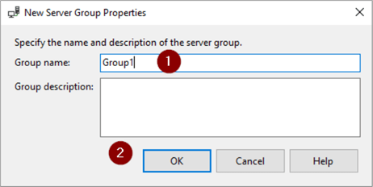
- Enter Server name
- Test
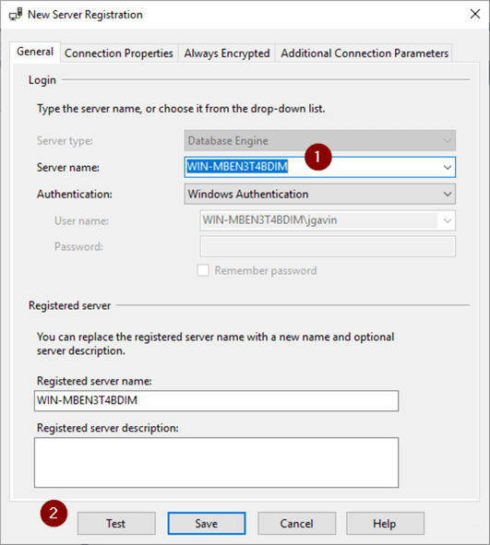
Verify test was successful.
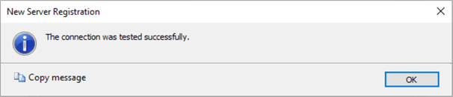
- Save
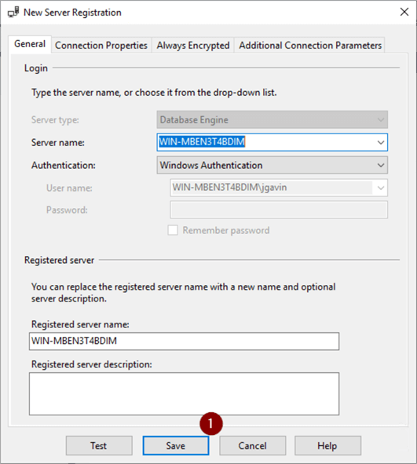
If you’re adding a significant number of Groups and / or SQL Servers to Registered Servers, it’s a good idea to back up the file that holds them.
- Right click on top group
- Tasks
- Export…
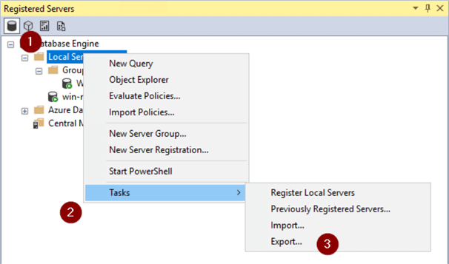
- Browse to directory and enter file name
- OK
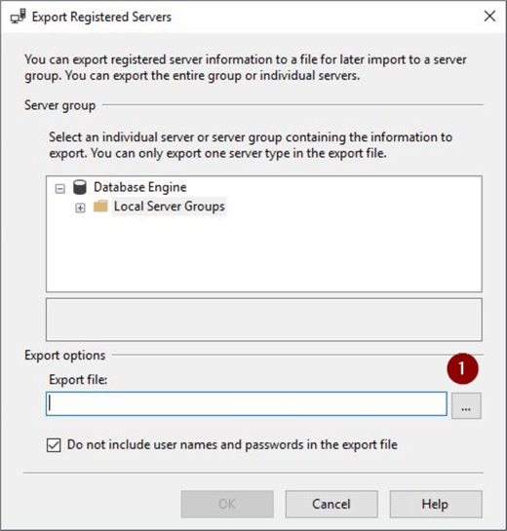
- Choose directory and enter file name
- Save
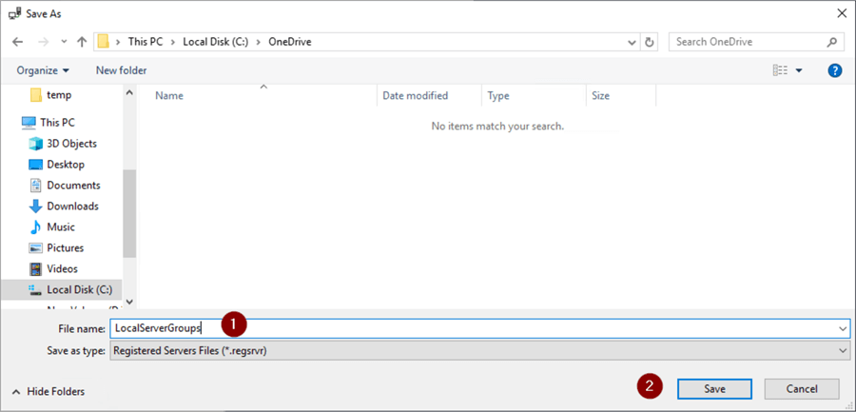
- OK
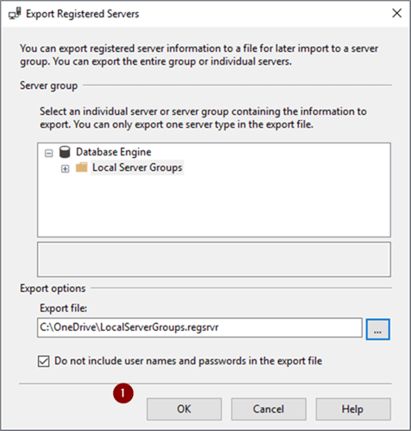

Block Highlighting in Query Window
If you’ve ever had a vertical block of text to edit you’ve probably asked if there is an easy way to do that. The answer is yes, there is.
Place the cursor where you want to begin. Hold the Shift and Alt keys and then highlight area to edit with the arrow keys or mouse to highlight a block.
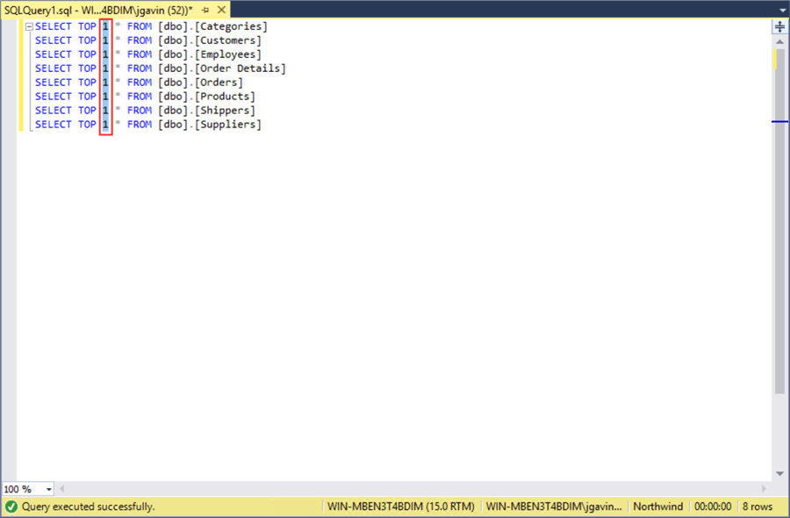
Enter or paste text into block just once to change every line in one action.
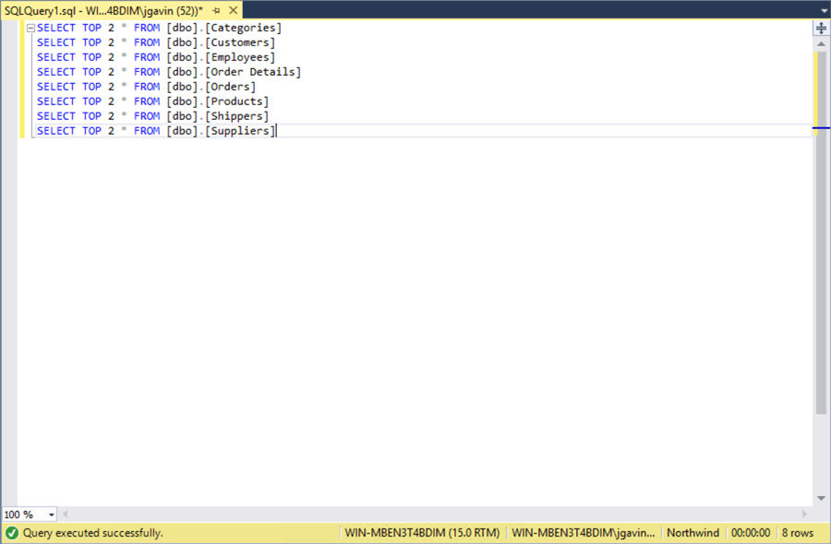

Switch Query Tabs in SSMS
It’s not uncommon to have quite a few Query Windows open at the same time. Clicking through them can become harder as the tabs get smaller as more windows are opened. Ctrl + Tab will open a window with a list of Query Windows.
Continue to Ctrl + Tab until you land on the Query Window you want. And Ctrl + Shift + Tab will move through the list in reverse.
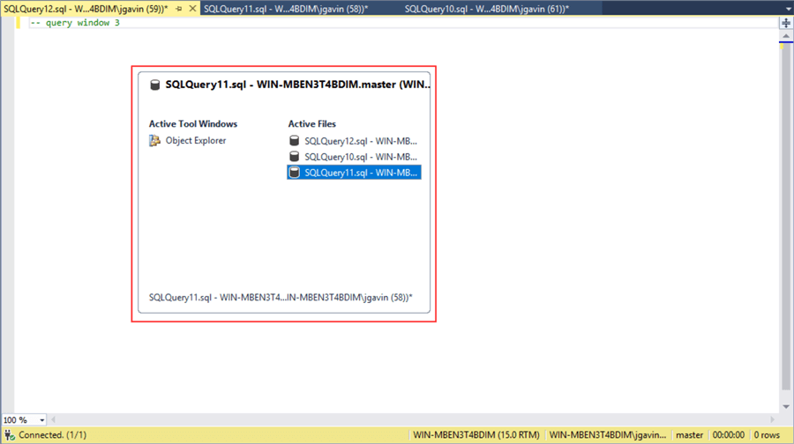

Upper Case and Lower Case Text in SSMS
It’s easy to make text all upper or lower case.
This screenshot shows an ‘EXEC sp_helpdb’ that was typed in using the shift key, but caps lock was on.
There is no need to retype it. Simply highlight the lower case text you want to change and Ctrl + Shift + U to make it all upper case. Highlight the upper case text to change and Ctrl + Shift + L to make it lower case.
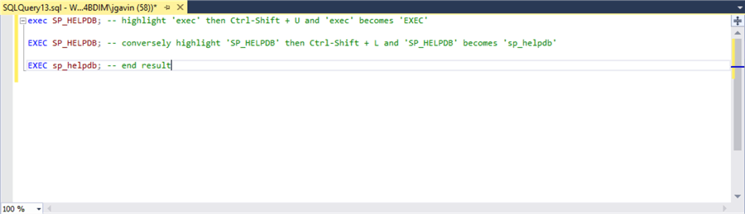

Cycle Clipboard Ring in SSMS
Here I’ve separately cut 3 lines of text. We know a Ctrl + V will paste the last line. What if I want to paste a line from the clipboard that wasn’t the last line?
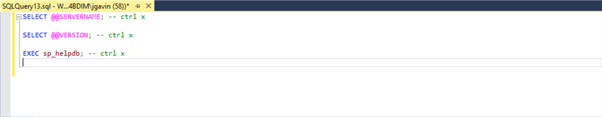
Ctrl + Shift + V will cycle through each line in the clipboard you get the one you want.
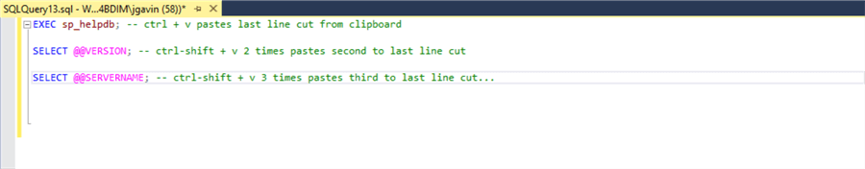

Database Dropdown in SSMS
If you want to change your database context from the dropdown it’s easy enough to click on it and select. A quicker way is to use a hotkey combination. Ctrl + U will bring you directly to the box where you can arrow up and down arrow keys to select your database. This is handy if you’re connected to an Azure SQL Database server and can’t use a ‘USE database_name;’.
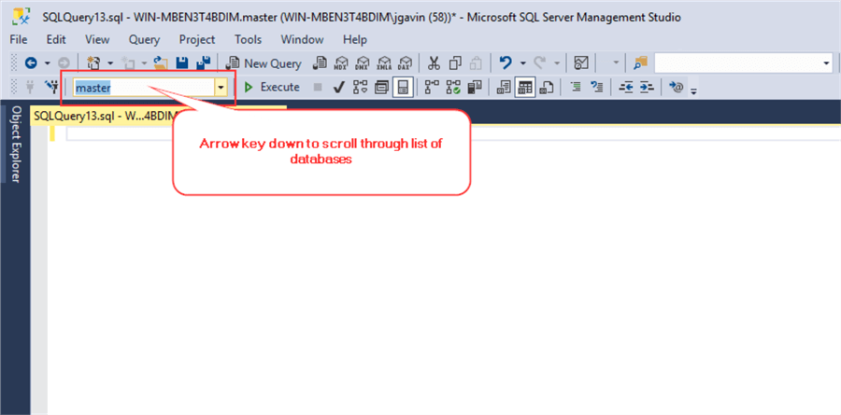

Switch between Results and Messages Tabs
Rather than mouse click on the Results and Messages tabs you can use the F6 key to switch back and forth between them.
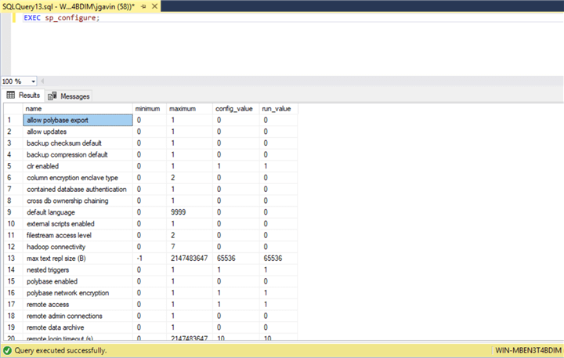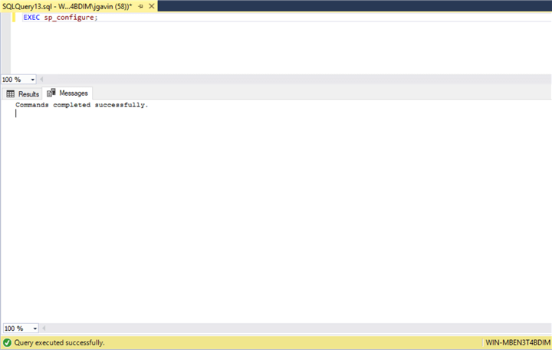

Comment and Uncomment Selected Text
SSMS gives you the ability to comment and uncomment highlighted text.
For this example, we have two simple queries and want to comment the first one out to be sure we don’t run it.
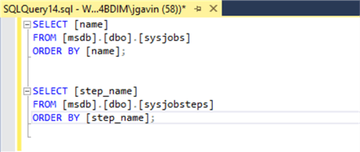
Highlight the first query’s text, then Ctrl + K + C to comment each line out. To uncomment, it’s a Ctrl + K + U.
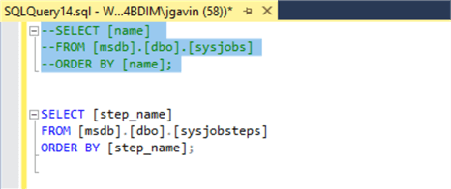

Open Integrated Web Browser in SSMS
It’s not as full featured and you won’t get the same experience as you would using a regular browser but sometimes it’s handy to have a browser within SSMS to avoid the visual distraction of switching applications. Ctrl + Alt + R will open it in an SSMS tab. You can Ctrl + Tab between it and your Query Windows.
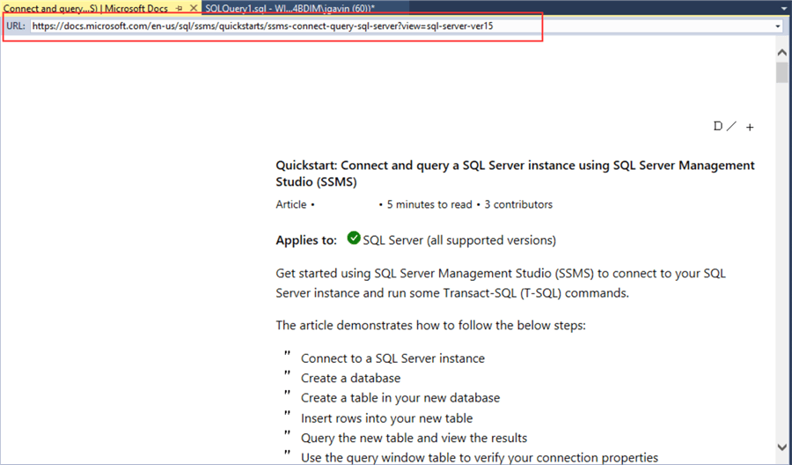

Hotkeys in SSMS
Following is a list of hotkey related actions shown above and their associated hotkey as a reference. See links below for more articles on SSMS shortcuts.
Action | Hotkey Combination
Block Highlighting in the Query Window | Shift + Alt + Arrow keys
Switch Query Tabs | Ctrl + Tab / Ctrl + Shift + Tab
Upper Case and Lower Case Text | Ctrl + Shift + U / Ctrl + Shift + L
Cycle Clipboard Ring | Ctrl + Shift + V
Use Database Dropdown | Ctrl + U
Switch between Results and Messages Tabs | F6
Comment and Uncomment Selected Text | Ctrl + K + C / Ctrl + K + U
Open Integrated Web Browser | Ctrl + Alt + R

