Supplementary Materials

Supplementary Figures

Figure S1: Distribution of solving times (i.e. time from landing to extracting nectar on novel flowers). Dashed line indicates the median.
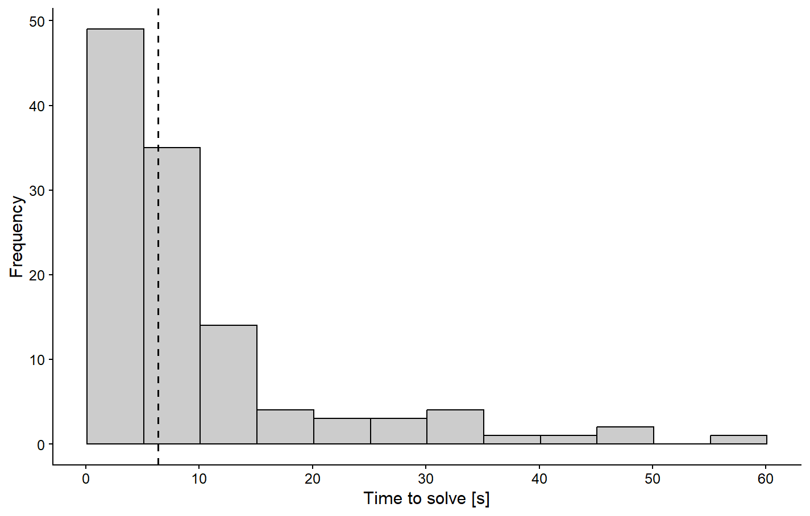

Figure S2: Time to give up (from landing to leaving flower without extracting reward) in the four innovation trials. Sample sizes (number of bees, shown on x-axis) are small since few bees failed to solve, i.e. extract reward (see also Table S4).
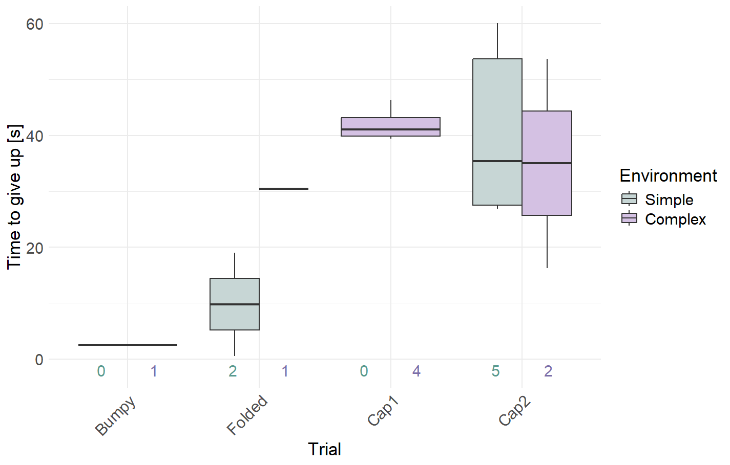

Figure S3. Relationships between individual traits and behavioral outcomes. Each panel shows the association between a bee’s trait (columns) and the proportion of trials in which bees landed on (top row) or solved (bottom row) a novel flower. Lines show linear model fits. Only search time significantly predicted the probability of landing or solving (Landing: p = 0.273, <0.0001, 0.754, 0.245, 0.93, 0.26, respectively; Solving: p = 0.11, 0.001, 0.10, 0.16, 0.27, respectively). All models: land or solve ~ trait.
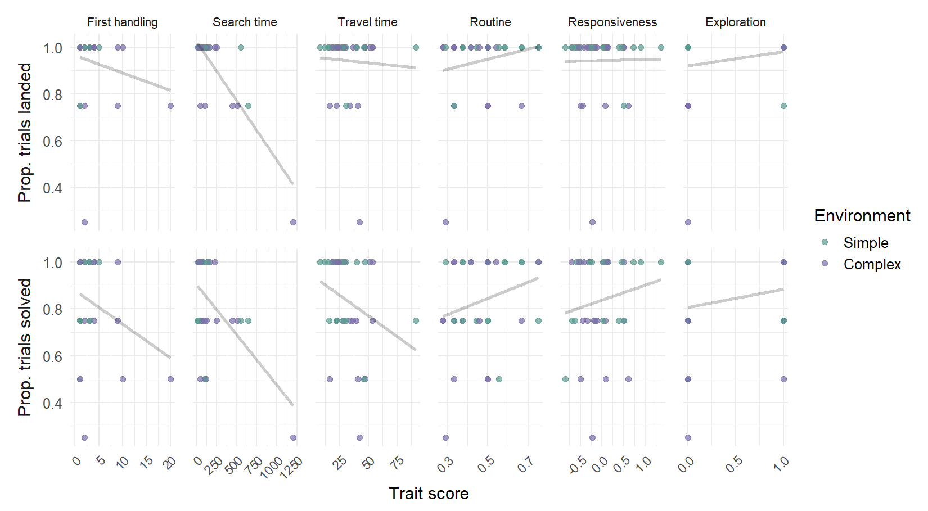

Supplementary Tables

Table S1: Effect of environment and trial on probability of landing on a novel flower.

 | Effect on landing on novel flower
Predictors | Odds Ratios | CI | p
Intercept | 33.82 | 6.30 – 646.19 | 0.001
Environment (complex vs simple) | 0.11 | 0.01 – 0.69 | 0.048
Trial (Folded vs Bumpy) | 4.68 | 0.62 – 96.27 | 0.185
Trial (Cap1 vs Bumpy) | 39475747.11 | 0.00 – NA | 0.992
Trial (Cap2 vs Bumpy) | 1.41 | 0.27 – 8.01 | 0.681
Observations | 140
R² Tjur | 0.093

Table S2: Effect of environment and trial on probability of solving a novel flower.

Effect on solving novel flower
Predictors | Odds Ratios | CI | p
Intercept | 35.79 | 6.87 – 668.15 | 0.001
Environment (complex vs simple) | 0.70 | 0.22 – 2.12 | 0.525
Trial (Folded vs Bumpy) | 0.35 | 0.02 – 2.88 | 0.370
Trial (Cap1 vs Bumpy) | 0.26 | 0.01 – 1.89 | 0.242
Trial (Cap2 vs Bumpy) | 0.12 | 0.01 – 0.73 | 0.053
Observations | 132
R² Tjur | 0.044

Table S3: Effect of environment and trial (and their interaction) on the time to solving a novel flower. Note that the response variable is log(time).

 | Effect on time to solve (reach reward) on novel flower
Predictors | Estimates | CI | p
Intercept | 1.26 | 0.91 – 1.61 | <0.001
Environment (complex vs simple) | 0.17 | -0.36 – 0.71 | 0.515
Trial (Folded vs Bumpy) | -0.03 | -0.53 – 0.47 | 0.906
Trial (Cap1 vs Bumpy) | 1.17 | 0.68 – 1.66 | <0.001
Trial (Cap2 vs Bumpy) | 1.22 | 0.69 – 1.75 | <0.001
Env x Trial (Folded) | -0.50 | -1.24 – 0.24 | 0.182
Env x Trial (Cap1) | -0.03 | -0.78 – 0.71 | 0.927
Env x Trial (Cap2) | -0.19 | -0.97 – 0.60 | 0.638
Observations | 117
R² / R² adjusted | 0.466 / 0.432

Table S4: Effect of environment and trial on the time to abandoning a flower, i.e. the time from landing to leaving the flower for bees who did not manage to access reward. Note that because of the very small sample size, we did not include interactions. Here, the response variable is time (not log(time) ). We only include this result for completeness.

 | Effect on the time to abandon a flower without solving
Predictors | Estimates | CI | p
Intercept | -0.14 | -39.84 – 39.56 | 0.994
Environment (complex vs simple) | 2.68 | -19.88 – 25.25 | 0.796
Trial (Folded vs Bumpy) | 39.44 | 2.92 – 75.96 | 0.037
Trial (Cap1 vs Bumpy) | 38.44 | -0.02 – 76.90 | 0.050
Trial (Cap2 vs Bumpy) | 15.93 | -24.68 – 56.53 | 0.403
Observations | 15
R² / R² adjusted | 0.519 / 0.327

Table S5: Effect of handling time in the first flower of the first trial (trial 1) on ‘innovation’, i.e. handling time (=solving time) on novel complex flowers (response variable is log(time) ).

 | Effect on solving time
Predictors | Estimates | CI | p
Intercept | 1.15 | 0.83 – 1.47 | <0.001
First handling time | 0.31 | -0.01 – 0.63 | 0.059
Trial (Folded vs Bumpy) | -0.06 | -0.51 – 0.39 | 0.795
Trial (Cap1 vs Bumpy) | 1.21 | 0.76 – 1.67 | <0.001
Trial (Cap2 vs Bumpy) | 1.04 | 0.55 – 1.53 | <0.001
First hand x Trial (Folded) | -0.34 | -0.79 – 0.10 | 0.132
First hand x Trial (Cap1) | -0.11 | -0.57 – 0.35 | 0.640
First hand x Trial (Cap2) | 0.10 | -0.38 – 0.58 | 0.677
Observations | 117
R² / R² adjusted | 0.502 / 0.471

Table S6: Effect of search time in trials 6 & 7 (the Bumpy & Folded flowers) on time to solving flowers in all trials (6, 7, 8a, 8b) (response variable is log(time) ).

 | Effect on solving time
Predictors | Estimates | CI | p
Intercept | 0.77 | -0.43 – 1.97 | 0.206
Search time on B&F | 0.14 | -0.15 – 0.43 | 0.342
Trial (Folded vs Bumpy) | 0.37 | -1.24 – 1.98 | 0.646
Trial (Cap1 vs Bumpy) | 1.49 | -0.05 – 3.03 | 0.058
Trial (Cap2 vs Bumpy) | 1.84 | 0.14 – 3.55 | 0.034
Search x Trial (Folded) | -0.16 | -0.54 – 0.22 | 0.416
Search x Trial (Cap1) | -0.09 | -0.45 – 0.27 | 0.635
Search x Trial (Cap2) | -0.17 | -0.57 – 0.22 | 0.392
Observations | 117
R² / R² adjusted | 0.461 / 0.426

Table S7: Effect of travel time (average over trials 2, 3, and 4) on ‘solving time’ (i.e. handling time in the innovation trials, 6, 7, 8a and 8b) (response variable is log(time) ).

 | Effect on solving time
Predictors | Estimates | CI | p
Intercept | -0.69 | -2.39 – 1.01 | 0.422
Travel in trial 2-4 | 0.61 | 0.11 – 1.12 | 0.018
Trial (Folded vs Bumpy) | 3.03 | 0.62 – 5.45 | 0.014
Trial (Cap1 vs Bumpy) | 2.66 | 0.22 – 5.09 | 0.033
Trial (Cap2 vs Bumpy) | 4.25 | 1.63 – 6.88 | 0.002
Travel x Trial (Folded) | -1.00 | -1.72 – -0.27 | 0.007
Travel x Trial (Cap1) | -0.45 | -1.18 – 0.27 | 0.219
Travel x Trial (Cap2) | -0.94 | -1.73 – -0.16 | 0.019
Observations | 117
R² / R² adjusted | 0.498 / 0.466

Table S8: Effect of routine formation (SRI index, see Methods) on solving time (response variable is log(time) ).

 | Effect on solving time
Predictors | Estimates | CI | p
Intercept | 0.18 | -0.79 – 1.15 | 0.720
SRI (Routine formation) | 2.39 | 0.46 – 4.31 | 0.016
Trial (Folded vs Bumpy) | 0.56 | -0.77 – 1.90 | 0.406
Trial (Cap1 vs Bumpy) | 2.46 | 1.14 – 3.77 | <0.001
Trial (Cap2 vs Bumpy) | 1.84 | 0.45 – 3.22 | 0.010
SRI x Trial (Folded) | -1.69 | -4.34 – 0.96 | 0.208
SRI x Trial (Cap1) | -2.68 | -5.30 – -0.06 | 0.045
SRI x Trial (Cap2) | -1.41 | -4.17 – 1.36 | 0.316
Observations | 117
R² / R² adjusted | 0.491 / 0.458

Table S9: Effect of responsiveness (see Methods) on solving time (response variable is log(time) ).

 | Effect on solving time
Predictors | Estimates | CI | p
Intercept | 1.32 | 1.06 – 1.58 | <0.001
Responsiveness | -0.39 | -0.88 – 0.11 | 0.125
Trial (Folded vs Bumpy) | -0.25 | -0.62 – 0.11 | 0.176
Trial (Cap1 vs Bumpy) | 1.16 | 0.80 – 1.53 | <0.001
Trial (Cap2 vs Bumpy) | 1.15 | 0.76 – 1.54 | <0.001
resp x Trial (Folded) | 0.72 | 0.01 – 1.43 | 0.047
resp x Trial (Cap1) | 0.25 | -0.45 – 0.96 | 0.479
resp x Trial (Cap2) | 0.64 | -0.12 – 1.41 | 0.099
Observations | 117
R² / R² adjusted | 0.479 / 0.446

Table S10: Effect of exploration (see Methods) on solving time (response variable is log(time) ).

 | Effect on solving time
Predictors | Estimates | CI | p
Intercept | 1.23 | 0.91 – 1.56 | <0.001
Exploration | 0.28 | -0.26 – 0.82 | 0.309
Trial (Folded vs Bumpy) | -0.00 | -0.47 – 0.46 | 0.996
Trial (Cap1 vs Bumpy) | 1.21 | 0.74 – 1.67 | <0.001
Trial (Cap2 vs Bumpy) | 1.27 | 0.76 – 1.77 | <0.001
Expl x Trial (Folded) | -0.70 | -1.45 – 0.06 | 0.071
Expl x Trial (Cap1) | -0.15 | -0.91 – 0.60 | 0.690
Expl x Trial (Cap2) | -0.33 | -1.12 – 0.46 | 0.411
Observations | 117
R² / R² adjusted | 0.473 / 0.439

