Supplementary Material S1
From Pedagogical Refuge to Status Showcase: The Child’s Room in Turkish Design Media after 1980 — A Longitudinal Visuo-Textual Analysis of AD (Art Decor), 1993–2005
The table lists every record in the inventory with its bibliographic data, harmonized genre and format, the material indicators completed from the archived scans, and the original Turkish headline with an English translation. Thumbnails reproduce the archived pages (47 images, records 24–46). The coded dataset, color measurements and issue-level index measures are provided in Supplementary Data S1 (Excel).
Table S1. Record-level analysis of child-room content in AD (Art Decor), 1993–2005 (n = 46).
No. / source | Visual reference | Genre / format | Indicators (from scans) | Headline / slogan (original; English translation)
1  June 1993  issue 3  pp. 44, 45 | — | Design page  editorial  [source label: Düzenleme (Arrangement)] | No archived scan; coded from headline only. | “Renkli, sevimli ve pratik iki tasarım: Çocuklara Özel”  [Colorful, cute and practical—two designs: special for children]
2  June 1993  issue 3  pp. 46, 48, 50, 52, 54, 56 | — | Promotion & advertising  product round-up / advertorial  [source label: Odalar ve Reklamlar (Rooms and advertisements)] | No archived scan; coded from headline only. | “Tasarımları, malzemeleri, renkleri ve firmalarıyla çocuk odaları”  [Children’s rooms with their designs, materials, colors and firms]
3  June 1993  issue 3  pp. 57 | — | Design page  editorial  [source label: Eğitim (Education)] | No archived scan; coded from headline only. | “Görünüm danışmanı Sedef Betil: Her Rengin Bir Mesajı Var”  [Appearance consultant Sedef Betil: every color has a message]
4  June 1993  issue 3  pp. 60–62 | — | Design page  editorial  [source label: Tasarım (Design)] | No archived scan; coded from headline only. | “Mimarların senaryoları ve tercihleriyle “Bir Mekân, Dört Çizgi””  [With architects’ scenarios and preferences: “One space, four lines”]
5  March 1994  issue 12  pp. 82, 84 | — | Design page  editorial  [source label: Tasarım (Design)] | No archived scan; coded from headline only. | “Dar mekânlar için tasarladığımız çok işlevli ve eğlenceli “Çocuk Odası Mobilyaları””  [Multifunctional and fun “children’s room furniture” we designed for small spaces]
6  June 1994  issue 15  pp. 16–17 | — | House feature  editorial  [source label: Mekânlar (Spaces)] | No archived scan; coded from headline only. | “Bursa’ya 18 km uzakta, Bademli’deki bahçeli evde Modern Yaklaşımlar”  [Modern approaches in a house with a garden in Bademli, 18 km from Bursa]
7  1994  issue 16–17  pp. 37 | — | House feature  editorial  [source label: Mekânlar (Spaces)] | No archived scan; coded from headline only. | “Uludağ eteklerinde modern, sade ve şık... Çekirge’de Daire”  [Modern, plain and chic at the foot of Uludağ… a flat in Çekirge]
8  1994  issue 21  pp. 44, 46, 48, 50, 52, 54, 56, 58, 60, 62, 64 | — | Promotion & advertising  product round-up / advertorial  [source label: Piyasa (Market)] | No archived scan; coded from headline only. | “Pratik, sevimli ve şık modelleriyle: Bebek ve Çocuk Mobilyaları”  [With practical, cute and chic models: baby and children’s furniture]
9  1994  issue 21  pp. 65 | — | Promotion & advertising  paid advertisement  [source label: Reklam (Advertisement)] | No archived scan; coded from headline only. | “Bu Dünya Çocuklarımızın...”  [This world belongs to our children…]
10  1994  issue 21  pp. 66, 68, 70, 72 | — | Promotion & advertising  product round-up / advertorial  [source label: Piyasa (Market)] | No archived scan; coded from headline only. | “Zengin renk, desen, malzeme seçenekleriyle eğitici ve eğlendirici ürünler: Çocuk odalarına özel”  [Educational and entertaining products with rich color, pattern and material options: special for children’s rooms]
11  1994  issue 21  pp. 76, 77 | — | Design page  editorial  [source label: Tasarım (Design)] | No archived scan; coded from headline only. | “Çocuklarınız için AD’den özel bir tasarım... Oyuncak Dolabı”  [A special design from AD for your children… a toy cupboard]
12  1995  issue 22  pp. 36 | — | House feature  editorial  [source label: Mekânlar (Spaces)] | No archived scan; coded from headline only. | “Çiftehavuzlar’da dubleks daire: Noel’i Kutlayan Ev”  [A duplex in Çiftehavuzlar: the house that celebrates Christmas]
13  1995  issue 23  pp. 18, 36, 37, 38, 39 | — | House feature  editorial  [source label: Posta, Mekânlar (News, Spaces)] | No archived scan; coded from headline only. | “İstanbul’un 2. Ulus semtinde Yannierler’in dubleksi: Tezatların Sentezi”  [The Yannier family’s duplex in Istanbul’s 2nd Ulus: a synthesis of contrasts]
14  1995  issue 24  pp. 23, 147 | — | Promotion & advertising  paid advertisement  [source label: Reklam (Advertisement)] | No archived scan; coded from headline only. | “Mobilya Reklamı”  [Furniture advertisement]
15  1996  issue 35  pp. 49 | — | House feature  editorial  [source label: Mekânlar (Spaces)] | No archived scan; coded from headline only. | “Marmara Denizi’ne ve adalara tepeden bakış: Konforlu ve Rahat”  [Overlooking the Sea of Marmara and the islands: comfortable and relaxed]
16  1996  issue 35  pp. 92 | — | Promotion & advertising  product round-up / advertorial  [source label: Piyasa (Market)] | No archived scan; coded from headline only. | “Yorgun yatıp keyifli ve dinç kalkmanız için piyasanın seçenekleri: Yatak Odası Takımları”  [The market’s options so that you go to bed tired and wake up cheerful and fresh: bedroom suites]
17  1996  issue 37  pp. 148–150, 152, 154, 156 | — | Promotion & advertising  product round-up / advertorial  [source label: Piyasa (Market)] | No archived scan; coded from headline only. | “Mobilyaları, titizlikle seçilen renkleri ve dinamizmleriyle... Genç Odaları”  [With their furniture, carefully chosen colors and dynamism… teenagers’ rooms]
18  1996  issue 38  pp. 39 | — | House feature  editorial  [source label: Mekânlar (Spaces)] | No archived scan; coded from headline only. | “Ulus sırtlarından Boğaziçi’ne... Şeffaf Villa Katı”  [From the Ulus ridges to the Bosphorus… a transparent villa floor]
19  1996  issue 40–41  pp. 36 | — | Promotion & advertising  product round-up / advertorial  [source label: Posta (News)] | No archived scan; coded from headline only. | “Letto’da bebek ve çocuk mobilyaları”  [Baby and children’s furniture at Letto]
20  1996  issue 40–41  pp. 36 | — | Promotion & advertising  product round-up / advertorial  [source label: Posta (News)] | No archived scan; coded from headline only. | “Anne adayları ve çocuklar için her şey”  [Everything for mothers-to-be and children]
21  1996  issue 40–41  pp. 212, 214, 220 | — | Promotion & advertising  product round-up / advertorial  [source label: Piyasa (Market)] | No archived scan; coded from headline only. | “Dudullu’daki Mobilyacılar Sitesi’ni sizin için dolaştık: Modoko’dan seçtiklerimiz”  [We toured the Dudullu furniture district for you: our picks from Modoko]
22  1996  issue 40–41  pp. 229 | — | Promotion & advertising  paid advertisement  [source label: Reklam (Advertisement)] | No archived scan; coded from headline only. | “Laminat Parke Reklamı”  [Laminate parquet advertisement]
23  1997  issue 46  pp. 48–49 | — | House feature  editorial  [source label: Mekânlar (Spaces)] | No archived scan; coded from headline only. | “Salonda odaklanan yaşama mekânı: Ulus’ta dubleks”  [A living space centered on the salon: a duplex in Ulus]
24  April 1997  issue 49  pp. 86–88, 90, 92, 94, 96, 98, 100 | 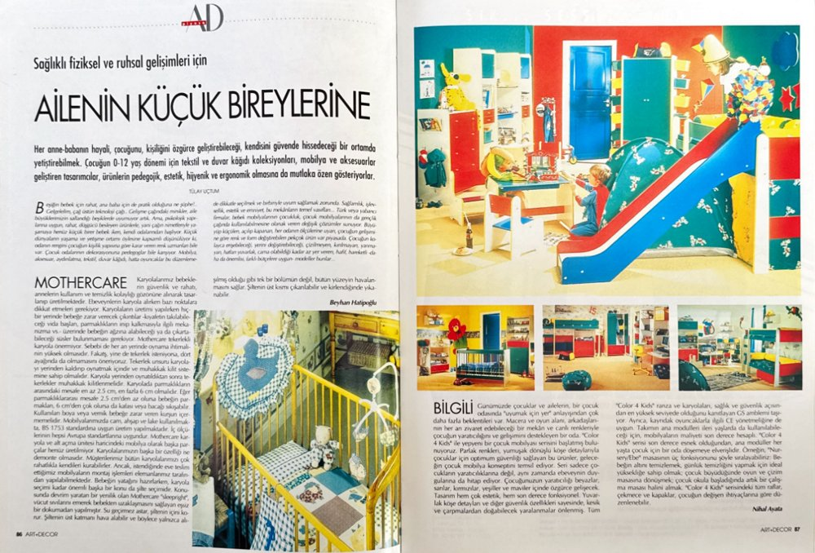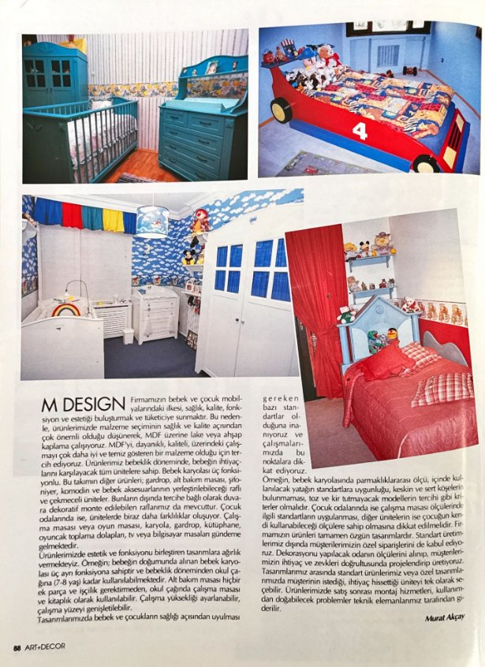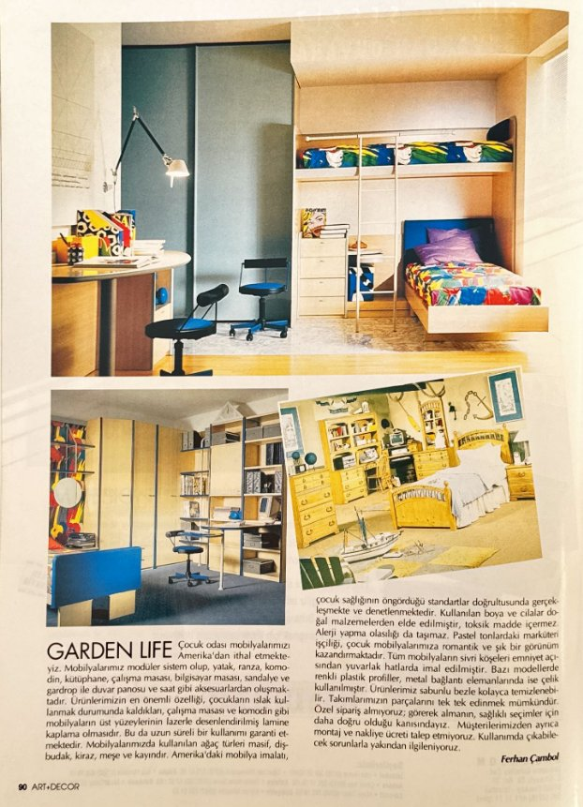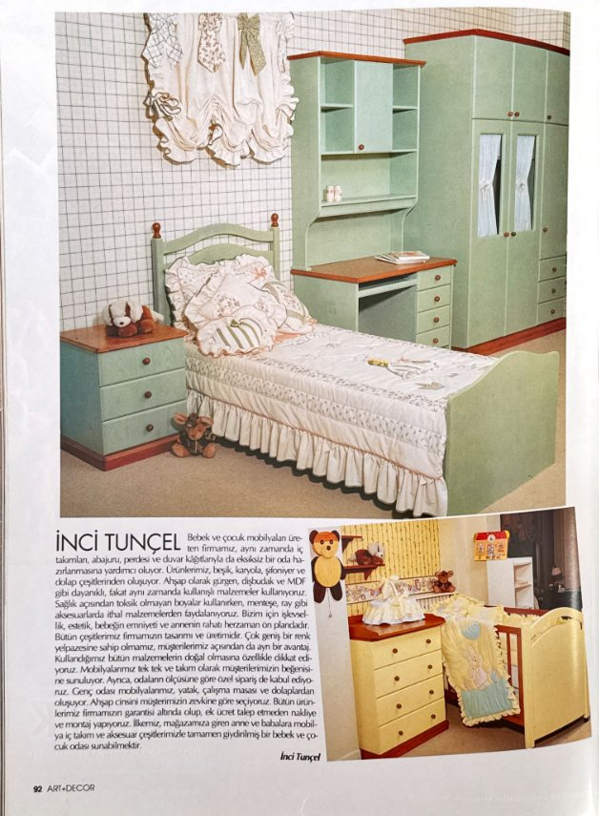  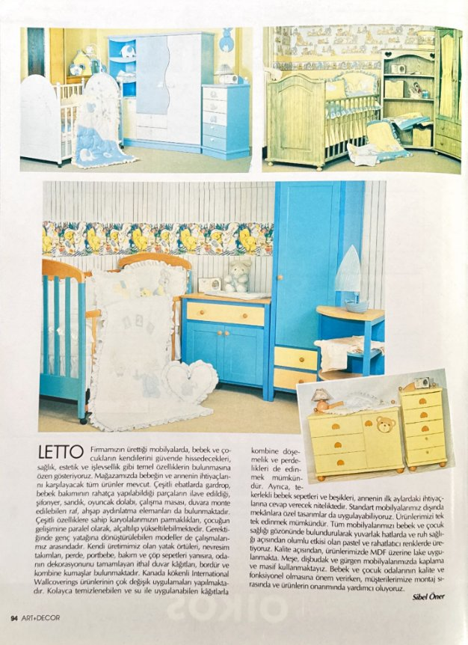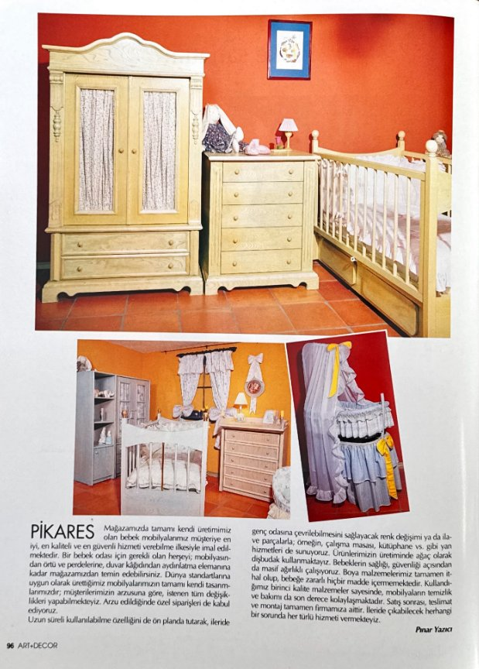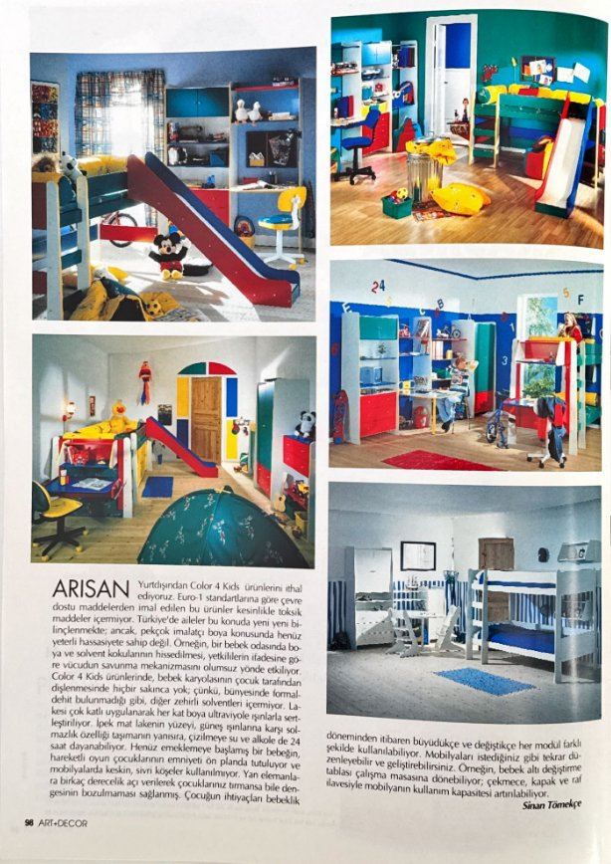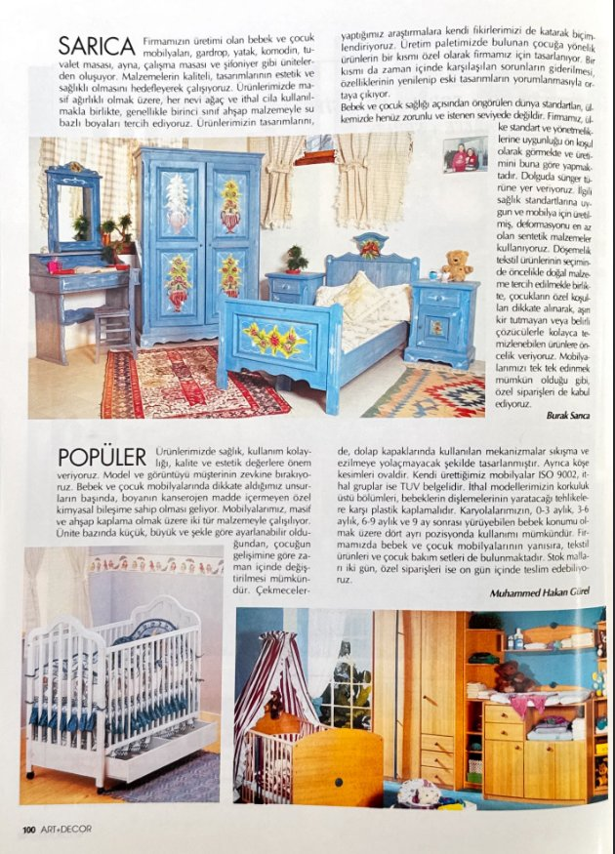 | Promotion & advertising  product round-up / advertorial  [source label: Tanıtım ve Reklamlar (Promotion and advertisements)] | Bed: cot, bunk, car-bed, slide play-bed  Floor: carpet, fitted carpet, parquet  Technology: computer/study desk  Brands: Mothercare, M Design, Garden Life, İnci Tunçel, Letto, Pikares, Arısan, Sarıca, Popüler  Theme: play park, racing car, country  Gender code: mixed (primary colors; pastel nurseries) | “Sağlıklı fiziksel ve ruhsal gelişimleri için Ailenin Küçük Bireylerine”  [To the family’s little individuals, for their healthy physical and mental development]
25  December 1998  issue 69  pp. 100, 102, 104, 106, 108, 110, 112, 114, 116, 118, 120 | 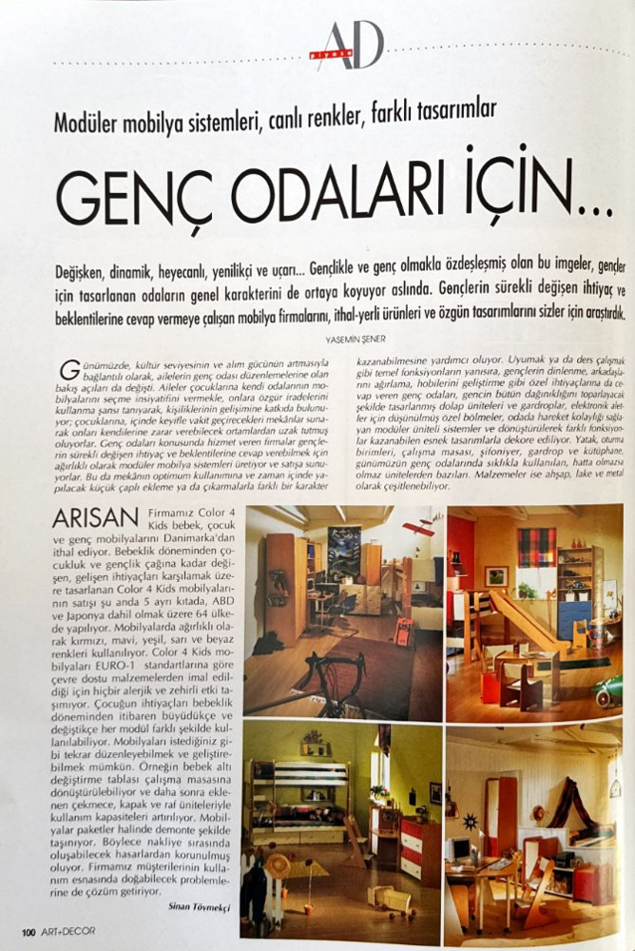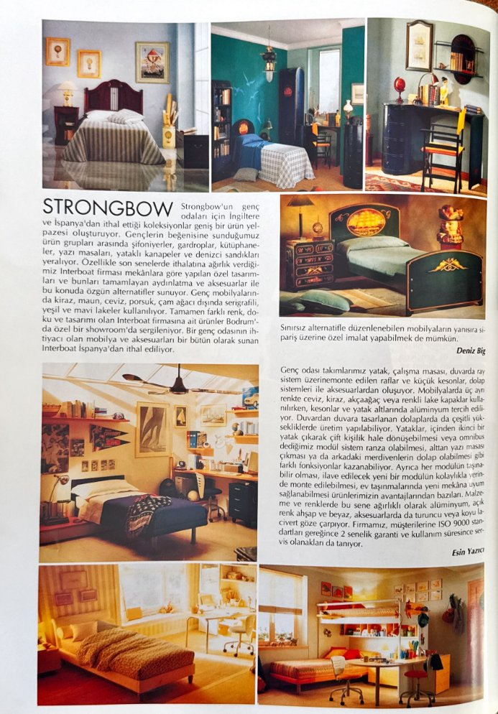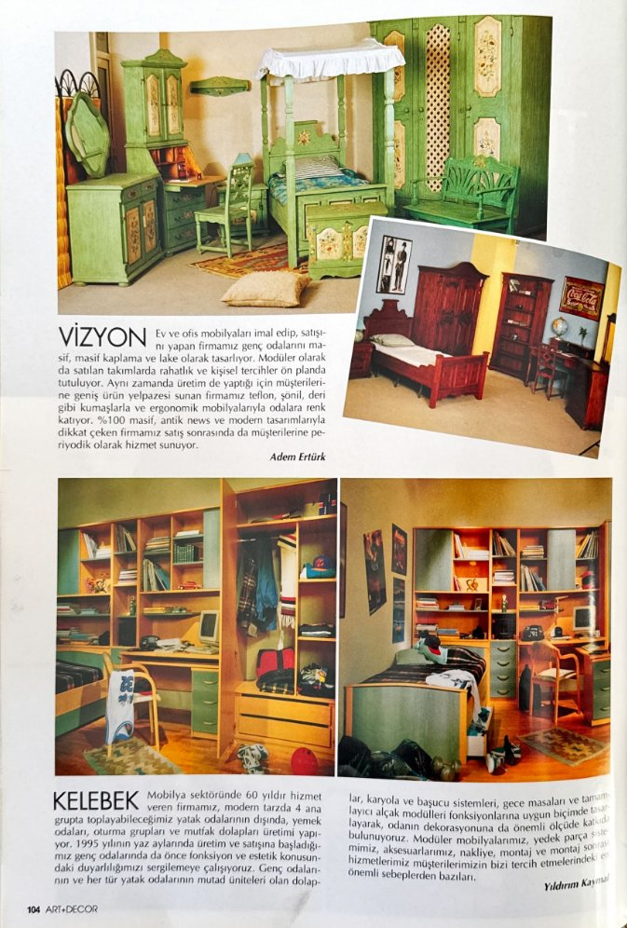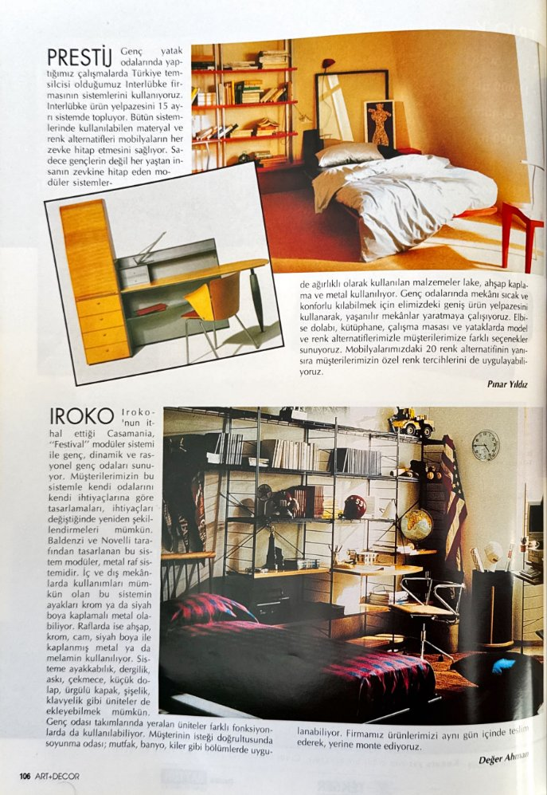  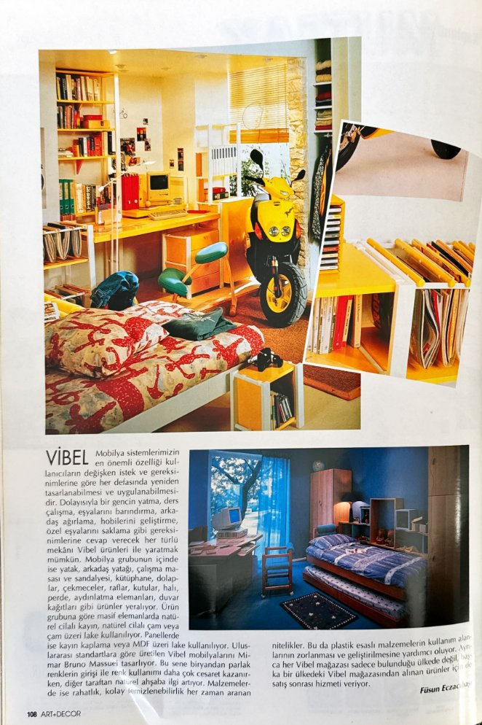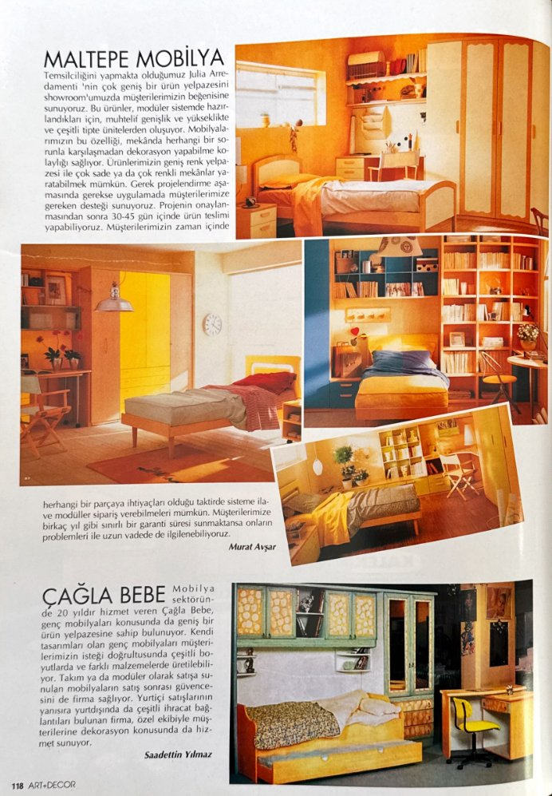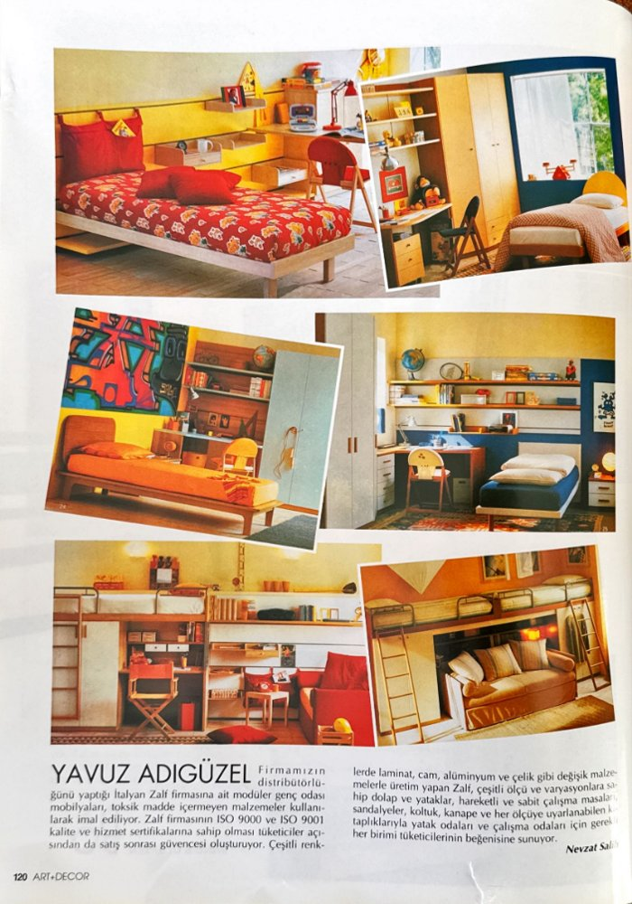 | Promotion & advertising  product round-up / advertorial  [source label: Tanıtım ve Reklamlar (Promotion and advertisements)] | Bed: modular bed, bunk, sofa-bed  Floor: parquet, kilim  Technology: computer; motorcycle prop  Brands: Arısan (Color 4 Kids), Strongbow, Vizyon, Kelebek, Prestij (Interlübke), Iroko (Casamania), Vibel, Maltepe, Çağla Bebe, Yavuz Adıgüzel (Zalf)  Theme: dynamic/modular teen room  Gender code: neutral–masculine | “Modüler mobilya sistemleri, canlı renkler, farklı tasarımlar: Genç Odaları İçin...”  [Modular furniture systems, vivid colors, different designs: for teenagers’ rooms…]
26  August 2001  issue 101  pp. 62–69 | 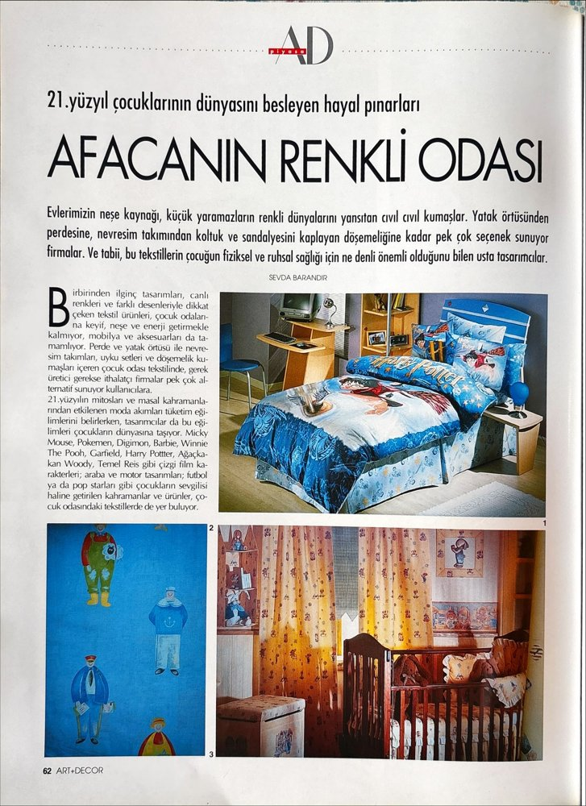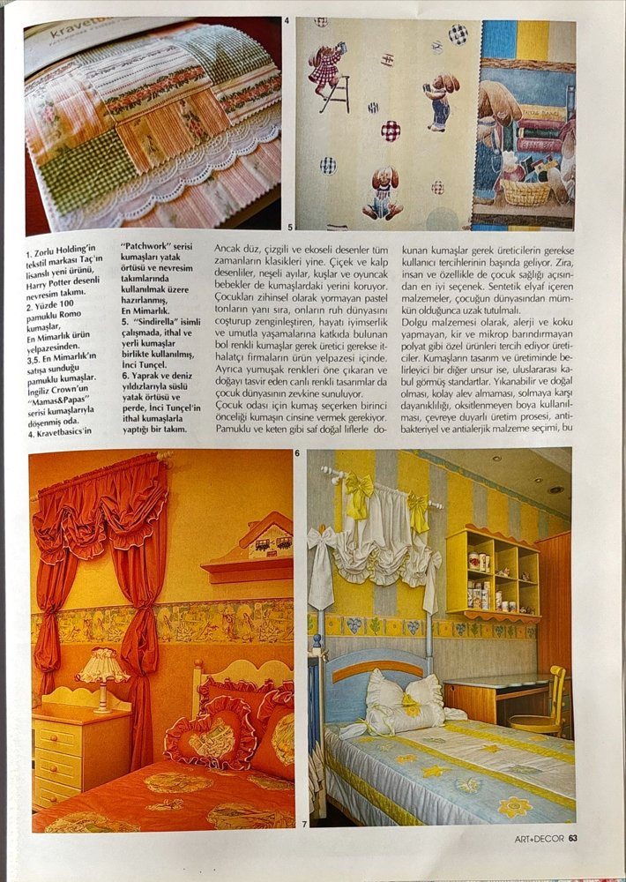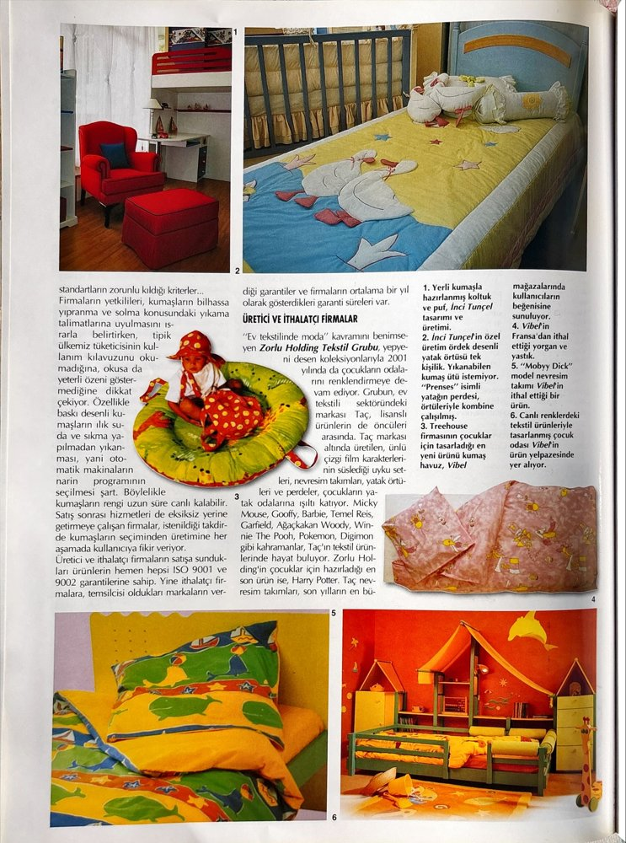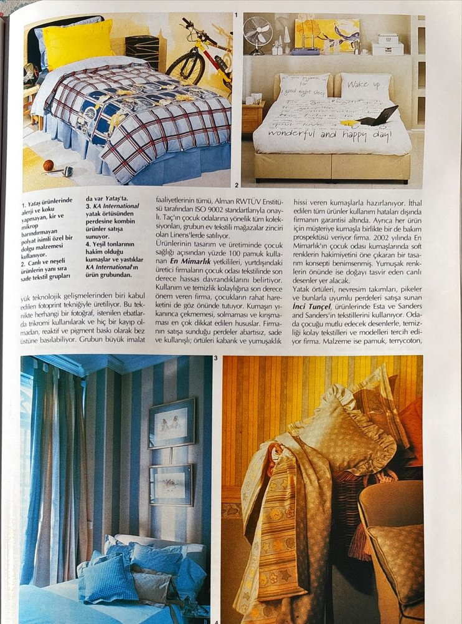  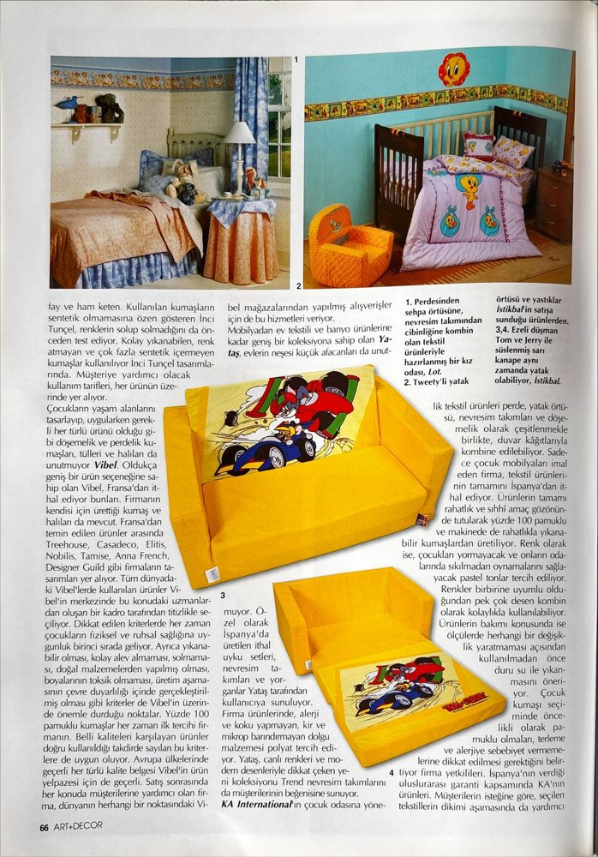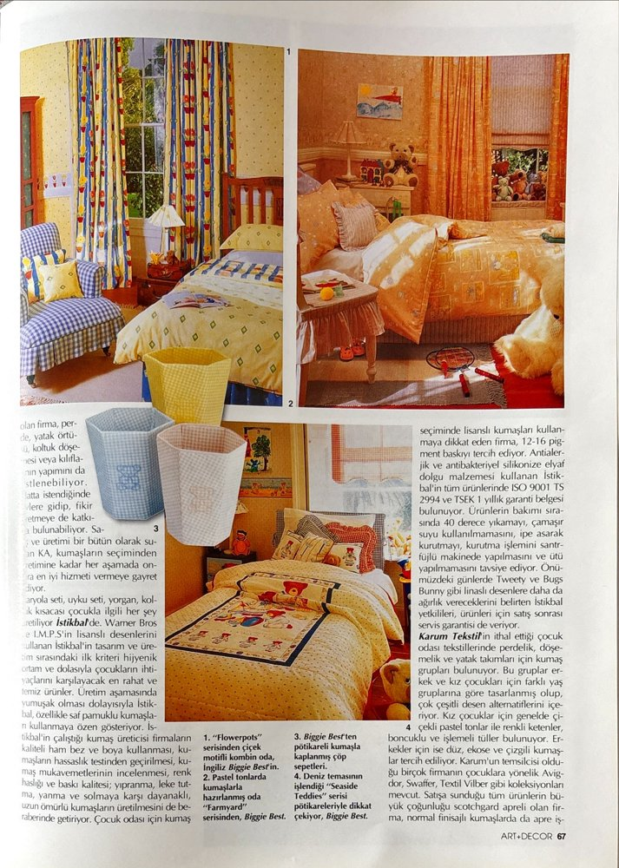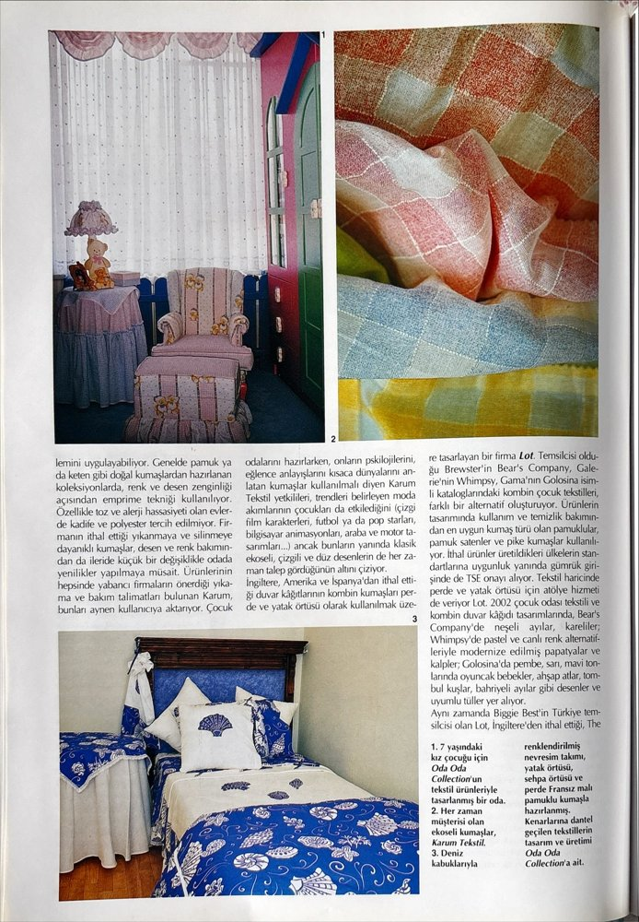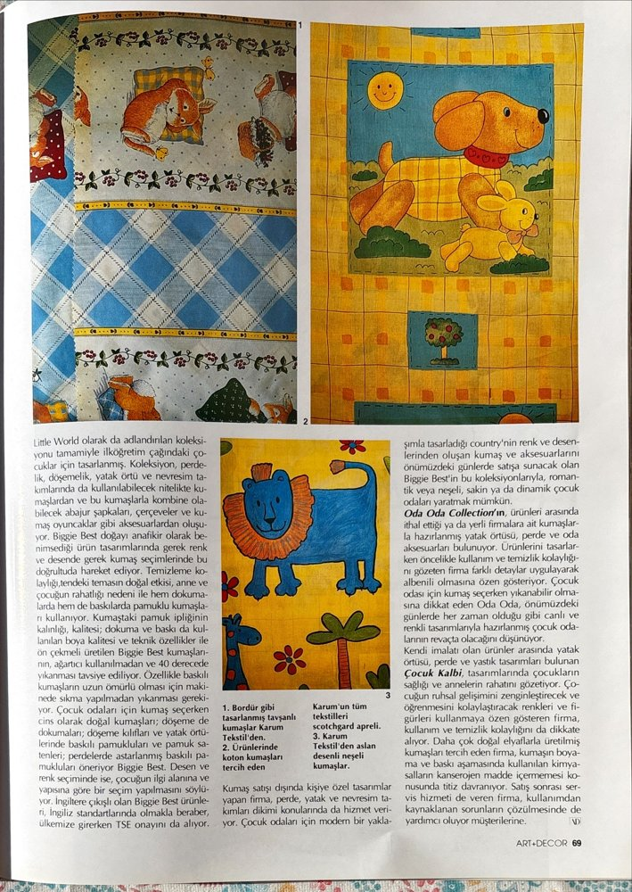 | Promotion & advertising  product round-up / advertorial  [source label: Tanıtım ve Reklamlar (Promotion and advertisements)] | Bed: textile-led (bedlinen, covers, curtains)  Floor: carpet  Technology: —  Brands: Taç (Zorlu), Vibel, Karum, Biggie Best, KA International  Theme: licensed characters (Mickey Mouse, Pokémon, Digimon, Barbie, Winnie the Pooh, Harry Potter)  Gender code: mixed; pink/blue lines | “Afacanın Renkli Odası”  [The rascal’s colorful room]
27  August 2001  issue 101  pp. 70 | 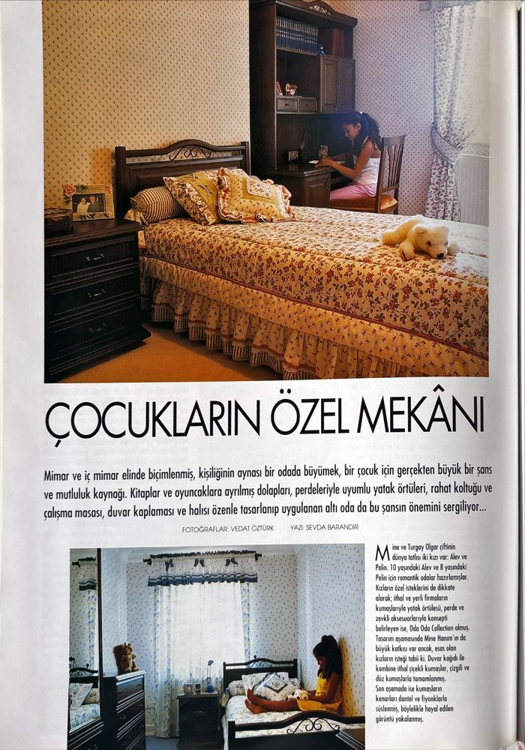 | Design page  editorial  [source label: Tasarım (Design)] | Bed: single wooden bed  Floor: carpet  Technology: —  Brands: Oda Oda Collection  Theme: romantic-classic, floral textiles  Gender code: girl | “Çocukların Özel Mekânı”  [Children’s private space]
28  August 2001  issue 101  pp. 71 | 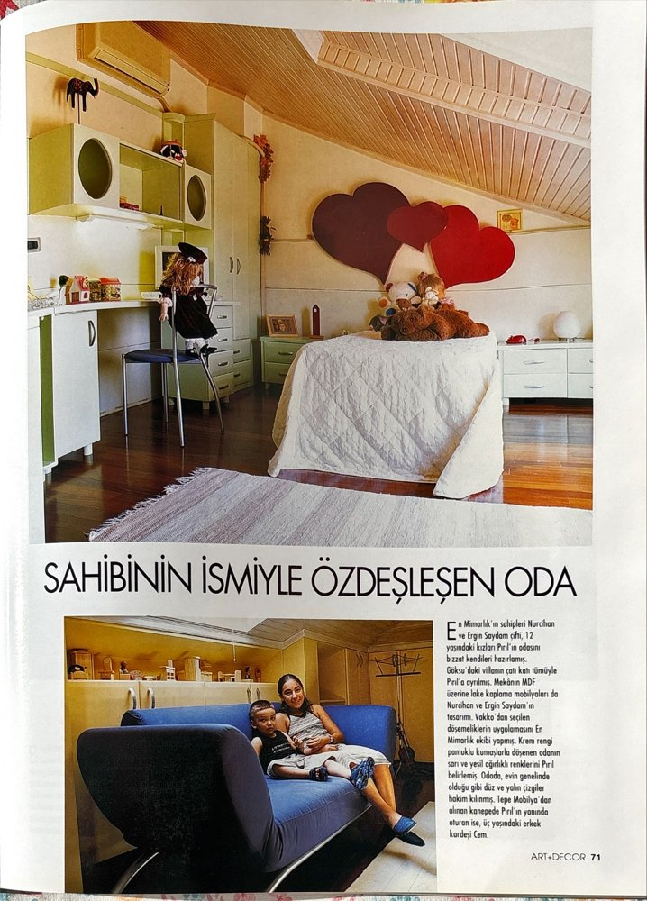 | Design page  editorial  [source label: Tasarım (Design)] | Bed: single bed, heart-shaped headboard  Floor: parquet + kilim  Technology: air-conditioner  Brands: En Mimarlık, Tepe Mobilya  Theme: personalization by name  Gender code: girl (brother: boy) | “Sahibinin İsmiyle Özdeşleşen Oda”  [The room that identifies with its owner’s name]
29  August 2001  issue 101  pp. 72 | 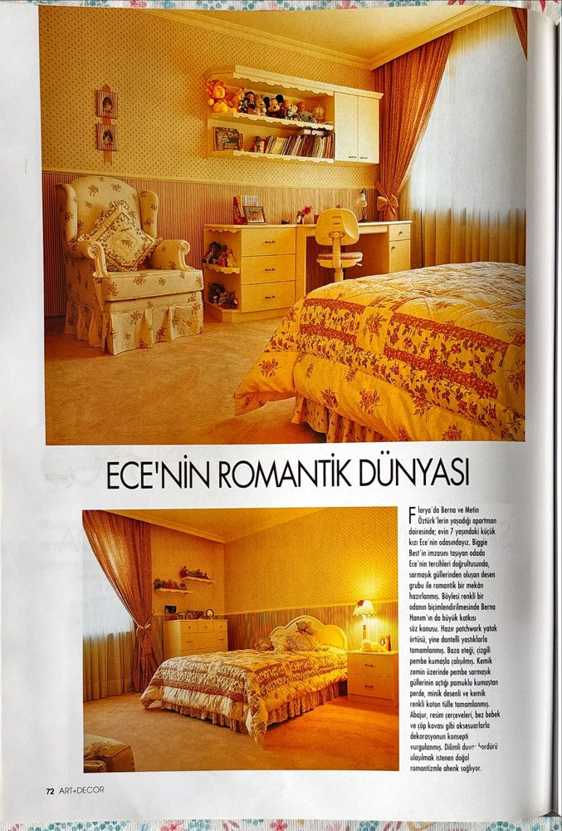 | Design page  editorial  [source label: Tasarım (Design)] | Bed: bed with patchwork cover  Floor: fitted carpet  Technology: —  Brands: Biggie Best  Theme: romantic world  Gender code: girl | “Ece’nin Romantik Dünyası”  [Ece’s romantic world]
30  August 2001  issue 101  pp. 73 | 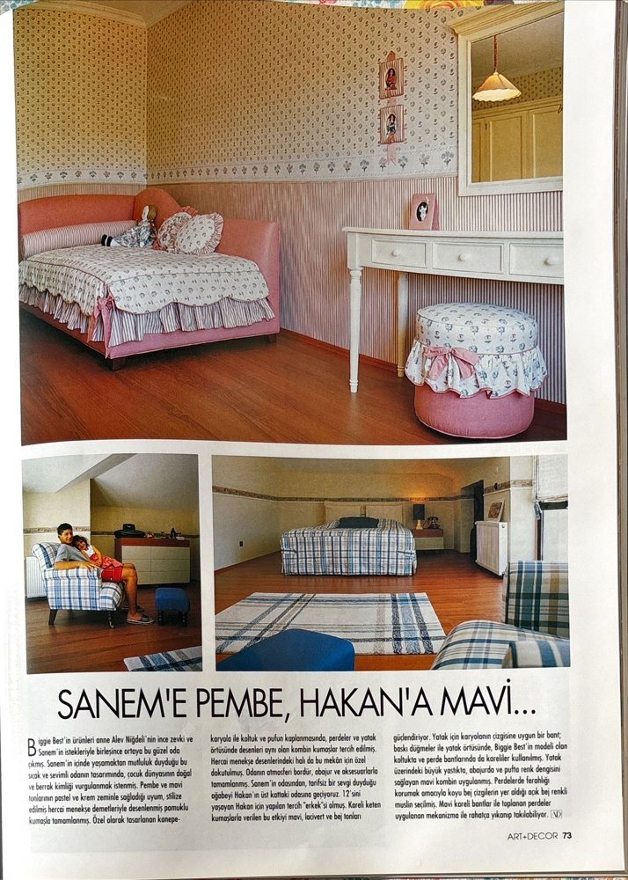 | Design page  editorial  [source label: Tasarım (Design)] | Bed: upholstered bed / checked bedcover  Floor: parquet  Technology: —  Brands: Biggie Best  Theme: color separation of siblings’ rooms  Gender code: binary pairing (pink/blue) | “Sanem’e Pembe, Hakan’a Mavi...”  [Pink for Sanem, blue for Hakan…]
31  October 2002  issue 115  pp. 139 | 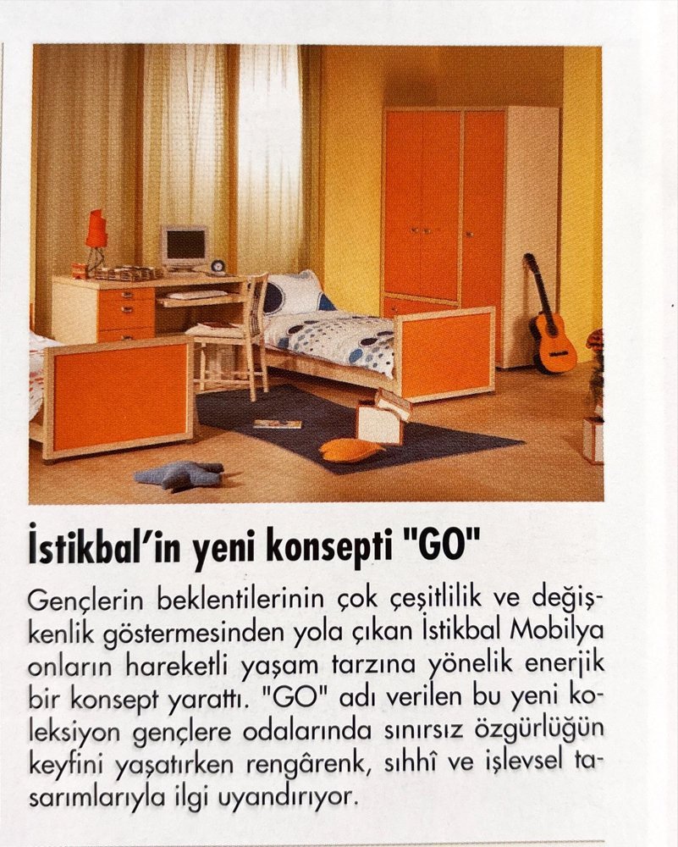 | Promotion & advertising  product round-up / advertorial  [source label: Tanıtım ve Reklamlar (Promotion and advertisements)] | Bed: single teen bed  Floor: laminate + rug  Technology: computer, guitar  Brands: İstikbal (GO)  Theme: active lifestyle, freedom  Gender code: neutral | “İstikbal’in Yeni Konsepti “GO””  [İstikbal’s new concept “GO”]
32  December 2003  issue 129  pp. 70–73 | 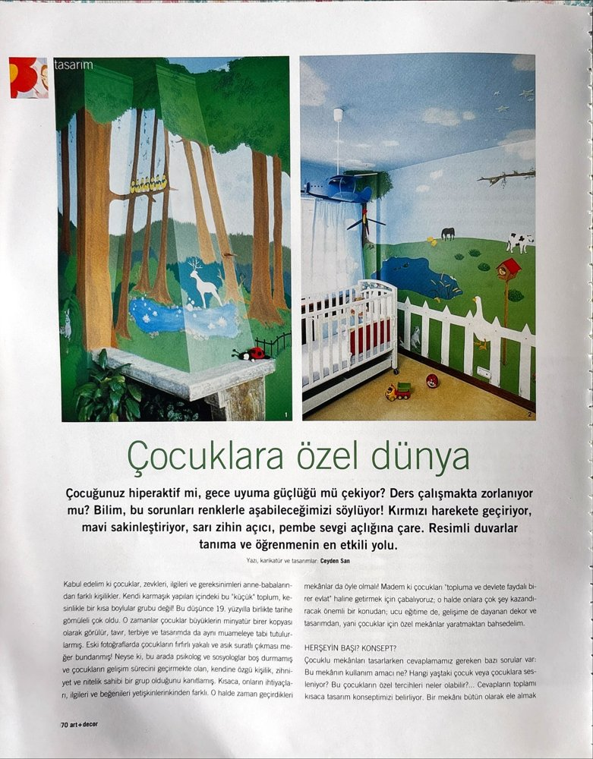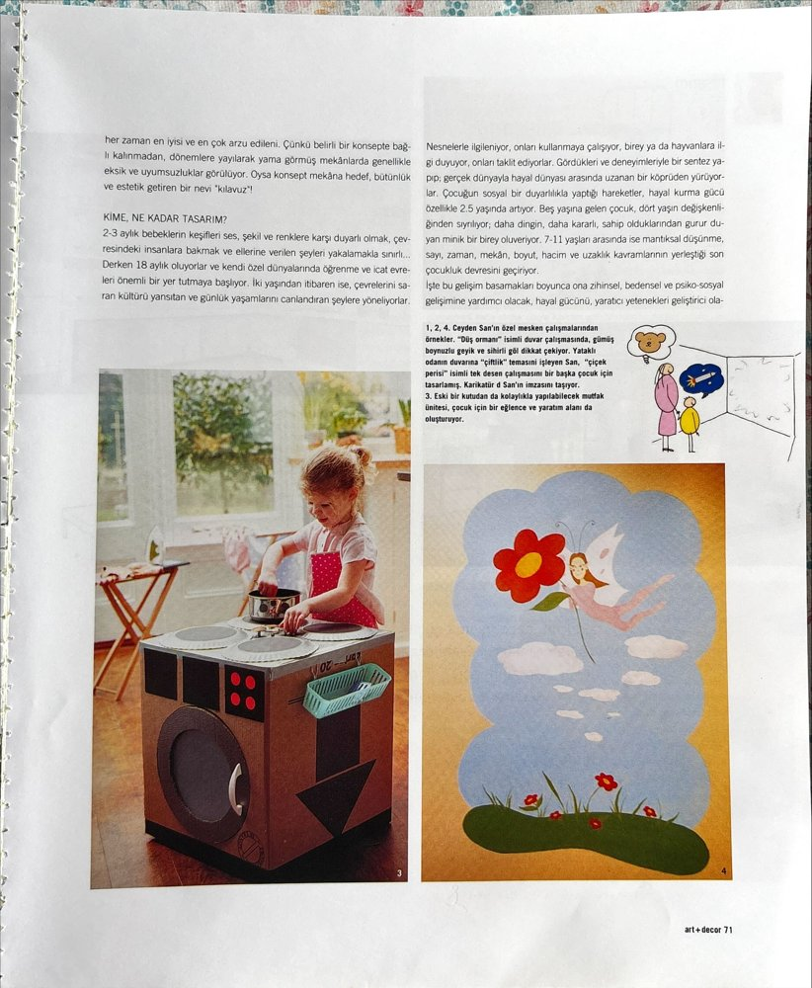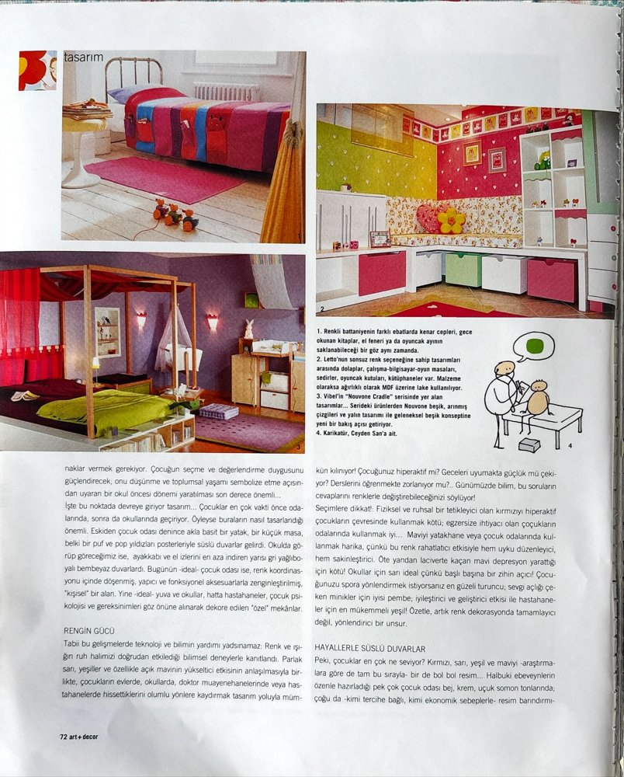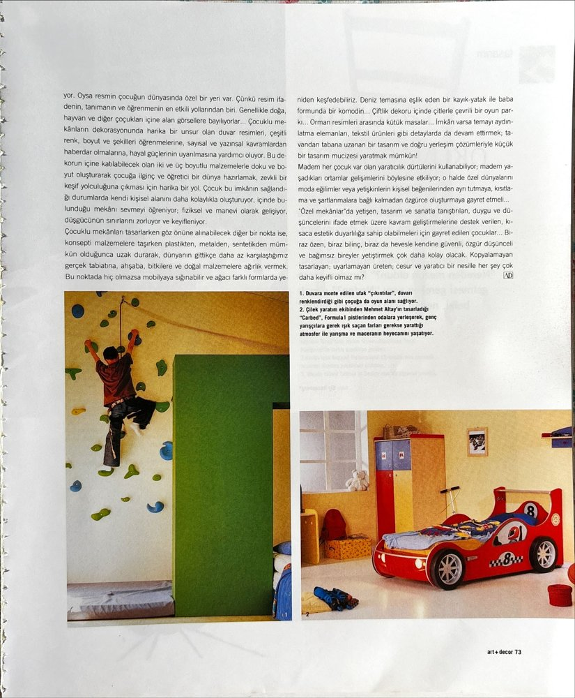 | Design page  editorial  [source label: Tasarım (Design)] | Bed: cot, car-bed  Floor: parquet  Technology: —  Brands: Vibel  Theme: murals, climbing wall, color psychology  Gender code: mixed | “Çocuklara Özel Dünya”  [A world special for children]
33  February 2004  issue 131  pp. 56–57 | 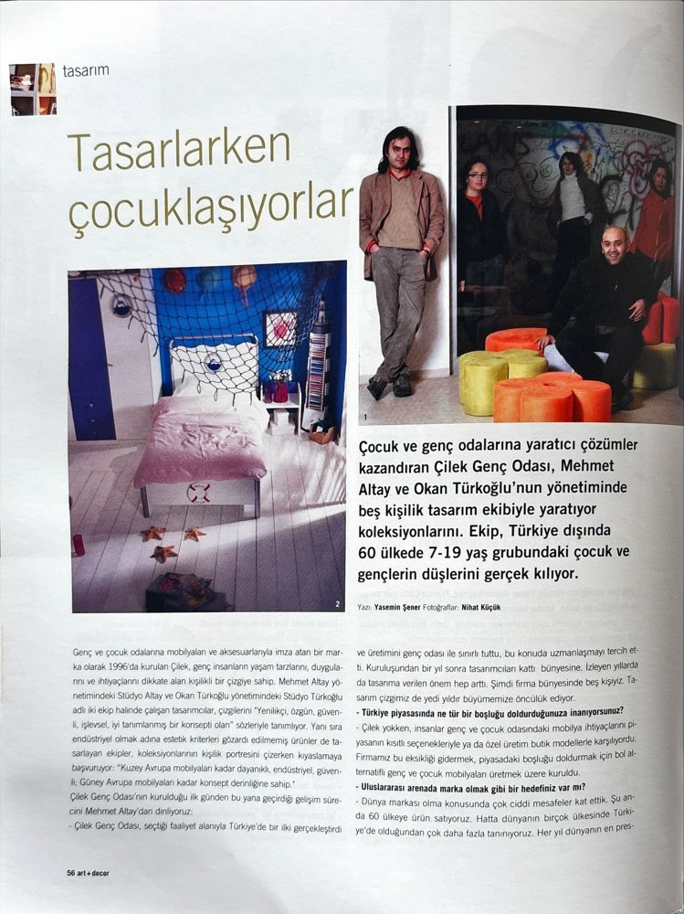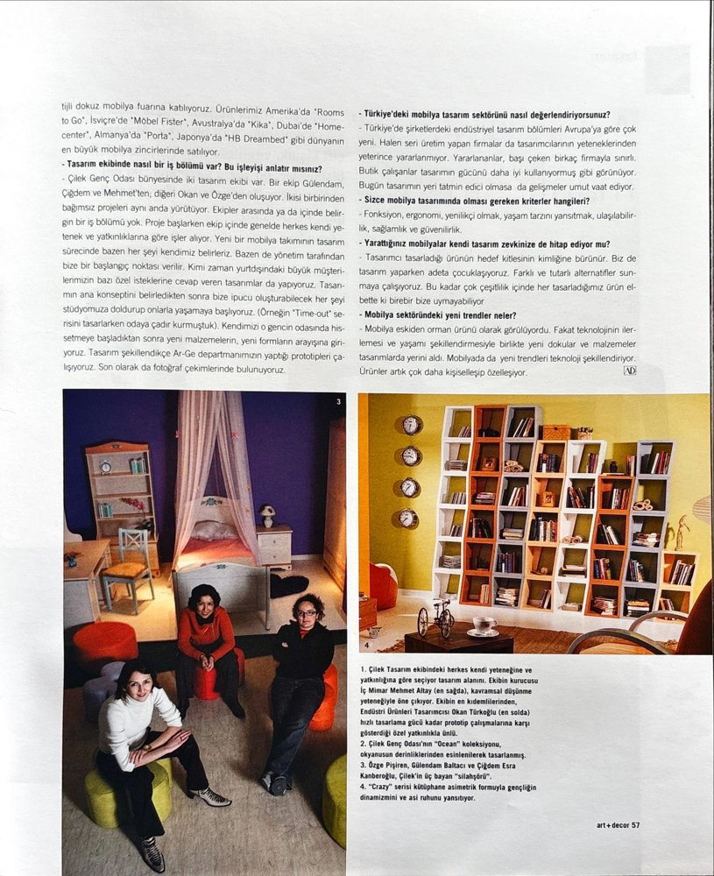 | Design page  editorial  [source label: Tasarım (Design)] | Bed: canopy bed  Floor: parquet  Technology: —  Brands: Çilek  Theme: design team; 7–19 age group; exports  Gender code: mixed | “Tasarlarken çocuklaşıyorlar”  [They become children while designing]
34  May 2004  issue 134  pp. 157 | 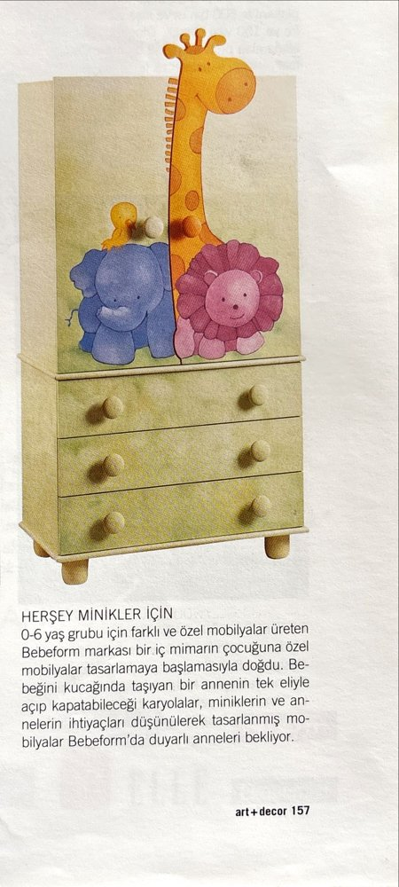 | Promotion & advertising  product round-up / advertorial  [source label: Tanıtım ve Reklamlar (Promotion and advertisements)] | Bed: convertible cot  Floor: —  Technology: —  Brands: Bebeform  Theme: animal figures  Gender code: neutral | “Herşey minikler için”  [Everything for the little ones]
35  May 2004  issue 134  pp. 160 | 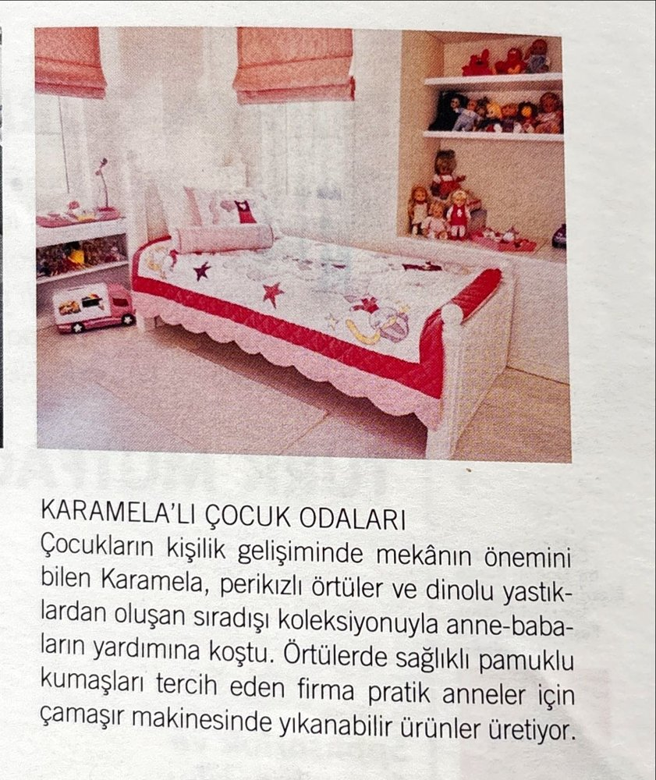 | Promotion & advertising  product round-up / advertorial  [source label: Tanıtım ve Reklamlar (Promotion and advertisements)] | Bed: single bed  Floor: light tiled floor  Technology: —  Brands: Karamela  Theme: fairy covers, dinosaur cushions  Gender code: binary pairing (fairy/dino) | “Karamela’lı Çocuk Odaları”  [Children’s rooms with Karamela]
36  June 2004  issue 135  pp. 77 | 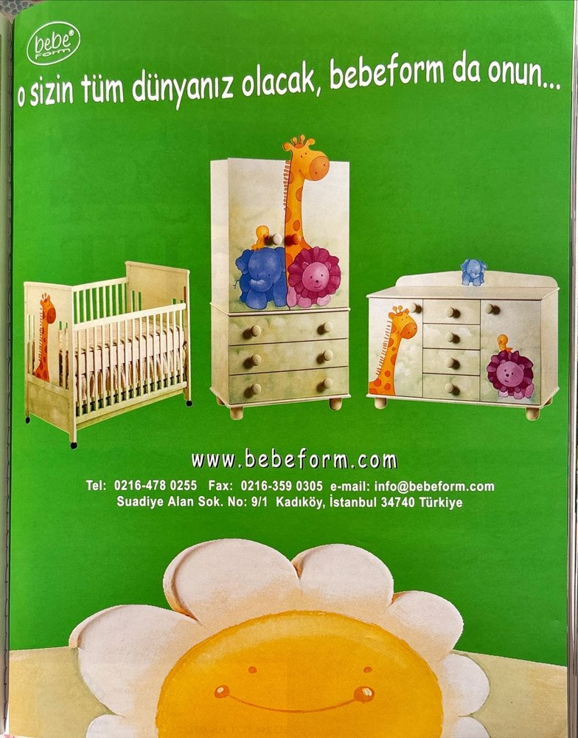 | Promotion & advertising  paid advertisement  [source label: Tanıtım ve Reklamlar (Promotion and advertisements)] | Bed: cot  Floor: —  Technology: —  Brands: Bebeform  Theme: animal figures, smiling sun  Gender code: neutral | “O sizin tüm dünyanız olacak, bebeform da onun...”  [It will be your whole world, and Bebeform will be his]
37  June 2004  issue 135  pp. 151 | 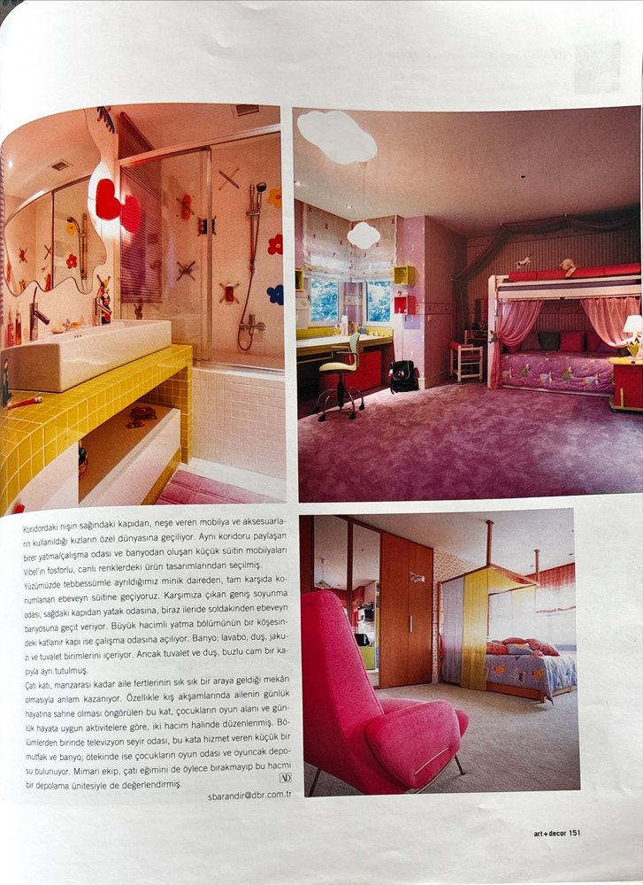 | House feature  editorial  [source label: Tanıtım ve Reklamlar (Promotion and advertisements)] | Bed: loft bed  Floor: fitted carpet  Technology: —  Brands: —  Theme: children’s floor / suite with bathroom  Gender code: girl | “Boğaz’da Yaşam Sevinci”  [Joy of living on the Bosphorus]
38  June 2004  issue 135  pp. 184 | 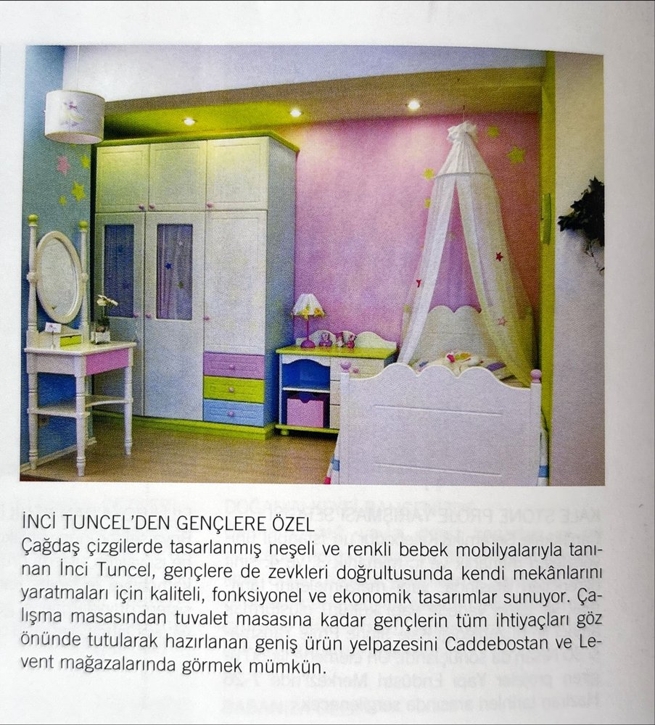 | Promotion & advertising  product round-up / advertorial  [source label: Tanıtım ve Reklamlar (Promotion and advertisements)] | Bed: canopy bed  Floor: parquet  Technology: —  Brands: İnci Tuncel (Caddebostan, Levent)  Theme: vanity table, pastel  Gender code: girl | “İnci Tuncel’den Gençlere Özel”  [Special for teenagers, from İnci Tuncel]
39  October 2004  issue 139  pp. 35 | 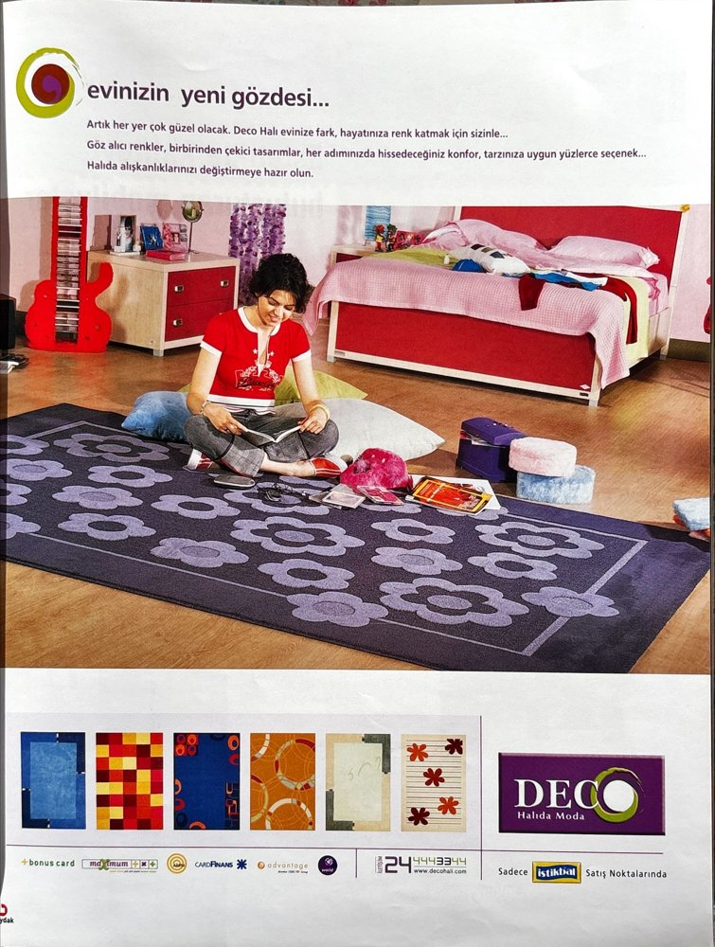 | Promotion & advertising  paid advertisement  [source label: Tanıtım ve Reklamlar (Promotion and advertisements)] | Bed: double teen bed  Floor: patterned rug  Technology: —  Brands: Deco Halı, İstikbal; credit-card logos  Theme: teenage girl, leisure  Gender code: girl | “Evinizin yeni gözdesi...”  [Your home’s new favorite…]
40  February 2005  issue 143  pp. 19 | 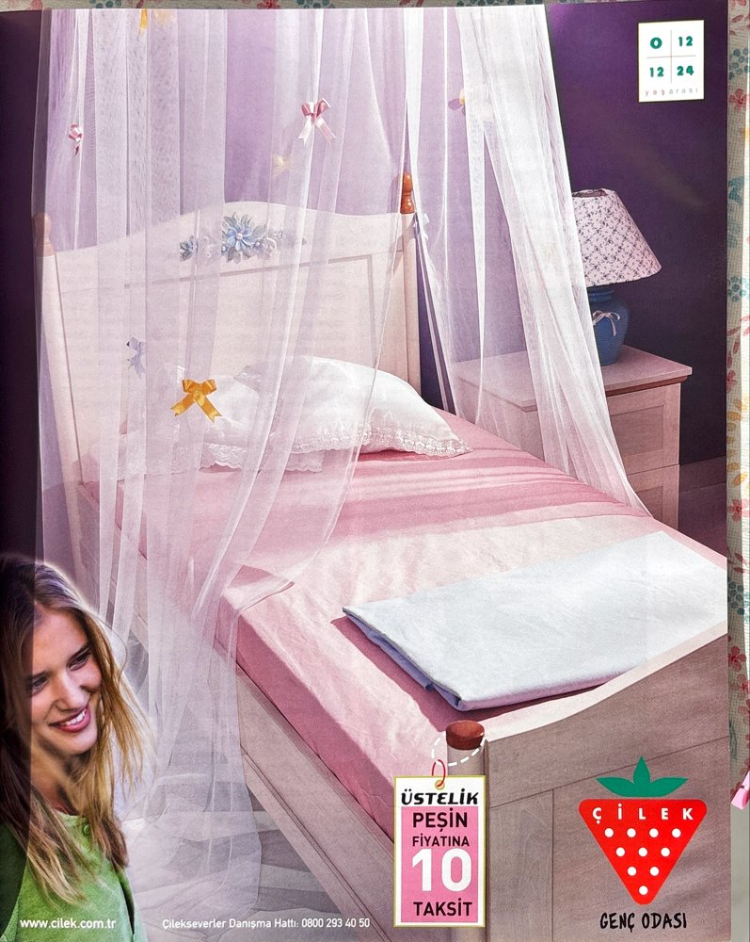 | Promotion & advertising  paid advertisement  [source label: Tanıtım ve Reklamlar (Promotion and advertisements)] | Bed: canopy bed  Floor: —  Technology: —  Brands: Çilek Genç Odası  Theme: ten installments at cash price  Gender code: girl | “Genç Odası (Çilek): Peşin fiyatına 10 taksit”  [Teen room (Çilek): ten installments at the cash price]
41  March 2005  issue 144  pp. 31 | 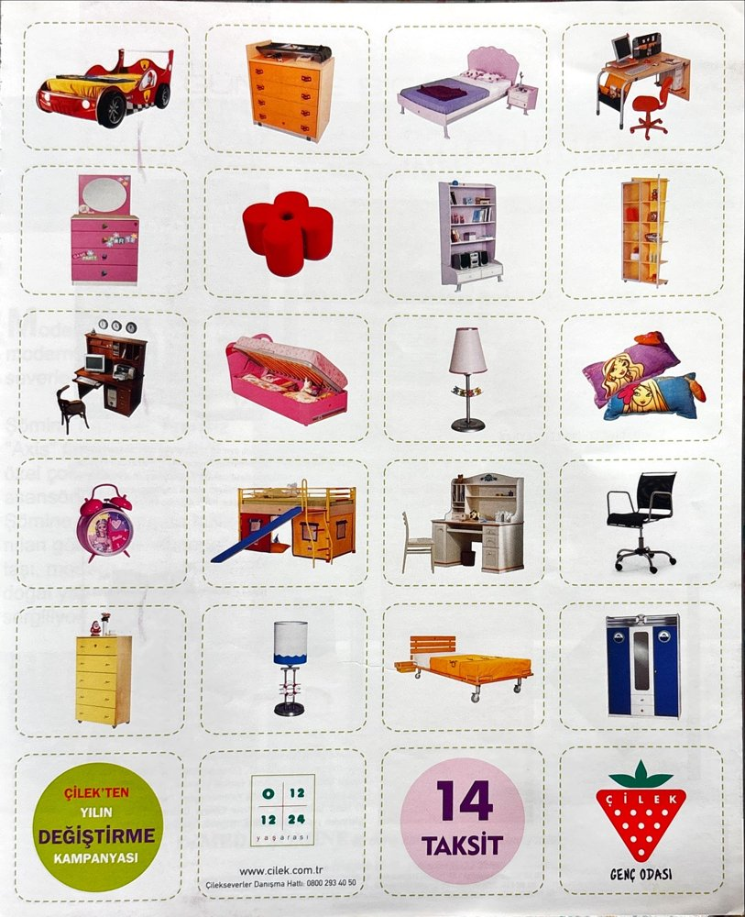 | Promotion & advertising  paid advertisement  [source label: Tanıtım ve Reklamlar (Promotion and advertisements)] | Bed: car-bed, bunk, bed  Floor: —  Technology: study desk / computer  Brands: Çilek  Theme: catalogue grid; 14 installments; trade-in campaign  Gender code: mixed | “Çilek’ten Yılın Değiştirme Kampanyası”  [Çilek’s trade-in campaign of the year]
42  May 2005  issue 146  pp. 147 | 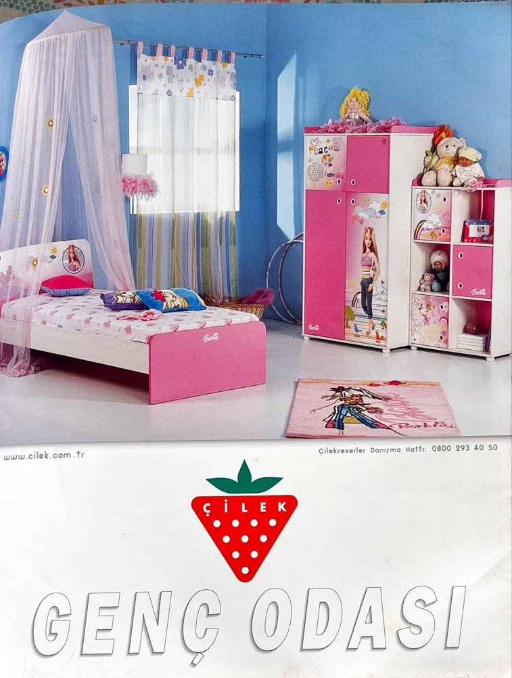 | Promotion & advertising  paid advertisement  [source label: Tanıtım ve Reklamlar (Promotion and advertisements)] | Bed: Barbie-licensed bed  Floor: Barbie rug  Technology: —  Brands: Çilek (Barbie)  Theme: licensed character  Gender code: girl | “Genç Odası”  [Teen room]
43  June 2005  issue 147  pp. 32 | 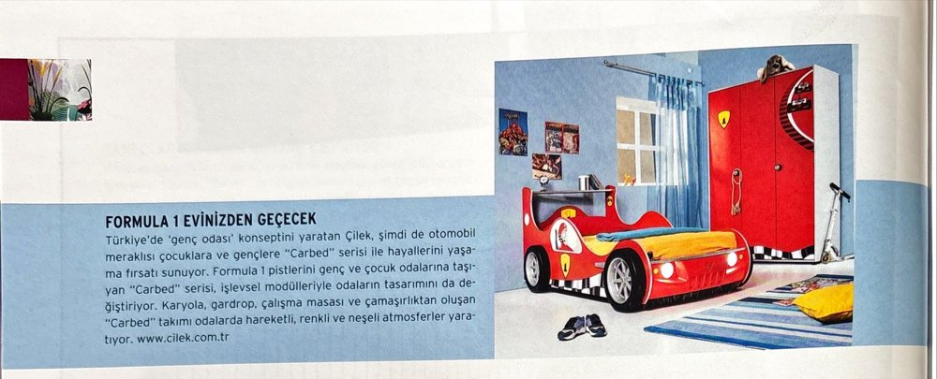 | Promotion & advertising  product round-up / advertorial  [source label: Tanıtım ve Reklamlar (Promotion and advertisements)] | Bed: Formula 1 car-bed (Carbed)  Floor: carpet  Technology: —  Brands: Çilek  Theme: motor racing  Gender code: boy | “Formula 1 Evinizden Geçecek”  [Formula 1 will pass through your home]
44  June 2005  issue 147  pp. 51 | 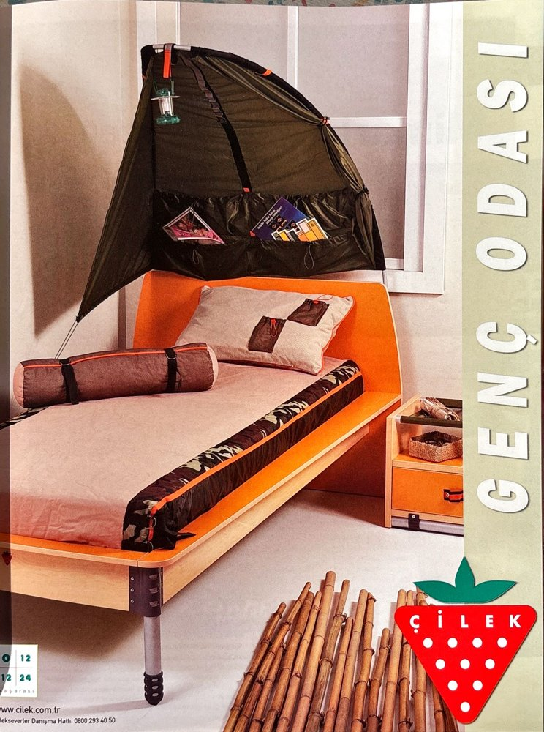 | Promotion & advertising  paid advertisement  [source label: Tanıtım ve Reklamlar (Promotion and advertisements)] | Bed: tent bed  Floor: bamboo mat  Technology: —  Brands: Çilek Genç Odası  Theme: adventure / camouflage  Gender code: boy | “Genç Odası”  [Teen room]
45  September 2005  issue 150  pp. 61 | 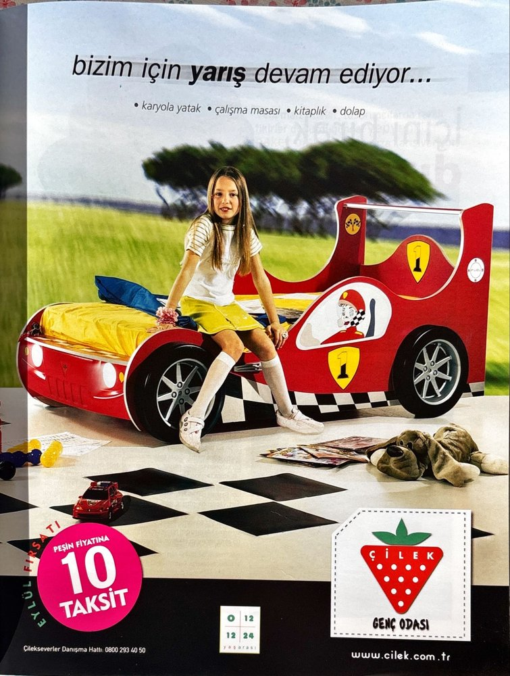 | Promotion & advertising  paid advertisement  [source label: Tanıtım ve Reklamlar (Promotion and advertisements)] | Bed: Formula 1 car-bed  Floor: checkered floor  Technology: —  Brands: Çilek  Theme: racing; ten installments  Gender code: mixed (girl + racing car) | “Bizim için yarış devam ediyor...”  [For us, the race goes on…]
46  October 2005  issue 151  pp. 39 | 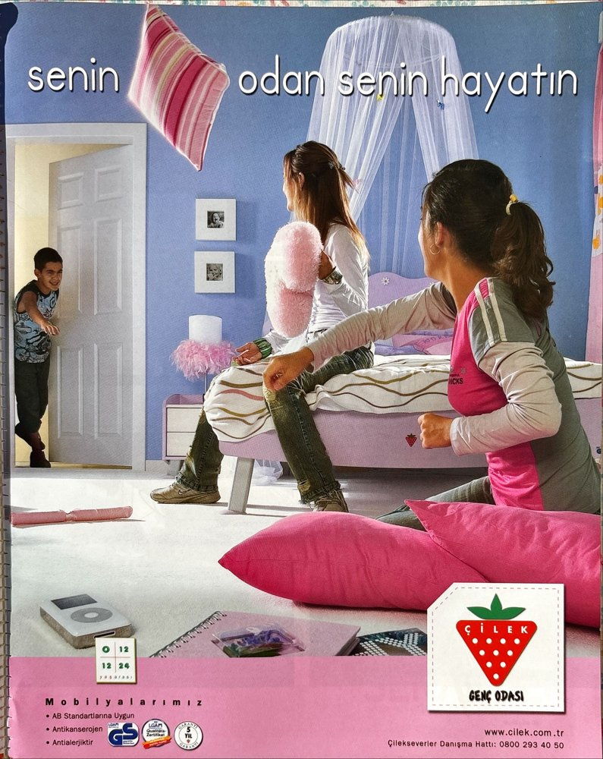 | Promotion & advertising  paid advertisement  [source label: Tanıtım ve Reklamlar (Promotion and advertisements)] | Bed: canopy bed  Floor: carpet  Technology: iPod  Brands: Çilek; EU standard, GS mark, anti-allergenic/anti-carcinogenic  Theme: teenage-girl lifestyle  Gender code: girl | “Senin odan senin hayatın”  [Your room is your life]
Note. Record 25: four of the eleven page images in the original inventory could not be recovered and are omitted. Record 37 was reclassified from “promotion” to house feature; the headline of record 40 was corrected from the scan (see Materials and Methods in the article). Publication months are taken from the issue-level index. Source labels are the magazine’s own section names, with English translations in parentheses. Page images: AD (Art Decor), Istanbul; reproduced for scholarly analysis [reproduction permission to be secured before publication].

Original Turkish: “Artık koltukçudan alınan hazır eşya ve möble ile evimizin içini dolduramayız” (Ziya, 1931, p. 14).
Original Turkish: “Bugün Avrupada bu odalara ve teferruata, çocuk odası, hizmetçi odası ve merdiveni, misafir salonu, sigara odası gibi birçok parçalar ilâve olunuyorsa da bizde daha yayılmamıştır” (Ziya, 1931, p. 15).
Original Turkish: “Yemek odasında hafif renklerin müzikleri gelsin, yatak odası ninni söylesin… Çocuk odası ise çocuğu kendi safiyeti ile büyütsün” (Mualla, 1931, p. 244).
Original Turkish: “yatak divanlarla mücehhez çocuk odası” (Schütte, 1944).
Original Turkish: “Terbiyevî cihetlerden ve lisan bakımından çocuklarının günün mühim zamanlarında kendilerinden ayrı ve bir mürebbiye ile beraber kalmasını istiyen yapı sahibi programında ortada bir müşterek salon ile iki yana taksim edilmiş her bir çocuk için odalar olması şartını kat’iyyen arzu etmiştir” (Bayhan, 1952, p. 186).
Original Turkish: “Mimar ve iç mimar elinde biçimlenmiş, kişiliğinin aynası bir odada büyümek, bir çocuk için gerçekten büyük bir şans ve mutluluk kaynağı” (AD, 2001, issue 101, p. 70).
Original Turkish: “Çocuğunuz hiperaktif mi, gece uyuma güçlüğü mü çekiyor? Ders çalışmakta zorlanıyor mu? Bilim, bu sorunları renklerle aşabileceğimizi söylüyor! Kırmızı harekete geçiriyor, mavi sakinleştiriyor, sarı zihin açıcı, pembe sevgi açlığına çare” (AD, 2003, issue 129, p. 70).

