Supplementary Material S2
From Pedagogical Refuge to Status Showcase: The Child’s Room in Turkish Design Media, 1993–2005
Methods appendix: corpus, index, coding, color measurement, statistics and journal benchmarking

S2.1 Choice of Source
The study covers the run of AD (Art Decor) from 1993, the year the magazine was launched, to 2005. In these twelve years post-1980 consumption practices and new lifestyle aspirations were most intensely reflected in the Turkish domestic interior, and the transformation of the child’s room into a market-targeted showcase can be followed most clearly. The choice of AD rests on a comparison with other periodicals of the time. Journals such as Arredamento Mimarlık (Arredamento Architecture) concentrated on professional practice and disciplinary debate and kept their distance from domestic consumption. Magazines such as Vizyon Dekor (Vision Décor) and Evim (My Home), by contrast, offered practical decoration advice to a broad readership. AD occupied the intersection of these two poles, combining designer-signed interiors, popular imagery, generous space for furniture brands and the lifestyle expectations of the upper middle class.

S2.2 Corpus Construction and Screening
To avoid selection bias, the complete run of 152 issues was screened page by page (full census). A record was defined as a contiguous editorial feature, product round-up or advertisement whose primary subject is a nursery, a child’s room or a teenager’s room, or a house feature in which such a room is presented as a distinct space. Records were registered with year, issue and page numbers, the magazine’s own section label and the headline or slogan. Screening yielded 46 records in 28 issues (112 pages). Page scans were archived for 23 records from 1997–2005 (47 usable images; four placeholders in record 25 could not be recovered).
Two records were harmonized during coding. Record 37, labeled “promotion” in the source, was reclassified as a house feature because the scans show an editorial presentation of a residence. The headline of record 40, transcribed in the first inventory as a duplicate of record 39, was corrected from the scan to the Çilek advertisement that it reproduces.

S2.3 Issue-Level Index
The record inventory was cross-checked against an issue-level content index of AD compiled by the research team. For each issue the index records the publication month, page count, cover headlines, contents and keywords. For 37 issues it also lists the featured spaces with their designer, location and type (202 spaces). Usable entries exist for 109 of the 152 issues; issues 16–47, 93–99 and 149 have not yet been indexed. The index was used in three ways:
- to check the coverage of the inventory;
- to construct an issue-level measure of child-room content that does not depend on the inventory;
- to describe the magazine’s size and the geography of its featured spaces.
An issue was coded as positive when its entry referred to children’s, babies’ or teenagers’ rooms, furniture, textiles or lighting. Children’s clothing, toys and shops were excluded, and references to a teenager’s room (genç odası) were coded separately. The index flags fourteen issues with relevant content that are missing from the inventory (issues 51, 70, 89, 100, 102, 103, 108, 109, 112, 136, 141, 145, 148 and 152). The inventory counts are therefore conservative. One discrepancy remains to be resolved against the printed issues: the inventory assigns the August 2001 features to issue 101, whereas the index lists them under issue 102.

S2.4 Coding Scheme and Layers
Coding followed the systematic visuo-textual analysis of Brown and Collins (2021), which treats image and text as one unit of meaning and proceeds from description to interpretation in documented steps. It was complemented by established procedures for the content analysis of visual material (Rose 2016; Krippendorff 2018). Each record was first coded for genre, harmonized into the magazine’s own three categories:
- design pages: editor- or designer-authored proposals for how a room should be;
- house features: real residences in which the room’s position in the dwelling can be observed;
- promotion and advertising: idealized studio settings through which brands market an imagined room.
Records were also coded for editorial format (editorial, product round-up or advertorial, or paid advertisement) and age segment (infant, child, teenager or mixed). Discourse was then coded with twelve binary themes. These were derived deductively from the theoretical framework and refined inductively during a first reading (article, Table 1).
Two coding layers were distinguished so that change in the magazine would not be confounded with change in the evidence available. The headline layer codes each record solely from its headline, strapline or slogan and is comparable across the whole period (n = 46). The visuo-textual layer also draws on images, captions, body text and paratexts (logos, certification marks, payment terms), and is available only for the scanned records (n = 23). For these records, six material indicators were completed from the images: bed type, floor finish, technology, brands, theme and gender code (Supplementary Material S1).
Inter-coder reliability. [To be completed by the authors before submission. Suggested procedure: a second coder independently codes a random 20 percent of records (at least ten) on both layers. Agreement is reported for each theme as percent agreement and Cohen’s κ (Cohen 1960), and disagreements are resolved by discussion. Report: “Agreement ranged from κ = __ to κ = __ (mean κ = __).”]

S2.5 Computational Color Analysis
All 47 usable scans were analyzed in Python (Pillow, NumPy, scikit-learn) to complement the qualitative reading of color with a reproducible measure. The procedure had five steps:
- White balance. Each image was white-balanced against the paper tone, estimated as the 90th percentile of bright, low-chroma pixels, to reduce the warm cast of photographed pages.
- Conversion. Images were resized to a maximum of 800 px and converted to HSV.
- Chromatic pixels. Pixels with saturation ≥ 0.25 and value ≥ 0.20 were treated as chromatic; this removes paper, black text and gray shadows.
- Hue families. Chromatic pixels were assigned to six hue families: pink/magenta 290–345°, red 345–15°, orange/yellow 15–65°, green 65–170°, blue/cyan 170–260° and violet 260–290°.
- Summary measures. The colorfulness index M of Hasler and Süsstrunk (2003) was computed, and a six-color dominant palette was extracted for each record by k-means clustering.
Image-level values were averaged to the record level. Because scans before 2001 are sparse, the visual analysis distinguishes three phases: 1997–1998 (n = 2), 2001–2003 (n = 7) and 2004–2005 (n = 14). The measure describes printed pages, not the rooms themselves, and is sensitive to printing and scanning conditions. It is therefore used comparatively, within one magazine and one scanning protocol.

S2.6 Statistical Treatment
Given the small, census-type corpus, statistics are used descriptively and to test the robustness of the interpretive reading, not to generalize to a population. Theme prevalence was compared between the first (1993–1996, n = 22) and last (2001–2005, n = 21) periods with two-sided Fisher’s exact tests; the middle period (1997–2000, n = 3) is reported but not tested.
The index covers 1997–2000 well (43 issues) but the early period poorly (14 issues, all from 1993–1994), so index-based shares were compared between 1997–2000 and 2001–2005. Thematic co-occurrence was summarized with the Jaccard index. Color indicators were compared across phases with Kruskal–Wallis tests, and between 2001–2003 and 2004–2005 with Mann–Whitney U tests. All analyses were run in Python (pandas; SciPy, Virtanen et al. 2020); the coded dataset and scripts are deposited with the data (see the Data Availability Statement).

S2.7 Journal Benchmarking
To position the study, we benchmarked fifteen journals that publish on culture, childhood and architecture or design. Their full publication records (17,788 works) were retrieved from OpenAlex (Priem et al. 2022; accessed 16 October 2026), and titles and abstracts were searched for terms related to children, bedrooms, consumption and Turkey. Retrieved works were read by title and, where needed, abstract to identify studies directly concerned with children’s domestic space. Because OpenAlex abstract coverage is incomplete for older volumes, counts are conservative; the benchmark is used for positioning rather than as a bibliometric result in its own right (Table S2; Figure S1).
Table S2. Benchmarked journals: indexed works and works mentioning Turkey in title or abstract (OpenAlex).
Journal | Works (n) | Turkey (n) | Turkey (%)
Journal of the History of Childhood and Youth | 1,033 | 2 | 0.19
Journal of Interior Design | 1,004 | 4 | 0.40
Childhood | 1,224 | 5 | 0.41
Journal of Design History | 1,997 | 11 | 0.55
Journal of Family History | 1,543 | 10 | 0.65
Design and Culture | 753 | 5 | 0.66
Journal of Consumer Culture | 912 | 7 | 0.77
Children’s Geographies | 1,315 | 11 | 0.84
Interiors: Design, Architecture, Culture | 309 | 3 | 0.97
Journal of Material Culture | 668 | 7 | 1.05
Design Issues | 1,605 | 17 | 1.06
The Journal of Architecture | 1,565 | 21 | 1.34
Gender, Place & Culture | 2,375 | 43 | 1.81
Home Cultures | 365 | 9 | 2.47
Space and Culture | 1,120 | 31 | 2.77
Total | 17,788 | 186 | 1.05
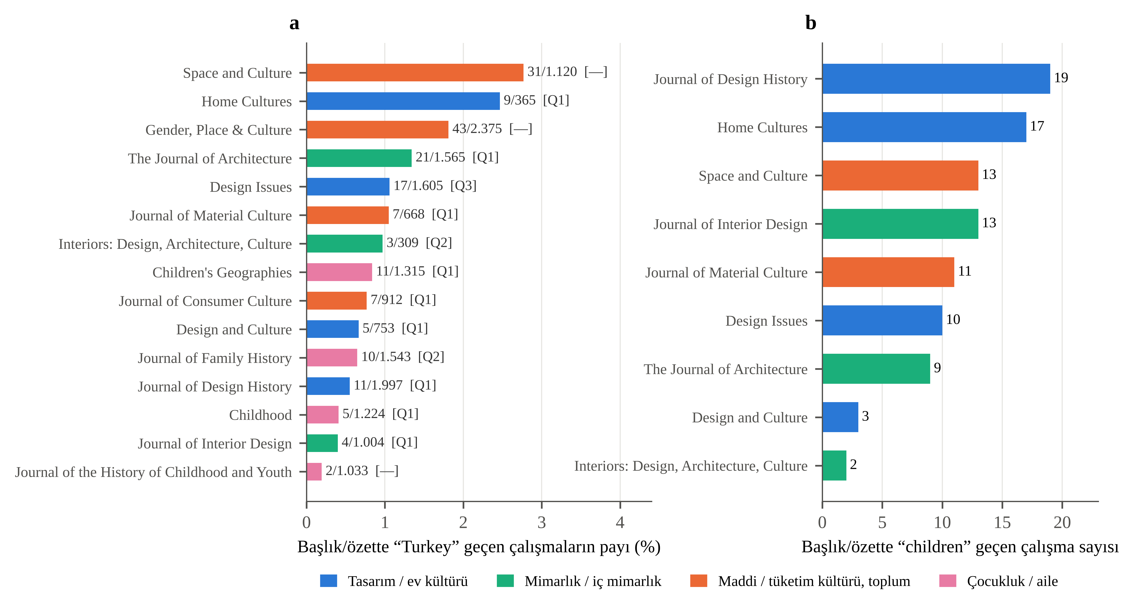
Figure S1. Benchmarked journals by number of indexed works and share of works mentioning Turkey. Authors’ analysis of OpenAlex data.

References
Brown, Nicole and Jane Collins. 2021. “Systematic Visuo-Textual Analysis: A Framework for Analysing Visual and Textual Data.” The Qualitative Report 26(4): 1275–90. https://doi.org/10.46743/2160-3715/2021.4838
Cohen, Jacob. 1960. “A Coefficient of Agreement for Nominal Scales.” Educational and Psychological Measurement 20(1): 37–46. https://doi.org/10.1177/001316446002000104
Hasler, David and Sabine Süsstrunk. 2003. “Measuring Colourfulness in Natural Images.” In Bernice E. Rogowitz and Thrasyvoulos N. Pappas (eds), Human Vision and Electronic Imaging VIII, Proceedings of SPIE 5007, pp. 87–95. Bellingham, WA: SPIE. https://doi.org/10.1117/12.477378
Krippendorff, Klaus. 2018. Content Analysis: An Introduction to Its Methodology, 4th edn. Thousand Oaks, CA: SAGE.
Priem, Jason, Heather Piwowar and Richard Orr. 2022. “OpenAlex: A Fully-Open Index of Scholarly Works, Authors, Venues, Institutions, and Concepts.” arXiv:2205.01833. https://doi.org/10.48550/arXiv.2205.01833
Rose, Gillian. 2016. Visual Methodologies: An Introduction to Researching with Visual Materials, 4th edn. London: SAGE.
Virtanen, Pauli, Ralf Gommers, Travis E. Oliphant, et al. 2020. “SciPy 1.0: Fundamental Algorithms for Scientific Computing in Python.” Nature Methods 17: 261–72. https://doi.org/10.1038/s41592-019-0686-2

