FIDELITY BANK PAYGATE INTEGRATION
Test Scenarios for
FIDELITY BANK PLC/ACADEMYVISTA LTD
Prepared by
Omon Ohiro
October 2015

Academy Vista Limited | B03 Eleganza Shopping Centre, Opp V.G.C Lagos | Tel: 08105387515
CREATIVE BRIEF

ABOUT ACADEMY VISTA
OUR PARTNERSHIP APPROACH
AcademyVista are an acclaimed software development house. We have been creating world class leading websites and bespoke software solutions since 2005, using the latest technology that delivers results and return on investment. We partner with many leading businesses, translating their objectives into workable, objective lead web sites.
We specialise in website design, bespoke software (online or offline) digital marketing, search engine optimisation, ecommerce and mobile web applications. Our offices are based in Lagos and we serve clients throughout the entire Nigeria.
We currently have 8 full-time members of staff and are currently enjoying a period of expansion as a result of our excellent reputation.
Our aim is to understand your web requirements and provide ongoing support. We hope that by exceeding your expectations in this project we will have an opportunity to support you in other areas of the business and in future website development.
MEET THE MANAGEMENT TEAM

William Aimakhu Omon Ohiro Cynthia Oseghale
Senior Program Consultant Programmer Extraordinaire Project Manager
Please note that all scenarios for now use the test site http://www.sistercitiesvocationaltraining.com/
Log in using username/password: ABOJE/Password 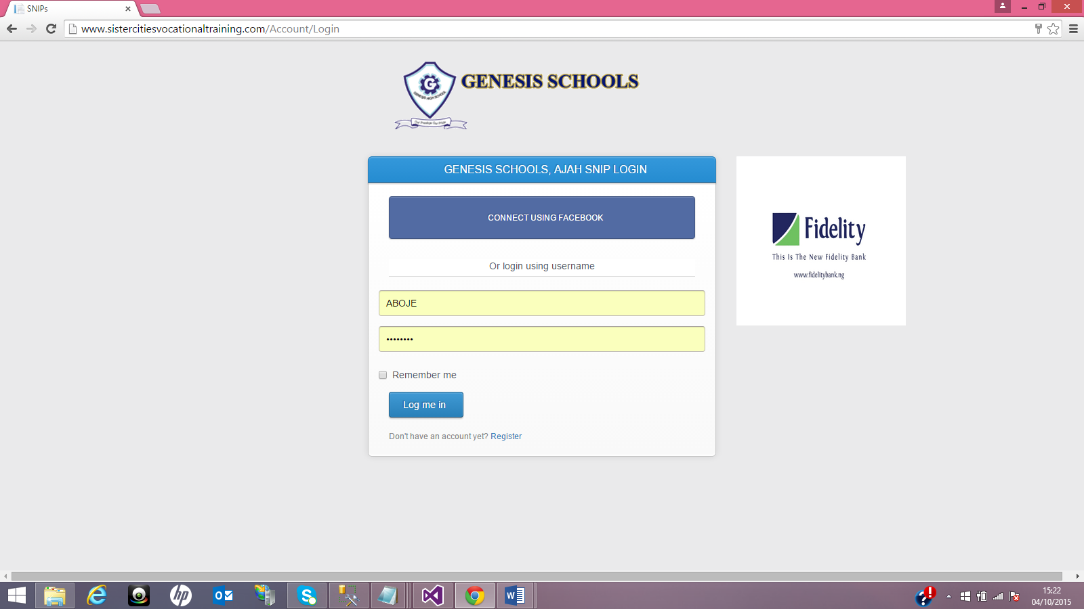
Click on school fees: 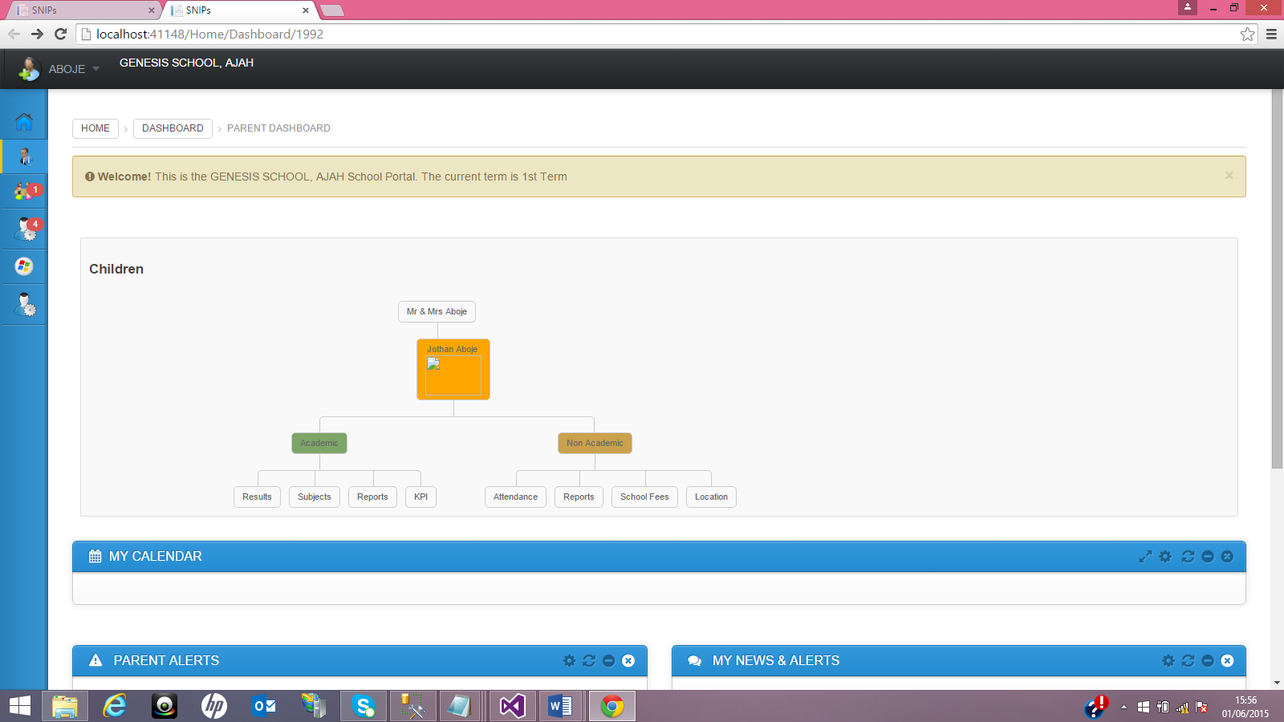
Choose from fee list and click on pay: 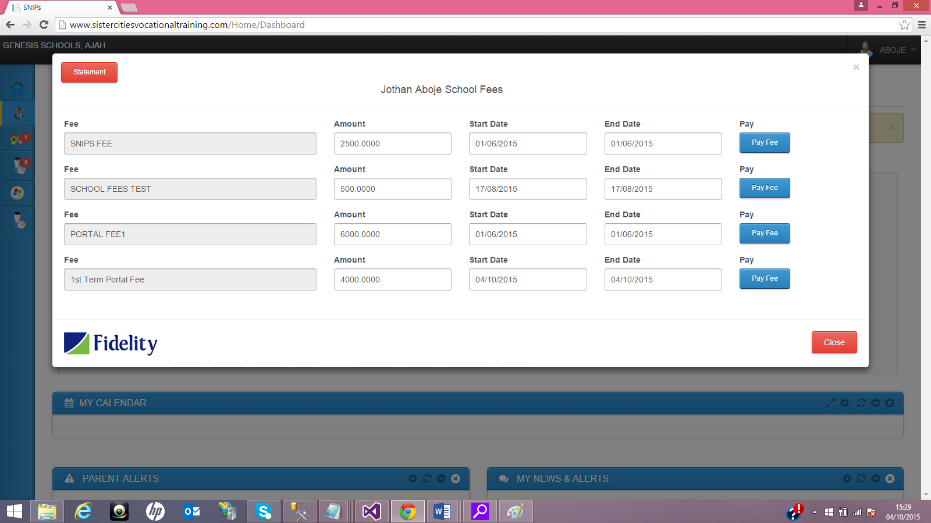
Enter amount in part or full and click on pay: 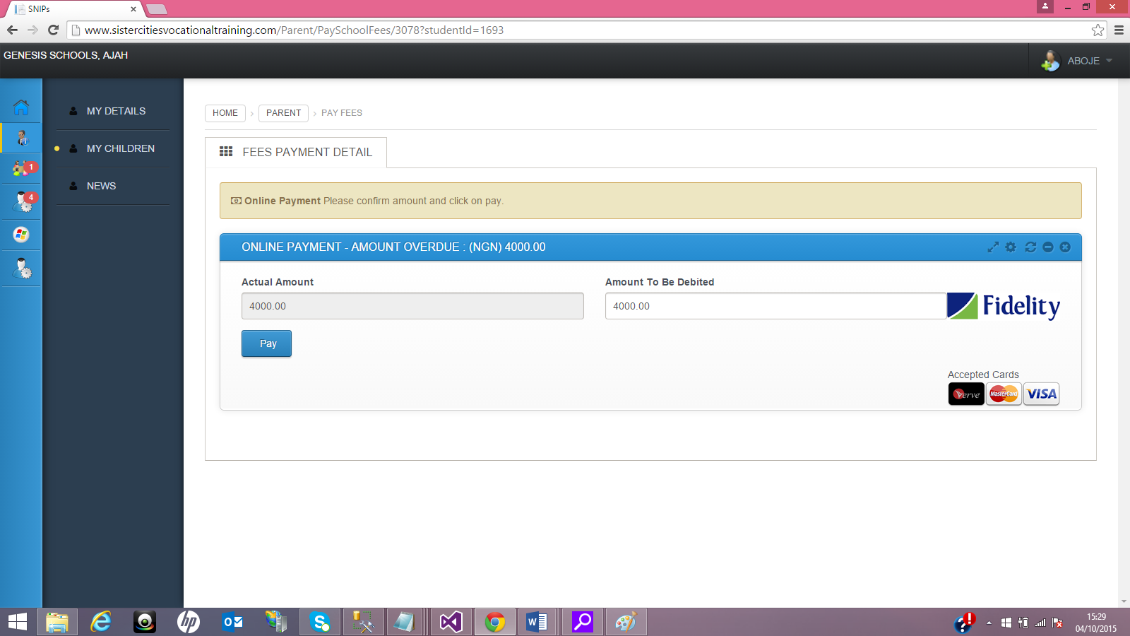

Select Verve and click continue: 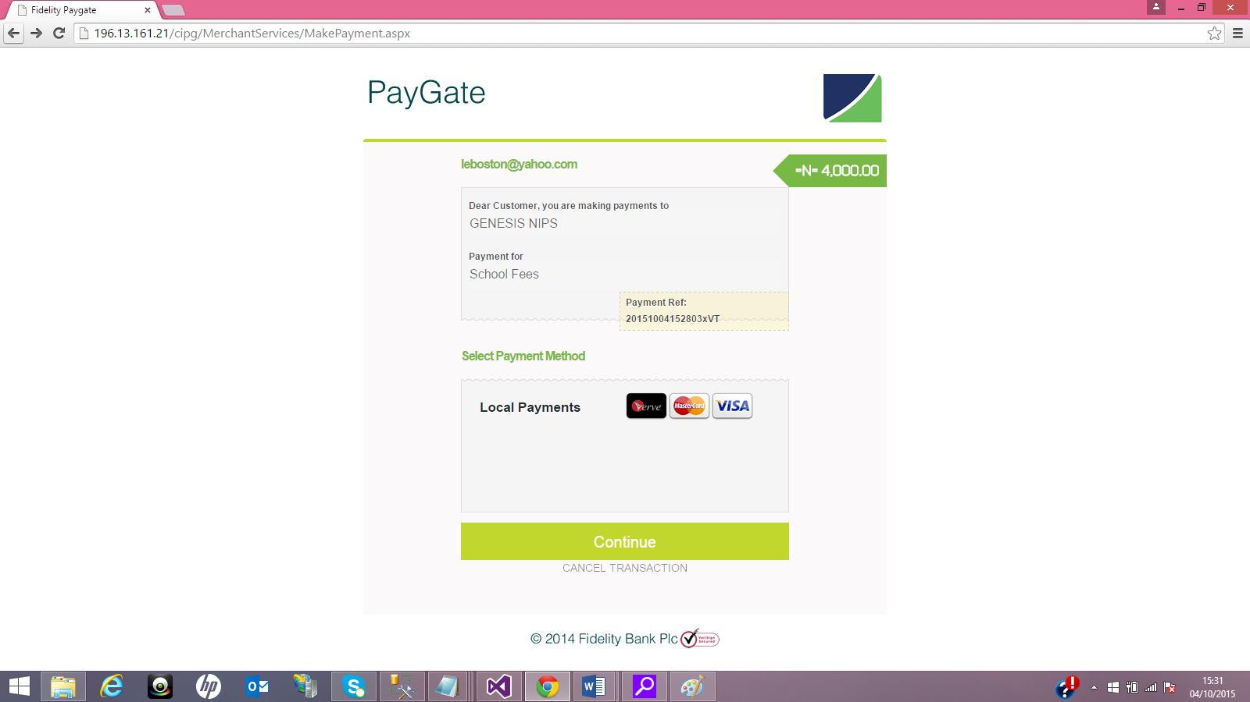
Enter card details for different scenarios: 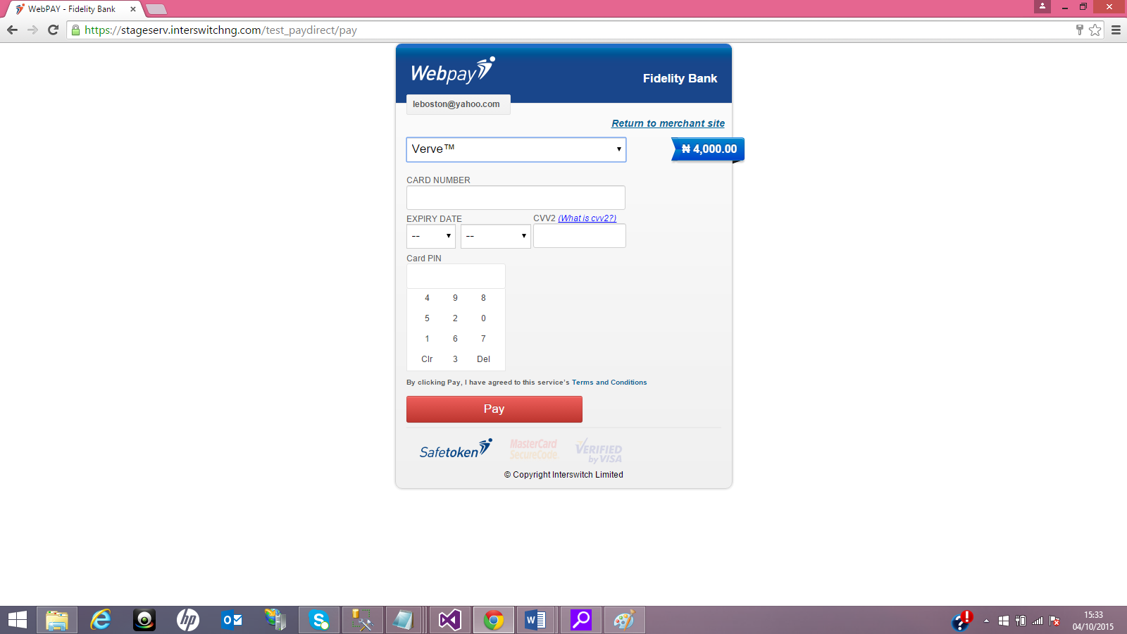

SUCCESS SCENARIO

Success
6280511000000095
Dec 2026
0000
123
This is the demo card with which you would always get a successful response

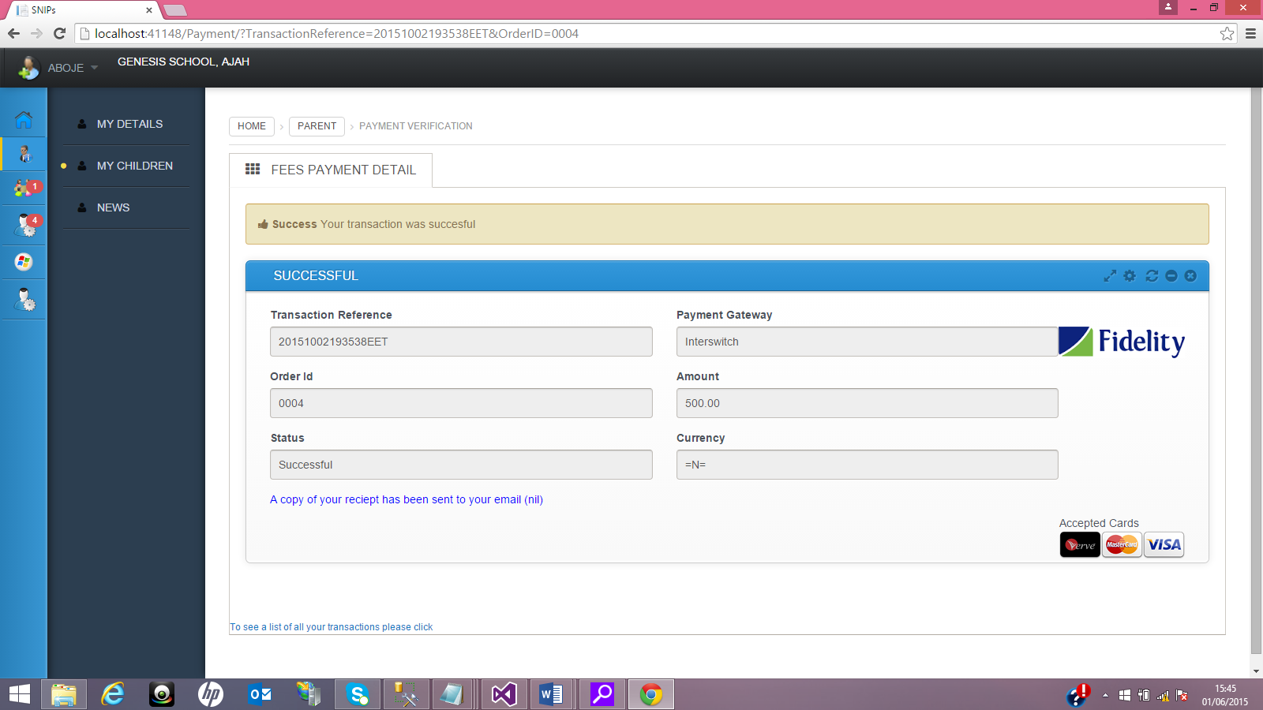

FAILURE SCENARIO

Expired Card
5061020000000000003
June 2014
1111
123
This is the demo card that would decline. Transaction unsuccessful.

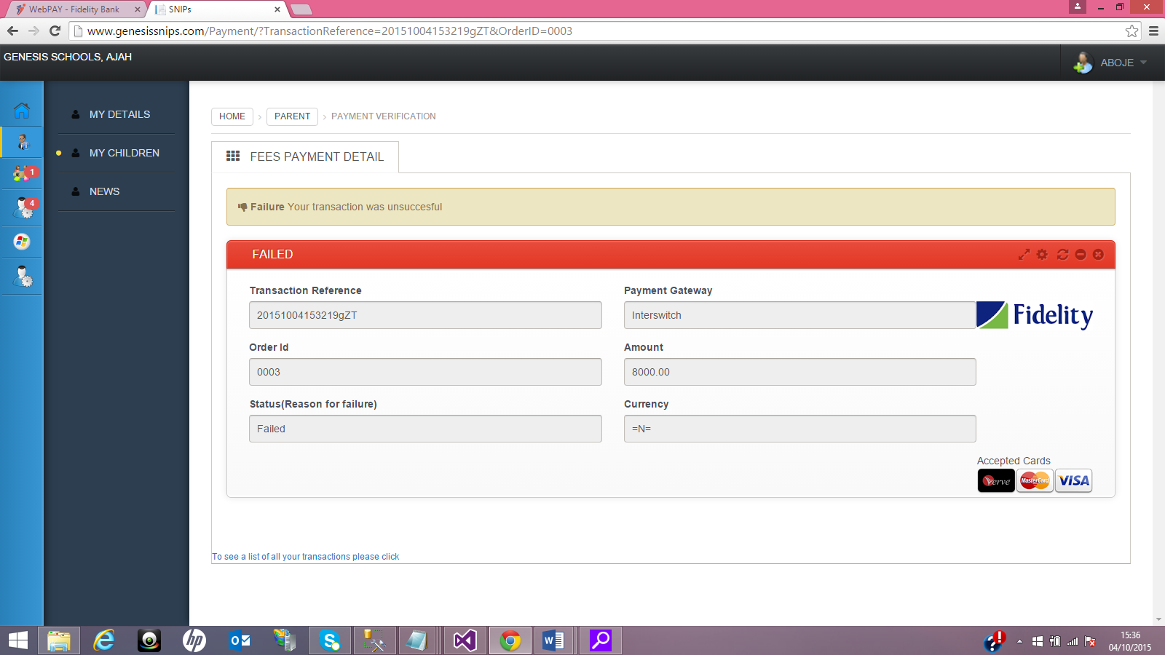

PENDING SCENARIO

