EEL101: Basic Electrical Lab Experiment No: 6 Date:

|  |  |  |  |
| --- | --- | --- | --- |
| **Batch**  **No.** |  | **Team Number** |  |
|  | **Team Member 1** | **Team Member 2** | **Team Member 3** |
| **Name** |  |  |  |
| **ID No** |  |  |  |
|  | **Team Member 4** | **Team Member 5** | **Team Member 6** |
| **Name** |  |  |  |
| **ID No** |  |  |  |

**Aim**: To perform no-load and load test on a 2 KVA single phase transformer.

**Objective:**

The objective of this experiment is to evaluate the performance and efficiency of a transformer under different load conditions. By conducting load tests, we aim to determine the maximum load capacity, efficiency, and voltage regulation characteristics of the transformer.

**Apparatus Required:**

**Single Phase Transformer (Name plate details):**

|  |  |  |
| --- | --- | --- |
| **Electrical Parameter** | **Value** | **Unit** |
| KVA Rating |  |  |
| Primary Voltage |  |  |
| Primary Current |  |  |
| Secondary Voltage |  |  |
| Secondary Current |  |  |

|  |  |  |  |
| --- | --- | --- | --- |
| **S. No.** | **Equipment** | **Specification** | **Quantity** |
| 1. | Digital Voltmeter |  |  |
| 2. | Digital Ammeter |  |  |
| 3. | Digital Wattmeter |  |  |
| 4. | Analog Voltmeter |  |  |
| 5. | Connecting leads |  |  |

**Theory:**

Transformers are essential electrical devices used to transfer electrical energy efficiently from one circuit to another through electromagnetic induction. They are widely employed in various applications such as power distribution, voltage regulation, and impedance matching. The basic principle of operation of a transformer relies on Faraday's law of electromagnetic induction and the concept of mutual inductance.

The key components of a transformer include a primary winding, a secondary winding, and a magnetic core. When an alternating current (AC) flows through the primary winding, it creates a varying magnetic field in the core. This changing magnetic field induces a voltage in the secondary winding through electromagnetic induction, resulting in the transfer of power from the primary side to the secondary side. When a circuit's state is changed, typically by applying or removing a voltage or current source, the circuit response changes over time before reaching a steady state. This change is known as the transient response.

**No-Load Test:**

The no-load test is an essential experiment conducted on transformers to evaluate their core losses and magnetizing current characteristics. It provides valuable insights into the transformer's efficiency and magnetizing impedance under no-load conditions.

During the no-load test, the secondary winding of the transformer is left open, and the primary winding is connected to a variable AC voltage source. The primary voltage is gradually increased until the rated primary voltage is reached, while the primary current and the voltage across the primary winding are measured.

Key parameters and concepts involved in the no-load test include:

**Core Losses:**

Core losses in a transformer primarily consist of two components: hysteresis losses and eddy current losses. Hysteresis losses occur due to the reversal of magnetization in the transformer's core material with each cycle of the alternating magnetic field. Eddy current losses result from the circulating currents induced in the core material due to the changing magnetic field.

**Magnetizing Current:**

Magnetizing current is the current drawn by the transformer when it is energized at no-load. It consists of two components: active component (Im) and reactive component (Ic). The active component represents the power absorbed by the core losses, while the reactive component represents the magnetizing current necessary to establish the magnetic flux in the core.

**No-Load Current:**

No-load current is the total current drawn by the transformer when it is energized at no-load. It includes both the magnetizing current and any additional current components due to losses in the winding resistance and stray losses.

**No-Load Power:**

No-load power is the power consumed by the transformer when it is operating at no-load. It is primarily due to core losses and a small component of copper losses.

The no-load test is typically performed to determine the following parameters:

No-Load Current (Io): The total current drawn by the transformer at no-load.

No-Load Power (P): The power consumed by the transformer at no-load.

No-Load Losses: The total losses in the transformer at no-load, including core losses and a small component of copper losses.

Magnetizing Current (Im): The component of current responsible for magnetizing the transformer's core.

**Full-Load Test:**

**Efficiency:**

Efficiency indicates how effectively the transformer converts electrical power from the input side to the output side. Higher efficiency values signify less power loss during the transformation process.

Power input to the transformer, P1 = sum of delivered power, iron losses and copper losses

Power output of the transformer, P2 = V2I2CosФ

Percentage Efficiency, ɳ = (P2/P1) ×100

**Voltage Regulation:**

Voltage regulation reflects the ability of the transformer to maintain a stable output voltage despite variations in load conditions. Lower voltage regulation values indicate better voltage stability.

When primary winding of transformer is energized with source of voltage V1 an e.m.f. E2 is induced across the secondary winding which is equal to secondary terminal voltage V2 at no load. On loading the transformer, the terminal voltage decreases from E2 to V2 this changing the voltage per unit no load voltage is called “voltage regulation”.

Percentage voltage regulation given by the relation.

V.R.=((E2-V1)/E2) ×100

During the load test experiment, the transformer is subjected to varying load levels, and measurements of input and output parameters are recorded. By analyzing these measurements and calculating efficiency, voltage regulation, and power factor at different load conditions, the performance characteristics of the transformer can be assessed, providing valuable insights into its operational efficiency and suitability for specific applications.

**Procedure:**

**Load Test:**

1. Make the connections as per the circuit diagram given in Fig. 1.

2. Keep the switch on primary side open so that load is zero to measure no load voltage. Also keep knob of auto transformer at zero output voltage position.

3. Now Switch on the supply and increase the voltage from auto transformer till voltage in voltmeter on the low voltage side reads 110 Volts.

4. Switch on certain lamps from the lamp load such that secondary winding current be approximately 10% of the rated current of secondary side (HV side).

5. Take the readings from Wattmeter, Voltmeter on both LV and HV sides, & Ammeter.

6. Increase the load current in steps of 10% of the rated value by switching on few more lamps & take the readings of the Wattmeter, Ammeter & Voltmeter up to full load.

7. Reduce the load to zero by switching off the lamps one-by-one.

**Circuit Diagram:**

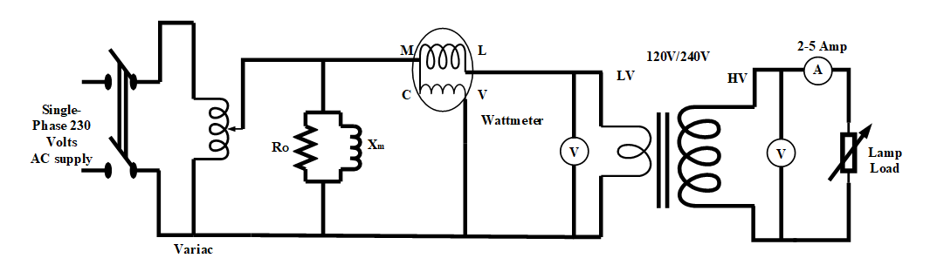

**Fig 1: Load Test on single phase transformer.**

**No-Load Test:**

1. Make the connections as per the circuit diagram given in Fig 2.

2. Keep the secondary side open so that load is zero to measure no load voltage. Also keep knob of auto transformer at zero output voltage position.

3. Now Switch on the supply and increase the voltage from auto transformer till voltage in voltmeter on the primary side reads 100 volts.

4. Now increase the voltage from the autotransformer in the steps of 20 volts and take five sets of reading till the reading reaches 200 Volts in the voltmeter on primary side.

5. Take the readings from voltmeters on primary and secondary sides and ammeter as well.

**Circuit Diagram:**

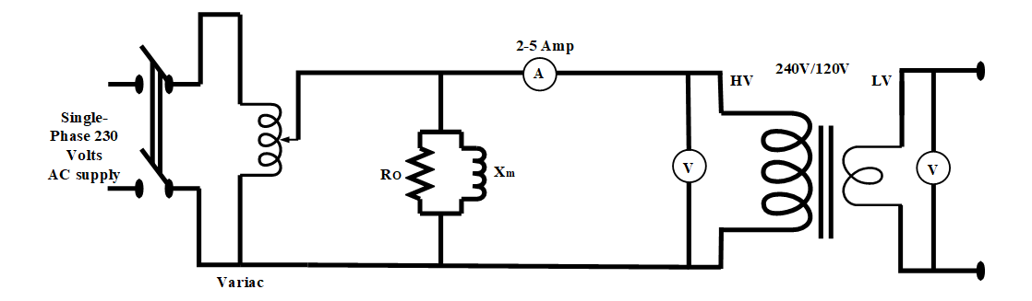

**Fig 2: Load Test on single phase transformer.**

**Observation Table:**

**Load-Test on Transformer:**

|  |  |  |  |  |
| --- | --- | --- | --- | --- |
| **S.No.** | **Voltmeter Reading (HV) Volts** | **Voltmeter Reading (LV) Volts** | **Ammeter Reading (Amps)** | **Wattmeter Reading** |
|  |  |  |  |  |
|  |  |  |  |  |
|  |  |  |  |  |
|  |  |  |  |  |
|  |  |  |  |  |

**No-Load Test on Transformer:**

|  |  |  |  |
| --- | --- | --- | --- |
| **S.No.** | **Voltmeter Reading (HV) Volts** | **Voltmeter Reading (LV) Volts** | **Ammeter Reading (Amps)** |
|  |  |  |  |
|  |  |  |  |
|  |  |  |  |
|  |  |  |  |
|  |  |  |  |

**Precautions:**

1. Switch on the power supply only in the presence of TAs.
2. Always wear shoes while performing the experiment and entering into the lab.
3. Instruments used should be of proper range.
4. All the connections should be tight.
5. Give the supply through auto transformer only by gradually rotating the knob. Do not operate the autotransformer abruptly and before switching on the supply keep the know of the autotransformer to zero position.
6. Never touch live conductors or Terminals.

**Post Lab Questions:**

1. Explain the regulation of a transformer?
2. What is the condition for maximum efficiency of a transformer?
3. Explain all day efficiency and commercial efficiency of a transformer?
4. What are the various losses occurring in the transformer?