Question 1: By default are django signals executed synchronously or asynchronously? Please support your answer with a code snippet that conclusively proves your stance. The code does not need to be elegant and production ready, we just need to understand your logic.
Answer: By default, django signals are executed synchronously. To prove this, a program was created to inspect the thread ID during execution, where the signal sender and the signal receiver would be run on the exact same thread. As for the implementation in code, a test endpoint was used to capture the thread name, fire a signal and capture the thread name in the receiver.
File: answers\views.py
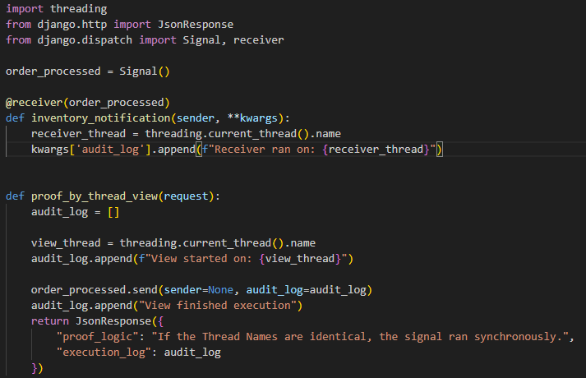
File: answers\urls.py
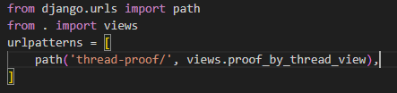
On running the server with python manage.py runserver and visiting http://127.0.0.1:8000/thread-proof/ the output is:
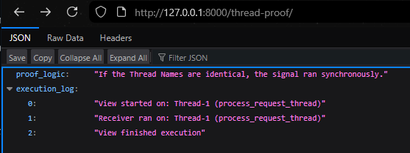
Question 2: Do django signals run in the same thread as the caller? Please support your answer with a code snippet that conclusively proves your stance. The code does not need to be elegant and production ready, we just need to understand your logic.

Answer: Yes, Django signals run in the same thread as the caller. To prove this, the system ID thread used by both the caller and the receiver can be inspected, to find whether they match and thus execute in the same thread context. Code can be implemented to compare the thread ID of the caller against that of the receiver in the following way.
File: answers\views.py
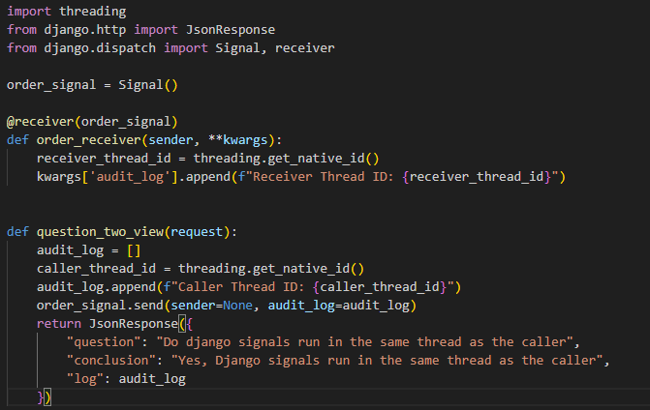
File: answers\urls.py
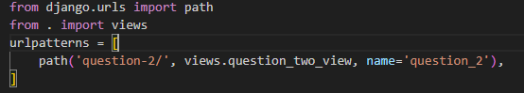
On running the server with python manage.py runserver and visiting http://127.0.0.1:8000/question-2/ the output is:
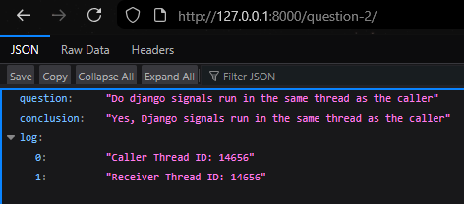
Question 3: By default do django signals run in the same database transaction as the caller? Please support your answer with a code snippet that conclusively proves your stance. The code does not need to be elegant and production ready, we just need to understand your logic.
Answer: Yes, django signals run in the same database transaction as the caller. To prove this, transaction.atomic() is utilized to create a transaction block. Inside this block, a database operation is executed, a signal is fired (which performs its own database operation) and then an exception is intentionally raised to force a rollback. If the signal runs in the same transaction, its database changes will be reverted along with the caller's changes.
A model AuditEntry was created along with a view that attempts to write to it, fires a signal, and then rolls back.
File: answers\models.py
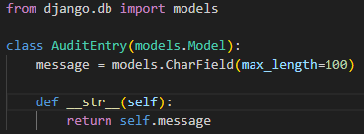
File: answers\views.py
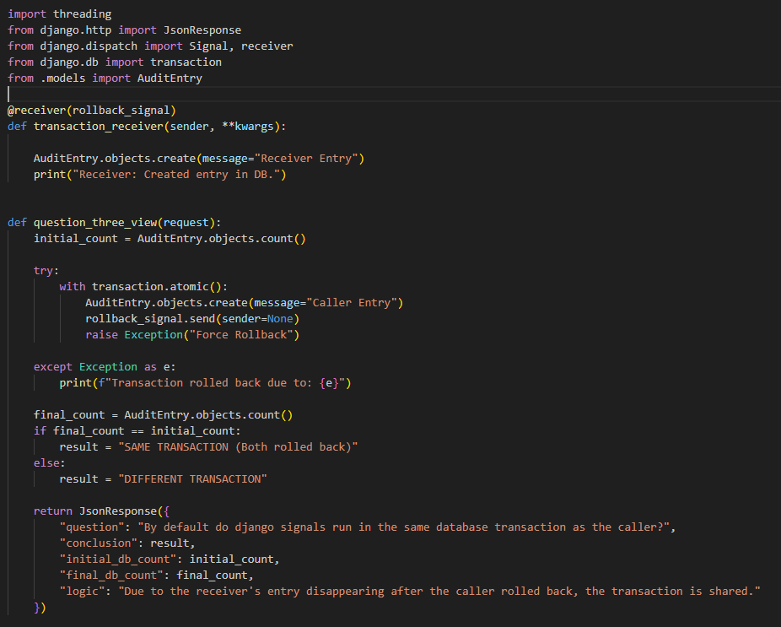
File: answers\urls.py
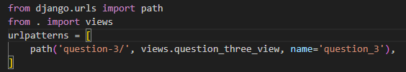
On visiting http://127.0.0.1:8000/question-3/, we get:
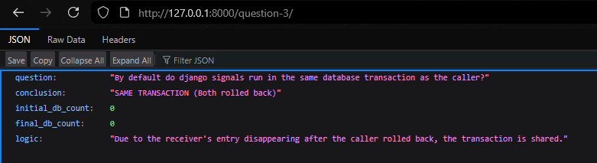
Conclusion: If the receiver runs in the same transaction, its data will also be rolled back (disappear). If it ran separately, its data would persist despite the caller's error.

Topic: Custom Classes in Python

Description: You are tasked with creating a Rectangle class with the following requirements:

- An instance of the Rectangle class requires length:int and width:int to be initialized.
- We can iterate over an instance of the Rectangle class
- When an instance of the Rectangle class is iterated over, we first get its length in the format: {'length': <VALUE_OF_LENGTH>} followed by the width {width: <VALUE_OF_WIDTH>}

Answer: The Rectangle class was implemented within the Django project to demonstrate its functionality via a web view.
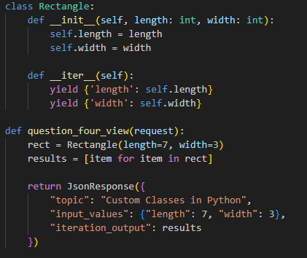
Visiting http://127.0.0.1:8000/question-4/, we get:
