Project #1

CA Roulette

CSC-05-45277

Abel Calderilla

17 July, 2016

**Introduction:**

Title: CA Roulette

This game is the California version of Roulette.

The idea of this game is a random number generator will act as a roulette wheel and the user will pick a number between 0 and 36. It also allows the user to pick an even/odd number, choose black/red, choose a street or a double street. If the user gets the right number or color, he/she will win money if the user bets money.

This game is for enjoyment purposes and not meant to be used for gambling.

**Summary:**

Project size: 85 lines

The # of variables: 15 variables

The # of methods: 4 methods

This project has four different methods in the application with more methods available to be put in the next project. I could add a pause function while doing a regular bet to make an inside bet in the random number generator, and make the app run as many times the user wants it to run. Also I could possible add a user interface to give the chance that the user wants to make an inside bet or not.

This app took me about two days to make and it is not the final version of the app. I wanted to add more into the app but I could not because there are still more lessons to be learned to complete my project. I originally wanted to make an app that makes the user input types of words and numbers that will return make a funny story as the output.

**Flow chart:**

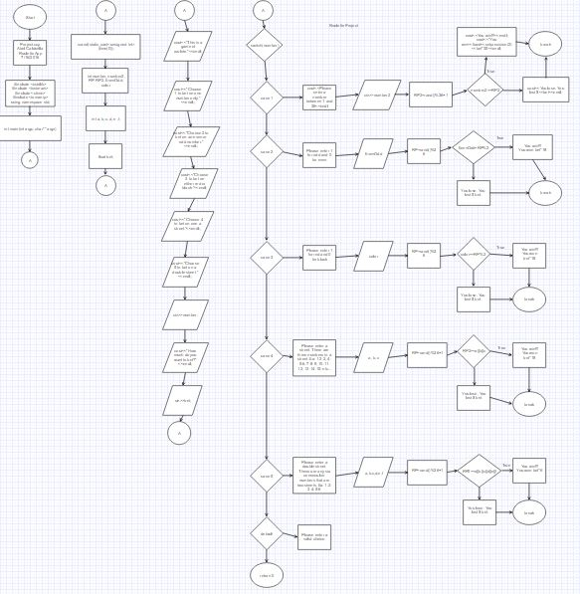

**Code comments:**

* File: Project.cpp

* Author: Abel Calderilla

* Roulette App

* Created on July 16, 2016, 10:31 PM

*/

#include <cstdlib> //cstandard library//

#include <iostream> //standard output//

#include <ctime> //random number generator//

#include <iomanip> //output//

using namespace std;

/*

*

*/

int main(int argc, char** argv) {

srand(static_cast<unsigned int>(time(0))); //random number generator//

int number,number2, RP, RP2, EvenOdd, color; //variables//

int a, b, c, d, e, f; //variables//

float bet; //variables//

//Menu//

cout<<"This is a game of roulette."<<endl;

cout<<"Choose 1 to bet on one number only."<<endl;

cout<<"Choose 2 to bet on an even or odd number."<<endl;

cout<<"Choose 3 to bet on either red or black."<<endl;

cout<<"Choose 4 to bet on street."<<endl;

cout<<"Choose 5 to bet on a double street."<<endl;

cin>>number;

cout<<"How much do you want to bet?"<<endl;

cin>>bet;

switch(number){

case 1: //case 1//

cout<<"Please enter a number between 1 and 36."<<endl;

cin>>number2;

RP2=rand()%36+1; //random number generator//

if(number2==RP2){

cout<<"You win!!!"<<endl;

cout<<"You won $ "<<fixed<<setprecision(2)<<bet*35<<endl;

break;

}else{

cout<<"You lose. You lost $"<<bet<<endl;

break;

}

case 2: //case 2//

cout<<"Please enter 1 for odd or 0 for even."<<endl;

cin>>EvenOdd;

RP=rand()%36; //random number generator//

if(EvenOdd==RP%2){

cout<<"You win!!!"<<endl;

cout<<"You won $ "<<fixed<<setprecision(2)<<bet*18<<endl;

break;

}else;{

cout<<"You lose. You lost $"<<bet<<endl;

break;

}

case 3: //case 3//

cout<<"Please enter 1 for red or 0 for black."<<endl;

cin>>color;

RP=rand()%36; //random number generator//

if(color==RP%2){

cout<<"You win!!!"<<endl;

cout<<"You won $ "<<fixed<<setprecision(2)<<bet*18<<endl;

break;

}else{

cout<<"You lose. You lost $"<<bet<<endl;

break;

}

case 4: //case 4//

cout<<"Please enter a street. These are three numbers in a row."<<endl;

cout<<"Ex: 1-2-3, 4-5-6, 7-8-9,10-11-12, 13-14-15, etc..."<<endl;

cin>>a>>b>>c;

RP2=rand()%36+1; //random number generator//

if(RP2==(a||b||c)){

cout<<"You win!!!"<<endl;

cout<<"You won $"<<fixed<<setprecision(2)<<bet*12<<endl;

break;

}else{

cout<<"You lose. You lost $ "<<bet<<endl;

break;

}

case 5: //case 5//

cout<<"Please enter any double street.These are any six consecutive"<<endl;

cout<<"numbers that are two streets. Ex: 1-2-3-4-5-6."<<endl;

cin>>a, b, c, d, e, f;

RP2=rand()%36+1;//random number generator//

if(RP2==(a||b||c||d||e||f)){

cout<<"You win!!!"<<endl;

cout<<"You won $"<<fixed<<setprecision<<bet*6<<endl;

break;

}else{

cout<<"You lose. You lost $ "<<bet<<endl;

break;

}

default: //default output if user does not input a choice//

cout<<"Please enter a valid choice."<<endl;

return 0;

}

}