SC1102: R Bootcamp Week 2
2026 Trimester 3
Table of Contents

← Back to the SC1102 course page

Welcome back to R
Oh, you’re still here! Great!
Clearly last week was so intellectually stimulating, you’ve come back for more. Well good news, this week we are tacking reproducibility!.
What is reproducibility I hear you ask?
Great question! Reproducibilty is the ability to reproduce a set of results given an input dataset and an accurate set of methods. In science, there aren’t many concepts more important than reproducbility. If you conduct a bunch of analyses or experiments to obtain a set of results, but the next person to attempt what you did can’t do so because either the initial input data is missing or corrupted, or the methodology by which you obtained your results is incomplete or inaccurate, you may as well have not done the analysis in the first place. If your scientific argument is based on an intellectual framework something like this:

then it might be time to step away from the science and head back to tiktok.
But it’s not just in science where reproducibility matters.

The need to publish your methods and workflows in a reproducible way is absolutely critical, but the problem is, it’s often incredibly boring and tedious. Luckily for you, we’re working in R where producing reproducible code is baked into the fabric of the whole language. Last week we learnt some basic commands in order take in some data, manipulate it and process it but the issue is that what we did can’t be easily recreated because it was all written and executed in the console. If I were to ask you right now to reproduce the final plot we created last week, you’d have to write out all the lines of R code again in order to do so. What we need is a way to save our code so that we can execute it on demand, whenever we like with the confidence that we’ll end up with exactly the same set of results each time. What we want is automatable, deterministic code.
So today, rather than typing code into the console, we are going to build an R script. To launch a new one, click File/New File/R script and you’ll see it open up in the top left panel of RStudio.
The first thing we typically do is write a comment line at the top with the name of the script and any extra information you’d like to provide users, after which we save it as a .R file. Last week I briefly mentioned comments but from now on, comments become critical. In case you don’t remember, a comment is a line of text or code that is preceded with a # character. In R, anything following a # will not be executed which means we can use this symbol to annotate our code in order to make it easier for other users or future versions of ourselves to read. It’s much easier to read a line of free text than trying to interpret an often convoluted code base and so we use comments wherever we have code in order to make it clear what the code does and why its there.
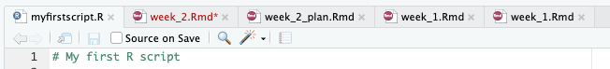
See in that first tab I have named my script myfirstscript.R. You can do the same by saving yours into a logical location in your directory. Last we we spoke about good folder structure and so while keeping that in mind, create a new folder using whatever method you like ensuring that your naming system is consistent and logical, and then save your new script there by clicking File/Save As.
Next up we’ll do something that is a little pedantic but I’m including it here to reinforce what it means to produce truly reproducible R code. We are going to check what version of R we are using and we’re going to write a a couple of lines that will warn users of our code if they are about to use a different version of R to the one it was initially created with. 99% of the time, if someone has a slightly different version of R, the code will still execute perfectly but occasionally new updates will include changes that alter how code may be interpreted. This can sometimes kill the code outright so that it doesn’t execute, or it might alter the type of output produced. Here’s the code block:
# Check your current version of R
R.version.string
## [1] "R version 4.5.1 (2025-06-13)"
For me, the version is 4.5.1, for you probably something else. We’re now going to store this string as a variable and execute a block of code to test whether the currently used version is the same or not. Of course here it will be exactly the same but if you were to later try to execute this on another machine, it may not be the case.
# Create the variable from the output of the command
R_version <- R.version.string
# Perform the test
if(R_version == "R version 4.5.1 (2025-06-13)") {
print("R version 4.5.1")
} else {
print("You are using a different version of R. Switch to version 4.5.1 to ensure reproducibilty")
}
## [1] "R version 4.5.1"
What we just did was an if-then-else statement which is common to many languages. They way it works is you say if some condition is met, then do this particular thing, but if it’s not true (else) then do this other thing. In R, then is not written explicitly, it’s implied by the open { curly brace.
So to break this down, what the code says is, if your version of R is 4.5.1, that is the output of the R.version.string command is precisely R version 4.5.1 (2025-06-13), then print the text R version 4.5.1, however if the output of R.version.string is anything else, print that long line of text instead. This code will not kill anything, it will just provide the user with the information that they are using a different version of R to the one that was intended by the programmer (you!) and so to proceed with caution.

So, is this it or are we actually going to do something today?
Great question, past me! We are in fact, going to do something and that something is produce a script that takes in a dataset that you’ve seen before, perform a bunch of functions on it and then create a few plots. The fun part though is that at the end of this process, we’re going to share the script we’ve written with one of our classmates to see whether or not they can run the code as it was intended, and produce the results exactly as we had done ourselves. If we can achieve this, then we can be sure that we’ve created reproducible code that will produce a consistent result regardless of who runs it.
First up, the data. We’re going to work with the paramecium population growth data you saw in the first section of this course and you can download a copy of this from the tutorial website. As we mentioned last week, directory structure is critically important so download this file to a logical place on your machine so we can find it easily to import it.
Now I want to introduce the concept of a working directory. This is a directory that you specify, usually at the top of your script that acts like your home base. Any file in this directory will be accessible directly from R and any file outside of it can be reached using a relative or a full path. Let’s set our working directory, import the data set we just downloaded and then produce a quick scatter plot to look at it. Remember, this week we are building a script so make sure you do this in the top left panel in your script and not just in the console in the bottom left panel.
# Set working directory
setwd("~/Documents/teaching/2026/TR3/SC1102/tutorial_2")
# Import the dataset which is located in this directory
paramecium <- read.csv("Paramecium_aurelia.csv")
Now produce a simple plot to visualise the data.
# Produce a simple scatter plot of the data
plot(paramecium$Time..days., paramecium$Paramecium,
# pch tells it what shape point to plot
pch = 19,
xlab = "Time (days)",
ylab = "Population size (N)",
main = "Paramecium population growth")
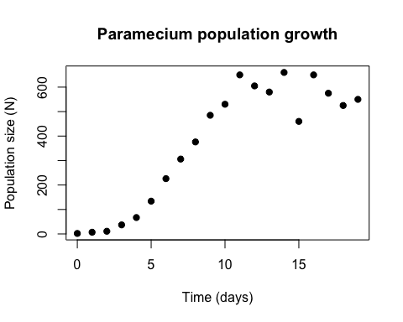
First, let’s fit a linear model. In a linear model, the population increases by the same amount each day. The formula for a linear fit is:
$$N=a+b*Time$$
Where:
N = Number of individuals
a = y intercept when time = 0
b = the slope ie. the rate of change of N per day
So what we need to do is to work out the slope and the y intercept. There are two ways we could do this, the long but clearly presented way that includes all working, or the short and slightly obfuscated way that abstracts away all the maths. The short way, which is the way most sane people would use in R is to use the lm() function built into R.
# Model a linear fit
linear_fit <- lm(Paramecium ~ Time..days., data = paramecium)
# Then have a look at the results
linear_fit
##
## Call:
## lm(formula = Paramecium ~ Time..days., data = paramecium)
##
## Coefficients:
## (Intercept) Time..days.
## 17.91 37.25
So the intercept is at 17.91 and the slope is 37.25, making the formula:
$$N=17.91+37.25*Time$$
Now the more difficult way would be to calculate the slope and the y intercept by hand calculating the slope b:
$$b=\frac{∑\left(xi​−\overset{‾}{x}\right)\left(yi​−\overset{‾}{y}​\right)}{∑{\left(xi​−\overset{‾}{x}\right)}^{2}}$$
and the y intercept a
$$a=\overset{‾}{y}​−b\overset{‾}{x}$$
Where:
x = time in days
y = number of paramecium
x_bar = mean(x)
y_bar = mean(y)
Now while this looks like lots of fun and it actually shows the maths behind the calculations, in reality people are always going to go along with using well established, built in functions in the place of writing everything out long form.
Let’s plot the trend line calculated using the lm() function.
# Produce the same scatter plot of the data
plot(paramecium$Time..days., paramecium$Paramecium,
# pch tells it what shape point to plot
pch = 19,
xlab = "Time (days)",
ylab = "Population size (N)",
main = "Paramecium population growth")
# Overlay the trendline
abline(linear_fit, col = "red", lwd = 2)
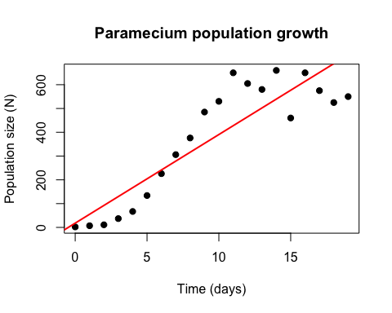
# Check out the R2 (Multiple R2) value
summary(linear_fit)
##
## Call:
## lm(formula = Paramecium ~ Time..days., data = paramecium)
##
## Residuals:
## Min 1Q Median 3Q Max
## -175.69 -84.23 -15.67 88.51 222.32
##
## Coefficients:
## Estimate Std. Error t value Pr(>|t|)
## (Intercept) 17.914 49.977 0.358 0.724
## Time..days. 37.251 4.497 8.283 1.49e-07 ***
## ---
## Signif. codes: 0 '***' 0.001 '**' 0.01 '*' 0.05 '.' 0.1 ' ' 1
##
## Residual standard error: 116 on 18 degrees of freedom
## Multiple R-squared: 0.7922, Adjusted R-squared: 0.7806
## F-statistic: 68.61 on 1 and 18 DF, p-value: 1.488e-07
Even though the R2 value isn’t too bad, we should all know that a linear trend is not realistic for modelling natural population growth. The only reason we get an R2 as good as we do is because the experiment was terminated only just after population growth appears to have ceased. What do you think might have happened to the R2 if the experiment had been allowed to carry on for another 10 or 100 days?
Let’s try test out a geometric or exponential model, which you’ll remember states that the rate of change is proportional to the current population size, independent of population density. First we’ll visualise this on a production function G(N) vs N for the population.
# Create an integer vector of all but the final final number of observations
N_t <- paramecium$Paramecium[-20]
# Calculate lambda (N_t+1/N_t)
lambda <- paramecium$Paramecium[-1] / N_t
# Calculate R
R <- lambda - 1
# Calculate G(N) as RN
GN <- R*N_t
# Plot N_t vs R
plot(N_t, GN,
pch = 19,
xlab = "N",
ylab = "G(N)",
main = "Production function")
# Geometric: G(N) = RN, a straight line through the origin
abline(a = 0, b = mean(R), col = "blue")
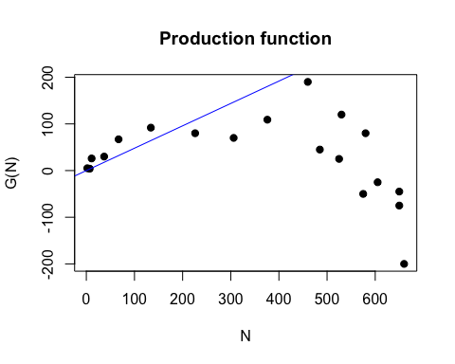
#
R_fit <- lm(R ~ N_t)
Again, we could manually calculate everything we need for a geometic model of our data, or we could go with using a built in function. Let’s just go with the function nls() (Nonlinear Least Squares).
# Use the nls() function to calculate the geometric model
# N0 = N in first row, R = the estimated growth rate (37% from linear model)
geometric_fit <- nls(Paramecium ~ N0 * (1 + R)^Time..days.,
data = paramecium,
start = list(N0 = 2, R = 0.4))
summary(geometric_fit)
##
## Formula: Paramecium ~ N0 * (1 + R)^Time..days.
##
## Parameters:
## Estimate Std. Error t value Pr(>|t|)
## N0 165.09122 43.00863 3.839 0.001203 **
## R 0.08123 0.01909 4.256 0.000476 ***
## ---
## Signif. codes: 0 '***' 0.001 '**' 0.01 '*' 0.05 '.' 0.1 ' ' 1
##
## Residual standard error: 153.8 on 18 degrees of freedom
##
## Number of iterations to convergence: 17
## Achieved convergence tolerance: 6.75e-06
nls() doesn’t calculate an R2 value so we’ll have to do it manually.
# Calculate residual sum of squares
rss_geometric <- sum(residuals(geometric_fit)^2)
# Calculate total sum of squares
tss_geometric <- sum((paramecium$Paramecium - mean(paramecium$Paramecium))^2)
# Calculate R2
r2_geometric <- 1 - rss_geometric/tss_geometric
r2_geometric
## [1] 0.6346182
Now let’s overlay this trend line on our plot. Unfortunately this isn’t quite as simple as with the linear regression
# Produce the same scatter plot of the data
plot(paramecium$Time..days., paramecium$Paramecium,
# pch tells it what shape point to plot
pch = 19,
xlab = "Time (days)",
ylab = "Population size (N)",
main = "Paramecium population growth")
# Create 200 evenly spaced points on the x axis between 0 and 19
time_seq <- seq(0, 19, length.out = 200)
# Use predict() to predict the values of y at these points given our model
pred <- predict(geometric_fit, newdata = data.frame(Time..days. = time_seq))
# Join up these points to create a curve
lines(time_seq, pred, col = "blue", lwd = 2)
# Put the linear regression line on here too
abline(linear_fit, col = "red", lwd = 2)
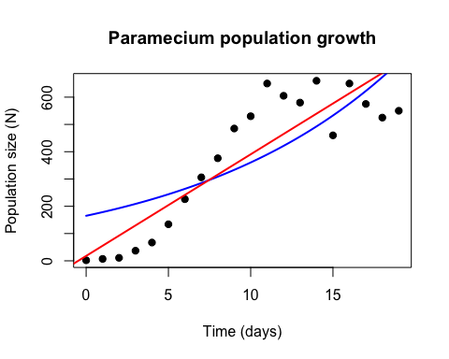
Total rubbish. Let’s try our third and final fit - logistic regression. Remember,
# Extract out all but the final (20th) row
N <- paramecium$Paramecium[-20]
# Create a numeric vector of the growth rate by dividing the difference in population size from one day to the next by the actual number on the previous day
R <- diff(paramecium$Paramecium) / N
# Plot per capita increase (R) vs population size (N)
plot(N, R, pch = 19, xlab = "N", ylab = "R")
R_fit <- lm(R ~ N)
abline(R_fit, col = "red")
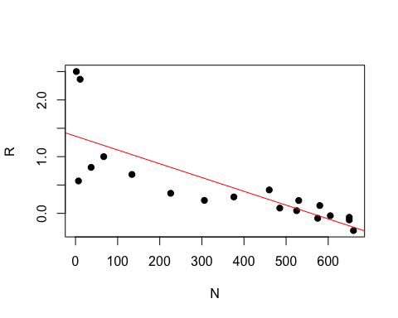

SC1102 R Bootcamp, James Cook University. Course home

