**Note:** Save this document in .docx format (preferred) or .rtf format (Rich Text Format, if you do not have Microsoft Word; suggest using WordPad.)

1. Analysis of the Problem
   1. A clear and precise statement of what the program needs to accomplish.

The program needs to calculate total ticket sales after each game. This includes money and number of tickets sold.

* 1. What data is available, if any, and what may be assumed.

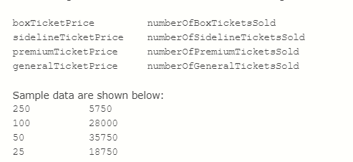The data provided is to be assumed. Assume prices are integers and file names and direction as strings.

* 1. What output is desired and the form it should take.

The output desired is that it saves in a separate txt file. Outputting to the shell is not what is desired. You have to add ofstream outfile and tell the machine to save to the specified file.

1. Algorithm
   1. Look at the detailed problems at the end of each chapter and answers at the end of the text to see how the algorithm should be presented.
   2. This should not be code, but pseudo-code, an English description of the steps the program will take.
   3. Include any equations.
   4. Another programmer should be able to code the program from this algorithm.

Declare variables as int by their price and number of tickets.

Declare totalTickets and Total Amount as a double.

Tell the machine to read from an input file instead of prompting the user to input data manually.

Tell the machine to save to an outfile, instead of through the shell.

Specify the price with the appropriate ticket type.

Calculate the total amount of tickets

totalTickets = (numBoxTickets + numSidelineTickets + numPremiumTickets + numGeneralTickets);

Calculate the total amount of tickets sold

totalAmount = (numBoxTickets * 250

+ numSidelineTickets * 100 + numPremiumTickets * 50

+ numGeneralTickets * 25);

Display output to output file and close input and output files.

Cout to the output file and return.

1. User Documentation
   1. What a user must do to use the program - be detailed, write it for that grandparent who does not even own a cell phone.
   2. Assume the user is sitting in front of your program as it has just started running - you do not need to describe how to launch the program (through Visual Studio or any other means.)
   3. Include what to expect for input, where to find output and how to terminate the program.

Since these are pulled from the files provided, all that must be done is tell the machine to open those specific files. Debug to run the program and check the results in the chosen output file. The input is provided (see question 1a to see a snapshot of the data). Find the output in the same file as the program. For me, that is C:\Users\Lina\source\repos\CampbellProject3

To terminate the program, simply exit out of Visual Studio 2019 by pressing the X at the top right corner.