To:
M+M Arquitectos
Carrer de Balmes 200
08006 Barcelona, Spain
Att.:
Laura Martin
Carlos Vega
Offer N: 042
End client: Garcia Family (private)
Carrer Major 18, 08870 Sitges
Site: Sitges 042
Date: 22 May 2026
Offer drafted by: Javier Soler
javier@maderapro.example
+34 600 000 000
SUBJECT: Supply and on-site assembly of a wooden-structure villa
With reference to your kind request, please find below our best offer for the design, supply and on-site assembly of the works described hereunder.
1. GENERAL INFORMATION
1.1 Dimensional characteristics
Description | m2 (*) | Coeff | m2 commercial | Slab check m2
Ground floor (P0) - habitable | 115 | 100% | 115
First floor (P1) - habitable | 110 | 100% | 110 | 110
First floor (P1) - terrace | 30 | 30% | 9 | 30
Attic (P2) - technical | 15 | 100% | 15 | 15
Roof | 150 | 0% | 0 | 150
(*) Areas measured from the architectural drawings supplied by the client.
Scope of intervention: from ground floor (P0) to attic (P2).
1.2 Structural design of the wooden structures
- Structural calculation according to Limit State Design (ULS and SLS)
- Construction drawings and connection details
1.3 Normative reference (by priority)
- Eurocode 5 - EN 1995-1-1 (design of timber structures)
- Eurocode 1 - EN 1991 (actions on structures)
- EN 14080:2013 - Requirements for glued laminated timber
- Local Catalan building regulations (CTE - Codigo Tecnico de la Edificacion)
1.4 Loads considered for the preliminary design

The structures covered by this proposal are designed using the following values:
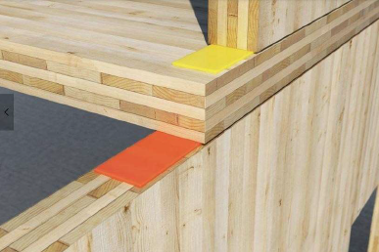

Permanent non-structural load (excluding self-weight of the wooden structure)  - Intermediate slab  - Roof slab | 3.50 kN/m2  1.00 kN/m2  1.50 kN/m2
Live load applied to slabs  - Intermediate slabs (residential)  - Terraces | 2.00 kN/m2  4.00 kN/m2
Snow load on the ground (coastal Catalonia, Sitges area, ~50 m a.s.l.) | 0.40 kN/m2
The Client accepts these values and undertakes to ensure they are respected in the construction and operation of the work, promptly communicating any proposed variation and/or non-conformity.
MaderaPro SL will not be liable for uses or building typologies different from those for which the work was originally requested.
1.5 Documentation received
For the preparation of this offer the following documents received from the client have been used:
- Architectural floor plans (ground, first floor, attic) - PDF, May 2026
- Site sections and elevations - PDF, May 2026
- Project notes from the call of 19 May 2026
SCOPE OF SUPPLY
SOLUTION 1 - SHELL ONLY (Structure)
STRUCTURE
External walls
Supply and assembly of load-bearing perimeter walls made of X-lam / CLT panels, cross-laminated boards, board strength class C24, non-visible quality, untreated, 5 layers, total thickness 140 mm.
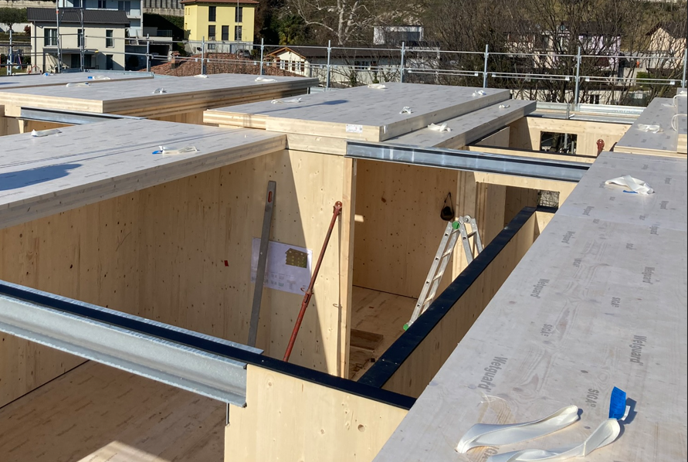
Internal load-bearing walls
Supply and assembly of internal load-bearing walls made of X-lam / CLT panels, cross-laminated boards, board strength class C24, non-visible quality, untreated, 5 layers, total thickness 100 mm.
Intermediate slab
Supply and assembly of intermediate slab composed of:
- X-lam / CLT cross-laminated panels, board strength class C24, non-visible quality, untreated, 5 and 7 layers
- Self-adhesive temporary waterproofing membrane on the entire slab, including the external terrace
Roof slab
Supply and assembly of pitched roof slab composed of:
- X-lam / CLT cross-laminated panels, board strength class C24, non-visible quality, untreated, 5 and 7 layers
- Self-adhesive temporary waterproofing membrane
Roof parapet (veletta)
Roof containment parapet made with X-lam panels, projecting 15 cm above the external edge of the roof finish, for insulation containment.
Terrace parapets
Solid terrace parapets made with X-lam panels, 100 mm thick, 3 layers.
Staircase and lift shaft
Staircase and lift shaft in reinforced concrete - by the client (excluded from this offer).
Steel carpentry structural elements
Supply and assembly of steel carpentry for fixing the structure, composed of:
- Steel beams made of standard commercial profiles, hot-dip galvanised, to support the intermediate slab
- Plates and angle brackets for fixing walls and slabs
- Plates for fixing the roof beams
- Various screws and bolts
Miscellaneous
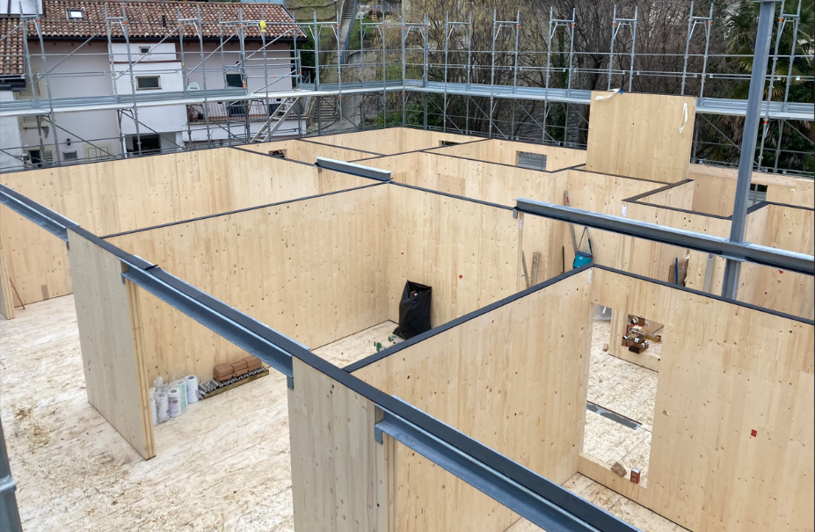
- Vapour barrier at the base of the ground-floor perimeter walls, fixed to the rough internal floor and folded up onto the timber wall
- Anti-noise strips between slabs and walls for damping vibration transmission
- Internal tapings and sealings for the air-tightness of the building envelope
- Steel base flashing (root) for protection of the walls at the ground connection
PROJECT MANAGEMENT AND SITE COORDINATION
Engineering
Executive design by our technical office, including:
- Structural calculation and 3D modelling
- Calculation report
- Construction drawings for prefabrication
- Assembly drawings of the structures
- Details of the main nodes (wall-to-ground, wall-window-envelope, roof insulation to facade)
Site coordination
Site management through a dedicated project manager who will coordinate our scope of work and interface with the site supervisor and the architects.
TOTAL SOLUTION 1 EUR 295,000.00 + VAT
SOLUTION 2 - ADVANCED SHELL (Structure + Envelope + Windows)
In addition to what is supplied in Solution 1, the following items are offered:
EXTERNAL WALL FINISH
External insulation
External insulation of the perimeter walls composed of (from inside to outside):
- Wood-fibre insulation panels, 200 mm thick
- Ventilated facade structure with battens and counter-battens
- Larch cladding boards, vertical orientation, natural finish
Terrace soffit cladding
Soffit cladding composed of:
- XPS plaster-carrier panel, 20-40 mm thick
- Skim coat with reinforcement mesh and coloured silicone final render
Parapet cladding
Cladding on both sides of the parapets composed of:
- XPS plaster-carrier panel, 20-40 mm thick
- Skim coat with reinforcement mesh and coloured silicone final render
ROOF PACKAGE AND METAL FLASHINGS
Pitched roof package
External insulation of the pitched roof composed of (from inside to outside):
- Vapour barrier, taped and sealed
- Wood-fibre insulation, 240 mm thick
- Ventilation gap, battens and counter-battens
- Ceramic tile final finish on a continuous waterproofing membrane
Metal flashings
Various pre-painted aluminium flashings composed of:
- Flashing above the roof parapet
- Flashings for the terrace parapets
- Downpipes to ground including elbows and fixing brackets
Terrace waterproofing
Terrace waterproofing composed of:
- Spruce battens for slope formation with wood-fibre insulation interposed where heated rooms are below
- OSB panel 22 mm for laying the waterproofing membrane
- Synthetic TPO/PVC waterproofing membrane
Note: terrace floor finish excluded.
WINDOWS AND EXTERNAL OPENINGS
External windows
External windows in aluminium-clad timber, triple glazing, double cavity, with the following indicative characteristics:
- Ug indicative: 0.6 W/m2K
- Glass stratigraphy (indicative): 4-4 - 14 Argon - 4 - 14 Argon - 4-4
Average unit size: 1.4 x 2.2 m. Total quantity: 14 units, ~43 m2 of opening area.
External shutters (manual)
External orientable louvre shutter system, aluminium S-profile, colour to be selected from the supplier swatch, manual operation. Electrical connections excluded.
Entrance door
Entrance door on the stair side, glazed aluminium, colour to be selected from the swatch.
Sills and thresholds
Aluminium sills and thresholds, RAL colour to be selected from the swatch.
MISCELLANEOUS SITE ITEMS
Scaffolding
Facade scaffolding, assembled to current regulations, planned for 3 months.
Should the site duration extend beyond this period for reasons not attributable to MaderaPro SL, monthly rental costs of EUR/m2 3.00 will be invoiced separately.
Site crane
Rental of self-erecting site crane, including transport, assembly and disassembly, planned for 3 months, including the operator with valid licence.
Should the site duration extend beyond this period for reasons not attributable to MaderaPro SL, monthly rental costs of EUR 2,200.00 will be invoiced separately. Any ancillary building works required to position the crane are excluded.
TOTAL SOLUTION 2 EUR 585,000.00 + VAT
SOLUTION 3 - ADVANCED SHELL + INTERNAL PLASTERBOARD
In addition to what is supplied in Solution 2, the following items are offered:
INTERNAL PLASTERBOARD
Counter-walls
Counter-walls applied to the X-lam walls, composed of steel or timber studs 50 mm thick, with mineral wool insulation interposed and a double plasterboard layer 12.5 + 12.5 mm. Includes joint sealing, skim coat and finishing - ready for painting.
Internal partitions
Internal non-load-bearing partitions made of steel or timber studs 75 mm thick, with mineral wool insulation interposed and a double plasterboard layer 12.5 + 12.5 mm on both sides. Includes joint sealing, skim coat and finishing - ready for painting.
Suspended ceilings
Suspended ceiling fixed to the slab, composed of a steel or timber structure 50 mm thick and a single plasterboard panel 12.5 mm. Includes joint sealing, skim coat and finishing - ready for painting.
TOTAL SOLUTION 3 EUR 695,000.00 + VAT
ITEMS INCLUDED IN THE OFFER
- Specialised workforce, including salary and social-security contributions according to national collective agreements
- Two-year postuma insurance covering 10% of the value of the works, in line with European standard practice
- Catering service for the workers
- Transfer of the workers to the site
- Cleaning of the work areas (waste disposal at landfill excluded)
- Transport of materials to site (unloading and trans-shipments excluded, road accessible to articulated truck assumed)
For Solutions 2 and 3 only:
- Site crane for the handling of the prefabricated elements, including operator
- Scaffolding compliant with regulations, required for the assembly
- Crane operator with valid national licence
EXCLUSIONS
- Site installation and temporary works
- Excavation and demolition works
- Concrete works (basement, lift shaft, staircase, external works)
- Stair-shaft finish
- Mechanical, electrical, plumbing and photovoltaic systems
- Plaster works (internal and external)
- Internal screeds
- Internal and external floor finishes
- Internal finishes (paint, decorative works)
- Carpentry and joinery works
- Site assistance to the MEP contractors (strongly recommended to guarantee air- and wind-tightness when systems penetrate the envelope) - quoted separately if required
- External landscaping
- Anything not explicitly described in this offer
OTHER OBLIGATIONS OF THE CLIENT
- Building permit, of which the client is the guarantor
- Architectural design and related administrative procedures
- Any counter-plates to be embedded in concrete pours
- Reinforced concrete kerb / curb for the wooden structure to rest on, including any levelling with non-shrink mortar
- Internal accessibility to the work area, free from obstacles for workers and articulated trucks
- Supply of all temporary safety works as per the safety plan prepared by the client
- Electrical and water supply at the workplace
- Provision of a storage area for materials, vehicles and equipment
- Stand-by hours for causes not attributable to us
- Site assistance for building trades
- Design of concrete structures
- Disposal of site residues
- Any fees for occupation of public land
- Any trans-shipments if necessary
- Anything not explicitly listed in the previous pages or under "Items included in the offer"
POSSIBLE HOURLY-RATE WORK
Hourly cost for time-and-material work EUR/h 75.00 + VAT
WARNINGS
WARNINGS ON THE CHARACTERISTICS OF TIMBER MATERIAL
For those who are not familiar with glulam and solid timber: cracks may form on main and secondary beams (more visible in solid wood), as well as torsions within natural tolerances. Tongue-and-groove boarding and panelling may undergo small movements and/or shrinkage, more visible if boards wider than the standard ~15 cm are chosen. Such deformations or shrinkage do not affect the structural performance of the elements.
Nominal thicknesses of planed material refer to the rough-sawn section as is common practice in our sector. Finished thicknesses are typically 3-4 mm (+/- 1 mm) less than the rough sections for single-side planing, and 6-8 mm less for both-side planing.
Colour variations: timber and boards treated with the same impregnating stain may show tonal differences from the sample and between each other. The absorption depends on the wood-fibre quality and on the specific batch.
DELIVERY TIME AND SCHEDULE
Indicative timing:
- Engineering: 6 weeks from the receipt of the priced executive architectural design
- Site start: 6 weeks from the client/site supervisor signing the construction drawings produced by MaderaPro SL
- On-site assembly of our works:
- Solution 1 - approx. 6 weeks, subject to unforeseen events or site interruptions
- Solution 2 - approx. 12 weeks
- Solution 3 - to be agreed depending on the MEP contractors of the client
PAYMENTS
Payments under this supply will be made in the following steps:
- 30% on order confirmation
- 15% on signature of the executive construction drawings
- 30% on delivery of the material to site
- 25% balance against monthly progress reports
Payment terms: bank transfer on sight of the invoice.
DEPOSIT
This order confirmation becomes effective from the date on which the agreed deposit is received.
REVISIONS AND VALIDITY OF THE OFFER
In case of design variations (typological, dimensional, or of any other kind) to the works included in the offer, a revision of the offer will be issued with the same characteristics as above.
This offer is valid for 30 days from the date of issue. After this period MaderaPro SL reserves the right to revise the prices above.
Remaining at your full disposal, we look forward to your kind reply.
Place and date
--------------------------------------------------
FOR ACCEPTANCE - THE CLIENT FOR MADERAPRO SL
-------------------------------------------------- --------------------------------------------------

