To run this tic tac toe integrated with chat feature:

1st: Click and open the TicTacToe.sln

2nd: Click on the green play button that looks like this |>

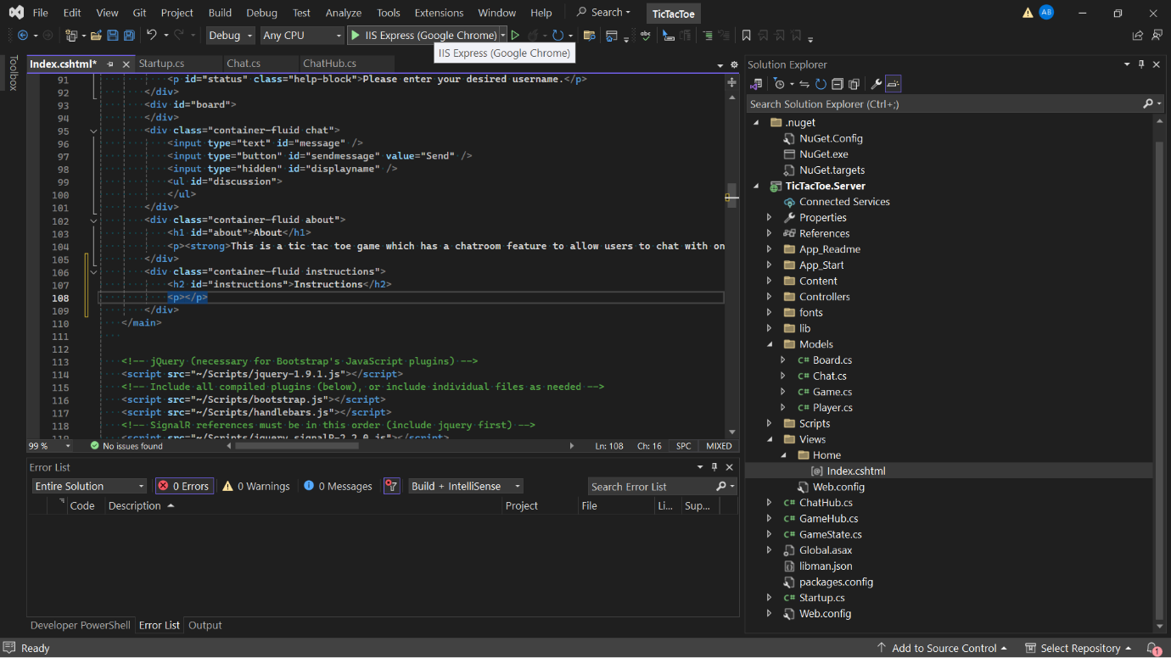

3rd: Once run and opened, input a desired username in the input text box and host a game.

4th: To join a game, copy the local host link above, open a new tab and paste it on the new tab.

5th: 2 players can now play with one another; additional players can wait in the lobby and chat with other players.

