HOW TO EDIT A FILE USING AN FTP PROGRAM

FTP stands for File Transport Protocol and is a method to access a remote server and add, change (edit,) and delete files as well as to upload files to the server and download files from it.

There are tons of FTP programs out there... for Mac, PC, and Linux. Some are free (like FileZilla,) some cost from $20 to $50.

Our shop uses Apple computers and we use a FTP program called YummyFTP (yes, kind of funny name, but a great program. If you go to <http://www.yummysoftware.com> and use the code: NEWMEDIACREATE on the 'buy' page, you will get a 25% discount!)

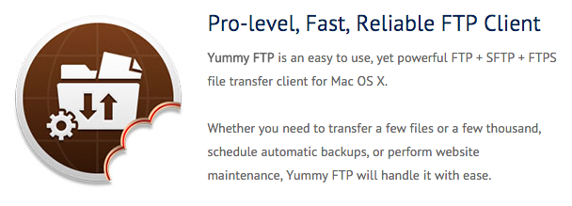

For PC (Windows) there are lots of good programs out there as well but we can't recommend any. So we suggest you just Google for "best FTP programs for Windows."

Just about all FTP programs look and work the same. You get a small "connect" screen where you put in the 3 entities you need to connect: server-name, username, and password. You get these from the company where you host your website.

After you connect you get a dual-window screen... the window on the left is your local computer and the one on the right is the remote computer... and you can drag and drop files between the windows to upload or download them.

This tutorial will only show you how to edit files, thus we'll only be concerned with the window on the right.

When looking for an FTP program, look for one that has a built-in editor if possible. But if it doesn't make sure it can use an external editor. Most have a built-in (or default) editor but often people like to configure the program to use a specific editor.

In this tutorial we are going to be showing the free and popular (because it is free!) FileZilla program. There is a version for Windows, Mac, and Linux. You can get FileZilla from <https://filezilla-project.org>.



**SET UP**

Obviously you have to install the program, but we won't cover that as it is different on the PC and Mac.

On most FTP programs (often called FTP 'clients') you have to do a small bit of set up if you want to use a specific editor so you should at least check to see what it is set to out of the box.

On FileZilla, you bring up the program and then find the Settings menu (On the Mac it is under the program name at the top... it may be different on Windows but there will be one somewhere.)

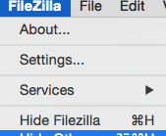

Click on the File Editing option and see if it is set to "Use Default Editor" and if so, give that a try (skip Logging In To Your Server section on page 6.)

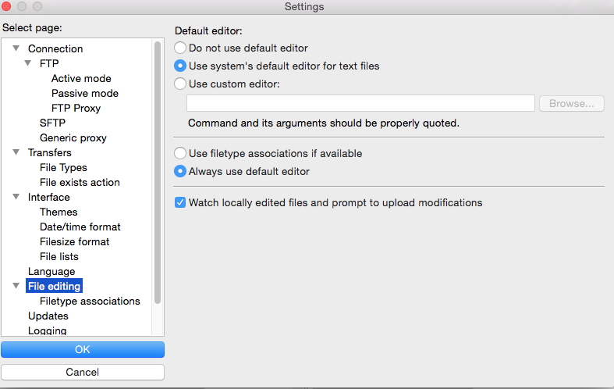

If after connecting you can't edit a file, you will want to set it to use an external editor. On FileZilla you click the Use Custom Editor button on the Settings File Editing screen which will make the Browse button active.

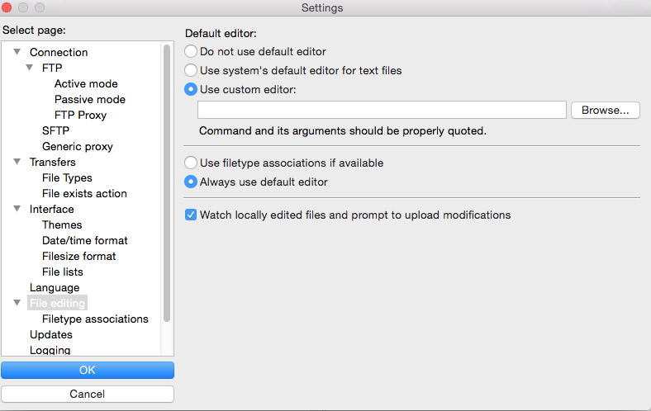

Then you use the Browse Button and find your editor in the pop-up menu. Since we like the TextWrangler editor we found it in the Applications folder, selected it and clicked the Open button in the lower right hand corner.

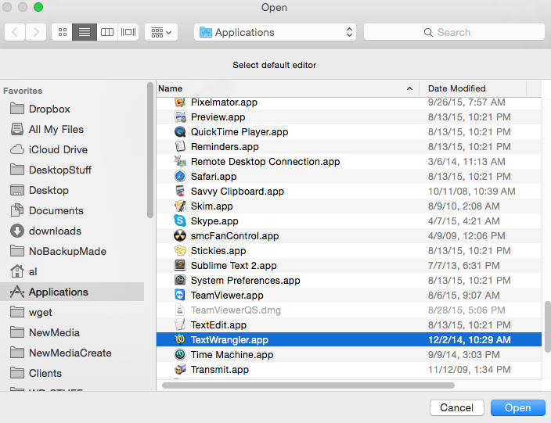

When you have selected the editor application, make sure you click the OK button on the left hand side of the Settings screen to save out your configuration settings.

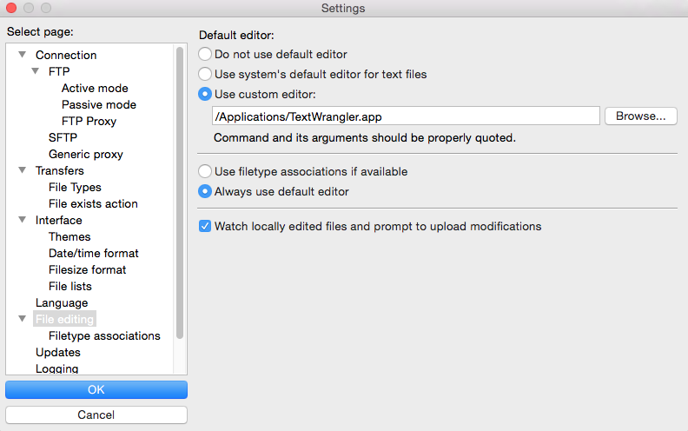

**LOGGING IN TO YOUR SERVER**

Now it is time to connect to your server. You do this by entering the Host (aka: server name) and the Username, and the the Password. You can leave the port number blank if you want and it will default to Port 21 meaning plain old FTP. **However, we STRONGLY, STRONGLY, STRONGLY(!) suggest you put in the number 22 in the Port box.** Port 22 will use the **SFTP** protocol **which is more secure**. However, some hosts don't accept SFTP (Port 22) so you will have to use Port 21. **Try 22 and use that if it works!**

(Note: In many apps simply entering a different port number won’t change the protocol and you need to select SFTP from a Protocol setting (like in YummyFTP). It’s perfectly possible to connect to a plain FTP server running on port 22. FileZilla just assumes you want SFTP.)

When you click Quickconnect button you should be taken to your remote server in a few seconds. If not, you will eventually get an error and most likely its becuase you have one of the entries wrong.

After the first time you log in to a server some programs will save the settings so that you only have to click a down-arrow next to Quickconnect. On other programs when you disconnect it will ask if you want to save the connection settings to a "Bookmark" and you will want to do this. The next time you go to Bookmark listing and pick your server.

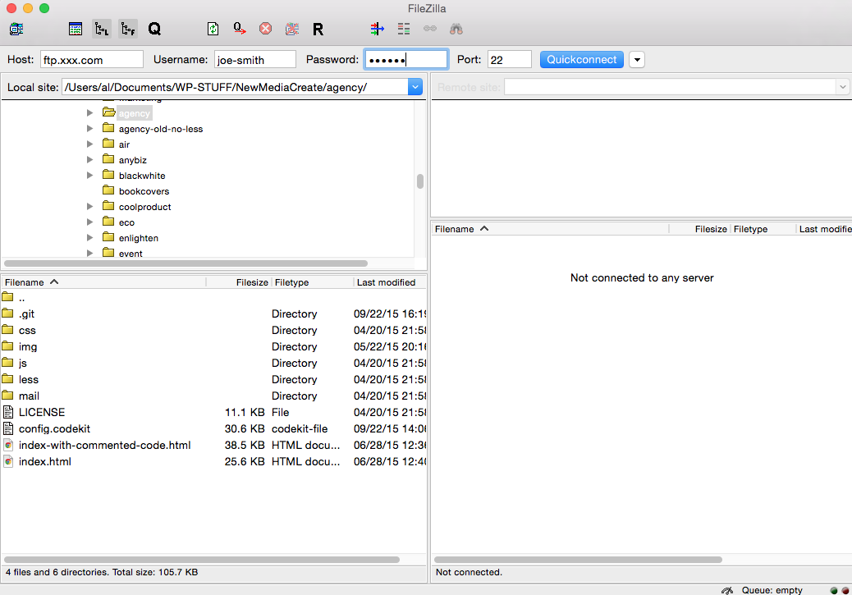

**EDITING YOUR FILE**

Once connected you use the right-side window to navigate to your file. Some programs will have a "tree" structure above and the files in whatever folder you click below, as you see here. The concept is to find your "web" folder and then the directory (usually called "wb" (not shown below) to where your content is.

On sites we do for you the content is all in ONE file called:

**index.html**

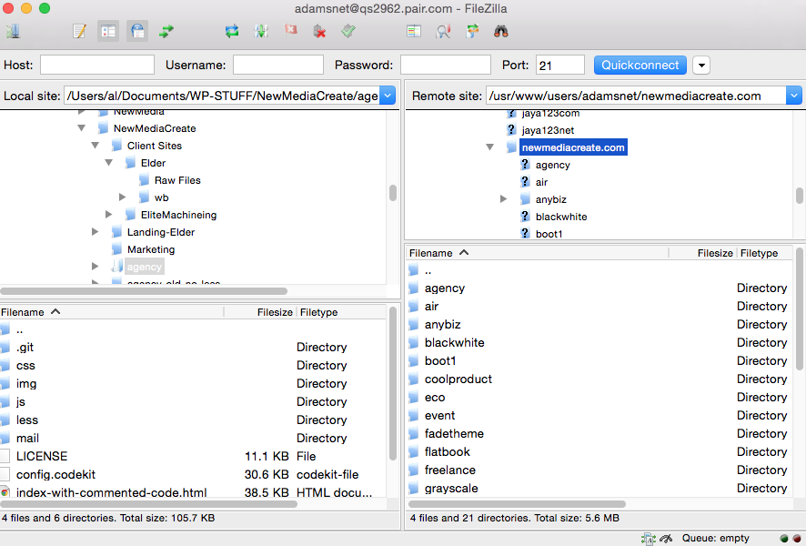

In the example below, our index.html file is in a folder called "fadetheme" (which is selected.) On FileZilla you have to click it to SELECT it.

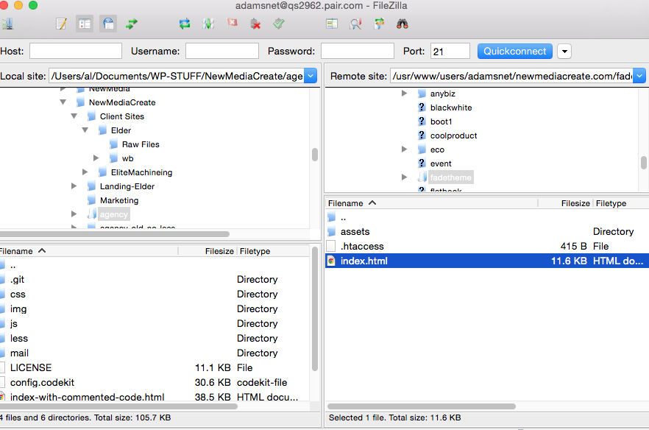

After you find index.html and select it, you then RIGHT CLICK on it and you will get a drop-down menu where you choose "View/Edit."

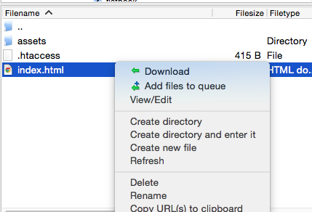

Some programs will let you select the file and have you click an "Edit" icon in the top menu bar.

That should bring the file up in the editor... either the built-in editor if the FTP program has one, or the editor of your choice (below is the popular and free TextWrangler editor for the Mac.)

All you need to do is scroll to where the text is that you want to change or add to (or delete) and just "do it."

Of course it will help if you know a bit of HTML, but it really is not necessary if you are just making minor changes.

If you are going to add a new paragraph it is wise to copy a previous one starting at the <p....> and ending with the </p> and pasting it and then changing the text. That way you are sure to get any formatting that is done via CSS if any is entered, such as:

<p class="make-red"> The cow jumped over the moon. </p>

It will come out red if there is a "make-red" class in the CSS file that stipulates that color.

(Probably way too much info so if you don't understand it, don't worry about it.)

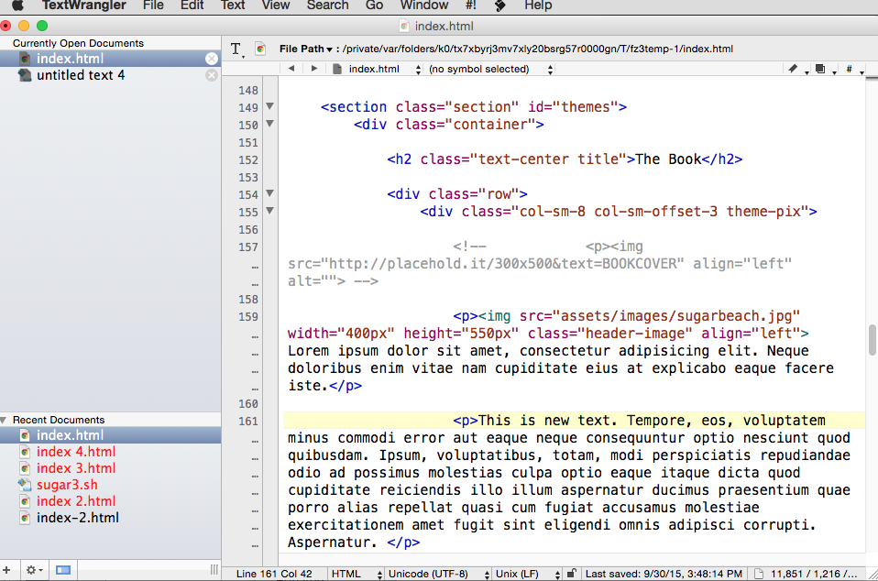

Once you click Save in your editor, most FTP programs will ask that you confirm the change. FileZilla offers you the option to save and continue or to save and quit... by which they say "delete local file."

(FYI, the way the FTP programs edit files is that you access them and they are magically downloaded to the editor on your computer. You make the changes and when you save they are magically uploaded back to the server and overwrite what was there before.)

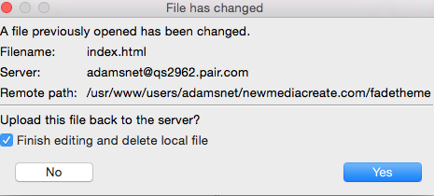

Once you have saved your changes you can go to your website and refresh the page and see how the changes look. Sometimes you have to re-load the page a few times because browsers often cache (save) the page to their own internal memory and don't know you made a change on the server.

**DISCONNECT**

While you can just quit your FTP program and it will auto-disconnect for you, it is better to click whatever 'disconnect" button the program uses... in this case it is red X... when you hover over it in FileZilla it shows you what the button does.

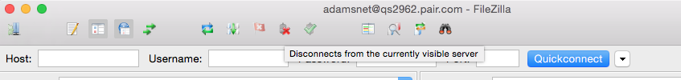

There is a lot more to using FTP programs and there are a ton of printed as well as video tutorials on FileZilla as well as other FTP programs. It would be a good idea if this is your first time using an FTP program to search on YouTube for a FTP or FileZilla tutorial and watch it.

-30-