Arrington Capehart
Module 1.2 Assignment
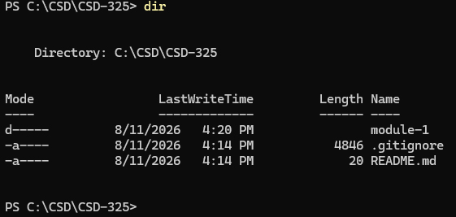
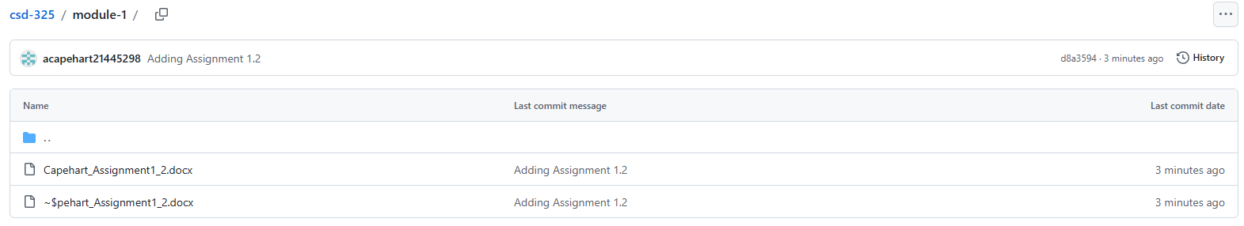
https://github.com/acapehart21445298/csd-325.git

