CIVE 202 – Civil Engineering Analysis II
Project #3 Report
Spring 2026
Gabriela Gonzalez Ng, Jamie Krab and Aaron Cardinale

Introduction/Background Information
Transportation plays an important role in the economy and shaping daily life in the US. Understanding these systems and how vehicles behave under real-world conditions is important to support informed decision-making. The Federal Highway Administration (FHWA) has asked us to analyze two datasets: the National Household Trave Survey (NHTS) and the Next Generation Simulation (NGSIM) Data. These two datasets provide insights into transportation usage characteristics and driving behavior. Additionally, we have been asked to organize and visualize the data provided using python.

Objectives
The following are the objectives of this analysis:
- To analyze and understand the data from the NHTS and the NGSIM data
- To create a bar chart, histogram, boxplot and two time-series plots based on two data sets provided
- To provide a Simulation study using the Intelligent Driver Model (IDM) to visualize and simulate vehicle behavior and vehicle trajectories
- To document the amount of time spent working on each task

Scope of Work
Team Members: Gabriela Gonzalez Ng, Jamie Krab and Aaron Cardinale
Date submitted for review: March 31st, 2026
Submitted to: Civil and Environmental Engineering Department faculty
Project Goals:
The goal of this project is to organize and visualize transportation systems data for the transportation planning group within our firm. We will do this using two datasets, the National Household Travel Survey (NHTS) and the Next Generation Simulation (NGSIM). These data sets have information about transportation usage characteristics and driving behavior. The client has requested 3 key analyses: (1) a bar chart, histogram, boxplot and two time-series plots representing the data provided, (2) Simulation study using the Intelligent Driver Model, (3) Timesheet documenting the time spent working on each task.
Project Tasks:
To achieve the goals for our project, our group has identified the following tasks to be completed by our team of professional engineers:
Task 1: Extract and organize NHTS and NGSIM Data
Data from the NHTS dataset will be downloaded into excel for processing in Python software, Jupyter Notebook. The data will be organized through grouping, sorting, and filtering functions.
Task 2: Create Visualizations of Trends and Features in Data
The data will then be plotted using matplotlib and seaborn libraries. A bar chart, histogram, boxplot, and two time-series plots will be made to achieve this goal. The plots will be customized, titled, and correctly labeled.
Task 3: Provide Simulation Study
Using an Intelligent Driver Model (IDM) we will provide a simulation study which will help visualize vehicle behavior and pathways.
Task 4: Provide Timesheet
All members will record how much time was spent working on each task and deliverable.
Project Deliverables:
The deliverables and due dates for this project are summarized in the following table:
Deliverable | Due to Client by
Raw Data files | 3/31/2026
Python Code File | 3/31/2026
Annotated Code Document | 3/31/2026
Written Report | 3/31/2026
GitHub Link | 3/31/2026
Scope of Work | 3/31/2026

Methods
In order to analyze the NHTS and NGSIM data our team used the following methods in chronological order:

Data Source
The National Household Travel Survey (NHTS) and the Next Generation Simulation (NGSIM) dataset was provided by the Federal Highway Administration (FHWA). This dataset includes transportation usage characteristics such as travel mode, vehicle age and household demographics, as well as driving behavior such as distance, velocity and trajectory. All the analyses conducted were made using these two CSV files.

Data Extraction and Organization
Data was extracted in Jupyter notebook (Python version 3.14.2) by importing the pandas’ package and converting it into a dataframe. Additionally, the Seaborn library was installed to create the visualizations of the CSV data provided. Data was organized into tables and filtered for easier analysis.

Data Visualization
To identify key patterns and trends, the following types of visualization were created using the matplotlib and seaborn library:
- Bar Chart: Vehicle Type was selected from the NHTS data and visualized using a bar chart to compare frequencies across the categories.
- Histogram: Vehicle age and its count were plotted in a histogram to examine its distribution.
- Box Plot: Vehicle age and fuel type was plotted using a box plot to compare the distribution of a continuous variable.
- Time-Series Plots: Two plots were created: Follower Speed vs Time and Leader Speed over Time. These were used to observe vehicle interaction and analyze driving behavior over time.

Intelligent Driver Model (IDM) Simulation
A simulation study was created using the Intelligent Driver Model to model vehicle behavior and vehicle trajectories. Data was used from the NGSIM dataset and selected based on a continuous trajectory.
The leader vehicle’s trajectory data such as position, speed and acceleration was used to simulate the follower’s vehicle’s behavior. The IDM equations were implemented in Python and were used to compute the follower’s acceleration over time based on parameters such as speed, minimum gap, desired time gap, maximum comfortable acceleration and comfortable braking deceleration.
The simulated follower acceleration was compared to the actual follower acceleration obtained from the NGSIM data set. The following time-series plots were created:
- Acceleration of Leader, Real Follower, and Simulated Follower
- Speed of Leader, Real Follower, and Simulated Follower
- Trajectory of Leader, Real Follower, and Simulated Follower
This comparison allows for the evaluation of how well IDM captures real-world driving behavior.

Time Tracking
The time spent on each task was recorded in a time data sheet. Task included written report, annotated code document, python code and a Gantt chart.

Results and Discussion
Based on the analysis conducted for the AirPurple air quality dataset, our team of engineers have found the following conclusions:

Bar Chart: Vehicles by Type in NHTS

A bar chart shown in Figure 1 was created to compare the vehicle type by the number of vehicles in the NHTS dataset. The results showed that Automobile/car/stationwagon had the highest number of frequencies compared to the other vehicle types at 6500 observations. While “something else” was the least vehicle type at almost 0 observations. This showed that according to the NHTS dataset, most people use Automobile compared to bigger vehicles such as SUVs, pick up trucks and vans.

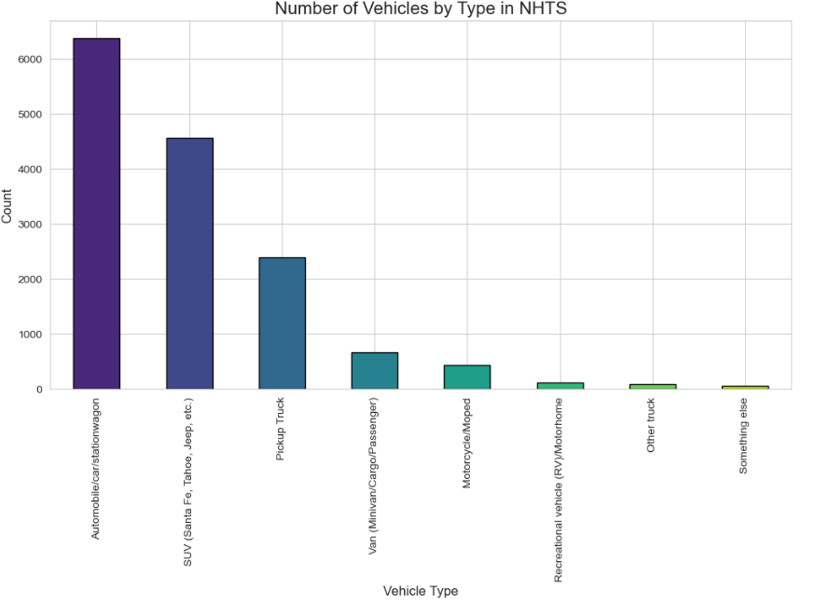
Figure 1 Number of Vehicles by Type in NHTS Bar Chart

Histogram: Vehicle Age Distribution

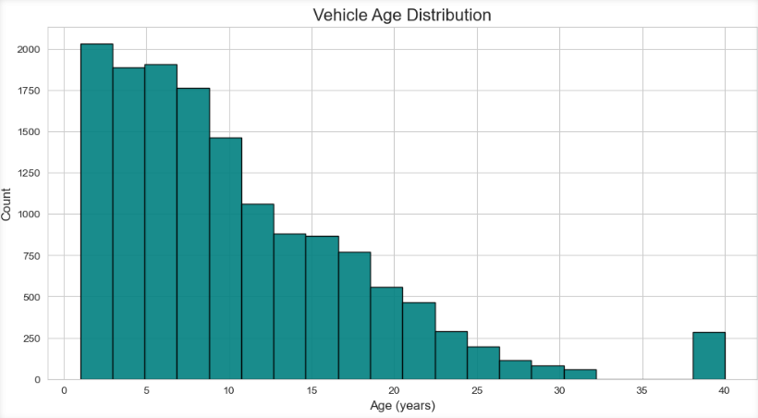
Figure 2 Vehicle Age Distribution Bar Chart

Boxplot: Fuel Type vs. Vehicle Age
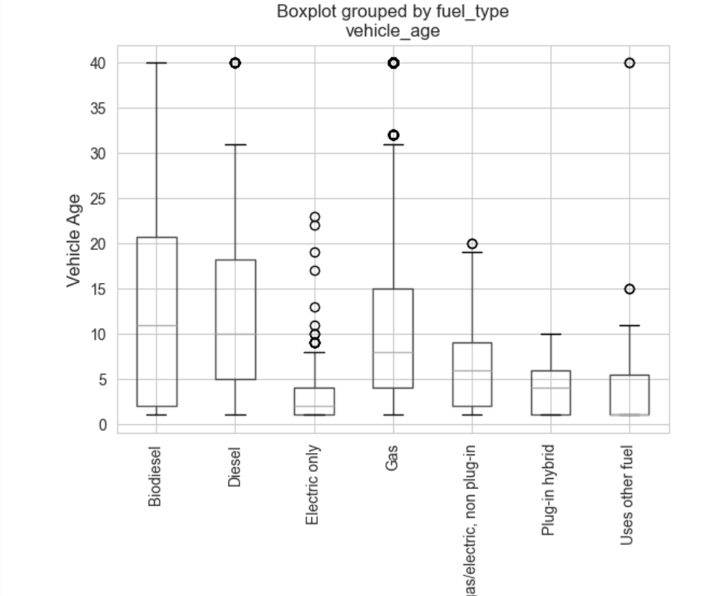
Figure 3 Fuel Type vs. Vehicle Age

Time Series Plots: Follower Speed, Leader Speed, Follower Acceleration, Leader Acceleration
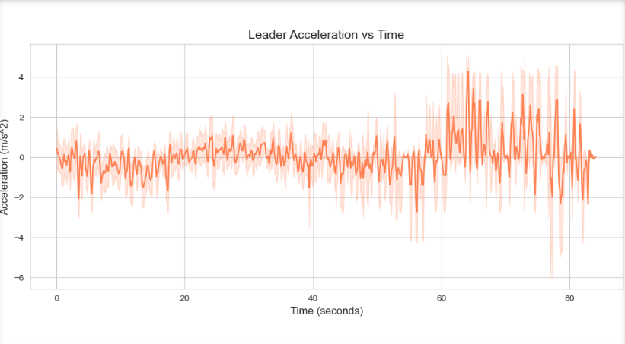
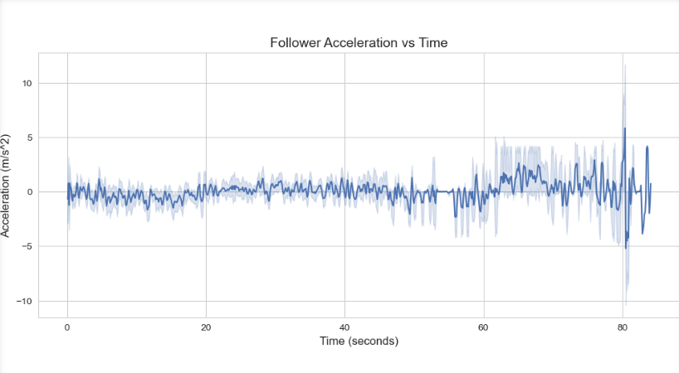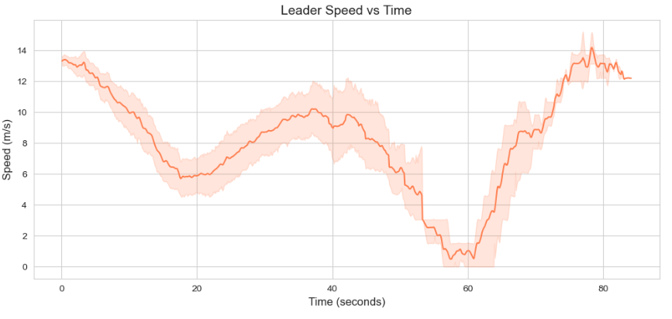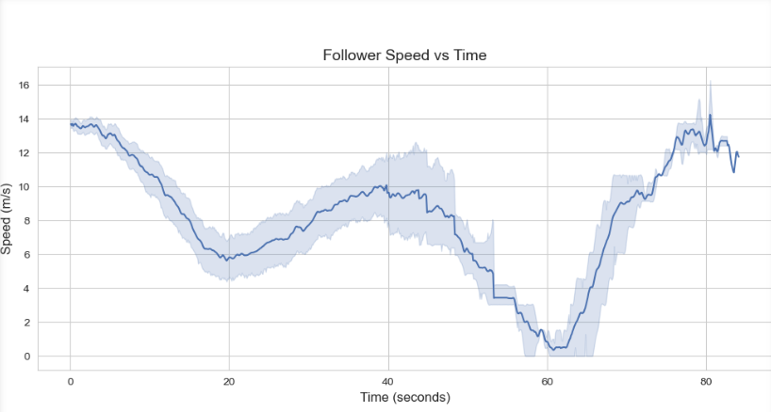

References

