GoM cod and haddock RDM

Lou Carr-Harris

December 28th, 2023

This file is an exploratory analysis of the effect of climate-induced shifts in angler catch-per-trip of Gulf of Maine cod and haddock. Results are based on 100 iterations of the recreation demand model. The RDM is calibrated to 2020 fishery conditions.

### Baseline (2020) fishery statistics

Cod keep per choice occasion

mean sd  
 0.0102 1e-04

Cod keep per trip

mean sd  
 0.0156 2e-04

Haddock keep per choice occasion

mean sd  
 2.0857 0.0104

Haddock keep per trip

mean sd  
 3.1916 0.006

### Baseline welfare calculations

After calibrating the simulation model to 2020 fishery conditions, I re-ran the model under two closure scenarios: (a) bag limits for both cod and haddock set to zero, and (b) bag limits for cod only set to zero.

#### Scenario (a): close both fisheries

CV per choice occasion

mean sd  
 66.12 0.47

Aggregate CV

mean sd  
 31611797 174899.7

Number of trips under closure

mean sd  
 256794.8 544.59

Number of trips under baseline fishery

mean sd  
 312755.2 0.89

Percent reduction in trips from baseline fishery

mean sd  
 -17.89 0.17

#### Scenario (b): close cod only

CV per choice occasion

mean sd  
 0.88 0.17

Aggregate CV

mean sd  
 420214.5 81018.19

Number of trips under closure

mean sd  
 312054.4 170.05

Number of trips under baseline fishery

mean sd  
 312755.1 0.85

Percent reduction in trips from baseline fishery

mean sd  
 -0.22 0.05

### Fishery outcomes under climate-induced changes in catch-per-trip

Each tab contains projected fishery outcomes based on input data from alternative copula models.

### Clayton (independent catch)

Cod and haddock keep per choice occasion:

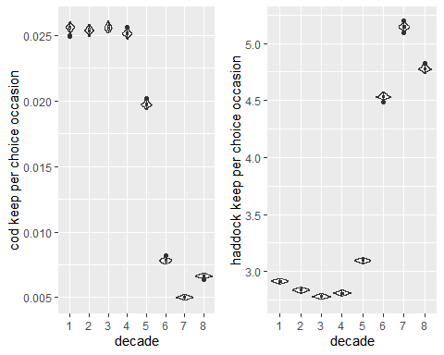

CV per choice occasion and number of trips:

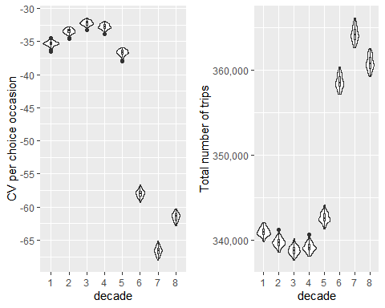

Correlation in catch and keep of cod and haddock per trip (kendall’s tau-b):

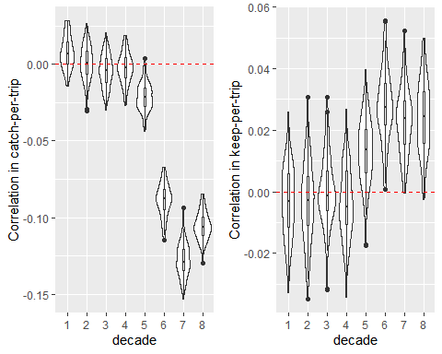

### Clayton (correlated catch)

Cod and haddock keep per choice occasion:

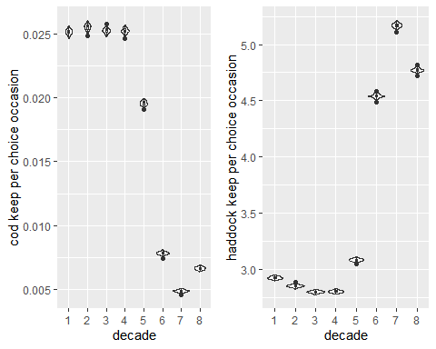

CV per choice occasion and number of trips:

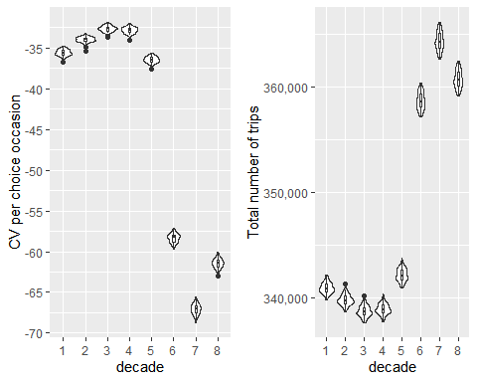

Correlation in catch and keep of cod and haddock per trip (kendall’s tau-b):

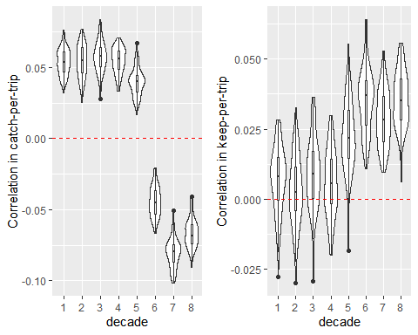

### Gumbel (independant catch)

Cod and haddock keep per choice occasion:

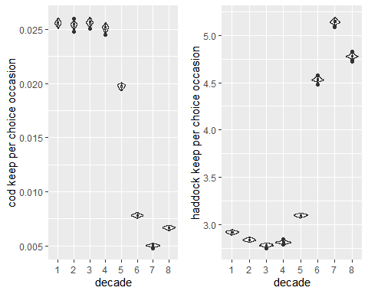

CV per choice occasion and number of trips:

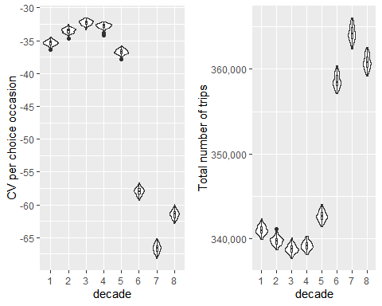

Correlation in catch and keep of cod and haddock per trip (kendall’s tau-b):

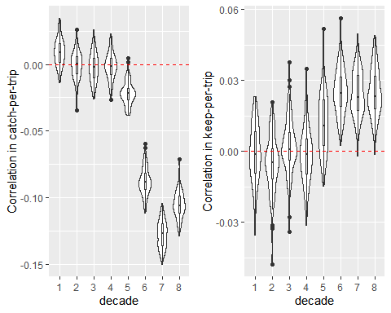

### Gumbel (correlated catch)

Cod and haddock keep per choice occasion:

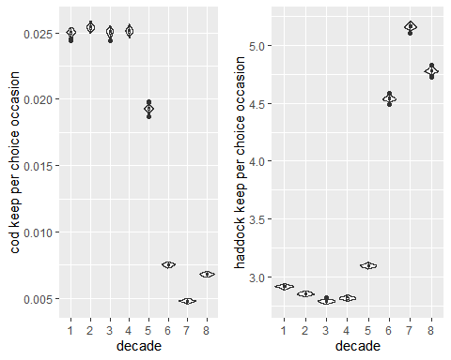

CV per choice occasion and number of trips:

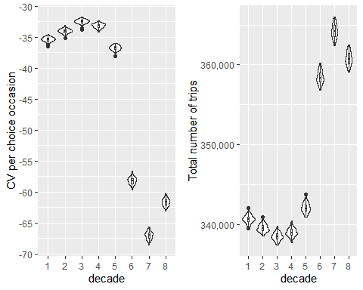

Correlation in catch and keep of cod and haddock per trip (kendall’s tau-b):

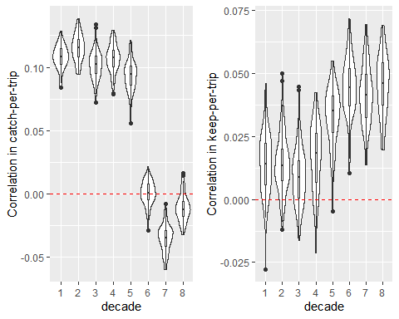

### Frank (independent catch)

Cod and haddock keep per choice occasion:

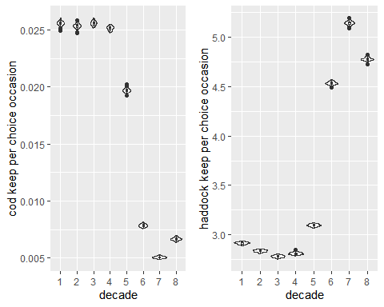

CV per choice occasion and number of trips:

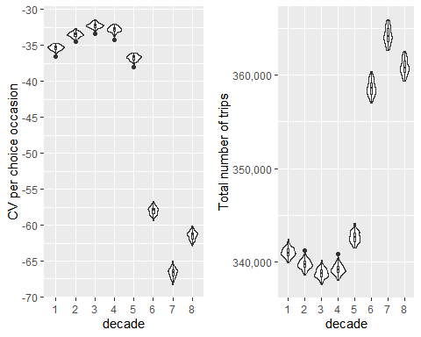

Correlation in catch and keep of cod and haddock per trip (kendall’s tau-b):

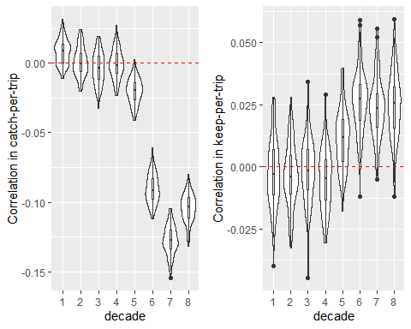

### Frank (correlated catch)

Cod and haddock keep per choice occasion:

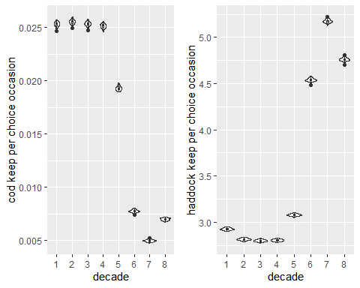

CV per choice occasion and number of trips:

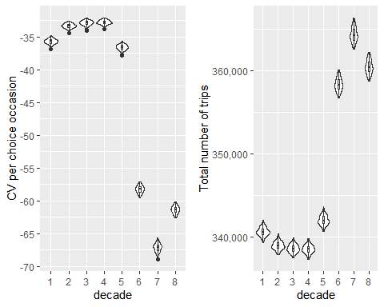

Correlation in catch and keep of cod and haddock per trip (kendall’s tau-b):

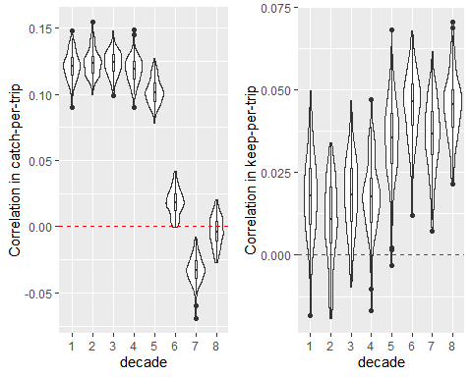

### All copulas (correlated catch, decade=1)

Cod and haddock keep per choice occasion:

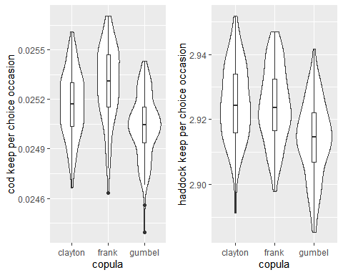

CV per choice occasion and number of trips:

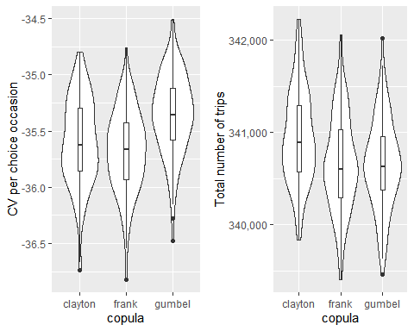

Correlation in catch and keep of cod and haddock per trip (kendall’s tau-b):

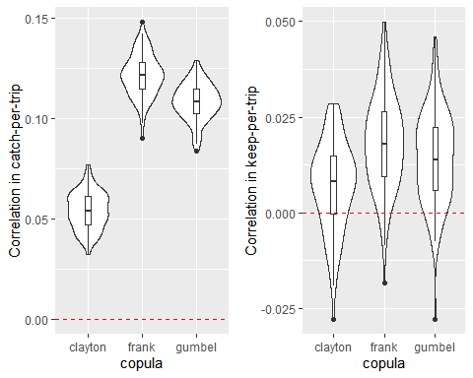

### All copulas (correlated catch, decade=4)

Cod and haddock keep per choice occasion:

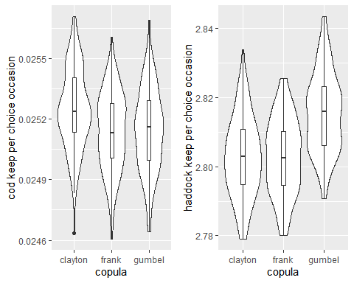

CV per choice occasion and number of trips:

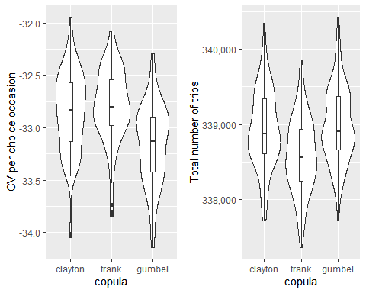

Correlation in catch and keep of cod and haddock per trip (kendall’s tau-b):

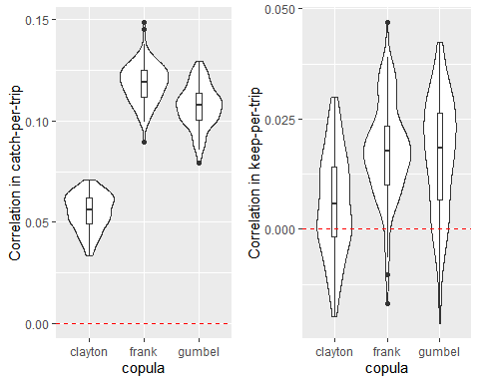

### All copulas (correlated catch, decade=8)

Cod and haddock keep per choice occasion:

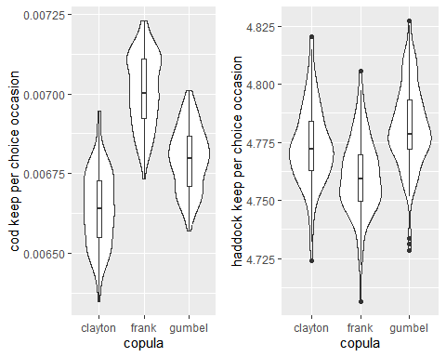

CV per choice occasion and number of trips:

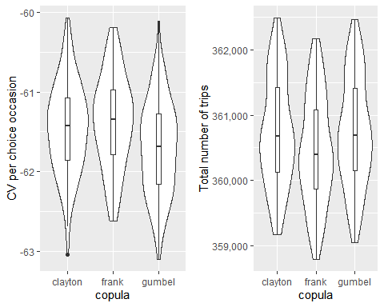

Correlation in catch and keep of cod and haddock per trip (kendall’s tau-b):

  