Homework 1
Comparing the protein sequences created by my Python script with the ones I obtained from Expasy, I found that the sequences match for all the sequences I tested. Both methods had identical protein sequences when translating the forward strand of the DNA.
Here’s an overview of the steps I followed and the results:
- Random DNA Sequences: I simulated 10 random DNA sequences each with 200 base pairs.
- Translation Reading Frames: I translated each DNA sequence into protein sequences in all three reading frames The Python script generated the correct protein sequences by reading in the forward direction from frame 1, frame 2, and frame 3.
- Reverse Translation: I also translated the reverse complement of each DNA sequence. However, I focused on comparing the forward strand results only.
- Comparison with Expasy: I compared the protein sequences from my Python script with those generated by Expasy. The protein sequences were identical across all tested DNA sequences.
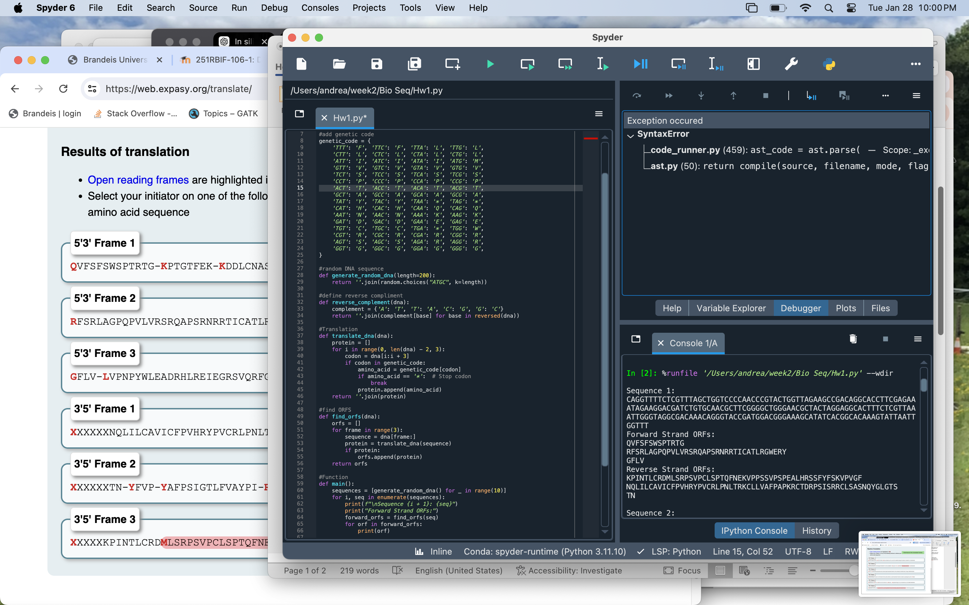
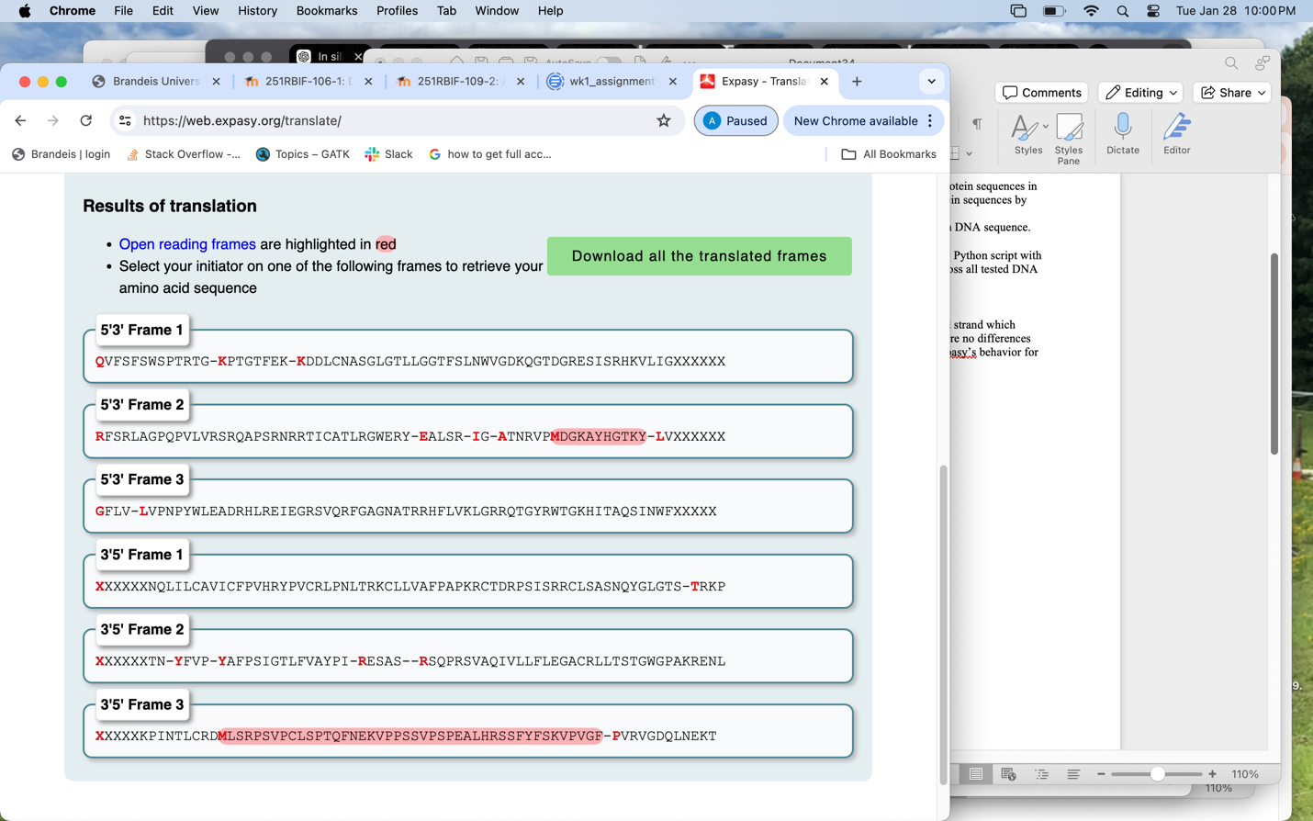
- Stop Codons: Both methods correctly handled stop codons.

The results from my Python script and Expasy were identical for the forward strand which confirmed that the translation of the sequences was correctly done. There were no differences between the two methods, showing that the Python script was similar to Expasy’s tool for translating the DNA sequences into protein sequences.

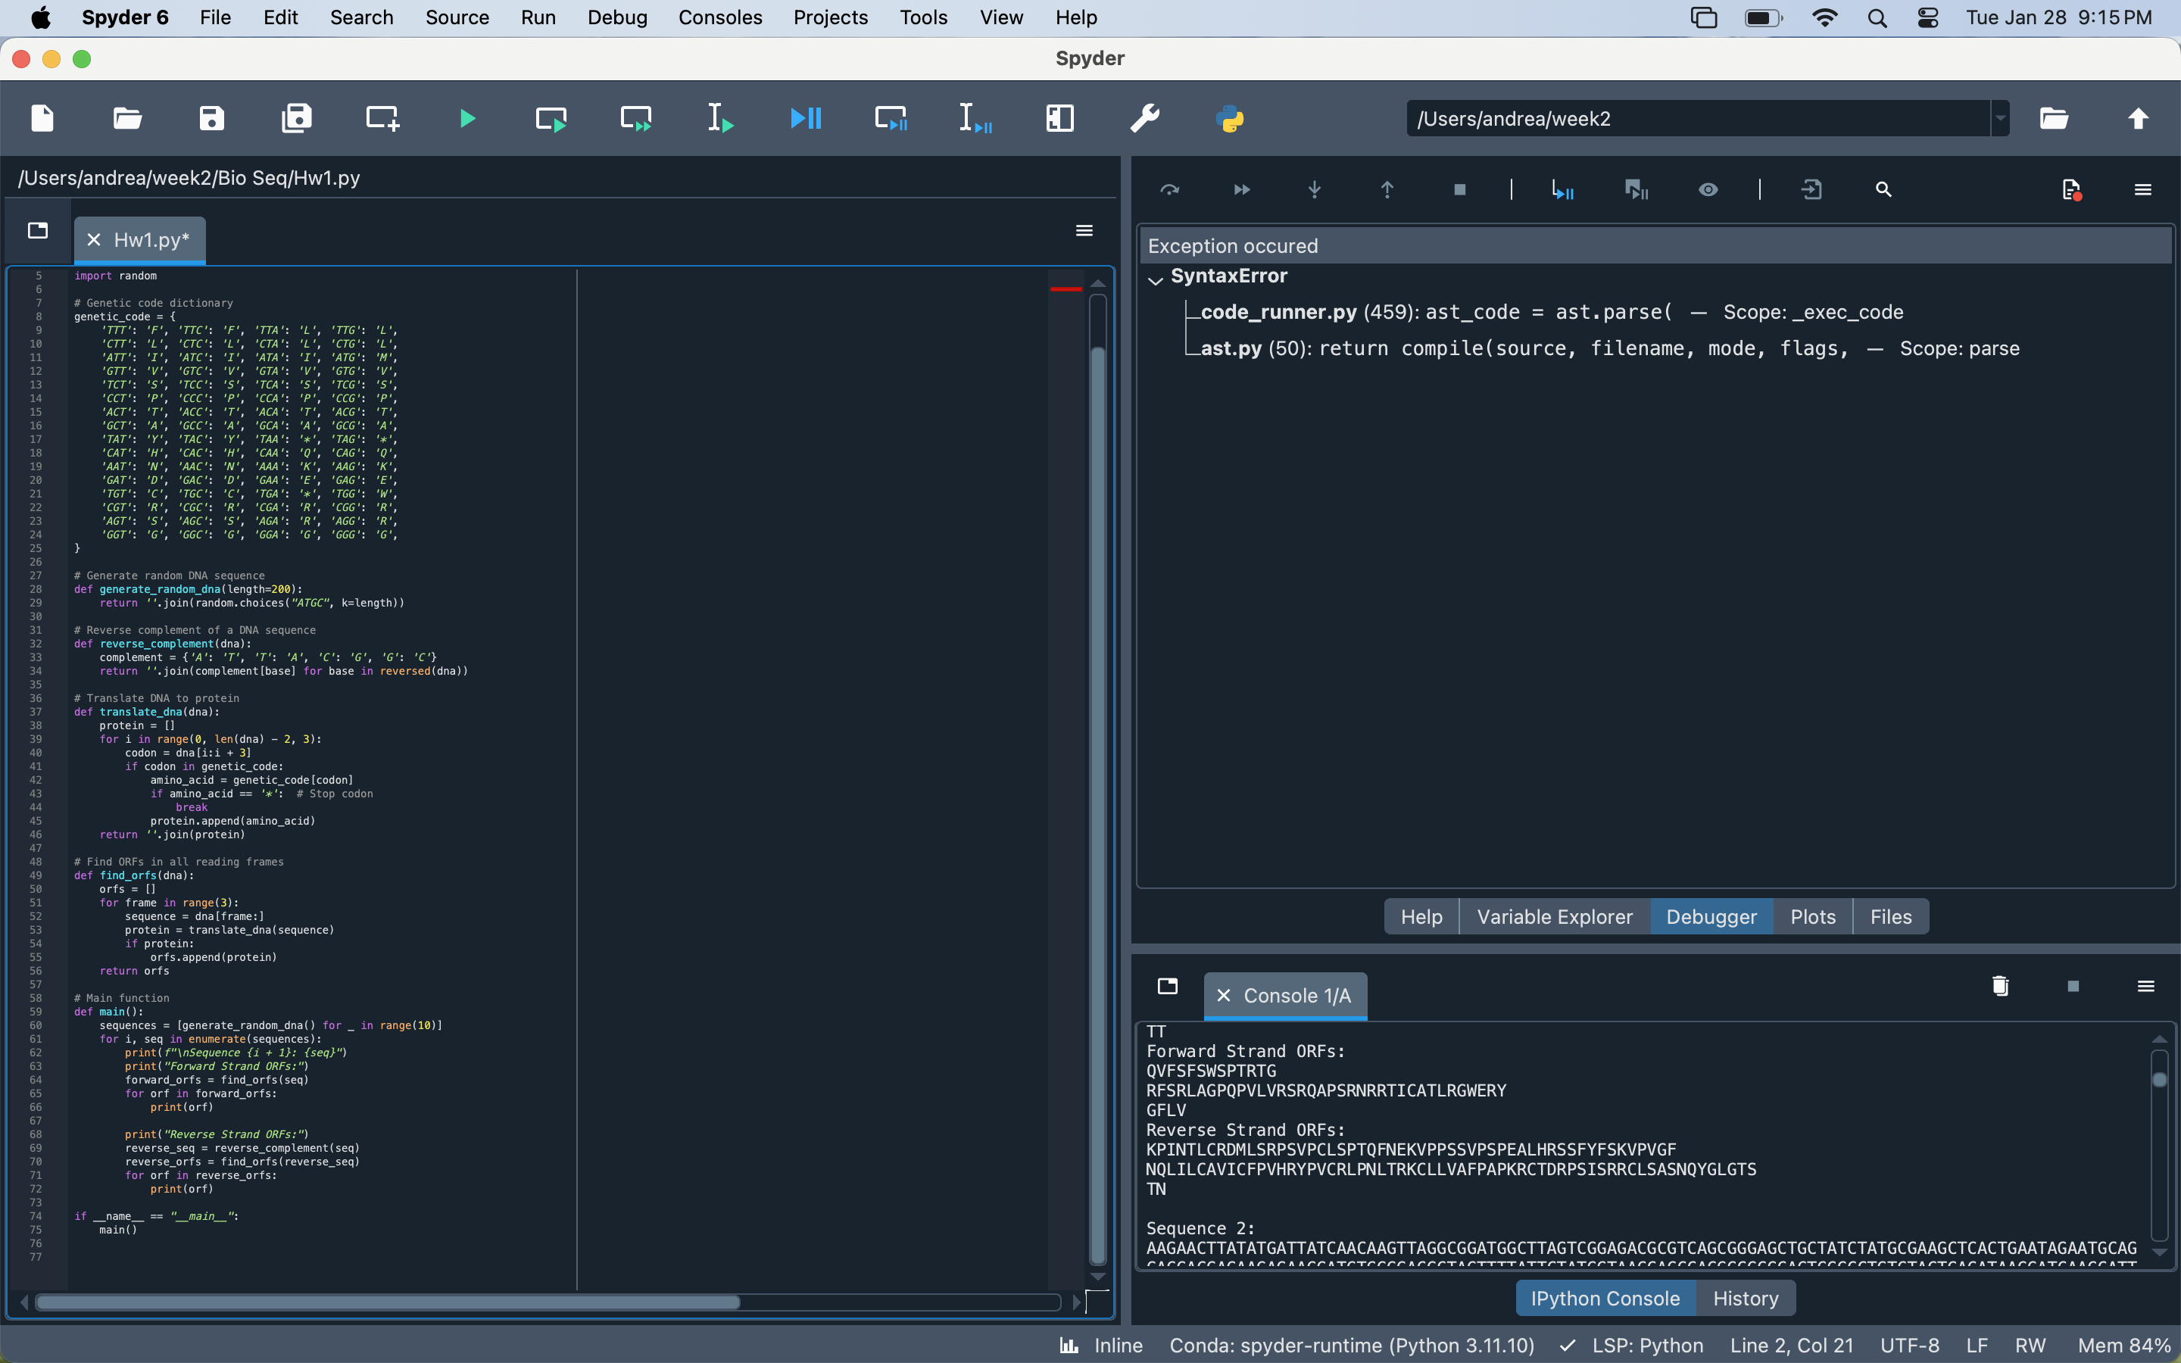
Citations:

Genetic code. (2025). Retrieved from https://en.wikipedia.org/wiki/Genetic_code
Expasy is operated by the SIB Swiss Institute of Bioinformatics Terms of Use | Privacy policy. (n.d.). Home. Retrieved from https://web.expasy.org/translate/
GeeksforGeeks. (2024). DNA to protein in python 3. Retrieved from https://www.geeksforgeeks.org/dna-protein-python-3/
Karl Eric SwansonKarl Eric Swanson 8311 gold badge11 silver badge55 bronze badges, mdmlmdml 22.9k88 gold badges6060 silver badges6666 bronze badges, & zero323zero323 330k108108 gold badges977977 silver badges950950 bronze badges. (1958). Translation DNA to protein. Retrieved from https://stackoverflow.com/questions/19521905/translation-dna-to-protein

