Biological Background and Rationale
FabH (β-ketoacyl-ACP synthase III) is an essential enzyme in the type II fatty acid synthesis (FAS II) pathway in bacteria. It catalyzes the initial condensation of acetyl-CoA and malonyl-ACP, a critical step in membrane lipid biosynthesis. FabH is required for bacterial viability, and its disruption has been shown to be lethal in multiple species including E. coli and S. aureus.
Importantly, humans rely on a distinct FAS I system which is a large, multifunctional protein complex with no direct equivalent to FabH. This structural and functional divergence makes FabH a possible selective antibacterial target with low risk of off-target effects in human cells.
To assess FabH's conservation across pathogens, I performed a multiple sequence alignment and phylogenetic analysis of FabH homologs from ten major Gram-positive and Gram-negative pathogens: E. coli, K. pneumoniae, A. baumannii, P. aeruginosa, S. aureus, S. pneumoniae, B. subtilis, and E. faecalis. The human fatty acid synthase (FASN) was included as a reference.

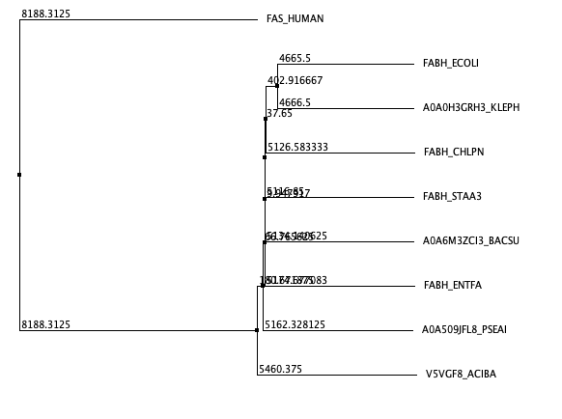
The phylogenetic tree revealed:
- Strong clustering of Gram-negative species (E. coli, K. pneumoniae, P. aeruginosa)
- Moderate clustering of Gram-positive species (S. aureus, B. subtilis, E. faecalis)
- A clear divergence of the human sequence, with a high branch length which confirms its evolutionary distance from bacterial FabH
This conservation across pathogens, along with divergence from human FASN, supports FabH as a broad-spectrum and selective antibacterial target. Literature further confirms FabH’s importance, and despite some exploration of it in high-throughput screening, no FabH inhibitors have reached clinical development, confirming it’s novelty.

Comparative Structural Analysis
FabH crystal structures were analyzed from three representative pathogens:
- E. coli (PDB: 5BNS)
- S. aureus (PDB: 3IL7)
- P. aeruginosa (PDB: 2X3E)
Using PyMOL, each structure was aligned to E. coli FabH (5BNS) to evaluate structural conservation. The RMSD values were:
- S. aureus (3IL7) vs. E. coli: 1.15 Å
- P. aeruginosa (2X3E) vs. E. coli: 1.16 Å
These values indicate high structural conservation, especially in the core α/β fold and the active site, which includes residues Cys112, His244, and Asn274. These are conserved across bacterial homologs and critical for catalytic activity.
To assess potential off target activity, the human fatty acid synthase domain (PDB: 3TJM) was aligned with FabH. The resulting RMSD of 20.87 Å shows no meaningful structural similarity, which also strongly supports target selectivity.
These findings suggest that the FabH active site is structurally conserved in pathogens and accessible for ligand binding while also being structurally unrelated to humans.

Binding Site and Druggability Analysis
Binding site prediction and druggability assessment were performed using DoGSiteScorer for FabH structures from three bacterial pathogens: Escherichia coli (PDB: 5BNS), Staphylococcus aureus (PDB: 3IL7), and Pseudomonas aeruginosa (PDB: 2X3E). Each structure was analyzed for volume, surface area, hydrogen bonding capacity, hydrophobicity, and overall druggability score to evaluate the feasibility of targeting FabH with a small-molecule inhibitor.
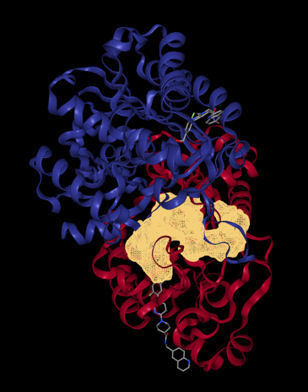

E. coli FabH (5BNS)
- Druggability Score: 0.87
- Volume: 687.15 Å³
- Surface Area: 769.67 Å²
- Hydrogen Bond Donors/Acceptors: 18 / 25
- Hydrophobic Interactions: 45
- Hydrophobicity Ratio: 0.51

The top-ranked pocket included catalytic residues Cys112, His244, and Asn274, confirming this site as the active site. The score and features indicate a highly druggable and chemically diverse pocket.

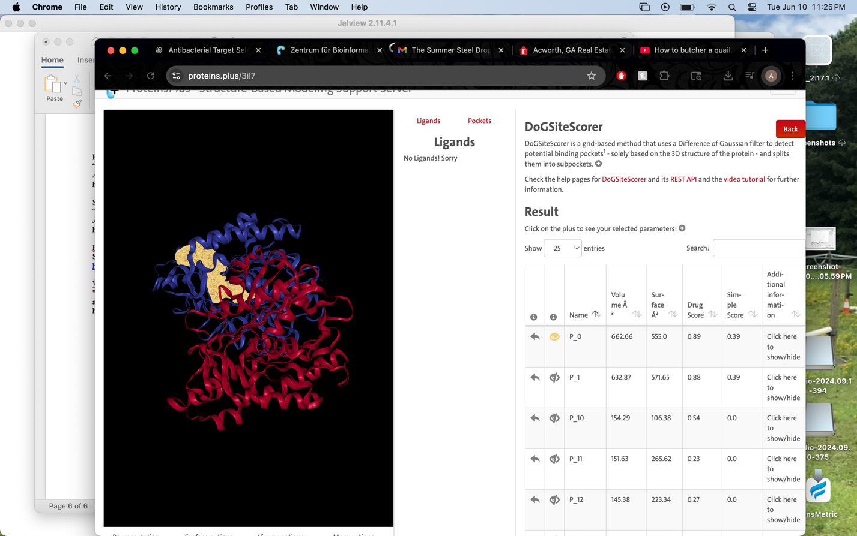
S. aureus FabH (3IL7)
- Druggability Score: 0.39
- Volume: 662.66 Å³
- Surface Area: 555.00 Å²
- Hydrogen Bond Donors/Acceptors: 17 / 40
- Hydrophobic Interactions: 22
- Hydrophobicity Ratio: 0.28

Although this pocket is in a similar location, the significantly lower druggability score and reduced hydrophobic character suggest that the S. aureus homolog may be more challenging to target with the same scaffold. However, the pocket still includes multiple polar and catalytic residues, supporting the possibility of optimization.

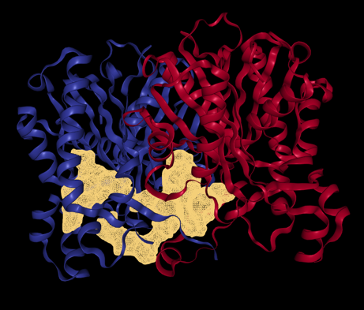

P. aeruginosa FabH (2X3E)
- Druggability Score: 0.81
- Volume: 1966.08 Å³
- Surface Area: 1747.96 Å²
- Hydrogen Bond Donors/Acceptors: 53 / 126
- Hydrophobic Interactions: 71
- Hydrophobicity Ratio: 0.28

This structure featured a large, accessible pocket with substantial hydrogen bonding potential and favorable dimensions for inhibitor binding. While the hydrophobicity is moderate, the high druggability score (0.81) and pocket size make this structure an excellent candidate for broad-spectrum inhibitor development.
FabH from E. coli and P. aeruginosa possess highly druggable active sites, while S. aureus shows slightly less favorable characteristics. Despite variability in hydrophobicity and pocket dimensions, all three species exhibit pockets that include key catalytic residues, confirming their relevance for structure-based drug design. These results reinforce FabH’s viability as a broad-spectrum antibacterial target, with the potential to optimize inhibitors across multiple bacterial pathogens.

Risk Assessment and Final Recommendation
Based on evolutionary and structural analyses, FabH is a strong candidate for a broad-spectrum antibacterial drug target.
Strengths include:
- Conserved sequence and structure across major bacterial pathogens
- Essential metabolic role in cell survival
- Clear divergence from human FASN, minimizing a toxicity risk

Potential risks:
- Resistance potential via mutation of active site residues
- Minor loop region variability which may affect ligand binding
Overall, these risks are outweighed by FabH's unique profile. I recommend initiating a drug discovery campaign targeting FabH, beginning with fragment-based screening and structure-guided lead optimization. The enzyme’s conservation, lack of human homologs, and available crystal structures supports the feasibility of discovering selective and potent inhibitors.

Citations
Heath, Robert J., and Charles O. Rock.
“Roles of the FabA and FabZ β-Hydroxyacyl-Acyl Carrier Protein Dehydratases in Escherichia coli Fatty Acid Biosynthesis.” Journal of Biological Chemistry, vol. 271, no. 44, 1996, pp. 27795–27801.
https://doi.org/10.1074/jbc.271.44.27795
Zhang, Yong-Mei, et al.
“Identification and Analysis of the Acyl Carrier Protein (ACP) Binding Site on β-Ketoacyl-ACP Synthase III.” Journal of Biological Chemistry, vol. 276, no. 10, 2001, pp. 8231–8238.
https://doi.org/10.1074/jbc.M009059200
Magnuson, Kevin, et al.
“Regulation of Fatty Acid Biosynthesis in Escherichia coli.” Microbiological Reviews, vol. 57, no. 3, 1993, pp. 522–542.
https://www.ncbi.nlm.nih.gov/pmc/articles/PMC372926/
Kapoor, Mohit, et al.
“Crystal Structure of β-Ketoacyl Acyl Carrier Protein Synthase III (FabH) from Staphylococcus aureus at 2.3 Å Resolution.” Journal of Bacteriology, vol. 186, no. 12, 2004, pp. 4189–4197.
https://doi.org/10.1128/JB.186.12.4189-4197.2004
Rock, Charles O., and J. D. Cronan Jr.
“Escherichia coli as a Model for the Regulation of Synthesis of Unsaturated Fatty Acids.” Annual Review of Microbiology, vol. 40, 1986, pp. 191–210.
https://doi.org/10.1146/annurev.mi.40.100186.001203
Smith, Steven.
“The Animal Fatty Acid Synthase: One Gene, One Polypeptide, Seven Enzymes.” FASEB Journal, vol. 8, no. 15, 1994, pp. 1248–1259.
https://doi.org/10.1096/fasebj.8.15.7956947
PyMOL Molecular Graphics System, Version 2.5.
Schrödinger, LLC. Accessed 10 June 2025.
https://pymol.org
Volkamer, Andrea, et al.
"DoGSiteScorer: a web server for automatic binding site prediction, analysis and druggability assessment." Bioinformatics, vol. 28, no. 15, 2012, pp. 2074–2075.
https:// doi.org/10.1093/bioinformatics/bts310

