**CSS Declaration**

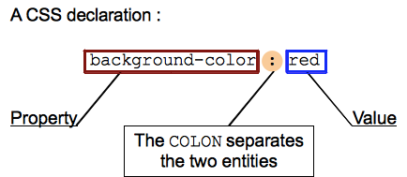

* Properties - an identifier, that is a human-readable *name*, that defines which feature is considered.
  + *Shorthand properties* are CSS properties that let you set the values of several other CSS properties simultaneously. Using a shorthand property, a Web developer can write more concise and often more readable style sheets, saving time and energy.
* Values - describe how the feature must be handled by the engine. Each property has a set of valid values, defined by a formal grammar, as well as a semantic meaning, implemented by the browser engine.
  + Keyword
  + Number - Length values for specifying e.g. element width, border thickness, or font size, and unitless integers for specifying e.g. relative line width or number of times to run an animation.
  + Dimension
    - Length units
    - Font-relative : em, ex, ch, rem
    - Viewport-percentage : vx, wh, vmin, umax
    - Absolute lengths : cm, mm, q, in, pt, pc, px
    - Angle units : deg, grad, rad
  + Duration : s, ms
  + Frequency : hz, khz
  + Resolution : dpi, dpcm, dppx
  + Percentages -  Can also be used to specify size or length — relative to a parent container's width or height
  + URL and URI’s
  + Colors - For specifying background colors, text colors, etc.
  + Strings
  + Functions - For specifying e.g. background images or background image gradients.
    - Calc()
    - Attr()
    - Counter()
    - Countless()
    - Linear-gradient()
    - Radial-gradient()
    - Translate
    - Scale
    - Rotate