**CSS Statements**

* At-Rules - start with an *at-keyword*, an '@' character followed immediately by an [identifier](https://www.w3.org/TR/CSS2/syndata.html#value-def-identifier) (for example, '@import', '@page').

-consists of everything up to and including the next semicolon (;) or the

next [block,](https://www.w3.org/TR/CSS2/syndata.html#block) whichever comes first.

* + *@*import *-* allows users to import style rules from other style sheets
  + @charset - must place the rule at the very beginning of the style sheet, preceded by no characters.
  + *@*media *-* rule specifies the target [media types](https://www.w3.org/TR/CSS2/media.html#media-types) (separated by commas) of a set of [statements](https://www.w3.org/TR/CSS2/syndata.html#tokenization) (delimited by curly braces). Construct allows style sheet rules for various media in the same style sheet
  + @page - rule consists of the keyword "@page", followed by an optional page selector, followed by a block containing declarations and at-rules. Comments and white space are allowed, but optional, between the @page token and the page selector and between the page selector and the block. The declarations in an @page rule are said to be in the *page context*.
* CSS Rule Set

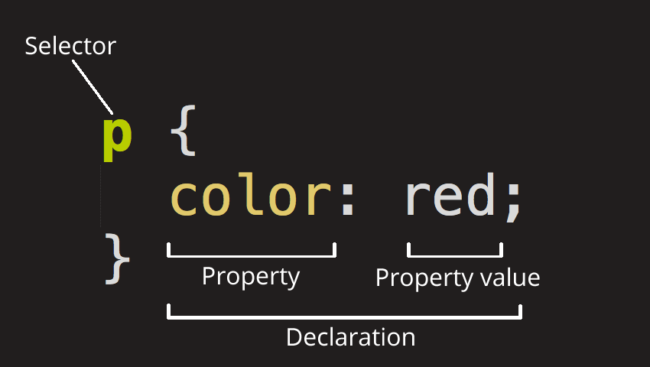

* + **Selector -** The HTML element name at the start of the rule set. It selects the element(s) to be styled (in this case, pelements).
    - Element Selector
    - ID Selector
    - Class Selector
    - Attribute Selector -
    - Pseudo Class Selector
  + **Declaration -** A single rule like color: red; specifying which of the element's **properties**you want to style.
  + **Properties -** Ways in which you can style a given HTML element. (In this case, color is a property of the p elements.) In CSS, you choose which properties you want to affect in your rule.
  + **Property value -** To the right of the property, after the colon, we have the **property value**, to choose one out of many possible appearances for a given property (there are many color values besides red).