**In-class assignment #2  
Color**  
  
Use the following online color picker to show which color best matches each of the most common color words from the English language.  Please continue reading these instructions to get to the list of color words.

Use this online color picker:  
  
[http://www.colorpicker.com/ (Links to an external site.)](http://www.colorpicker.com/)

To communicate your personal color choices, you will type in**HSB coordinates** (3 numbers) for each word.

**HSB coordinates:**using an online color picker, adjust the appearance of the color to match each word you wrote. Please pick the color that best matches your personal impression of what is most typical for each color word.  Record **just the top 3** **numbers** for the color in **HSB** coordinates.  **HSB**stands for **H**ue, **S**aturation, and **B**rightness.

 Here's a **high-tech screenshot** showing which numbers to use after you've clicked on your color choice: 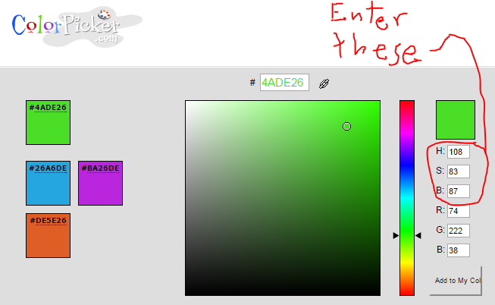

**To submit your answers:**

1) Copy and the text below the dotted line.

2) Click the "Submit Assignment" graphic at the top of this web page.

3) Paste the text into the response box.

4) Finally, type in your 3 HSB numbers for each color inside the parentheses after each color name.  Here is an example of what each line should look like after you've typed in your numbers:  Gray (65 50 50)

- - - - - - - - -

Red ()

Orange ()

Yellow ()

Green ()

Blue ()

Indigo ()

Violet ()

Brown ()

Purple ()

Top of Form