AirKit Specification

This document is specification on the AirKit system

Modification

2015.04.30 - AC – Creation

2015.06.15 – AC - Improvements

Table of Contents

1 The project 2

1.1 Principe 2

1.1.1 Components 2

1.1.2 Connection principle 2

1.1.3 Functional principle 3

2 Used Material 4

# The project

The project is a kit designed for people that assembly their own Air Flow Heater.

## Principe

### Components

The system is composed of the following elements:

1. One master unit
2. One in house temperature sensor
3. One outside temperature sensor ( inside the Air Sensor)
4. One low flow fan
5. One electrically controlled air gate

In option we can add

1. One solar battery
2. One HMI (Human Machine Interface = Screen and Buttons)

### Connection principle

Depending of the two sensor temperatures the Master will activate the air flow and close/open the gate.

Air Sensor with

Black Heater

House Wall

Controlled Gate

Controlled Fan

Outside

temp sensor

Inside

temp sensor

Master

Power plug

Or solar pannel

### Functional principle

The system has 2 parameters:

* Mode
  + Winter
  + Summer
* Temperature Offset (O)

The system has 2 inputs

* Outside Temperature (TO)
* Inside Temperature (TI)

The system has 2 outputs

* Fan command (FC)
* Gate Command (GC)

Function

The important is to run the air flow if the temperature is good inside the air sensor.

A simple offset value should do the job.

* In winter mode we want to warm the room
  + if TO > TI+O
    - the gate is opened and the ventilator is turned on
  + if TO < TI
    - the gate is closed and the ventilator is turned off
* In summer mode we want to cool down the room
  + if TO < TI-O
    - the gate is opened and the ventilator is turned on
  + if TO > TI
    - the gate is closed and the ventilator is turned off

## http://fr.farnell.com/productimages/standard/fr_FR/2133071-40.jpgUsed Material

### Master

For the first prototypes we will use an ARDIUNO board, they are relatively cheap and easy to get.

To be able to improve later I choose the Arduino Board Leonardo (25€)

<http://www.arduino.cc/en/Main/ArduinoBoardLeonardo>

The Ardiuno solution allows the user to upgrade it himself later. It is an Open Source platform, so later if we could release the design as an Open Source Project

### Power source

The master is powered with a classic USB micro cable.

It allows using any solar battery bank or any phone charger.

We could then don’t include the power charger in the kit because many people will have an old phone charger to use.

The same usb connector is use to connect the master to a computer.

### Others elements

TBC

# Final use

## Assembly

The master will be furnished in a box with a domino to connect all elements.

The user will then have to screw the 4 element in the box and close it

## Setup of parameters

A jumper on the master allows switching between summer/winter without having to connect to a computer.

To change other parameters (offset) the user will have

* to connect the master to a computer
* start a software on his computer
* use the software to change the values

## Monitoring

The same software used to setup the parameters can be used to monitor the system.

So if you connect the master to a computer you can see the inside and outside temperature and the state of the fan and gate in live.

# Evolution

## Kit Option

We can sell one kit with option latter

* Base kit
  + Arduino board
  + Temperature sensor
  + Fan
* 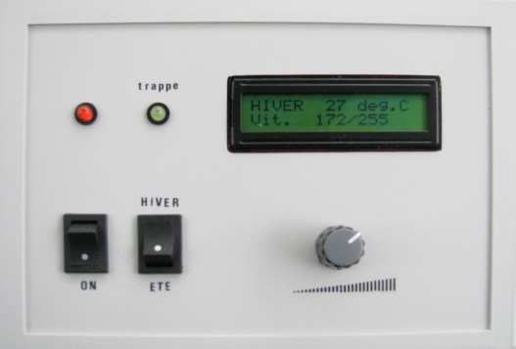Option Box
  + Nice box to put the Arduino
* Option Gate
  + Electrically controlled gate
* Option solar
  + Small battery with solar panel
* Option Hmi
  + Screen and button