class04.R
allysoncauffiel
2026-01-16
x <- 1:50
plot(x)
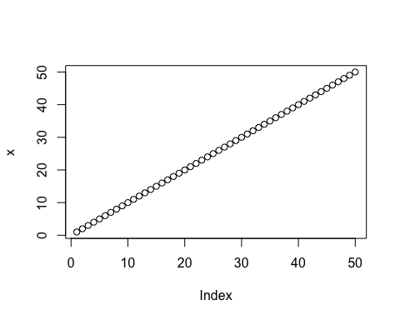
plot(x, sin(x), typ = "l", col="green", lwd=3, xlab="Is is lunch time yet?")
