NAME  Alvin Dave Avila |  | DATE  February 4, 2017 | SCORE
SCHEDULE  10:00 – 12:50 | SCORE |  | SCORE

LABORATORY EXERCISES
RECURSION

OBJECTIVES:
- Understand recursion and its parts
- Use recursion to solve programming problems

PROCEDURE:
- Encode the C++ program below.
- Save as rec1.cpp,and rec2.cpp, respectively.
- Compile and run the program by pressing Ctrl + F9.
- For each syntax or logical error encountered in the given program, do the following:
- Correct the error
- Recompile the program
- Repeat step 4 until no errors are encountered in the program.
- Illustrate the output of the modified program.

Program No. 1

#include <iostream>
Output:
The number is: 1
The number is: 2
The number is: 3
The number is: 4
The number is: 5
The number is: 6
The number is: 7
The number is: 8
The number is: 9

using namespace std;

void numberFunction(int i) {
cout << "The number is: " << i << endl;
i++;
if(i<10) {
numberFunction(i);
}
}

int main() {

int i = 1;
numberFunction(i);

return 0;
}

Program No. 2

#include <iostream>
using namespace std;

int factorial(int);

int main() {
int n;
cout<<"Enter a number to find factorial: ";
cin>>n;
cout<<"Factorial of "<<n<<" = "<<factorial(n);
return 0;
}
Output:
Enter a number to find factorial: 5
Factorial of 5 = 120

int factorial(int n) {
if (n>1) {
return n*factorial(n-1);
}
else {
return 1;
}
}

Supplementary Problem

- A recursive function that sums up the 10 integers in an array.

Program:

#include <iostream>
using namespace std;

int summation(int arr[], int n){
if (n < 0) {
return 0;
}

return arr[n] + summation(arr, --n);
}

int main(){
int arr[] = {1,2,3,4,5,6,7,8,9,10};
int sum;
sum = summation(arr,9);
cout << "\nSummation of 10 is : " << sum;

return 0;
}

Output:

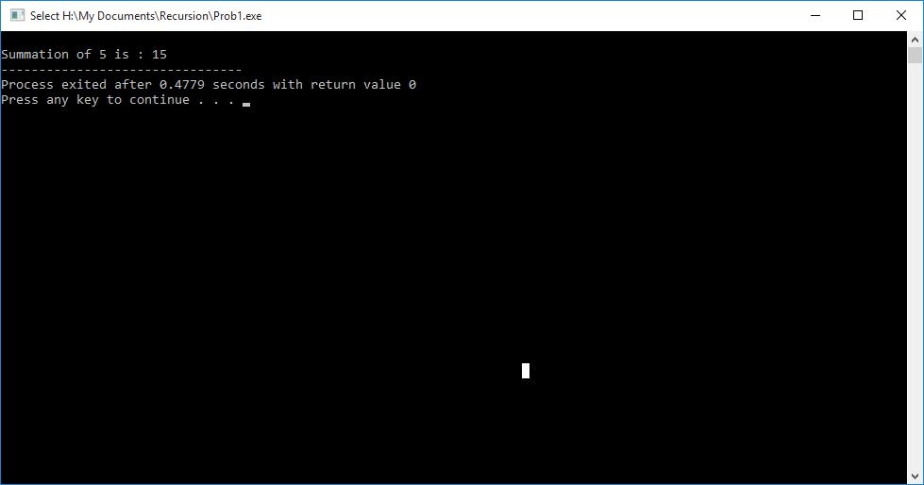

- A recursive function to produce the Fibonacci number for a given index in the series.
Use the function int fibonacci(int n)

Program:

#include <iostream>
using namespace std;

int fibonacci(int n){
if( n < 2 ){
return n;
}
else{
return fibonacci(n-1) + fibonacci(n-2);
}
}

int main(){
int i = 10;
cout << "\nFibonacci number of 10 is: " << fibonacci(i) << endl;

return 0;
}

Output:

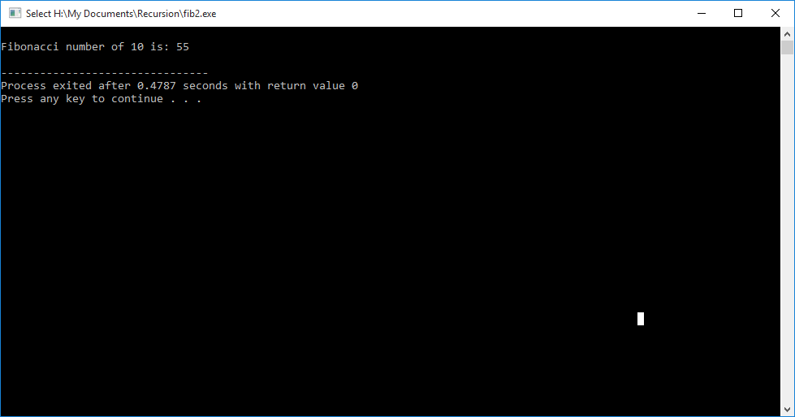
- A recursive function which raises its first parameter to the power of its second parameter.
Use the function int power(int number, int power)

Program:

#include <iostream>
using namespace std;

int power(int number, int exp){
if(exp==0){
return 0;
}
else if(exp==1){
return number;
}
else{
return number * power(number, exp-1);
}
}

int main(){
int num1, num2, prod;
cout << "Input integer : ";
cin >> num1;
cout <<"\nInput its power : ";
cin >> num2;
prod = power(num1,num2);
cout << "\nResult : "<< prod;
return 0;
}

Output:
