COM1008: Web and Internet Technology

Assignment: Website

**Planning and Design Document**

1. General Ethos

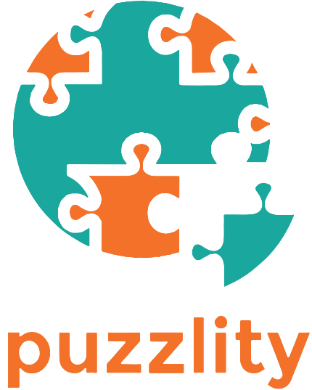

Figure 1.1 Logo of the company, created using Photoshop

The name “Puzzlity” is the combination of “Puzzle” and “Creativity”. Creativity is used here because it is a crucial factor for children which will enhance their ability to problem-solve, innovate and explore new areas. The logo is a puzzle globe made up of only two colours, simple yet attractive. Lazaris (2009) stated that bright and vivid colours should be used on the website as they will be eye-catching and easily hold a child’s attention for a long period of time. Therefore, the website will have a straightforward design, with bright colours, concise text and big buttons. It will try to use more graphics or image in navigation rather than just texts. The images to be used in the puzzle will be happy mood-themed and suitable for children.

1. Site Map

The website would be easier to develop by separating the puzzles pages and other main pages. This is because the puzzle game is planned to be the last part of the implementation. The home page will have buttons which link to the recommendations page and the puzzles list page. The recommendations page will have a link to the puzzle chosen to implement and may include links to other websites. Every page will have a footer which will have links to About Us, Contact Us and Accessibility. All of the pages will be linked with the same stylesheet and JavaScript to have unified effects. However, the puzzle game page will have an extra stylesheet and JavaScript link to it for specific effects on the puzzle only.

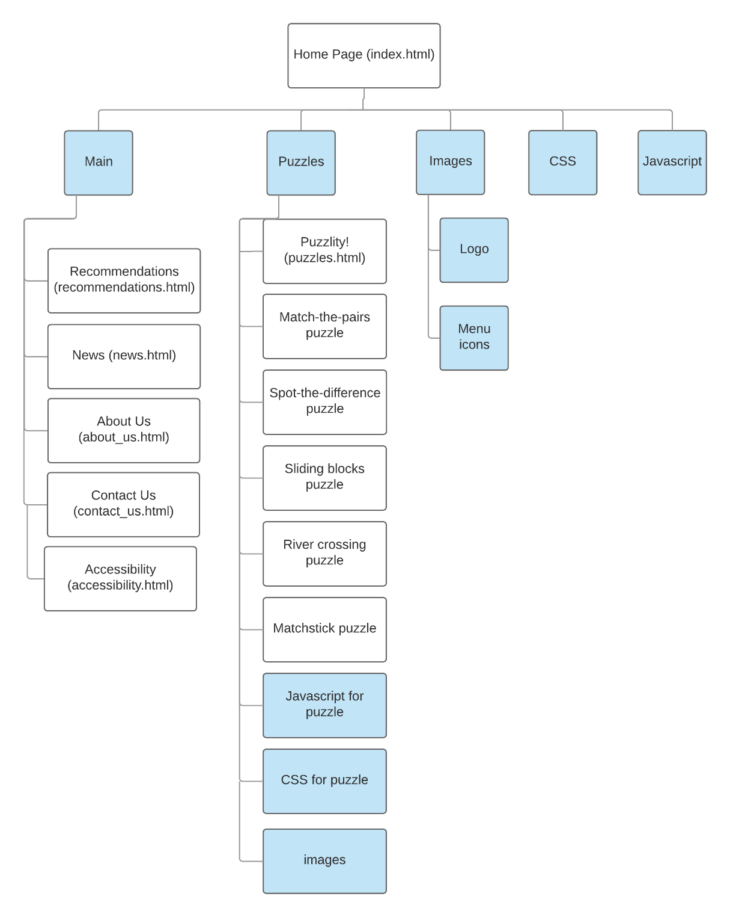

Figure 2.1 Site map of the website

1. Accessibility

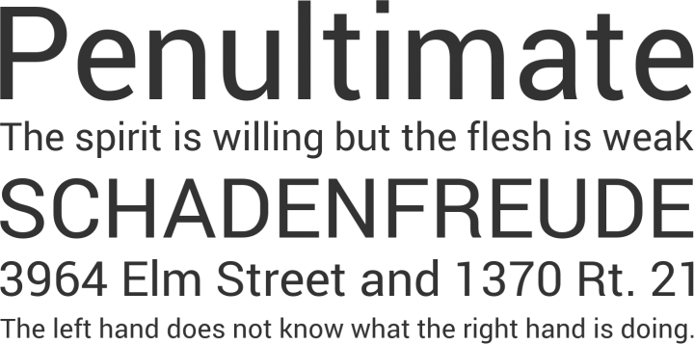

Figure 3.1 Open Sans, a good and readable font

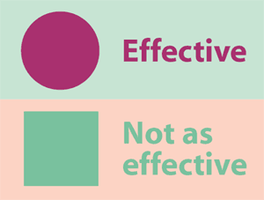

Figure 3.2 An example of contrasting colours from templatemonster.com

A standard and clean font like Open Sans (Figure 3.1) will be used to increase readability. High contrasting colours will be used for the text and background to prevent reading difficulties for users with poor eyesight (Webaim.org, 2013). Users with colour blindness might have several difficulties browsing the website and playing the puzzle games. Hence, images will be tested on a colour blindness simulator website before using. According to Bulat (2011) and Liu (2010), high contrast colours should be used for foreground and background colour and avoid using colours with similar lightness, as shown in Figure 3.2. It is preferred to use colours on the opposite ends of the colour spectrum. For visually impaired users, all images on the website will have an alternate text for screen readers.

1. Design mock-ups

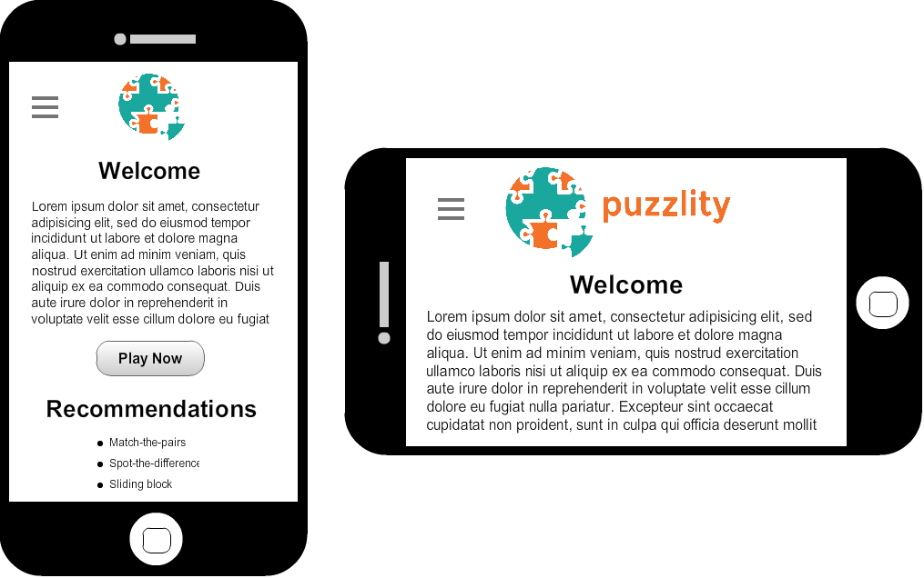

Figure 4.1 Home page on mobile

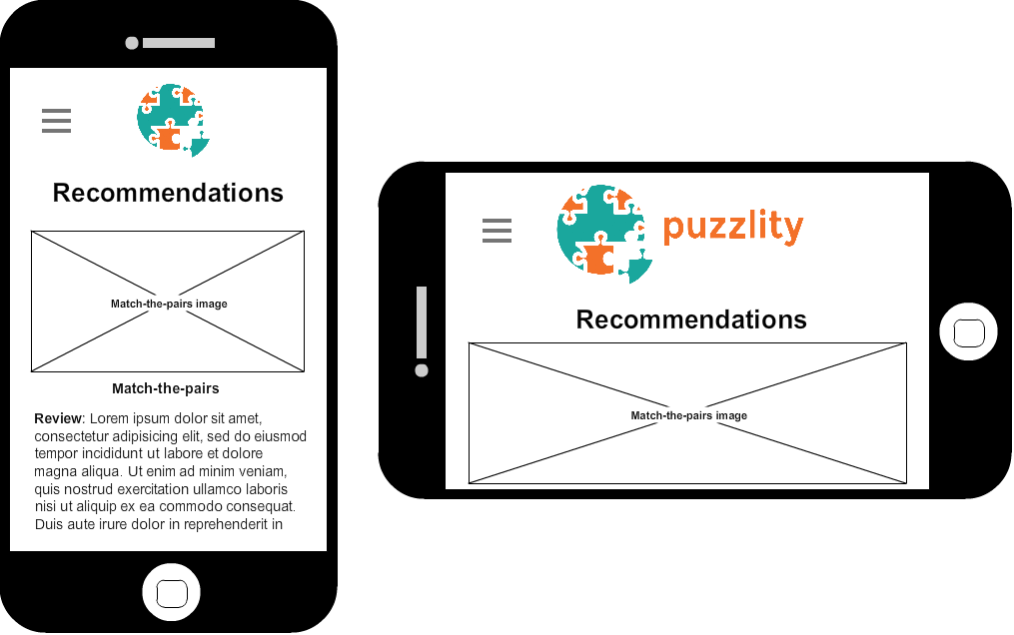

*Figure 4.2 Recommendations page on mobile*

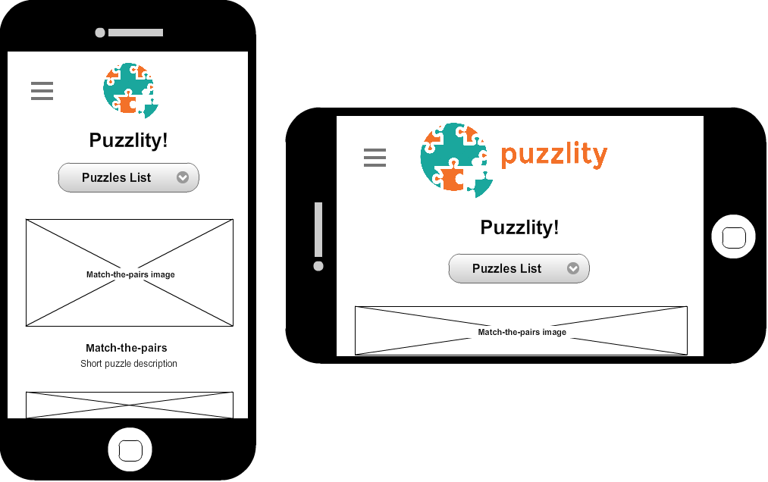

*Figure 4.3 Puzzles page on mobile*

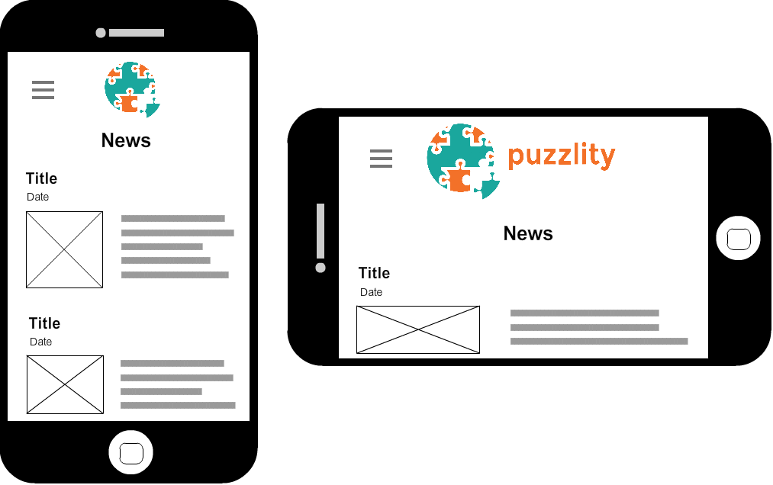

*Figure 4.4 News page on mobile*

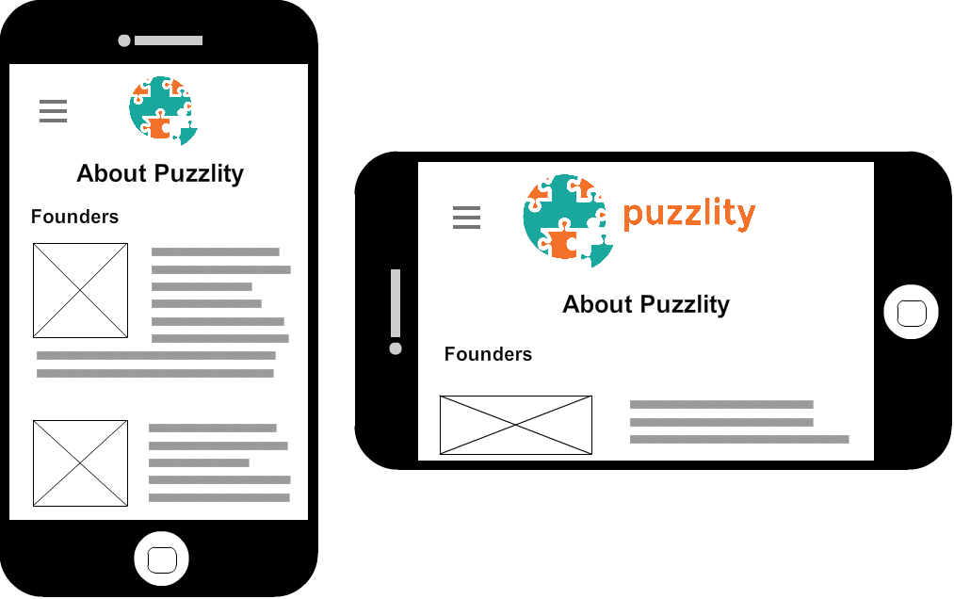

*Figure 4.5 About Us page on mobile*

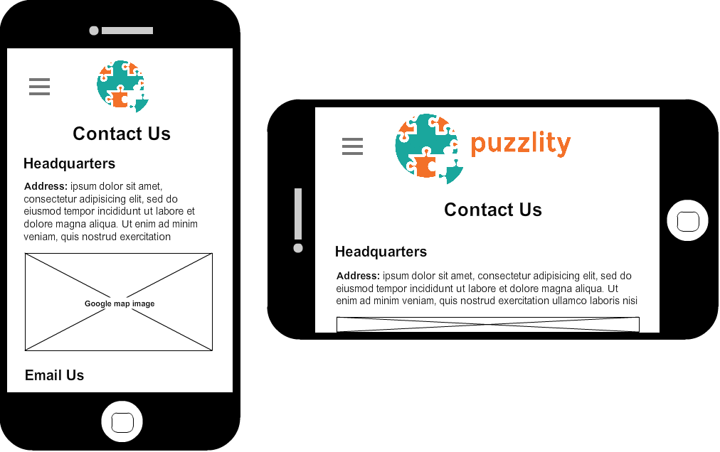

*Figure 4.6 Contact Us page on mobile*

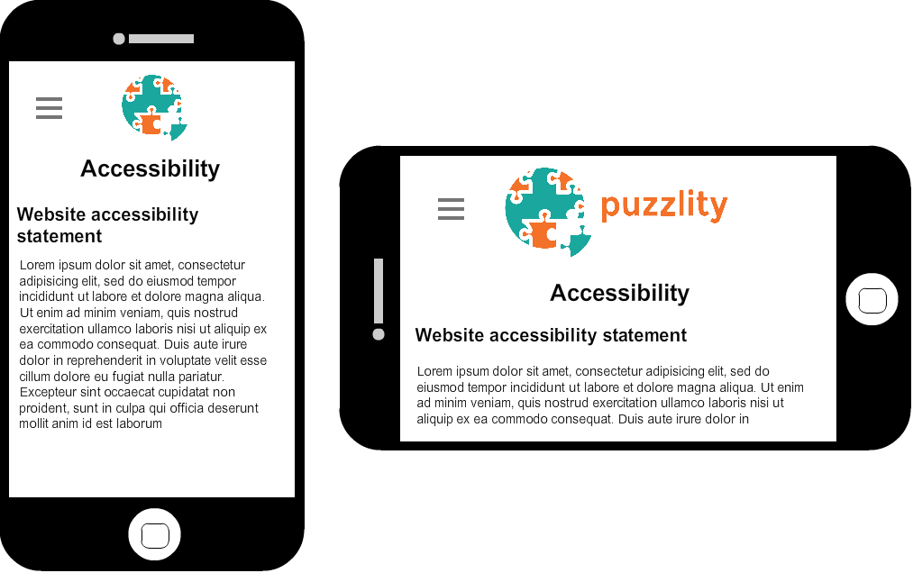

*Figure 4.7 Accessibility page on mobile*

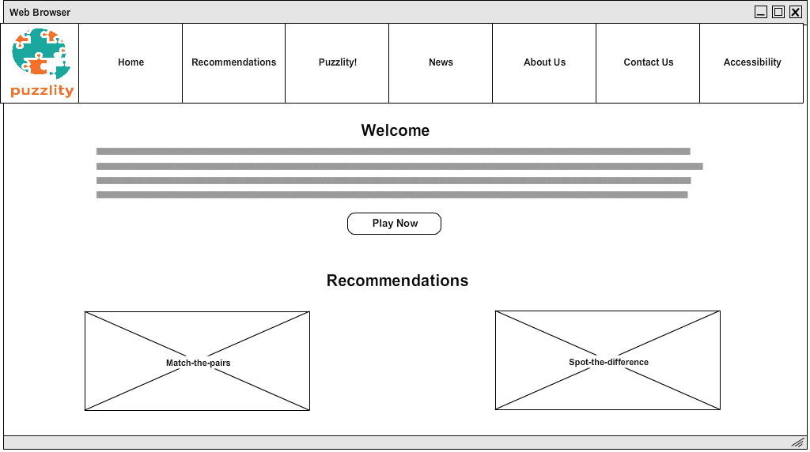

*Figure 4.8 Home page on desktop*

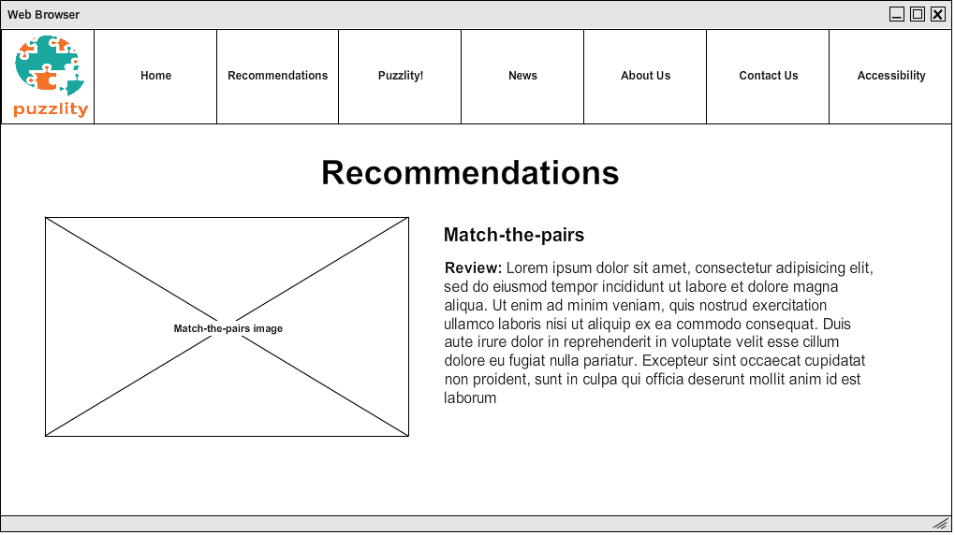

*Figure 4.9 Recommendations page on desktop*

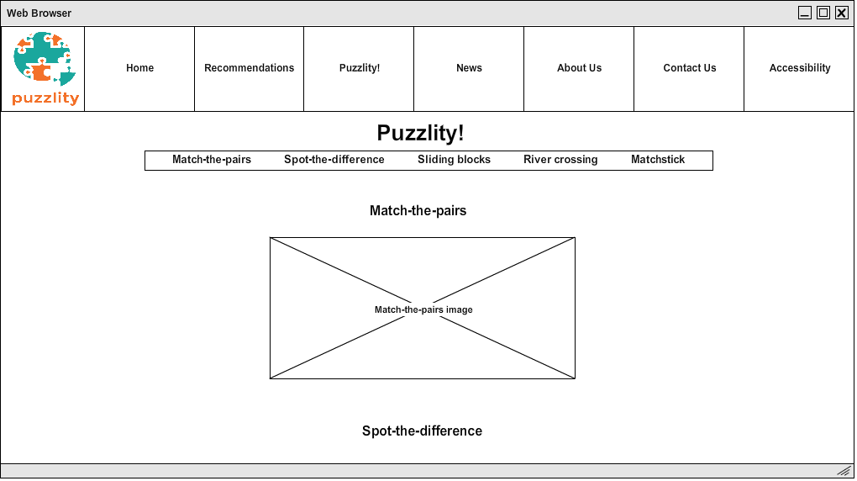

*Figure 4.10 Puzzles page on desktop*

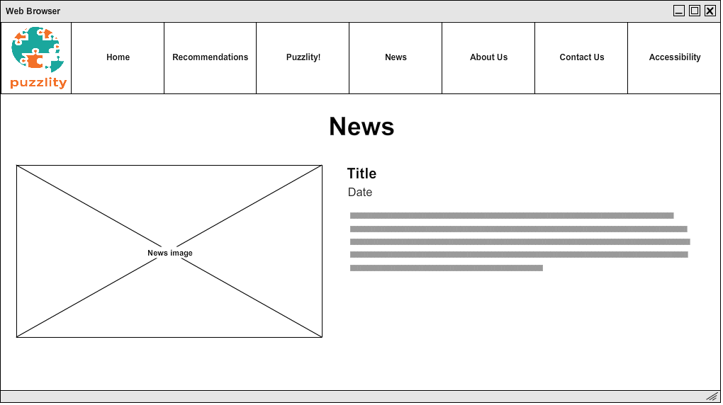

*Figure 4.11 News page on desktop*

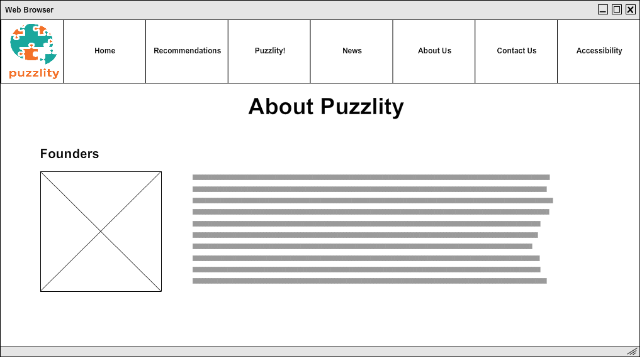

*Figure 4.12 About Us page on desktop*

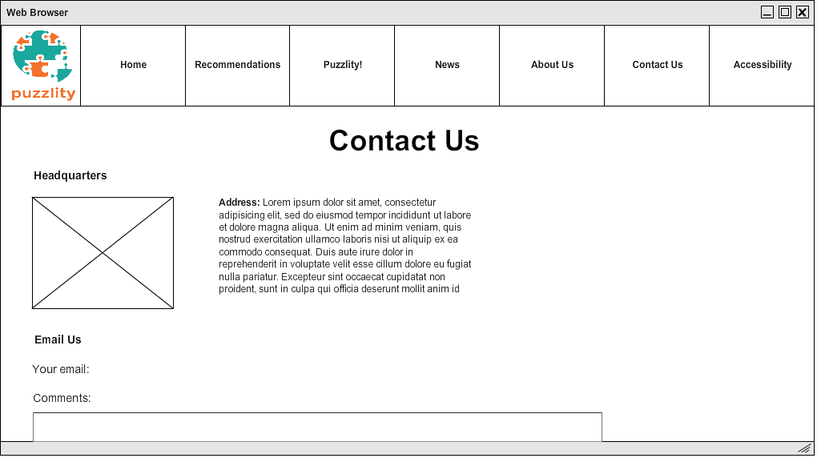

*Figure 4.13 Contact Us page on desktop*

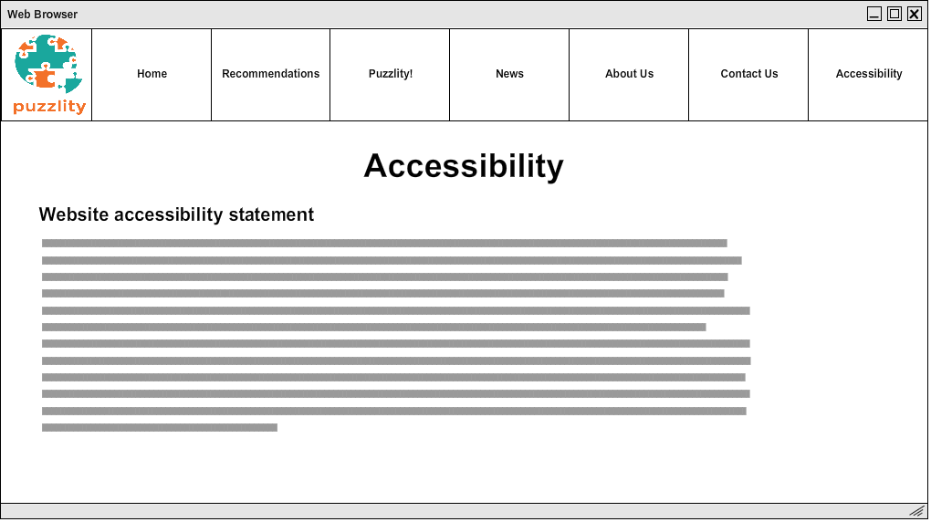

*Figure 4.14 Accessibility page on desktop*

Three break points are decided to use in the design. The first is a maximum of 600px screen width, the second is a maximum of 1000px screen width, and the third is for large screen of 2000px and above. According to <http://mydevice.io/devices/>, common smartphones have a screen width lower than 600px, and tablets have screen width between 600px and 1024px. The following website: <http://www.w3schools.com/browsers/browsers_display.asp> has shown that 97% of its visitors have a screen width of 1024px or higher. Therefore, these breakpoints are sufficient to support the majority of users and devices today.

1. Menu System

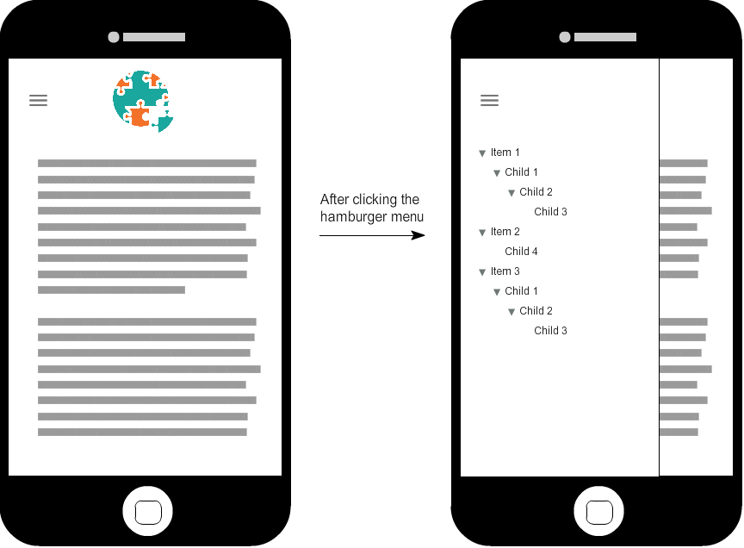

*Figure 5.1 “Off-canvas” menu design on mobile*

On the desktop, the navigation bar is at the top of the web page, with the logo placed at the most left inside it. This saves the space as it would be wasteful for just putting a logo in a header section. “Always-off canvas” is decided to be used for the menu system in mobile as the menu button uses minimal space on the screen and it clearly shows the whole menu. Moreover, it doesn’t keep the page covered with the canvas as the menu closes itself when the user clicks outside the canvas or the menu button.

1. Puzzle Game Design

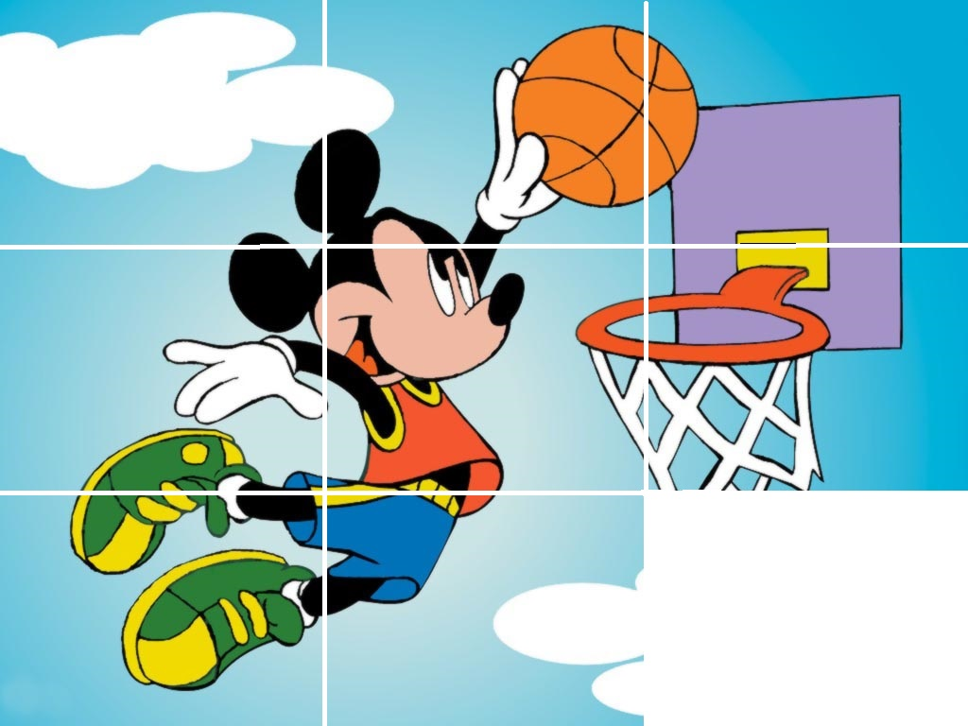

*Figure 6.1 An example image of sliding blocks puzzle*

The sliding blocks puzzle is chosen to be implemented. According to <http://caniuse.com/#search=canvas>, basic features of Canvas are fully supported in iOS Safari, Android Browser, Chrome for Android but only partial support in Opera Mini. However, not all advanced features are supported and the game might have problems on the mobile version. In order to ensure that the puzzle game will work for users suffering from colour vision deficiency, all the images will be tested on <http://www.color-blindness.com/coblis-color-blindness-simulator/> to make sure that the outlines of the image are clearly visible for colour blind people.

# **Bibliography**

Bulat, A. (2011). *Why Color Blindness is No Longer a Problem for Web Design.* [Online]   
Available at: http://www.templatemonster.com/blog/designing-colorblind-friendly-website/  
[Accessed 3 November 2016].

Lazaris, L. (2009). *Designing Websites For Kids: Trends And Best Practices.* [Online]   
Available at: https://www.smashingmagazine.com/2009/11/designing-websites-for-kids-trends-and-best-practices/  
[Accessed 27 October 2016].

Liu, J. (2010). *Color Blindness & Web Design.* [Online]   
Available at: https://www.usability.gov/get-involved/blog/2010/02/color-blindness.html  
[Accessed 3 November 2016].

Webaim.org. (2013). *WebAIM: Fonts.* [Online] Available at: http://webaim.org/techniques/fonts/

[Accessed 3 November 2016]