COM1008: Web and Internet Technology

Assignment: Website

**Development and Testing Document**

1. Changes

First of all, the site map has slightly changed during the development. Below is the image of the new site map:

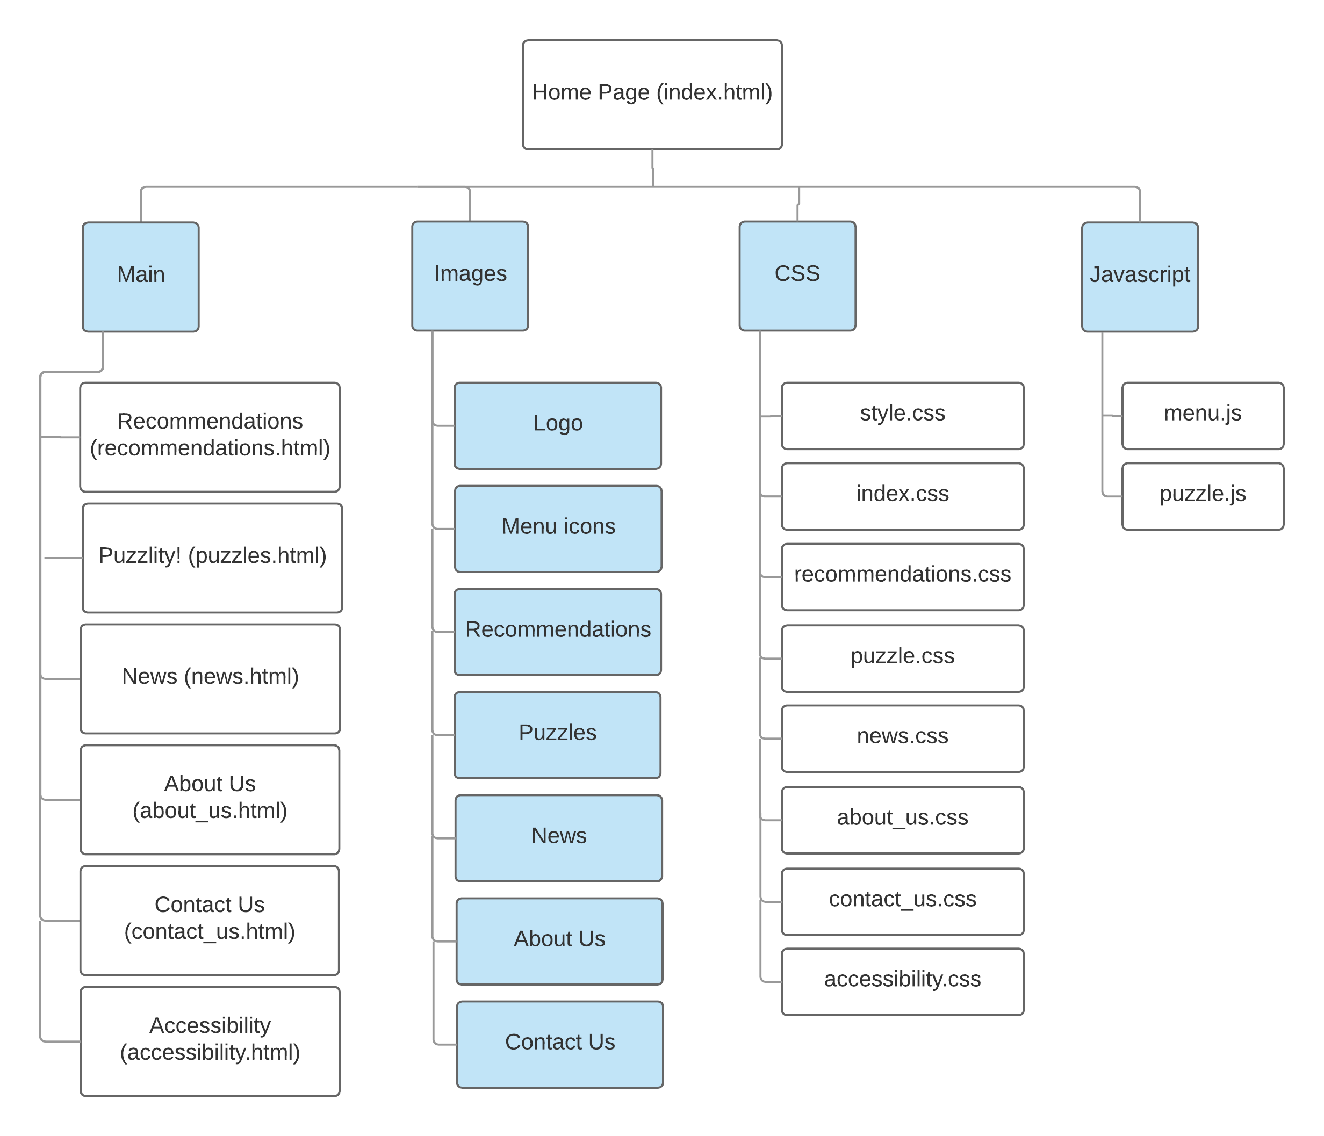

Figure 1.1 New site map of the website

Firstly, the puzzle game page is moved to the main folder because the HTML template used for all pages is the same, except the relative links between the home page and main pages. All the images, CSS and Javascript files are grouped and placed in a separate folder. This makes the relative links more organized and the implementation process

Secondly, instead of having only two menu designs shown in the design mock-ups, the menu system is now changed at 600px and 1000px of screen width:

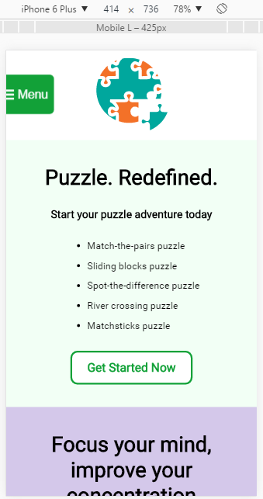 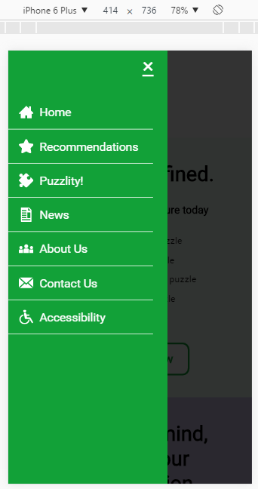

Figure 1.2 Menu system on mobile

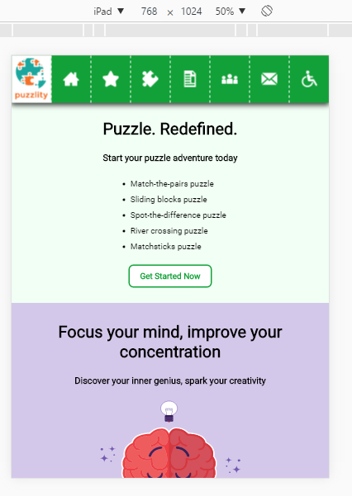

*Figure 1.3 Menu system on slightly larger display e.g. tablet or landscape phone ( > 600px)*

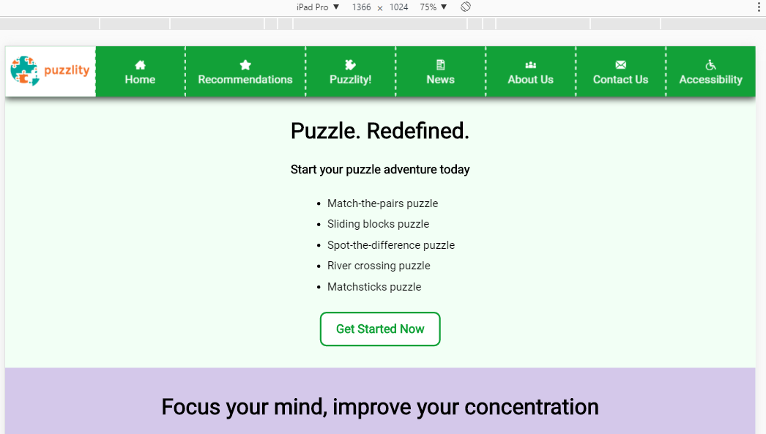

*Figure 1.4 Menu system on large screen ( > 1000px)*

Extra menu design is added at 600px screen width because the text could not fit into the column. It will either be too small and unreadable or overflow into the next column and have unintended outcomes. Therefore, the text was decided to be removed and the menu icons were enlarged because the icons used is fairly intuitive.

Several tweakpoints were added during the development phase. One for the menu system, one for the Recommendations page and one for the Contact Us page. The images below show the changes of the page and how the tweakpoints improved the appearance of the pages.

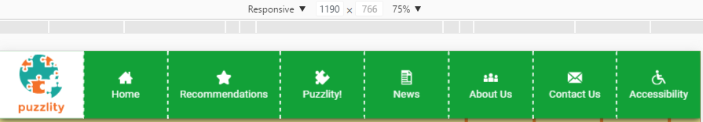

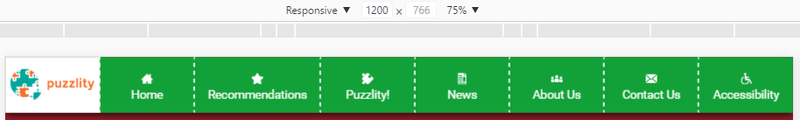

*Figure 1.5 Tweakpoint for the menu system at width 1200px*

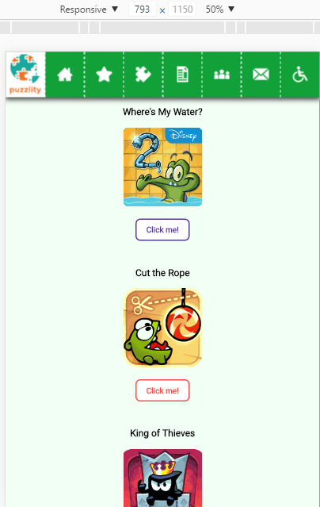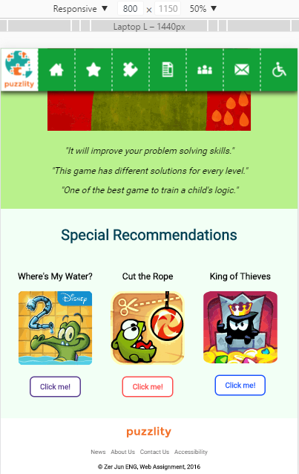

*Figure 1.6 Tweakpoint for the Recommendations page at width 800px*

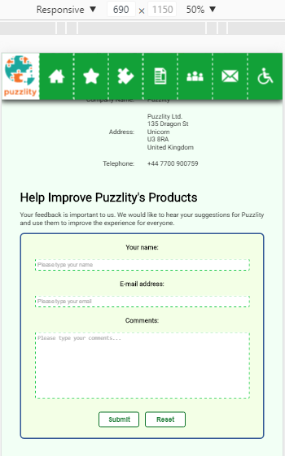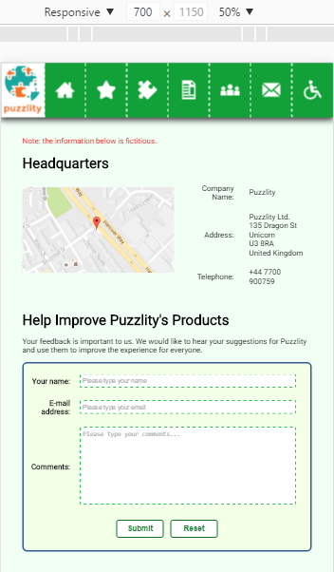

*Figure 1.7 Tweakpoint for the Contact Us page at width 700px*

1. Organisation

The HTML template includes the head section, header, menu system, body, and footer. The CSS template includes the header, menu system, main background colour and footer. These parts are implemented first because they will be the same across every page. The benefits of using a template is that the basic code structure will be the same, hence it will be easier to modify the same content on all pages just by changing the templates. Both templates are fully implemented and validated for structure at <https://validator.w3.org/> to ensure no errors will occur while working on other pages.

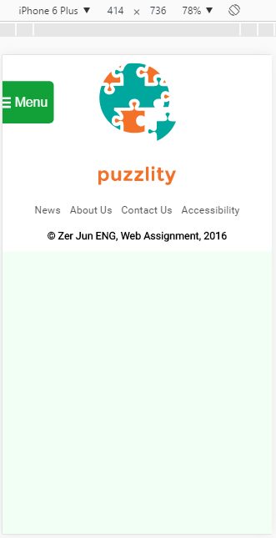 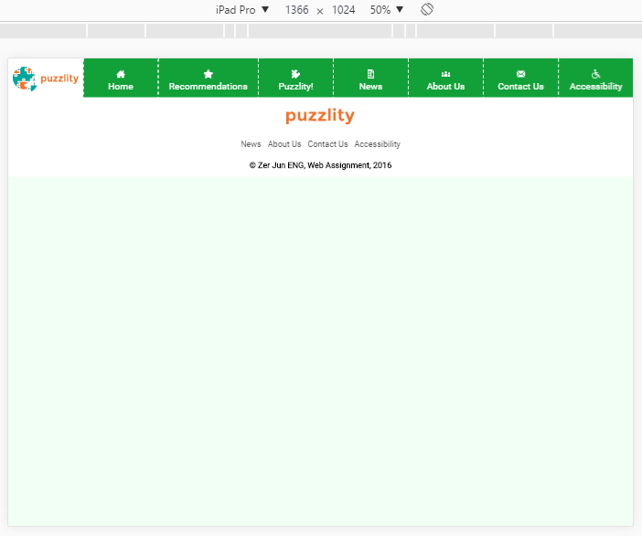

*Figure 2.1 HTML and CSS template on all pages*

Neither the CSS reset nor normalize was used on the website. Since this assignment only needs to consider the last two major version of web browsers, every feature used was checked on <http://caniuse.com> for browsers support info. The most important feature to check for is canvas since the website and the puzzle game is aimed to work on both the mobile and desktop version.

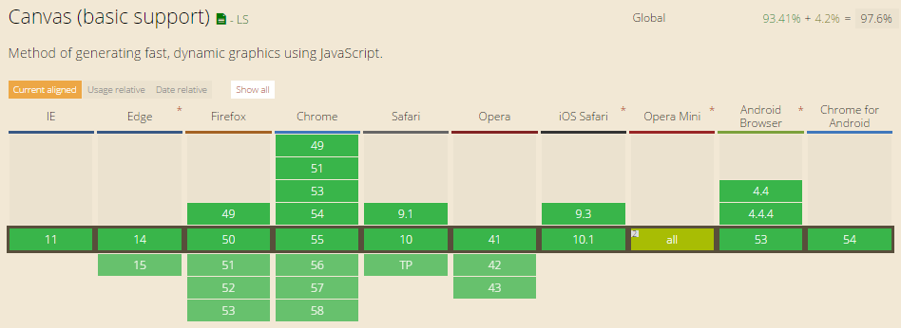

*Figure 2.2 Canvas feature support on browsers version*

The organisation of the file structure is mentioned above as the site map has changed. This website is easy to maintain as it is small-sized and each file type belongs to a specific folder. If there were errors in relative links, it could be spotted easily as the files are well-organised.

The only debugging tool used in this assignment is the Google Chrome built-in Developer Tools. It is used to tune CSS’s margin and padding values, test the website on different screen display and test the puzzle game’s Javascript.

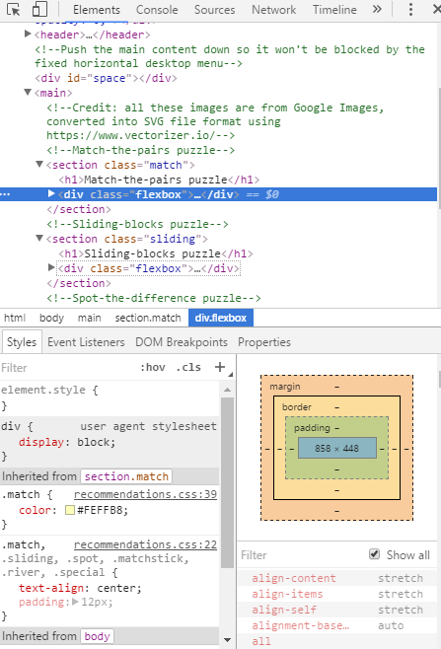

*Figure 2.3 Google Chrome Developer Tools*

1. Optimisation

The logos of the website, the images in the home page and the Recommendations page are converted into SVG format using <https://www.vectorizer.io/>. However, some of the images have larger file size which slow down the loading speed. Therefore, image compressor websites like <https://compressor.io/> and <https://jakearchibald.github.io/svgomg/> were used to reduce the file size of the images to improve the loading times.

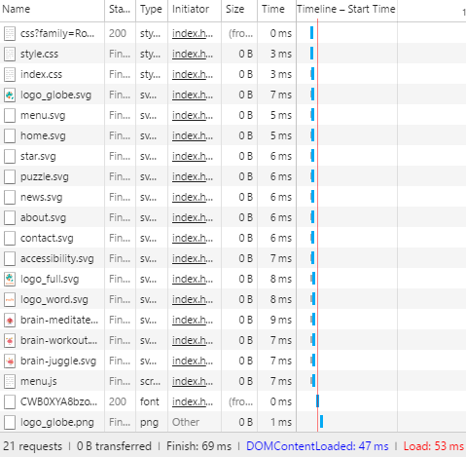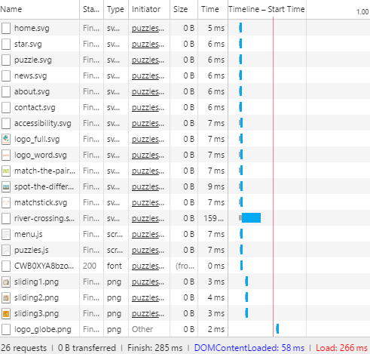

*Figure 3.1 Loading speed of the home page(left) and puzzle game page(right)*

1. Security

According to <http://www.scriptarchive.com/formmail.html>, the FormMail script was last updated on 14 July 2009, which could be highly vulnerable to many security threats nowadays. Attackers could inject new executable malicious script into the form and steal the personal information of the user who inputs data into it. The form doesn’t have an encryption system, which means that the data sent by the users are not secure. Moreover, the website itself doesn’t have SSL security, sensitive information could be intercepted by attackers if they were not encrypted. The Javascript of the puzzle game might get modified by attackers to execute malicious scripts. The website itself might be the target of SQL Injection or Denial of Service attack.

1. Testing

The website will be tested on Google Chrome and Firefox on desktop, and Google Chrome, Firefox and Opera on mobile.

**Desktop version:**

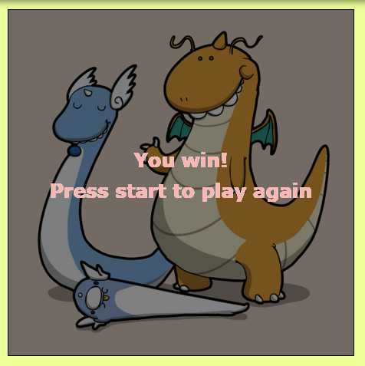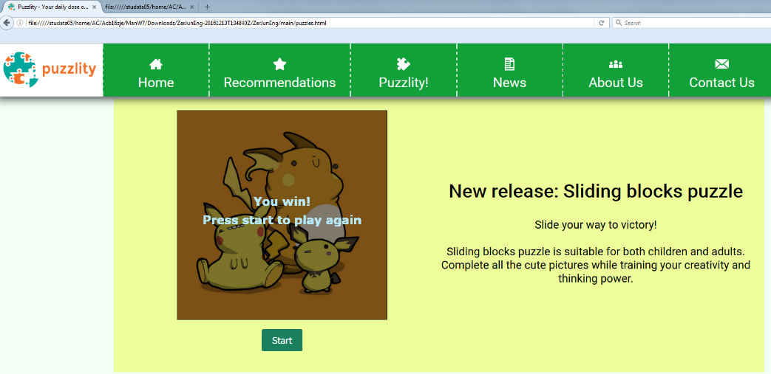

*Figure 5.1 Winning the game on desktop version of Google Chrome (left) and Firefox (right)*

The website and the puzzle game have no problems running on the desktop version of Google Chrome and Firefox.

**Mobile version:**

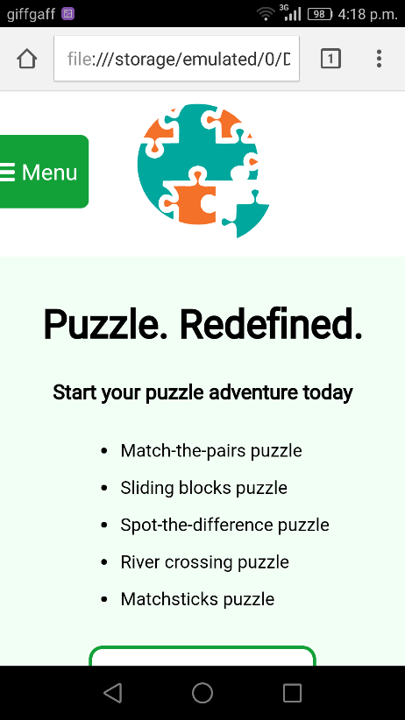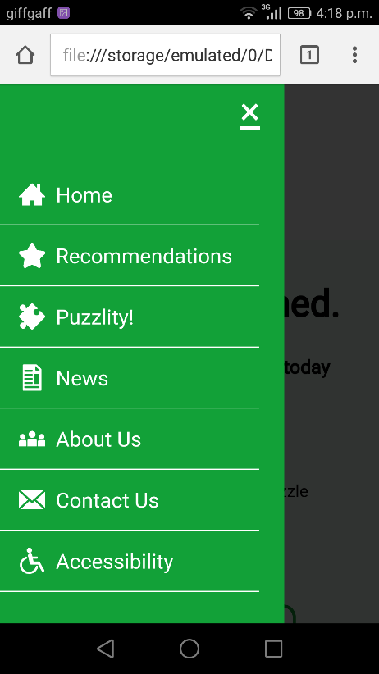

*Figure 5.2 Home page and menu system on Google Chrome mobile*

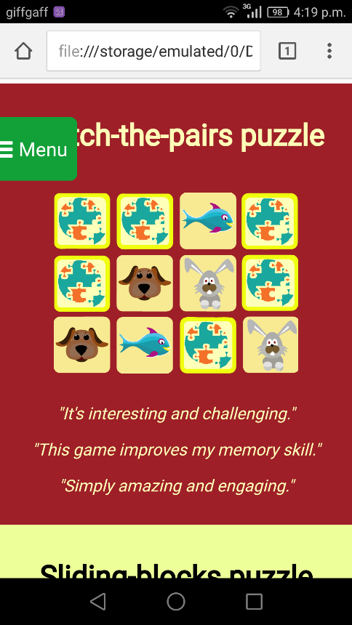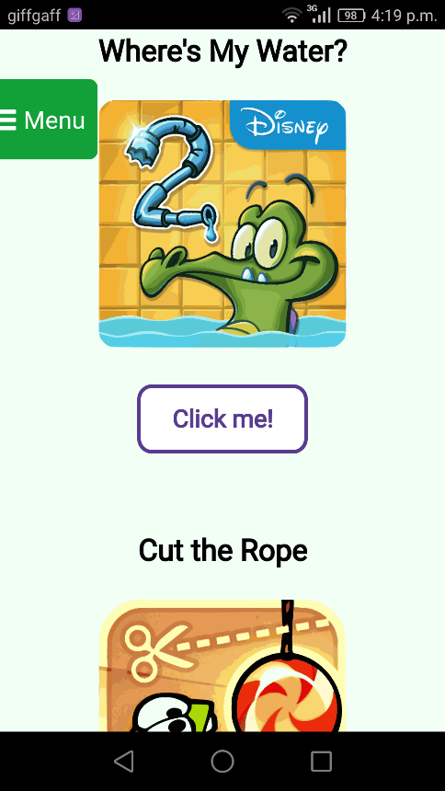

*Figure 5.3 Recommendations page on Google Chrome mobile*

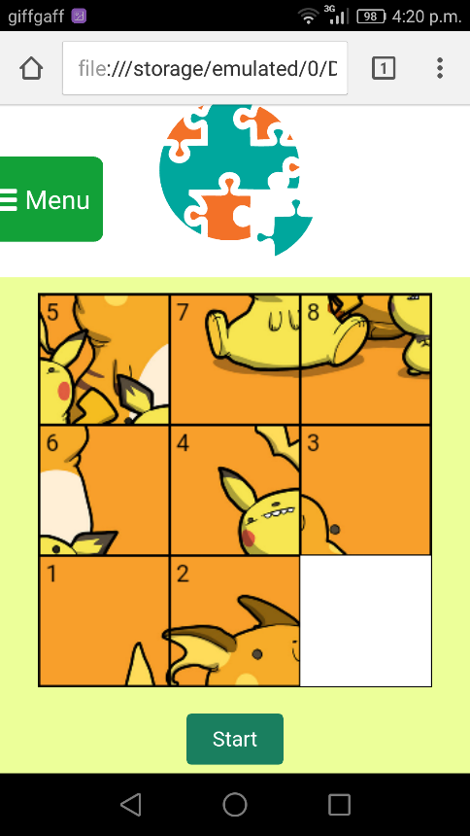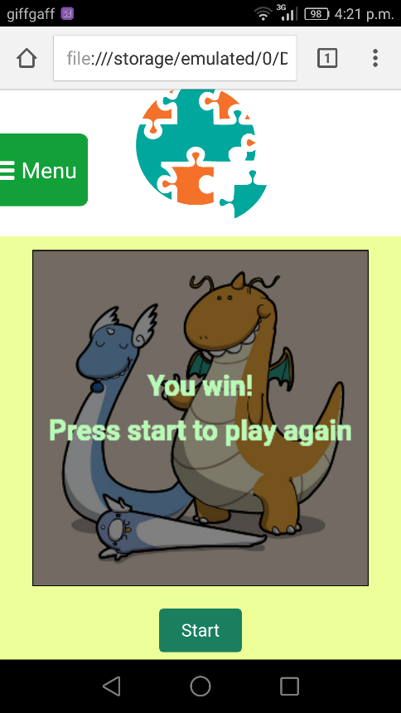

*Figure 5.4 Puzzle game page on Google Chrome mobile*

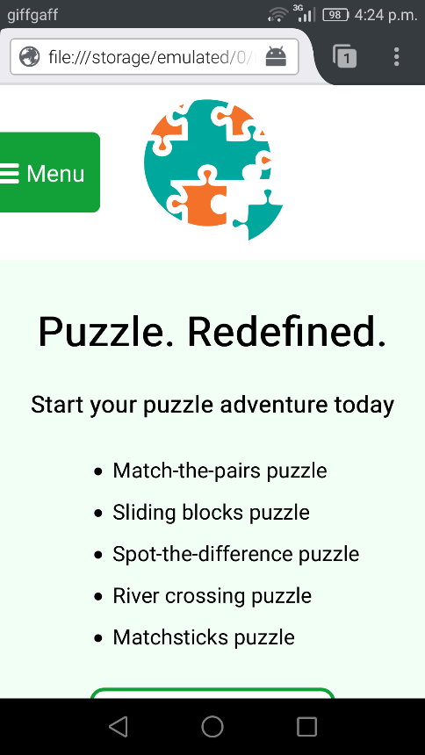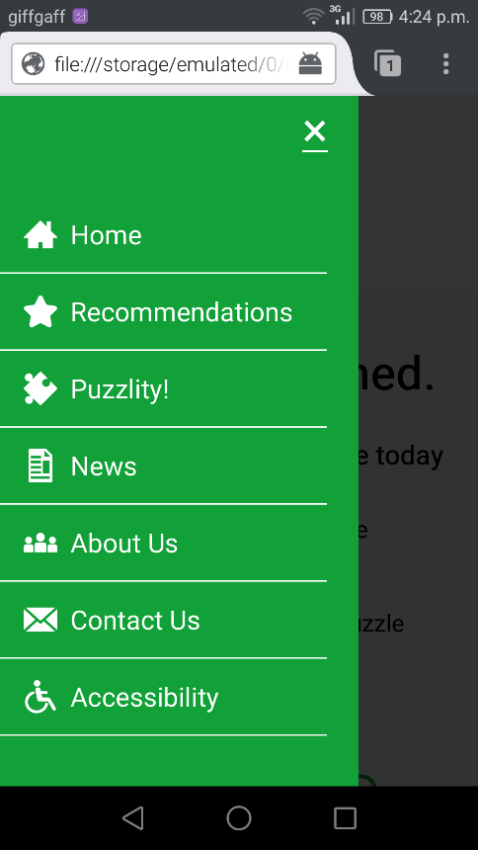

*Figure 5.5 Home page and menu system on Firefox mobile*

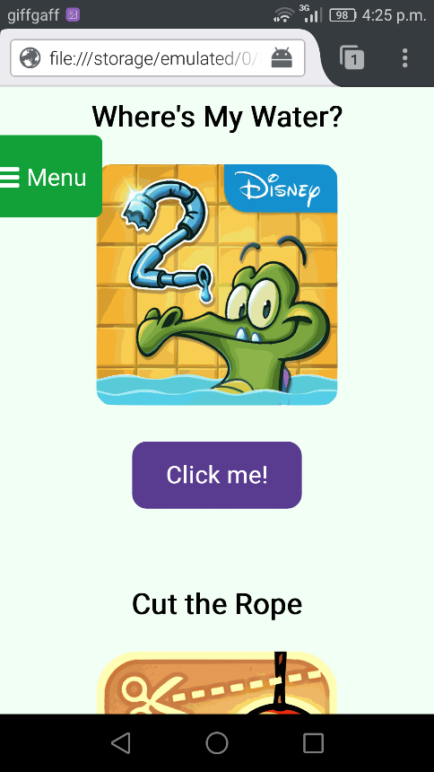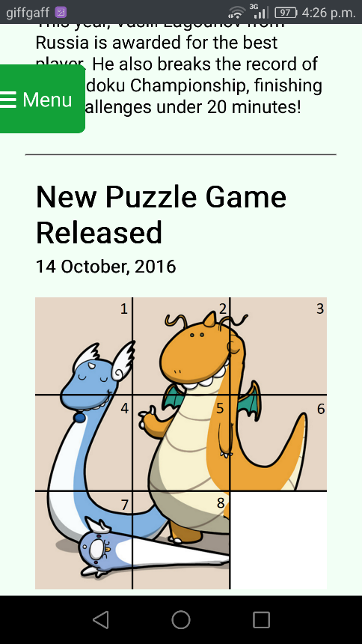

*Figure 5.6 Recommendations page(left) and News page(right) on Firefox mobile*

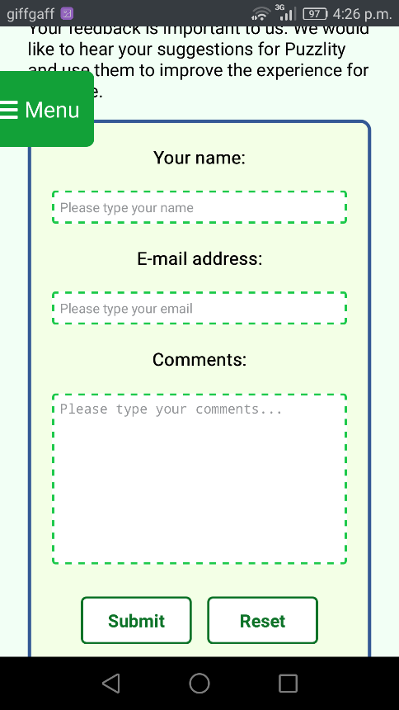

*Figure 5.7 Contact Us page form on Firefox mobile*

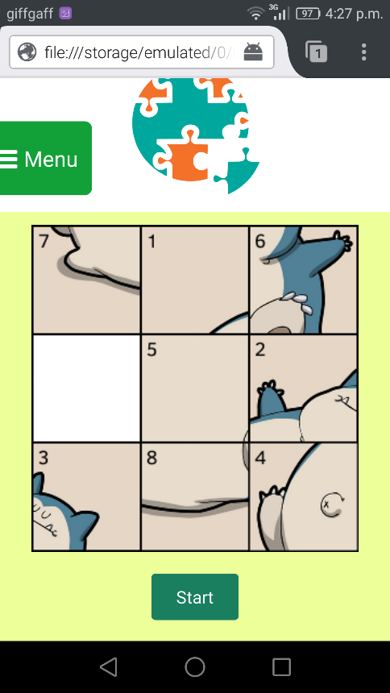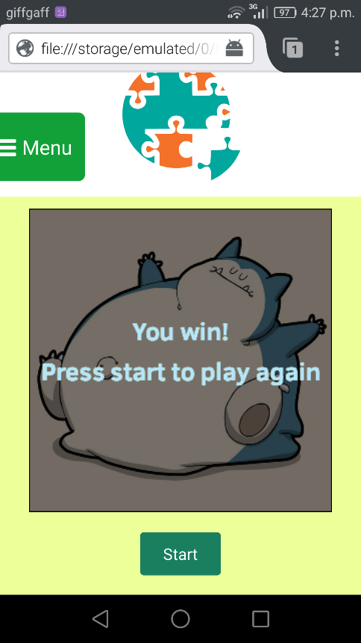

*Figure 5.8 Puzzle game page on Firefox mobile*

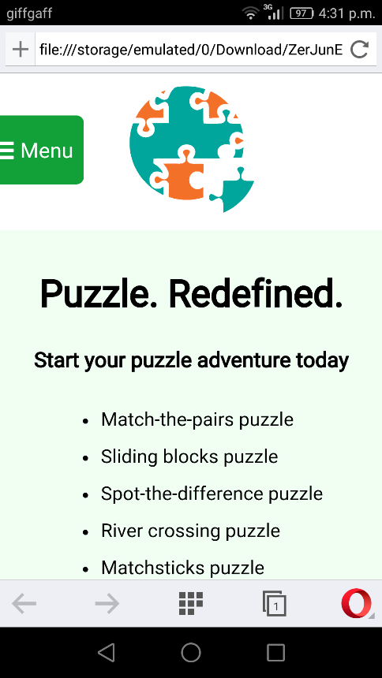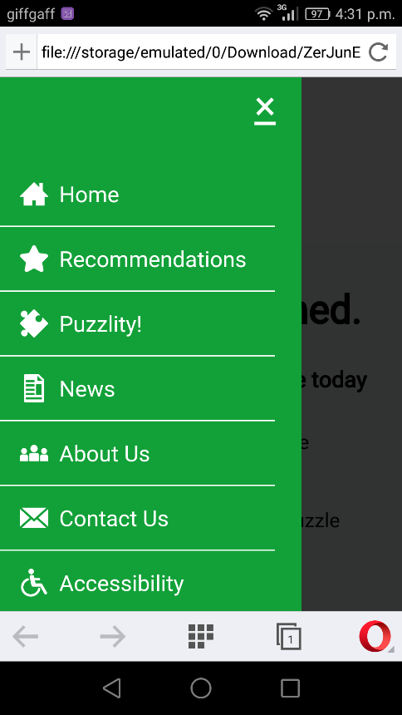

*Figure 5.9 Home page and menu system on Opera mobile*

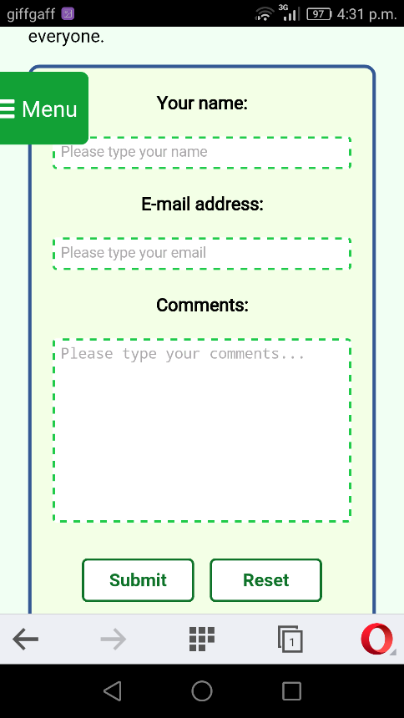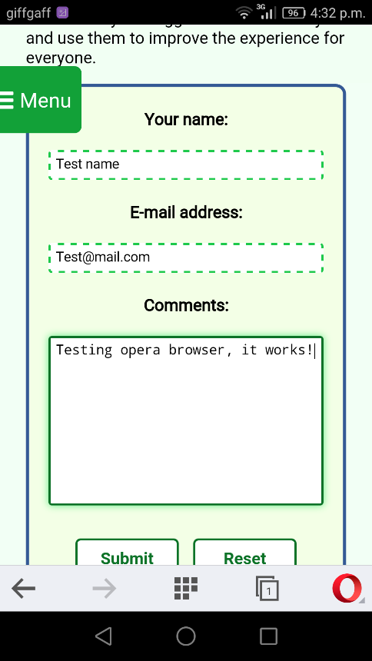

*Figure 5.10 Contact Us page form on Opera mobile*

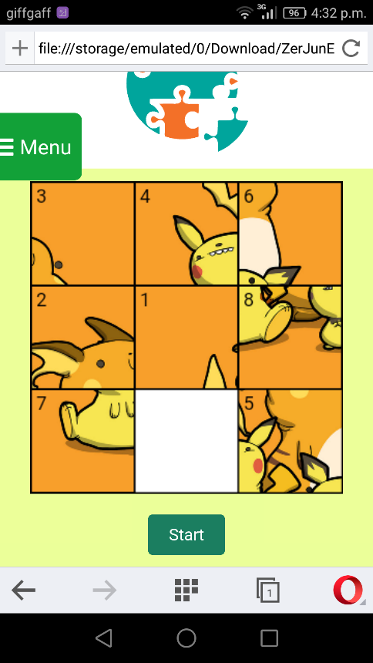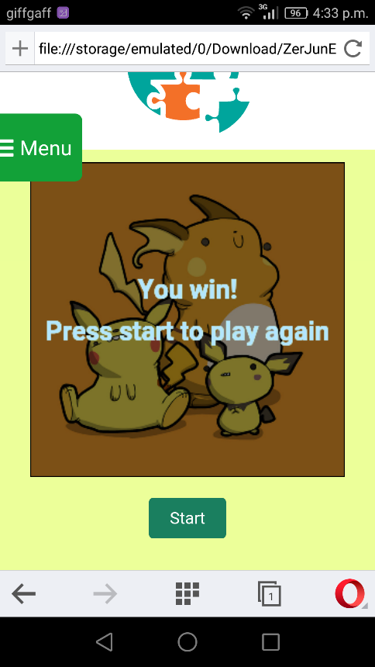

*Figure 5.11 Puzzle game page on Opera mobile*

The testing results on Google Chrome, Firefox, Opera have shown that the website is fully functional on both desktop and mobile version. The puzzle game and the ending animation also work on mobile devices. The appearance and layout are same with the one tested using Chrome Developer Tools.