Applications of Cellular Automata in Forest Fire Simulation

**Jakub Wielgorski, Hubert Baran**

**Abstract:** This paper describes a cellular automata model designed to predict forest fires occurring near the location of a U.S. town. By using this developed system, we managed to find out the approximate time that any given fire takes to reach the location of said city form multiple possible fire sources. Moreover, simulating different weather conditions allowed us to explore the importance of wind, and its direction and speed. Further experimentation showed us the best ways of dealing with a fire, giving much-needed time for town officials to plan an evacuation. The main advantage of such an approach is its efficiency and accuracy in modeling such real-life situations. It can be used to make decisions about the town’s evacuation as well as which strategies to use in order to extinguish the fire in the quickest possible way.

**1. Introduction and Background (Literature Review)**

“The cell represents the simplest level of organization that manifests all the features of the phenomenon of life” (Harold, F. 2003). . Cellular automata, in a nutshell, is the name assigned to a computational model composed of grids of cells and was inspired by observation of different living organisms. In this model, each cell is treated as a single input-output device that performs computation and has a finite number of states. Each cell in the grid only has direct influence on its neighbors, indicating the flow of information. This model has many applications in modern systems, because of its superior efficiency in certain kinds of Computer Science problems (Xiaoping, 2017). One of the most popular problems solved by applying this approach is the Forest Fire Spread simulated model algorithm. The goal of said model was to predict how a fire would spread in a mapped area under various weather conditions, taking into consideration such factors as wind direction and speed (Karafyllidis, 1997). An accurate simulation of such an event would be able to explore the potential spread of a forest fire in a given region and help to provide clues on which strategies would be the best for extinguishing it as well as proposing suggestions for which regions should be evacuated first.

Using cellular automata for modeling forest fires is a state-of-the-art approach widely used by a variety of systems, and yields very satisfactory results. The perfect example of this would be FARSITE (Kanga, Singh 2017) as it is used to deal with this type of problem; it is widely used by U.S. federal and state land management as a good simulator of forest fires. Another application was described in (Xiaoping, 2017) where such a model achieved over 87% mean accuracy. Due to those successes, our team, consisting of computational environmental engineers, was assigned to develop a CA-based model to explore potential forest fire spread in regions prone to fires.

Within the region considered by the model, there is a US town whose power source is a nearby generating plant - a potential source of ignition. Furthermore, there are discussions on building a waste incinerator (another potential source of ignition) in a directly adjacent neighborhood. Having a system simulating potential fires in the surrounding area would help argumentation in favor or against those plans. Our team has decided that for modeling the region and simulating the fire we will use the approach described in (Xiaoping, 2017), due to its aforementioned capabilities.

To implement such a system one firstly needs to describe all possible states in which each cell in this deterministic cellular automaton could be. In his paper, (Xiaoping, 2017) considered a set of 5 possible states, hereby represented as S, and accordingly assigning a value to it. Following his description, S = 0 (unburned), S = 1 (early burning), S = 2 (fully burning, has the ability to ignite surrounding cells), S = 3 (extinguishing), and S = 4 (extinguished). The transition rules between states are taken from real-life examples of forest fires. Cells with state S = 2 are able to ignite neighboring cells and make them change the state from unburned to early burning. Following the logical order, cells in an early burning state will eventually (after delta t time) hit the state of fully burning and then will extinguish gradually. The whole system strongly depends on the parameters that describe the modeled virtual world. The parameters considered by (Xiaoping, 2017) are speed of forest fire and wind level, which are acknowledged as the most important in a research paper by (Karafyllidis, 1997). Moreover, air humidity as well as the angle between wind direction and fire spread direction were added as additional parameters to achieve results that are more realistic.

**2. Materials and Methods**

DETAILED DESCRIPTION OF THE MODEL

Following the principle of the spatial structure of the cellular automata, the area considered in the project will be represented as a grid of cells**.** Any given area, regardless of the various possible terrain types, can be represented using those cells**.** Each cell is described by specific fuel resource parameters which indicate their flammability and the time that it takes to completely burn them. Our grid map will consist of a combination of these 4 types of terrains:

* Large areas of chaparral.
* A large reservoir/lake
* A canyon containing scrubland or grassland
* A smaller area of dense forest.

The event of fire will be shown by the 5 different states that each cell can have; described in paper work by (Xiaoping) with the initial state S = 0 (unburned).

As stated by officials, this U.S. town is located in a region prone to fires. More specifically, they have become concerned about the possible fire risk posed to the town by a power generating plant situated 50km to the north. A new waste incinerator – another potential source of ignition - has been proposed to be sited around 70km north-east of the town. The location of each facility as well as the surrounding vegetation is shown in the picture below.

The grid representing our model will consist of 200 by 200 cells representing 50km^2. This number suits the situation described by the town generals very well, as it allows us to model each type of terrain in detail. Having more cells would strongly affect the computation performance of our system, and fewer cells would impact the accuracy of the model representation.

FUEL RESOURCE PARAMETERS

Firstly let’s take a deeper look at the parameters describing different type of vegetation. According to the task description, large areas of chaparral can catch fire quite easily, and each square km can burn for several days. To indicate those features we assigned the fuel resource burning time per km parameter to 84 hours. Another terrain type to consider is a canyon, which contains scrubland and grassland, which ignite very easily, and each square km burns for several hours. So, in our model, the time that it takes to completely burn a km of this type of area is set to 4 hours, which is considerably faster than the one chosen for chaparral. Lastly, in our model we needed to carefully assign the value of the same parameter to the dense forest which contains trees that do not ignite very easily, but once they are alight, each km^2 can burn for up to one month. In this case, and following this description, we decided to model the worst case scenario and set the parameter to exactly 30 days. In all cases the phase of burning is described by 3 states (early burning, fully burning and extinguishing) with the last state being extinguished. The time of the last of all states is proportional to the parameter that describes fuel resource burning time per km, with the period of fully burning being the longest.

WEATHER MODELING

One of the main goals of this simulation is to study how the time to reach the town from the incinerator would change depending on the wind’s direction. To make sure that our simulation is consistent with actual real-life events of fire, we modeled the weather of the discussed area. The model takes into account the effects of the level of wind as well as its angle to the fire direction and lastly the temperature of the surrounding area. We assume that if there is no wind the fire is spread in all directions with a circular shape, and adding wind will change the direction of the fire spread accordingly. To model the wind we used an idea taken from (Xiaoping, 2017) using wind coefficient $K_{ϕ}=ⅇ^{0.1783⋅v⋅cosφ}$, where $φ$ is the angle between wind direction and fire spread direction, and v is the wind speed. The equation that is used to compute the speed of the forest fire spread (m/min) uses the wind coefficient and looks as follows:

$R=R_{M}⋅K_{ϕ}$,

Where $R_{M}$ is the individual flammable factor for different materials.

TIMESTEP

Lastly our team faced the challenge of choosing a time step for our simulation that would capture the details regarding the fuel resource parameters effectively. To fit the constraints - it takes approximately 4 hours for scrubland or grassland to completely burn and that it takes up to 30 days for the forest to burn out - we ended up picking 30 min as the timestep. During each step, each and every cell will compute whether it should set alight based on how many cells around it are ‘on fire’ and the direction of the wind, as well as its speed.Different burning thresholds were applied to cells representing different terrain types as described in our FUEL RESOURCE PARAMETERS section. Due to the existence of more than one ‘burning’ state, we have decided to base the values for our thresholds according to the specific state of surrounding cells as well as data on the wind, and not just on whether they’re burning. To account for the existing unpredictability of fire, a random number is assigned to each cell, with a cell setting on fire if this random number does not meet its respective threshold.

**3. Results**

*3.1. The relative time for a fire starting at the power plant and incinerator to reach the town assuming a prevailing wind direction.*

We have started our experimentation with a plain model by setting the wind parameter to zero and measuring the time at which the fire line hits the town to set the lower bound for our results. This experiment was repeated for two fire sources, one from the power generating plant and one from the waste incarcerator.As we expected, the fire line had become a circular line surrounding the fire source and expanding in every direction. Once the fire reached the canyon containing scrubland the fire line changed and expanded rapidly all over this type of vegetation due to its flammable features*.* The fire started at the generating plant reached the town faster than the one with its source placed in the waste incinerator due to the closer distance.

The next thing to do was to check how adding wind with a prevailing direction – southern – would affect the time needed for the fire to reach the town, and how changing the speed of wind would affect those results. By increasing the speed of wind slowly and running the simulation we managed to observe the pattern that the time taken to reach the town by fire is inversely proportional to the to the rise of wind’s speed.

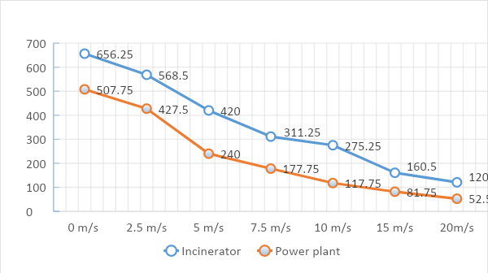

Chart shows correlation between wind speed (m/s) and time (h) for fire to reach the town, for an incinerator and a power plant as the fire ignition sources.

3.2. A study on how time to reach the town from the incinerator would change depending on the wind’s direction.

Once we established how the strength of the wind affects the time taken by a fire to reach the town, following the logical order the next variable that we took under experimentation was the wind’s direction. Seeking to model the event of fire as realistic as possible we changed the direction of wind with constant speed in order to find the best and worst scenario. This would allow for a better strategy for dealing with the situation. With the source of ignition located in the incinerator we experimented with 8 different possible directions that the wind would blow in. As to be expected, the fire reached the city the fastest with the wind blowing in the exact direction to the town – south east. Setting the wind to the opposite direction resulted with extending this time to almost twice as long. In conclusion we have proven that the wind direction is as important a factor as the wind’s speed and should definitely be considered.

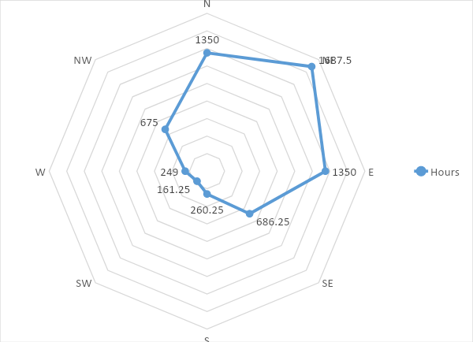

This chart describe in what time (h) fire would reach the town, depending on wind direction. With the ignition point set to incinerator and a wind speed set to 10m/s (average wind speed in California)

3.3. Short-term intervention in the case of a fire starting at the incinerator

Town officials have at disposal a limited quantity of water that can be dropped aerially to cease the fire in case of such an event. It is only enough to cover approximately 10 km square of the burning area so it is crucial to plan the best place for the drop of water, so as to most effectively slow down the fire. Using our model we experimented with different possible locations for such an action, assuming that the fire started at the incinerator and that there is a prevailing wind blowing in South-West direction (worst-case scenario) with a speed of 10m/s, which is the average in California – the state with the most fire occurrences in the USA. Another assumption taken by our model is that the dropped water will evaporate after 75 hours and after this time, it will not be able to stop the fire. We checked a lot of potential locations for the drop in order to find what would give us the best results and put the most important possibilities on the graph below.

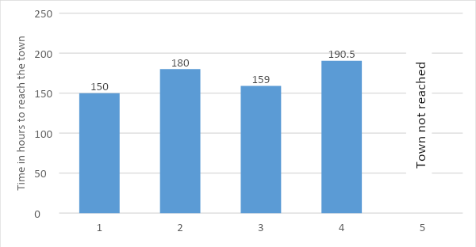

An obvious choice was to drop the water just next to the fire source within hours of the fire starting, and as expected it has given us the best results by completely extinguishing the fire (see figure 1. (**d**)). Yet if we assume that firefighters would not be able to react that quickly, then according to our simulation the best choice would be to drop half the amount of possessed water on the east of the dense forest covering 5 km squared of the land and the rest on the south of the forest. By doing that the time taken by the fire to reach the town is extended from 150 to 190.5 hours (see figure 1. (**c**)).

|  |  |
| --- | --- |
| (**a**) | (**b**) |
| (**c)** | (**d**) |

**Figure 1.** Test cases of short-term intervention in the case of a fire starting at the incinerator: (**a**) east side of the forest; (**b**) south side of the forest; (**c**) east and south side of the forest, 5km^2 each; (**d**) surrounding of the incinerator 18 hours after ignition

3.4 Long-term intervention in the case of a fire starting at the incinerator

There are ongoing discussions about the possibility of doubling the existing area of dense forest. The main question in this debate is in regards to which direction it should be extended towards. With weather parameters set to the same values as in the short-term intervention experiment, we ran our model testing different possibilities to give the most accurate answer.

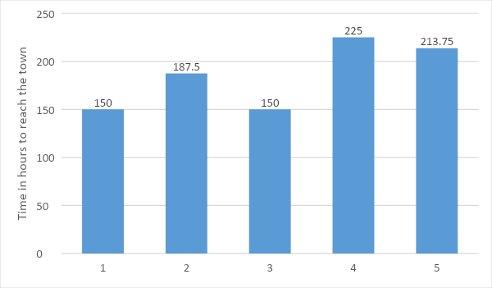

Best results were achieved by extending the forest to the west and to the south (see picture). Such a natural barrier would significantly slow down the fire, which would in this case reach the city after 225 hours of burning. This is compelling because it gives almost 75 hours more for planning the town evacuations.

The other cases that we have tried are extensions to the western and southern sides of the forest, as well as planting the forest in the area just next to the waste incinerator. The best results after the first case were achieved by the last case, resulting in the fire reaching the town after 213,75 hours.

|  |  |  |
| --- | --- | --- |
| (**a**)    (**d**) | (**b**)    (**e**) | (**c**)    (**f**) |

**Figure 1.** Test cases of a long-term intervention in the case of a fire starting at the incinerator: (**a**) extension to the western side of the forest; (**b)** extension to the southern side of the forest; (**c**) extension to the western and southern side of the forest; (**d**) planting the forest just next to waste incinerator; (e) barrier parallel to canyon; (f) barrier above forest to west side

Lastly, we considered other possibilities for slowing down the fire. As we learned, the canyon, containing scrubland, is the easiest area to ignite, and spreads fire the fastest. In conclusion, we acknowledge that the best chance to slow down the fire would be just next to this area. We started experimenting with creating a natural barrier (e.g. river) in parallel to this very flammable type of terrain, resulting in the very promising result of 180h until the fire would reach the town, which gives over an extra day for evacuation. Another experiment was to set the river above the dense forest to its west side, which extended the time to 197h.

**4. Discussion**

The model we presented was addressed to answer question of town offcial’s. After creating simulation environment, we successfully carried out many experiments that included effects of different natural factors on fire spreading (wind direction/ wind speed), as well as effects of short and long term interventions to prevent fire reaching the town.

From the results of the first simulation, we could see how southern wind velocity affects the time of reaching the town by fire with an ignition start points in incinerator and a power plant. The results of this experiment shows a time to reach the town from incinerator ranged from 27 days with zero wind, to only 5 days with 20m/s wind. In the second case, with ignition points at the power plant, time ranged from 21days to 2 days. It’s worth noticing that with the increasing wind speed, the difference of time to reach the town from both sources, lowered. For wind with speed 0m/s time from the incinerator was greater by 150h than time from a power plant, and for wind with speed 20m/s, difference was only 70h.

The second simulation showed how the direction of wind affect the time of fire reaching the town with constant wind velocity 10m/s and fire ignition source in an incinerator. The results confirmed our intuitive predictions, because the longest time was 70 days with the north-west wind, and the shortest was 6 days for wind blowing to south-east. In most usual in this area, south wind direction, time to reach the town was 11 days, which means that wind conditions are unfavourable for town position.

Next three series of simulations, checked how short-term and long-term interventions can prolong the time of reaching the town. When water drops were executed, then the best location would be west and south side of the forest, with rectangular area of 5km^2 each. Other, worth considering option would be dropping water next to the source (incinerator), what depending on our simulation, would have to be done not later than 18-20 hours after ignition. That could totally extinguish the fire.

For long term interventions, we considered increasing an area of dense forest and building a fire breaks. In case of forest, the best extension direction(s) would be west and/or south side, what would increase a time of reaching the town by approximately 75 hours. In case of fire breaks, the best option would be building it from a point above the forest to the west, to stop the fire from reaching the town from the north side.

**5. Conclusions**

By studying and applying cellular automata, we created a model capable of simulation forest fires. Our model considered fire behaviour dependent on multiple factors. Two of the most important factors are related to the wind, its direction and speed is highly influential on time of the fire spreading. Another important factor – type of material. Highly flammable materials like chaparral or scrubland tend to burn fast, so it's easier for fire to spread on them than on, in example, dense forest. After all, three possible interventions were considered, and optimal actions were concluded for each type of it. We believe that the information we provided across all of this study would be useful for town official’s in case of a real danger, to save people’s lives and their possessions.

**References**

1. Harold, F. (2003). *The way of the cell*. Oxford: Oxford University Press.
2. Xiaoping, R., Hui, S., Yu, X,., Zhang, G., Wu, B., Forest fire spread simulation based on cellular automata, Natural Hazards, 2017, 91(1) pp. 309-319
3. Karafyllidis, I., Thanailakis, T., A model for predicting forest fire spreading using cellular automata, Ecological Modelling, 1997, 99(1), pp. 87-97
4. Suraj Kumar Singh, S. (2017). *Forest Fire Simulation Modeling using Remote Sensing & GIS*. [ebook] Available at: <https://www.researchgate.net/profile/Shruti_Kanga2/publication/325848449_Forest_Fire_Simulation_Modeling_using_Remote_Sensing_GIS/links/5b2b9bf0aca2720a941f0f3e/Forest-Fire-Simulation-Modeling-using-Remote-Sensing-GIS.pdf?download=true>.