Preparation of Manuscripts for ACM Inroads

Mark W. Bailey and Laurie Smith King *(Do not include these in your initial anonymous submission)*

Writing manuscripts for publication in *ACM Inroads* differs from traditional technical journal publication. This article serves as a template for the formatting style and tone of an *Inroads* submission. We cover a variety of formatting issues from layout to figures and references. Every article includes a leader (aka, Lede, Lead) of about 75-100 words that introduces the article and summarizes its essence in language that encourages readers to continue reading. For information on leaders, see [*Types of Leads*](http://www.neshaminy.org/cms/lib6/PA01000466/Centricity/Domain/439/Cp6%20-%20HANDOUT%20CNN%20Types%20of%20lead-ins.pdf)*.* Those that read this article generally are more successful in publishing in *Inroads*.

# Introduction

This document is formatted following the *Inroads* formatting specifications. Since you must submit your manuscript as a Microsoft Word document, we encourage you to use this document as a template for your manuscript so it will adhere to the *Inroads* formatting specifications.

# Magazine Articles

As you prepare a submission, please keep in mind that *Inroads* is a magazine, not a research journal, so keep references and math symbols to a minimum; resist the urge to have multiple subheadings, but do add art and images. The narrative you draft should be informative, upbeat, written for a broad-based audience, and should have no statement that cannot be supported.

## Titles and Author Rights and Permission Forms

Before submitting your manuscript, carefully consider your title. A good title prepares the reader for content to come. A title also identifies the work and appears on ACM author rights / copyright forms. Upon manuscript submission, ACM will automatically send you a notice regarding permission or author rights / copyright forms for author completion and signature. Submission of one of these forms, as appropriate for the type of submission, is a requirement. No manuscript can be published without completion of the appropriate forms. Significant changes in title will require completion of a new set of forms.

## Reviewing

*Inroads* magazine uses a double-blind process for review in which the identities of the authors are concealed from the reviewers, and vice versa. The double-blind process protects both the authors and reviewers from any possible bias. The process requires that the submission initially arrive anonymously. After an acceptance, the authors must update the manuscript to include all identifying information. Figure 1 shows the flow of manuscript submissions through the *Inroads* publication process.

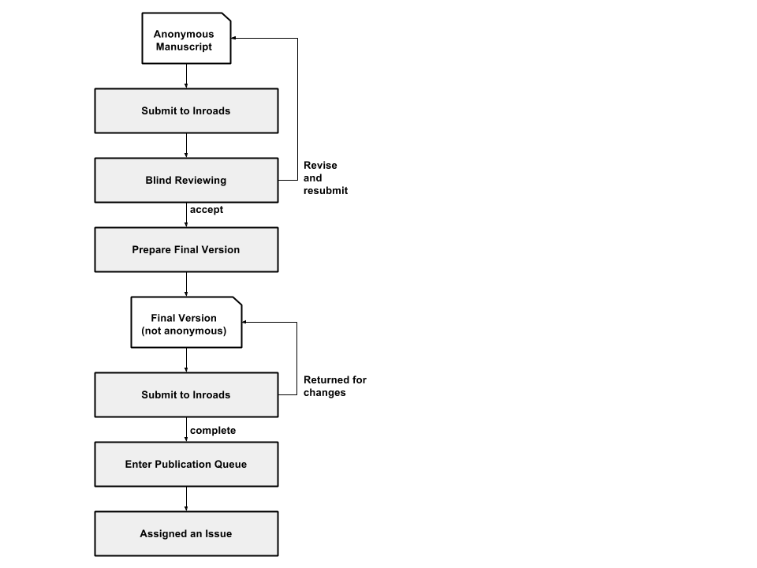Figure 1. Inroads publication process.

*Inroads* expects new, unpublished material. In support of this goal, ACM uses iThenticate to ensure the originality of written work before publication. As a first step after a submission, *Inroads* submits the anonymous document to iThenticate, which compares the text to published material (at least 43 billion web pages and 130 million content items). iThenticate provides editors with a set of similarity indices and helps them identify material that has been previously published, either in whole or large part, including prior publications of authors.

## Images and Figures

As a magazine, *Inroads* not only encourages, but also expects the use of relevant images in support of written narratives. All images must be high resolution, which means at least 300 dpi in JPG format; such files are usually about 1.5 MB. Additionally, the use of third-party images or materials requires permission from the owner of the material and attribution of the source. Authors should use images where fees are not required.

When you include a figure or image, your manuscript should explicitly introduce the figure and reference it in the body of the text. As exhibited in the previous section, reference figures using Figure, not Fig. or other abbreviations. If your figure or image comes from another source—from which you have permission to use the figure—you should include the source in the figure caption. Please include your images in the text of the manuscript with notations to the Art Director on where they need to appear in the final markup. Submit separate files containing high-quality copies of any images or figures you reference in your text.

## Reviewer Scorecard

The Reviewer Scorecard found under *Instructions & Forms* on the *Inroads* ScholarOne Manuscript submission site is an excellent resource for an author to gain understanding on what *Inroads* is seeking. New users will be more successful when they understand what the *Inroads* reviewers are assessing.

# Acknowledgements

The editorial staff of *Inroads* is grateful to the many authors and contributors to *Inroads* and the publication staff at ACM headquarters who make this magazine possible.

# References

References are numbered and listed in alphabetical order by first author’s last name. For more information on reference format and citation, see the [*Inroads Citation Guide*](http://mc.manuscriptcentral.com/societyimages/inroads/CitationGuide2016December.pdf).

1. Brassard, G. and Bratley, P. Fundamentals of Algorithmics. (New Jersey: Prentice Hall, 1996): chapter 7.7.
2. Greenberg, J. ed., Of Prairie, Woods, and Water: Two Centuries of Chicago Nature Writing. (Chicago: University of Chicago Press, 2008).
3. Patt, Y. and Patel, S. Introduction to Computing Architecture. 2nd ed. (New York: McGraw Hill, 2008).
4. ScholarOne Manuscript Central *Author Quick Start Guide.;*[http://mchelp.manuscriptcentral.com/gethelpnow/tutorials/author.pdf.](http://mchelp.manuscriptcentral.com/gethelpnow/tutorials/author.pdf) Accessed 2013 22 June.

# Author Details

*(do not include these in your initial anonymous submission)*

Mark W. Bailey  
Department of Computer Science  
Hamilton College  
198 College Hill Rd  
Clinton, NY USA  
mbailey@hamilton.edu

Laurie Smith King  
Department of Mathematics and Computer Science  
College of the Holy Cross  
Worcester, MA USA   
lking@holycross.edu