4

**Instructional Design + Knowledge Components: A Systematic Method for Refining Instruction**

# Luke Gusukuma

Department of Computer Science Virginia Tech

Blacksburg, Virginia [lukesg08@vt.edu](mailto:lukesg08@vt.edu)

Austin Cory Bart Department of Computer Science Virginia Tech

Blacksburg, Virginia [acbart@vt.edu](mailto:acbart@vt.edu)

Dennis Kafura

Department of Computer Science Virginia Tech

Blacksburg, Virginia [kafura@cs.vt.edu](mailto:kafura@cs.vt.edu)

**ABSTRACT**

Jeremy Ernst School of Education Virginia Tech Blacksburg, Virginia [jvernst@vt.edu](mailto:jvernst@vt.edu)

Katherine Cennamo School of Education Virginia Tech Blacksburg, Virginia [cennamo@vt.edu](mailto:cennamo@vt.edu)

1. **INTRODUCTION**

This paper reports on a systematic method used to improve an existing unit of instruction. The method is distinctive in combin- ing steps of instructional design with "knowledge components" from a cognitively-based framework of learning. Instructional de- sign is used to develop assessment instruments that incorporate information about student misconceptions. The method uses the assessment instruments to evaluate student performance and learn- ing gains, while statistical analysis evaluates the quality of the instruments themselves using measures of difficulty and discrimi- nation. Fine-grain insight into possible improvements is enabled by the knowledge components implicated by the assessment. The method is illustrated and evaluated by applying it to a unit of in- struction on collection-based iteration in a computational thinking class. Data gathered during this evaluation highlights a number of opportunities within the unit to refine the instruction.

## CCS CONCEPTS

* **Applied computing** → **Education**; Learning management sys- tems;

## KEYWORDS

Knowledge Components, CS1, CS Education, Assessment, Instruc- tional Design

**ACM Reference format:**

Luke Gusukuma, Austin Cory Bart, Dennis Kafura, Jeremy Ernst, and Kather- ine Cennamo. 2018. Instructional Design + Knowledge Components: A Sys- tematic Method for Refining Instruction. In *Proceedings of ACM SIGCSE conference, Baltimore, Maryland USA, February 2018 (SIGCSE’18),* 6 pages. <https://doi.org/10.475/123_4>

Permission to make digital or hard copies of part or all of this work for personal or classroom use is granted without fee provided that copies are not made or distributed for profit or commercial advantage and that copies bear this notice and the full citation on the first page. Copyrights for third-party components of this work must be honored. For all other uses, contact the owner/author(s).

*SIGCSE’18, February 2018, Baltimore, Maryland USA*

© 2018 Copyright held by the owner/author(s). ACM ISBN 123-4567-24-567/08/06.

<https://doi.org/10.475/123_4>

Revision is a crucial component of course design. Frequently, how- ever, the original instruction and accompanying assessments have not been developed using any kind of formal process, but instead were developed from informed experience while using informal means. In other cases, the instruction was "inherited", often with overlapping contributions and viewpoints from various instruc- tors. Of course, experienced instructors often have valuable insight into the misconceptions held by students. When instructors have the opportunity to refine a curriculum, or even rebuild it from the ground up, the process can benefit from this prior knowledge. Still, using ad-hoc processes can limit the effectiveness of a revision opportunity in the same way that large software projects suffer without guidance from formal design methodologies.

Course revision and development can benefit from using formal methods of Instructional Design to guide development, although in our experience many computing instructors are unaware of these methodologies. The field of Instructional Design has been around for many decades, and a variety of models and frameworks exist that systematize the design of learning experiences [2, 4, 7]. In a few cases, researchers in computing education have used elements of formal ID models in their work, such as Needs Assessments [9] or comparing instructional strategies [3]. Some works even note the parallels of Software Engineering and Instructional Design [5, 6], yet few suggest targeted ways for computing educators to incor- porate ID into their curriculum design efforts [1], suggesting a need within the literature for a well-described model suitable for computing education researchers.

In this paper, we describe our activities in the practical improve- ment of a targeted unit of existing instruction. This paper makes two contributions:

* + The development of a method for improving a targeted unit of instruction that combines steps of instructional design with elements of a cognitively-based framework of learn- ing and is particularly suited for the design of computing instruction, and
  + The illustration and evaluation of the method as applied to a unit of instruction on collection-based iteration in a introductory computing class.

The audience for this paper are instructors seeking an approach- able and effort-conscious way of improving a specific part of their course. We believe the method is approachable; while it does require some reading and preparation, it does not require extraordinary training or overly sophisticated statistical analysis. The method is effort-conscious, requiring a modest time investment. We esti- mate that creating the assessment instruments (the first step of the method) took three of the co-authors one full week of effort, so con- servatively one person-month. The analysis step took four of the co-authors less than a week to conduct. Again, a person-month of effort. Finally, the method is (at least in our view and use) focused on a “unit” of instruction (i.e., a single topic) which in our case was a unit lasting four class days on the topic of collection-based iteration. While the method can be used to incrementally improve an entire course one unit at a time, we realize that in practice not all units in a course may require improvement. Rather, especially critical or under-performing units can be targeted. This work also makes a partial contribution toward the development of a concept inventory [10,](#_bookmark8) [11], specifically for the topic of iteration.

We give an outline of our method and use this outline as a guide to the organization of the rest of the paper. The method has four steps:

* 1. Design assessment
     + identify instructional goals (sec 2.1)
     + identify misconceptions (sec 2.2)
     + conduct instructional analysis (sec 2.3)
     + create assessment instruments (sec 2.4)
  2. Collect assessment data
     + administer assessment instruments (Sec 3.1)
     + tabulate student performance and learning gains (Sec 3.2 and Table 1 and Figure 2)
     + tabulate item analysis to identify item difficulty and dis- crimination (Sec 3.2 and Table 2)
  3. 3. analyze student learning and assessment instruments
     + identify items with weak learning gains and valid assess- ments (Sec 4.1 and 4.2)
     + identify implicated knowledge components (Sec 4.3)
  4. 4. improvement
     + correct suspect items in assessment instruments
     + improve instruction (presentation, problems, feedback)

Roughly, the steps in the design assessment step are a subset of the Dick and Carey instructional design process [4], though more specialized. For example, in our method, the Dick and Carey step of identifying instructional goals is limited to identifying the goal of the unit of instruction selected for improvement. The identify misconceptions set is the Dick and Carey step of Learner and Con- text Analysis that is focused on the misconceptions of the learners and any parts of the context relevant to the misconceptions. The instructional analysis and assessment instrument steps are the same as in the Dick and Carey model.

An understanding of the learners is central to the instructional design process. The model that we describe leverages the cognitive modeling aspects of the Knowledge Learning Instruction Framework (KLI) [8] to enhance a sub-set of a formalized Instructional Design

process [4]. An operational definition that a Knowledge Com- ponent is "an acquired unit of cognitive function or structure that can be inferred from performance on a set of related tasks" [8]. Through this method we build on and integrate existing techniques.

The steps to analyze student learning and the assessment in- struments use standard statistical techniques to study the assess- ment data collected by administering the assessment instruments. Through this analysis, specific knowledge components are impli- cated by assessment items with reasonable difficulty and discrimi- nation and with less than desired student performance or learning gains. Comparison across different assessment items are used to refine the list of implicated knowledge components.

## DESIGN ASSESSMENT

Assessment-driven improvement of instruction relies on assessment instruments that are directly relatable to the instruction. Some systematic instructional design process must be used to achieve this linkage. In our case, a subset of the Dick and Cary model [4] was used where some of the steps were narrowed or refined for the task at hand.

## Identifying Instructional Goals

We targeted one of the most difficult and important parts of our curriculum, collection based iteration. Not only is collection-based iteration one of the more difficult items in our curriculum, it is also central to our curriculum which revolves around data science. Specifically, students must be able to use iteration to compute simple quantitative measures of list-oriented data (e.g., averages) and gen- erate standard visualizations (e.g. histograms). Two instructional goals emerged: "Construct an algorithm that outputs a quantitative measure of the values in a given list" and "Construct an algorithm that produces a visualization based on the values in a given list". Each goal expresses an observable skill that we expect our students to learn from the instruction. For brevity, only the first of these is considered in this paper.

## Identify Misconceptions

An initial list of student misconceptions about collection-based iteration was developed through personal observation and semi- automated analysis. Personal observations in the classroom were done informally. In our class format, instructors would walk around the classroom and help students who are engaged in active learning exercises with other students. The interaction with students helped build our intuition regarding misconceptions and student knowl- edge. Semi-automated inspection of previous student code bolstered our personal observations. For brevity, the tools and methodologies used in the semi-automated inspection are omitted. The miscon- ceptions played a role both in identifying knowledge components (a misconception suggests one or more partially understood or mis- understood knowledge component) and in developing distractors on the multiple choice assessment questions.

While we developed tools for the semi-automated analysis of student code, this is not a requirement of using the method. Any information regarding student misconceptions, from any formal or informal data source, is useful.

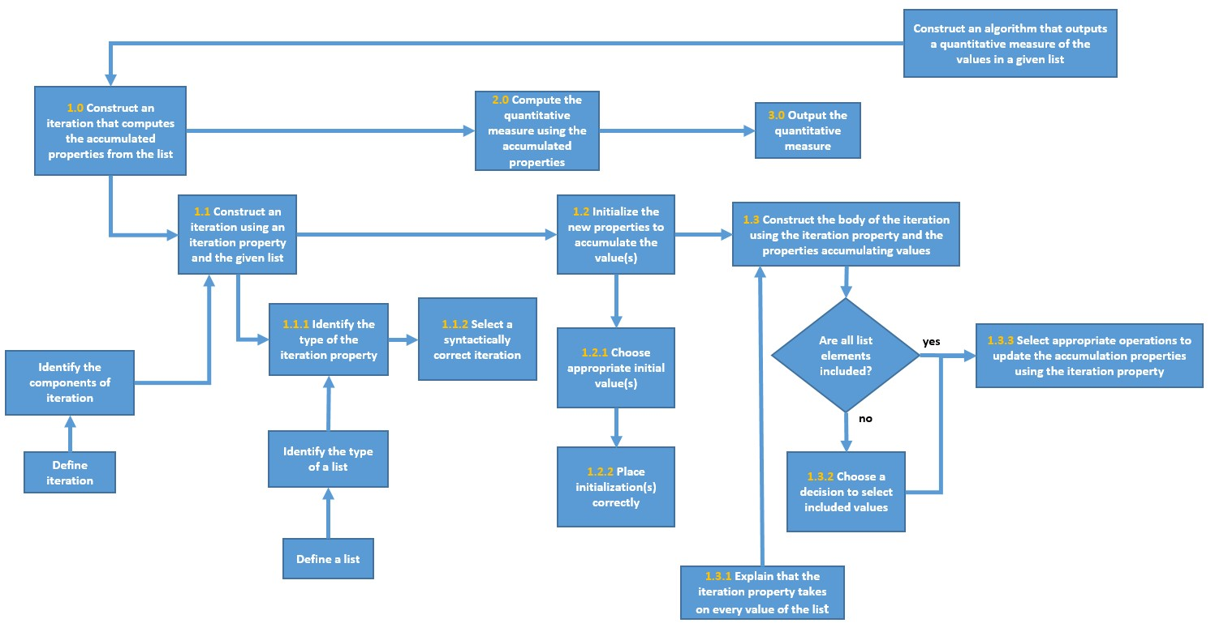

### Figure 1: Final iteration of Instructional Design Diagram

* 1. **Instructional Analysis**

For our instructional goal we determined the baseline knowledge we expected students to have at the beginning of the iteration unit. The units prior to iteration provide instruction on basic initializa- tion, Boolean logic, if-else constructs, as well as a knowledge of the basic data types (string, integer, and float). Determining the base- line knowledge of the students is important to having well defined boundaries about what was, and was not, out of the scope of our instructional analysis.

Using our instructional goal, Bloom’s taxonomy, our list of mis- conceptions, the baseline knowledge, and previous course material as a guides, we created a rough task analysis diagram of skills we wanted our students to be able to perform. To break the instruc- tional goal down into subtasks and steps, we went through the process of discerning what skills were being exercised and used to produce our learning goal. We used Bloom’s taxonomy as a guide to make sure we included items from lower cognitive levels, to higher cognitive levels. The list of misconceptions helped us identify items in the diagram. For example, we included "Identify a subtype of list" as a task because our observations showed that students would occasionally use strings instead of numbers when constructing a list. After establishing a hierarchy of tasks, we formalized our task analysis into an instructional design diagram. The diagram shown in Figure 1 is a final iteration of the diagram after multiple iterations of refining our performance objectives and tasks.

We also generated performance objectives for each task in the diagram. A performance objective identifies for a given problem what the student will be able to accomplish and with what accuracy.

For example, for Task 1.1.1 "Construct an interation property", two performance objectives are:

* + 1. Given a list explain what type of value the iteration property will have.
    2. Given a list select the type of the iteration property from among several choices.

Many other performance objectives are possible for this task. The value of stating these performance objectives is that they lead directly to the formation of assessment questions. They are the linkage between the assessment data gathered later and the instruc- tional steps.

## Assessment Instruments

Our assessment instruments (the pretest and post-tests) had two parts. The first part was a multiple choice test that assessed the individual subtasks in the instructional analysis diagram. The second part was a free response coding questions that assessed the top level instructional goal. To generate the multiple choice questions, we drew upon the performance objectives defined earlier, using those that could be cast into a multiple choice form. The misconceptions that we found in our earlier analysis (semi-automated inspection and observation) and refined in our instructional analysis drove the creation of the distractors we used for the test.

After creating the test, we used the answer choices to generate a formalized list of knowledge components as the student’s selection of an answer choice represents knowledge we can infer the student to have (or not have). Table 3 has a small sample list of KCs (full list provided on request). It is important

to keep in mind that, because KCs are inferred by instructors from student performance, different instructors will come up with different KCs due to both teaching differences and student population differences. That being said, a large number of these knowledge components are likely transferable to other student populations, or may serve as a starting point for other instructors.

## COLLECT AND TABULATE DATA

The data was collected using parallel pre- and post-tests adminis- tered before, during, and after the unit of instruction. The tabulated data allows both an analysis of student learning and an assessment of the instruments used to measure that learning (i.e., the pre- and post- tests). Both analyses are needed because gains or deficit in student learning should not be ascribed on the basis of a suspect measurement instrument.

The tests were administered over two sections of the class that each met twice a week. The unit of instruction took place over three class days. The pretest was given at the end of the class prior to the unit beginning. The first post-test was given at the beginning of the third day of instruction. The second post-test was given two class days after the first post-test. The third post-test was given eight class days after the second post-test. The first three tests were administered using a block-based representation of the code for the questions and answer choices. The last post-test was adminis- tered after the students had completed the Python coding portion of the class and was administered using the text representation for questions and answer choices. All tests were planned to be admin- istered in class. However, an issue with the learning management system for one section necessitated the pretest for that section to be administered as a take home test. To insure that the difference in pretest administration did not invalidate the pretest we conducted an independent 2-group Mann-Whitney U test between the two sections. The p-value of 0.8157 suggests that there were no signifi- cant differences caused by taking the test at home instead of in the classroom.

The number of consenting participants were a total of 67 for the pretest, 75 for post-test 1, 72 for post-test 2, and 69 for post-test 3. Of those students participants, 55 participated in each test.

## Administer Assessment

The assessment consisted of one pretest and three post-tests. Each test has nine multiple choice questions and one free response pro- gramming question. In this paper we will focus only on the multiple choice questions. The ordering and content of the multiple choice questions remained the same, but the details of the questions (e.g. summing distances vs. summing prices) and the ordering of the answer choices changed between tests. The tests were administered in an online format via a learning management system where each question was presented one at a time, with students not being able to go back to a previous question. This format was used because

later questions in the test can give away answers to previous ques- tions in the test (e.g., the code in a later question could give the answer to an earlier recall question).

## Tabulate Data

Table 1 presents the data on student learning showing the percent of student answering each question correctly on each test. Learning gains were calculated as (post-pre)/ (1- pre) where pre and post represent the percentage of students who correctly answered each assessment question. The percent correct is an absolute measure of student performance while the learning gains is a measure relative to the studentsâĂŹ starting (pretest) point. The learning gains are presented graphically in Figure 2.

Table 2 presents the data for the assessment of the three post- test instruments on an item (i.e., question) by item basis. The item difficulty is a proportion of collective correct responses. The dis- crimination ability of post-test items is characterized through sum- mary correlation between a continuous and binary variable (overall outcome in relation to item-level association).

~~The assessment data can be analyzed as follows~~. Questions 2-9 have notable increases in learning outcome while, there was no detectable learning gain for question 1 across the 3 tests.. BBased on analysis of item difficulty, questions 2 and 5 had the highest proportional outcome on the post-test, reflected in the student learning gains on post-test 1, post-test 2 and post-test3. Questions 3 and 6 had very little change in learning gains (average change of less than 0.03), and were identified by the portion of correct responses as items of lower difficulty, but with stronger discriminative power. Question 4 has a comparatively higher level of post-test difficulty in relation to questions 2, 3, 5, 6, and 9 and has moderate discriminative power (summary correlation of 0.599). Question 7 shows reasonably high learning gains on post-tests 2 and 3 (0.834 and 0.914 respectively), but shows much smaller progressions of learning gains in the first post-test. The resulting difference in learning gains is highlighted in the discussion section. Questions 8 and 9 had strikingly similar behaviors in their learning gains curves (see Figure 2) as well as their interesting learning gain drops on post-test 3 and are also highlighted.

## ANALYZE DATA

The tabulated assessment item data is analyzed in two steps. First, areas of possible improvement are identified. Assessment instru- ment improvements are indicated by low quality questions (i.e., those with problematic difficulty or discrimination). Improving these questions leads to a better assessment instrument. Instruc- tional improvement are indicated by high quality questions where materially better student performance is possible. Second, for in- structional improvements the related knowledge components are identified.

## Identify Possible Improvements

Question 1 appears to be of low quality. The level of correct re- sponses is inconsistent and low and the learning gains are very

### Table 1: Learning Outcomes

Percent of students correct Learning Gains s

|  |  |  |  |  |  |  |  |  |
| --- | --- | --- | --- | --- | --- | --- | --- | --- |
| Que tion  q1 q2 q3 | - pre post1 post2 post 3 | | | | post1 | post2 | post 3 | and 3 (0.834 and 0.914). Questions 8 and 9 have significant drops in  learning gains between post-tests 2 and 3 (0.715 to 0.565 and 0.875 to 0.662 respectively). One hypothesis is that the introduction of |
| 0.646 | 0.547 | 0.708 | 0.594 | -0.279 | 0.177 | -0.145 | dictionaries between post-tests 2 and 3 resulted in confusion on |
| 0.633 | 0.947 | 1.000 | 1.000 | 0.855 | 1.000 | 1.000 | those questions. This suggests that materials involving dictionaries |
| 0.329 | 0.947 | 0.931 | 0.942 | 0.921 | 0.896 | 0.914 | should be a focus for future improvement. |
| q4 | 0.241 | 0.693 | 0.708 | 0.797 | 0.596 | 0.616 | 0.733 | Question 4 is a high quality questions indicating an area of |
| q5 | 0.709 | 1.000 | 1.000 | 1.000 | 1.000 | 1.000 | 1.000 | improvement in student performance. The students showed lower |
| q6 | 0.519 | 0.907 | 0.875 | 0.899 | 0.806 | 0.740 | 0.789 | learning gains than we would have liked; learning gains were 0.596, |
| q7 | 0.329 | 0.467 | 0.889 | 0.942 | 0.205 | 0.834 | 0.914 | 0.616, and 0.733 across the three post-tests respectively. The low |
| q8 | 0.367 | 0.507 | 0.819 | 0.725 | 0.221 | 0.715 | 0.565 | learning gains flags the particular question as containing concepts |
| q9 | 0.443 | 0.773 | 0.931 | 0.812 | 0.593 | 0.875 | 0.662 | that our students are not mastering. The fact that 73% of students |
|  |  |  |  |  |  |  |  | get this question correct, and the fact that it’s correlation to test |

3 (0.789). Questions 7 through 9 have low learning gains on the first post-test because the material for those questions was not yet taught. Question 7 showing good learning gains on post-tests 2

### Table 2: Item Analysis

Average Standard Deviation

score is 0.599, we can tell that the question itself is a fairly balanced discrimination value appropriate to its difficulty, meaning that the content of the question itself, and not the clarity of it, is something we need to address in our instructional material.

|  |  |  |  |  |  |
| --- | --- | --- | --- | --- | --- |
|  | Proportion Correct | Discri- mination | Proportion Correct | Discri- mination | In summary, we have identified an assessment item to improve  (Question 1), a topic for the future application of our method (dic- |
| Q1 | 0.616 | 0.588 | 0.068 | 0.040 | tionaries as indicated by Questions 8 and 9), and a current topic  study further (Question 4). |
| Q2 | 0.982 | -0 | 0.025 | -0 |  |
| Q3 | 0.940 | 0.222 | 0.007 | 0.066 |  |
| Q4 | 0.733 | 0.599 | 0.046 | 0.105 | **4.2 Identify Knowledge Components** |
| Q5 | 1 | -0 | 0 | -0 | Exploring the knowledge components of a question, like Question |
| Q6 | 0.893 | 0.546 | 0.013 | 0.111 | 4, that points to possible instructional improvements allows for a |
| Q7 | 0.766 | 0.398 | 0.213 | 0.127 | fine-grain understanding of precisely what in the instruction needs |
| Q8 | 0.684 | 0.659 | 0.131 | 0.114 | to be improved. For brevity, we’ll focus on answer choice "a" for |
| Q9 | 0.838 | 0.356 | 0.067 | 0.044 | Question 4 (see Figure 3) that was one of the two most commonly |

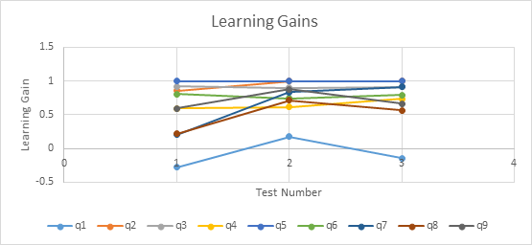

### Figure 2: Learning Gains by Question

poor (Table 1). The overall level of performance is the lowest of all items (Table 2). We are not sure if there is some ordering effect that affected this question and distorted the learning outcomes. Additionally, the content for this question was based on identifying data types which limited us in actually making parallel question on each test as the only suitable types for the distractors were float, integer, and string. We are informed by this analysis to consider revising this question. Questions 2, 3, and 5 (all with learning gains consistently above 0.855 and never dropping) leave little room for improvement. Question 6 has acceptable learning gains by post-test

selected distractors. We want to know what knowledge components

led students to select this distractor. From answer choice "a", we can infer that the students have the following knowledge components (see Table 3): 6, parts of 18, and to some confidence, 23. The missing pieces of knowledge are other subparts of knowledge component 18 as well as knowledge components 12 and 22.

By identifying the knowledge components, we have a list of specific ideas against which we can review our instruction. For instance, we know the student has at least some partial compe- tency with regards to knowledge component 18. So an instructional improvement from the syntactic perspective is to make clearer the basic accumulation pattern for summing a list using iteration. However, another approach, using knowledge component 12, is to make clearer how a list is distinctly different from a sum, or a way of summarizing a list. A third approach would be to use direct instruction: "don’t use the list in for loop". A fourth approach is to include in our programming environment specific tests for this misconception and provide immediate feedback linked to "just in time" instruction.

In summary, we have identified four different approaches to address the misconceptions revealed by the knowledge components in Question 4. Other guidance could be gained by examining other associated knowledge components in this question and study how these same knowledge components appear in other questions. For example, Question 3 also contains knowledge component 12 but

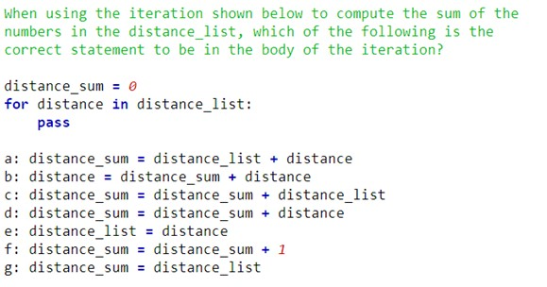

### Figure 3: Question 4 template

**Table 3: Knowledge Components for Question 4**

[8] Kenneth Koedinger, Albert T Corbett, and Charles Perfetti. 2012. The Knowledge- Learning-Instruction Framework: Bridging the Science-Practice Chasm to En- hance Robust Student Learning. *Cognitive science* 36.5, Article 5 (2012), 757-798 pages.

[9] Nasir I. Mohd, Azilah N. Nor, and Naufal U. Irfan. 2010. Instructional Strategy in the Teaching of Computer Programming: A Need Assessment Analyses. *TOJET :* *The Turkish Online Journal of Educational Technology* 9, 2 (2010).

[10] Cynthia. Taylor, Daniel Zingaro, Leo Porter, Kevin C. Webb, Cynthia Bailey Lee, and M. Clancy. 2014. Computer science concept inventories: past and future. *Computer Science Education* 24, 4 (2014), 253-276.

[11] Allison Elliott Tew and Mark Guzdial. 2011. The FCS1: a language indepen- dent assessment of CS1 knowledge. In *Proceedings of the 42th ACM Technical Symposium on Computer Science Education*. ACM, 111–116.

KC Number description

KC006 The iteration property takes on each value of the list

KC012 The sum and the list are two different items KC018 Update for sum is sum = sum + iteration_ prop-

erty (has 6 different sub parts) KC020 You can’t add the list to a number KC022 The list is not used in accumulation KC023 The list is not used as an accumulator

performance on Question 3 question is on the upper end (learning gains averaging .9). Does this mean that students generally have knowledge component 12 and the problem is elsewhere? Or does it mean that knowledge component 12 in the context of accumulation is problematic?

## CONCLUSION

In this paper we have presented a pragmatic method for improving instruction by combining knowledge components from a cognitively- based framework with selected steps from a commonly referenced model of instructional design. We have shown how we have ap- plied this method to our instruction of collection based iteration in a computational thinking course. We hope that this work better informs the community about the possibility of using principled methods to assess and revise critical topics with reasonable level of effort.

## REFERENCES

[1] Austin Cory Bart and Clifford A. Shaffer. 2016. Instructional Design is to Teaching As Software Engineering is to Programming *(SIGCSE ’16)*. 240–241.

[2] Robert K Branson, Gail T Rayner, J Lamarr Cox, John P Furman, and FJ King. 1975.

*Interservice procedures for instructional systems development. executive summary* *and model*. Technical Report. DTIC Document.

[3] Michael E. Caspersen and Jens Bennedsen. 2007. Instructional Design of a Programming Course: A Learning Theoretic Approach *(ICER ’07)*. 111–122.

[4] Walter Dick, Lou Carey, James O Carey, and others. 2001. *The systematic design* *of instruction*. Vol. 5. Longman New York.

[5] Ian Douglas. 2006. Issues in software engineering of relevance to instructional design. *TechTrends* 50, 5 (2006), 28–35.

[6] J. Philip East. 2004. Applying Software Design Methodology to Instructional Design. *Computer Science Education* 14, 4 (2004), 257–276.

[7] Peter J Esseff and Mary Sullivan Esseff. 1998. Instructional Development Learning System (IDLS). (1998).