Q1)

int val = 5;

int ref = 10;

int* ptr = new int(15);

Stack Heap



|  |
| --- |
|  |
|  |
|  |
| 15 |
| 10 |
| 5 |

|  |
| --- |
|  |
|  |
|  |
|  |
|  |
|  |

* Created initial memory

int val = 5;

int ref = 10;

int* ptr = new int(15);

// called method that was created

void pass_by_val_ref_ptr(int val, int & ref, int * ptr)

{

val = 50;

ref = 100;

*ptr = 150;

}

Stack Heap

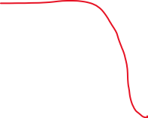

|  |
| --- |
|  |
|  |
|  |
| 150 (15) |
| 100 (10) |
| 5 |

|  |
| --- |
|  |
|  |
|  |
| 150 |
| 100 |
| 50 |

* After the method was called, except the ‘val’ value, other attributes were passed by reference and pointer.