1. Install docker as per the mentioned link

https://docs.aws.amazon.com/AmazonECS/latest/developerguide/docker-basics.html

2. First ensure docker install on ec2 instance

curl -LO "https://dl.k8s.io/release/**$(**curl -L -s https://dl.k8s.io/release/stable.txt**)**/bin/linux/amd64/kubectl"

chmod +x ./kubectl

sudo mv ./kubectl /usr/local/bin/kubectl

kubectl version --client

curl -Lo minikube https://storage.googleapis.com/minikube/releases/latest/minikube-linux-amd64 \

&& chmod +x minikube \

&& sudo mv minikube /usr/local/bin/

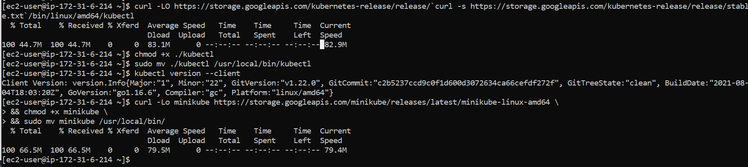

minikube config set driver docker

minikube start

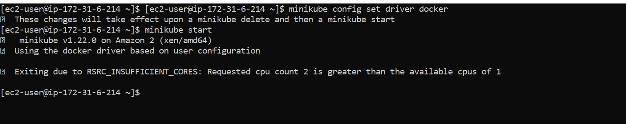

Shutdown the EC2 Instance and change the instance type to t3.medium

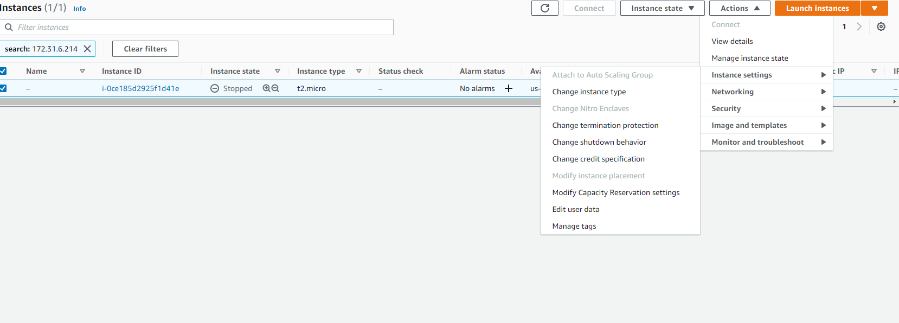

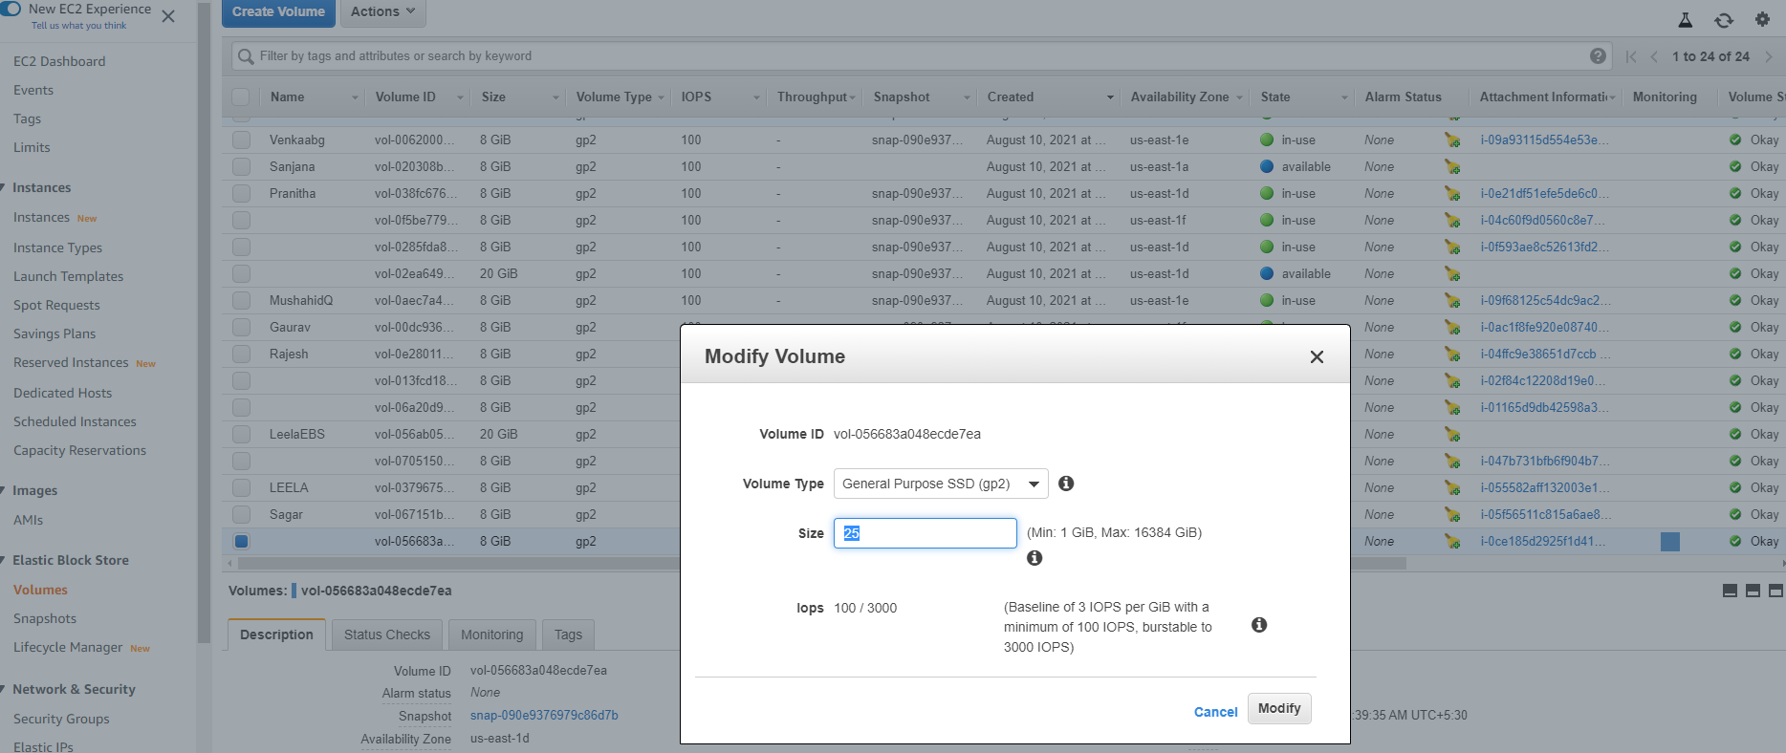

Increase the root disk size ( 25G)

Start the instance

sudo systemctl enable docker

sudo systemctl start docker

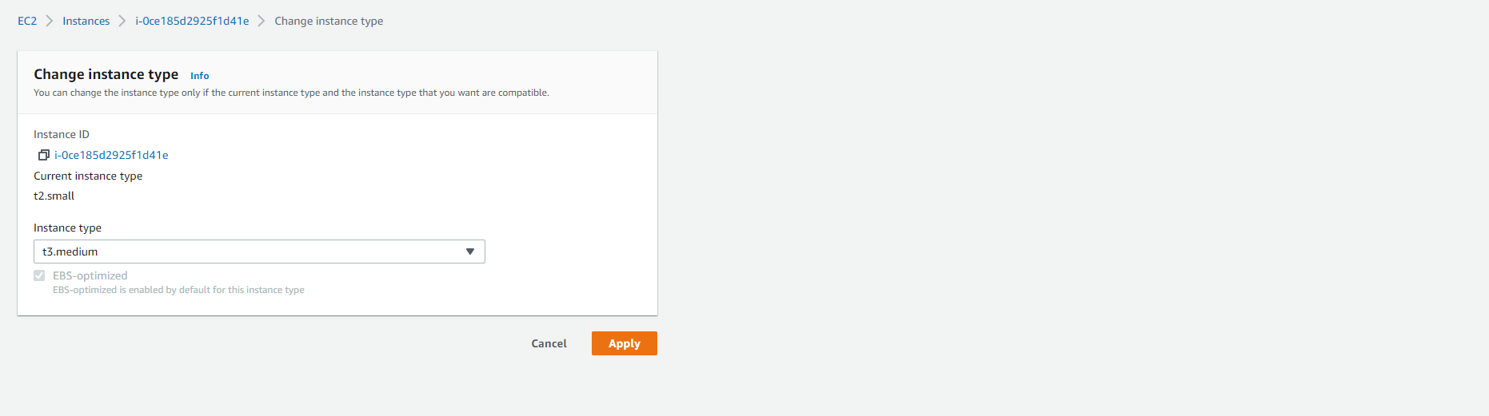

minikube start --nodes 4 -p multinode

minikube delete -p multinode

minikube status -p multinode

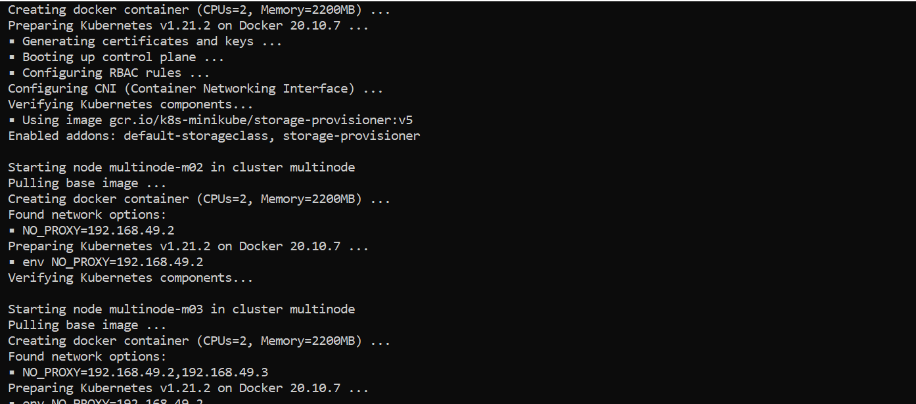

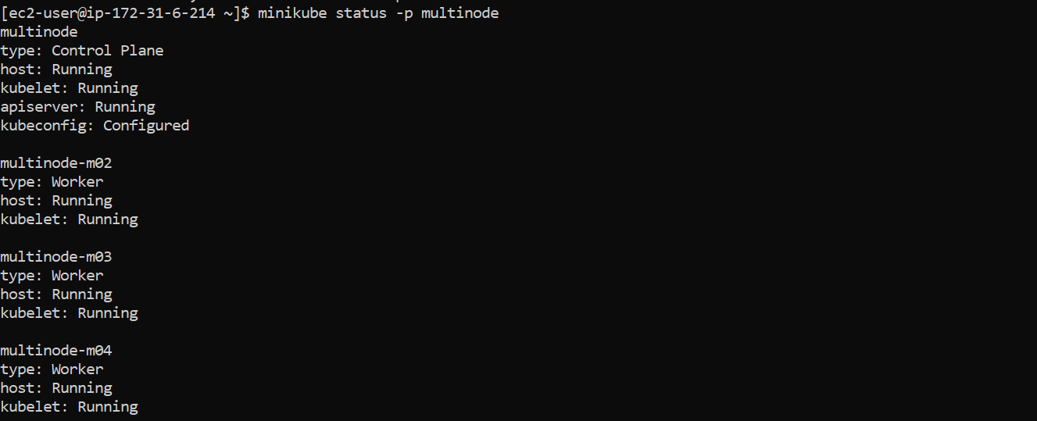

[ec2-user@ip-172-31-6-214 docker-compose-example]$ minikube status -p multinode

multinode

type: Control Plane

host: Running

kubelet: Running

apiserver: Running

kubeconfig: Configured

multinode-m02

type: Worker

host: Running

kubelet: Running

multinode-m03

type: Worker

host: Running

kubelet: Running

multinode-m04

type: Worker

host: Running

kubelet: Running

[ec2-user@ip-172-31-6-214 docker-compose-example]$

kubectl get pods

[ec2-user@ip-172-31-6-214 docker-compose-example]$ minikube status -p multinode

multinode

type: Control Plane

host: Running

kubelet: Running

apiserver: Running

kubeconfig: Configured

multinode-m02

type: Worker

host: Running

kubelet: Running

multinode-m03

type: Worker

host: Running

kubelet: Running

multinode-m04

type: Worker

host: Running

kubelet: Running

[ec2-user@ip-172-31-6-214 docker-compose-example]$