EXECUTIVE SUMMARY

University of Essex online |SRM_PCOM7E AUGUST 2022

GROUP 5

Lapierre, Patricia; Rigas, Iason; Roongta, Yash

2022

Table of Contents

Executive Summary 2

1. Potential risks 2

1.1 Potential risks 2

1.2 Raw data 4

2. Methodology 4

2.1 Quantitative risk modelling approach 4

2.2 Standardised scores and prioritised criteria 6

2.3 Assumptions 7

3. Supply chain analysis 7

3.1 Calculations 7

3.2 Results 10

4. Quality analysis 12

4.1 Calculations 12

4.2 Results 14

5. Discussion 15

5.1 Summary of results 15

5.2 Recommendations 15

6. Business Continuity/Disaster Recovery (DR) 16

6.1 Introduction 16

6.2 Requirements 16

6.3 Solution Description 16

6.4 Vendor lock-in Considerations 21

6.5 Local BC/DR Design 22

Appendix A 25

# Executive Summary

This executive summary was created for Pampered pets and it is a sequel to the risk identification report. It is divided into six sections: potential risks, methodology, supply chain analysis, quality analysis, discussion, and Business Continuity/Disaster Recovery (BC/DR).

## Potential risks

### Potential risks

Rathore, Thakkar, and Jha (2017: 1275) have provided an extensive list of authors that studied supply chain risks (included in Appendix A). This executive summary follows the reasoning of Olson and Wu (2017: 31), which states that “the first focus is on the purpose of the business - the product”. Furthermore, the main characteristics to consider for a product are quality, meeting specifications, cost, and delivery (*Ibid*). Table 1.1 resumes Olson and Wu’s (2017: 32) table on risks’ value hierarchy in supply chain, plus the fourth column presents criteria that were chosen for the quantitative risk analysis.

Table 1.1 Value hierarchy for supply chain risk and criteria

|  |  |  |
| --- | --- | --- |
| **Second Level** | **Third Level** | **Criteria** |
| Quality |  | Work force ability to produce quality product |
| Cost | Price | Expected cost per unit |
| Investment required | Acquisition and building cost |
| Holding cost/service level trade-off |  |
| On-time delivery |  |  |
| Manufacturability | Outsourcing opportunity cost/risk trade-off |  |
| Ability to expand production | Expandability |
| New technology breakthrough |  |
| Product obsolescence |  |
| Deliverability | Transportation system | Transportation system reliability |
| Insurance cost | Insurance structure |
| Communication | IS breakdown | Information system linkage |
| Distorted information leading to bullwhip effect |  |
| Forecast accuracy |  |
| Integration |  |
| Viruses/bugs/hackers |  |
| Flexibility | Agility of sources | Agility to change in demand |
| Ability to replace sources as needed |  |
| Safety | Plant disaster |  |
| Labour | Risk of strikes, disputes | Work force propensity for labour dispute |
| Government | Customs and regulations |  |
|  | Governmental stability |
| War and Terrorism |  |  |
| Overall economy | Economic downturn |  |
| Exchange rate risk |  |
| Specific regional economy | Labour cost influence |  |
| Changes in competitive advantage |  |
|  | Tax structure |
| Specific market | Price fluctuation |  |
| Customer demand volatility |  |
| Customer payment |  |
|  | Uncontrollable disaster | Risk of disaster |
| Diseases, epidemics |  |

### 1.2 Raw data

To execute a quantitative risk analysis, there is a need to possess valid data. Olson and Wu (2017) provided data for 10 options of potential sites for expanding production in new facilities. The locations are evaluated on 12 criteria that represent risks to the supply chain. Table 1.2 presents the associated data found in Olson and Wu (2017: 36).

Table 1.2 Plant siting data

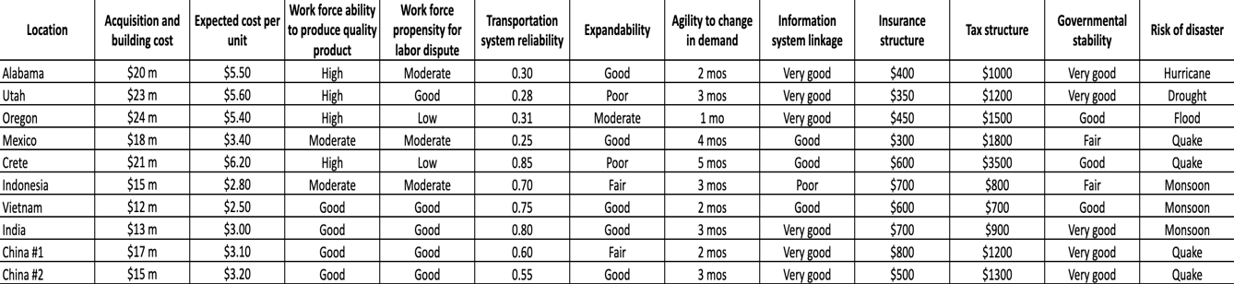

## Methodology

### Quantitative risk modelling approach

This executive summary runs quantitative risk modelling on two aspects: supply chain’s analysis and quality’s analysis. For the first analysis, two different variances for the Multiple-Criteria Decision Making (MCDM) are used to fortify the results’ validity of adding new locations to the supply chain security. For the quality analysis, probabilities are calculated to establish if adding new sites might have an impact on the product, mainly the level of quality and the level of resilience to maintain the quality.

#### MCDM for supply chain analysis

* Simple Multiattribute Rating Theory (SMART):

“The SMART method assigns the most important criterion a value of 1.0, and then assesses relative importance by considering the proportional worth to the best on the most important criterion” (Olson and Wu, 2017: 37).

* Risk assessment using Fuzzy Technique for Order of Preference by Similarity to Ideal Solution (TOPSIS)

“This method is based on the concept that the chosen alternative should have the shortest distance to Positive Ideal Solution (PIS) (the solution which minimises the cost criteria and maximises the benefit criteria) and the farthest distance to Negative Ideal Solution (NIS)” (Nădăban, Dzitac, and Dzitac, 2016: 826).

#### b) Probability from quality

* Conditional Probability

This method evaluates the possibility of an outcome to happen, based on the existence of a previous outcome.

* Diachronic Bayes Theorem

The Diachronic interpretation of Bayes Theorem gives us a way to update the probability of a hypothesis, considering some bodies of data. Sometimes, we can compute the prior based on background information. When the set of hypotheses is mutually exclusive and collectively exhaustive, you can multiply the likelihoods by any factor, if you apply the same factor to the entire collective.

### 2.2 Standardised scores and prioritised criteria

Before starting the modelling there are two steps that need to be executed: The standardisation of the scoring for the selected locations and the prioritisation of the criteria. Using Olson and Wu’s (2017: 38) data, table 2.1 provides standardised scoring for the selected criteria and table 2.2 shows the order of criteria desired to be used in the modelling.

Table 2.1 Standardised scores for plant siting data

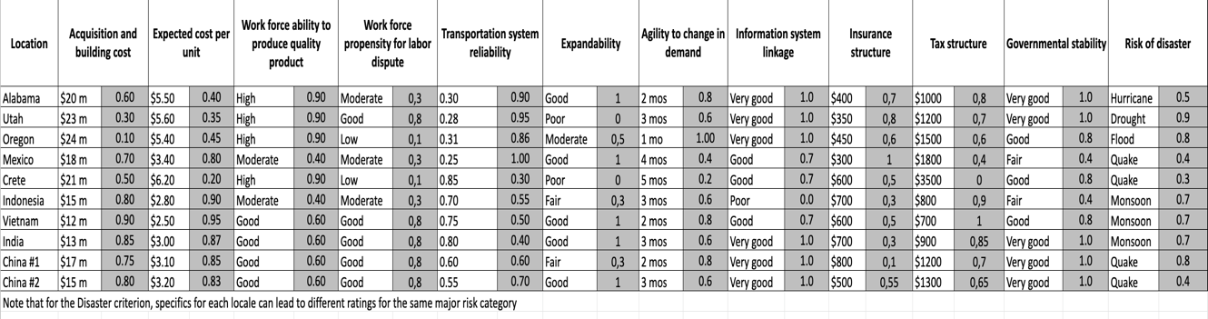

Table 2.2 Prioritised criteria

|  |  |  |  |
| --- | --- | --- | --- |
|  | **Criterion** | **Rating** | **Proportion** |
| 1. | Work force ability to produce quality product | 1 | 0,167 |
| 2. | Expected cost per unit | 0,8 | 0,133 |
| 3. | Risk of disaster | 0,7 | 0,117 |
| 4. | Agility to change in demand | 0,65 | 0,108 |
| 5. | Transportation system reliability | 0,6 | 0,100 |
| 6. | Expandability | 0,58 | 0,097 |
| 7. | Governmental stability | 0,4 | 0,067 |
| 8. | Tax structure | 0,35 | 0,058 |
| 9. | Insurance structure | 0,32 | 0,053 |
| 10. | Acquisition and building cost | 0,3 | 0,050 |
| 11. | Information system linkage | 0,2 | 0,033 |
| 12. | Work force ability to produce quality product | 0,1 | 0,017 |
| Total |  | 6 | 1,000 |

### Assumptions

* 1. Financial constraints are not an issue
  2. Pampered pets are exploring expanding in one or more of the 10 sites suggested above
  3. Pampered pets agrees with the criteria selected for the quantitative risk’s analysis
  4. Pampered pets agrees with the order decided for the criteria selected for the quantitative risk’s analysis
  5. Olson and Wu’s (2017: 36) data are still valid
  6. Any assumed probabilities and subsequent calculations are from a perspective from an “ideal world scenario”

## Supply chain analysis

### 3.1 Calculations

#### SMART modelling

Table 3.1 shows the previously agreed order of the criteria, as well as the ranking values, based on Olson and Wu’s data (2017: 37-38), and the proportions for each criterion, as they are the results of the ranking on the total value of ranking. Table 3.2 represents the original raw data, the standardized scoring, and the weight, which is the result of the standardized score multiplied by the proportion of each criterion. The last column shows the total score of each location.

Table 3.1 SMART modelling

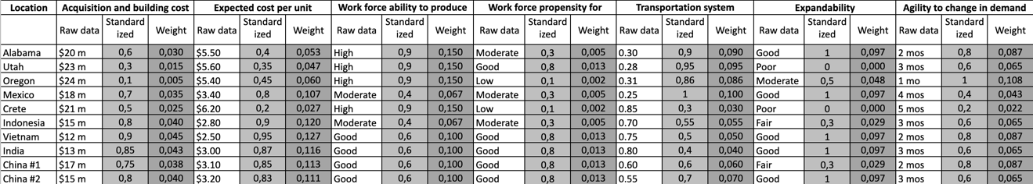

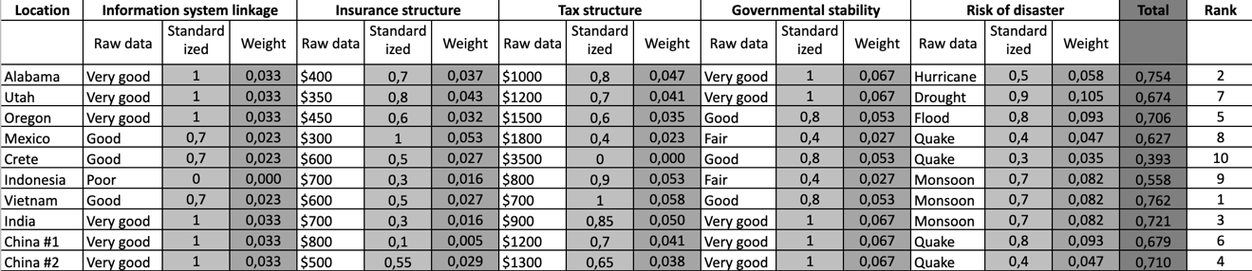

Table 3.2 Results from the SMART modelling

|  |  |  |
| --- | --- | --- |
| Location | Score | Rank |
| Vietnam | 0,762 | 1 |
| Alabama | 0,754 | 2 |
| India | 0,721 | 3 |
| China #2 | 0,710 | 4 |
| Oregon | 0,706 | 5 |
| China #1 | 0,679 | 6 |
| Utah | 0,674 | 7 |
| Mexico | 0,629 | 8 |
| Indonesia | 0,562 | 9 |
| Crete | 0,463 | 10 |

#### Fuzzy TOPSIS modelling

Table 3.3 reuses the order of the criteria plus some sub-groups ranking for the most important criteria and the least important criteria. It gives more weight to the most important criteria. The values in the second column are based on Olson and Wu’s data (2017: 42). The last column shows results from the total value of based on 1st divided by the based-on 1st’s value.

Table 3.4 presents the original raw data, the standardised scoring, and the weight, which is the result of the standardised score multiplied by the proportion of each criterion. However, only the best location in each criterion can get the weight to be multiplied by its standardised score. The last column shows the total score of each location.

Table 3.3 Fuzzy TOPSIS modelling

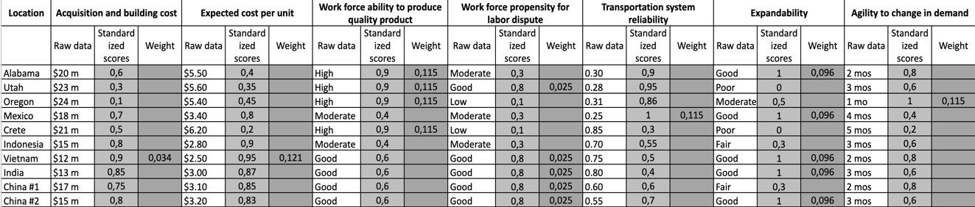

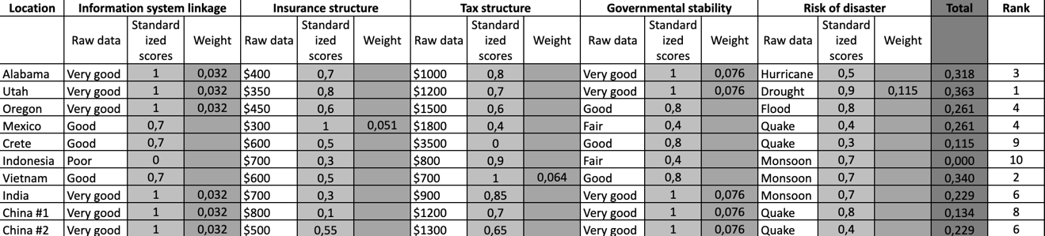

Table 3.4 Result from the Fuzzy TOPSIS modelling

|  |  |  |
| --- | --- | --- |
| Location | Score | Rank |
| Utah | 0,363 | 1 |
| Vietnam | 0,340 | 2 |
| Alabama | 0,318 | 3 |
| Oregon | 0,261 | 4 |
| Mexico | 0,261 | 4 |
| India | 0,229 | 6 |
| China #2 | 0,229 | 6 |
| China #1 | 8,000 | 8 |
| Crete | 0,115 | 9 |
| Indonesia | 0,000 | 10 |

### 3.2 Results

After running the two MADMs, it is apparent that some locations are performing better than others. However, there is no consensus on a clear winner, so there is a need to proportionally evaluate their performance. For this part, instead of ranking the best location with a value of 1, and the worst with a value of 10, a reverse ranking was produced; the best location receives the value 9 and the worst, the value 0. Table 3.7 presents the new rankings according to the results and the reverse score for each location. Graphic 3.1 illustrates the average for each location according to their scores. Table 3.8 illustrates the best locations for a potential expansion in new sites of the supply chain.

Table 3.7 Ranking according to reverse score

|  |  |  |  |  |
| --- | --- | --- | --- | --- |
| **Location** | **SMART method** | **Fuzzy TOPSIS method** | **Average** | **Ranking** |
| Alabama | 8 | 7 | 7,50 | 2 |
| Utah | 3 | 9 | 6,00 | 3 |
| Oregon | 5 | 6 | 5,50 | 4 |
| Mexico | 2 | 5 | 3,50 | 7 |
| Crete | 0 | 1 | 0,50 | 9 |
| Indonesia | 1 | 0 | 0,50 | 10 |
| Vietnam | 9 | 8 | 8,50 | 1 |
| India | 7 | 4 | 5,50 | 4 |
| China #1 | 4 | 2 | 3,00 | 8 |
| China #2 | 6 | 4 | 5,00 | 6 |

Graphic 3.1 Ranking according to reverse score

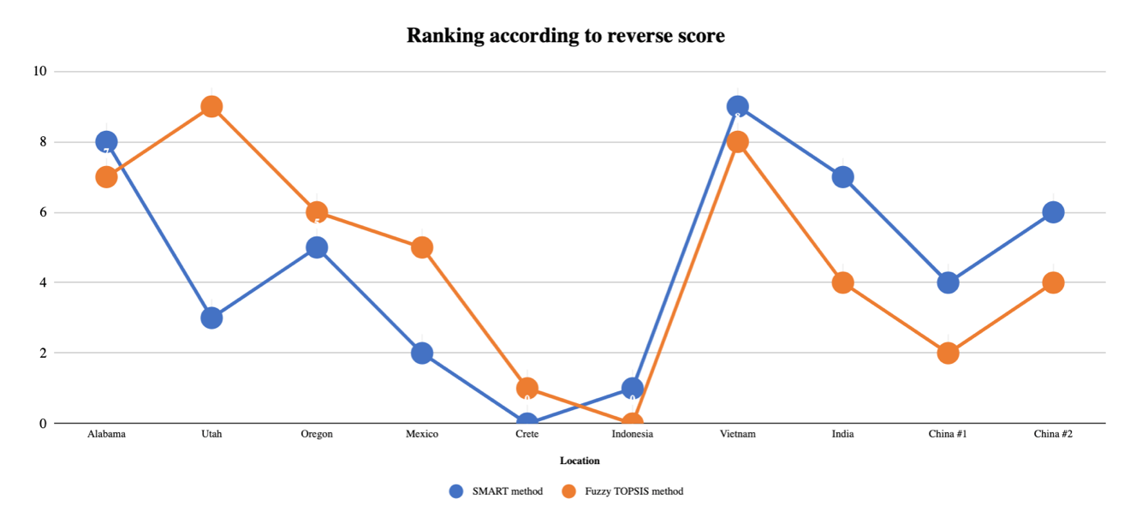

Table 3.8 Final result’s ranking of the best sites

|  |  |  |
| --- | --- | --- |
| **Rank** | **Location** | **Average** |
| Best | Vietnam | 8,50 |
| 2nd | Alabama | 7,50 |
| 3rd | Utah | 6,00 |
| Correct | India + Oregon | 5,50 |
| Passable | China #2 | 5,00 |

## Quality analysis

## 4.1 Calculations

#### a) Adding new sites – impact on level of quality

For the quality analysis the executive summary presents some probability calculations for two scenarios. Considering that Vietnam was the best site for expansion (according to the previous analysis) and that its standardised data for quality is 60% versus 90% for Alabama, Utah, or Oregon, the first scenario includes Vietnam as the first site, where the second scenario puts Vietnam at the fourth location. Table 4.1 shows the results for both scenarios. Note that calculation stops when the result reaches below 50%, which would indicate a change in the quality.

Table 4.1 Results of adding new sites on the level of quality

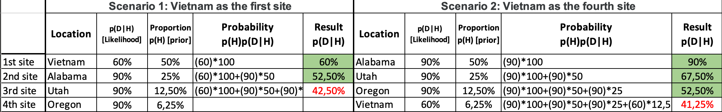

#### b) Building resilience on the level of quality

The second aspect of quality analysed is the resilience level for the products’ quality. Considering the results from the previous analysis, Vietnam is excluded from the following Bayesian’s analysis, preferring the American sites, with 90% of chance of not change in the quality. Table 4.1 shows the Bayes theorem calculations, whereas Graphic 4.1 presents the resilience level increasing as new sites are added to the equation.

This is calculated using a simple formula (Downey, 2013: 23):

Table 4.1 Result of adding new sites on building the resilience of quality

|  |  |  |  |  |
| --- | --- | --- | --- | --- |
| **Case** | **p(H) [Prior]** | **p(D|H) Likelihood]** | **p(H)p(D|H)** | **p(H|D) [Result]** |
| Alabama | 0.5 | 90 | 45 | 0.9 |
| 0.5 | 10 | 5 | 0.1 |
| Utah | 0.5 | (90)(90) | 162 | 0.987804878 |
| 0.5 | (10)(10) | 2 | 0.012195122 |
| Oregon | 0.5 | (90)(90)(90) | 14580 | 0.998630137 |
| 0.5 | (10)(10)(10) | 20 | 0.001369863 |

Figure 1: Increase in resilience with each new added site.

Figure 2: Reduction in fragility of supply chain with each added site

## 4.2 Results

As table 4.1 shows, if Vietnam is the first site to expand to, only one other site can be added to the supply chain, as the third site brings the probability to 42,5%, meaning there is more than 50% chance that the quality level would change. Comparatively, if Vietnam is the fourth site’s option, there can be three sites to expand to, before falling under 50%, which would be Alabama, Utah, and Oregon. Additionally, the analysis on the resilience to maintain the level of quality shows that the more there are locations, the higher the chance to build resilience.

## Discussion

### 5.1 Summary of results

After the supply chain analysis, it is evident that six strong sites have been identified to expand to, while ensuring the security of the global supply chain: Vietnam, Alabama, Utah, Oregon, India, and China #2. Following the quality analysis, it is evident that excluding Vietnam from the potential expansion sites ensures that Pampered Pets has a better chance to maintain their high-quality level of products.

### 5.2 Recommendations

As the supply chain and quality analysis demonstrates, Alabama, Utah, and Oregon should be considered as potential sites where to establish expanding facilities. According to the analysis, those locations ensure that supply chain security and quality would not be impacted negatively. However, according to the original raw data, an eye should be kept on some aspects for the American sites: acquisition and building cost, expected cost per unit, work force propensity for labour dispute, and expandability.

## 6. Business Continuity/Disaster Recovery (DR)

### 6.1 Introduction

This disaster recovery strategy enables both business continuity, which is concerned with the continuation of business activities in case of adverse events, and disaster recovery, which is focused on restoring access and infrastructure after a disaster. A resilient system needs to be developed to address both aspects and ensure the required uptime for the online shop as well as risks by local disasters in the areas identified in the analysis above.

### 6.2 Requirements

The business impact analysis has demonstrated that the online shop is a Critical Business Function (CBF) which should be available on a 24/7/365 basis with a recovery time objective (RTO) and a recovery point objective (RPO) of 1 minute as illustrated below:

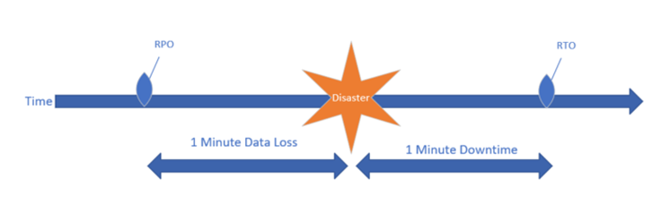

Figure 3 Illustration of disaster recovery requirements

### 6.3 Solution Description

To address the stringent requirements, a warm standby multi cloud architecture which foresees mirroring data, and a failover mechanism is proposed. Such an architecture is typical for responding to stringent RTO and RPO requirements (Alhazmi & Malaiya, 2013). Implementing DR in the cloud increases resilience but using a single cloud vendor comes with security challenges as there is reliance on the same infrastructure issues, software stacks and organisational failures, as well as the potential for vendor lock-in (Alshammari et al., 2017). All these aspects can be mitigated by utilising services from different cloud service providers to ensure additional resilience, vendor independence, and mechanisms for ensuring data security (Gu et al., 2014).

The solution proposed is vendor agnostic meaning that it can be implemented with any combination of reliable cloud vendors, examples could include Amazon, Google, and Microsoft. The proposed architecture consists initially of the primary active system (Figure 4 - in green), hosting the online shop running in a cloud service provider (CSP) with dynamic scalability indicated in yellow as additional capacity is provisioned when necessary to respond to additional demand. The green system runs in the US region to ensure low latency and system performance.

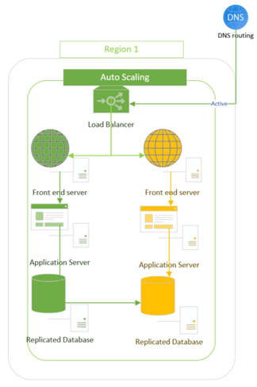

Figure 4 Primary production system (green system)

In case of a disaster, traffic will be routed to the warm standby system (Figure 5- shown in blue), which operates in a different CSP and a different region. The blue system is always up and running but to save costs, it is only running with the minimum instances and services required to provide initial functionality in case of a disaster affecting the green system. Depending on the demand in place, the blue system will scale up dynamically to provide the necessary capacity. The user will not notice any impact in terms of functionality as the data will exist in the system already. Depending on the initial load placed on the blue system there might be a short performance penalty as the blue system scales up automatically to respond to the existing demand. The blue system runs in non-us region to mitigate the risk of a local disaster affecting both systems.

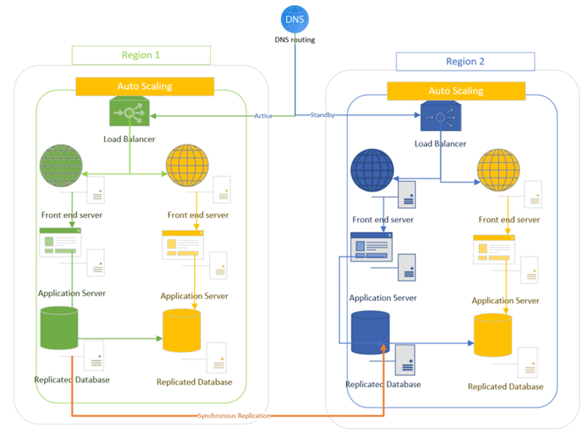

Figure 5 Illustration of the primary system (green) and secondary failover system (blue) including synchronous replication

This failover mechanism ensures business continuity and near zero downtime and data loss. Such as seamless transition is made possible through a mechanism of synchronous replication of the database which addresses the issue of replication latency in the cloud and ensures that the required RPO value is met (Alshammari et al., 2017). The synchronous replication mechanism is based on a concept employing three cloud providers like the concept proposed by Gu et al. (Gu et al., 2014). Data is replicated to ensure redundancy and security as data can be dispersed between CSPs and encrypted if necessary. The normal operation of the green system is illustrated below:

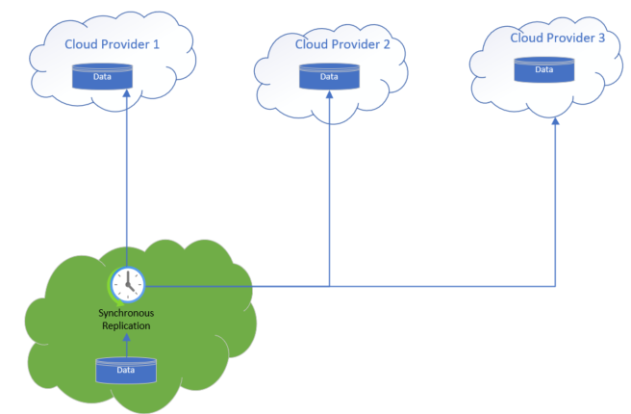

Figure 6 Synchronous replication mechanism from primary system to three cloud providers

Data is continuously synchronised to the failover (blue) system and therefore in case of a disaster data will be already available in the blue system to ensure business continuity:

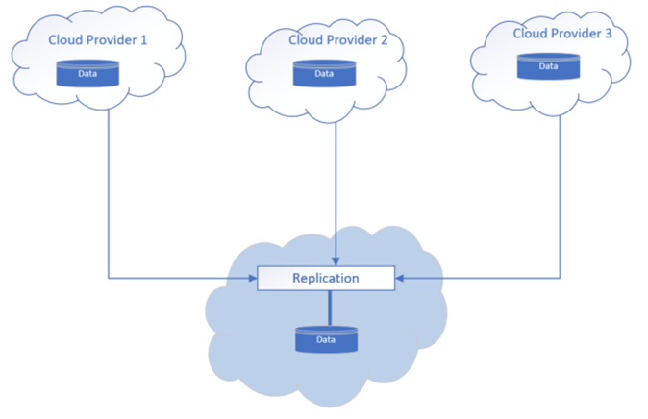

Figure 7 Synchronous replication to the secondary system

### 6.4 Vendor lock-in Considerations

CSPs offer vendor specific services based on proprietary technologies with specifications that vary from vendor to vendor including custom APIs and services. This often leads to a situation in which cloud users become dependent on a certain vendor for services due to lack of interoperability between providers and technical incompatibilities (Opara-Martins et al., 2014). In the multi cloud solution design proposed above the risk of vendor lock-in is mitigated by design as the integration and interoperability between CSPs is solved at the design stage by proposing a system which is interoperable in its concept by relying on basic infrastructure such as database replications instead of custom services and APIs provided by vendors.

### 6.5 Local BC/DR Design

To mitigate the local risks identified in the quantitative analysis, additional provisions are made for addressing local disasters. In the event of a disaster affecting the potentials locations in the geographical region of the United States, the online shop will be available, but potentially not able to reach the affected areas. This risk can be mitigated by relying on national infrastructure and using LTE modems to connect to the internet in case of local outages, or using commercial satellite internet providers such as Viasat, HughesNet, Skycasters or Starlink. Diesel generators can be used to ensure adequate power supply in case of outages.

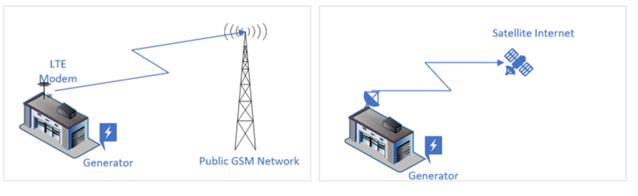

Figure 8 Local BC/DR provisions to enable connectivity in case of local disasters

**References**

Alhazmi, O. H., & Malaiya, Y. K. (2013). Evaluating disaster recovery plans using the cloud. Proceedings - Annual Reliability and Maintainability Symposium. Available from : <https://www.cs.colostate.edu/~malaiya/p/DisasterRecovery2013.pdf> [Accessed 14 October 2022]

Alshammari, M. M. et al. (2017) ‘Disaster recovery in single-cloud and multi-cloud environments: Issues and challenges’, in 2017 4th IEEE International Conference on Engineering Technologies and Applied Sciences (ICETAS). 2017 IEEE. pp. 1–7. [Online].

Downey, A. (2013) Think Bayes. 1st edition. Sebastopol, California: O’Reilly & Associates. [Online].

Gu, Y., Wang, D., & Liu, C. (2014). DR-Cloud: Multi-Cloud Based Disaster Recovery Service (Vol. 19, Issue 1. Tsinghua science and technology. 19 (1), 13–23. Available from : <https://dc.tsinghuajournals.com/cgi/viewcontent.cgi?article=1480&context=tsinghua-science-and-technology> [Accessed 19 October 2022]

Nădăban, S., Dzitac, S., & Dzitac, I. (2016). Fuzzy TOPSIS: A general view. *Procedia computer science*, *91*, 823-831. [Online]

Olson, D. L., & Wu, D. D. (2017). Enterprise risk management in supply chains. In *Enterprise Risk Management Models* (pp. 1-15). Springer, Berlin, Heidelberg. [Online]

Rathore, R., Thakkar, J. J., & Jha, J. K. (2017). A quantitative risk assessment methodology and evaluation of food supply chain. *The International Journal of Logistics Management*. [Online]

# Appendix A

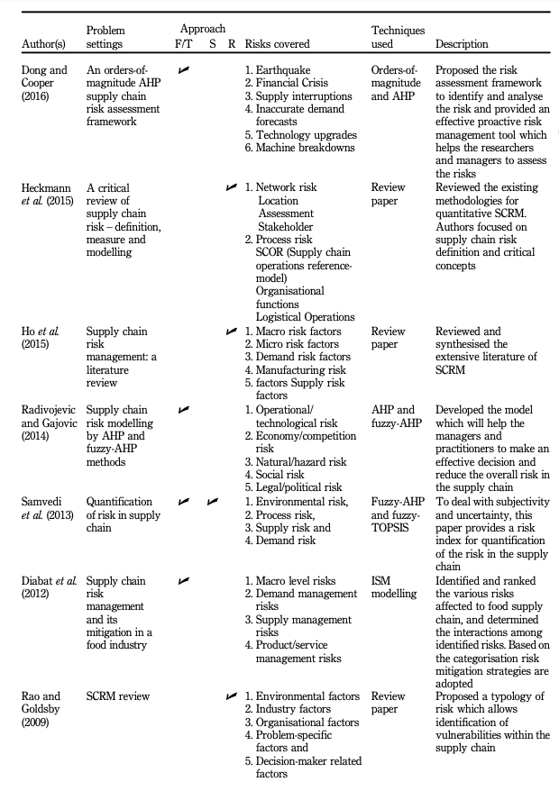

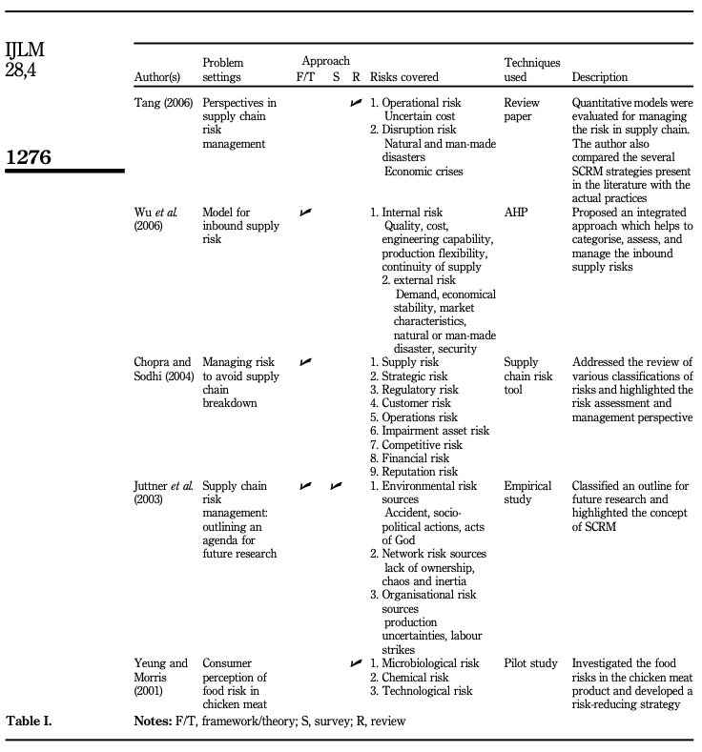

Rathore, Thakkar, and Jha (2017: 1275-1276)