DATA ANALYSIS PROJECT REPORT
Customer Shopping Behavior Analysis
Python | MySQL | Power BI — 3,900 customer purchase records

Executive Summary
This report analyzes 3,900 retail purchase records to understand how revenue, subscriptions, discounts, products and customer demographics relate to customer spending. Python was used to inspect and clean the data, MySQL to answer ten business questions, and Power BI to present the results in an interactive dashboard.
Headline metrics
Metric | Value | Note
Customer records | 3,900 | One purchase per customer ID
Total revenue | $233,081 | Sum of purchase amounts
Average purchase amount | $59.76 | Median $60; range $20–$100
Average customer age | 44.1 years | Range 18–70
Average review rating | 3.75 / 5 | 37 missing values imputed
Subscribers | 1,053 (27.0%) | 2,847 non-subscribers (73.0%)
Male / female customers | 2,652 (68.0%) / 1,248 (32.0%) | Male revenue share 67.7%
Customers with a discount applied | 1,677 (43.0%) | 2,223 purchases without a discount

Key takeaways
- Revenue is driven by customer volume, not spend per purchase. Male customers generate 67.7% of revenue ($157,890 vs. $75,191), but this mirrors their 68.0% share of customers; average spend per customer is almost identical (about $59.54 vs. $60.25).
- Subscribers do not spend more. Average purchase is $59.49 for subscribers and $59.87 for non-subscribers, and the subscription rate is flat (26–28%) across all four spending quartiles.
- Revenue is concentrated in three age groups. Young adults, middle-aged and adult customers together generate 89.3% of revenue; seniors contribute 9.0% and teens only 1.8%.
- The customer base is highly established. Loyal customers make up 79.9% of the base (3,116), returning customers 18.0% (701) and new customers only 2.1% (83).
- Spending is widely dispersed. The top quartile of customers spends an average of $90.58 per purchase, about 3.1 times the $29.14 average of the bottom quartile.

1. Introduction
This project analyzes customer shopping behavior using a retail customer dataset. The main objective was to apply data-analysis techniques to identify patterns in customer spending, subscriptions, discounts, products, shipping methods and customer characteristics.
Python and pandas were used to inspect and prepare the dataset, MySQL was used for structured queries and more advanced customer and sales analysis, and Power BI was used to build an interactive dashboard that presents the results visually.
The analysis focused on ten business questions covering revenue, customer spending, products, subscriptions, discounts, customer segmentation and demographics.

2. Dataset Overview
The dataset contains 3,900 records and 18 variables describing individual customer purchases: Customer ID, Age, Gender, Item Purchased, Category, Purchase Amount (USD), Location, Size, Color, Season, Review Rating, Subscription Status, Shipping Type, Discount Applied, Promo Code Used, Previous Purchases, Payment Method and Frequency of Purchases.

2.1 Numerical variables
Table 1. Summary statistics of numerical variables
Statistic | Age | Purchase amount (USD) | Review rating | Previous purchases | Customer ID
Count | 3,900 | 3,900 | 3,863 | 3,900 | 3,900
Mean | 44.07 | 59.76 | 3.75 | 25.35 | 1,950.5
Std. deviation | 15.21 | 23.69 | 0.72 | 14.45 | 1,126.0
Minimum | 18 | 20 | 2.5 | 1 | 1
25th percentile | 31 | 39 | 3.1 | 13 | 975.8
Median | 44 | 60 | 3.8 | 25 | 1,950.5
75th percentile | 57 | 81 | 4.4 | 38 | 2,925.3
Maximum | 70 | 100 | 5.0 | 50 | 3,900

2.2 Categorical variables
Table 2. Profile of categorical variables
Variable | Unique values | Most frequent value | Frequency
Gender | 2 | Male | 2,652 (68.0%)
Category | 4 | Clothing | 1,737 (44.5%)
Item purchased | 25 | Blouse | 171
Location | 50 | Montana | 96
Size | 4 | M | 1,755 (45.0%)
Color | 25 | Olive | 177
Season | 4 | Spring | 999 (25.6%)
Subscription status | 2 | No | 2,847 (73.0%)
Shipping type | 6 | Free Shipping | 675 (17.3%)
Discount applied | 2 | No | 2,223 (57.0%)
Promo code used | 2 | No | 2,223 (57.0%)
Payment method | 6 | PayPal | 677 (17.4%)
Purchase frequency | 7 | Every 3 Months | 584 (15.0%)

Purchase amounts are evenly spread between $20 and $100 (mean $59.76, median $60), and the customer age range of 18–70 is centered on 44 years. Discount applied and promo code used have identical counts, which suggests the two fields record the same event.

3. Data Preparation
Before analysis, the dataset was inspected for its columns, data types and categorical variables, and missing values were identified. The following steps were then completed:
- Missing values. Review Rating was the only variable with missing observations: 37 of 3,900 records (0.95%). Rather than dropping these records, each was filled with the median rating of its product category.
- Column names. Names were standardized to lowercase with underscores for use in MySQL (e.g. purchase_amount_usd).
- Age groups. Age was converted into five groups: teen, young adult, adult, middle-aged and senior.
- Purchase frequency. Frequency labels were converted into an approximate number of days between purchases (e.g. weekly = 7 days, monthly = 30 days) to allow quantitative analysis.
- Database import. The cleaned dataset was loaded into MySQL, where the ten business questions were answered with SQL.

4. SQL Analysis
Each of the ten analyses below states its objective, shows the query result and summarizes the main finding.

4.1 Revenue by Gender
Objective: determine whether male or female customers contribute more to total sales. SUM() was used to total purchase revenue and GROUP BY to separate customers by gender.
Table 3. Total revenue by gender
Gender | Total revenue (USD) | Share of revenue | Customers
Male | $157,890 | 67.7% | 2,652
Female | $75,191 | 32.3% | 1,248
Total | $233,081 | 100.0% | 3,900
Finding: Male customers generate more than twice the revenue of female customers ($157,890 vs. $75,191). This gap is explained by customer count: men are 68.0% of customers and generate 67.7% of revenue, and average revenue per customer is nearly equal ($59.54 male vs. $60.25 female). Growth in female customers, rather than higher spend per customer, is the lever for closing the gap.

4.2 High-Spending Discount Users
Objective: identify customers who received a discount but still spent more than the overall average purchase amount ($59.76). The query filtered on two conditions: a discount was applied, and the purchase amount exceeded the average.
Table 4. Sample of high-spending discount users (first 9 records of the result)
Customer ID | Purchase amount (USD)
2 | $64
3 | $73
4 | $90
7 | $85
9 | $97
12 | $68
13 | $72
16 | $81
20 | $90
Finding: Discounts are not limited to low-value purchases: the customers listed spent between $64 and $97, all above the $59.76 average. Several (customers 4, 9 and 20) spent $90 or more, so promotions are also being used by high-value customers who might have purchased at full price.

4.3 Top 5 Products by Rating
Objective: find the products with the highest average review rating. Products were grouped, their ratings averaged, then sorted in descending order and limited to five.
Table 5. Top five products by average review rating
Rank | Product | Average rating
1 | Gloves | 3.86
2 | Sandals | 3.84
3 | Boots | 3.82
4 | Hat | 3.80
5 | Skirt | 3.78
Finding: Gloves lead with 3.86, followed by Sandals (3.84) and Boots (3.82). The five products sit within just 0.08 points of each other and only 0.03–0.11 above the overall average of 3.75, so satisfaction is fairly uniform across the range.

4.4 Shipping Type Comparison
Objective: test whether customers choosing different shipping options spend differently, using AVG() on the purchase amount for each shipping method.
Table 6. Average purchase amount by shipping type
Shipping type | Average purchase (USD)
Express | $60.48
Standard | $58.46
Finding: Express shipping customers spend $2.02 more on average than Standard customers ($60.48 vs. $58.46), a difference of about 3.5%. This is small, and it does not mean shipping choice causes higher spending, since other customer characteristics may play a role.

4.5 Subscribers vs. Non-Subscribers
Objective: compare customers with and without a subscription on average purchase amount and total revenue, grouped by subscription status.
Table 7. Subscription comparison
Status | Customers | Avg. purchase (USD) | Revenue (USD) | Revenue share
Subscribers | 1,053 | $59.49 | $62,645 | 26.9%
Non-subscribers | 2,847 | $59.87 | $170,436 | 73.1%
Total | 3,900 | $59.76 | $233,081 | 100.0%
Finding: Subscribers account for 27.0% of customers and 26.9% of revenue, and their average purchase ($59.49) is slightly lower than that of non-subscribers ($59.87). Subscription is therefore not associated with larger purchases. With 73.0% of customers not subscribed, the opportunity lies in conversion and retention rather than basket size.

4.6 Discount-Dependent Products
Objective: identify the products most strongly associated with discounts. For each product, the share of purchases made with a discount was calculated (discounted purchases ÷ total purchases) and the top five products were selected.
Table 8. Top five products by share of discounted purchases
Rank | Product | Discounted purchases
1 | Sneakers | 50%
2 | Hat | 50%
3 | Coat | 49%
4 | Sweater | 48%
5 | Pants | 47%
Finding: Sneakers and Hats are bought with a discount in half of all purchases, with Coats (49%), Sweaters (48%) and Pants (47%) close behind. All five exceed the dataset-wide discount rate of 43.0%, but only by 4–7 percentage points, so no product is overwhelmingly dependent on promotions. Using the share of purchases rather than raw counts keeps popular products from dominating the ranking.

4.7 Customer Segmentation
Objective: classify customers as new, returning or loyal based on their previous purchase behavior, instead of treating the customer base as one group.
Table 9. Customers by segment
Segment | Customers | Share of customers
Loyal | 3,116 | 79.9%
Returning | 701 | 18.0%
New | 83 | 2.1%
Total | 3,900 | 100.0%
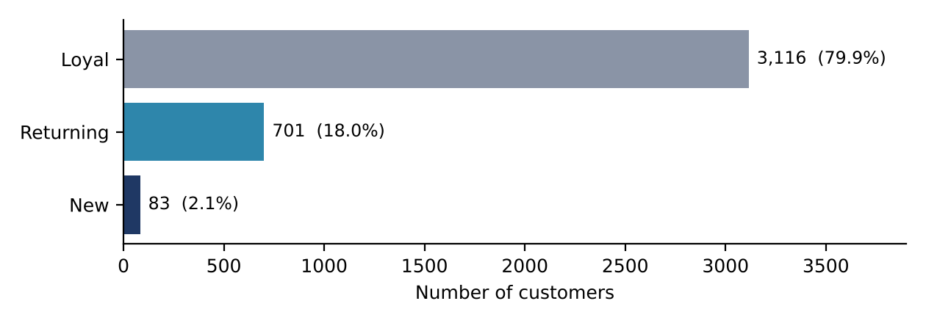
Figure 1. Customer segmentation by purchase history.
Finding: Four out of five customers (79.9%) are loyal and only 2.1% are new. The business retains customers well, but the very small share of new customers points to limited acquisition and a need for new-customer marketing to sustain growth.

4.8 Top 3 Products per Category
Objective: find the three most purchased products within each category. A ranking window function partitions products by category, so top products are identified separately within each category rather than overall.
Table 10. Most purchased products by category
Category | Product | Purchases
Accessories | Jewelry | 171
Accessories | Belt | 161
Accessories | Sunglasses | 161
Clothing | Blouse | 171
Clothing | Pants | 171
Clothing | Shirt | 169
Footwear | Sandals | 160
Footwear | Shoes | 150
Footwear | Sneakers | 145
Outerwear | Jacket | 163
Finding: Leading products are strongly clustered: Jewelry, Blouse and Pants each have 171 purchases, and Sandals lead Footwear with 160. Within each category the top products sit within about 10–15 purchases of one another, so demand is spread across several products rather than dominated by one.

4.9 Revenue by Age Group
Objective: determine which age groups contribute most to total revenue by totaling purchase revenue for each group.
Table 11. Revenue by age group
Age group | Total revenue (USD) | Share of revenue
Young adult | $74,833 | 32.1%
Middle-aged | $67,576 | 29.0%
Adult | $65,629 | 28.2%
Senior | $20,904 | 9.0%
Teen | $4,139 | 1.8%
Total | $233,081 | 100.0%
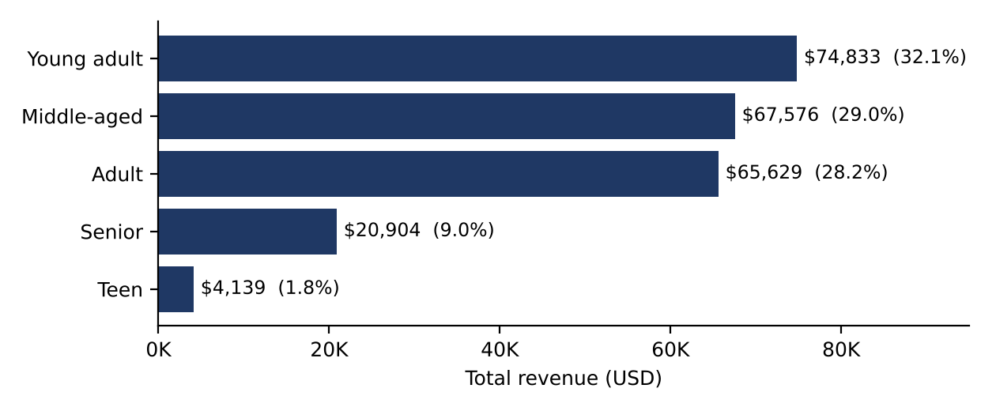
Figure 2. Total revenue by age group.
Finding: Young adults are the largest revenue source ($74,833, 32.1%), but the three working-age groups are close together and combine for 89.3% of revenue. Seniors (9.0%) and teens (1.8%) contribute relatively little, which marks them as under-penetrated segments.

4.10 Customer Spending Quartiles
Objective: rank customers by purchase amount, split them into four equal spending groups with NTILE(4), and compare subscription status across the groups. Quartile 1 contains the highest spenders and Quartile 4 the lowest.
Table 12. Spending quartiles and subscription status
Quartile | Customers | Subscribers | Subscription rate | Avg. purchase (USD)
Q1 (highest) | 975 | 257 | 26.4% | $90.58
Q2 | 975 | 272 | 27.9% | $70.14
Q3 | 975 | 270 | 27.7% | $49.19
Q4 (lowest) | 975 | 254 | 26.1% | $29.14
Total | 3,900 | 1,053 | 27.0% | $59.76
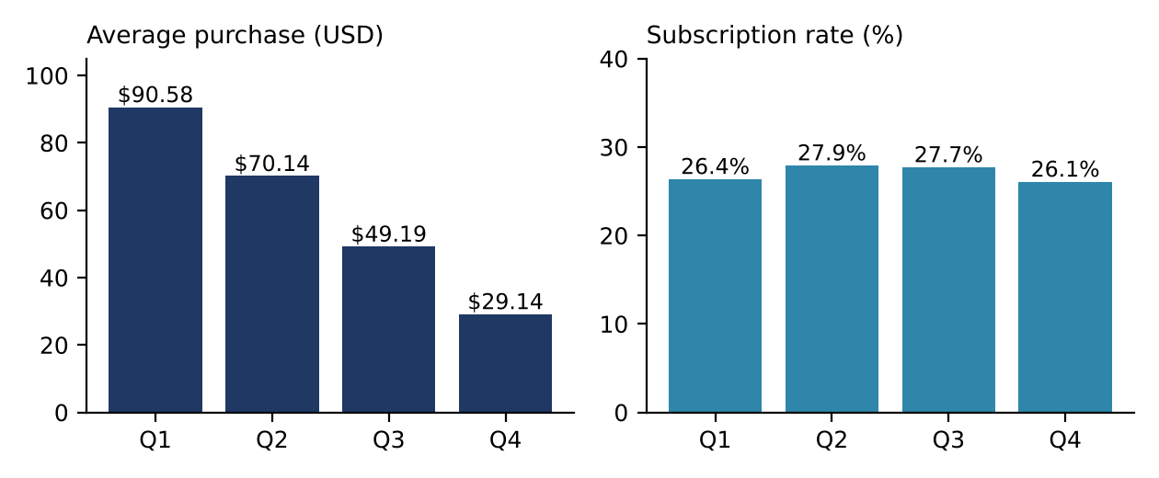
Figure 3. Average purchase amount and subscription rate by spending quartile.
Finding: Average purchase falls steeply from $90.58 in Q1 to $29.14 in Q4, yet the subscription rate stays between 26.1% and 27.9% in every quartile. Subscription status is therefore essentially unrelated to spending level, consistent with the result in Section 4.5.

5. Power BI Dashboard
After the SQL analysis, the results were used to build an interactive Power BI dashboard titled “Customer Behavior Dashboard”. It gives a one-page overview of the customer base, purchase value, subscription mix, category performance and demographics, so users can read key indicators together instead of reviewing individual SQL outputs.

5.1 Dashboard overview
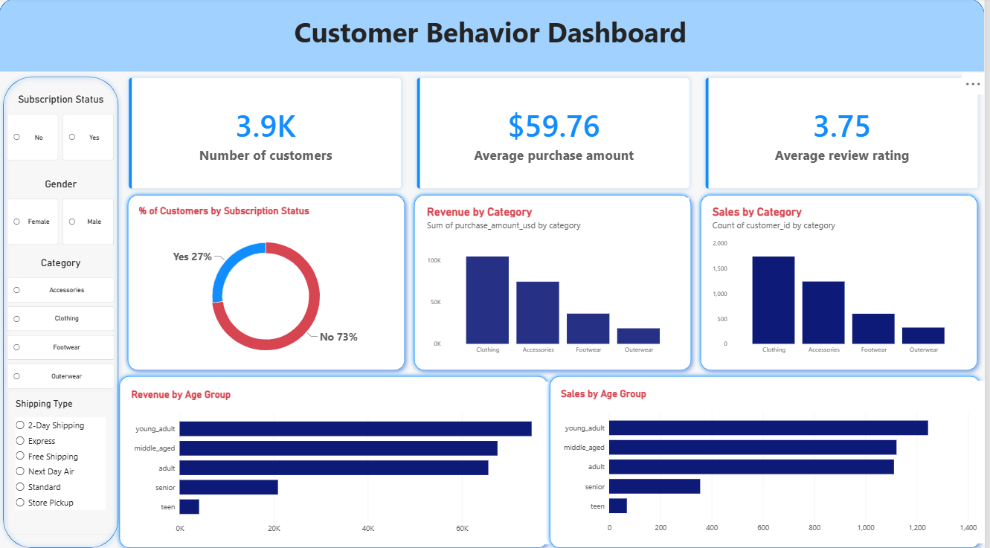
Figure 4. Customer Behavior Dashboard (Power BI).

5.2 Dashboard components
Table 13. Dashboard layout
Component | Visual | What it shows
KPI cards | Number of customers | 3.9K customer records
KPI cards | Average purchase amount | $59.76
KPI cards | Average review rating | 3.75
Chart | Donut: % of customers by subscription status | Yes 27% / No 73%
Chart | Revenue by Category (column) | Sum of purchase amount by category
Chart | Sales by Category (column) | Count of customers by category
Chart | Revenue by Age Group (bar) | Sum of purchase amount by age group
Chart | Sales by Age Group (bar) | Count of customers by age group
Slicers | Subscription status, Gender, Category, Shipping type | Filter every visual on the page

5.3 Dashboard interpretation
- KPI cards. The dashboard covers 3.9K customers with an average purchase of $59.76 and an average review rating of 3.75, matching the Python summary statistics in Section 2.
- Subscription mix. The donut chart shows 73% of customers without a subscription and 27% with one (2,847 and 1,053 customers), confirming the result in Section 4.5.
- Category performance. Clothing is the largest category on both measures: about 1,737 sales and roughly $104K in revenue. Accessories follow (about $74K), then Footwear (about $36K) and Outerwear (about $18K). Revenue and sales rank the categories in the same order, so category revenue is driven by volume.
- Age groups. Young adults generate the most revenue (about $75K) and the most sales (about 1,250), followed by middle-aged and adult customers. Seniors (about $21K) and teens (about $4K) are far smaller, matching Table 11.
- Interactivity. The four slicers (subscription status, gender, category and shipping type) allow any view to be filtered to a specific customer group.
Note: The discount, product-rating, segmentation and spending-quartile analyses were performed in SQL (Section 4) and are not shown on the dashboard page. Values for category and age-group counts are read from the chart axes and are approximate; exact revenue figures are given in the SQL tables.

6. Key Findings

6.1 Summary of results
Table 14. Key results by analysis
Area | Key result | Implication
Gender | Male 67.7% of revenue; per-customer spend equal ($59.54 vs. $60.25) | Revenue gap is a customer-count gap
Age | Three working-age groups = 89.3% of revenue; teens 1.8% | Seniors and teens are under-penetrated
Subscription | 27.0% subscribed; avg. $59.49 vs. $59.87 | Subscribers do not spend more
Discounts | 43.0% of purchases discounted; top products 47–50% | No product is overly promotion-dependent
Products | Top rating 3.86 (Gloves); overall 3.75 | Satisfaction is uniform across products
Shipping | Express $60.48 vs. Standard $58.46 | Small (3.5%) difference
Segments | Loyal 79.9%, Returning 18.0%, New 2.1% | Strong retention, weak acquisition
Quartiles | Q1 $90.58 vs. Q4 $29.14; subscription 26–28% in all | Spending is dispersed; subscription is unrelated

6.2 Recommendations
- Grow the customer base. Only 83 new customers (2.1%) are present; target acquisition campaigns, especially among female customers, who generate spending equal to male customers but are only 32% of the base.
- Rework the subscription offer. Subscribers spend no more than other customers, so add benefits that increase basket size or purchase frequency, not just access.
- Target under-penetrated age groups. Seniors and teens generate 9.0% and 1.8% of revenue; test targeted products and channels for them.
- Review discount strategy. Discounts reach high spenders ($64–$97 purchases) and 43% of all purchases, so test whether selective discounting would protect margin without hurting sales.

7. Limitations
- Association, not causation. The data records observed behavior and cannot show why customers behave as they do; for example, the link between discounts and purchase amount does not prove discounts cause higher spending.
- Missing drivers. Income, marketing exposure, pre-discount price and individual preferences are not available.
- Generalizability. Results reflect this dataset of 3,900 records and may not represent customers outside it.
- Transformed variables. 37 missing review ratings (0.95%) were filled with category medians, and purchase-frequency labels were converted to approximate day counts.
- Partial query outputs. The shipping comparison covers Express and Standard only, although six shipping types exist in the data.

8. Conclusion
This project used SQL and data visualization to analyze 3,900 customer purchases worth $233,081 in total, with an average purchase of $59.76. Its main result is that revenue differences across gender, age and subscription groups are driven mainly by the number of customers in each group, not by how much each customer spends. Subscribers spend no more than non-subscribers, subscription is unrelated to spending level, and the base is dominated by loyal customers (79.9%) with very few new ones (2.1%).
MySQL supported grouped calculations, filtering, ranking, segmentation and window functions such as NTILE(), and Power BI communicated the headline results through an interactive dashboard. Overall, the project shows a complete data-analysis workflow:
data preparation → SQL analysis → business insights → data visualization

