# E-AcadEase: ETEEAP Academic Progress Monitoring System

**A Thesis**

Presented to the Faculty of the

College of Science

Technological University of the Philippines

Ayala Boulevard, Manila

**By**

**CAPCO, ANTHONY CHRISTIAN**

**COLEEN, GARCIA**

**GULMATICO, ADRIAN JAY**

**TIONGSON, JESPER CHRIS**

**YBAÑEZ, KARL**

**In Partial Fulfillment of the**

**Requirements for the Degree of**

**Bachelor of Science in Computer Science**

**TABLE OF CONTENTS**

E-AcadEase: ETEEAP Academic Progress Monitoring System i

LIST OF TABLES iv

LIST OF FIGURES v

CHAPTER 1 1

Background of the Study 1

Objectives of the Study 3

Scope and Delimitations of Study 5

CHAPTER 2 8

Review of Related Literature 8

Conceptual Model of the Study 18

CHAPTER 3 22

Methodology 22

Project Design 22

System Flow Chart 23

Project Development 32

Requirements Planning 33

User Design 33

Construction 33

Cutover 34

Operation and Testing Procedure 34

CHAPTER 4 48

Results and Discussion 48

Project Structure 48

Admin 49

Instructors 58

Students 65

Project Capabilities and Limitations 70

Project Evaluation 72

CHAPTER 5 78

Summary of Findings, Conclusions, and Recommendations 78

Summary of Findings 78

Conclusions 79

Recommendations 80

References 82

# LIST OF TABLES

**Table 4. 1** Functional Suitability Evaluation Result 73

**Table 4. 2** Performance Efficiency Evaluation Result 74

**Table 4. 3** Usability Evaluation Result 75

**Table 4. 4** Reliability Evaluation Result 76

**Table 4. 5** Maintainability Evaluation Result 77

# LIST OF FIGURES

**Figure 2. 1** Conceptual Model of the Study 18

**Figure 3. 1** System Flow Chart for Student 23

**Figure 3. 2** System Flow Chart for Instructor 25

**Figure 3. 3** System Flow Chart for Director 27

**Figure 3. 4** Entity Relationship Diagram of the System 30

**Figure 3. 5** Use Case Diagram of the System 31

**Figure 3. 6** Rapid Application Development Model (RAD) 32

**Figure 4. 1** Login Page 48

**Figure 4. 2** Dashboard of Admin 49

**Figure 4. 3** Instructor Tab of Admin 50

**Figure 4. 4** Instructor Tab of Admin - Filtered to College of Science 50

**Figure 4. 5** Instructor Tab of Admin - Instructor Profile 51

**Figure 4.** **6** Students Tab of Admin 52

**Figure 4. 7** Students Tab for Admin - Filtered List 52

**Figure 4. 8** Students Tab for Admin - Enrolling a student 53

**Figure 4. 9** Students Tab for Admin - Status of Honorarium 53

**Figure 4. 10** Courses Tab of Admin 54

**Figure 4. 11** Courses Tab for Admin - Add a New Course 54

**Figure 4. 12** Manage Users Tab for Admin 55

**Figure 4. 13** Manage Users Tab for Admin - Add Instructor 56

**Figure 4. 14** Manage Users Tab for Admin - Add Student 57

**Figure 4. 15** Manage Account of Admin 58

**Figure 4. 16** First Time Login for Instructors 59

**Figure 4. 17** Students Tab of Instructor - New Instructor 60

**Figure 4. 18** Students Tab for Instructor 60

**Figure 4. 19** Students Tab of Instructor - Student Request for Teaching Services 61

**Figure 4. 20** Subject Requirement Assign by Instructor 62

**Figure 4. 21** Subject Requirement View/Update for Instructor 63

**Figure 4. 22** Submit a Grade of a Student for Instructor 64

**Figure 4. 23** Manage Account Tab of Instructor 65

**Figure 4. 24** First Time Login of Students 66

**Figure 4. 25** Status Payment of Students 67

**Figure 4. 26** Status Payment of Students - Upload Successful 67

**Figure 4. 27** Subjects of Student Tab 68

**Figure 4. 28** Subjects of Student Tab - Requirements 68

**Figure 4. 29** Subjects of Student Tab - Subject Completed 69

# CHAPTER 1

## Background of the Study

The impact of having a college degree is multifaceted and complex. Wheelahan (2020) mentioned that college degrees can have conflicting effects as they may add to social inequality while also positively impacting individual lives. Mishler (1983) and Suhre (2006) mentioned the positive impacts of a degree, with adult graduates reporting job-related changes and personal gains. Not all people were fortunate enough to have a formal college education and attain a college degree(Canon & Gascon, 2013) before the implementation of the Republic Act 10931 of 2017, or the free education law, an act promoting universal access to quality tertiary education by providing free tuition and other fees in state universities, colleges, local universities, and technical-vocational institutions to name a few in the Philippines. The financial difficulties (Zhang, 2020) and other reasons that hinder their entry to universities or maintain studying during education before the implementation have led students to skip tertiary education or discontinue their tertiary education. As a result, these students pursue entering the workforce instead of entering tertiary or finishing their way through it.

The Commission on Higher Education (CHED) has an alternative program called the Expanded Tertiary Education Equivalency and Accreditation Program (ETEEAP) for professional individuals with at least five (5) years of work experience. Their knowledge, skills, achievements, and experiences obtained throughout their jobs can earn them school credits. These credits are then deducted from the total number of credits or units that they are required to earn before they graduate and have a degree on a course. Having more relevant professional experience the applicant has in their desired course to take, the sooner they can earn their bachelor’s degree. The process of enrollment for ETEEAP applicants is quite different from a regular college student applicant. This requires a thorough assessment of their submitted portfolio, their relevant documents, and a different exam. Faculties and concerned parties manually conduct the process of evaluation.

The COVID-19 pandemic led to a significant increase in the use of electronic applications especially in the education sector (Sweidan et al., 2021) (AL-Msloum, 2021). The ETEEAP Department of the Technological University of the Philippines, Manila (TUPM-M) implemented an online application process to adapt non-contact methods. Interested applicants must submit their applications and portfolios with relevant documents via email to the department. After receiving the applications, evaluators will undertake a preliminary assessment based on the submitted documentation. This initial evaluation will determine whether the applicant moves on to the next step, which includes a personal interview with the evaluator.

Despite the implementation of an online application process, the ETEEAP Department at the Technological University of the Philippines continues to use a manual approach to monitor student progress, particularly in terms of tracking requirements and status updates. The lack of standard or automated methods in recording, collecting, and analyzing data poses significant challenges especially in tracking graduates (Romanick et al., 2014). Furthermore, the department still uses a manual system to track fees for services given by instructors to ETEEAP students. Tracking payments using manual methods are prone to errors, inefficiencies and delay (Mujataba et al., 2000). As a result, this study was proposed to develop solutions that simplify and enhance monitoring systems, assuring improved efficiency and accuracy in handling student information inside the TUP-M’s ETEEAP program and payment to services tracking system.

## Objectives of the Study

***General Objectives***

The ETEEAP Department of the Technological University of the Philippines, Manila has a manual method of tracking ETEEAP student progress when it comes to their requirements that reflect their status and manual method of tracking the payment to teaching services conducted by the instructors for the ETEEAP students.

The general objective of this study is to improve the overall effectiveness, transparency, and functionality of learning management and tracking of payment to teaching services rendered by instructors to the ETEEAP department at Technological University of the Philippines-Manila by designing, developing, and implementing a web-based monitoring system.

***Specific Objectives***

This section lists the specific objectives needed for this study:

1. Design a web-based monitoring system with the following:

For the Director:

* Allow the Director to create account for student.
* Allow the Director to create account for instructor.
* Allow the Director to add a subject to the system.
* Allow the Director to add a course to the system.
* Allow the Director to assign an instructor to an enrolled student.
* Allow the Director to view instructors.
* Allow the Director to view students.
* Allow the Director to view subjects’ attached requirements.
* Allow the Director to view instructors’s attached honorarium requirements.
* Allow the Director to change the status of honorarium.
* Allow the Director to generate and download reports.

For the Instructor:

* Allow the Instructor to view and edit profile.
* Allow the Instructor to view students request for teaching services.
* Allow the Instructor to accept student requests.
* Allow the Instructor to view their enrolled students.
* Allow the Instructor to post and edit subject requirements.
* Allow the Instructor to view student’s attached requirements.
* Allow the Instructor to return posted requirements.
* Allow the Instructor to submit a final grade of the subject.
* Allow the Instructor to attach requirements for honorarium requirements.
* Allow the Instructor to view the status of payment to instructor’s services/ honorarium.

For the ETEEAP Student:

* Allow the Student to view and edit profile.
* Allow the Student to view their enrolled subject.
* Allow the Student to view their instructor per subject enrolled.
* Allow the Student to view their enrolled course.
* Allow the Student to view their subject requirement.
* Allow the Student to attach/edit their subject requirement
* Allow the Student to view their subject’s final grade.

1. Design a database for students, instructors and for the ETEEAP director.
2. Design the system's front-end using HTML and CSS.
3. Create the application using Flask framework — requiring Python, HTML, CSS, Javascript knowledge.
4. Test and improve the effectiveness of the system in terms of functional suitability and usability.
5. Evaluate the acceptability of the system using the ISO25010 quality software model.

## Scope and Delimitations of Study

The system includes the development of a web-based tracking and monitoring system for the ETEEAP program at the Technological University of the Philippines, Manila. The Director will be allowed to easily handle administrative processes from ETEEAP students and teachers such as creating accounts for new instructors and students and monitoring their status and progress. Instructors will be able to immediately view the enrolled students assigned to them and keep track of the progress of those student requirements which the instructors have assigned. Instructors can also view the status of payment to teaching services or honorarium for the service rendered once a course or subject has been completed by an ETEEAP student. On the other hand, ETEEAP students will be able to view their progress via attachment and uploading of requirements for the ETEEAP program.

Python, Flask, HTML, CSS, and JavaScript were all used in the development of the system. The administrative role is intended exclusively for the Director of the ETEEAP department. This means that only the Director has the authority to handle account creation, assign instructors to students, and perform other administrative functions such as generating reports and viewing the dashboard. The Director's access is tailored to the specific responsibilities associated with administrative oversight. Instructors are assigned special access to the capabilities of the system based on their role such as viewing the requesting students for teaching services, accepting their request and posting academic requirements. ETEEAP students, on the other hand, have access to functionalities that support their academic path such as knowing the current instructor for each subject, requirements posted for the subjects, uploading their requirement and view its status. They can utilize the system to view enrolled courses and attach any essential documents such as payment receipts for verification purposes. This separate access structure ensures that each user, whether Director or Instructor, only has access to the functionality related to their particular jobs, increasing system efficiency and security.

While noting the tracking of payment to instructor services per student, particularly upon completion of a subject, the study does not go into the details of the detailed financial procedures in relation to honorarium, and auditing processes linked with the ETEEAP program. It also does not include synchronized and asynchronized meetings via the application, recording of meetings, and messaging.

These scope and delimitations ensure that the system is implemented in a focused, efficient manner within the parameters set by the ETEEAP program.

**Significance of the Study**

The development of the system will be of great benefit to the ETEEAP department at the Technological University of the Philippines-Manila (TUPM) and its beneficiaries. The ETEEAP department may benefit from the web-based system's implementation as it provides a streamlined and organized way to manage duties. The ability to centrally monitor student subjects, courses, and requirements promotes better organization and effectiveness in administration. Furthermore, this adds to the general improvement of administrative, and monitoring operations within the ETEEAP department such as monitoring and drawing relevant information provided by the system such as filtered generated report on population of students and enrollees for each course, subjects, their location if foreign or local, their age and gender which give significant information and report required to enhance the ETEEAP program, hence can increase efficiency and delivery of service.

Beneficiaries, particularly ETEEAP students and instructors, stand to benefit greatly from a more user-friendly and quick enrolling process, which allows them to conveniently submit required documentation and monitor their academic progress. Instructors benefit from a streamlined system that allows them to handle student requirements, track payment statuses on honorariums, and concentrate on their teaching duties. The system's improved functionality creates a more favorable and conducive learning environment for both ETEEAP students and instructors.

Lastly, the significance of this study goes beyond its immediate use. The proposed web-based monitoring system could serve as a pioneering model and reference for academics working on similar projects in educational institutions. Its techniques, technical solutions, and lessons learned are useful tools for future research aimed at improving operations in academic contexts. As a result, this study not only meets the current demands of the ETEEAP department and its beneficiaries, but it also benefits the broader academic community by establishing the foundation for ongoing improvement and innovation in educational administrative systems.

# CHAPTER 2

This chapter focuses on the review of related literature and related studies, the conceptual model of the study, and the operational definition of terms used in the study.

## Review of Related Literature

This part shows the relevant ideas and key concepts the researchers used in this study.

**Technology in Education**

Importance of technology in education is widely recognized as Johnson and Smith (2015) investigate the benefits and prospects associated with integrating technology into education, particularly focusing on the positive impact on teaching and learning experiences. Their study underscores the potential for technology to revolutionize educational practices and improve overall learning outcomes. It is also further supported by the potential of educational technology to enhance the classroom learning environment and facilitate the learning and teaching processes (Stošić, 2015).

**Prior Academic Progress Monitoring Systems**

There are various developed academic progress monitoring systems created to track and assist in supporting student’s progress. Brown et al. (2018) assesses the historical development and impact of academic progress monitoring systems in diverse educational settings. (Hasnan et al., 2014) invented an automated tracking system for students' progress towards graduation reducing the time it takes to graduate. The authors highlight the positive outcomes these systems have had on student engagement, retention, and academic success. Some crucial aspects highlighted are evaluation of student enabling educators to assess academic performance of their student’s overtime, customized learning plans for students diverse needs and quality assurance to name a few.

**ETEEAP Framework**

Garcia and Reyes (2021) delve into the intricacies of the Expanded Tertiary Education Equivalency and Accreditation Program (ETEEAP), emphasizing its role in providing opportunities for working professionals to gain academic credits based on their prior learning and experiences. Their literature review explores the relevance and significance of ETEEAP in catering to non-traditional learners.

**Learning Analytics**

Wang and Lee (2017) focus on learning analytics as a pivotal aspect of educational technology, discussing its potential to provide data-driven insights for improving learning outcomes. The authors explore how the principles of learning analytics align with the goals of the E-AcadEase system in delivering data-driven information for academic progress monitoring. Their findings contribute to insights by utilizing data in academic contexts.

**Challenges in Academic Progress Monitoring**

Smith (2022) addresses challenges associated with the implementation of academic progress monitoring systems, offering insights into issues such as data privacy, system usability, and inclusivity. The study provides a comprehensive overview of the potential obstacles that may arise during the deployment of systems like E-AcadEase.

**Online Enrollment Systems**

Tan and Gao (2010) explore the advantages and opportunities offered by online enrollment systems, emphasizing process improvement and efficiency within educational institutions. Their literature discusses the potential for enhancing enrollment processes through digital means, thereby contributing to organizational improvements.

**Learning Management Systems (LMS)**

Johnson et al. (2018) examined the role of Learning Management Systems in higher education, highlighting the importance of centralized platforms for tracking student progress, managing course materials, and facilitating communication between students and instructors.

**ETEEAP Programs and Challenges**

A study by Santos (2016) delved into the challenges and opportunities of the Expanded Tertiary Education Equivalency and Accreditation Program (ETEEAP), providing insights into the unique needs and requirements of non-traditional students pursuing higher education through this alternative pathway.

**Web-Based Monitoring Systems in Education**

The work of Chen et al. (2017) explored the benefits and challenges of implementing web-based monitoring systems in educational settings. The study emphasizes the potential for increased efficiency and transparency in administrative processes.

**Impact of Technology in Higher Education**

Altbach et al. (2019) conducted a comprehensive review of the impact of technology on higher education globally. The study discusses the transformative effects of technology on teaching methods, student engagement, and administrative processes.

**Role of Directors in Educational Institutions**

Smith and Andrews (2015) investigated the key responsibilities and challenges faced by directors in educational institutions. Understanding the role of directors is crucial for designing a system that meets their specific needs in overseeing ETEEAP programs.

**User Interface Design in Educational Systems**

Nielsen (2016) provided insights into the principles of effective user interface design, emphasizing the importance of creating intuitive and user-friendly interfaces for educational systems.

**Flask Framework in Web Development**

Grinberg (2018) discussed the Flask framework's features and advantages in web development, providing a foundation for understanding the technical aspects of the chosen framework for the E-AcadEase system.

**Use of Figma in UI/UX Design**

Finkel (2019)explored the role of Figma in UI/UX design, highlighting its collaborative features and its significance in creating visually appealing and user-centric interfaces for web applications.

**ISO25010 Quality Software Model**

ISO/IEC 25010 standards were reviewed to understand the quality characteristics and metrics used for evaluating the acceptability and effectiveness of software systems, ensuring that the developed system aligns with industry standards.

**Blended Learning Models**

Anderson and Chen (2016) delve into the advantages and challenges posed by blended learning models in higher education. Their study explores how a combination of traditional and online learning methods can influence academic progress and contribute to the effectiveness of academic monitoring systems.

**Gamification in Education**

Kim and Patel (2018) investigate the application of gamification principles in educational technology. Their research emphasizes the potential for incorporating gamified elements into academic progress monitoring systems, enhancing student engagement and motivation.

**Mobile Learning Technologies**

Rodriguez and Gupta (2017) explore the impact of mobile learning technologies on academic progress. Their literature review discusses how the integration of mobile devices and applications can facilitate real-time monitoring and provide personalized feedback to students.

**Educational Data Mining**

Turner and White (2020) provide insights into the field of educational data mining, focusing on how data-driven analysis can inform decision-making in academic settings. Their study discusses the relevance of data mining techniques in the context of academic progress monitoring systems.

**Social Learning Platforms**

Zhang and Chang (2019) investigate the role of social learning platforms in educational technology. Their literature review highlights the potential for collaborative and social features to be integrated into academic progress monitoring systems, fostering a sense of community and knowledge sharing.

**Review of Related Studies**

**Development of Online Monitoring Systems in Tertiary Institutions**

Garcia et al. (2017) presented a case study on the development and implementation of an online monitoring system in a tertiary institution, outlining the challenges faced and lessons learned during the process.

**Integration of Flask Framework in Educational Platforms**

Kim (2019) investigated the integration of the Flask framework in developing educational platforms, discussing the advantages and limitations of using this framework for web-based systems.

**Enhancing Administrative Processes through Web-Based Systems**

Wang et al. (2020) conducted a study on the impact of web-based systems on enhancing administrative processes in educational institutions, focusing on improving efficiency and reducing manual workloads.

**Evaluation of User Acceptance in Educational Software**

Cheng et al. (2018) conducted an evaluation of user acceptance for educational software, providing insights into factors influencing users' perceptions and satisfaction with the implemented systems.

**Benefits of Rapid Application Development (RAD) in Software Development**

Sommerville (2019) explored the benefits and challenges of Rapid Application Development (RAD) in software development projects, emphasizing its role in iterative and quick-paced development cycles.

**Assessment of Learning Management Systems**

Robinson (2017) conducted an assessment of various Learning Management Systems, analyzing their features, usability, and impact on student learning experiences in higher education.

**Role of Artificial Intelligence in Educational Systems**

Li (2018) discussed the role of Artificial Intelligence in educational systems, exploring its potential for personalized learning, adaptive assessments, and overall improvement in the educational landscape.

**Database Management in Academic Environments**

Gupta et al. (2016) investigated best practices in database management for academic environments, emphasizing the importance of organized and secure data storage for efficient system functionality.

**Use of Use Case Diagrams in System Design**

Ambler (2017) provided insights into the use of Use Case Diagrams in system design, explaining their role in representing system functionalities and interactions between different actors.

**Impact of COVID-19 on Educational Processes**

A study by Jones and Brown (2020) analyzed the impact of the COVID-19 pandemic on educational processes, highlighting the accelerated adoption of online systems and the need for flexible and adaptive educational technologies.

**Effectiveness of Academic Progress Monitoring Systems**

Tan and Gao (2019) evaluate the effectiveness of various academic progress monitoring systems in tertiary education, shedding light on their impact on student success rates. The study emphasizes the positive outcomes observed when well-implemented systems are integrated into educational institutions.

**User Satisfaction in E-Learning Platforms**

Johnson et al. (2018) investigates user satisfaction with e-learning platforms, providing insights into the experiences and preferences of users. The study aims to contribute valuable information to the design and adoption considerations of systems like E-AcadEase, ensuring high user satisfaction.

**Implementation of ETEEAP Programs**

Reyes and Smith (2020) examine the challenges and opportunities associated with the implementation of ETEEAP programs, focusing on the unique needs and experiences of non-traditional learners. Their research informs the design considerations for E-AcadEase, ensuring alignment with the goals of ETEEAP.

**Data Privacy in Educational Technology**

Brown (2016) investigates data privacy concerns in educational technology, offering a comprehensive review of the associated challenges and best practices. The study provides valuable insights for addressing ethical considerations in the development and deployment of E-AcadEase.

**Inclusive Design in Educational Technology**

Lee and Wang (2021) explore the importance of inclusive design in educational technology, emphasizing the need for systems like E-AcadEase to cater to a diverse range of learners. The study contributes to ensuring that the E-AcadEase system is accessible and beneficial to all students, regardless of their backgrounds.

**Impact of Virtual Reality in Education**

Patel et al. (2018) examines the impact of virtual reality on educational experiences. Their study focuses on how virtual reality technologies can be utilized within academic progress monitoring systems to create immersive learning environments and enhance student comprehension.

**Efficacy of Learning Management Systems**

Carter and Thomas (2017) assess the efficacy of learning management systems in higher education. Their research explores how the features and functionalities of these systems contribute to efficient academic progress monitoring and student performance improvement.

**Online Assessment Strategies**

Yang and Chen (2021) investigate online assessment strategies and their influence on academic progress. Their study discusses how various assessment methods implemented within academic progress monitoring systems can contribute to a comprehensive understanding of student learning outcomes.

**Personalized Learning Platforms**

Davis and Wang (2019) explore the concept of personalized learning platforms in educational technology. Their literature review emphasizes the potential for tailoring academic progress monitoring systems to individual student needs, providing a personalized and adaptive learning experience.

**Faculty Perceptions of Technology Integration**

Smith and Turner (2016) examine faculty perceptions of technology integration in academic settings. Their study explores how educators perceive the role of academic progress monitoring systems in facilitating teaching strategies and improving student outcomes.

## Conceptual Model of the Study

The researchers gathered information that resulted in the idea of using Python programming language to develop the web-based system. The Python programming language provides the necessary libraries and functionalities that the system will need, especially for machine learning, FLASK framework and other functional libraries.

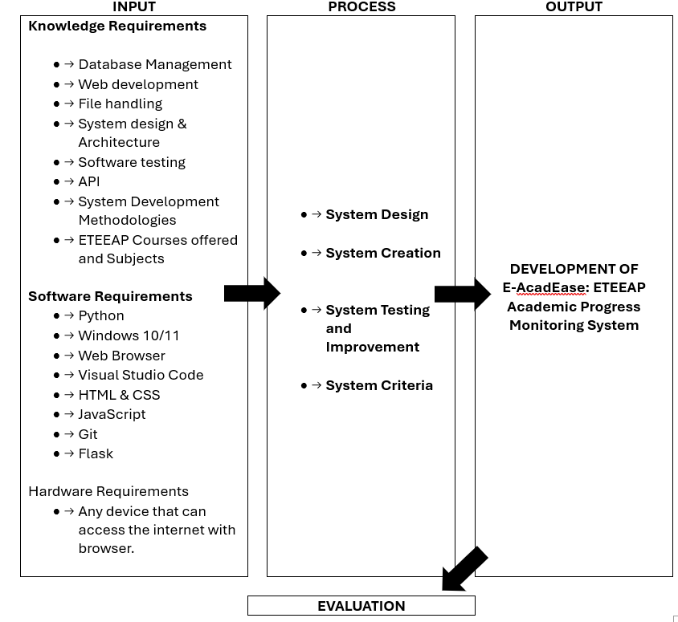

**Figure 2. 1** Conceptual Model of the Study

**Operational Definition of Terms**

1. ETEEAP (Expanded Tertiary Education Equivalency and Accreditation Program): A government-initiated program in the Philippines that provides an alternative avenue for individuals to earn a degree through the assessment and accreditation of their prior learning and work experiences.
2. Web-Based System: An application or software accessible through a web browser that allows users to interact with the system over the internet.
3. Flask: A micro web framework written in Python, utilized as the back-end framework for developing the web-based system.
4. Figma: A collaborative design tool used for creating the user interface (UI) of the web application, facilitating interaction and visibility for users.
5. Visual Studio Code: An integrated development environment (IDE) tool used for coding and development tasks during the creation of the system.
6. ISO25010 Quality Software Model: A set of international standards defining software quality characteristics and metrics, used to evaluate the acceptability and effectiveness of the developed system.
7. Enrollment System: A subsystem within the developed system focusing on the registration and admission processes for ETEEAP students.
8. Learning Management System: A subsystem within the developed system that aids in the management and monitoring of enrolled students' progress, requirements, and courses.
9. Database Management: The systematic organization, storage, and retrieval of data within the system, ensuring efficient data handling for various functionalities.
10. Rapid Application Development (RAD): A development model utilized in the project, emphasizing quick prototyping and iterative feedback to expedite the software development life cycle.
11. User Interface (UI): The graphical layout and elements presented to users in the web application, designed using Figma for an intuitive and user-friendly experience.
12. System Flow Chart: Visual representation detailing the step-by-step processes and interactions within the developed system for different users, including students, instructors, and the director.
13. Use Case Diagram: A diagram illustrating the various interactions and functionalities of the system, showcasing the roles and actions of actors such as students, instructors, and the director.
14. Beta Testing: The phase during project development where the system is deployed to a limited audience for real-world testing and feedback before its final release.
15. ISO/IEC 25010 Software Quality Metrics: International standards used to evaluate the quality attributes of the software, including functionality, usability, reliability, and efficiency.
16. Likert Scale Responses: A method of measuring participants' opinions and attitudes using a scale, typically ranging from strongly agree to strongly disagree, to assess the system's acceptability and performance.
17. Weighted Mean: A statistical measure used to calculate the average value of responses, giving different weights to various indicators based on their significance in the evaluation criteria.
18. Honorarium: Or called payment-to-teaching services rendered by the University Instructors to ETEEAP students in the duration of an academic calendar per subject taken by the student.

# CHAPTER 3

## Methodology

In this chapter, the focus lies on the research techniques and methods employed to tackle the investigation and interpretation using specific research techniques and instruments. Additionally, this chapter delves into project design, project development, operation and testing procedures, and evaluation procedures.

## Project Design

The researchers developed a web-based monitoring system for the students, Instructors, and the Director of ETEEAP department that will assist them with the assigning of students to instructors, monitoring progress of students by checking requirements and checking status of payment to services or honorarium made by the instructors.

The researchers used HTML and CSS to develop the user interface of the web application that will provide interaction and visibility to users using their devices with access to the internet. For the framework of the system, Flask is utilized by the researchers. Flask, a web application framework that is written in Python, provides the researchers with libraries and functionalities needed to develop the system’s web application.

## System Flow Chart

The system flow chart of the system developed.

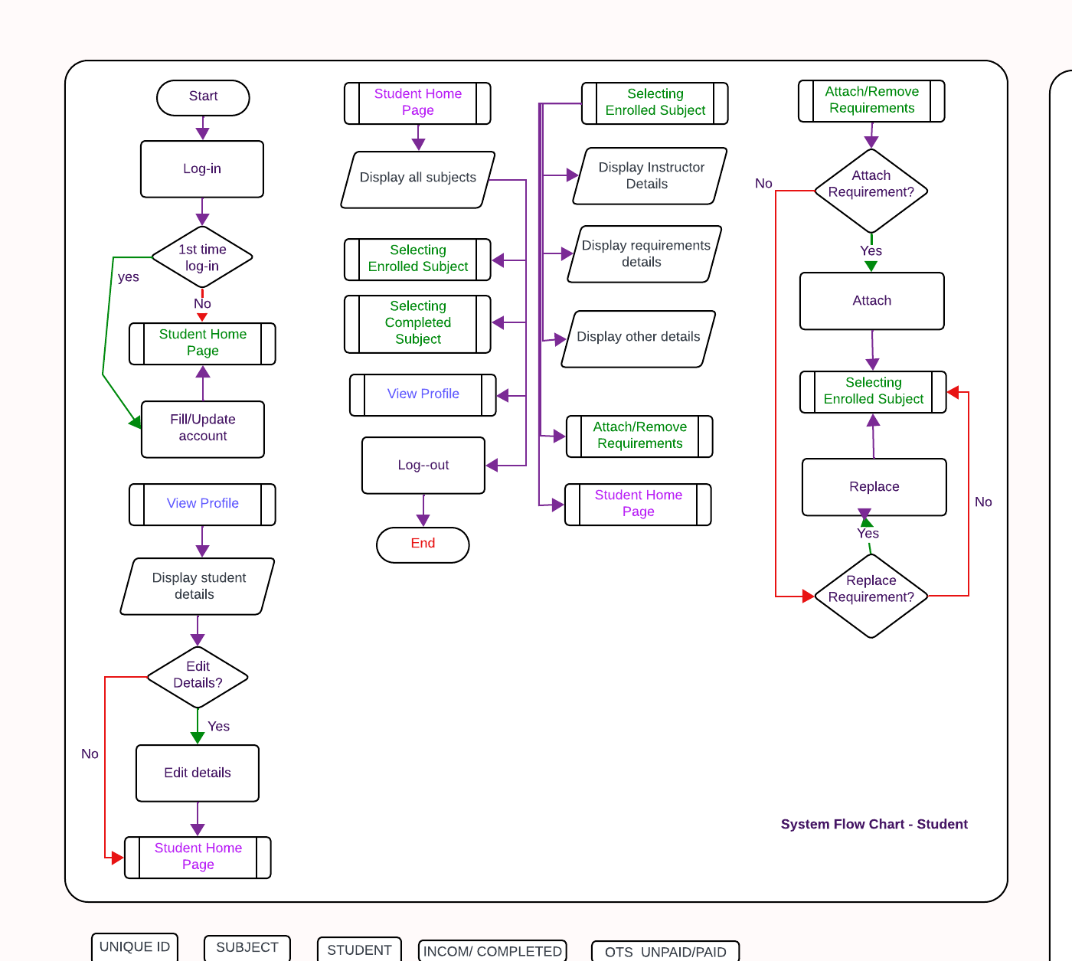

**Figure 3. 1** System Flow Chart for Student

The following are the procedures for the development of a web-based system for the student new account:

1. Browsing the website of the ETEEAP home page displays a login page.
2. Students with newly created accounts will use the credentials (username and password) given by the ETEEAP director to log in to the system..
3. The student can fill in required information, upload pictures and attach important documents such as receipt of enrollment.
4. Upon completion of the form, students will be redirected to the student home page.

The following are the procedures for the development of a web-based system for the student account:

1. Browsing the website of the ETEEAP home page displays a login page.
2. Students with accounts will provide their login credentials in the forms.
3. Invalid credentials will lock accounts of students for 1 hour after 3 failed login attempts.
4. Successful login attempts will redirect students to the student homepage where they can select and view Subject and Accounts.
5. In the Subjects tab, students can view current enrolled subjects.
6. In each subject on the subjects tab, students can view the assigned instructor.
7. In the subject tab, a student can click on add or replace requirements.
8. Requirements and status of enrolled subjects can be viewed once selected.
9. In the Accounts tab, students can edit their personal information.

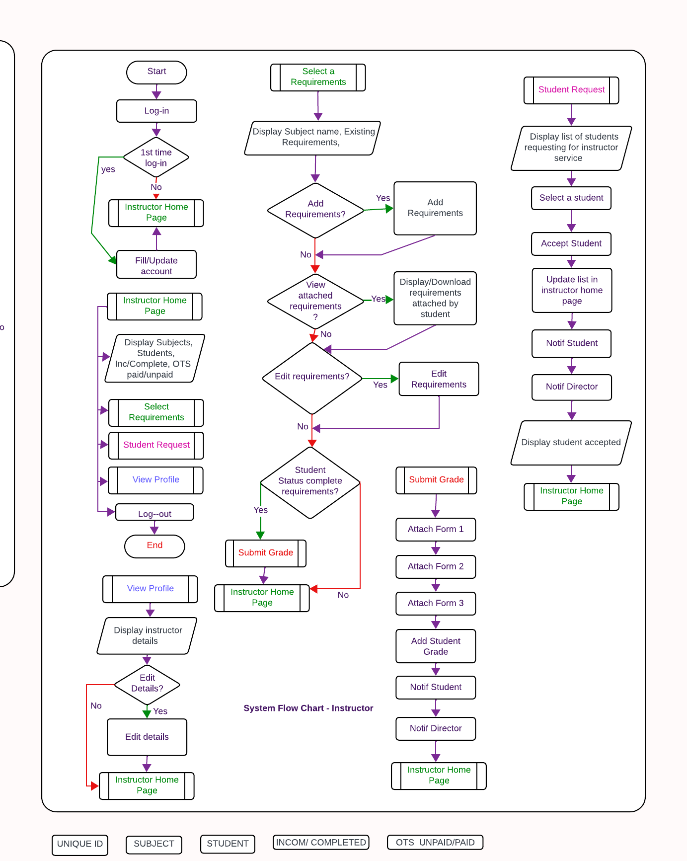

**Figure 3. 2** System Flow Chart for Instructor

The following are the procedures for the development of a web-based system for the instructor new account:

1. Browsing the website of the ETEEAP home page displays a login page.
2. Instructors with newly created accounts should proceed completing the details provided to complete their account information and update password.
3. Proceed button will only be available unless required fields in the form are complete.

The following are the procedures for the development of a web-based system for the instructor account:

1. Browsing the website of the ETEEAP home page displays a login page.
2. Instructors with accounts will provide their login credentials in the forms.
3. Successful login attempts will redirect Instructors to the Instructor homepage where they can select and view Current Students, Student Requests and view their accounts.
4. In the Students tab, Instructors can view assigned students displayed in a list.
5. On the same page, the instructors can then accept the request of students for teaching services.
6. Upon Selecting a student on the current Students tab, instructors can post and edit requirements, and view the requirements to the selected student.
7. Upon completion of requirement on the selected student, Instructors can now complete the subject taken by the student by attachment of forms 1-3 provided by the ETEEAP department and on the system and by providing the grade to the student.
8. Students that are tagged as completed requirements will change their status on the system.
9. In the Accounts tab, Instructors can edit and save their personal information.

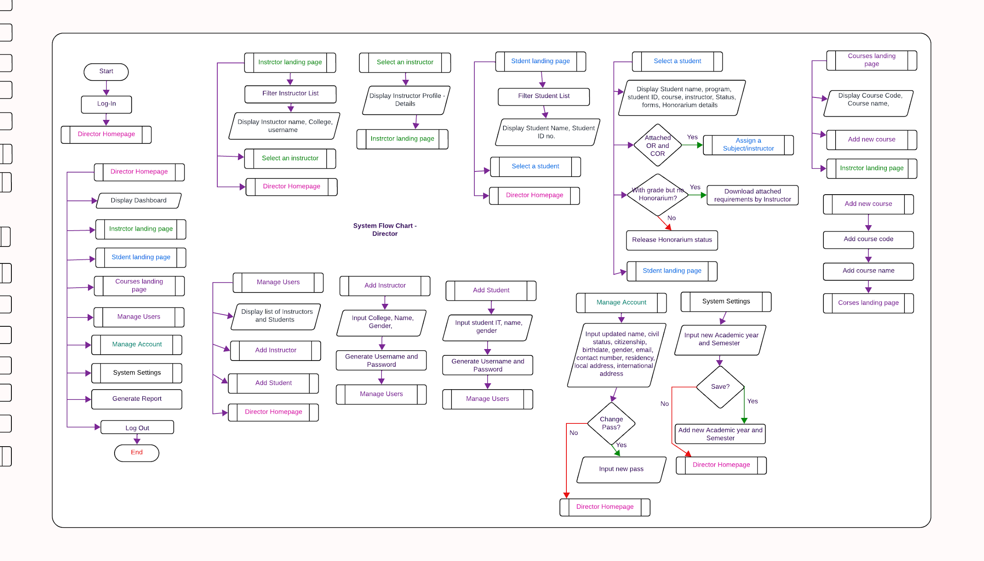

**Figure 3. 3** System Flow Chart for Director

The following are the procedures for the development of a web-based system for the instructor account:

1. Browsing the website of the ETEEAP home page displays a login page.
2. The Director will have to provide their login credentials in the forms.
3. Successful login attempts will redirect the Director to the Director homepage where they can select from the following views, Director’s landing page (dashboard), Instructors landing page, Students landing page, Courses landing page, Manage user page, Manage account page, System settings and Generate Report.
4. Clicking on the Instructor page will redirect the director to a new page.
5. On this page (Instructor landing page), listed details of instructors are displayed. .
6. Clicking from the list a specific instructor will open a window about the selected instructor.
7. On the same page, a list of instructors is displayed.
8. Clicking on a specific instructor displays the selected instructor’s details and profile.
9. Clicking on the Student landing page will redirect the director to a new page.
10. On this page (Student landing page), listed details of students are displayed.
11. Clicking enroll student from the list a specific student will open a pop-up window details about the selected student.
12. The pop-up window will display the details of the selected student on their course, instructors, status, forms, and honorarium status.
13. On the same pop-up window, the director can change the status of honorarium per subject or enroll a student.
14. Clicking on the Manage Users page will redirect the director to a new page.
15. On this page (manage users page) will display the list of instructors and students present on the system.
16. On this same page the director can add a new account on instructor and student by clicking on the add account button.
17. Clicking the add account button on the same page will open a new window that will collect new user information for students or instructors that will be added to the system after clicking on the Add button.
18. Clicking on the manage account button will redirect the director to a new page.
19. On this page (manage account), the director can edit the administrator details such as name, civil status, citizenship, birthdate, gender, email, contact number, residency, address and change admin password.
20. Clicking on the system settings button will redirect the director to a new page.
21. On this page (system settings), the director can add a new academic year and semester to the system.
22. Clicking on the generate button will redirect the director to a new page.
23. On this page (generate report), the director can filter out details from the database and will generate reports exported to excel form. Details can be chosen from Students or faculty information on the system.

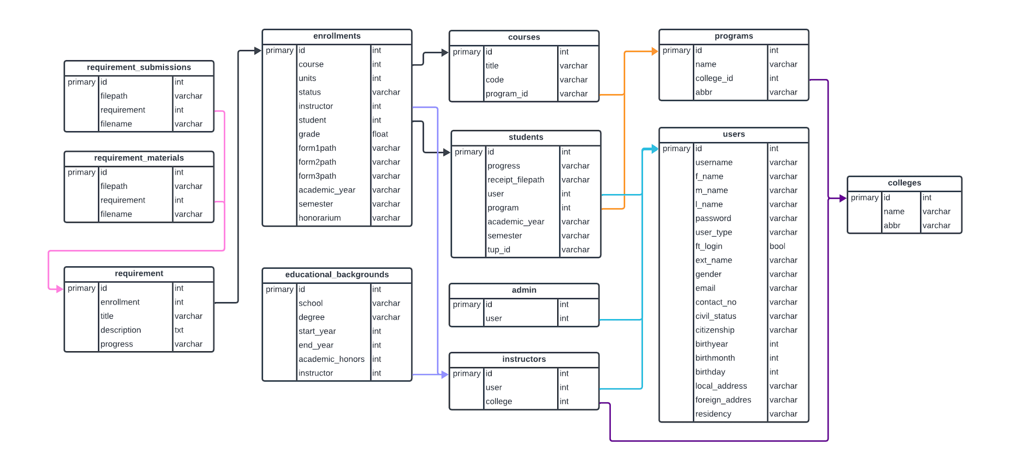

**Figure 3. 4** Entity Relationship Diagram of the System

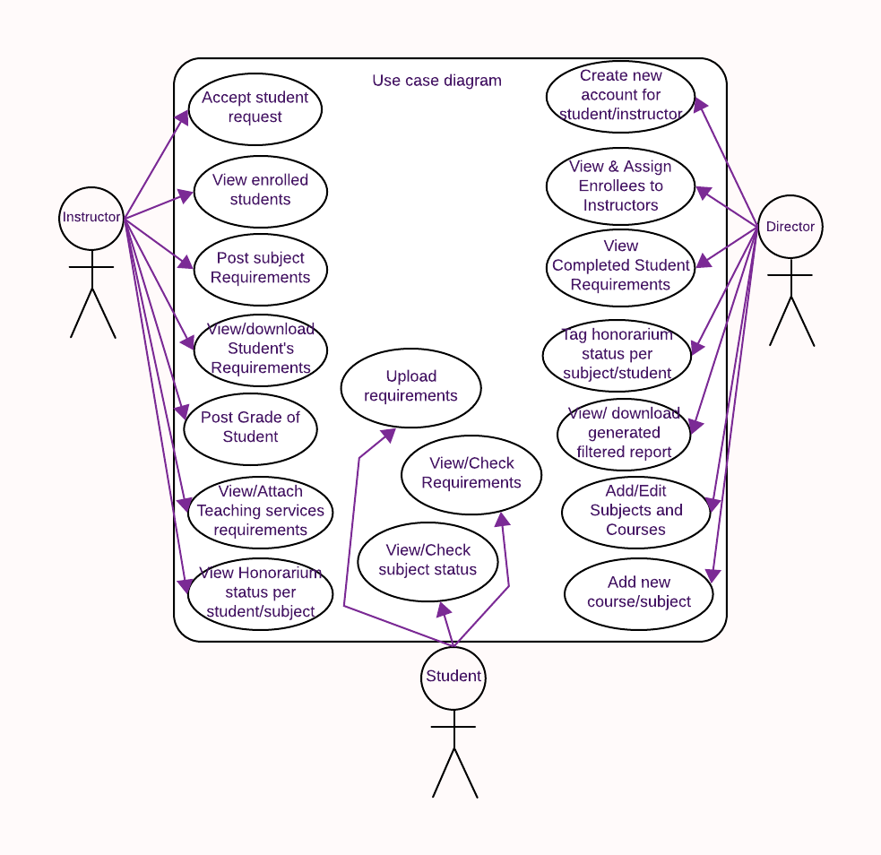

**Figure 3. 5** Use Case Diagram of the System

The figure above shows the use case diagram for the developed system. The diagram represents the corresponding actor and their respective function. The enrollee as a student, the Instructor and the ETEEAP administrator or Director are the actors in this method. The student as enrollee can view and check requirements, check their instructors assigned and view status of subjects. The instructors, on the other hand, can check their current enrolled and completed students per subject. They can also post, edit, and check student requirements. Another use case they have is to view the status of Payment to Services per student enrolled and graduated to each instructor and accept teaching services requests of students. The Director can view and create new enrollees and instructor accounts. The Director can also assign an instructor to a newly enrolled student to handle the course or subject to be taken by the student. The Director can also view the status of enrolled and completed students. The director also can add courses and subjects to the system. The Director can tag status of payment to services of instructors in the system and generate filtered reports.

## Project Development

The process and stages involved in the development of the system are presented in this chapter. The tools, techniques, and steps undertaken for the completion of the system are also presented in this chapter.

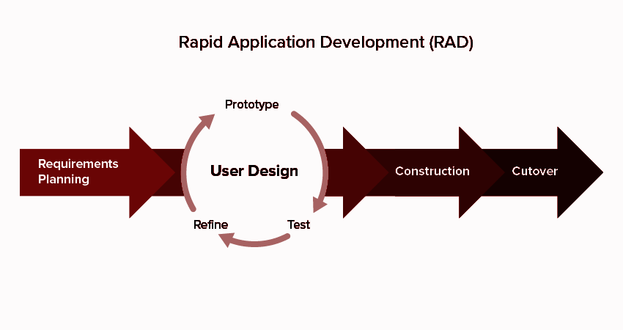

**Figure 3. 6** Rapid Application Development Model (RAD)

The figure above shows the adaptive development model RAD that is based on prototyping and quick feedback. The RAD is a software development life cycle (SDLC) approach that prioritizes building and developing software prototypes. RAD allows researchers and software developers to quickly make multiple updates or changes to the software and keep reiterating as frequently as possible without having to start from scratch on each cycle. RAD is composed of four basic development stages.

## Requirements Planning

This initial phase focuses on gathering, quickly understanding, and identifying the objectives and requirements of the end user in a broad nature. The broad nature of the requirements allows the researchers to segment the requirements at different points in the development cycle and on each iteration allowing for flexibility to accommodate changes based on feedback from the user. The researchers made sure to acquire essential information and feedback from the end user and maintain communication through the development cycle of the evaluation system.

## User Design

This phase involves the constant interaction between the user and the researchers in creating prototypes. RAD allows rapid prototyping enabling the researchers to show to the user the software prototype and receive feedback from the user. The researchers take advantage of rapid prototyping to accommodate changing user preferences that meet the expectations of the user.

## Construction

The construction phase implies the amalgamation of user feedback and requirements, reviews, and alteration during the development to flesh out a working system from a working prototype model. Problems on the prototype such as bugs are addressed during this phase ensuring the software aligns with the user needs.

## Cutover

The last phase in this SDLC, Cutover or the deployment phase, involves the implementation of a functioning system and its delivery to the end user. The deployment phase allows the conduction of intensive testing, user training, documentation, system simulation, issue tracking, and final customization in a live production environment. The researchers will finalize updates and maintenance in this phase ensuring the system’s successful implementation.

## Operation and Testing Procedure

**Operation Procedure**

The system required the following procedures to function:

**For department Director accessing the Director’s homepage:**

1. Director access to the website.
2. Director will log in as administrators.
3. Director will be redirected to the dashboard that presents graphs.

**For department Director accessing the Director’s Students Tab:**

1. Director logged in into the website and selected the Students Tab.
2. The director can filter the list of students displayed by setting the academic year and semester using the drop-down option and pressing Apply.
3. The Director can select a student from the list provided on the page to enroll.
4. Upon selecting a student to enroll, a new pop window will be displayed about the details of the selected student.
5. On this same window, a course and instructor drop down option is available for the director to choose from and if completed, the director can now press the Enroll button.
6. After the enroll button, the student details on the subject and course will be displayed by selecting the student enroll button.
7. The window on the student profile will display the newly subject and instructor added to the student’s profile and on pending status.
8. Once the instructor has accepted the student, the status will change to Ongoing to show that the student and teacher will now conduct classes.
9. Upon completion of the subject, the status of the student’s subject on the profile will change to Completed.
10. Once a student has completed a subject, the forms will be available for download located beside the subject status on the student profile window.
11. On this same profile window, the director can update the status of honorarium per subject attended by the student from “On Process” to “Released” by clicking on the release button.

**For department Director accessing the Instructors Tab:**

1. Director logged in into the website and selected the Instructors Tab.
2. The Director can view and select instructors on the list in the page.
3. The Director can filter the list of instructors on this page by selecting on the drop-down menu for college options for College of Science, College of Industrial Education and College of Industrial Technology.
4. Clicking on the Info button in row of an instructor will display a pop-up window for the instructor’s profile.

**For department Director accessing the Courses tab:**

1. Director logged in into the website and selected the Courses Tab.
2. The Director can view and select the collection courses displayed.
3. The Director can view the list of programs on the left panel by scrolling on the list.
4. The Director can view the list of courses on the right panel by scrolling down ont he lists.
5. To add a new course, click on the Add course button present on the upper right of courses panel to display the new window for adding a new course.
6. On this new window, the Director can type in a new Course Code and title. Press the add course button to save it on to the system.

**For department Director accessing the Manage Users tab - Adding Instructor:**

1. Director logged in into the website and selected the Manage users tab.
2. The Director can view and select the list of instructors and students on the system.
3. To add new instructor to the system, the Director should click on the Add account button that will pop-up a new window Add Instructor Account.
4. On this new window, the Director should select the assigned college on the drop-down menu option.
5. The Director should fill in the details of the instructor on the surname, first name, middle name, extension text boxes.
6. The Director should select the gender from the drop-down menu.
7. The login details for the username and one-time password are automatically generated by the system and should be saved by the Director to send these credentials to the instructor later.
8. The system will show a prompt message saying the user has been successfully added to the system upon clicking the add user button.
9. The Director can now forward the credentials to the instructor so they can login to the system.

**For department Director accessing the Manage Users tab - Adding Student:**

1. Director logged in into the website and selected the Manage users tab.
2. The Director can view and select the list of instructors and students on the system.
3. To add a new student to the system, the Director should click on the Add account button that will pop-up a new window Add Student Account.
4. On this new window, the Director should key-in the TUP Student ID of the ETEEAP student.
5. The Director should fill in the details of the student on the surname, first name, middle name, extension text boxes.
6. The Director should select the gender from the drop-down menu.
7. The login details for the username and one-time password are automatically generated by the system and should be saved by the Director to send these credentials to the student later.
8. The system will show a prompt message saying the user has been successfully added to the system upon clicking the add user button.
9. The Director can now forward the credentials to the student so they can login to the system.

**For department Director accessing the Manage Account Tab:**

1. Director logged in into the website and selected the Manage account tab.
2. On this page, the Director has the profile details of the administrator.
3. To edit the administrator details, the Director should click on the Edit button beside the Account Details text at the top.
4. Clicking on the edit button will enable the text boxes to be editable.
5. To save edited details on the Account details, the Director should click on the Update Account Details button at the bottom of the page.
6. To undo changes or cancel editing, the Director should click on the Undo Edit button beside the Account Details text at the top.
7. To change admin password of the system, the Director should click on the Change Password button found at the bottom of the page.
8. Clicking on the Change Password button will display a new pop-up window Change Password.
9. The Director should key-in the current password, new password and confirm the new password on the text boxes.
10. To save changes, the Director should click on the Save New Password button.

**For department Director accessing the System Settings Tab:**

1. Director logged in into the website and selected the System Settings tab.
2. To add a new Academic Year to the system, the Director should click on the Edit button beside the System Settings label on the webpage.
3. After clicking on the Edit button, the Academic year text label can be edited, and the semester drop down option can be selected to the desired semester.
4. Once the academic year and semester has been completed, the Director should click on the Save button.
5. The latest academic year and semester will be reflected on this page after saving.

**For department Director accessing the Generate Report Tab - Student Report:**

1. Director logged in into the website and selected the Generate Report tab.
2. On this page, the Director can generate filtered reports either about the instructors or the students.
3. To generate a report on the Student Data Report Generation portion, the Director should first select at least one or a combination of the radio buttons for Age, Gender, Residency and Course Status.
4. Next step is to select options for Academic year, Semester, College, and program drop-down menu option. These options can be left defaulted to ALL options.
5. When satisfied with the selected filters, the Director can now click on the Generate Student Report button found beside the Student Data Report Generation label and will prompt the Director for the download information.

**For department Director accessing the Generate Report Tab - Student Report:**

1. Director logged in into the website and selected the Generate Report tab.
2. On this page, the Director can generate filtered reports either about the instructors or the students.
3. To generate a report on the Faculty Data Report Generation portion, the Director should first select at least one or both the Course status and Status of Honorarium radio buttons.
4. Next step is to select options for Academic year, Semester and College drop-down menu options. These options can be left defaulted to ALL options.
5. When satisfied with the selected filters, the Director can now click on the Generate Faculty Report button found beside the Faculty Data Report Generation label and will prompt the Director for the download information.

**For Instructors accessing the Instructor’s Student Tab:**

1. Instructor logged in into the website and selected the Students tab.
2. The list of students based on the criteria of the selected Academic Year and Semester on the drop-down menu will be displayed.
3. To change the list of the students, the instructor should select the appropriate Academic year and semester.
4. Once selected, the instructor should click on the Apply button to update the list.
5. Pending status on the list means the student is requesting for teaching services that the instructor can accept.
6. Ongoing status on the list means the student and the instructor are currently conducting classes.
7. Completed status on the list means that the classes between the student and instructor have ended.

**For Instructors accessing the Instructor’s Student Tab - Posting Requirements:**

1. Instructor logged in into the website and selected the Student Tab
2. If the student is not on the list, the instructor should change the selected academic year and semester appropriately and press the apply button to update the list.
3. Once the student appears on the list, click the Requirements button in-line of the desired student, and will display a new window.
4. The new window will display the current requirements posted if there is any. To add a new requirement, simply press the Add requirement button on the top right portion of the window and it will refresh the current window.
5. The instructor should now add a new requirement by filling out the Title text box and the Description text box. The instructor can also attach additional resources by clicking on the Choose files Button before pressing the Post button.
6. After pressing the Post button, the instructor will be redirected to the previous window with the updated list of requirements for the subject.

**For Instructors accessing the Instructor’s Student Tab - Returning Requirement:**

1. Instructor logged in into the website and selected the Student Tab
2. If the student is not on the list, the instructor should change the selected academic year and semester appropriately and press the apply button to update the list.
3. Once the student appears on the list, click the Requirements button in-line of the desired student, and will display a new window.
4. The new window will display the current requirements posted if there is any. To open the desired requirement, click the Open button in-line with the requirement,
5. Clicking the Open button will redirect the instructor to the requirements. On this same page, the instructor can view and download the materials and submissions attached.
6. The instructor can return the task to the student by clicking on the return button.

**For Instructors accessing the Instructor’s Student Tab - Submitting Grade:**

1. Instructor logged in into the website and selected the Student Tab.
2. If the student is not on the list, the instructor should change the selected academic year and semester appropriately and press the apply button to update the list.
3. Once the student appears with its corresponding subject on the list, click the Requirements button in-line of the desired student and will display a new window.
4. On the upper right screen of this new window, the Submit Grade button should be clicked by the instructor.
5. Clicking on the Submit Grade button will update the window to Grade Submission.
6. On this page, the instructor can download the forms Daily Time Record, Student’s Summary Grade and Tutor’s Evaluation Report that should be filled up by the instructor.
7. The three mentioned forms should be attached to the three upload files present on the window. To attach each file, the instructor should click on each Choose File button and select each form per file.
8. After attaching the files on the window, the instructor can now select the appropriate Final Grade on the drop-down menu and press the Submit Grade button after checking the details carefully.
9. After submitting the grade, the instructor will be redirected to the previous window with the updated details on the student and subject. The information on the student will display the Final Grade submitted and the honorarium status.

**For Instructors accessing the Manage Account Tab:**

1. Instructor logged in into the website and selected the Manage Account Tab.
2. The upper portion of this window shows the personal information of the instructor.
3. The lower portion of this window shows the educational background of the instruction.
4. To update details on this page, the instructor should click on the Edit button beside the Account Details label found on top of the page.
5. Clicking on the button enables the text field to be editable by the instructor.
6. Once editing is complete, the instructor should now click on the Update Account Details button found in the middle of the page.
7. To add an educational background, click the edit follow step number 4 and simply fill out the details on the editable fields in the Educational background portion and then click the add button to save details.

**For Instructors accessing the Manage Account Tab - Change password:**

1. Instructor logged in into the website and selected the Manage Account Tab.
2. In the middle portion of the page, the instructor should click on the Change Password button.
3. Upon clicking on the Change Password button, a new window will appear prompting the instructor to type in the current password, new password and confirming the new password.
4. After filling out the password details, the instructor should click on the Save New password button to update the password.

**For Student accessing the Student’s Enrollment Tab:**

1. Students logged in into the website and selected the Enrollment Tab.
2. For newly enrolled students, the student should attach the Official Receipt and Certificate of Registration.
3. To attach the files, simply click on the Choose file Button on the page and select the appropriate file then upload.

**For Student accessing the Student’s Subject Tab:**

1. Students logged in into the website and selected the Subjects Tab.
2. On this page is a list of the subjects that are associated with the student.
3. The pending status means that the subject is waiting for the indicated instructor to accept the teaching services request assigned.
4. The ongoing status indicates that the subject is current for the semester.
5. The completed status indicates that the subject has been completed and verified with the Final Grade indicated.

**For Student accessing the Student’s Subject Tab - Checking/Uploading Requirements:**

1. Students logged in into the website and selected the Subjects Tab.
2. The student should browse for the appropriate subject on the list.
3. Click on the requirements button in-line with the desired subject and it will display a new window.
4. The window entitled from the subject will display a list of requirements and attachments for the subject.
5. Incomplete status of a requirement indicates that the student has not yet turned in the assignment.
6. Turned-in status of the requirements signifies that the student has turned in the requirement.
7. To view a requirement, simply click on the Open button and the student will be redirected to details of the requirement.
8. The student can now read the Description of the requirement and download the materials attached by clicking on the item below the materials label.
9. To attach a file, the student should click on the Attach File button beside the Submissions label. The student can attach multiple files in each requirement.
10. To finish the requirement upon successful upload of attachments, the student should click on the Turn in button found on the upper right corner of the window.

**Evaluation Procedure**

To evaluate the acceptability of the system, the ISO/IEC 25010 software quality measures were utilized. The system assessment was separated into two (2) phases, system demonstration and final evaluation.

**System Demonstration**

In this phase, the researchers carried out the following tasks:

1. Send invitations to participants, which consist of specified respondents.
2. Presented the system to the specified participants.
3. Deployed the system beta testing and allowed the respondents to use and explore the system.

**Final Evaluation**

In this final phase, the researchers assessed the system using the following procedures:

1. Prepared an evaluation instrument using the ISO/IEC 25010 Software Quality Metrics.
2. Distributed the link or survey of evaluation instruments to participants.
3. The respondents were given questionnaires, the results of which are displayed from Table 4.1 to 4.5 as Likert scale responses.
4. Collected and tabulated the data.
5. Calculate the weighted mean for each indicator as well as the overall weighted mean for each criterion.
6. Using the comparable descriptive rating in Table 4.1 to 4.5, interpret the outcome.

# 

# CHAPTER 4

## Results and Discussion

This chapter presents the results of the study, covering an overview of the implementation process of the web-based monitoring system as well as its capabilities and limitations. The chapter also includes an evaluation of the project, discussing the system's overall performance.

## Project Structure

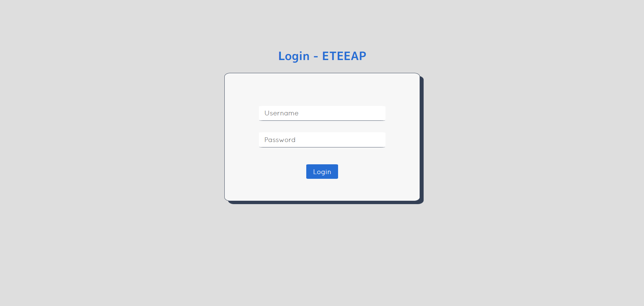

**Figure 4. 1** Login Page

The visitors of the webpage will be redirected to the Login page for the time they access the website. Visitors will be required to login using their credentials allowing secure access for administrators, instructors, and students. Users can log in with their credentials for them to access specific features and information relevant to their use.

### Admin

The following images show the user interface designed for administrators of the system. These interfaces provide a comprehensive view of the system's functionalities and allow administrators to effectively use and manage the system.

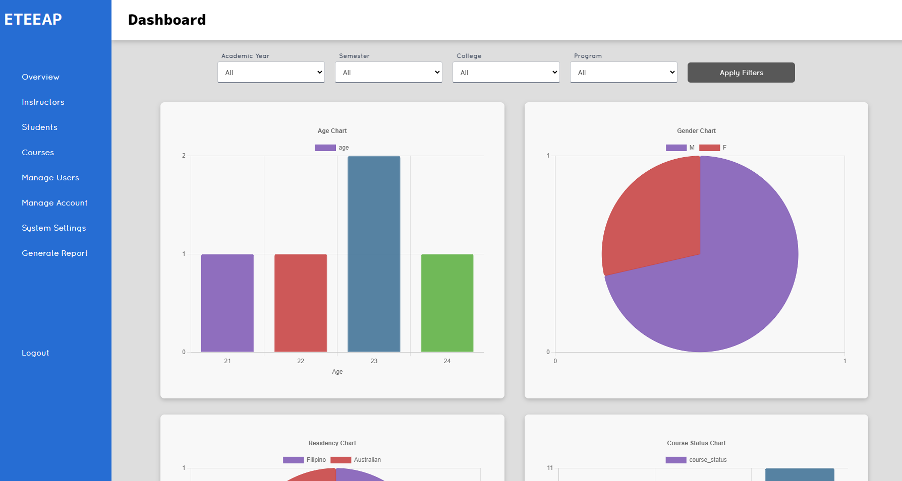

**Figure 4. 2** Dashboard of Admin

Upon successful login by the administrator, they are presented with the dashboard as shown in the image above. The dashboard displays filtered information that can be selected by the administrator. The information is automatically displayed based on the data selected. Displayed information is pulled directly from the systems database. Charts displayed are for age, gender, residency and course status which are relevant to the ETEEAP department's report requirements.

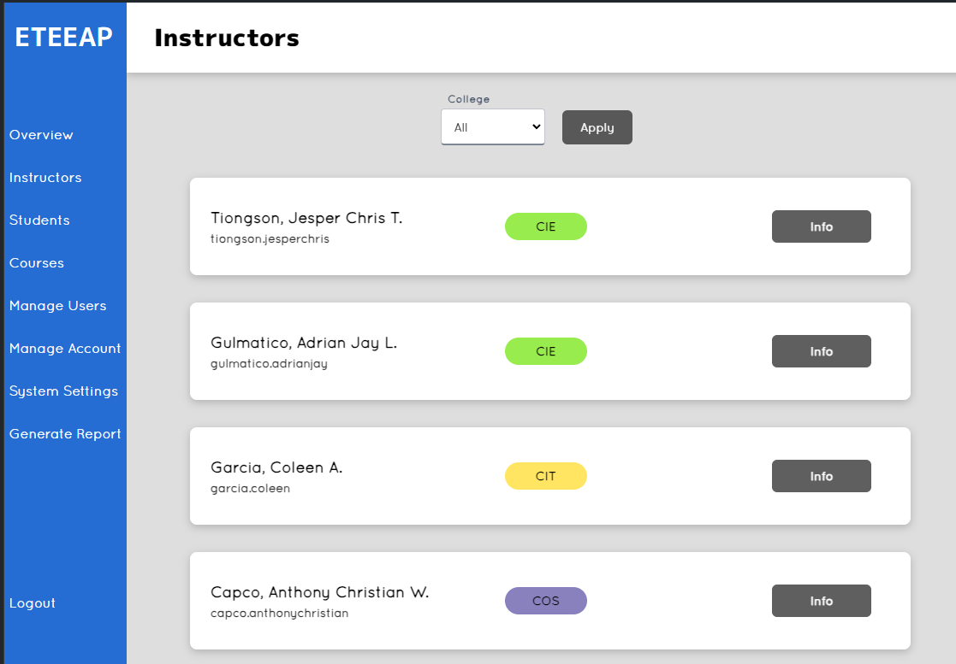

**Figure 4. 3** Instructor Tab of Admin

On the instructor tab, the administrators can view the list of instructors on this interface. The college filter drop box allows this page to filter the instructor list to specific colleges. The info button situated at the right side of each instructor on the list displays a pop-up window for the instructor’s profile.

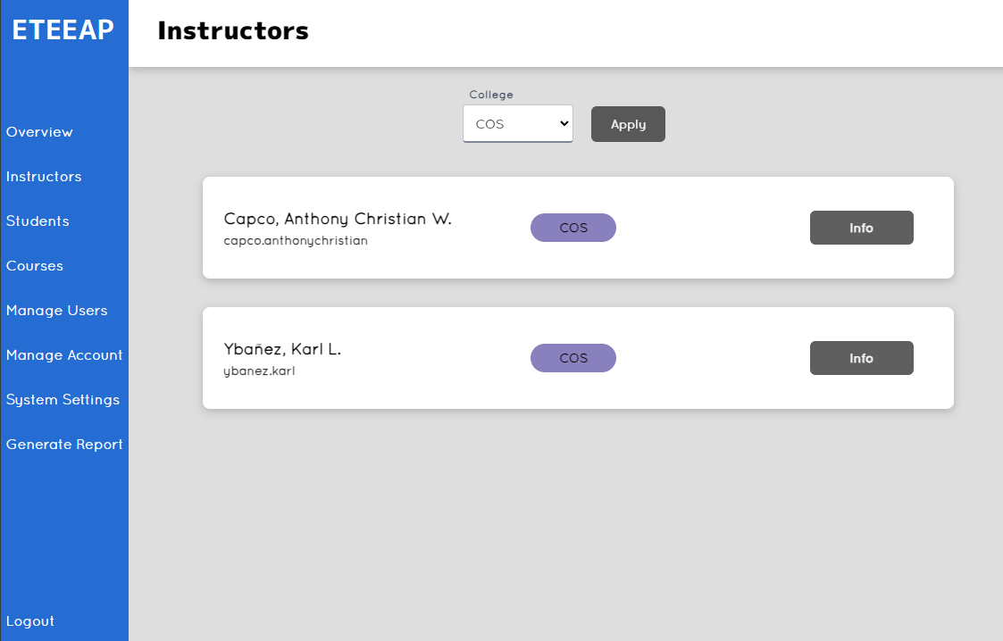

**Figure 4. 4** Instructor Tab of Admin - Filtered to College of Science

The image above displays the Instructor Tab of Admin web page that is filtered to College of Science instructors only.

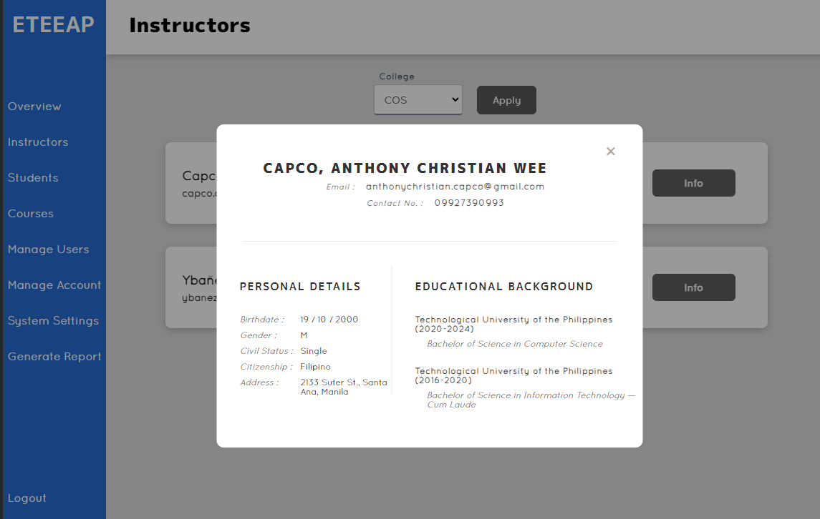

**Figure 4. 5** Instructor Tab of Admin - Instructor Profile

The image above displays the Instructor Tab of Admin webpage upon selecting an instructor and checking their profile by clicking the info button of the selected instructor.

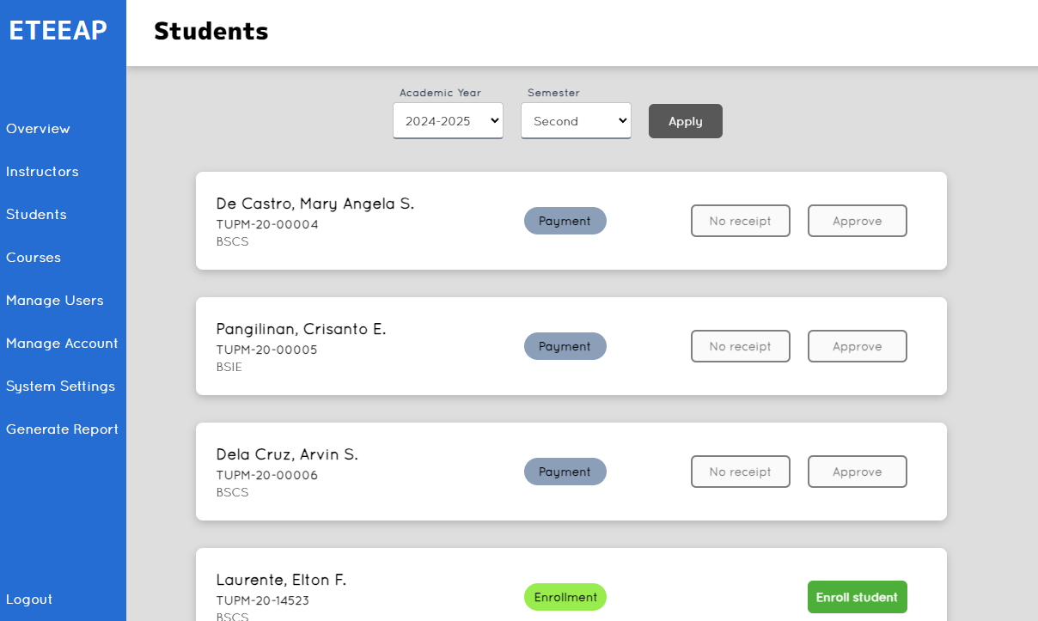

**Figure 4.** **6** Students Tab of Admin

Similar to the instructor’s tab, this is where administrators can see the list of ETEEAP students, enroll a student, their status on the program, and relevant information per student.

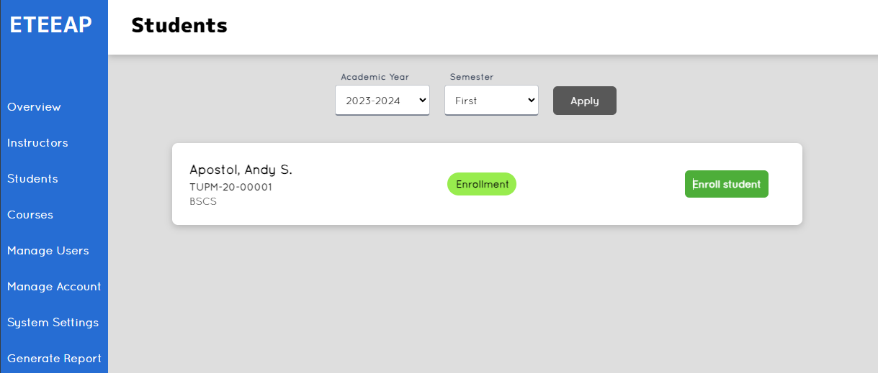

**Figure 4. 7** Students Tab for Admin - Filtered List

The admin can filter out the list of students on this webpage. The admin can select from the list of academic year and semester present on the database to be displayed on the page.

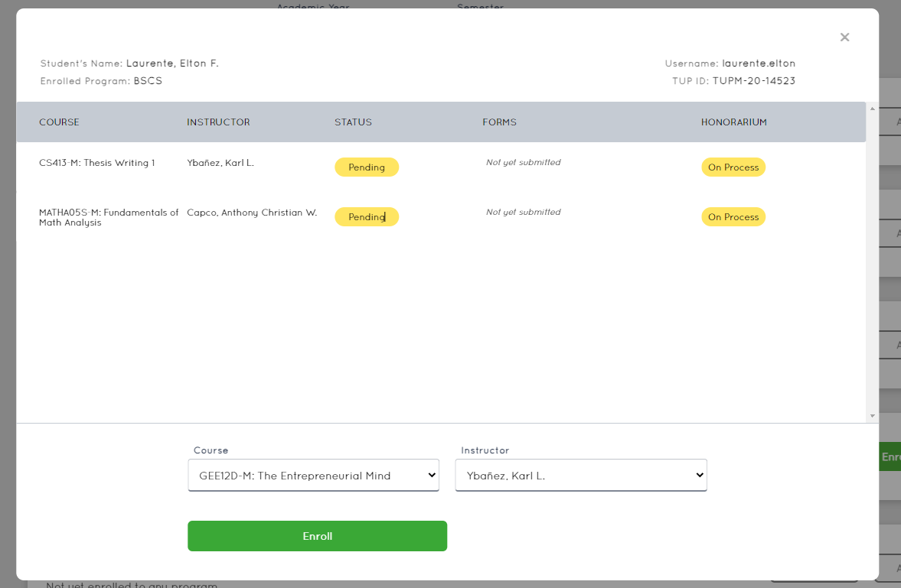

**Figure 4. 8** Students Tab for Admin - Enrolling a student

Upon selecting a student on the list, a new window will pop-up as shown above. The course and instructor can be selected from the drop-down list and finally clicking on the Enroll button to enlist the student.

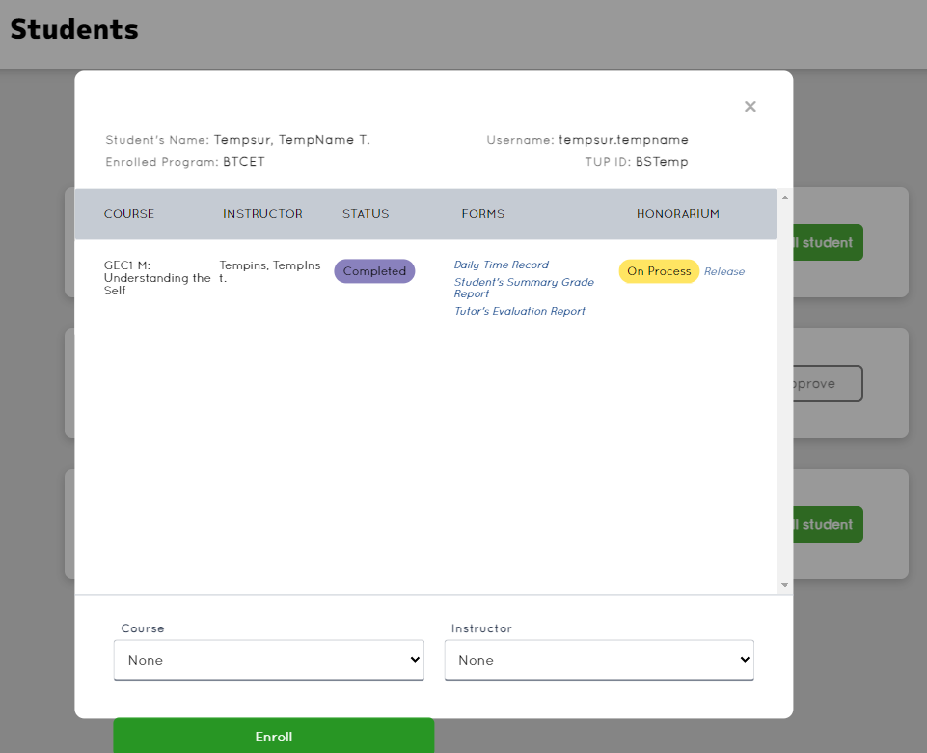

**Figure 4. 9** Students Tab for Admin - Status of Honorarium

When a student accomplished a subject and grade is returned to the student and reflected on the system, the status of the subject for the student will change to Completed and the Honorarium process will begin. Aside from the honorarium, the other requirements are attached on this window for the admin to view easily. Upon clicking on the release status button for the honorarium, this will be displayed as released.

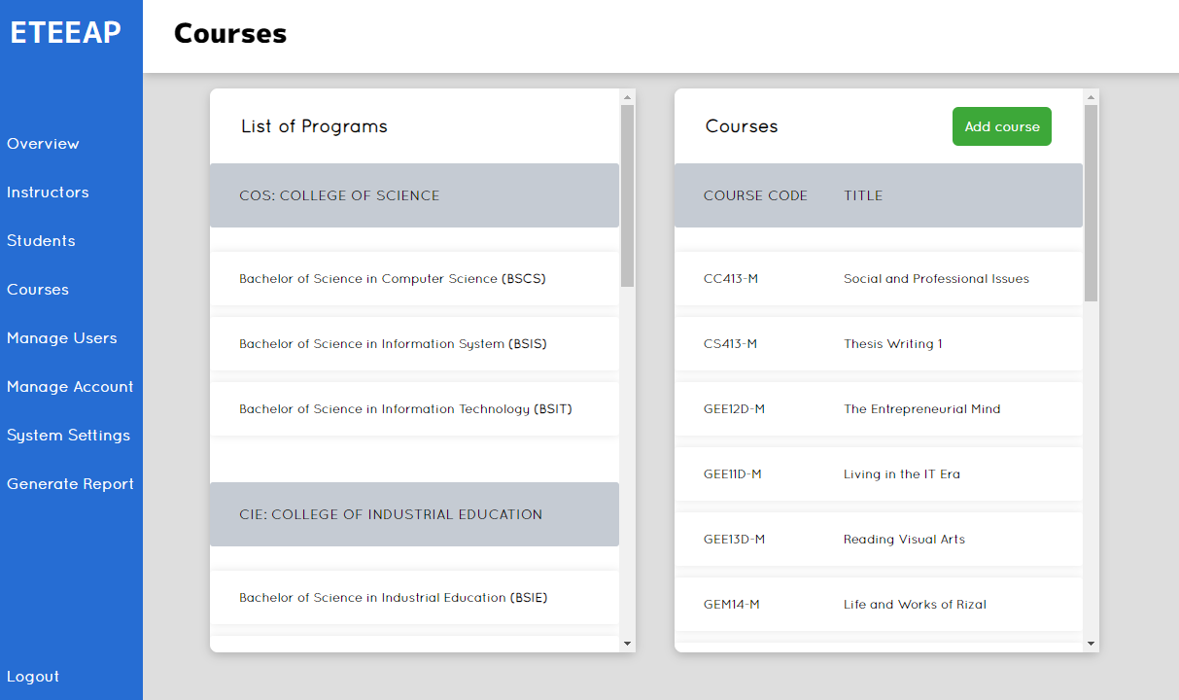

**Figure 4. 10** Courses Tab of Admin

This tab shows the list of courses offered by the ETEEAP. On this interface, you can also see the course’s corresponding code and the list of subjects offered. The admin can add a course and a subject by clicking the Add course button on the upper right of the screen.

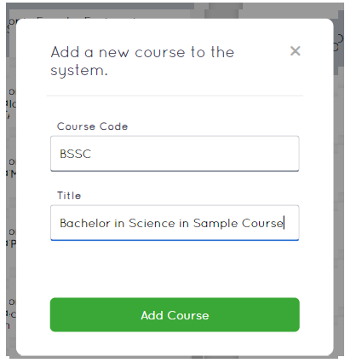

**Figure 4. 11** Courses Tab for Admin - Add a New Course

A prompt window will be displayed upon clicking on the Add course button as shown on the image above. This will allow the admin to add another subject on the list.

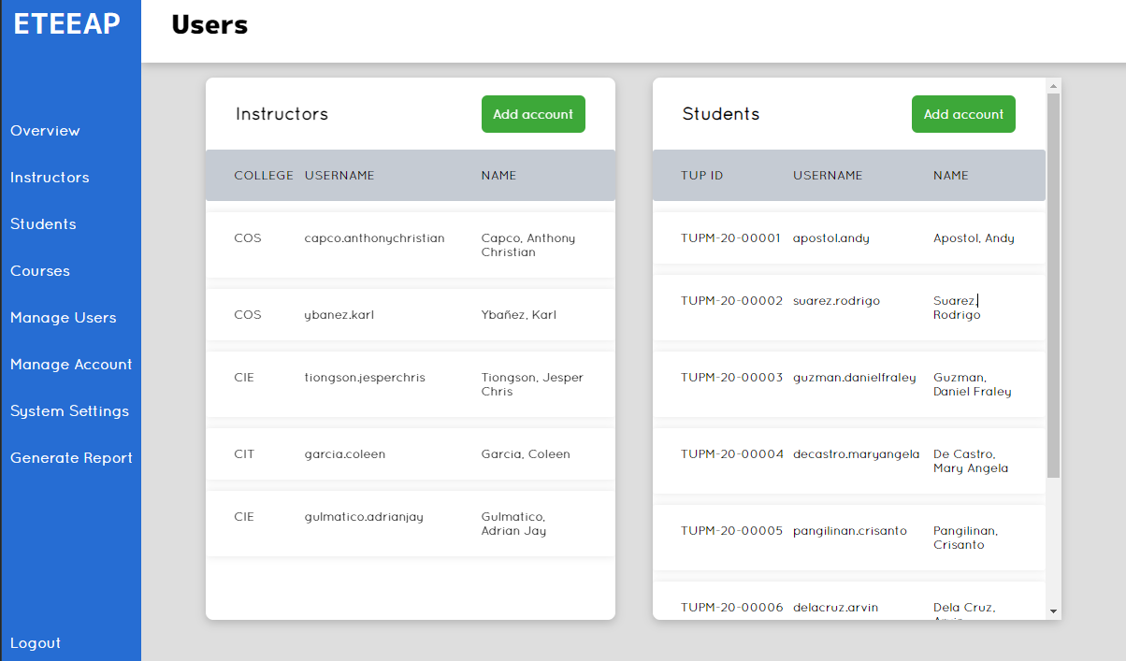

**Figure 4. 12** Manage Users Tab for Admin

The Manage Users Tab of the Directors page enables the Director to manage both the Instructor and Students accounts in a list. This helps the Director to navigate or search for instructors or students on the system. Aside from navigating from the accounts on the list, the Director can also add a new account for a student or an instructor.

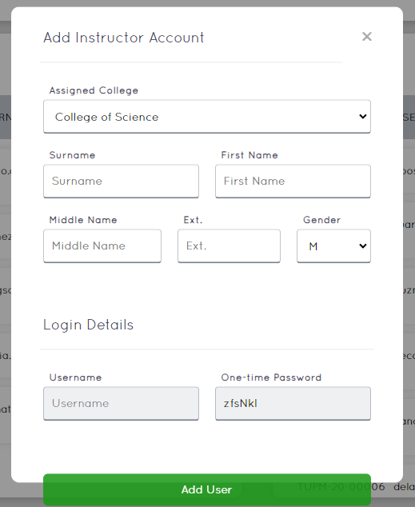

**Figure 4. 13** Manage Users Tab for Admin - Add Instructor

The Manage Users Tab of the Directors page enables the Director to add instructors on the system by displaying the prompt window as displayed on the image above. The director can assign a college which the instructor is grouped into, fill in details such as surname, first name, middle name, extension, and gender. Username and password are automatically generated by the system and should be noted by the admin which will then be forwarded to the user account holder for login credentials.

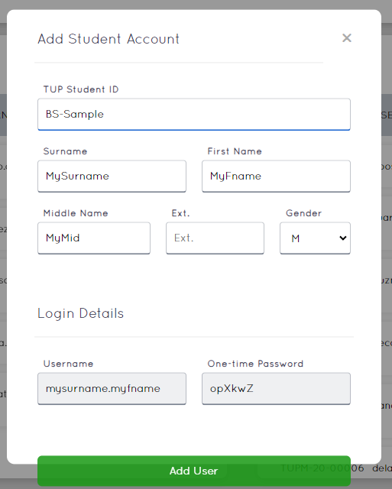

**Figure 4. 14** Manage Users Tab for Admin - Add Student

The Manage Users Tab of the Directors page enables the Director to add students on the system by displaying the prompt window as displayed on the image above. The director can assign the Student ID, fill in details such as surname, first name, middle name, extension, and gender. Username and password are automatically generated by the system and along with the TUP student ID, should be noted by the admin which will then be forwarded to the user account holder for login credentials.

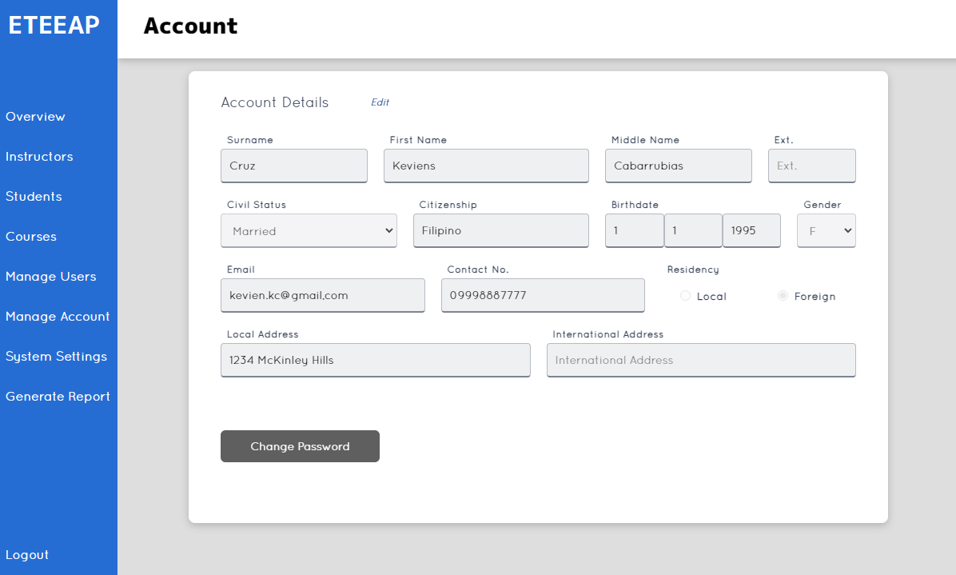

**Figure 4. 15** Manage Account of Admin

The Manage Account for Admin tab enables the admin to edit profile details for the administrator. This also allows the admin to change the current password for the admin.

### 

### Instructors

The following images are for users that are categorized as instructors. The interfaces they can access will assist them in tracking their students and its requirements and the honorarium.

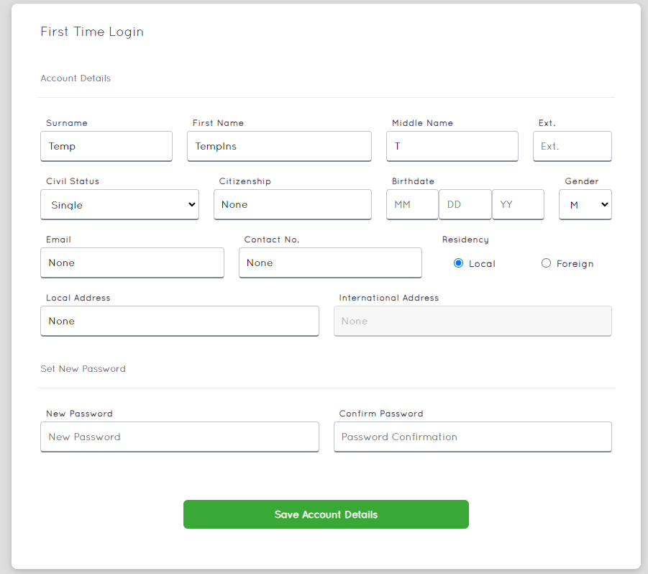

**Figure 4. 16** First Time Login for Instructors

Upon first-time successful login of an instructor, they will be redirected to this page to fill out necessary information needed by the ETEEAP department. They will need to provide a new password along with the information they provided to the system.

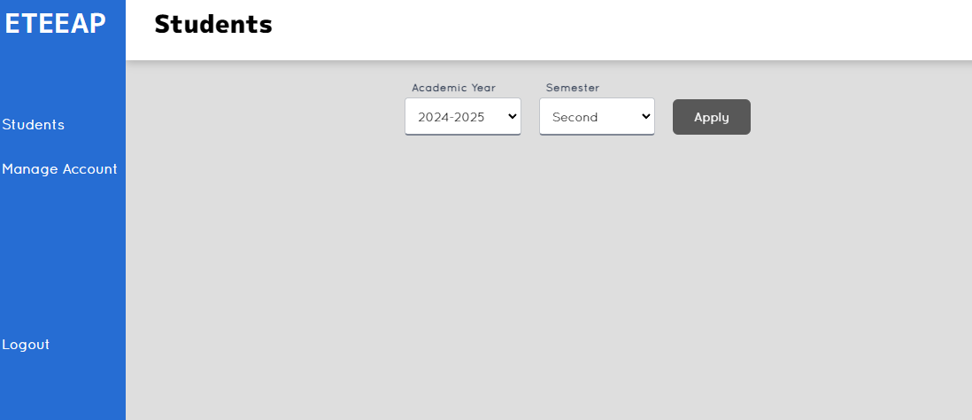

**Figure 4. 17** Students Tab of Instructor - New Instructor

Upon successful login of the instructor to the page, the Instructor landing page will be shown as the image above. On this page, the instructor can navigate between Students and Managing their account.

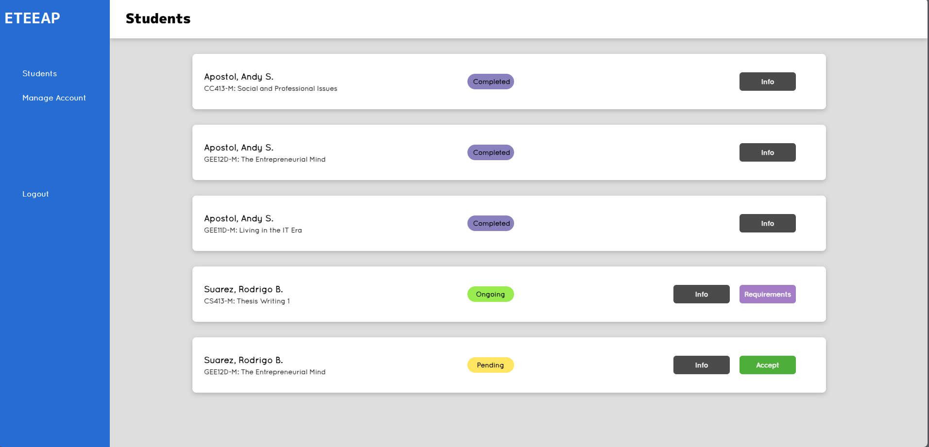

**Figure 4. 18** Students Tab for Instructor

On this page the instructor can view the students enrolled to the account of the instructor. A tag on each student account on the list is shown as *‘Completed’*, *‘Ongoing’* and *‘Pending’* that indicates the status of each student enrolled. *‘Completed’* status indicates that the student already completed the last subject enrolled. *‘Ongoing’* status indicates that the student is currently enrolled. And the *‘Pending’* status indicates that the student is requesting teaching services for the instructor. Accepting students' requests changes the status of the student to ‘Ongoing’. The instructor can check the information on each student via clicking on the Info button in line with each student on the list. The instructor can also attach or update requirements per student on this page.

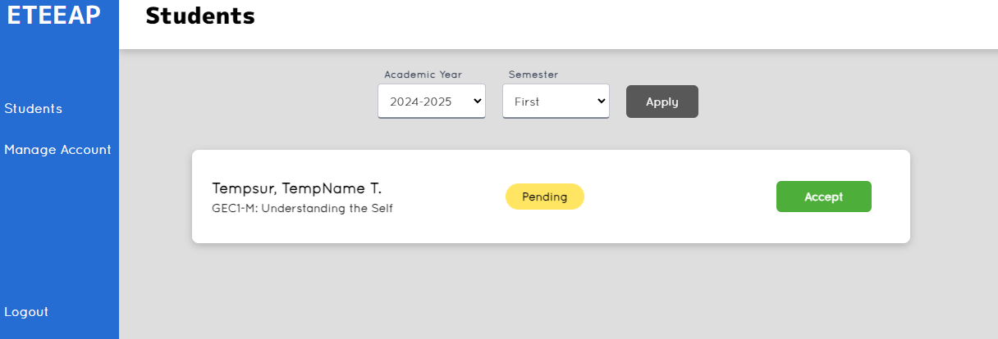

**Figure 4. 19** Students Tab of Instructor - Student Request for Teaching Services

The image above shows a webpage displaying a student requesting for teaching services. The instructor can accept the student and the teaching services to the ETEEAP student will begin.

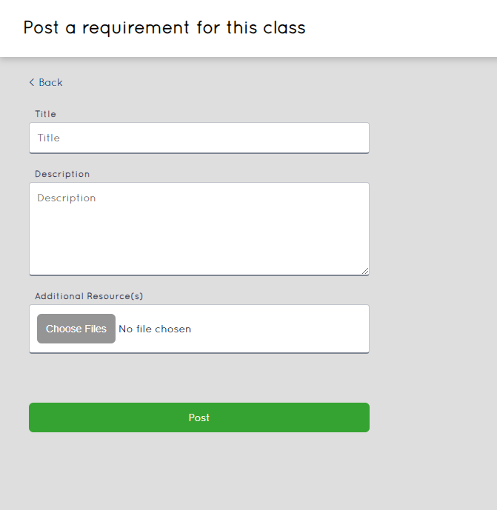

**Figure 4. 20** Subject Requirement Assign by Instructor

Upon clicking the Requirement button on the Instructor homepage, the page shown on the image above will be displayed for the instructor. This will enable the instructor to post a requirement and attached supporting documents on the subject. Title is mandatory on this requirement and a Description will allow the instructor to key in additional information about the specific requirement.

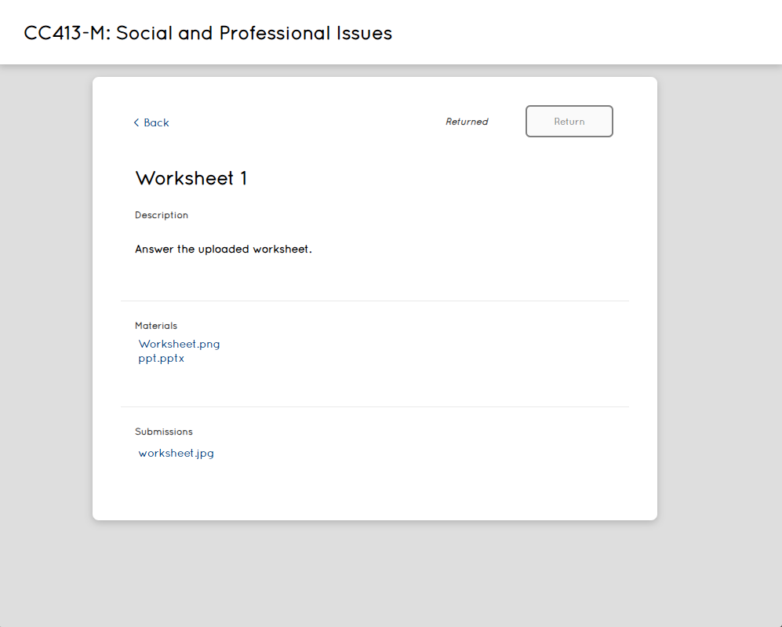

**Figure 4. 21** Subject Requirement View/Update for Instructor

On this page enables the instructor to add or edit a requirement about enrolled students. The instructor can add a title on this requirement. A description of the requirement is also available on this page to give instruction to students. Class materials can be attached on this page to help students on their tasks and can be downloaded by both student and instructor or edited by the instructor. Uploads of the student for the requirement can be downloaded from this page by the instructor. When the requirement is satisfied by the student, the instructor can change the status of the requirement by clicking on the ‘Return’ status button to signify that the requirement has been met.

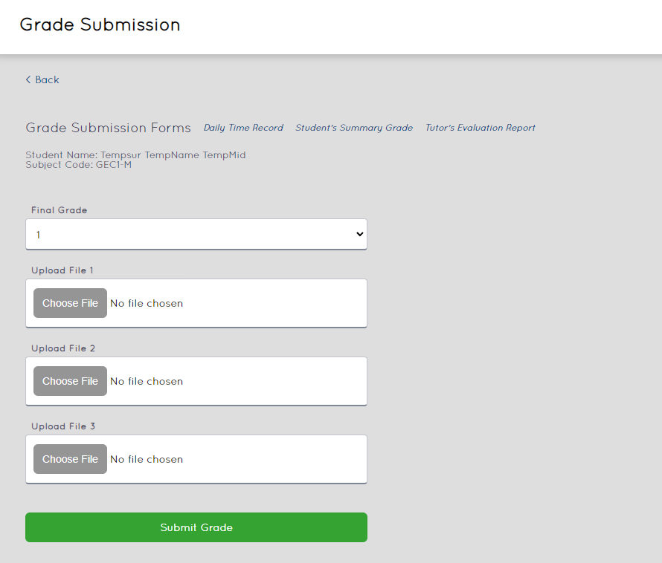

**Figure 4. 22** Submit a Grade of a Student for Instructor

When the requirements or task are met by the student, the instructor can go to the image shown above by navigating to the requirements button and clicking the Submit Grade button of a student enrolled to the instructor. Instructors are required to attach three forms which are available on the same page namely Daily Time Record, Student’s Summary Grade and Tutor’s Evaluation Report. After attaching the filled-out forms, they need to select a grade and click the submit button.

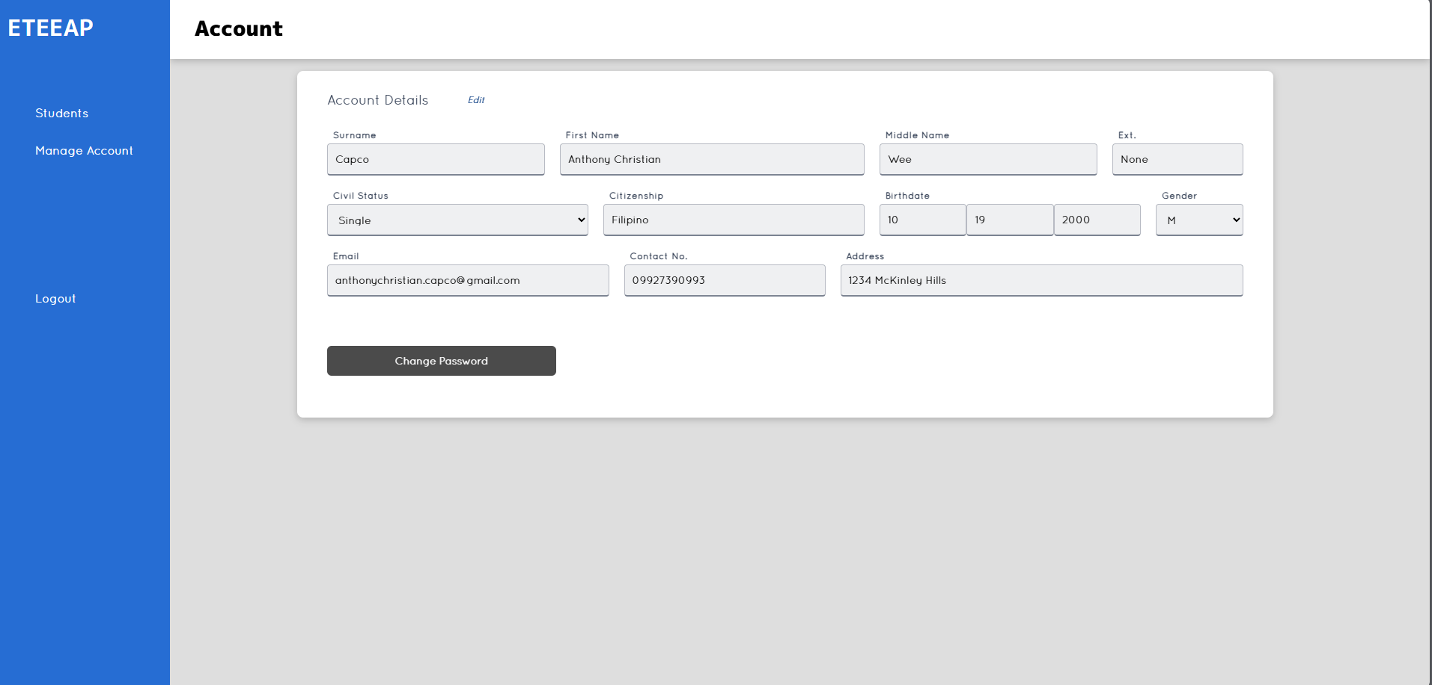

**Figure 4. 23** Manage Account Tab of Instructor

The instructor can manage their account on the system by clicking on the “Manage account” button from the left panel. This will display the image shown above. From this page, the instructor can edit their surname, first name, middle name, civil status, citizenship, birth date, gender, email address, contact number and address. This page also allows the instructor to change their password.

### 

### Students

The following images are the interfaces that are tailored for student users. These will improve their learning experience by providing students with easy access to their progress, including completed requirements and status.

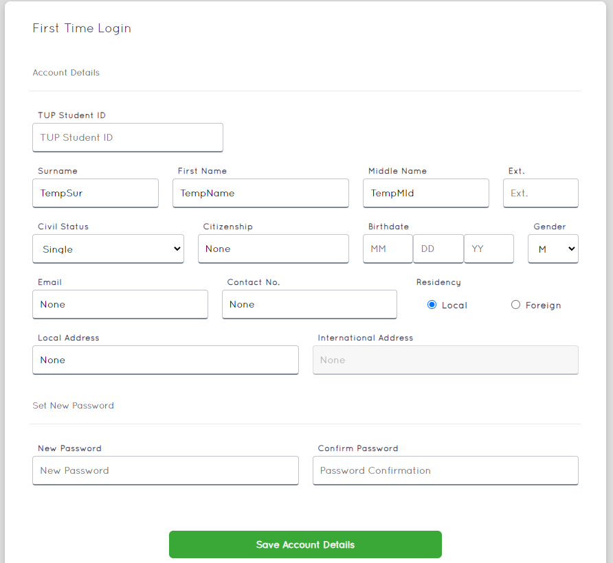

**Figure 4. 24** First Time Login of Students

Upon first-time successful login of a student, they will be redirected to this page to fill out necessary information needed by the ETEEAP department. They will need to provide a new password along with the information they provided to the system.

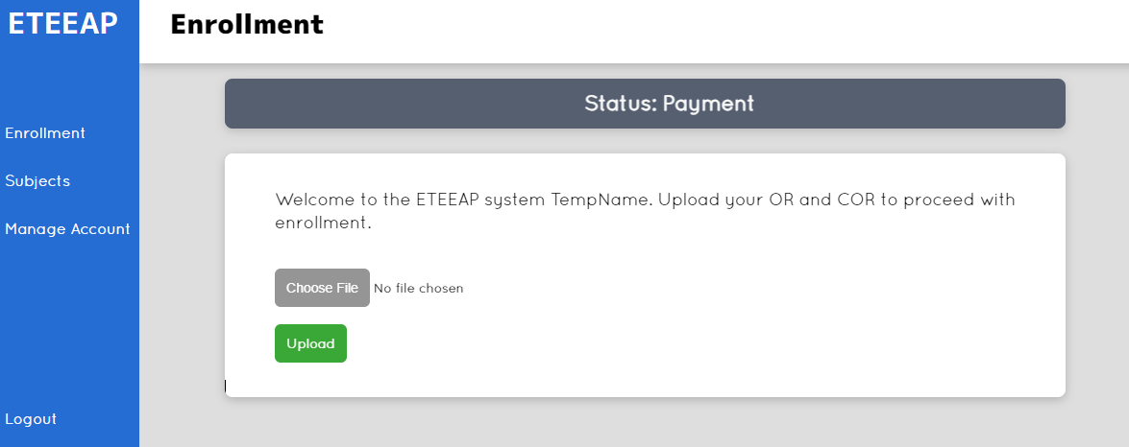

**Figure 4. 25** Status Payment of Students

Students upon login, need to upload their receipt and COR to proceed on this page. Upon attachment of the documents, this be reflected on the side of the ETEEAP director.

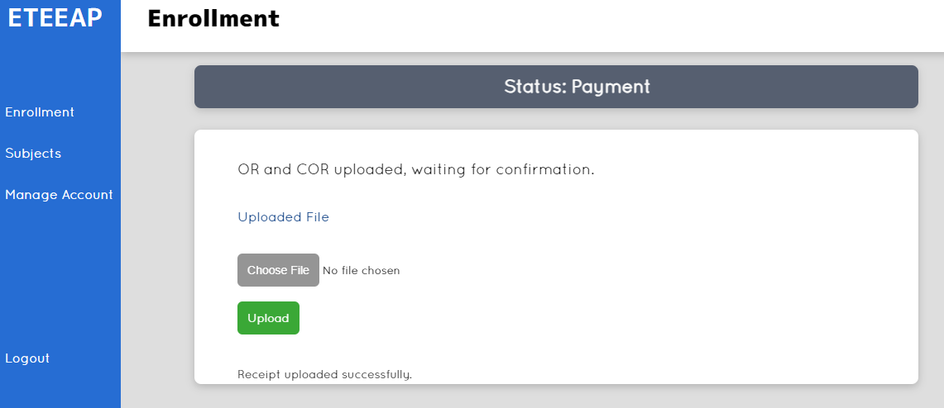

**Figure 4. 26** Status Payment of Students - Upload Successful

After payment and issuance of Official Receipt and Certificate of Registration, students need to upload Official Receipt and Certificate of Registration to the website.

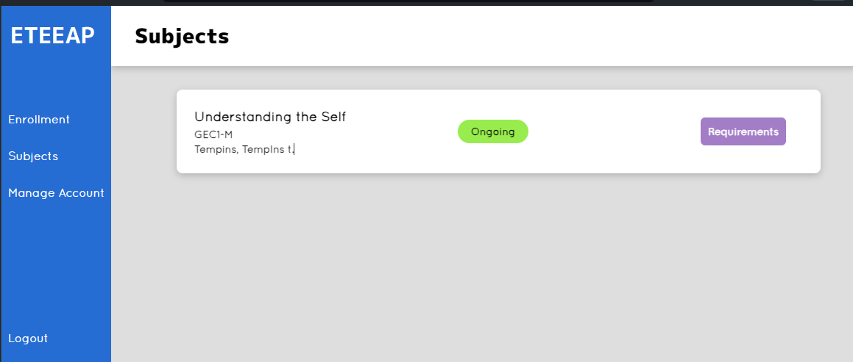

**Figure 4. 27** Subjects of Student Tab

The webpage as shown in the image above displays the student’s enrolled subjects. Students can view the requirements for the specific subject.

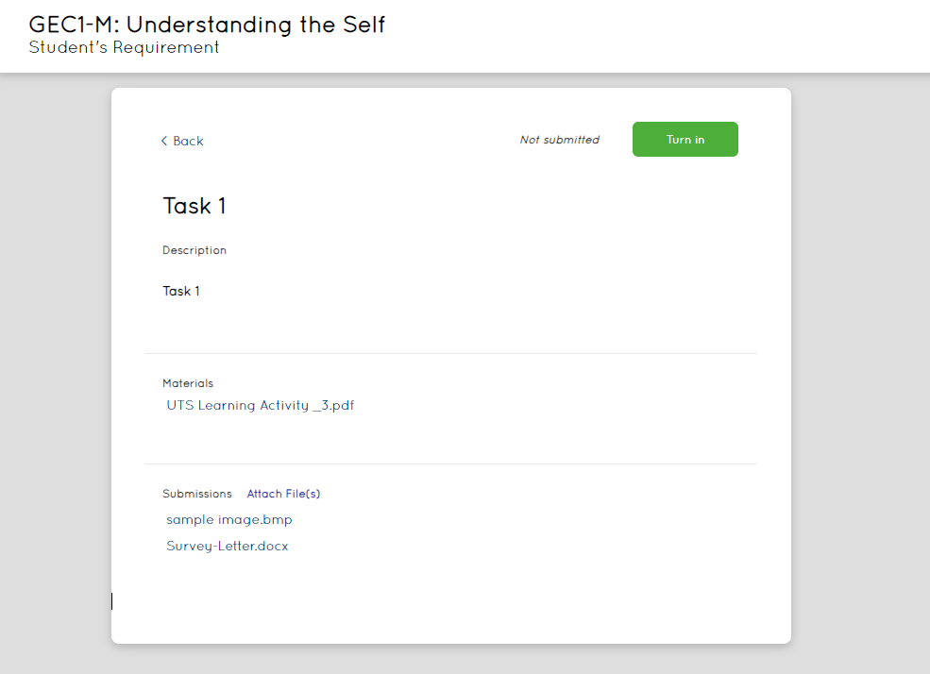

**Figure 4. 28** Subjects of Student Tab - Requirements

Students need to upload or attach requirements for the task posted by the instructors. Students can do the mentioned instructions by navigating to the requirements of a specific subject as shown in the above image. They can click on the Attach File function on the window and attach their requirements.

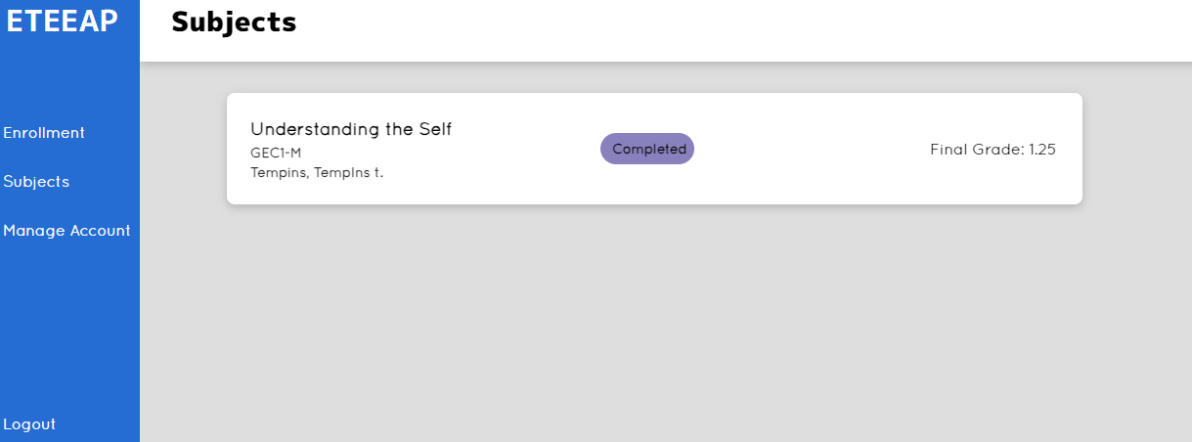

**Figure 4. 29** Subjects of Student Tab - Subject Completed

The image above displays a sample subject that is on a completed status shown for the student. The details of the subject and the grade is shown for the student.

## 

## 

## 

## Project Capabilities and Limitations

The developed website enables the University Director for ETEEAP to create accounts for ETEEAP students and instructors for the Technological University of the Philippines, Manila. The students and instructors in turn will check and update their newly created accounts. Upon successful creation and updating of the student account, the ETEEAP Director will enroll students to instructors on the web page with corresponding subjects and courses. This will notify instructors at their end of students requesting for their teaching services on their account upon login in. Instructors can accept students' requests. Upon accepting the student’s request, instructors can now start their teaching services and post requirements on subjects that the student enrolled. Instructors can then add multiple tasks and upload supporting documents for the students to check. Students can view, upload and edit their requirements on their subject’s page. Upon the end of semester and requirements of the students are satisfied, the instructors should fill up the necessary forms provided on the system, attach the forms with the corresponding grade for the student. This will be reflected to the ETEEAP admin and to the student marking the completion of the subject. In turn, the ETEEAP director can now process the Honorarium for the teaching services conducted by the instructor and release the status thereafter upon satisfying the requirements for the release of honorarium. The ETEEAP Director can monitor all these metrics via the overview tab, which presents the data in graphical form with filter options such as academic year, semester, college, and program for a clearer understanding of the situation. Additionally, the Director can generate reports on students’ age, gender, residency, course status, and faculty course status and honorarium status, with the ability to apply filters to these reports as well.

The process of enrolling ETEEAP students; starting from inquiry of students, submission of preliminary requirements, interview, submission of additional documents, exam, and other succeeding process such as payment of necessary services required is not covered by the system. The system is not designed to accommodate live meetings, online notebook, online class setup, and calendar which are already available to the system utilized by the University.

The developed website needs internet connection to function properly. The website is accessible for devices with web browsers, but the system does not support mobile devices.

## 

## Project Evaluation

The evaluation of the E-AcadEase: ETEEAP Academic Progress Monitoring System was conducted to determine its effectiveness, usability, and overall quality based on the ISO/IEC 25010 standard for software product quality. A total of 30 respondents, consisting of students, instructors, and administrative staff from the Technological University of the Philippines-Manila, as well as experts outside the campus participated in this evaluation. The scale used for the evaluation ranged from 4 (highly acceptable) to 1 (not acceptable).

|  |  |  |  |  |
| --- | --- | --- | --- | --- |
| 1. **Functional Suitability** | **4** | **3** | **2** | **1** |
| 1. Functional Completeness | 15 (50.00%) | 10 (33.33%) | 5 (16.67%) |  |
| 1. Functional Correctness | 18 (60.00%) | 10 (33.33%) | 2 (6.67%) |  |
| 1. Functional Appropriateness | 17 (56.67%) | 13 (43.33%) |  |  |

**Table 4. 1** Functional Suitability Evaluation Result

The table above displays the Functional Suitability Evaluation result of the system, which represents a degree to which the system provides functionalities that satisfy stated and implied requirements when used under specified conditions. This is specifically assessed using the following sub-characteristics: Functional Completeness, Functional Correctness, and Functional Appropriateness.

Functional Completeness refers to the level to which the system functions satisfy all the specified tasks and user objectives. In this sub-characteristic, 50% of the respondents (15 instances) rated the system as 4 (highly acceptable), indicating that the system sufficiently met the needs of the user. Another 33.33% (10 instances) rated it as acceptable (3), suggesting that the system performs well but they find minor gaps, and 16.67% (5 instances) rated it as 2 (slightly acceptable) pointing that not all users’ requirements are fulfilled. No respondents rated it as 1, indicating a generally high level of completeness.

Functional Correctness refers to the accuracy of the results the system provides based on the industry-standard applications and mathematics. In this sub-characteristic, 60% of the respondents rated the system as 4 (highly acceptable), indicating their confidence in the accuracy of the system’s outputs. 33.33% rated it as 3 (acceptable), this strengthened the claim that accurate results are being delivered. A small fraction, 6.67%, rated it as 2 (slightly acceptable), this suggests that occasional inaccuracies are observed.

Functional Appropriateness refers to how suitable the system functions are for their intended purposes. In this sub-characteristic, 56.7% of the respondents rated the system as 4 (highly acceptable) and 43.33% rated it as 3 (acceptable) meaning features are well-suited for their intended purposes.

|  |  |  |  |  |
| --- | --- | --- | --- | --- |
| 1. **Performance Efficiency** | **4** | **3** | **2** | **1** |
| 1. Time-Behavior | 21 (70.00%) | 7 (23.33%) | 2 (6.67%) |  |
| 1. Resource Utilization | 18 (60.00%) | 12 (40.00%) |  |  |
| 1. Capacity | 15 (50.00%) | 12 (40.00%) | 3 (10.00%) |  |

**Table 4. 2** Performance Efficiency Evaluation Result

The table above displays the Performance Efficiency Evaluation of the system, which shows the system’s ability to execute its functions within set time and throughput criteria while also using resources efficiently such as CPU, memory, storage, network devices energy, etc.) under certain conditions. This is specifically assessed using the following sub-characteristics: Time behavior, Resource Utilization, and Capacity.

Time behavior refers to the degree to which the system’s response time and throughput rates satisfy requirements when performing its functions. In this sub-characteristic, 70% of the respondents (21 instances) rated the system as 4 (highly acceptable) and 23.33% (7 instances) rated it as 3 (acceptable) shows that the system performs its tasks efficiently on most conditions with occasional delays or response times that can be improved but 6.67% (2 instances) rated it as 2 (slightly acceptable) that tells the researchers that there are situations where response time is slower than desired.

Resource Utilization refers to the degree to which the quantity and types of resources consumed by the system meet the requirements when performing its functions. In this sub-characteristic, it shows that 60% of the respondents (18 instances) rated the system as 4 (highly acceptable), and 40% (12 instances) rated it as 3 (acceptable), with this knowledge, users agree that the system uses available resources effectively and efficiently.

Capacity refers to the degree to which the maximum limits of the system parameters satisfy the requirements. In this sub-characteristic, 50% (15 instances) of the respondents rated the system as highly acceptable, indicating that the system can manage volumes of data without compromising performance. 40% (12 instances) rated it as acceptable and 10% (3 instances) suggests that the system experiences problems when under extreme conditions.

|  |  |  |  |  |
| --- | --- | --- | --- | --- |
| 1. **Usability** | **4** | **3** | **2** | **1** |
| 1. Learnability | 18 (60.00%) | 12 (40.00%) |  |  |
| 1. Operability | 19 (63.33%) | 9 (30.00%) | 2 (6.67%) |  |

**Table 4. 3** Usability Evaluation Result

The table above displays the Usability Evaluation result of the system, which refers to how well the system can be utilized to achieve the requirements effectively, efficiently, and satisfactorily. It is specifically assessed using the following sub-characteristics: Learnability, and Operability.

Learnability refers to the ease of learning how to use the system. In this sub-characteristic, 69% of the respondents (18% instances) rated the system as 4 (highly acceptable), indicating that the system is user-friendly and 40% (12 instances) rated it as 3 (acceptable), with no ratings below 2 (slightly acceptable) further implies that most users can easily grasp how to use the system.

Operability refers to whether the system has attributes that make it easy to operate. In this sub-characteristic, 63.33% of the respondents (19 instances) rated the system as 4 (highly acceptable), indicating that more than half found it easy to operate and navigate. 30% (9 instances) rated it as 3 (acceptable) and 6.67% (2 instances) rated it as 2 (slightly acceptable) showing that there are difficulty in operating the system for some user and that there is are for improvement.

|  |  |  |  |  |
| --- | --- | --- | --- | --- |
| 1. **Reliability** | **4** | **3** | **2** | **1** |
| 1. Availability | 16 (53.33%) | 9 (30.00%) | 5 (16.67%) |  |
| 1. Fault Tolerance | 12 (40.00%) | 13 (43.33%) | 5 (16.67%) |  |

**Table 4. 4** Reliability Evaluation Result

The table above displays the Reliability Evaluation results of the system, which refers to the degree to which the system performs specific functions under given conditions for a set amount of time. This is specifically assessed using the following sub-characteristics: Availability and Fault Tolerance.

Availability refers to the degree to which the system is operational and accessible when necessary. In this sub characteristic, 53.33% of the respondents (16 instances) rated the system as 4 (highly acceptable), implying that the system is readily available whenever they use it while 30% (9 instances) rated it as 3 (acceptable), and 16.67% (5 instances) rated it as 2 (slightly acceptable). This tells the researchers that almost half of the respondents agree that there is area for improvement on the availability of the system.

Fault Tolerance refers to the degree to which the system works as intended despite the presence of problems. In this sub-characteristic, 40.00% of the respondents (12 instances) rated the system as 4 (highly acceptable) and 43.33% (13 instances) rated it as 3 (acceptable), which shows that most users find that the system handles errors effectively in most cases. However, 16.67% (5 instances) rated it as 2 (slightly acceptable), indicating the need for improvements to ensure smooth operation of the system.

|  |  |  |  |  |
| --- | --- | --- | --- | --- |
| 1. **Maintainability** | **4** | **3** | **2** | **1** |
| 1. Reusability | 18 (60.00%) | 8 (26.67%) | 4 (13.33%) |  |
| 1. Modifiability | 16 (53.33%) | 12 (40.00%) | 2 (6.67%) |  |
| 1. Testability | 18 (60.00%) | 11 (36.67%) | 1 (3.33%) |  |

**Table 4. 5** Maintainability Evaluation Result

The table above displays the Maintainability evaluation results of the system, which refers to the degree of efficiency and effectiveness with which the system may be adjusted to enhance, rectify, or adapt to changes in the environment and needs. This is specifically assessed using the following sub-characteristics: Reusability, Modifiability, and Testability.

Reusability refers to the system’s ability to function well in several systems or in the construction of additional assets. In this sub-characteristic, 60% of the respondents (18 instances) rated the system as 4 (highly acceptable), suggesting that the system shows a high level of reusability. While 26.67% (8 instances) rated it as 3 (acceptable), finding some difficulty in repurposing the system. Additionally, 13.33% (4 instances) of the respondents rated it as 2 (slightly acceptable). They agree that it is a challenge to use the system elements in other applications.

Modifiability refers to the degree to which the system can be changed in a way that it improves upon its original design and prevents new deficiencies from being introduced. In this sub-characteristic, 53.33% of the respondents (16 instances) rated the system as 4 (highly acceptable), describing the system as highly flexible. While 40% (12 instances) rated it as 3 (acceptable), although flexible, they agree that some aspects may encounter problems. However, 6.67% (2 instance) rated it as 2 (slightly acceptable), suggesting significant challenges in adjusting to evolving requirements.

Testability refers to the degree of effectiveness which the system test criteria can be defined and carried out to determine whether those criteria have been satisfied. In this sub-characteristic, 60% of the respondents (18 instances) rated the system as 4 (highly acceptable), describing the system as easy to be tested and verified. 36.67% (11 instances) rated it as 3 (acceptable), strengthening the initial claim. Only 1 user (3.33%) rated it as 2 (slightly acceptable).

# 

# CHAPTER 5

## Summary of Findings, Conclusions, and Recommendations

The summary of findings, conclusions made, and recommendations will be discussed in this chapter.

## Summary of Findings

The system was created to improve the overall effectiveness, transparency, and functionality of learning management and tracking of payment to teaching services rendered by instructors to the ETEEAP department at Technological University of the Philippines-Manila. The web application was created using HTML and CSS for the user interface and Flask was used for the framework. A total of 30 respondents were selected to test and evaluate the system. These respondents consisted of students, faculty, and administrative staff from the Technological University of the Philippines-Manila, and experts from outside the campus. The research instrument used was a questionnaire that adheres to the ISO/IEC 25010:2011 standard for software quality evaluation.

The findings in the evaluation provided valuable insights into the strengths and areas for improvement of the web application. The key results from the analysis of the questionnaire responses are summarized below:

1. **Functional Suitability**

The evaluation of the Functional Suitability of the E-AcadEase system indicates strong performance across all specified sub-characteristics, particularly in terms of functional correctness and appropriateness. However, there is still room for improvement to enhance its functional completeness and address minor gaps in functionality.

1. **Performance Efficiency**

The evaluation of Performance Efficiency of the E-AcadEase system shows that it has strong performance efficiency. With most evaluations being highly acceptable, the system demonstrates a solid performance in Time-Behavior, Resource Utilization, and Capacity.

1. **Usability**

Usability evaluation results also show a great performance, with many ratings falling into the highly acceptable or acceptable category. Both learnability and operability are highly rated, reflecting the product's ability to be quickly learnt and efficiently operated.

1. **Reliability**

In summary, the reliability evaluation of the E-AcadEase system shows moderate to high levels of reliability. While both availability and fault tolerance received high ratings, both can be improved to solve specific problems encountered by users.

1. **Maintainability**

Overall, the Maintainability evaluation of the E-AcadEase system reflects a high level of maintainability, with most evaluation ratings being highly acceptable or acceptable. While the system demonstrates strength in all maintainability aspects, there are areas where enhancements can be made to further improve the system.

## Conclusions

The following conclusions were derived from the careful assessment and inspection of the implemented system, based on the evaluation and findings attained during the process.

1. The web-based system have been built to include the following features:
   1. The system works as an academic progress tracking system for ETEEAP students, University instructors and for the ETEEAP department who partakes in the ETEEAP program. The system captures operational data, and the features of the system are well liked based on positive user experience expressed by the ETEEAP department in contrast to the existing manual system which is a combination of multiple systems and recorded manually to excel sheet.
   2. The system allows the ETEEAP department to customize and generate specific reports according to their unique needs. This functionality significantly reduces the effort and time required compared to the current system used by the department, where generating such reports is a tedious and time-consuming process.
2. The system was tested and received high marks in terms of Functional suitability.
3. Evaluation results yielded high ratings from the respondents that indicates acceptability of the developed system. They also agree that there is room for improvement.

## Recommendations

Based on the findings and conclusion of the study, recommendations are proposed to enhance the system’s effectiveness, usability, and overall quality. Applying these recommendations will not only improve the system but also to cater different scenarios and users in the future.

1. When entering a new course, the administrator should be able to view previously used course codes as they type them in.
2. The system should support mobile device users or android and apple applications.
3. Create a user guide for new users.
4. Change the user interface to make it more soothing to the eyes of the user.
5. Support for dark mode.
6. Consistent table size and spaces.
7. Edit/Remove list of Course and Subjects.
8. Messaging feature for communication in the system.
9. Out-of-band authentication support using sms, email and other platforms for sending credentials of newly created accounts.
10. Upload/Attach profile picture for users of the system.
11. Require complex passwords like special characters, non-easy and repeating passwords and avoid old password use.

# 

# References

*Academics* - *Expanded Tertiary Education Equivalency And Accreditation Program.* (n.d.). Technological University of the Philippines. Retrieved January 16, 2024, from https://tup.edu.ph/pages/academics/expanded-tertiary-education-equivalency-and-accred

AL-Msloum, A. (2021). Increase in the use of Electronic Applications – An impact analysis of COVID – 19 Pandemic. Bioscience Biotechnology Research Communications, 14(3), 1008-1014. doi.org/10.21786/bbrc/14.3.16

Anderson, J., & Chen, Q. (2016). Blended Learning Models: Enhancing Academic Progress in Higher Education. Journal of Online Learning, 24(3), 145-162.

Brown, A. (2016). Data Privacy in Educational Technology: Concerns and Best Practices. Journal of Educational Data Mining, 28(1), 56-72.

Brown, A., & Johnson, L. (2019). Effectiveness of Academic Progress Monitoring Systems. Journal of Higher Education Technology, 25(3), 123-145.

Carter, R., & Thomas, L. (2017). Efficacy of Learning Management Systems in Higher Education. Educational Technology Research and Development, 35(4), 231-248.

Chen, L., Wang, Y., & Johnson, M. (2017). Enhancing Educational Processes through Web-Based Monitoring Systems. Journal of Educational Technology, 42(3), 215-230.

Davis, M., & Wang, Y. (2019). Personalized Learning Platforms: Tailoring Academic Progress Monitoring Systems to Individual Needs. Journal of Educational Technology, 42(1), 78-94.

Finkel, R. (2019). Figma in UI/UX Design: A Comprehensive Guide. Design Journal, 15(2), 123-140.

Garcia, M., & Reyes, J. (2021). Implementation of ETEEAP Programs: Challenges and Opportunities. Journal of Lifelong Learning, 15(2), 67-82.

Garcia, A., et al. (2017). Development and Implementation of an Online Monitoring System in Tertiary Institutions: A Case Study. International Journal of Information Systems, 30(4), 567-582.

Grinberg, M. (2018). Flask Framework: Building Web Applications with Python. O'Reilly Media.

Hasnan, S., Abdul Aziz, R., & Abdul Hamid, A. (2014). Postgraduate Tracking System: Student Research Progress Tracking Tool. International Research in Education, 3(1), 47-53. doi:10.5296/ire.v3i1.6539

Jenkins, J. (2001). [Title of the Article]. Journal Name, Volume(Issue), Page Range. doi:xxxxxxx

Johnson, S., & Smith, P. (2015). Technology in Education: Current Trends and Future Directions. International Journal of Educational Technology, 30(2), 87-102.

Johnson, S., Lee, M., & Wang, L. (2018). User Satisfaction in E-Learning Platforms: A Comprehensive Review. Computers & Education, 82(1), 345-362.

Jones, R., & Brown, S. (2020). Impact of the COVID-19 Pandemic on Educational Processes: An Analysis of Accelerated Online Adoption. Educational Technology Review, 38(1), 78-92.

Kim, S., & Patel, K. (2018). Gamification in Education: Enhancing Student Engagement through Academic Progress Monitoring Systems. Educational Technology & Society, 21(2), 273-287.

Kim, J. (2019). Integration of Flask Framework in Educational Platforms. Proceedings of the International Conference on Software Engineering (ICSE), 245-258.

Lee, M., & Wang, L. (2021). Inclusive Design in Educational Technology. Journal of Inclusive Education, 18(1), 45-60.

Li, X. (2018). Artificial Intelligence in Educational Systems: Opportunities and Challenges. Journal of Educational Technology Research, 41(1), 55-68.

Mishler, C. J. (1983). ADULTS' PERCEPTIONS OF THE BENEFITS OF A COLLEGE DEGREE. Research in Higher Education, 19(2), 233-230. doi.org/10.1007/BF00974760

Mujataba, F., Sullivan, E., & Lee, K.J. (2000). A Method for Detecting Errors in Discounted Fee-For-Service Payments by Insurance Companies. Ear, nose & throat journal, 79(3), 148-152. doi.org/10.1177/014556130007900307

Nielsen, J. (2016). Principles of Effective User Interface Design. Interaction Design Foundation.

Patel, A., et al. (2018). Impact of Virtual Reality in Education: Creating Immersive Learning Environments. Journal of Interactive Learning Research, 28(4), 435-452.

Reyes, J., & Smith, P. (2020). Implementation of ETEEAP Programs: Challenges and Opportunities. Journal of Lifelong Learning, 15(2), 67-82.

Rodriguez, J., & Gupta, S. (2017). Mobile Learning Technologies: Real-Time Monitoring and Feedback for Academic Progress. International Journal of Mobile and Blended Learning, 9(2), 45-61.

Robinson, P. (2017). Assessment of Learning Management Systems: A Comparative Analysis. Educational Technology Journal, 36(2), 189-204.

Romanick, M., Ng, K., Herbert, M., & Coller, B. S. (2014). The Rockefeller University Graduate Tracking Survey System. Clinical and Translational Science, 8(4), 326-329. https://doi.org/10.1111/cts.12238

Siemens, G. (2013). Learning Analytics: The Emergence of a Discipline. American Behavioral Scientist, 57(10), 1380-1400.

Smith, P. (2022). Challenges in Academic Progress Monitoring Systems. Educational Technology Journal, 42(4), 321-335.

Smith, P., & Turner, B. (2016). Faculty Perceptions of Technology Integration: Implications for Academic Progress Monitoring. Journal of Educational Technology & Society, 19(3), 125-139.

Somerville, I. (2019). Benefits of Rapid Application Development (RAD) in Software Development Projects. Journal of Software Engineering, 28(4), 321-336.

Suhre, C. J.M., Jasen, E. P.W.A., & Harskamp, E. G. (2006). Impact of degree program satisfaction on the persistence of college students. Higher Education, 54, 207-226. doi.org/10.1007/S10734-005-2376-5

Sweidan, S. Z., Abu Laban, S. S., Alnaimat, N. A., & Darabkh, K. A. (2021). SEG-COVID: A Student Electronic Guide within Covid-19 Pandemic. 2021 9th International Conference on Information and Education Technology, 9, 139-144. doi.org/10.1109/ICIET51873.2021.9419656

Tan, A., & Gao, B. (2010). Advantages and Opportunities of Online Enrollment Systems in Educational Institutions. Journal of Educational Administration, 33(2), 167-182.

Tan, A., & Gao, B. (2019). Effectiveness of Academic Progress Monitoring Systems. Journal of Educational Technology Research, 27(2), 89-104.

Technological University of the Philippines. (n.d.). Academics - Expanded Tertiary Education Equivalency And Accreditation Program. Retrieved January 16, 2024, from https://tup.edu.ph/pages/academics/expanded-tertiary-education-equivalency-and-accred

Turner, B., & White, H. (2020). Educational Data Mining: Informing Decision-Making in Academic Progress Monitoring Systems. Journal of Educational Data Mining, 32(3), 189-205.

Wang, H., et al. (2020). Impact of Web-Based Systems on Administrative Processes in Educational Institutions. International Journal of Information Management, 25(1), 98-113.

Wang, L., Lee, M., & Johnson, S. (2017). Learning Analytics: The Emergence of a Discipline. American Behavioral Scientist, 57(10), 1380-1400.

Wheelahan, L., & Moodie, G. (2020). A degree is a degree? The impact of elite universities on colleges offering degrees. International Journal of Training Research, 101-105. doi.org/10.1080/14480220.2020.1830837

Zhang, L., & Chang, M. (2019). Social Learning Platforms: Fostering Community and Knowledge Sharing in Academic Progress Monitoring Systems. International Journal of Computer-Supported Collaborative Learning, 14(4), 427-446.

Zhang, R. (2020). Research on Student-Centered Financial Aid to College Students with Financial Difficulties. Advances in Economics, Business and Management Research, 153, 349-352. doi.org/10.2991/aebmr.k.201111.059

Yang, C., & Chen, W. (2021). Online Assessment Strategies: Enhancing Academic Progress Monitoring in Higher Education. Computers & Education, 103(1), 102-118.