Report
UDENT INFORMATION:
Name: Nguyen Chi Bao
Student ID: ITCSIU24008
Class: [Your Class]
COMPLETED EXERCISES:
[x] Exercise 1: Database & User Model
[x] Exercise 2: User Model & DAO
[x] Exercise 3: Login/Logout Controllers
[x] Exercise 4: Views & Dashboard
[x] Exercise 5: Authentication Filter
[x] Exercise 6: Admin Authorization Filter
[x] Exercise 7: Role-Based UI
[x] Exercise 8: Change Password AUTHENTICATION COMPONENTS:
- Models: User.java
- DAOs: UserDAO.java
- Controllers: LoginController.java, LogoutController.java, DashboardController.java
- Filters: AuthFilter.java, AdminFilter.java
- Views: login.jsp, dashboard.jsp, updated student
-list.jsp TEST CREDENTIALS: Admin:
- Username: admin - Password: password123 Regular User: - Username: john - Password: password123 FEATURES IMPLEMENTED:
- User authentication with BCrypt
- Session management - Login/Logout functionality - Dashboard with statistics
- Authentication filter for protected pages
- Admin authorization filter
- Role-based UI elements - Password security
Q5
- The AuthFilter intercepts all requests to the application (/*).
- It defines a list of public URLs (login, logout, static files) that bypass authentication.
- For other requests, it checks the session to see if a user attribute exists.
- If the user is logged in, the request continues; if not, the filter redirects to /login.
- This ensures only authenticated users can access protected pages, while public resources remain open.

Q6
- This code defines a Servlet Filter (AdminFilter) that intercepts requests to /student.
- It checks the action parameter; if the action is one of "new", "insert", "edit", "update", or "delete", admin rights are required.
- The filter retrieves the current session and the User object stored in it.
- If the user exists and user.isAdmin() returns true, the request continues; otherwise, the user is redirected to either the login page or an error message.
- Non-admin actions bypass the filter and are allowed through without restriction.
Q7
Update student view
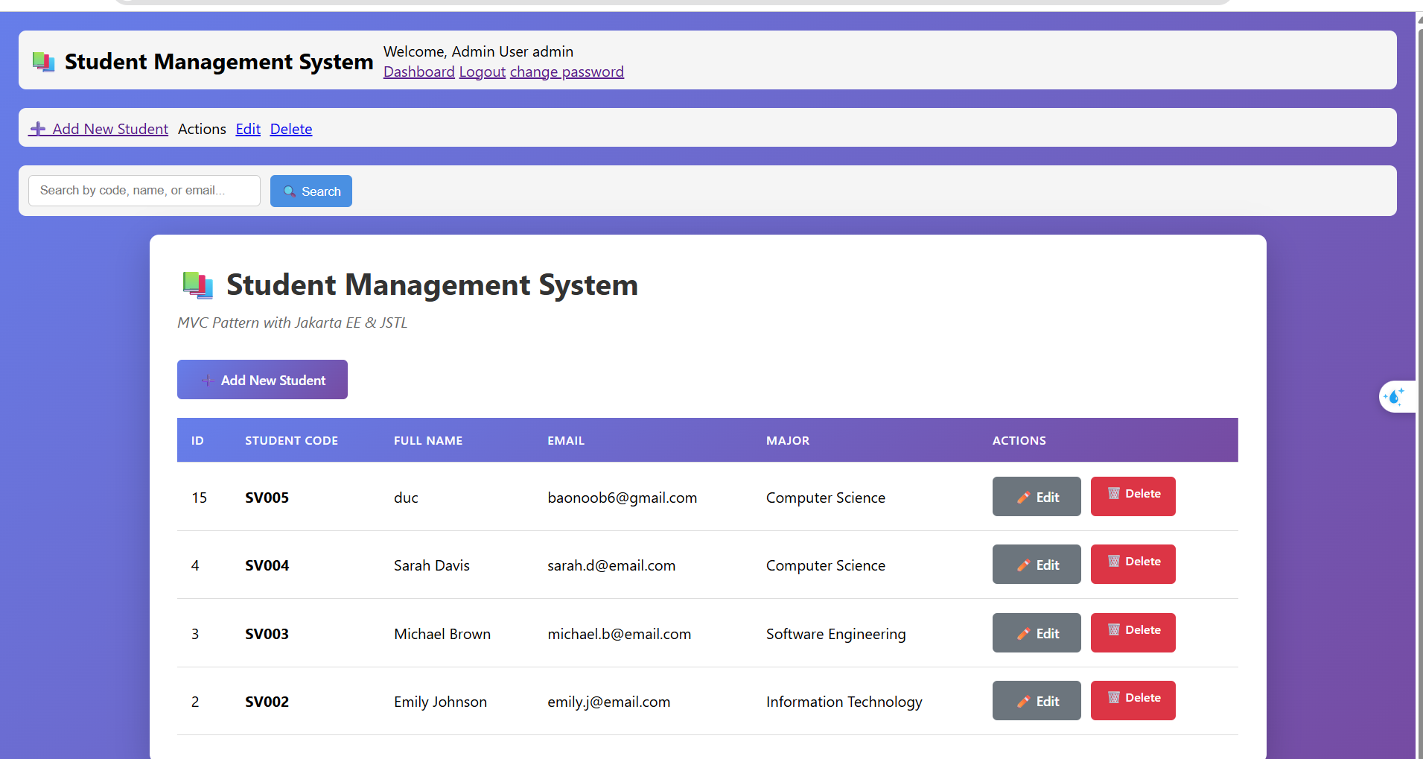
Q8
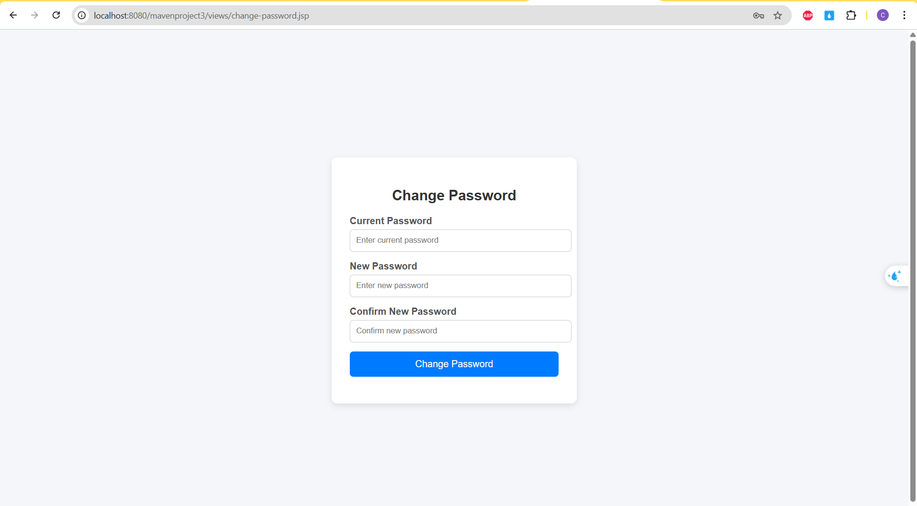
Change password
- This servlet (ChangePasswordController) handles requests to /change-password.
- In doGet, it simply forwards the user to the JSP form for changing their password.
- In doPost, it checks if a user is logged in via session; if not, redirects to login.
- It validates the current password with BCrypt, ensures the new password is long enough, and matches the confirmation.
- If valid, it updates the password in the database, refreshes the session user, and shows a success or error message on the JSP.

