-VIETNAM NATIONAL UNIVERSITY OF HO CHI MINH CITY
INTERNATIONAL UNIVERSITY
SCHOOL OF COMPUTER SCIENCE AND ENGINEERING

Assignment 1 Report
Coffee Shop Web
Course: Web Application Development- IT079IU
ADVISOR:
Assoc. Prof. Nguyễn Thị Thúy Loan
Table of content
Site map………………………………………….……2
Features………………………………………………8
Credit…………………………………………………9

1
Soul of Coffee Map
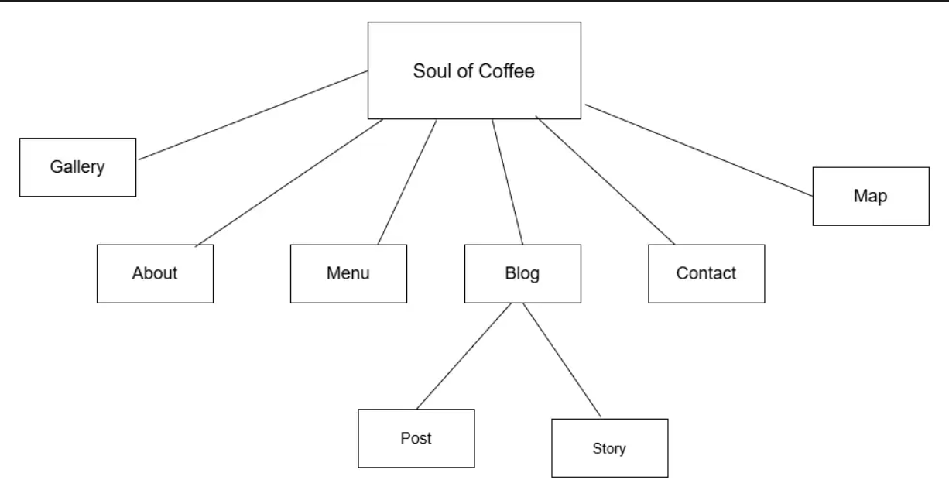
Picture of Soul of Coffee Map
Home
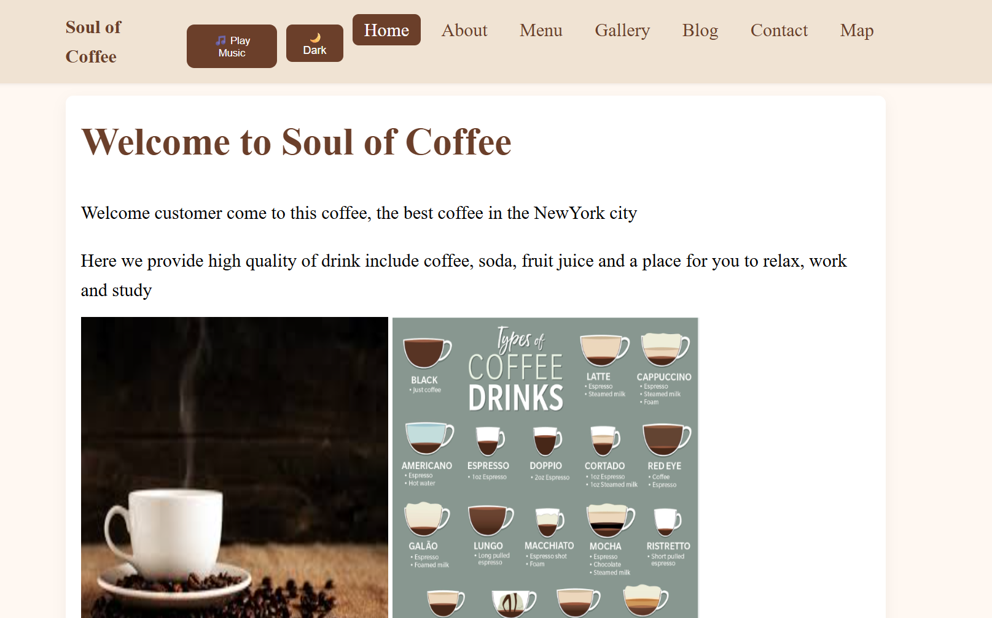
2
About
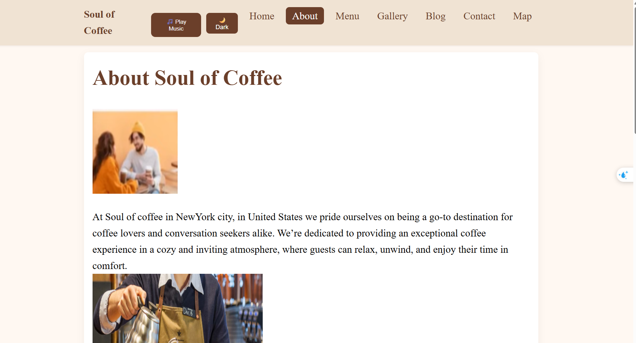
Menu
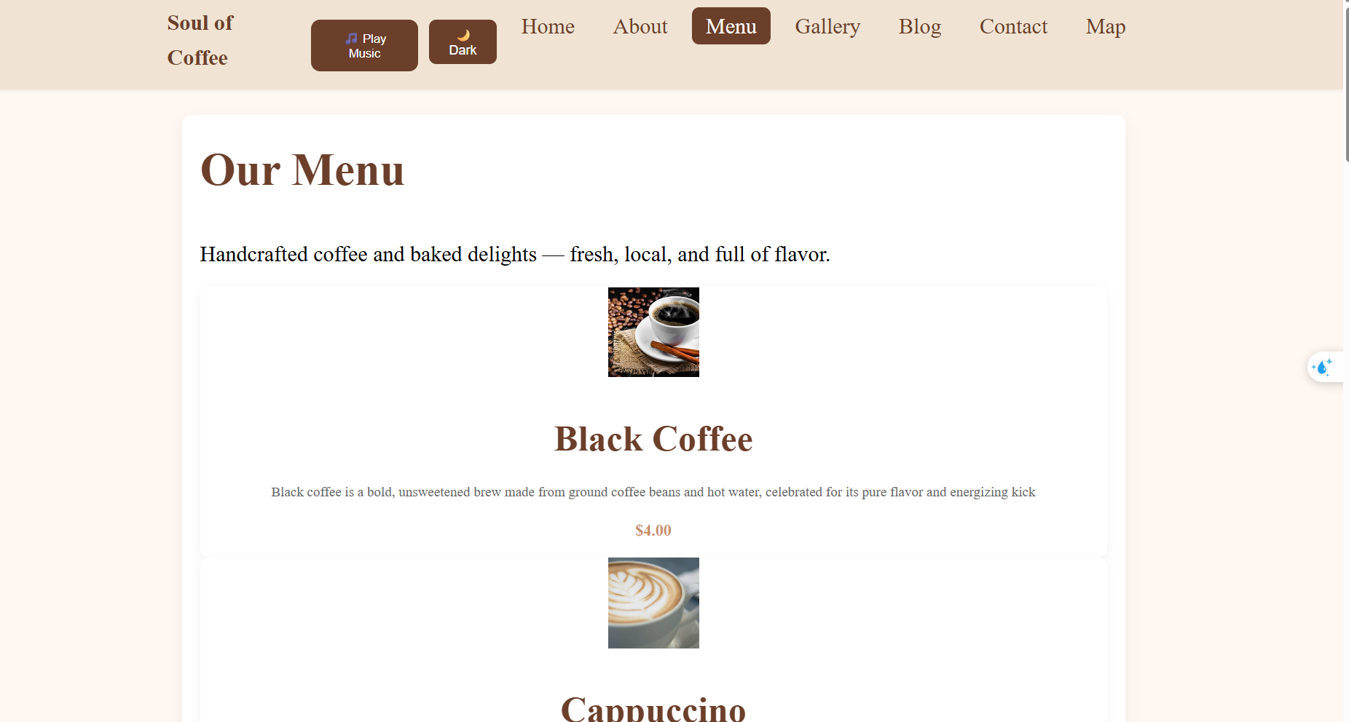

3
Gallery
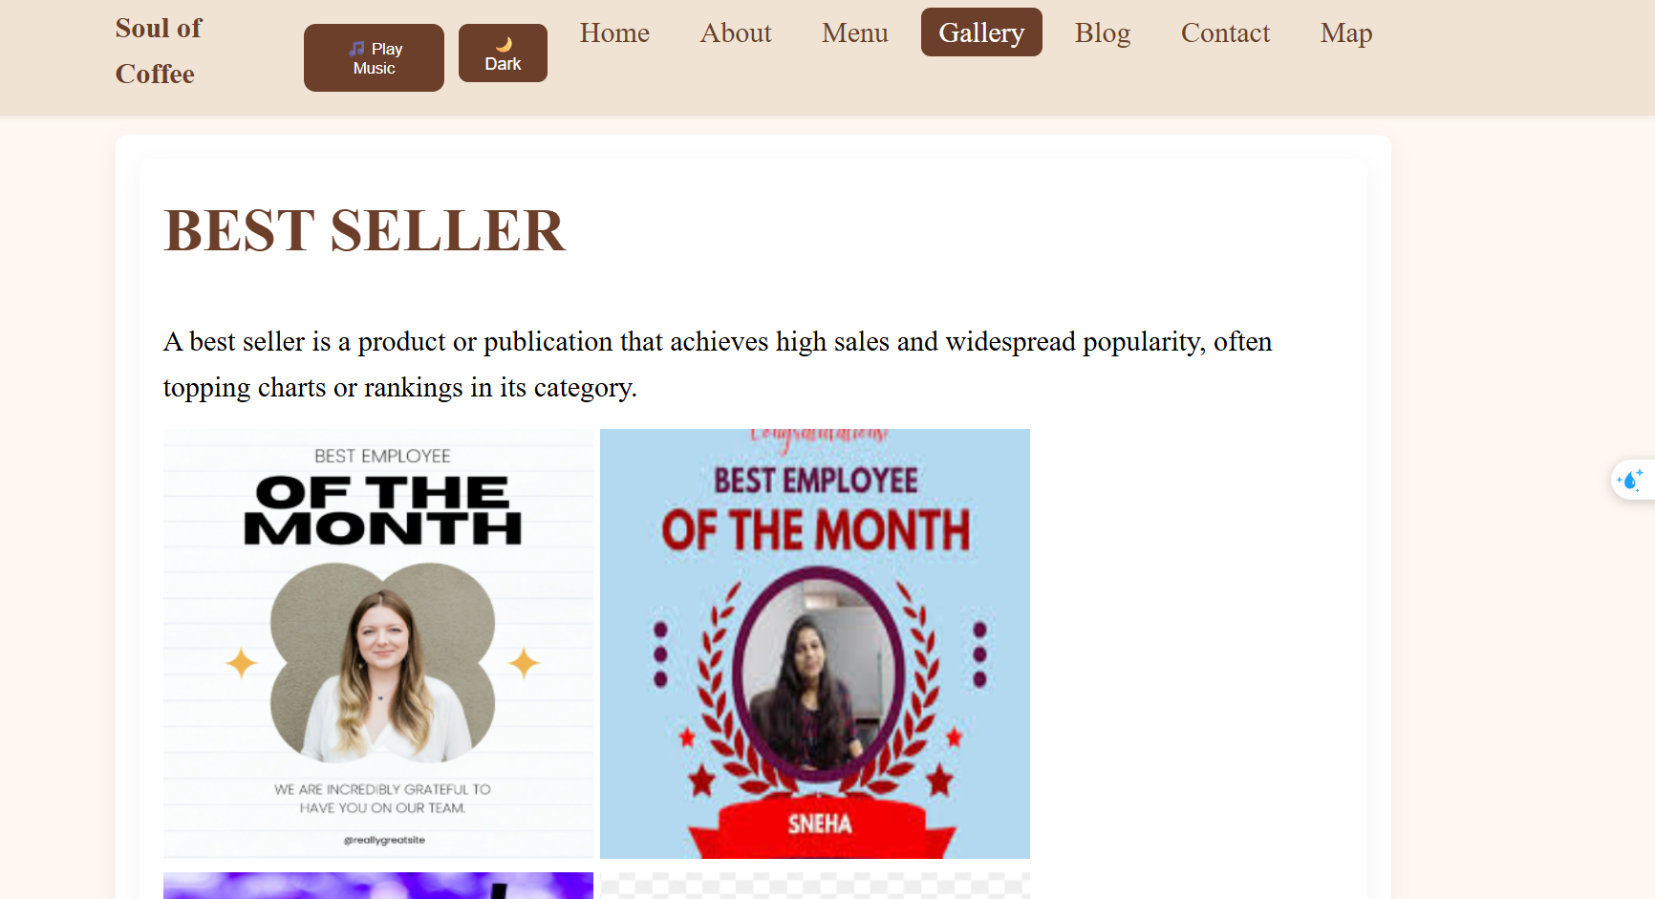
Blog
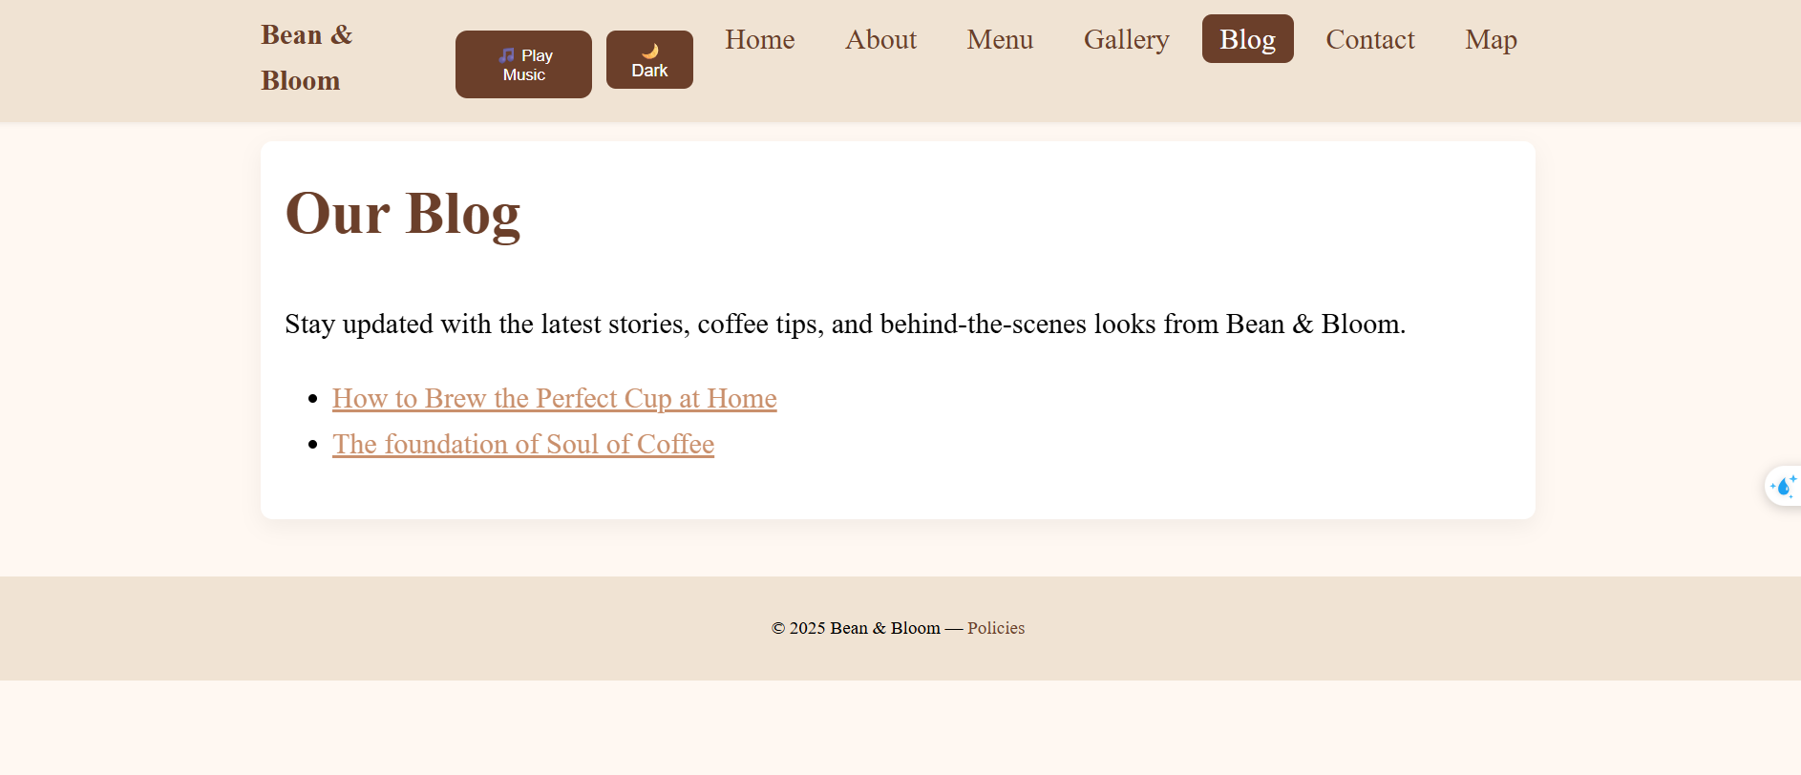
Post

4
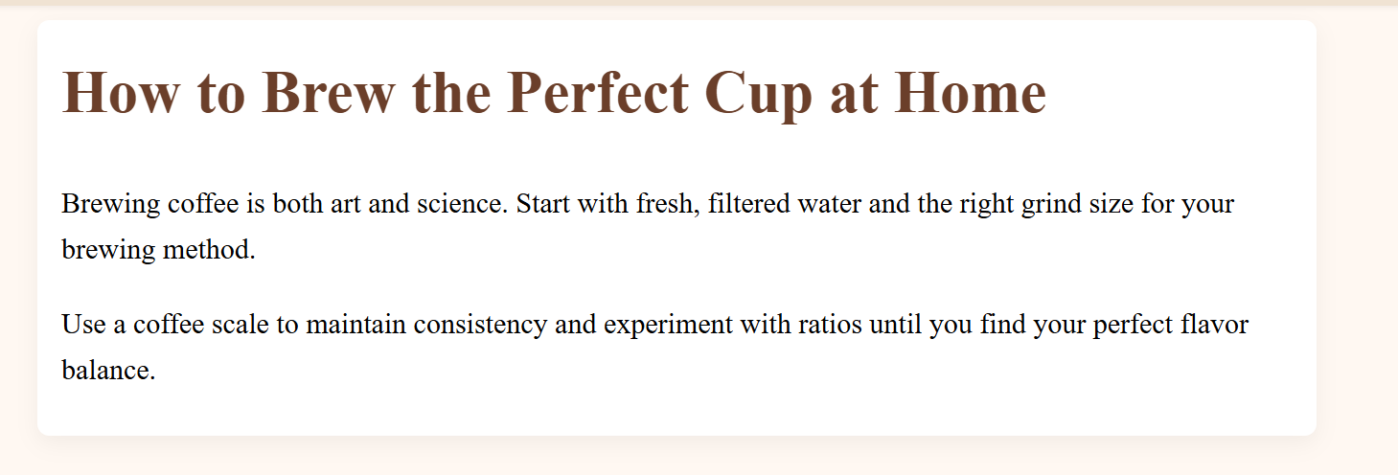
Story
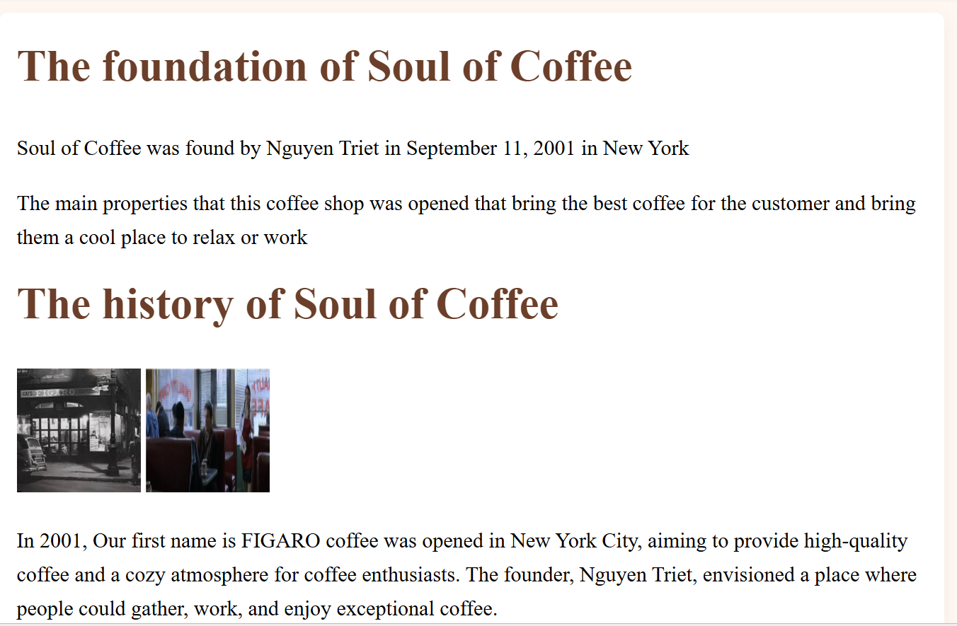

5
Feedback
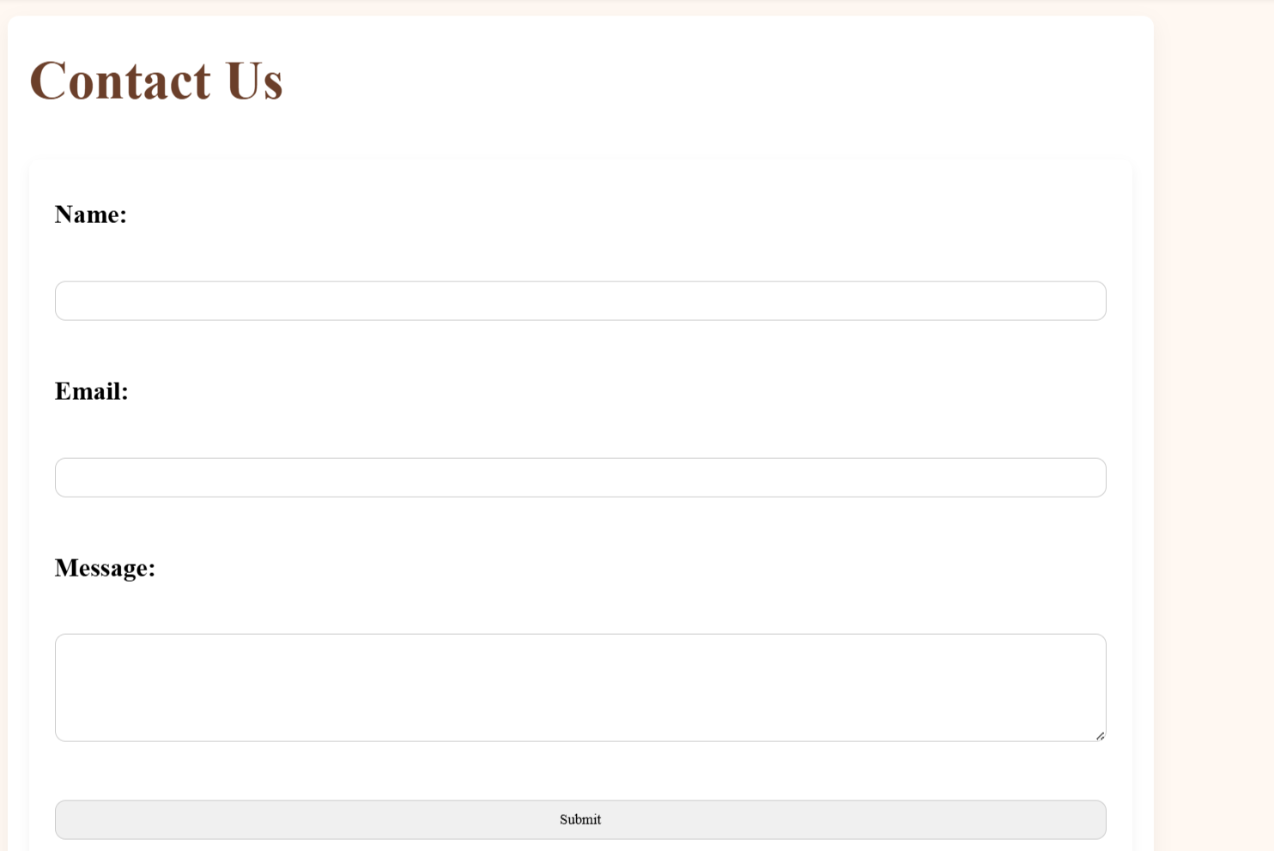

6
Map
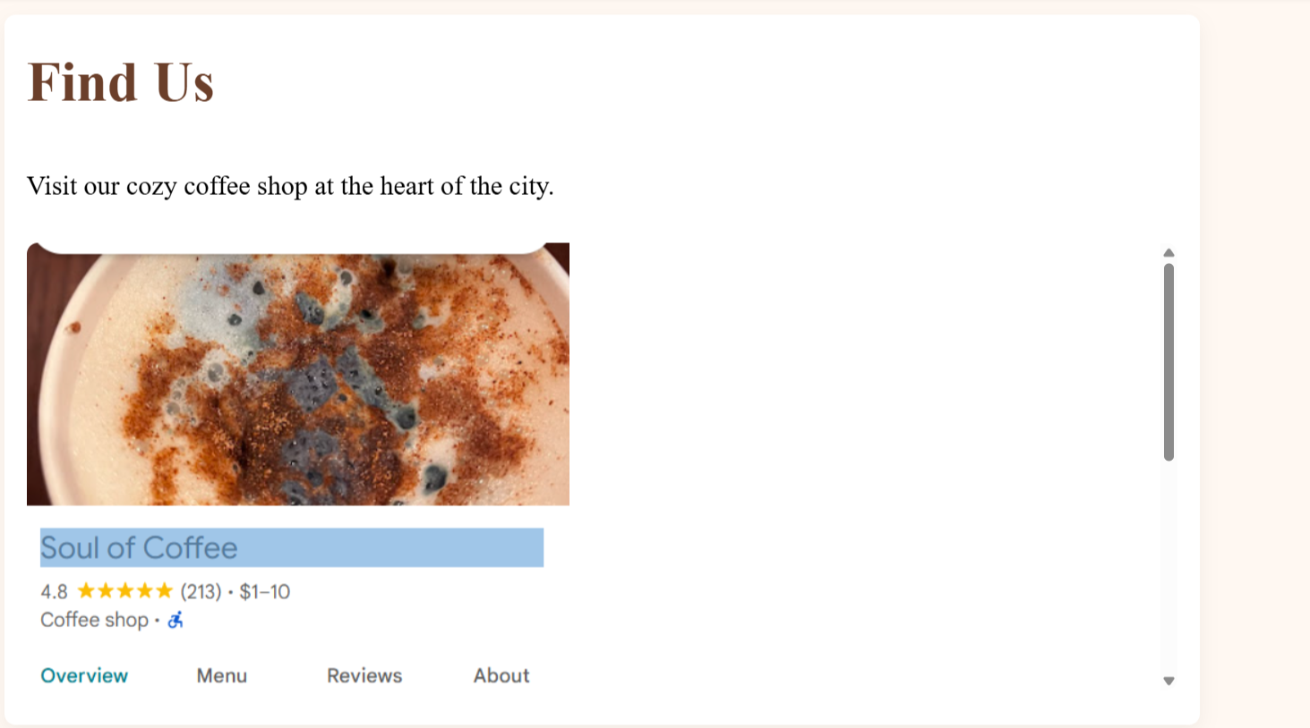

7
How to use
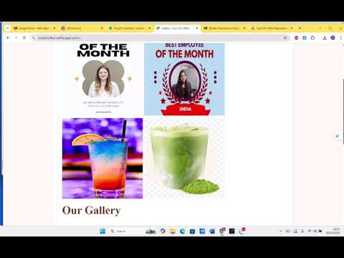
How to use soul of coffee video( please turn on max volume)
Note: This video recorded when web still demo more stuff added to it

8
Credits:
Song: Dark Soul 3 Theme
https://www.youtube.com/watch?v=ch6I15iBliE
Picture: Drink
https://weaverscoffee.com/blogs/blog/the-benefits-of-drinking-black-coffee?srsltid=AfmBOorXM8bdGzoS_81L8GUJlkB1Qu7JVOEPrk5pHfJb7_TOVoUCoq66
https://esquirescoffee.co.uk/news/history-cappuccino/
https://www.istockphoto.com/vi/anh/soda-chanh-xanh-tr%C3%AAn-b%C3%A0n-g%E1%BB%97-v%E1%BB%9Bi-n%E1%BB%81n-b%E1%BA%A7u-tr%E1%BB%9Di-xanh-gm621268202-108467837
Food
https://mcdelivery.vn/vn/browse/menu.html?daypartId=1&catId=1 9
Other image
https://unsplash.com/fr/s/photos/coffee-shop
Soul Origin
https://www.youtube.com/watch?v=PbbyOaYDYDA
Google Map
https://maps.app.goo.gl/KtgSXCu9azRuqCfV9

10

