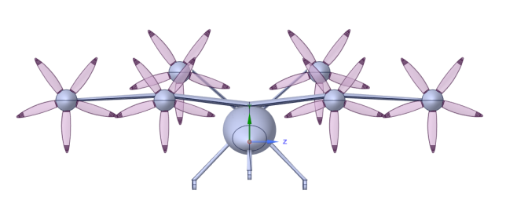 | 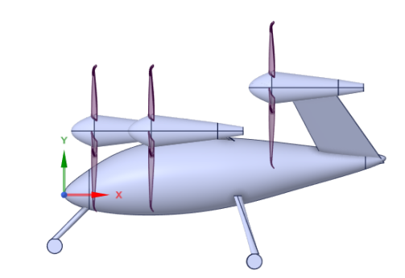
(a) 正视图 | (b) 侧视图
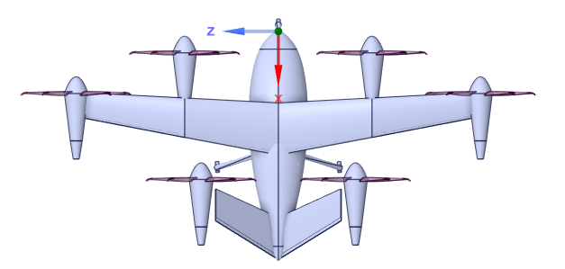 | 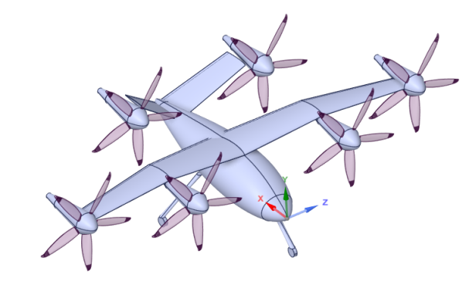
(c) 俯视图 | (d) 斜视图
图2-1巡航状态三视图

尺寸参数与惯量参数如表2-1所示：

表2-1 eVTOL尺寸与惯量参数
参数 | 值 | 参数 | 值
最大起飞质量/kg | 2255.52 | $$I_{xx}/(kg·m^{2})$$ | 10807.40
载荷/kg | 450 | $$I_{yy}/(kg·m^{2})$$ | 4563.43
机翼参考面积/m² | 12.2 | $$I_{zz}/(kg·m^{2})$$ | 13399.68
机翼展长/m | 11.6 | $$I_{xy}/(kg·m^{2})$$ | 0
平均气动弦长/m | 1.102 | $$I_{xz}/(kg·m^{2})$$ | 95.23
全机长度/m | 6.4 | $$I_{yz}/(kg·m^{2})$$ | 0

表2-2 起飞阶段螺旋桨气动数据
桨距角(deg) | V | N(RPM) | J | $$C_{T}$$ | $$C_{P}$$ | $$eff$$ | T(N)
13 | 2.5 | 150 | 0.3333 | 0.0941 | 0.0544 | 0.0876 | 58.4
 | 2.5 | 200 | 0.2500 | 0.1462 | 0.0744 | 0.1449 | 161
 | 2.5 | 250 | 0.2000 | 0.3033 | 0.1457 | 0.3095 | 522
 | 2.5 | 300 | 0.1667 | 0.3718 | 0.1742 | 0.3840 | 922
 | 2.5 | 350 | 0.1429 | 0.3926 | 0.1797 | 0.4103 | 1325
 | 2.5 | 400 | 0.1250 | 0.4037 | 0.1815 | 0.4257 | 1780
 | 2.5 | 450 | 0.1111 | 0.4110 | 0.1832 | 0.4353 | 2293
 | 2.5 | 500 | 0.1000 | 0.4150 | 0.1829 | 0.4420 | 2860
 | 2.5 | 550 | 0.0909 | 0.4160 | 0.1825 | 0.4442 | 3468
 | 2.5 | 600 | 0.0833 | 0.4139 | 0.1782 | 0.4461 | 4107
 | 2.5 | 650 | 0.0769 | 0.4189 | 0.1812 | 0.4503 | 4877
 | 2.5 | 700 | 0.0714 | 0.4153 | 0.1772 | 0.4496 | 5600
 | 2.5 | 750 | 0.0667 | 0.4139 | 0.1765 | 0.4483 | 6417
 | 2.5 | 800 | 0.0625 | 0.4099 | 0.1756 | 0.4428 | 7230
 | 2.5 | 850 | 0.0588 | 0.4122 | 0.1745 | 0.4479 | 8208
 | 2.5 | 900 | 0.0556 | 0.4049 | 0.1722 | 0.4389 | 9040
 | 2.5 | 950 | 0.0526 | 0.3994 | 0.1679 | 0.4355 | 9933
 | 2.5 | 1000 | 0.0500 | 0.3945 | 0.1669 | 0.4288 | 10870

表2-3 巡航阶段螺旋桨气动数据
桨距角(deg) | V | N(RPM) | J | $$C_{T}$$ | $$C_{P}$$ | $$eff$$ | T(N)
72.43773 | 65 | 150 | 8.6667 | 0.021 | 0.782 | 0.230 | 12.2
 | 65 | 200 | 6.5000 | 0.228 | 1.900 | 0.775 | 240.7
 | 65 | 250 | 5.2000 | 0.344 | 2.260 | 0.787 | 567.4
 | 65 | 300 | 4.3333 | 0.421 | 2.358 | 0.775 | 1000.0
 | 65 | 350 | 3.7143 | 0.475 | 2.350 | 0.750 | 1535.7
 | 65 | 400 | 3.2500 | 0.518 | 2.310 | 0.725 | 2185.3
 | 65 | 450 | 2.8889 | 0.555 | 2.275 | 0.700 | 2966.2
 | 65 | 500 | 2.6000 | 0.588 | 2.250 | 0.680 | 3879.7
 | 65 | 550 | 2.3636 | 0.614 | 2.200 | 0.660 | 4902.0
 | 65 | 600 | 2.1667 | 0.638 | 2.140 | 0.640 | 6061.8
 | 65 | 650 | 2.0000 | 0.656 | 2.100 | 0.620 | 7314.9
 | 65 | 700 | 1.8571 | 0.670 | 2.075 | 0.600 | 8664.7
 | 65 | 750 | 1.7333 | 0.680 | 2.040 | 0.580 | 10095.1
 | 65 | 800 | 1.6250 | 0.700 | 2.000 | 0.560 | 11823.8
 | 65 | 850 | 1.5294 | 0.708 | 1.970 | 0.550 | 13500.6
 | 65 | 900 | 1.4444 | 0.720 | 1.950 | 0.540 | 15392.1
 | 65 | 950 | 1.3684 | 0.738 | 1.940 | 0.520 | 17578.6
 | 65 | 1000 | 1.3000 | 0.748 | 1.930 | 0.500 | 19741.6

表2-4纵向气动数据
$$\text{α}\text{ (°)}$$ | $$C_{L}$$ | $$C_{D}$$ | $$C_{m}$$ | $$C_{L}/C_{D}$$
-10 | -0.35658 | 0.035873 | 0.221934 | -9.93993
-9 | -0.25831 | 0.033927 | 0.21101 | -7.61358
-8 | -0.15979 | 0.032548 | 0.199947 | -4.90927
-7 | -0.06108 | 0.031745 | 0.183027 | -1.92399
-6 | 0.037764 | 0.031525 | 0.167725 | 1.197906
-5 | 0.136675 | 0.031892 | 0.153058 | 4.285558
-4 | 0.235594 | 0.032851 | 0.137354 | 7.171593
-3 | 0.334461 | 0.034402 | 0.120143 | 9.722138
-2 | 0.433214 | 0.036545 | 0.101412 | 11.85426
-1 | 0.531792 | 0.039279 | 0.081129 | 13.53884
0 | 0.630134 | 0.042599 | 0.059077 | 14.79223
1 | 0.72818 | 0.0465 | 0.035299 | 15.65978
2 | 0.825868 | 0.050974 | 0.009871 | 16.20175
3 | 0.92314 | 0.056013 | -0.01709 | 16.48082
4 | 1.019935 | 0.061604 | -0.04524 | 16.55631
5 | 1.116196 | 0.067735 | -0.07519 | 16.47887
6 | 1.211864 | 0.074393 | -0.10659 | 16.29003
7 | 1.306883 | 0.08156 | -0.13941 | 16.02358
8 | 1.401196 | 0.08922 | -0.17405 | 15.70495
9 | 1.494749 | 0.097353 | -0.20953 | 15.35391
10 | 1.587487 | 0.105939 | -0.24629 | 14.98492
11 | 1.679358 | 0.114956 | -0.28447 | 14.6087
12 | 1.770312 | 0.12438 | -0.32365 | 14.23309
13 | 1.860297 | 0.134186 | -0.36334 | 13.86357

表2-7横航向气动特性
$$\text{α (°)}$$ | $$\text{β (°)}$$ |  | 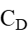 | 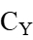 |  | 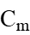
-4 | 0 | 0.242685 | 0.014944 | 0 | 0 | 0.12571 | 0
 | 4 | 0.237688 | 0.013763 | -0.025001 | -0.002749 | 0.132761 | 0.005621
 | 8 | 0.228693 | 0.016072 | -0.04961 | -0.005304 | 0.14358 | 0.011128
0 | 0 | 0.629111 | 0.022433 | 0 | 0 | 0.057932 | 0
 | 4 | 0.624278 | 0.02086 | -0.029071 | -0.000951 | 0.060736 | 0.006335
 | 8 | 0.611296 | 0.022611 | -0.055836 | -0.001637 | 0.067164 | 0.012028
4 | 0 | 1.0144 | 0.40027 | 0 | 0 | -0.066719 | 0
 | 4 | 1.008995 | 0.040612 | -0.033505 | 0.000777 | -0.066318 | 0.005863
 | 8 | 0.990889 | 0.042057 | -0.067169 | 0.001429 | -0.060523 | 0.011863
8 | 0 | 1.402109 | 0.070331 | 0 | 0 | -0.254899 | 0
 | 4 | 1.39366 | 0.070477 | -0.041871 | 0.002 | -0.252658 | 0.005349
 | 8 | 1.356662 | 0.068027 | -0.092378 | 0.00272 | -0.214139 | 0.013447

表2-8 evtol 动导数表
α (°) | V(m·s⁻¹) | $$C_{mq}$$ | $$C_{Lq}$$ | $$C_{lp}$$ | $$C_{lr}$$ | $$C_{np}$$ | $$C_{nr}$$ | $$C_{Yp}$$ | $$C_{Yr}$$
15.719 | 40.916 | -11.37824 | 6.43356 | -0.52608 | 0.48833 | -0.26579 | -0.04814 | -0.19462 | 0.30345
15.509 | 41.052 | -11.29628 | 6.40791 | -0.52672 | 0.48434 | -0.2583 | -0.05074 | -0.21121 | 0.31054
15.052 | 41.368 | -11.29848 | 6.41648 | -0.52846 | 0.47571 | -0.25124 | -0.05163 | -0.21604 | 0.30991
14.573 | 41.715 | -11.30635 | 6.42701 | -0.53037 | 0.46669 | -0.24423 | -0.0523 | -0.22013 | 0.30879
14.609 | 41.701 | -11.1386 | 6.33936 | -0.53106 | 0.46776 | -0.23758 | -0.05563 | -0.24769 | 0.32251
13.925 | 42.218 | -11.21618 | 6.3894 | -0.5336 | 0.45473 | -0.23027 | -0.05517 | -0.24316 | 0.3156
12.742 | 43.188 | -11.46257 | 6.53689 | -0.5371 | 0.4317 | -0.22233 | -0.05232 | -0.21649 | 0.29561
12.029 | 43.832 | -11.55178 | 6.59631 | -0.53947 | 0.41788 | -0.21467 | -0.05191 | -0.21127 | 0.28909
11.356 | 44.482 | -11.63078 | 6.65028 | -0.54173 | 0.40483 | -0.20689 | -0.05175 | -0.20823 | 0.28398
10.685 | 45.176 | -11.71553 | 6.70742 | -0.54395 | 0.39174 | -0.19896 | -0.05166 | -0.20554 | 0.27923
10.005 | 45.926 | -11.81165 | 6.77035 | -0.54614 | 0.37845 | -0.19086 | -0.05159 | -0.20281 | 0.27462
9.315 | 46.745 | -11.92347 | 6.8406 | -0.54832 | 0.36489 | -0.18258 | -0.05155 | -0.19983 | 0.27008
8.608 | 47.646 | -12.05628 | 6.91896 | -0.55048 | 0.35096 | -0.17413 | -0.05151 | -0.19612 | 0.26533
7.779 | 48.797 | -12.24923 | 7.00818 | -0.55272 | 0.33451 | -0.16551 | -0.05102 | -0.18233 | 0.25577
7.125 | 49.791 | -12.40463 | 7.15622 | -0.55474 | 0.32161 | -0.15664 | -0.05142 | -0.18969 | 0.25921
6.429 | 50.918 | -12.59617 | 7.25143 | -0.55679 | 0.30784 | -0.14753 | -0.05174 | -0.18883 | 0.25585
5.673 | 52.263 | -12.8256 | 7.37777 | -0.55886 | 0.29283 | -0.13816 | -0.0519 | -0.18552 | 0.25236
4.888 | 53.804 | -13.06988 | 7.5161 | -0.56094 | 0.27725 | -0.12842 | -0.05207 | -0.18193 | 0.24905
4.066 | 55.601 | -13.3074 | 7.65842 | -0.56305 | 0.26097 | -0.1182 | -0.0522 | -0.17809 | 0.24573
3.195 | 57.755 | -13.49869 | 7.79138 | -0.56522 | 0.24365 | -0.10733 | -0.05222 | -0.17383 | 0.24201
2.25 | 60.44 | -13.56347 | 7.8847 | -0.56739 | 0.22463 | -0.09563 | -0.05181 | -0.16862 | 0.23669
1.208 | 63.944 | -13.43088 | 7.911 | -0.56951 | 0.20313 | -0.0829 | -0.05069 | -0.16183 | 0.2286
0.93 | 64.994 | -13.37332 | 7.91022 | -0.57003 | 0.19736 | -0.07953 | -0.05033 | -0.1599 | 0.22626
0.87 | 65.214 | -13.36099 | 7.90987 | -0.57014 | 0.19619 | -0.07884 | -0.05026 | -0.15951 | 0.22579
0.056 | 68.707 | -13.16663 | 7.90137 | -0.57161 | 0.17912 | -0.06889 | -0.04915 | -0.15367 | 0.21895
-1.222 | 75.595 | -12.84401 | 7.88942 | -0.57375 | 0.15241 | -0.05328 | -0.04745 | -0.14439 | 0.20886
-2.66 | 86.733 | -12.49367 | 7.89206 | -0.57595 | 0.12228 | -0.03556 | -0.04561 | -0.13396 | 0.19861
-4.337 | 109.593 | -12.1232 | 7.92285 | -0.57825 | 0.08704 | -0.01468 | -0.04357 | -0.12214 | 0.18807

表2-10 副翼气动效能数据（单位：deg⁻¹）
$$\text{α}\text{ (°)}$$ | $$ΔC_{c}/Δδ_{a}$$ | $$ΔC_{l}/Δδ_{a}$$ | $$ΔC_{n}/Δδ_{a}$$
-4 | 0.000082 | -0.00291 | 0.000031
0 | -0.000004 | -0.0029 | 0.000025
1 | -0.000025 | -0.002889 | 0.000021
4 | -0.000088 | -0.00287 | 0.000011
8 | -0.000170 | -0.00283 | 0.000052
12 | -0.000291 | -0.00293 | 0.000092

表2-9 左侧尾翼舵面气动效能数据（单位：deg⁻¹）
$$\text{α}\text{ (°)}$$ | $$ΔC_{L}/Δδ_{l}$$ | $$ΔC_{D}/Δδ_{l}$$ | $$ΔC_{C}/Δδ_{l}$$ | $$ΔC_{l}/Δδ_{l}$$ | $$ΔC_{m}/Δδ_{l}$$ | $$ΔC_{n}/Δδ_{l}$$
-4 | 0.004340 | -0.000208 | 0.002426 | 0.000416 | -0.010238 | -0.000603
0 | 0.004453 | -0.000034 | 0.002494 | 0.000385 | -0.01054 | -0.000650
1 | 0.004476 | 0.000013 | 0.002508 | 0.000376 | -0.010601 | -0.000661
4 | 0.004526 | 0.000162 | 0.002542 | 0.000346 | -0.010742 | -0.000689
8 | 0.004553 | 0.000374 | 0.002569 | 0.000301 | -0.010839 | -0.000718
12 | 0.004532 | 0.000596 | 0.002574 | 0.000251 | -0.010821 | -0.000738

表2-10 右侧尾翼舵面气动效能数据（单位：deg⁻¹）
$$\text{α}\text{ (°)}$$ | $$ΔC_{L}/Δδ_{r}$$ | $$ΔC_{D}/Δδ_{r}$$ | $$ΔC_{C}/Δδ_{r}$$ | $$ΔC_{l}/Δδ_{r}$$ | $$ΔC_{m}/Δδ_{r}$$ | $$ΔC_{n}/Δδ_{r}$$
-4 | 0.004340 | -0.000208 | -0.002426 | -0.000416 | -0.010238 | 0.000603
0 | 0.004453 | -0.000034 | -0.002494 | -0.000385 | -0.01054 | 0.000650
1 | 0.004476 | 0.000013 | -0.002508 | -0.000376 | -0.010601 | 0.000661
4 | 0.004526 | 0.000162 | -0.002542 | -0.000346 | -0.010742 | 0.000689
8 | 0.004553 | 0.000374 | -0.002569 | -0.000301 | -0.010839 | 0.000718
12 | 0.004532 | 0.000596 | -0.002574 | -0.000251 | -0.010821 | 0.000738

