

Release Radar v1.2
Solution design, architecture review and root-cause analysis
UiPath release-notes portal with a UiPath agent
Item | Detail
Project | Release Radar (uipath-release-notes-portal)
Document version | 1.2 final (matches code version v1.2)
Date | September 28, 2026
Prepared by | Aslam Basha, Accelirate
v1.1 built by | Shivansh Srivastav
Audience | Accelirate internal team (engineering and delivery)
Classification | Internal
Status | Code complete, 40 of 40 tests pass, new agent deployed, first full analysis completed on 28 Sep 2026 (36 of 36 chunks). Remaining: hosting (section 9.1).

Contents

If the table of contents looks empty, right-click it in Word and choose Update Field.

1. Executive summary
Release Radar is an internal web portal. It takes UiPath's monthly Automation Cloud release notes and shows, per product, what changed, who is affected and whether anything breaks. A UiPath agent writes the analysis. We call the agent through an Orchestrator API trigger.
Version 1.1 did not work. We found 10 root causes. Five of them stopped it completely, and one is a security risk:
- The agent itself always failed. Its prompt requires an "Analyze Files" tool that is not attached, and it expects a File input while the portal sends text (RC-09, RC-10).
- Input limit. Orchestrator accepts at most 10,000 characters of job input (counted as JSON). A monthly page is 14,000 to 36,000 characters. The model's token setting cannot change this (RC-02, RC-03).
- Browser redirect handling. redirect: "manual" hides UiPath's 303 redirect, so the browser can never collect a running job's result (RC-04).
- "txt file" input. A multipart file upload is not a documented API-trigger input. The portal then showed an Orchestrator "Pending" job record as if it were the answer (RC-05).
- Security. The UiPath token is compiled into the built JavaScript (dist/) (RC-01).
Verdict on the architecture: not solid, so it was redesigned (section 4). In v1.2 all UiPath calls run in a scheduled pipeline (GitHub Actions weekly, or start-local.bat on a PC). It splits each month into chunks under the limit, calls a new agent with a String input, checks every answer, and publishes a month only when its analysis is complete. The portal reads static JSON, holds no secrets, and loads instantly.
Proof it works (details in section 7)
- New agent ReleaseNotes_Agent_v2 deployed with its own API trigger. Two real jobs on 28 Sep 2026 (Studio Web debug and deployed serverless job) returned valid output; the pipeline merged it with 3 of 3 products and 7 of 7 changes.
- 0 of 36 chunks exceed the limit on the live January to August 2026 pages (largest 7,723 of an 8,000 budget). 546 of 546 highlight bullets reach the agent exactly once.
- First full run (28 Sep 2026): 36 of 36 agent jobs valid in about 11 minutes. January to August 2026 published: 211 of 211 product entries analysed, 561 updates, 38 breaking changes (section 7.6).
- The live checks and the first run found and fixed 6 problems (4 in the parser, 1 in the merge, 1 in the local start-up) (section 7.3).
- 40 of 40 automated tests pass, including real agent output from v1.1 and v2.
- The production build contains no token, no Bearer header and no Orchestrator URL.

Before go-live
- Rotate the old UiPath token that was in .env / dist/ (it was also shared in the v1.1 zip).
- Host it on GitHub Pages or UiPath Coded Apps (section 9.1). The first analysis is already done and included, so the first hosted run makes no agent calls.

2. What we are building

2.1 Purpose
UiPath publishes Automation Cloud release notes twice a month (around the 15th and at month end). Each monthly page is long, covers three cloud environments and mixes highlights with large status tables. Our team needs a quick answer to three questions: what changed, what is the impact, and what breaks. Release Radar gives that answer per product, per month.

2.2 Users and scope
Topic | In scope (v1.2) | Out of scope (possible later)
Users | Accelirate internal team | Clients / external users
Source | UiPath monthly platform page cloud-platform-<month>-<year> (public markdown version) | Per-product release-note pages linked from the catalog
Environments | Automation Cloud, Public Sector, Dedicated (one tab each) | Automation Suite, standalone products
Months | From January 2026 onward, found automatically | Earlier years (set RR_START_MONTH)
Analysis | Agent summary, changes, impact and breaking-change flag per product | Customer-specific impact scoring

2.3 Domain, region and compliance context
Question | Answer
Domain | Internal IT and automation-delivery tooling (SaaS-style web app).
Data handled | UiPath's public documentation and AI summaries of it. No customer data, personal data (PII), health data (PHI) or payment data.
Region | GitHub (global) and UiPath Automation Cloud (Accelirate tenant). All data is public, so there is no data-residency requirement.
Regulations in scope | HIPAA, GDPR and PCI-DSS do not apply (no regulated data). We follow secure-development and secrets practices aligned with SOC 2 Trust Services Criteria (CC6, CC7, CC8) and the OWASP Top 10 (2021). See section 8.
AI use | The LLM runs inside UiPath (agent), under UiPath's AI Trust Layer. The portal labels the output as AI-generated and shows UiPath's original text one click away.

3. Review of v1.1 (as-is)

3.1 How v1.1 worked
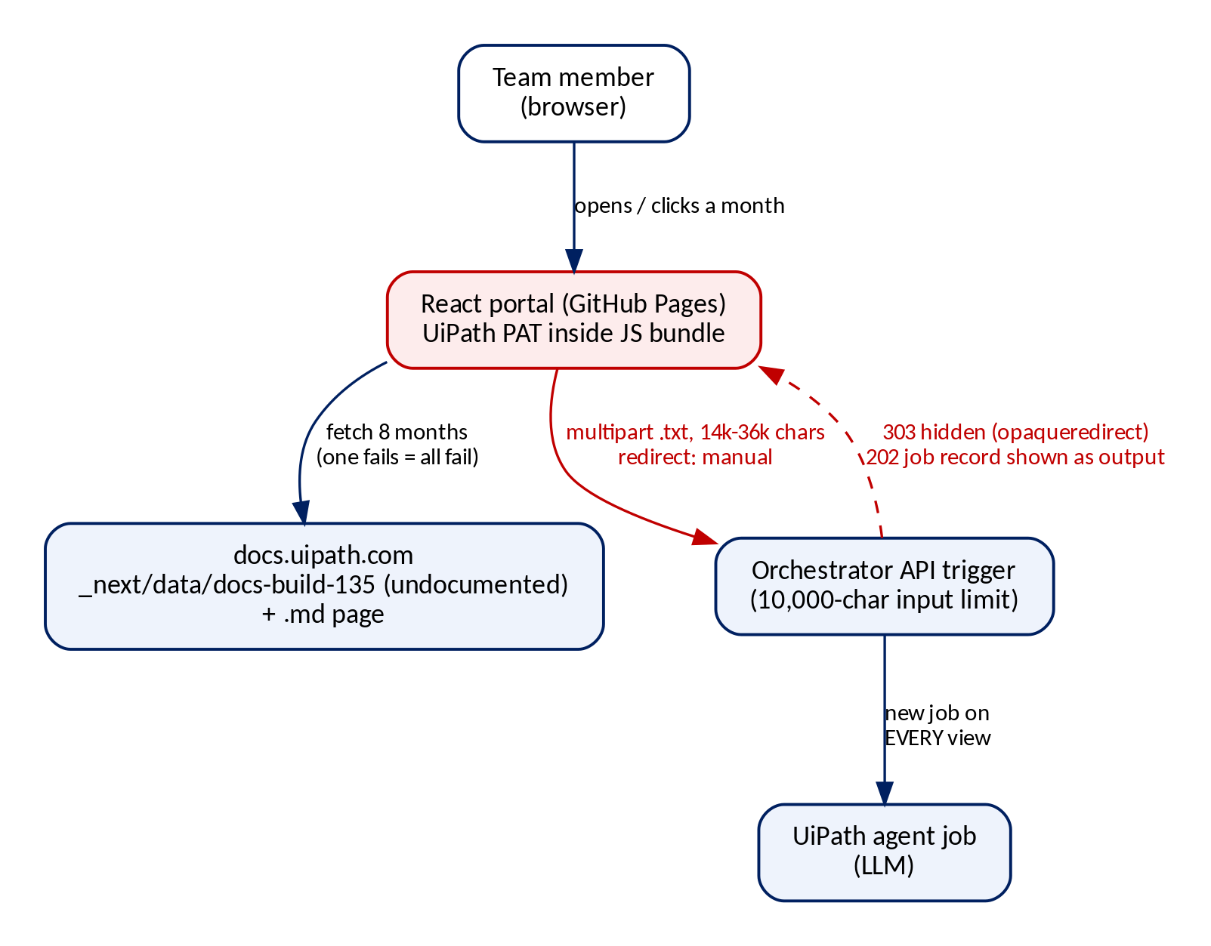
Figure 1. v1.1: the browser holds the token and calls UiPath directly
- The React portal (GitHub Pages) loads 8 months from an undocumented docs.uipath.com endpoint (_next/data/docs-build-135).
- When a month is selected, the browser downloads that month's markdown (14k to 36k characters).
- The browser sends it as a .txt file to the Orchestrator API trigger, with the UiPath token in the request.
- UiPath starts an agent job. The browser waits and tries to follow redirects to get the result.
- The raw JSON answer (or error) is printed on the page and in the console.

3.2 Architecture assessment
Area | Rating | Why
Security | Critical | UiPath token inside the browser bundle. Once deployed, anyone who opens the site could read it and start jobs.
Reliability | Weak | The agent always faulted; the browser waits on long jobs; redirect handling cannot work; one failed month breaks all months.
Correctness | Weak | Input cut by the 10,000-character limit. No validation, so a "Pending" job record was shown as the result.
Cost / scale | Weak | A new paid agent job on every page view and month click. Nothing stored.
Maintainability | Weak | Undocumented docs endpoint tied to a build number, months hard-coded to Jan-Aug 2026, dependencies set to "latest".
User experience | Needs work | Raw JSON dump; updates for one product split across Early/Late sections; month list hidden on phones.

Verdict
The v1.1 architecture is not solid and cannot be fixed with small patches, because the core problem is where the work happens (in the browser). v1.2 keeps what was good (React + Vite, GitHub Pages, the agent's output format) and moves the agent calls to a scheduled pipeline with a working agent.

4. Target architecture (v1.2)
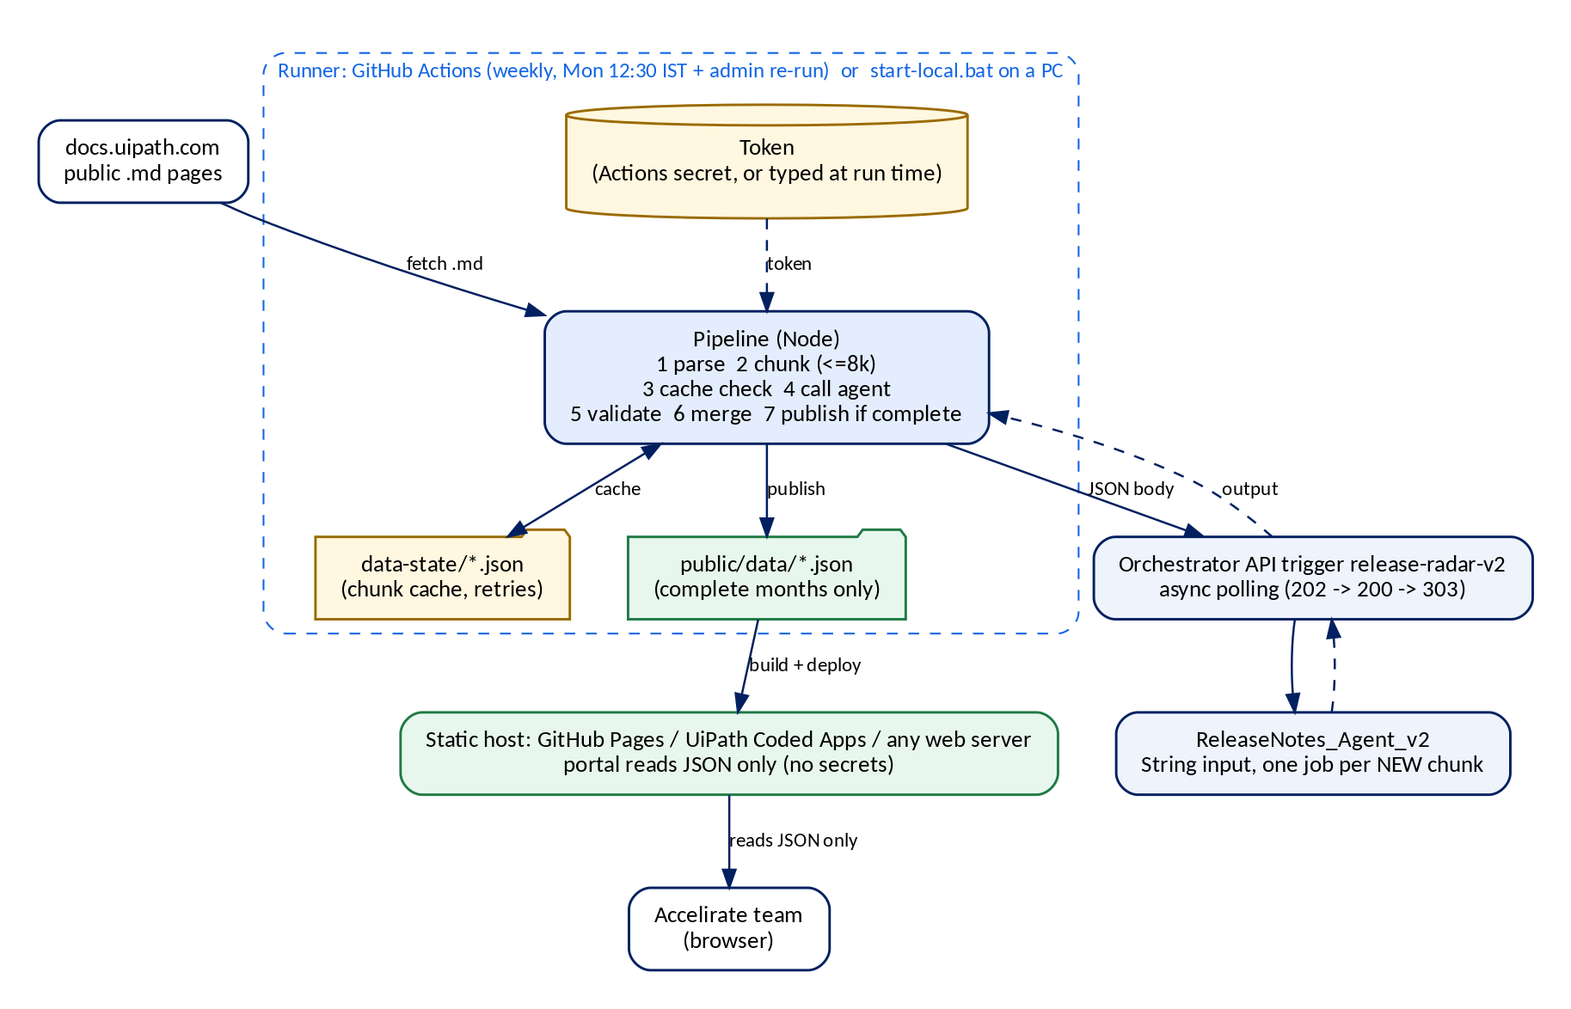
Figure 2. v1.2: a scheduled pipeline talks to UiPath; the portal only reads static JSON

4.1 Components
Component | What it does | File(s)
Runner | GitHub Actions every Monday 12:30 IST plus an admin "Run workflow" button; or start-local.bat on a Windows PC (analysis first, then the portal). | .github/workflows/release-radar.yml, start-local.bat
Source reader | Downloads each month's public markdown. HTTP 404 means "not published yet" and is skipped. | pipeline/lib/pipeline.js
Parser | Turns the page into environment > timeframe > product highlights, plus the release catalog. Handles every heading and table style seen on the live pages. | pipeline/lib/markdown.js
Chunker | Packs whole products into chunks of at most 8,000 JSON characters, repeats the section header in each chunk, splits a long product only between bullets. | pipeline/lib/chunker.js
UiPath client | Gets a token (PAT or OAuth app), starts the job, polls, fetches output. Retries short outages, stops on 401/403/404, enforces a timeout. | pipeline/lib/uipath.js
Validator and merger | Checks each answer against the agent contract, retries once if invalid, merges answers per product. | pipeline/lib/merge.js
Store and cache | Publishes a month only when complete (public/data/). Keeps the chunk cache and retries in data-state/. | pipeline/lib/store.js
Portal | One tab per cloud, one card per product for the whole month, click for all updates (summary and impact first, agent analysis and UiPath's wording on click), breaking-change box, search, breaking-only filter. | src/App.jsx, src/lib/view-model.js
Agent | ReleaseNotes_Agent_v2: low-code agent, gpt-5.4, temperature 0, no tools, String input, same output contract as v1.1. | UiPath Studio Web / Orchestrator

4.2 How data flows
- The runner starts (weekly, on demand, or locally).
- First run: every month from RR_START_MONTH. Later runs: only the latest RR_RECHECK_MONTHS months (default 2); older published months are frozen and not even downloaded.
- Each page is parsed and chunked. Chunks analysed before (same fingerprint) reuse the stored answer, so unchanged text costs nothing.
- New chunks go to the agent through the API trigger, two at a time, using async polling (up to 20 minutes per job).
- Each answer is validated. An invalid answer is retried once, then marked failed. Other chunks continue.
- A month is published to public/data/analysis/<YYYY-MM>.json only when every chunk is valid. Otherwise the previous version stays live and the failed chunks are retried next run.
- The site is rebuilt and deployed. The browser reads JSON only and never contacts UiPath.

4.3 Key design decisions
Decision | Why | Alternative considered
Pre-compute on a schedule, not on every click | Notes change about twice a month. Instant pages, fixed cost, same answer for everyone, no secrets in the browser. | On-demand backend proxy. More cost and infrastructure.
Weekly run on Monday 12:30 IST | Requested schedule; UiPath publishes around the 15th and month end, so a week is at most the delay. Admin re-run for urgent refreshes. | Daily run (more runs, same result).
Publish only complete months | Readers never see half-finished analysis or status labels. | Show partial results with labels (rejected: confusing).
New agent with String input | The v1.1 agent could not run (missing tool, File input). A String input is the documented API-trigger pattern. The v1.1 agent is left untouched. | Attach the tool and upload job attachments (UIPATH_INPUT_TYPE=file is supported if ever needed).
Chunk by product inside a section, 8,000 budget | The limit counts JSON characters including escapes; 8,000 leaves a 20% margin. Sections stay separate so answers merge without guessing. | Storage-bucket reference: needs the agent to read files with a tool.
Async polling call mode | Documented flow with no 15-minute cap (long polling has one). | Long polling: available through UIPATH_CALL_MODE.
Static JSON in the repo, relative build paths | Versioned history, zero infrastructure, and the same build works on GitHub Pages, UiPath Coded Apps or any host. | Database: not needed at this volume.

5. Issues and root causes
Each issue lists what we saw, the root cause, the evidence and the fix. Where the exact v1.1 attempt is not in the zip, the cause is marked most likely and the evidence is shown.

5.1 Summary
ID | Issue | Severity | Root cause (one line) | v1.2
RC-01 | UiPath token exposed | Critical | VITE_* variables are compiled into the public JS bundle by design | Fixed
RC-02 | "Agent takes max 10,000 characters" | High | Orchestrator limit on job input JSON, not an LLM limit | Fixed
RC-03 | Chunking attempt failed | High | Cuts by characters or by section; one section alone is 10,318 chars; no merge step | Fixed
RC-04 | API call "not working" | High | redirect: "manual" hides UiPath's 303 in browsers (opaque redirect) | Fixed
RC-05 | txt-file input; "Pending" shown as output | High | File upload is not a documented API-trigger input; any 2xx treated as success | Fixed
RC-06 | Fragile data source | Medium | Undocumented _next/data/docs-build-135 endpoint; months hard-coded | Fixed
RC-07 | Cost and inconsistent results | Medium | New agent job on every page view; nothing stored | Fixed
RC-08 | Silent failures | Medium | No validation; errors only in the browser console | Fixed
RC-09 | Agent job always faults | High | Prompt requires the Analyze Files tool; no tool is attached | Fixed (new agent)
RC-10 | Portal and agent disagree on the input | High | Agent expects File release_notes_file; portal sends text | Fixed (new agent)

RC-01 UiPath token exposed in the browser bundle (Critical)
What we saw | The token is in .env as VITE_RELEASE_NOTES_PAT_TOKEN and in plain text inside dist/assets/index-*.js. .gitignore did not exclude .env. The repo is public and npm run deploy publishes dist/.
Root cause | Vite puts every VITE_* variable into the JavaScript sent to the browser, by design; Vite's docs say they must not hold secrets. A static site cannot keep a secret.
Evidence | Token string found in the local dist bundle. On 26 Sep 2026 the live site and committed dist/ were an older build without it, so the token was not public yet, but the next deploy from a machine with .env would publish it.
Fix in v1.2 | The browser holds no credentials. The token lives in GitHub Actions secrets, or is typed at run time by start-local.bat (hidden, not saved). .gitignore covers .env and dist/. The build has a Content-Security-Policy. Action: rotate the old token.

RC-02 "The agent can take at most 10,000 characters" (High)
What we saw | Long markdown made the call fail. Raising the model token setting to 128,000 did not help.
Root cause | Orchestrator accepts at most 10,000 characters for the JSON form of a job's input arguments on API calls (names, quotes and escapes count). The check happens before the agent runs, so model settings do not matter. Monthly pages are 14,356 to 36,308 characters.
Evidence | UiPath docs, "About Input and Output Arguments". Page sizes measured on the live site (section 7.2).
Fix in v1.2 | Chunker: each chunk is measured exactly as sent (including $callMode) and kept at or under 8,000. Budgets above 10,000 are rejected in code, and a test fails if any chunk is too big.

RC-03 The chunking attempt failed (High)
What we saw | "I tried chunks too but it is getting failed." The code of that attempt is not in the zip.
Root cause (most likely) | Chunks were cut by character count and/or by whole section. One section alone (Early August 2026 highlights) is 10,318 characters, so a section-sized chunk still breaks the limit. Character cuts split sentences, and there was no step to merge answers.
Evidence | The saved agent output says the release notes were "truncated after the beginning of the cost-basis description" (input cut mid-sentence).
Fix in v1.2 | Chunks hold whole products, never mix sections and repeat the section header. An oversized product is split between bullets and labelled "part 1 of 2". Answers are merged per product.

RC-04 The API call does not return results in the browser (High)
What we saw | "I tried calling the API but it is not working."
Root cause | fetch(..., { redirect: "manual" }) turns a 3xx answer into an "opaqueredirect" response (status 0, no headers). UiPath answers a running job with 303 + Location, which the code cannot read. In local development the Vite proxy also passed UiPath's redirect to another origin, and browsers drop the Authorization header on cross-origin redirects.
Evidence | src/App.jsx (v1.1) lines 103-107 and 124-131. UiPath docs "Call modes explained". WHATWG Fetch change "Remove Authorization header upon cross-origin redirect".
Fix in v1.2 | Calls run in Node, where manual redirects show the real status and Location. The client follows the documented async-polling flow (202, 200 while running, 303 to output) and sends the token on every step. Covered by tests against a mock trigger.

RC-05 "txt file" input, and a "Pending" job shown as the answer (High)
What we saw | The portal sends a multipart form with a file. A saved response (agent-response-output.json) is { "state": "Pending", "key": ..., "organizationUnitId": ... }.
Root cause (most likely) | API-trigger arguments and $callMode are documented as a JSON body. A file upload is not a documented API-trigger input. The trigger then used its default call mode (Async polling), which returns 202 with a job record, and v1.1 treated every 2xx as success.
Evidence | UiPath docs "Managing API triggers" and "Call modes explained". The saved response is an Orchestrator job record, not agent output.
Fix in v1.2 | JSON body with a String argument release_notes_markdown sent to the new agent. Every answer is validated; job records are rejected (a test uses the real saved file).

RC-06 Fragile data source (Medium)
What we saw | Months load from docs.uipath.com/_next/data/docs-build-135/... and the list is fixed to January-August 2026.
Root cause | docs-build-135 is a build number that changes when UiPath redeploys its docs; the URL then returns 404. All months load with Promise.all, so one failure breaks the portal.
Evidence | src/App.jsx (v1.1) line 9 and lines 202-210.
Fix in v1.2 | Uses the public markdown pages. Months are found automatically; each month is processed on its own; the last good data is kept if a download fails.

RC-07 Cost and inconsistent results (Medium)
What we saw | The agent runs on page load and on every month click.
Root cause | The call sits in a React effect with no cache or storage. Every viewer starts a new paid job, and two viewers can see different answers.
Evidence | src/App.jsx (v1.1) lines 305-309.
Fix in v1.2 | The agent runs only for new or changed text. Answers are stored and versioned, so everyone sees the same result.

RC-08 Silent failures and weak error visibility (Medium)
What we saw | Errors are only in the browser console. Any JSON is dumped on screen as a success.
Root cause | No check of the agent answer and no status model.
Evidence | src/App.jsx (v1.1) lines 280-286 and 488-505.
Fix in v1.2 | Validation and retry; clear exit codes and a run summary; a month is published only when complete, so the portal never shows broken or partial data.

RC-09 The deployed agent always faults (High)
What we saw | Agent jobs from the v1.1 trigger (process version 1.0.1) end in Faulted with an "Analyze Files tool is unavailable" error.
Root cause | The agent's prompt tells it to read the input with the Analyze Files tool, but no tool is attached to the agent. The agent is a low-code agent (agent.json), not a coded agent as first thought.
Evidence | Job details and traces in Orchestrator; the agent definition in Studio Web (read-only for us, owned by Shivansh).
Fix in v1.2 | New agent ReleaseNotes_Agent_v2 with no tools and a text input, so there is nothing to fail. Verified with real jobs on 28 Sep 2026 (section 7.4). The v1.1 agent is left as it is.

RC-10 Portal and agent disagree on the input (High)
What we saw | The v1.1 portal sends release_notes_markdown; the v1.1 agent's input schema is a File argument release_notes_file.
Root cause | The agent was switched to a file input during troubleshooting, but the caller was not changed to match, and API triggers do not accept a file upload (RC-05).
Evidence | Agent input schema in Studio Web and on the API trigger's runtime arguments.
Fix in v1.2 | One contract on both sides: String release_notes_markdown in, changes_by_product out. The trigger shows the String input, and the pipeline sends exactly that name.

Minor findings (Low)
- Dependencies were set to "latest". v1.2 pins exact versions with a lockfile.
- On phones the month list was hidden by CSS. v1.2 shows it as a scrollable row.
- Legacy files (script.js, old fixtures) and the Vite dev proxy were removed.
- v1.1 injected UiPath HTML with dangerouslySetInnerHTML. v1.2 renders text through React only.

6. How the v1.2 fixes work

6.1 Chunking without losing context
Every chunk starts with the same header, so the agent always knows the month, environment and timeframe. Example (shortened):
# UiPath release notes: August 2026
## Automation Cloud Dedicated and Test Cloud Dedicated
### Late August 2026 (August 21, 2026, August 25, 2026, August 26, 2026)
#### Release highlights

**Agents** (released August 21, 2026)

* New assignment criteria for agent escalations: Workload, All users in group, ...

- Only the product highlight text is sent. Intro text and the status tables are parsed by code instead (cheaper and exact).
- A chunk never mixes two sections. A product too big for one chunk is split between bullets and labelled "part 1 of N".
- Size is measured exactly as the request is sent, including $callMode. Default budget 8,000 (20% below the limit).

6.2 Talking to UiPath correctly
- Get a token: a Personal Access Token, or OAuth client credentials from a UiPath External Application. OAuth tokens are cached until shortly before expiry.
- POST the JSON body to the trigger with $callMode: "AsyncRequestReply". Expect 202 and a status URL.
- Poll the status URL. 200 means still running; Faulted or Stopped ends the job with an error.
- 303 points to the output URL. GET it to receive the agent's output.
- Short outages (429, 5xx, network) are retried with back-off. 401, 403 and 404 stop the whole run at once, with a plain-English hint.

6.3 Validation and merge
- An answer must contain a changes_by_product object. Common wrappers (JSON string, nested output) are accepted; Orchestrator job records are rejected.
- Answers are matched to the products that were sent. A product listed on several Dedicated dates shares one analysis and shows all its release dates.
- If UiPath's text says "breaking change" but the agent did not flag one, the portal shows a "please verify" note.

6.4 Cost control
Situation | Agent jobs
First run (January to August 2026) | 36. January and February contain release dates only, so 0 jobs for them.
Weekly run, nothing changed | 0
UiPath publishes a new timeframe (twice a month) | Only the new or changed sections, usually 3 to 6 jobs
Admin forces a re-run of one month | About 6
After changing the agent prompt or model | Set RR_CACHE_KEY to a new value once; all months are re-analysed

6.5 Portal
One tab per cloud (Automation Cloud, Public Sector, Dedicated). Inside a tab: headline numbers, a breaking-changes box, search and a "breaking only" filter, and one card per product for the whole month (no Early/Late split). Clicking a card opens all its updates with summary and impact first; the agent's detailed analysis and UiPath's original wording open on click. Months with release dates only (January, February 2026) show the released products and dates. No status labels are shown.

7. Verification and evidence

7.1 Automated tests (40 of 40 pass)
Area | Tests | What is proven
Parser and chunker | 12 | All heading styles incl. Dedicated date headings, all catalog formats (flattened HTML, pipe tables with and without a Layer column), bold cells, catalog dates, every chunk within budget, no section mixing, every bullet exactly once, safe splitting.
Validation and merge | 7 | Real output of the v1.1 agent and of the deployed v2 agent accepted; the real Pending job record rejected; split parts merged; repeated Dedicated products share one analysis.
UiPath client | 7 | Async polling (202, 200, 303, output) with the token on every call; long polling; 401 fails fast; 502 retried; faulted job; timeout; OAuth token cached.
Configuration | 1 | Secrets required unless dry run; bad values rejected.
Pipeline end to end | 8 | Publishes complete months only; unchanged run = 0 jobs; only changed text re-analysed; failed chunk retried alone; older months frozen; release-date months; 401 stops early; dry run; original text optional; file-attachment mode.
Local portal server | 1 | Serves the published data, blocks path traversal, returns 404/405 correctly.
Portal view model | 4 | One tab per cloud, one entry per product per month, Dedicated dates merged, search and filters.

Run them with npm test. The same tests run in GitHub Actions before every analysis.

7.2 Live validation against real UiPath pages (28 Sep 2026)
The final parser and chunker were run against the live docs.uipath.com pages. Bullets were counted directly in the raw page and compared with the chunks.
Month (2026) | Page size (chars) | Product blocks | Bullets in chunks / in page | Chunks | Largest chunk (JSON chars)
January | 14,356 | 0 | 0 / 0 | 0 (dates only) | -
February | 33,558 | 0 | 0 / 0 | 0 (dates only) | -
March | 36,179 | 38 | 99 / 99 | 6 | 4,531
April | 36,138 | 29 | 81 / 81 | 6 | 4,667
May | 29,123 | 34 | 79 / 79 | 6 | 3,194
June | 36,308 | 37 | 105 / 105 | 6 | 6,626
July | 35,842 | 37 | 95 / 95 | 6 | 7,723
August | 35,445 | 36 | 87 / 87 | 6 | 6,996

Result: 36 chunks, none above the 8,000 budget, 546 of 546 bullets exactly once, 0 parser warnings. September 2026 was not published yet (HTTP 404) and will be picked up automatically.

7.3 Problems found by the live checks and the first run, and fixed
Problem | Effect before the fix | Fix
Dedicated date headings written as ##### March 19, 2026 (March to July) | The date became a "product" and the real products lost their release date | A date heading is now a date group
Catalog rows whose Layer column says "Product" | Read as table headers, so whole rows were lost | A header row must name both Product and Release status
**bold** product names in catalog cells | Names shown with asterisks | Bold markers removed
Catalog date only in the heading, or the section's single release date | Released products without a date | Date taken from the heading or the section
Same product on several Dedicated dates in one chunk | Later entries looked "not analysed" | One shared analysis with all dates
Portal did not start after the first Windows run (analysis itself succeeded) | "localhost refused to connect"; the window closed, so the error was not visible | Portal served by a zero-dependency Node server (pipeline/serve.mjs, this PC only); window stays open; build output in build.log; open-portal.bat to view without a token

7.4 Real UiPath runs of the new agent
Run | Input | Result
Studio Web debug (28 Sep 2026) | Public Sector, Late August 2026 chunk (1,120 chars) | Successful in 13 s. 3 products, 7 changes. Merged by the pipeline code: 3 of 3 products, status complete.
Deployed job, Cloud - Serverless (28 Sep 2026) | Dedicated, Late August 2026 chunk (2,352 chars, 10 product entries on 3 dates) | Successful in 26 s. Valid changes_by_product; repeated products returned once, as the merge now expects.

7.5 Build, security and portal checks
- Clean install from the lockfile, 40 tests and the production build: all pass.
- Built bundle: no token pattern, no "Bearer", no Orchestrator URL. Content-Security-Policy present.
- Portal rendered in headless Chrome with real agent output: cloud tabs, merged Dedicated products, drawer with "Released Aug 21, Aug 25, Aug 26", no status words, no stray asterisks, no page errors. Also loads correctly from a sub-folder (relative paths).

7.6 First full run (28 Sep 2026, Windows PC, start-local.bat)
Month (2026) | Result | Product entries analysed | Updates | Breaking
January | Release dates only | - | - | -
February | Release dates only | - | - | -
March | Published, 6 of 6 chunks | 38 of 38 | 97 | 3
April | Published, 6 of 6 chunks | 29 of 29 | 82 | 4
May | Published, 6 of 6 chunks | 34 of 34 | 81 | 3
June | Published, 6 of 6 chunks | 37 of 37 | 105 | 1
July | Published, 6 of 6 chunks | 37 of 37 | 102 | 17
August | Published, 6 of 6 chunks | 36 of 36 | 94 | 10

The analysis took about 11 minutes (2 jobs in parallel). No retries were needed, no product came back unmatched, and there were no parser warnings. The portal was then checked with this real data in headless Chrome: 8 months listed, cloud tabs, product cards, drawer, no status words, no page errors.

8. Security and compliance

8.1 Controls
Control | How v1.2 implements it | Reference
Secrets management | Credentials only in GitHub encrypted secrets or typed at run time locally (hidden, never saved); nothing in code or the browser; .env git-ignored; old token to be rotated. | SOC 2 CC6.1; OWASP A07 / CWE-798
Least privilege | Token scope OR.Jobs only; folder role limited to Jobs Create + View; short token expiry. Each workflow job gets only the GitHub permissions it needs. | SOC 2 CC6.3
Change management | All changes through Git; tests run before every analysis; exact dependency versions with a lockfile. | SOC 2 CC8.1; OWASP A08
Monitoring | GitHub Actions run history and step summary; failure emails; clear exit codes locally. | SOC 2 CC7.2
Browser hardening | Content-Security-Policy; no inline scripts; no raw HTML injection; external links use rel=noreferrer. | OWASP A03, A05
Data classification | Public UiPath documentation and AI summaries only. No PII, PHI or payment data. | Out of HIPAA, GDPR, PCI-DSS scope
AI governance | LLM runs inside UiPath (AI Trust Layer); temperature 0; output labelled AI-generated; original text one click away; breaking-change cross-check. | Internal AI-use practice

8.2 Remaining risks and recommendations
Risk | Recommendation | Owner
A GitHub Pages site is public on the internet, even from a private repo (except with GitHub Enterprise Cloud access control). | If it must be Accelirate-only: host on UiPath Coded Apps (Accelirate tenant) or private Pages on Enterprise Cloud. Content is public-derived, so risk is low. | Aslam (decision)
The data files store UiPath's original highlight text. | If the site is public, set RR_STORE_SOURCE=false to publish only the analysis and links. | Aslam (decision)
The repo is in a personal account (accelerate14). | Transfer it to the Accelirate GitHub organisation. | Repo owner
A PAT is tied to one person and is not available for directory (SSO) users. | For the scheduled run, use an External Application (client credentials). | UiPath admin
UiPath may change the page format again. | Parser warnings are logged, the last good data is kept, and tests cover every format seen so far. | Developer
The LLM can mis-judge a breaking change. | Cross-check against UiPath's text, show the original, keep the AI disclaimer. | Built in

9. Deployment and runbook
Step-by-step hosting instructions (GitHub Pages, UiPath Coded Apps, any web server) are in the separate Release Radar v1.2 Handover and Hosting Guide. This section is the short version.

9.1 Go-live steps
- Rotate the old token. In UiPath, revoke the PAT used in v1.1.
- Create a token for the run: Preferences > Personal Access Token > Generate new token, scope Orchestrator API Access > OR.Jobs, short expiry. For the scheduled GitHub run, an External Application with scope OR.Jobs is better.
- First run: done on 28 Sep 2026 and included in the package. To refresh on a PC, double-click start-local.bat and paste the token; to only view, double-click open-portal.bat (http://127.0.0.1:5173).
- Host it: follow the Handover and Hosting Guide (GitHub Pages recommended). Put the trigger URL and token in GitHub secrets and run the workflow once.

9.2 Agent and trigger details
Item | Value
Solution / process | Release_Radar_Agent_v1_2 / ReleaseNotes_Agent_v2 (package 1.0.0)
Folder | Uipath_ReleaseNotes > Release_Radar_Agent_v1_2 (runtime Cloud - Serverless)
Trigger | release-radar-v2, POST, default call mode Async polling
Trigger URL | https://cloud.uipath.com/accelirateuipcl/Spyro/orchestrator_/t/270ed9a5-9e3a-44cb-a751-882ab3952d40/release-radar-v2
Input / output | release_notes_markdown (String) / changes_by_product (object)
Model settings | gpt-5.4, temperature 0, max iterations 5, no tools
Access needed by the caller | Jobs: Create + View in the folder above

9.3 Day-to-day operation
Task | How
Refresh now | GitHub: Actions > Release Radar > Run workflow. Locally: run start-local.bat.
View locally without a token | Double-click open-portal.bat (or npm run serve).
Re-analyse one month | Run workflow with month = 2026-08 and force = true (or node --env-file=.env pipeline/run.js --month 2026-08 --force).
After changing the agent | Set RR_CACHE_KEY to a new value (for example agent-v3) and run once.
New month appears | Automatic. The first weekly run after UiPath publishes picks it up.
Check without UiPath | npm run analyze:dry (parse and chunk only, no credentials).

9.4 Plug-and-play for another tenant or client
Nothing client-specific is in the code. To reuse it: import the agent into the other tenant, create its API trigger, set the trigger URL and identity as secrets or in .env, and run. The source site and page naming are configurable too (RR_SOURCE_BASE_URL, RR_SLUG_TEMPLATE).

9.5 Troubleshooting
Message | Meaning | Action
HTTP 401 | Wrong or expired token | Create a new token; for OAuth check client ID and secret
HTTP 403 | Missing folder role or scope | Give Jobs Create + View in the agent's folder; scope OR.Jobs
HTTP 404 | Wrong trigger URL, or trigger disabled | Copy the URL from the trigger again; enable it
HTTP 400 (input rejected) | Argument name or type mismatch | Input must be String release_notes_markdown
Job ended in state Faulted | The agent job failed | Open the job in Orchestrator, check logs and traces
A month is missing in the portal | Its analysis is not complete yet | Next run retries only the failed chunks
Push rejected in "Commit refreshed data" | Branch protection | Allow the GitHub Actions bot to push to main

10. Decisions needed
# | Decision | Options | Recommendation
1 | Where to host | GitHub Pages (anyone with the link) / UiPath Coded Apps (only members of the Accelirate UiPath organisation can sign in) / other | GitHub Pages for speed; UiPath Coded Apps if it must be Accelirate-only
2 | UiPath identity for the weekly run | External Application / PAT | External Application (not tied to one person)
3 | Repository owner | Personal account / Accelirate organisation | Accelirate organisation
4 | v1.1 agent | Keep / retire | Retire after v1.2 is live (it cannot run as configured)
5 | v2 scope | Analyse per-product pages linked from the catalog (useful for January and February, which have no highlight text) | Plan after one month of v1.2

Appendix A. Configuration reference
Variable | Secret? | Default | Purpose
UIPATH_TRIGGER_URL | Yes | - | Full API trigger URL
UIPATH_PAT | Yes | - | Personal access token (locally it can be typed at run time instead)
UIPATH_CLIENT_ID / UIPATH_CLIENT_SECRET | Yes | - | External Application credentials
UIPATH_ORG | No | - | Organisation name, used to build the OAuth token URL
UIPATH_SCOPES | No | OR.Jobs | OAuth scope(s) requested
UIPATH_INPUT_ARG | No | release_notes_markdown | Name of the agent input
UIPATH_INPUT_TYPE | No | text | text = String argument; file = job attachment
UIPATH_CALL_MODE | No | AsyncRequestReply | Or LongPolling
RR_START_MONTH | No | 2026-01 | First month to process
RR_RECHECK_MONTHS | No | 2 | Latest months re-checked after the first run
RR_MAX_ARGS_JSON_CHARS | No | 8000 | Chunk budget (2,000 to 10,000)
RR_CONCURRENCY | No | 2 | Parallel agent jobs (1 to 5)
RR_CACHE_KEY | No | v1 | Change to force one full re-analysis
RR_JOB_TIMEOUT_MS | No | 1200000 | Max wait per job (20 minutes)
RR_STORE_SOURCE | No | true | false = publish analysis and links only
RR_FAIL_ON_PARTIAL | No | false | Exit code 3 if a month is not complete (set by start-local)
VITE_ADMIN_RERUN_URL | No (public) | set by workflow | Admin link shown in the portal

Appendix B. File map
v1.2 file | Status | Notes
src/App.jsx, src/lib/view-model.js, styles.css | Rewritten | Reads static JSON; tabs, cards, drawer; no credentials
pipeline/ (lib, run.js, serve.mjs, check-env.mjs, has-credentials.mjs, tests) | New | Parser, chunker, UiPath client, merge, store, CLI, local server, 40 tests
start-local.bat, start-local.sh, open-portal.bat | New | Analysis first, then the portal; token asked at run time; view-only start
.github/workflows/release-radar.yml | New | Weekly schedule, admin re-run, deploy to GitHub Pages
public/data/, data-state/, dist/ | New | First analysis (Jan-Aug 2026), working state, and a prebuilt portal (dist is not committed to Git)
vite.config.js, package.json, package-lock.json | Changed | Relative paths, CSP, pinned versions, scripts
.gitignore, .env.example, README.md, CHANGES.md, docs/ | New / changed | Setup guide and documents
script.js, api-check.json, response.json, .env, dist/, deploy.yml | Removed | Legacy or unsafe

Appendix C. Sources
- UiPath, Orchestrator: API triggers (authentication, Jobs permissions) https://docs.uipath.com/orchestrator/automation-cloud/latest/user-guide/api-triggers
- UiPath, Orchestrator: Call modes explained https://docs.uipath.com/orchestrator/automation-cloud/latest/user-guide/call-modes-explained
- UiPath, Orchestrator: About Input and Output Arguments (10,000-character limit) https://docs.uipath.com/orchestrator/automation-cloud/latest/user-guide/about-input-and-output-arguments
- UiPath, Orchestrator: Managing API triggers https://docs.uipath.com/orchestrator/automation-cloud/latest/user-guide/managing-api-triggers
- UiPath, Automation Cloud: Personal Access Tokens https://docs.uipath.com/automation-cloud/automation-cloud/latest/api-guide/personal-access-tokens
- UiPath, Automation Cloud: External Applications (OAuth) https://docs.uipath.com/automation-cloud/automation-cloud/latest/api-guide/accessing-uipath-resources-using-external-applications
- UiPath, Coded Apps: Getting started (hosting at <org>.uipath.host) https://uipath.github.io/uipath-typescript/coded-apps/getting-started/
- UiPath, Coded Apps: FAQ (sign-in needs organisation membership) https://docs.uipath.com/apps/automation-cloud/latest/user-guide-ca/faq
- GitHub Docs: What is GitHub Pages? https://docs.github.com/en/pages/getting-started-with-github-pages/what-is-github-pages
- Vite: Env Variables and Modes (VITE_ variables are exposed to the client) https://vite.dev/guide/env-and-mode
- WHATWG Fetch: Remove Authorization header upon cross-origin redirect https://github.com/whatwg/fetch/pull/1544
- Live data checked on 28 Sep 2026: docs.uipath.com monthly markdown pages (January to August 2026) and the Accelirate UiPath tenant (agent, trigger and jobs).

