**1.1 导入库**

import os

import shutil

import numpy as np

from paddle.io import Dataset,DataLoader

from paddle.vision import transforms as T

from paddle.nn import functional as F

import cv2

import paddle

import matplotlib.pyplot as plt

import paddle.nn as nn

from tqdm import tqdm

**1.2 定义超参**

#验证集的数量

eval_num=1000

#所有图像的大小

image_size=(224,224)

#训练图片路径

train_images_path="data/train_image"

#标签图像路径

label_images_path="data/train_50k_mask"

#测试图片路径

test_images_path="data/val_image"

#批量大小

batch_size=4

**2.2 读取图像路径**

* input：

train_images_path="data/train_image"

label_images_path="data/train_50k_mask"

* output：

shape = (49000, 2)、(1000, 2)、(11878, 1)

train_data[0] = ['data/train_image/n02910353/n02910353_3750.png', 'data/train_50k_mask/n02910353/n02910353_3750.png']

eval_data[0] = ['data/train_image/n03785016/n03785016_285.png','data/train_50k_mask/n03785016/n03785016_285.png']

test_data = ['data/val_image/ILSVRC2012_val_00011639.JPEG']

def get_path(image_path):

    files=[]

    for dir_name in os.listdir(image_path):

        for image_name in os.listdir(os.path.join(image_path,dir_name)):

            if image_name.endswith('.png') and not image_name.startswith('.'):

                files.append(os.path.join(image_path,dir_name,image_name))

    return sorted(files)

def get_test_data(test_images_path):

    test_data=[]

    for name in os.listdir(test_images_path):

        img_path=os.path.join(test_images_path,name)

        test_data.append(img_path)

    test_data=np.expand_dims(np.array(test_data),axis=1)

    return test_data

#扩展一维，以便将images与labels合并

images=np.expand_dims(np.array(get_path(train_images_path)),axis=1)

labels=np.expand_dims(np.array(get_path(label_images_path)),axis=1)

data=np.array(np.concatenate((images,labels),axis=1))

#打乱数据，同时也不会影响images与labels的对应关系

np.random.shuffle(data)

#分割数据集

train_data=data[:-eval_num,:]

eval_data=data[-eval_num:,:]

test_data=get_test_data(test_images_path)

print(train_data.shape, train_data[0])

print(eval_data.shape, eval_data[0])

print(test_data.shape, test_data[0])

**2.3 数据增强**

封装数据预处理函数，其中训练集与验证集、测试集的函数不同，训练集可以加入图像色彩的调整，但如果要加入水平翻转，缩放等方法，注意要同时对label也做同样处理验证集和测试集可以将图像色彩的调整去掉，因为加入数据预处理的原因是扩大特征空间，使得模型有更好的拟合能力，但验证集就没必要扩大数据的特征空间了。

train_transform=T.Compose([

            T.Resize(image_size),  #裁剪

            T.ColorJitter(0.1,0.1,0.1,0.1), #亮度，对比度，饱和度和色调

            T.Transpose(), #CHW

            T.Normalize(mean=0.,std=255.) #归一化

        ])

eval_transform=T.Compose([

            T.Resize(image_size),

            T.Transpose(),

            T.Normalize(mean=0.,std=255.)

        ])

**2.4 定义数据读取器**

* 继承Paddle.io.Dataset类
* 调用Paddle.io.DataLoader类

class ImageDataset(Dataset):

    def __init__(self,path,transform):

        super(ImageDataset, self).__init__()

        self.path=path

        self.transform=transform

    def _load_image(self,path):

        '''

        该方法作用为通过路径获取图像

        '''

        img=cv2.imread(path)

        img=cv2.resize(img,image_size)

        return img

    def __getitem__(self,index):

        '''

        这里之所以不对label使用transform，因为观察数据集发现label的图像矩阵主要为0或1

        但偶尔也有0-255的值，所以要对label分情况处理

        而对data都进行transform是因为data都是彩色图片，图像矩阵皆为0-255，所以可以统一处理

        '''

        path=self.path[index]

        if len(path)==2:

            data_path,label_path=path

            data,label=self._load_image(data_path),self._load_image(label_path)

            data,label=self.transform(data),label

            label = label.transpose((2, 0, 1))

            label = label[0, :, :]

            label = np.expand_dims(label, axis=0)

            if True in (label>1):

                label=label/255.

            label = label.astype("int64")

            return data,label

        if len(path)==1:

            data=self._load_image(path[0])

            data=self.transform(data)

            return data

    def __len__(self):

        return len(self.path)

#获取数据读取器

train_dataset=ImageDataset(train_data,train_transform)

eval_dataset=ImageDataset(eval_data,eval_transform)

test_dataset=ImageDataset(test_data,eval_transform)

train_dataloader=DataLoader(train_dataset,batch_size=batch_size,shuffle=True,drop_last=True)

eval_dataloader=DataLoader(eval_dataset,batch_size=batch_size,shuffle=True,drop_last=True)

**2.5 观察读取的图像**

def show_images(imgs):

    #imgs是一个列表，列表里是多个tensor对象

    #定义总的方框的大小

    plt.figure(figsize=(3*len(imgs),3), dpi=80)

    for i in range(len(imgs)):

        #定义小方框

        plt.subplot(1, len(imgs), i + 1)

        #matplotlib库只能识别numpy类型的数据，tensor无法识别

        imgs[i]=imgs[i].numpy()

        #展示取出的数据

        plt.imshow(imgs[i][0],cmap="gray",aspect="auto")

        #设置坐标轴

        plt.xticks([])

        plt.yticks([])

data,label=next(train_dataloader())

show_images([data[0],label[0]])

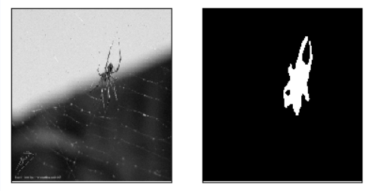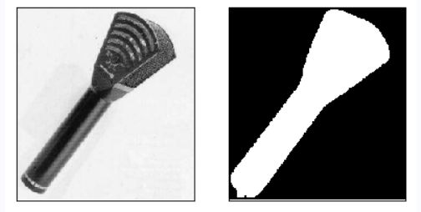

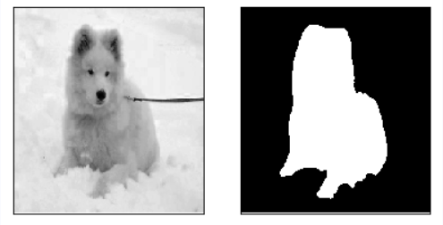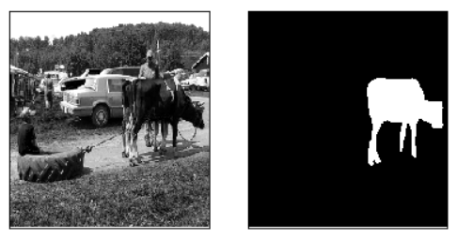

# 三、网络模型搭建

## 3.1 UNet

U-Net网络结构因为形似字母“U”而得名，最早是在医学影像的细胞分割任务中提出，结构简单适合处理小数量级的数据集。比较于FCN网络的像素相加，U-Net是对通道进行concat操作，保留上下文信息的同时，加强了它们之间的语义联系。整体是一个Encode-Decode的结构，如下图所示。

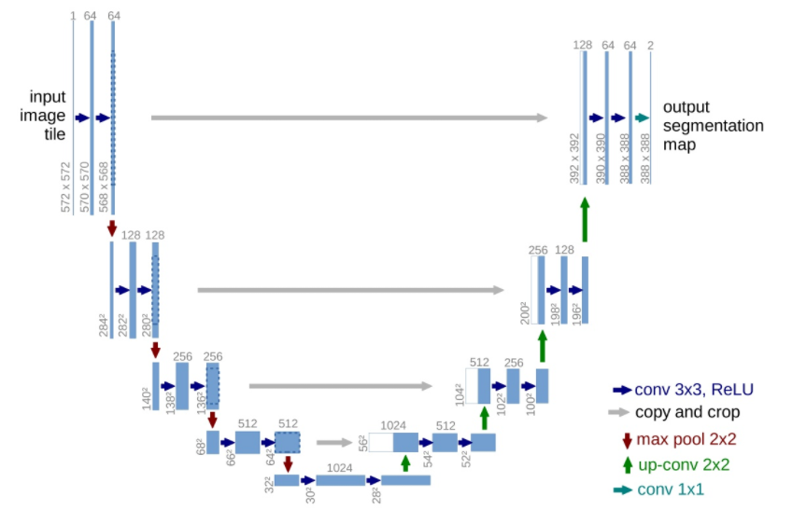

* **知识点1**:下采样Encode包括conv和max pool，上采样Decode包括up-conv和conv。
* **知识点2**:U-Net特点在于灰色箭头，利用通道融合使上下文信息紧密联系起来。

"""

paddlepaddle-gpu==2.2.1

time:2021.07.16 9:00

author:CP

backbone：U-net

"""

import paddle

from paddle import nn

class Encoder(nn.Layer):#下采样：两层卷积，两层归一化，最后池化。

    def __init__(self, num_channels, num_filters):

        super(Encoder,self).__init__()#继承父类的初始化

        self.conv1 = nn.Conv2D(in_channels=num_channels,

                              out_channels=num_filters,

                              kernel_size=3,#3x3卷积核，步长为1，填充为1，不改变图片尺寸[H W]

                              stride=1,

                              padding=1)

        self.bn1   = nn.BatchNorm(num_filters,act="relu")#归一化，并使用了激活函数

        self.conv2 = nn.Conv2D(in_channels=num_filters,

                              out_channels=num_filters,

                              kernel_size=3,

                              stride=1,

                              padding=1)

        self.bn2   = nn.BatchNorm(num_filters,act="relu")

        self.pool  = nn.MaxPool2D(kernel_size=2,stride=2,padding="SAME")#池化层，图片尺寸减半[H/2 W/2]

    def forward(self,inputs):

        x = self.conv1(inputs)

        x = self.bn1(x)

        x = self.conv2(x)

        x = self.bn2(x)

        x_conv = x           #两个输出，灰色 ->

        x_pool = self.pool(x)#两个输出，红色 |

        return x_conv, x_pool

class Decoder(nn.Layer):#上采样：一层反卷积，两层卷积层，两层归一化

    def __init__(self, num_channels, num_filters):

        super(Decoder,self).__init__()

        self.up = nn.Conv2DTranspose(in_channels=num_channels,

                                    out_channels=num_filters,

                                    kernel_size=2,

                                    stride=2,

                                    padding=0)#图片尺寸变大一倍[2*H 2*W]

        self.conv1 = nn.Conv2D(in_channels=num_filters*2,

                              out_channels=num_filters,

                              kernel_size=3,

                              stride=1,

                              padding=1)

        self.bn1   = nn.BatchNorm(num_filters,act="relu")

        self.conv2 = nn.Conv2D(in_channels=num_filters,

                              out_channels=num_filters,

                              kernel_size=3,

                              stride=1,

                              padding=1)

        self.bn2   = nn.BatchNorm(num_filters,act="relu")

    def forward(self,input_conv,input_pool):

        x = self.up(input_pool)

        h_diff = (input_conv.shape[2]-x.shape[2])

        w_diff = (input_conv.shape[3]-x.shape[3])

        pad = nn.Pad2D(padding=[h_diff//2, h_diff-h_diff//2, w_diff//2, w_diff-w_diff//2])

        x = pad(x)                                #以下采样保存的feature map为基准，填充上采样的feature map尺寸

        x = paddle.concat(x=[input_conv,x],axis=1)#考虑上下文信息，in_channels扩大两倍

        x = self.conv1(x)

        x = self.bn1(x)

        x = self.conv2(x)

        x = self.bn2(x)

        return x

class UNet(nn.Layer):

    def __init__(self,num_classes=59):

        super(UNet,self).__init__()

        self.down1 = Encoder(num_channels=  3, num_filters=64) #下采样

        self.down2 = Encoder(num_channels= 64, num_filters=128)

        self.down3 = Encoder(num_channels=128, num_filters=256)

        self.down4 = Encoder(num_channels=256, num_filters=512)

        self.mid_conv1 = nn.Conv2D(512,1024,1)                 #中间层

        self.mid_bn1   = nn.BatchNorm(1024,act="relu")

        self.mid_conv2 = nn.Conv2D(1024,1024,1)

        self.mid_bn2   = nn.BatchNorm(1024,act="relu")

        self.up4 = Decoder(1024,512)                           #上采样

        self.up3 = Decoder(512,256)

        self.up2 = Decoder(256,128)

        self.up1 = Decoder(128,64)

        self.last_conv = nn.Conv2D(64,num_classes,1)           #1x1卷积，softmax做分类

    def forward(self,inputs):

        x1, x = self.down1(inputs)

        x2, x = self.down2(x)

        x3, x = self.down3(x)

        x4, x = self.down4(x)

        x = self.mid_conv1(x)

        x = self.mid_bn1(x)

        x = self.mid_conv2(x)

        x = self.mid_bn2(x)

        x = self.up4(x4, x)

        x = self.up3(x3, x)

        x = self.up2(x2, x)

        x = self.up1(x1, x)

        x = self.last_conv(x)

        return x

paddle.summary(UNet(), (1, 3, 600, 600))

**3.2 PSPNet**

Pyramid Scene Parsing Network（PSPNet）网络结构形似金字塔而被命名，能够聚合不同尺度下的上下文信息，在场景解析上有很好的效果。PSPNet的精髓在于pyramid parsing module的构建，能够增大深层区域的感受野。

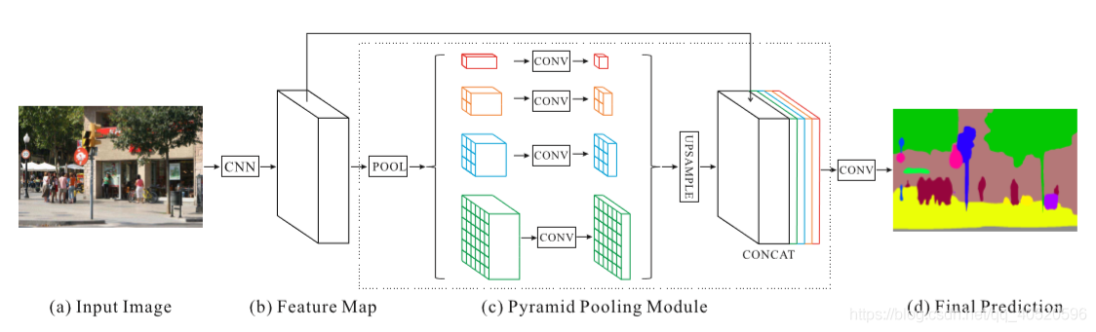

* **知识点1**:多尺度特征融合可以提高模型性能，深层网络中包含更多的语义信息和较小的位置信息。
* **知识点2**:input image需要通过CNN网路提取特征，这里使用的是飞桨预训练的resnet50网络。

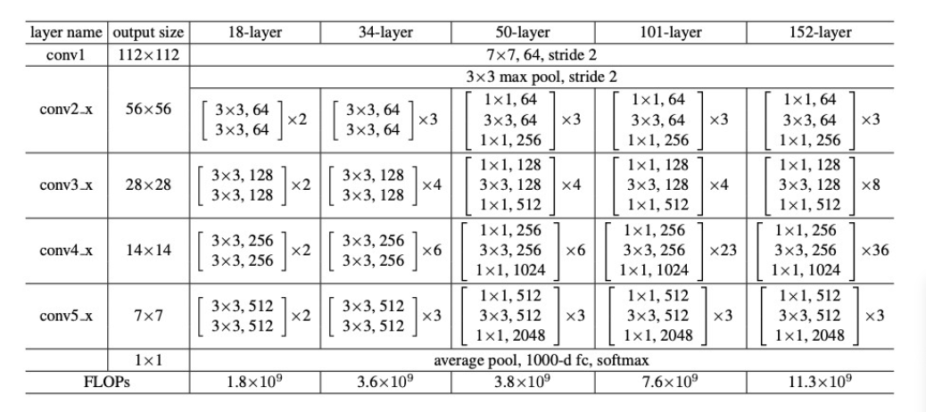

* **知识点3**:PSPmodule将CNN的输出划成四个通道，然后进行上采样，全局特征和局部特征进行融合得到2C通道。

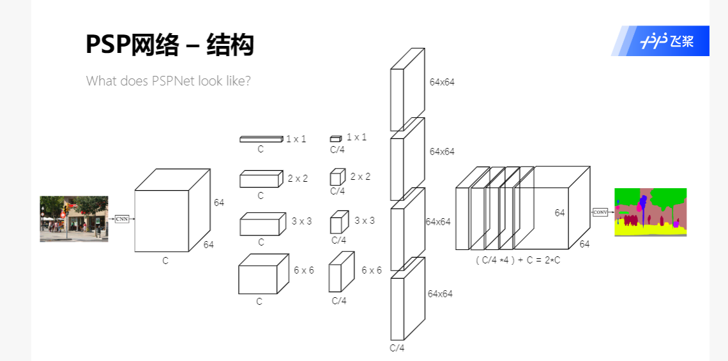

"""

paddlepaddle-gpu==2.2.1

time:2021.07.16 9:00

author:CP

backbone：PSPnet

"""

import paddle

import paddle.nn as nn

class PSPModule(nn.Layer):

    """

    num_channels：输入通道数为C

    num_filters ：输出通道数为C/4

    bin_size_list=[1,2,3,6]

    get1:

        nn.LayerList创建一个空列表的层

        .append拼接“层”的列表

    get2:

        paddle.nn.AdaptiveMaxPool2D输出固定尺寸的image_size[H,W]

        paddle.nn.functional.interpolate卷积操作后，还原图片尺寸大小

        paddle.concat [H,W]同尺寸的图片，合并通道[C]

    """

    def __init__(self, num_channels, bin_size_list):

        super(PSPModule,self).__init__()

        num_filters = num_channels // len(bin_size_list) #C/4

        self.features = nn.LayerList()         #一个层的空列表

        for i in range(len(bin_size_list)):

            self.features.append(

                paddle.nn.Sequential(

                    paddle.nn.AdaptiveMaxPool2D(output_size=bin_size_list[i]),

                    paddle.nn.Conv2D(in_channels=num_channels, out_channels=num_filters, kernel_size=1),

                    paddle.nn.BatchNorm2D(num_features=num_filters)

                )

            )

    def forward(self, inputs):

        out = [inputs] #list

        for idx, layerlist in enumerate(self.features):

            x = layerlist(inputs)

            x = paddle.nn.functional.interpolate(x=x, size=inputs.shape[2::], mode='bilinear', align_corners=True)

            out.append(x)

        out = paddle.concat(x=out, axis=1) #NCHW

        return out

from paddle.vision.models import resnet50

class PSPnet(nn.Layer):

    def __init__(self, num_classes=59, backbone='resnet50'):

        super(PSPnet, self).__init__()

        """

        https://github.com/PaddlePaddle/Paddle/blob/release/2.1/python/paddle/vision/models/resnet.py

        重复利用resnet50网络模型：

            1.初始化函数关键词——backbone

            2.神经网络模型实例化

            3.源代码查找层的变量名

        """

        # resnet50 3->2048

        res = resnet50()

        self.layer0 = nn.Sequential(res.conv1, res.bn1, res.relu, res.maxpool)

        self.layer1 = res.layer1

        self.layer2 = res.layer2

        self.layer3 = res.layer3

        self.layer4 = res.layer4#输出通道为2048

        #pspmodule 2048->4096

        num_channels = 2048

        self.pspmodule = PSPModule(num_channels, [1,2,3,6])

        num_channels *= 2

        #cls 4096->num_classes

        self.classifier = nn.Sequential(

                             nn.Conv2D(num_channels,512,3,1,1),

                             nn.BatchNorm(512,act='relu'),

                             nn.Dropout(),

                             nn.Conv2D(512,num_classes,1))

        #aux:1024->256->num_classes

        #单独分离出一层来计算函数损失

    def forward(self,inputs):

        x = self.layer0(inputs)

        x = self.layer1(x)

        x = self.layer2(x)

        x = self.layer3(x)

        x = self.layer4(x)

        x = self.pspmodule(x)

        x = self.classifier(x)

        x = paddle.nn.functional.interpolate(x=x, size=inputs.shape[2::], mode='bilinear', align_corners=True)

        return x

paddle.summary(PSPnet(), (1, 3, 600, 600))

**3.3 Deeplabv3**

空洞卷积（Dilatee/Atrous Convolution）是一种特殊的卷积算子，针对卷积神经网络在下采样时图像分辨率降低、部分信息丢失而提出的卷积思路，通过在卷积核中添加空洞以获得更大的感受野。

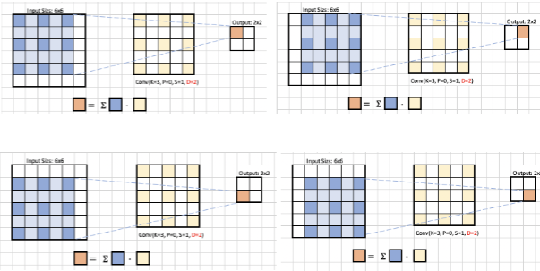

* 3x3卷积核，dilation rate 分别为1， 2， 4，空洞部分填充零。
* 输入大小为[H，W]，卷积核大小为{FH，FW]，填充为P，步幅为S，计算输出大小

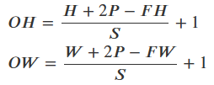

* 3x3卷积核可以等效为5x5，假设卷积核大小k=3，空洞数d=2，则等效卷积核k‘，感受野RF，第一层感受野为3，Si为之前所有层步长的乘积。RFa=3，RFb=5，RFc=8。

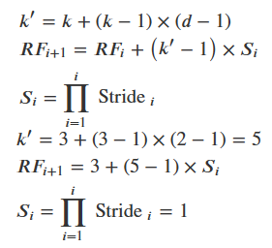

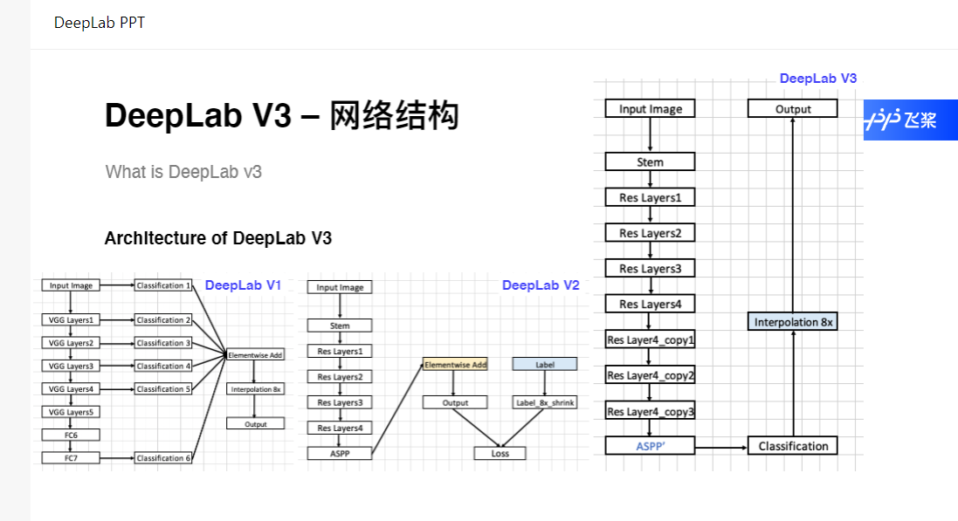

"""

paddlepaddle-gpu==2.2.1

time:2021.07.20 9:00

author:CP

Deeplabv3

"""

import paddle

import paddle.nn as nn

class ASPPPooling(nn.Layer):

    def __init__(self,num_channels,num_filters):

        super(ASPPPooling,self).__init__()

        self.adaptive_pool = nn.AdaptiveMaxPool2D(output_size=3)

        self.features = nn.Sequential(

                                        nn.Conv2D(num_channels, num_filters,1),

                                        nn.BatchNorm(num_filters, act="relu")

                                          )

    def forward(self, inputs):

        n1, c1, h1, w1 = inputs.shape

        x = self.adaptive_pool(inputs)

        x = self.features(x)

        x = nn.functional.interpolate(x, (h1, w1), align_corners=False)

        return x

class ASPPConv(nn.Layer):

    def __init__(self,num_channels,num_filters,dilations):

        super(ASPPConv,self).__init__()

        self.asppconv = nn.Sequential(

                            nn.Conv2D(num_channels,num_filters,3,padding=dilations,dilation=dilations),

                            nn.BatchNorm(num_filters, act="relu")

                            )

    def forward(self,inputs):

        x = self.asppconv(inputs)

        return x

#ASPP模块最大的特点是使用了空洞卷积来增大感受野

class ASPPModule(nn.Layer):

    def __init__(self, num_channels, num_filters, rates):

        super(ASPPModule, self).__init__()

        self.features = nn.LayerList()

        #层一

        self.features.append(nn.Sequential(

                                        nn.Conv2D(num_channels, num_filters,1),

                                        nn.BatchNorm(num_filters, act="relu")

                                          )

                            )

        #层二

        for r in rates:

            self.features.append(ASPPConv(num_channels, num_filters, r))

        #层三

        self.features.append(ASPPPooling(num_channels, num_filters))

        #层四

        self.project  = nn.Sequential(

                                    nn.Conv2D(num_filters*(2+len(rates)), num_filters, 1),#TODO

                                    nn.BatchNorm(num_filters, act="relu")

                                     )

    def forward(self, inputs):

        out = []

        for op in self.features:

            out.append(op(inputs))

        x = paddle.concat(x=out,axis=1)

        x = self.project(x)

        return x

class DeeplabHead(nn.Layer):

    def __init__(self, num_channels, num_classes):

        super(DeeplabHead, self).__init__()

        self.head = nn.Sequential(

                            ASPPModule(num_channels, 256, [12, 24, 36]),

                            nn.Conv2D(256, 256, 3, padding=1),

                            nn.BatchNorm(256, act="relu"),

                            nn.Conv2D(256, num_classes, 1)

                            )

    def forward(self, inputs):

        x = self.head(inputs)

        return x

from paddle.vision.models import resnet50

from paddle.vision.models.resnet import BottleneckBlock

class Deeplabv3(nn.Layer):

    def __init__(self, num_classes=59, backbone='resnet50'):

        super(Deeplabv3, self).__init__()

        # resnet50 3->2048

        # resnet50 四层layers = [3 4 6 3]

        # 调用resnet.py模块，空洞卷积[2 4 8 16]

        res = resnet50()

        res.inplanes = 64        #初始化输入层

        self.layer0 = nn.Sequential(res.conv1, res.bn1, res.relu, res.maxpool)

        self.layer1 = res._make_layer(BottleneckBlock, 64,3)

        self.layer2 = res._make_layer(BottleneckBlock,128,4)

        self.layer3 = res._make_layer(BottleneckBlock,256,6)

        self.layer4 = res._make_layer(BottleneckBlock,512,3,stride=2,dilate= 2) #dilation=2

        self.layer5 = res._make_layer(BottleneckBlock,512,3,stride=2,dilate= 4) #dilation=4

        self.layer6 = res._make_layer(BottleneckBlock,512,3,stride=2,dilate= 8) #dilation=8

        self.layer7 = res._make_layer(BottleneckBlock,512,3,stride=2,dilate=16) #dilation=16

        feature_dim = 2048      #输出层通道2048

        self.deeplabhead = DeeplabHead(feature_dim, num_classes)

    def forward(self, inputs):

        x = self.layer0(inputs)

        x = self.layer1(x)

        x = self.layer2(x)

        x = self.layer3(x)

        x = self.layer4(x)

        x = self.layer5(x)

        x = self.layer6(x)

        x = self.layer7(x)

        x = self.deeplabhead(x)#ASPP模块进行分类

        # 恢复原图尺寸

        x = paddle.nn.functional.interpolate(x=x, size=inputs.shape[2::], mode='bilinear', align_corners=True)

        return x

paddle.summary(Deeplabv3(), (1, 3, 600, 600))

# 四、高层API训练

CodeMarkdown

## 4.1 模型训练

#模型参数保存路径

work_path = "/home/aistudio/net_params/"

if os.path.exists(work_path):

    shutil.rmtree(work_path)

os.mkdir(work_path)

#实例化，网络三选一，默认U-Net

model = paddle.Model(UNet(2))       #U-Net

# model = paddle.Model(PSPnet(2))    #PSPNet

#model = paddle.Model(Deeplabv3(2)) #Deeplabv3

"""

beta1 = paddle.to_tensor([0.9], dtype="float32")

beta2 = paddle.to_tensor([0.99], dtype="float32")

opt=paddle.optimizer.Adam(learning_rate=1e-3

                            , beta1=0.9

                            , beta2=0.999

                            , epsilon=1e-08

                            , parameters=model.parameters()

                            , weight_decay=1e-2

                            , grad_clip=None

                            , name=None

                            )

"""

#定义优化器和损失函数

opt=paddle.optimizer.Momentum(learning_rate=1e-3,parameters=model.parameters(),weight_decay=1e-2)

model.prepare(opt, paddle.nn.CrossEntropyLoss(axis=1))

#启动模型训练

model.fit(train_dataloader, eval_dataloader, epochs=10,verbose=2,save_dir="./net_params",log_freq=200)

**4.2 模型预测**

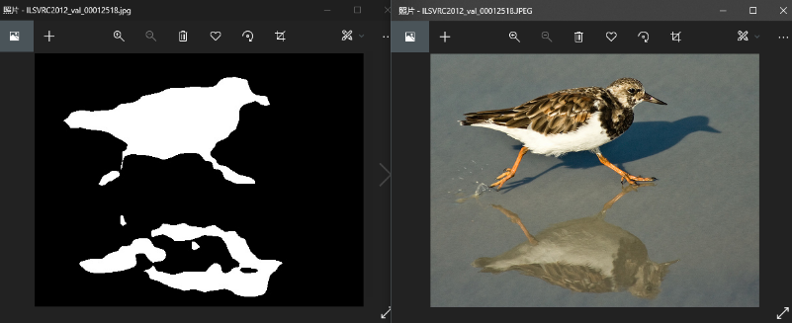

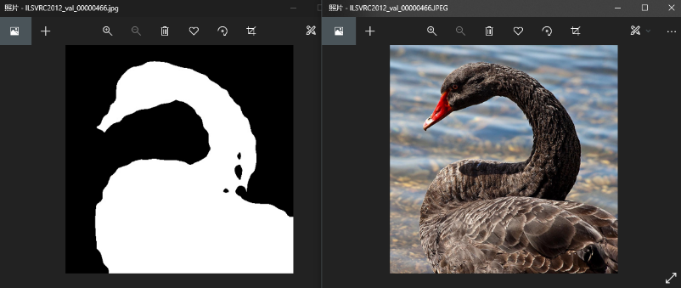

#预测图像保存路径

work_path = "/home/aistudio/data/val_label"

if os.path.exists(work_path):

    shutil.rmtree(work_path)

os.mkdir(work_path)

#读取模型参数文件路径

save_dir=work_path

checkpoint_path="./net_params/final"

#实例化，网络三选一，默认U-Net

model = paddle.Model(UNet(2))       #U-Net

#model = paddle.Model(PSPnet(2))    #PSPNet

#model = paddle.Model(Deeplabv3(2)) #Deeplabv3

model.load(checkpoint_path)

for i,img in tqdm(enumerate(test_dataset)):

    img=paddle.to_tensor(img).unsqueeze(0)

    predict=np.array(model.predict_batch(img)).squeeze(0).squeeze(0)

    predict=predict.argmax(axis=0)

    image_path=test_dataset.path[i]

    path_lst=image_path[0].split("/")

    save_path=os.path.join(save_dir,path_lst[-1][:-5])+".jpg"

    cv2.imwrite(save_path,predict*255)