What is Angular:-

* It is java script framework that creates SPA applications.
* SPAS are basically everything loaded from the server in single HTML file. Then without page refresh, we see different content. That is, angular JS replaces DOM at run time.
* In angular application, we use components. These component supported by files like



* .ts file .html files are connected.
* Typescript is superset of Java script and has classes, interfaces and variables types checked strongly.

Q: How to bootstrap our angular app ?

A: In .angular-cli.json fie, add

"styles": [

"styles.css",

"../node_modules/bootstrap/dist/css/bootstrap.min.css"

Q: How angular starts up

A: In index.html file, we use angular created component <<app-root>>. Angular by itself includes javascripts in index.html and load main.ts.

This main.ts calls AppModule->AppComponent->AppComponent.html

Q: What is component ?

A: Angular application is basically collections of components. Initially, we have root component. Then we build our own components that could have their own styling , business logic. And moreover,

This is good from modularity perspective coz that increases reusability.

Q: what is a Module

A: Our components bundled into modules. An application can have many modules.

🡪 A .ts file must file must have template or templateURL. Here , template means our html file.

🡪 A component is selectable using selector, by attribute or using .class type (as we use in css)

Q: What are Directives?

A: They are instructions for DOM!. E.g. <p app-turn-green></p>, ngIf etc..

Q: what is ngStyle,ngIF

A: ngIF is an structural directive. ngStyle is an attribute directive like HTML attribute.

Q: ngClass: It is used to add/remove CSS classes to our DOM elements.

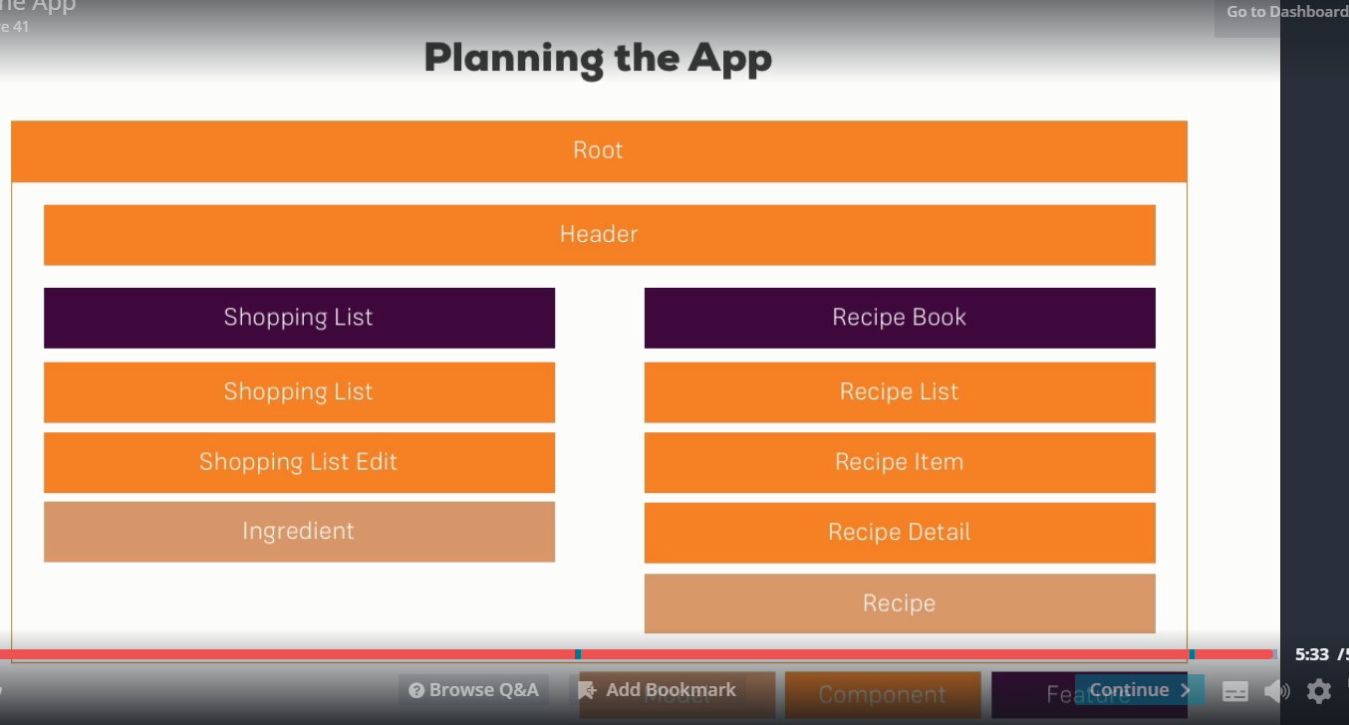

Q: How to install latest version of bootstrap.

A: Go to project folder. Run the command : npm install –save bootstrap

Inform angular about using bootstrap. We can do this by below in .angular-cli.json :-

"styles": [

"styles.css",

"../node_modules/bootstrap/dist/css/bootstrap.min.css"

],

Q: How to create a component.

A: ng g c recipes –spec false ng g c recipes/recipies-list –spec false [spec is testing purpose.]

Q: *ngFor ??

A: It allowed repeat of code in our template.

Q: F12 developer tool , we have source maps. It is a map b/w main.bundle.js and our source ts files. It helps us to put a debug point. Similar, we have angular augular.