

SCHOOL OF SCIENCE AND TECHNOLOGY
SOFTWARE ENGINEERING 1
MODULE CODE: SOFT40121

Program Development Project

SUBMITTED
BY
PURNIMA MALNEEDI
STUDENT ID: N0768969
SUBMITTED TO
Dr Neil Sculthorpe

Submission Date: 16-01-2018

Contents

1. Introduction 3
2. Specification 4
3. Design 5
4. Testing 7
5. Implementation 9
6. Analysis and conclusion 9
7. References 9

Introduction

This report describes the application specifications, design, testing and analysis for University course finder.
University Course finder is a C# console application which is used by both students and admin staff to search for courses available and the brief description of each course and student registration with the course code.
Application will first ask whether it is student or admin who is trying to access. If it is admin then admin credentials will be asked and validated. Once after he/she logged in can search for list of courses, with in detail description of each course and existing student details with the username provided by the student. In addition admin will be provided access to directory files where he/she can manually modify the course file also admin will be provided access to student records to change the student details manually upon student request.
If student is accessing the application then it will ask whether he/she want to login or search for the course. If student want to search for a course he/she will be asked to enter the course code to see the in detail description of that particular code. They can do as many searches until they find the right course. Once the course code is decided by the student, he/she will be asked to register for that course or not. If he/she chooses to register then program will prompt to enter his personal details and it will ask student to generate password. Password will be validated by the system and system will generate unique random student ID/Username and it will be displayed to the student along with course code to use it for future logins and then exit the program. Also all these details will be stored in a text file with the name of student ID including login details (User ID and password) in to predefined path.
If Student choose to login he/she will be asked to enter his credentials and application will validate whether user exists or not and then will verify password as well. If the credentials were not matching with existing details, corresponding message will be displayed to the student. If student able to login, console will display the student details and will prompt student to change his course. If student choose to change the course then console will display the course list following with registration process as discussed above. Once he complete the process console will display the message with the same User Name and the modified course code then exit the console application. Also system will overwrite the details entered by the student in the same student file.
Apart from this if student want to change any single particular information like address, phone number or course code he/she can contact admin to change the particular information. Then admin can manually access the student file with the username provided by the student and can modify the details.

Specification
System Requirements:
To run this application without any interruptions it’s better to check compatibility of the system and application. The key requirements are discussed below.
- Microsoft Visual Studio Community 2017
- Version 15.3.5 and above
- Course file path should be matched with the path as stated in code file.
- Student file path should match with the path as stated in code file.
Program Features:
The application provides below key features for students and admin, those are explained below
Admin:
- Admin can view the list of courses available.
- Admin can see full course description by entering the required course code.
- Admin can go back to the course list again and again until he completes his search.
- Admin can search for the student details with the student user name (Student ID).
- Admin can view all student details if the Student ID matches with existing student list.

Student:
- Student can view the list of courses available.
- Student can see full course description by entering the particular course code.
- Student can go back to the course list again and again until he founds the suitable course that matches with their interest.
- Student can proceed with registration with the course code that they choose.
- Student will be asked to enter their personal details along with password creation. Then unique random student ID will be generated and displayed to the student. Also all these details will be stored to a text file with the name of newly generated unique student ID.
- Student can login to view student details including course code using their username and password that is created as part of registration.
- Student username and Password will be validated by the application, so that only a valid user can access the particular details.
- Student can modify their details and also they can change to different course if they want at any time.

Design
The below flow chart explains the program flow of the application for student and admin.

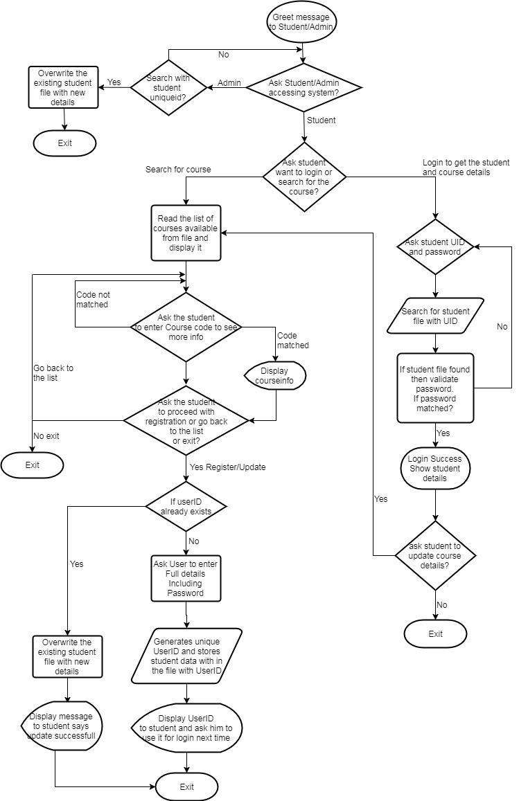
I have used below key data structures to achieve the goals that are shown in the above flow chart.
- Stream Reader
- Lists
- Arrays
- Stream Writer
- System functions (Random)
- Try Catch and Throw
- Procedure and Functions
- Conditional Statements: IF
- Loop Statements: For and Do While

Please find the description of data structures used in the University course finder application.
- Stream Reader to read the course files and descriptions.
- Lists to display the student details. In addition used Steam Reader to read each line from student file and add them to the list to display it in the console.
- Used string Array to prompt the student details in the console. Once student enters all his details then all the details will be saved to List which will then be written to a file using stream Writer.
- Used predefined system function ‘random’ to generate the unique student id.
- Used Try and Catch in most of the places to handle the exceptions. Used Throw to explicitly raise the exception.
- Functions and Procedures are used to eliminate the reusable/duplicated code. For example in my program I have got many cases where user will be prompted by some message and will be asked to enter their choice. For this I have created ‘readUserChoice’ function to prompt and read the user choice.
- Used conditional statements IF to perform the conditional based logic.
- Used loop statements, do while and for to perform some tasks multiple times. For example do while is used to validate the user password and repeat for 3 times if user enters invalid password. Similarly for is used to loop through the student details List and display the list elements.
In this program I have used plain text files to store the student and course details. Because they are easy to read and can be easily modified by the admin for the ease of single particular detail modification, where as in console application all details need to be reentered even if student want to change any single parameter.

Testing
Software testing is a process of executing a program or application with the intent to find the below [1]
- To find the bugs in the application.
- To validate and verify whether the application meets the requirements of the design [1].
- Works without any errors.

Following test cases expected to be tested as part of unit testing the application. Test specifications for admin and student explained below.
Admin:
Search for Course:
- Admin should only be allowed to use the application if they enter valid credentials.
- Admin should only get 3 attempts to enter the valid username and valid password. Appropriate message should be displayed for in correct credentials.
- Admin should be able to see the entire course available which includes course code and course name. If no courses available then appropriate message should be displayed.
- Admin should be able to see the full description of the course by entering valid course code.
- Admin should be able to go back to course list if the course description is not matched with the student requirements. The process should repeat until they find the right choice or want to exit.
Search for student:
- Admin should be able to search for student details using student ID (Username). If the student file not exists with the student id then appropriate message should be displayed.
- As an admin no need to enter password to read the student details.
- Admin should be able to read the student details from the console if student id exists.

Student:
Search and Register for Course:
- Student should be able to see the entire course available which includes course code and course name. If no courses available then appropriate message should be displayed.
- Student should be able to see the full description of the course by entering valid course code.
- Student should be able to go back to course list if the course description is not matched with the student requirements. The process should repeat until they want to search again.
- Student should be asked to carry on with the registration if student like the course.
- Student should be prompted to enter their full details (like forename, surname etc.) including password. Some user faulty inputs handled here like if user enter a blank string or enter key by mistake then same message will be prompted again.
- Student should be asked to enter password twice and it should be validated, if the both passwords not matched then password should be asked again. Password should only be asked 3 times in case of incorrect password entered and should exit the program if student exceeds 3 times.
- Student should able to complete registration after giving all the details. A unique student id should be generated and displayed to the student with appropriate message.
Login and Update student and course details:
- Student should only be allowed to login if they enter valid credentials.
- Student should be asked to enter Username. If the student file not exist with the username then message should be displayed and exit the application.
- Student should only get 3 attempts to enter the valid password if the student ID found. Appropriate message should be displayed for in correct credentials.
- Student should be able to read the student details from the console if student id exists.
- Student should be asked to change the course details.
- If student wants to change the course then registration process will repeat again to display the courses and read the student details. But the existing student ID file should be overwritten with the new details instead of creating new id again.
Apart from the above standard test cases there are some tests should be performed for the user faulty inputs. I have taken care of this in my program.
- In my program there are several options will be prompted to the user and read the user choices.
For example student will be given options 1.search for the course 2.login. Here user should enter 1 or 2. But if user enters 3-9 or some string value then question will be prompted again instead of throwing exception.
User faulty input test scenarios:
- All the user options should be prompted again if user enters the input value outside of the range
- All the user options should be prompted again if user enters the string value or blank string for multiple choice kinds of options.
- For string input options (student details like forename, surname etc.) message should be prompted again if user enters blank string
I have ensured that all the above test cases executed on my program successfully.

Implementation
I have faced small issue in my code when I am reading the student details from the file. Because the file consists of all the details line by line, student password is stored in 11th line. As we don’t have any kind of specific command to identify the password in a text file I have used hard coded value.

As I have used plain text files to store the student details includes password. I thought it would be better to encrypt the password instead of saving directly. I have looked at some options but they are at advanced level than what I have read so far. So I thought of leave it for now and concentrated on familiar topics to accomplish the task.

Analysis and conclusion
Finally I can conclude that my program meets the all requirements that I have expected to do. However there are some improvements can be made to the program to give more features and better error handling in some scenarios. It is good to have Update student details functionality for Admin instead of manual updates in the file. It is good to implement the code that courses can be categorized into groups, so that user can easily search for required category instead of searching all the courses. For example a computing student can be able to search for computer related courses only.

I have written this program in best possible way as I can. However If I would have to do this program again then I will write all the possible requirements upfront with proper time estimates. So that I will know whether I can achieve the target on time with all the required tasks.

References
- Istqbexamcertification.com. (2018). What is Software Testing?. [online] Available at: http://istqbexamcertification.com/what-is-software-testing/ [Accessed 15 Jan. 2018].

