 if j not in C, which is prepared from corpus, how to find it

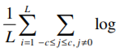

1/0

C: R Lx 1

Context  
(One hot encoded)

T: R L x 1

Target (One hot encoded)

H: R m x L

V: R L x m

U: R L x m