AccessPath Verifier — Technical Build Brief
Card-based joint architecture for the accessibility verification engine

What we're building
A tool that tests architectural floor plans against avatars representing people with various mobility and functional limitations, to verify whether a design is actually usable (can this person reach the outlet, clear the doorway, transfer to the shower) before it gets built.

Core concept
Instead of building one full-body model per named diagnosis (a “arthritis avatar,” a “stroke avatar”), the body is decomposed into independent joint cards — shoulder, elbow, wrist, hip, knee, ankle, etc. Each card holds baseline (able-bodied) range of motion plus optional overrides. A named condition is just a set of overrides applied to specific cards — never a separate model. This is the same approach used in the published virtual-user-modeling research we sourced (VERITAS/Applied Ergonomics 2015): disabilities are modeled as ~100+ independent functional parameters, not as single labeled shapes.

Six-step pipeline
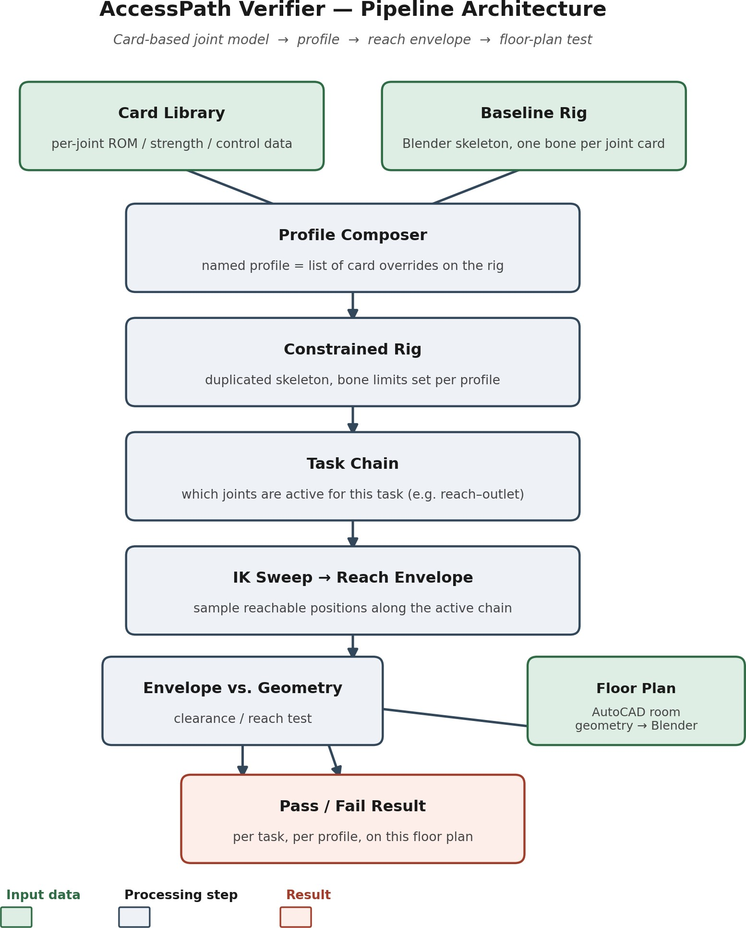

1. Baseline rig
One Blender skeleton with a bone for every joint in the card taxonomy. This is the neutral, no-disability control avatar. Card baseline values populate Blender's Limit Rotation constraints on each bone.
Done means: The skeleton exists with all joints named to match the card list, and an unconstrained avatar moves and poses correctly.

2. Card library (data, not geometry)
A JSON/spreadsheet/small database — separate from the .blend file — holding baseline ROM plus condition-specific overrides per joint. Each entry carries a source citation and a status (sourced / interpolated / placeholder), so it's always clear what's real data versus a stand-in.
Done means: A new citation for one joint/condition can be entered by editing one row, with zero changes to rigging or geometry.

3. Profile composer
A script that takes a named profile (a list of card overrides — e.g. “moderate stroke, right hemiparesis”) and rewrites the bone constraints on a duplicated skeleton accordingly.
Done means: Passing a profile name in produces a correctly constrained rig, with no manual constraint-editing.

4. Envelope generation
The constrained joint chain is swept through its allowed range using inverse kinematics (IKPy), sampling reachable hand/foot positions. The union of those positions is the reach envelope — computed from the cards, not hand-modeled per diagnosis.
Done means: For a given profile and chain, the tool outputs a reach volume without any per-diagnosis custom asset having been built.

5. Task chain
A task (e.g. “reach the wall outlet,” “clear the doorway”) specifies which joints are in play — shoulder–elbow–wrist plus trunk lean, for example — rather than testing the whole body at once.
Done means: A short list of named tasks exists, each mapped to a specific joint chain.

6. Floor-plan test
Room geometry, built in AutoCAD and imported into Blender, is checked against the generated envelope for that profile and task: pass or fail, per fixture or clearance.
Done means: A test room produces a pass/fail result per profile per task, viewable in Blender.

Card data schema
Fields every joint card needs, regardless of which condition it's describing:
Field | Holds
joint_id | e.g. shoulder_R, knee_L, wrist_R
parent_joint | What it's chained to (elbow's parent = shoulder)
DOF | Relevant axes for that joint (shoulder: flexion/extension, abduction/adduction, rotation)
baseline_ROM | Able-bodied min/max per axis, in degrees
condition_ROM | Override min/max per axis, tagged to a condition + severity
strength | Weight-bearing / push / pull capacity (categorical is fine if no numeric source exists)
control | Speed and steadiness — kept separate from range so tremor/spasticity/ataxia don't get forced into a pure angle limit
laterality | Symmetric, or independent left/right (needed for hemiplegia, single-limb loss)
dependency_flags | e.g. “requires free hand for balance” — how one card restricts what another can do at the same time
source | Citation, sample size, year
status | sourced / interpolated / placeholder

Build order
Cards are sourced and built incrementally — the verifier does not wait for every joint/condition combination to be complete before it's usable.
- Arm chain + trunk stability (shoulder–elbow–wrist–hand) — covers the most common test case, reach-to-fixture.
- Leg chain (hip–knee–ankle) — standing and transfer checks.
- Fine-motor / finger cards — hardest to source, least likely to be what fails a floor plan, built last.

Why this architecture
Fewer distinct assets are needed than one full model per diagnosis. The tool is usable with only some cards fully sourced — a card can ship as real data now and get upgraded later without touching the rig, the composer, or the envelope logic. Reuse is automatic: a shoulder card with reduced abduction applies equally to arthritis, stroke, or rotator cuff injury. Asymmetric conditions (hemiplegia, single-limb loss) are handled natively through independent left/right values, rather than needing a separate symmetric-vs-asymmetric model.

Current tech stack
MakeHuman | Open-source body shape generation
OpenSim | Clinically validated musculoskeletal modeling (Stanford SimBios) — reference/validation
IKPy | Open-source inverse kinematics library — drives the envelope sweep
Blender | Rig, constraints, envelope generation, floor-plan test scene
AutoCAD (student license) | Used only to build test-room geometry, imported into Blender — the product does not depend on AutoCAD
NHANES + peer-reviewed papers | Anthropometric and joint ROM data sourcing

Open sourcing gaps (as of this brief)
Still unsourced with a real citation: arthritis-specific reach reduction, KAFO/orthotic sweep width, and spatial-neglect cone angle. These should carry status “placeholder” in the card library until a citable source is found — the pipeline works with placeholders in place, it just flags them as not yet real.

AccessPath — internal build brief. Prepared for technical collaborator handoff.

