Venue Client Design 2.0
Futures Laboratory
Argonne National Laboratory
9700 S. Cass Ave.
Argonne, IL 60439

Introduction
The Venue Client is an Access Grid user’s interface to Virtual Venues. Through it, users enter venues, interact with their contents, start applications, and exchange data with the venue.

 | Requirement | Description
1.0
2.0
 | Follow/Lead
 | Permits users to follow/lead each other through the venue space
 | Shared application support
 | Provide interface for associating data types with applications
 | Dereference the data type/application associations to launch the appropriate application
 | Save data type/application associations in user configuration

Technology Decisions

Abstractions

VenueClient (base)

VenueClientUI

Interactions

Follow/Lead
A venue client is represented in a venue by its client profile. Each venue client runs a SOAP server, the URL of which is contained in its client profile. One user can, then, select a second user in the venue and make calls to its SOAP server. Calls to arrange follow/lead relationships between clients are made via this SOAP interface.

When a client enters a venue, it messages its followers to enter the same venue over the SOAP interface. A follower only responds to requests made by its registered leader.

Interactions between venue clients during follow/lead are outlined in the following sequence diagrams.

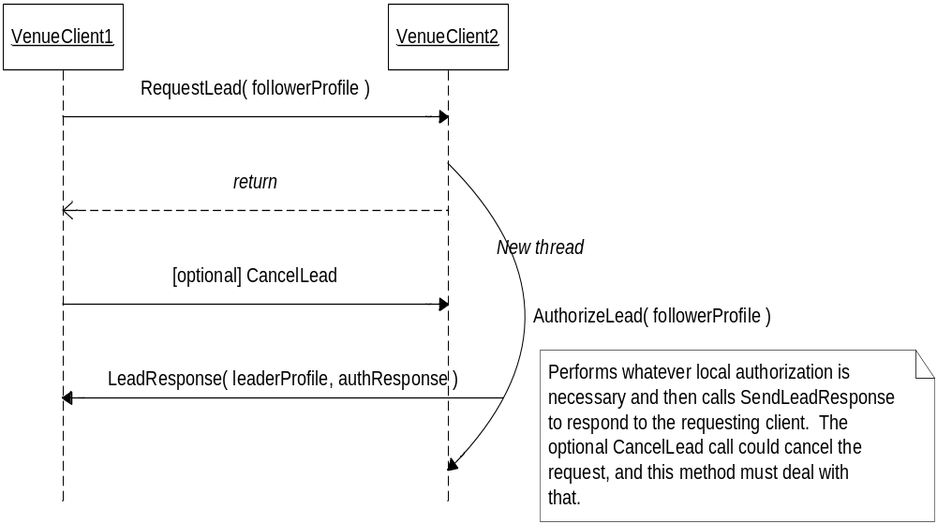Sequence diagram - Follow

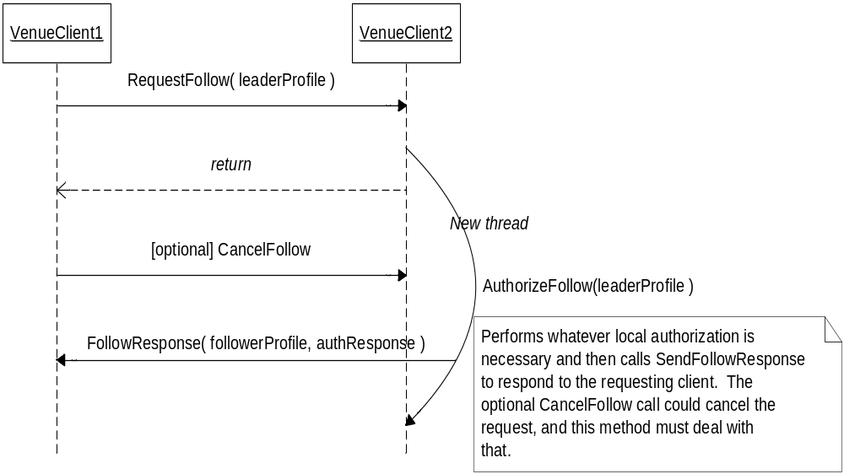Sequence diagram - Lead

Shared Application support
The venue client supports integration of shared applications for collaboration within a venue. This support consists of the following functionality:

Provide interface for adding applications to the venue
This interface will be very simple, requiring only an application name, description of the application, and a mimetype.

Provide interface for user to associate mimetypes with applications
This interface should be similar to that in a web browser. The user should be able to specify, for each mimetype, one shared application and one non-shared application.

Launch the appropriate application for a given mimetype
When a user chooses to join a shared application session in a venue, the client will examine the mimetype associated with the session, dereference the mimetype to the application specified by the user, and start the application. If the user has not specified an application for the mimetype, the venue client will prompt the user to specify one, launching the application when the association has been successfully completed.

The venue client will start the application with the following command-line:

[python] executable[.py] <appObjectUrl> <profileFile>

The executable may be a python script, in which case it will be executed as an argument to python. appObjectUrl is the URL to the application object web service; profileFile is the path to a file containing the user’s profile.

Interactions between the application component and the application object are outlined in the sequence diagram below.
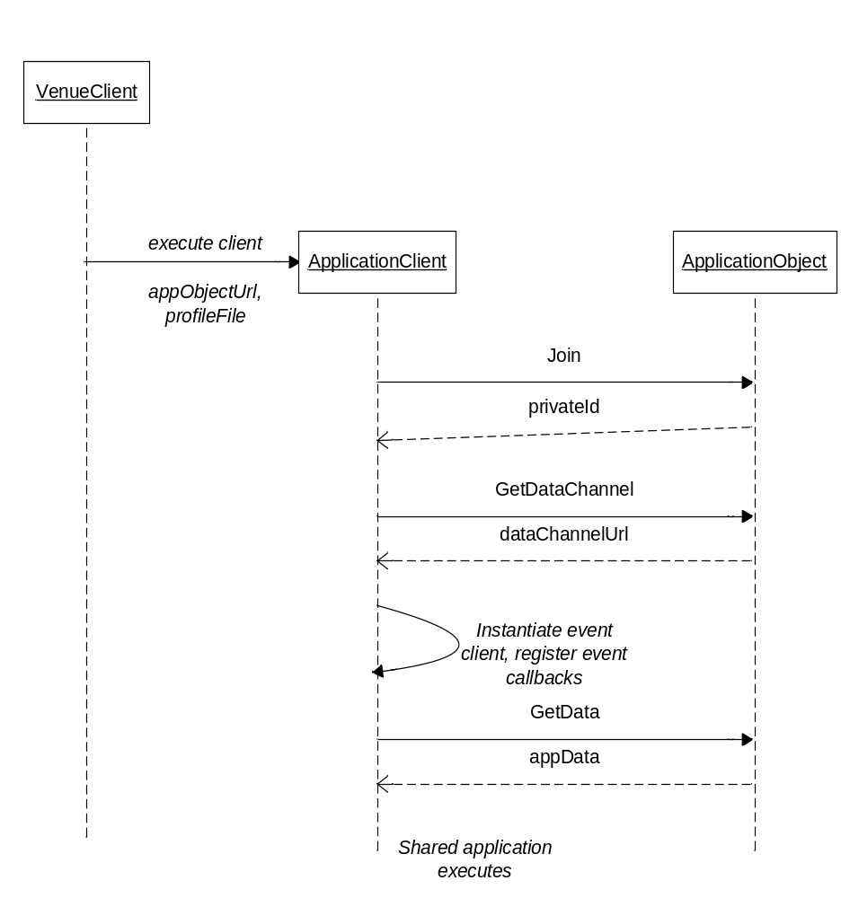
Sequence diagram – Shared applications

Specifications

Venue Client

Attribute | Descriptions
pendingLeader | Profile of user who’s been requested to lead this node, but hasn’t confirmed
leaderProfile | Profile of user leading this client
pendingFollowers : ClientProfile [] | List of profiles of users who’ve been requested to follow this client, but haven’t confirmed
followerProfiles : ClientProfile [] | List of profiles of users who are following this client
appAssociations : dict() | Dictionary of mimetype/executable associations  key is mimetype  value is executable name

Method Signature | Description
Methods to support Follow
RequestLead ( self, followerProfile ) | RequestLead accepts requests from other clients who wish to be lead
AuthorizeLead ( self, clientProfile ) | Authorize requests to lead this client.  Subclasses should override this method to perform their specific authorization, calling SendLeadResponse thereafter.
SendLeadResponse( self, clientProfile, response ) | SendLeadResponse responds to requests to lead other venue clients.
LeadResponse ( self, leaderProfile, isAuthorized ) | LeadResponse is called by other venue clients to respond to lead requests sent by this client. A UI client would override this method to give the user visual feedback to the Lead request.
Methods to support Lead
RequestFollow ( self, leaderProfile ) | RequestFollow accepts requests for other clients to lead this client
AuthorizeFollow ( self, leaderProfile ) | Authorize requests to lead this client.  Subclasses should override this method to perform their specific authorization, calling SendFollowResponse thereafter.
SendFollowResponse( self, leaderProfile,response ) | This method responds to requests to be led by other venue clients.
FollowResponse ( self, followerProfile, isAuthorized ) | FollowResponse is called by other venue clients to respond to follow requests sent by this client. A UI client would override this method to give the user visual feedback to the Follow request.
Methods to support Shared Applications
AddAppAssociation(mimeType, executable)
RemoveAppAssociation(mimeType)
GetAppAssociation(mimeType) : executable

Glossary

References

Notes

