Contents

1.0 Introduction 2
1.1 Background 2
1. 2 Overview 3
2. 0 Actions 4
2.1 Start Using Venue Management 4
2.1.1 Run Program 4
2.1.2 Set up Certificate 4
2.1.3 Create Grid Proxy 6
2.2 Start a Venue Server 7
2.3 Connect To a Venue Server 7
2.4 Add Venue 7
Title and Description 7
Encryption 7
Addressing 7
Exits 8
2.5 Modify Venue 8
2.6 Remove Venue 8
2.7 Add Administrator 9
2.8 Modify Administrator 9
2.9 Remove Administrator 9
2.10 Change Server Multicast Address 9
2.11 Change Server Storage Location 10
2.12 Change Server Encryption 10
3. Other Information 10
3.1 Certificates 10
3.1.1 What is a Certificate? 10
3.1.2 Why use Certificates? 11
3.1.3 Distinguished Name 11

1.0 Introduction

1.1 Background
The Access Grid is an internet-based model for video conferencing that focuses on group-to-group communication, using an ensemble of resources including multimedia large-format displays, presentation and interactive environments, and interfaces to Grid middleware and visualization environments. For instance, the Access Grid is used for large-scale distributed meetings, collaborative work sessions, seminars, lectures, tutorials, and training. Even though the Access Grid is concentrated on group interactions, it also provides an access point for individual desktop users, permitting one-to-many or one-to-one communication.

The virtual meeting space, where people come together to collaborate in the Access Grid, is called a Virtual Venue. If authorized, the Venue provides users with all the necessary information needed to communicate with each other, including audio and video streams, user capabilities, data, services, applications, and connections to other venues.

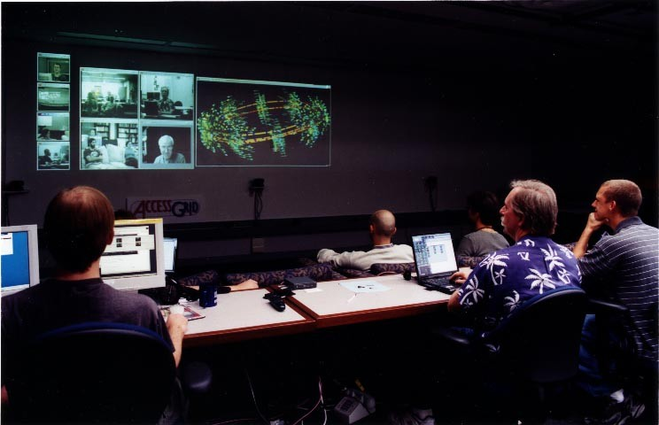
Every user connects to a Virtual Venue from their particular environment, identified as a Node, which contains collaborative resources needed to provide high-quality user experiences. Access Grid users are given the ability to layout nodes according to their own preference. Examples of node configurations could be a desktop using a Quick Camera or an entire room with several microphones, cameras, and advanced display environments. The image in Figure 1 shows one of several nodes available at Argonne National Laboratory.
Figure 1. A node at Argonne National Laboratory

1. 2 Overview
The Venue Management is an administrative tool used to create and maintain venues located on a server. It includes information about present venues on the server, their storage location, authorized administrators and what kind of encryption to use for media communication.

In Figure 2, you can see the Venue Management connected to a venue server at https://vv2:9000/VenueServer. The “Venues” tab is displaying a list of venues currently up and running with the selected venue’s information displayed to the right. The buttons, “Add”, “Modify”, and “Delete”, seen under the list, can be used to add a new venue or modify current selected venue in the list.

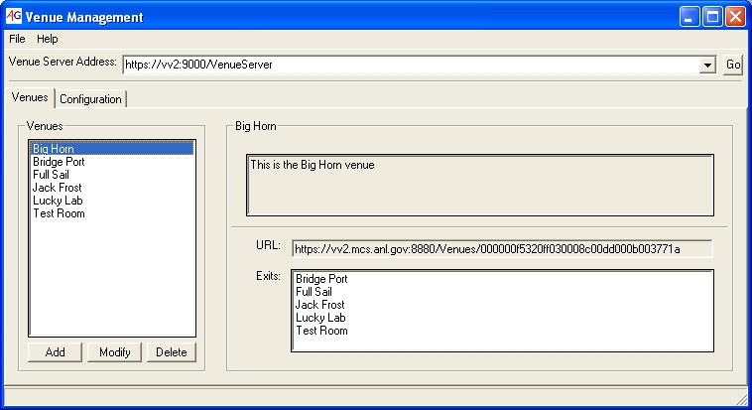
Figure 2. Venue Management, with focus on the "Venues" tab

The second tab, shown in Figure 3, includes details about the server configuration. Only administrators are allowed to change the venue server, their names are displayed on the list to the left. An administrator is allowed to add, modify, and remove other administrators using the buttons under the list. Multicast addresses are as default assigned from a standard range but can be customized to fulfill users’ needs. The “Storage Location” indicates where venues located on this server will save their data, each venue will use the path specified as a base for data storage. If the “Encryption Media” option is set all venues will, by default, use encrypted media streams. However, each venue gives you the option to change the encryption setting.

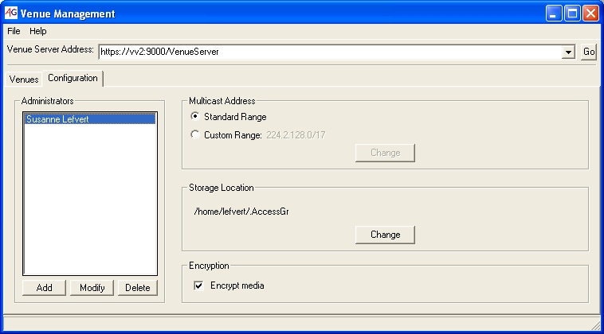
Figure 3. Venue Management, with focus on the "Configuration" tab

2. 0 Actions

2.1 Start Using Venue Management

2.1.1 Run Program
For Windows users:
Go to the Start menu and select “All Programs-Access Grid Toolkit-Venue Management”.

For Linux users:
Run VenueManagement.

2.1.2 Set up Certificate
In order to connect to a venue you have to have a valid grid certificate (for more information about certificates, see section 3.1).

For Windows users:
Go to “Get a Certificate” in the “Windows Globus” start menu. A window will appear prompting you for necessary information to create your certificate and the distinguished name you will be associated with (for more information about distinguished names read section 3.1.3). Please try to remember the password you select since you will be using this in the future. After you are done, a file called usercert.pem is created at the specified location, send this file to leggett@mcs.anl.gov who will provide you with a user certificate. This can take some time depending on how many requests are being processed at the moment, please be patient.

When your request has been approved, you will receive an email containing your certificate files, place them in C:\Documents and Settings\<your user name>\Application Data\globus\ together with usercer.pem as instructed in the email. After receiving all your certificate files you are ready to configure your certificate settings by selecting “Globus Configuration” from the “Windows Globus” start menu. The window in Figure 4 is displayed, click “Next”.

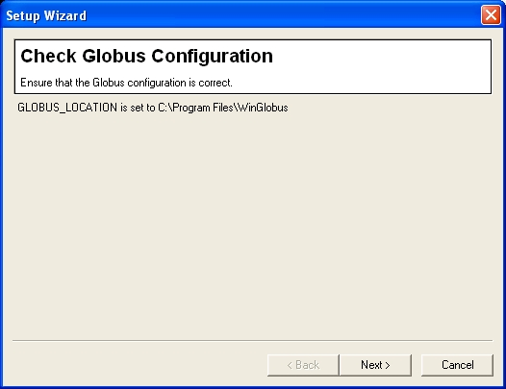
Figure 4 Configure your certificate settings

A new window, shown in Figure 5, will now open. Make sure you see four “OK” to the right of the certificate files. If any of the files are missing, you will have to find where the files are located by using the “Browse” button. After this is done, click “Next>” (If you have not requested a certificate yet, read section 2.1.2.)

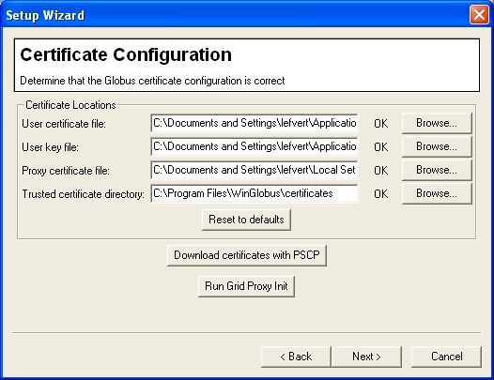
Four “OK” indicates your certificate is installed properly
Figure 5 Configure your certificate settings
Finally, the window in Figure 6 will appear, click “Finish” and your certificate should be configured.

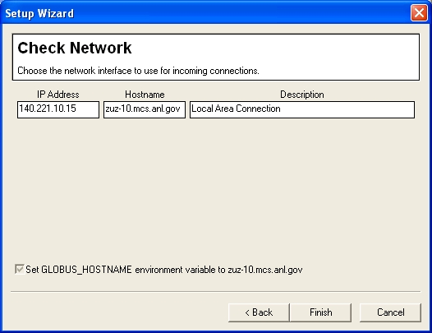
Figure 6 Configure your certificate settings

For Linux users:
NEEDS TO BE SPECIFIED

2.1.3 Create Grid Proxy
In order to successfully connect to the venue server you have to have a valid grid proxy certificate (for more information read section 3.1). If missing, the dialog in Figure 7 will enable you to create a proxy certificate. Fill in the password you choose when you initially requested your certificate in the “Passphrase” field. The “Proxy lifetime (hours)” field indicates for how long this proxy certificate will be valid, default value is 8 hours but feel free to change this number to something greater. After specifying the validity of the proxy, click “Ok”.
WRITE SOMETHING ABOUT WHY IT IS MORE SECURE TO HAVE SHORTER VALIDITY

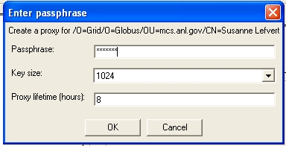
Figure 7 Create grid proxy

2.2 Start a Venue Server
For Windows users:
Go to the Start menu and select “All Programs-Access Grid Toolkit-Venue Server”. The default server URL address is https://localhost:8000/VenueServer.

For Linux users:
NEEDS TO BE SPECIFIED

2.3 Connect To a Venue Server
To connect to a Venue Server, enter the venue server URL address (https://<host>:<port>/VenueServer) in the Address Bar, and then click “Go”, see Figure 8.

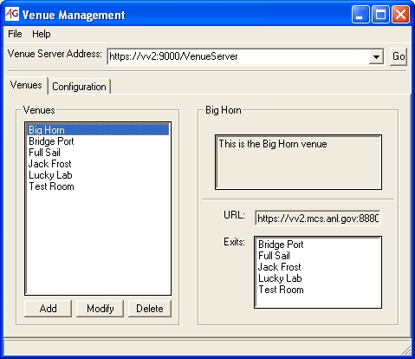
Figure 8. Use the address bar to connect to a venue server

2.4 Add Venue

Title and Description
Click on “Add” under the list of venues in the “Venues” tab. You will then see the dialog in Figure 9 appear. At a minimum, you need to specify the title of the venue and give it a description.

Encryption
You are also given the option to modify the encryption setting, if you mark “Encrypt Media” your media streams will be encrypted. You can decide if you want to specify a key for the encryption or leave the “Optional Key” field blank, the key will then be assigned automatically.

Addressing
The media streams are by default using multicast addressing, however, venues can be created with static addressing as well. Static addressing of video and audio streams requires you to specify ip address, port and a time to live value.

Exits
To connect your venue to other venues use the “Exits” section. By default, venues located on the server you are connected to are displayed in the box with title “Available Venues”. However, you can get venues from other servers by entering the url address of the remote server and click “Go” available under the list of exits. To add an exit, use the “Add Exit” button. In the list to the right you can see exits added to this venue. If you want to remove an exit, select the exit you wish to delete, and click “Remove Exit”. Finally, click “Ok” to create the venue.

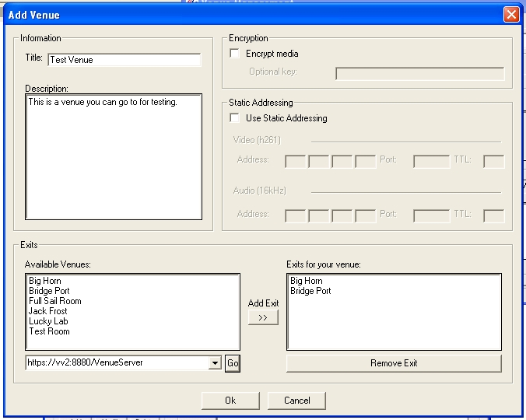
Figure 9 Create a new venue

2.5 Modify Venue
Select the venue you want to change then click on “Modify” under the list of venues in the “Venues” tab, a similar dialog as used to add a venue is displayed, see Figure 9. Modify appropriate fields then click “Ok”. (For more information about specific options, read section 2.3)

2.6 Remove Venue
Select the venue you wish to remove from the list of venues, and click the “Delete” button under the list. Click “Ok” in the next dialog to really make sure you want to remove the venue and it should disappear from the list.

2.7 Add Administrator
To authorize people the rights to use a venue server, you have to add them as administrators. Of course, only administrators are allowed to add other administrators. Under the “Configuration” tab you find a list of administrators, click the “Add” button and the dialog in Figure 10 will appear. All you need to add an administrator is that person’s distinguished name (for more information about distinguished names, see section 3.1.3). Click “Ok”.

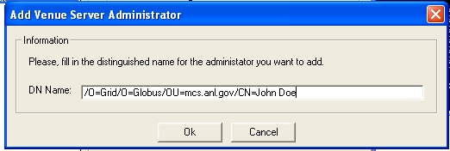
Figure 10 Add venue server administrator

2.8 Modify Administrator
Under the “Configuration” tab you find a list of administrators, select the administrator you wish to change and click the “Modify” button. A similar dialog, as shown in Figure 10, will appear. Change the administrator’s distinguished name then click “Ok” (for more information about distinguished names see section 3.1.3). Not to state the obvious, but be careful not to fill in an incorrect distinguished name for yourself as this will result in you not being authorize to perform any actions on the server, for example, change your distinguished name back to the correct one.

2.9 Remove Administrator
Under the “Configuration” tab you find a list of administrators, select the administrator you wish to remove and click the “Delete” button. Click “Ok” when next dialog is displayed. Not to state the obvious, but be careful not to remove yourself as this will result in you not being authorize to perform any actions on the server, for example, add yourself as an administrator.

2.10 Change Server Multicast Address
Multicast addresses, for all venues in the server, are by default assigned from a standard range. This can be changed by selecting “Custom Range” from the “Multicast Address” section in the “Configuration” tab and enter an ip address and a mask value. If you want to use static addressing for individual venues you can specify that when you create a new venue (read section 2.3)

2.11 Change Server Storage Location
All venues have a storage location where data added to the venue is going to be saved. The base path is the same for all venues and can be changed in the “Storage Location” section of the “Configuration” tab. Click on “Change” then enter the path in the “Path” field shown in Figure 11 then click “Ok”.

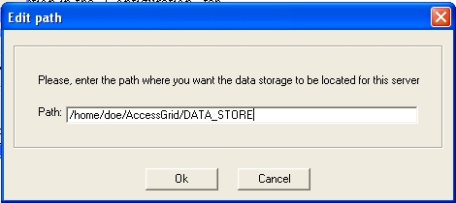
Figure 11 Change storage location path

2.12 Change Server Encryption
If you select “Encrypt Media” in the “Encryption” section of the “Configuration” tab, all venues on this server will by default use encryption. However, you still have the ability to change the encryption setting when adding a new venue or you can decide to modify an already existing venue (see section 2.3 or 2.4 for more information).

3. Other Information

3.1 Certificates

3.1.1 What is a Certificate?
Every user and service in the Access Grid is required to have a valid certificate issued from a trusted certificate authority. Certificates are a form of electronic identification that is superior of the well known and widely used password strategy. This form of authentication aims to reduce the many problems seen with passwords such as poorly chosen, forgotten, and insecurely stored passwords, in order to enable a reliable environment for collaboration. The certificate authority is responsible for giving you a certificate, thus make sure you really are who you say you are.

3.1.2 Why use Certificates?
A Certificate is basically used to assure your security when connected to the Access Grid. Some examples of security provided in the certificate mechanism are:

1. Dealing with authentication during log in procedures to identify who you are.
2. Authorize what resources people are allowed and have permission to access.
3. Preserve confidentiality by just showing given individuals resources and information they are supposed to see, secure transactions, etc.
4. Take care of users’ integrity; for example, backup of resources when something unexpected happens.

For more information about security through certificates, see http://www.globus.org/security/

3.1.3 Distinguished Name
A Distinguished Name (DN) is a globally unique identifier that represents the user as an individual. In the Access Grid, DNs are constructed from entity name and domain information. The following is an example of a distinguished name "/O=Grid/O=Globus/OU=mcs.anl.gov/CN=John Doe”. You can find your distinguished name in the usercert.pem file, created when you requested your certificate, by default located in C:\Documents and Settings\<your user name>\Application Data\globus\usercert.pem.

